***A comprehensive Review on: Filsapri (Sparsantan) for the treatment of proteinuria and IgA Neuropathy.***

**Abstract**:

For individuals with primary immunoglobulin A nephropathy (IgAN), sparsenten (Filsapri) is a once-daily oral medicine used as non-immuno suppression therapy to lower urine protein levels (proteinuria). Comparable to irbesartan, sparsenten was well tolerated and had a consistent safety profile in all clinical trials completed to date. (1,2) An endothelin and angiotensin ll receptor antagonist called Filsapri (Sparsenten) is prescribed for proteinuria in adult patients with primary IgAN(2) when the disease progresses quickly and the urine protein to creatinine ratio (UPCR) is 1.5 g/g or higher.IgA nephropathy is a significant etiology of renal disease in young adults and one of the world’s major causes of primary glomerulonephritis. Globally, glomerulonephritis (GN) can offer valuable insights about illness incidence patterns by age, gender, and location.It is seen as a disease mediated by an immunological complex. IgAN is an uncommon kidney disease (2) that affects up to 150,000 people in the United States, with an estimated 30,000 to 50,000 of these patients having glomerular disease, which is the primary cause of kidney failure (21). In the United States and Europe, sparsenten has been approved as an orphan medication to treat FSGS and IgAN. The Protect Study is a worldwide, randomized, multicenter, double-blind, active-controlled clinical trial that compares the safety and effectiveness of Filsapri to Irbesartan (10) in the treatment of IgAN and persistent proteinuria even when angiotensin converting enzyme (ACE) or ARB medication has reached its maximum tolerated level. IgA build up at in the kidney (4), which results in cellular alterations within the glomeruli and impairs glomerular filtration, is the hallmark of this uncommon illness.This harms the glomerular filtration barrier and results in cellular alterations within the glomeruli. (5, 18, 20) An ongoing phase 3 trial is examining sparsentan, a new, non-immunosuppressive, single-molecule, dual endothelin and angiotensin receptor antagonist, in adults with IgA nephropathy.(2) According to Traverse, a decrease in proteinuria was the basis for the FDA’s expedited approval of Filspari in cases of IgA nephropathy in February (5). According to the business, Sparsentan’s Phase 3 trial is being used to treat focal segmental glomerulosclerosis, or FSGS (9).

**Keywords**:

Focal segment glomeruli sclerosis (FSGS) , proteinuria, Sparsenten, Angiotensin ll , Endothelin, IgAN

**Introduction**:

FDA to lessen proteinuria in adult patients suffering from primary IgA nephropathy, which is the main cause of long-term renal impairment. Within 10 to 20 years (7), 20% to 40% of patients with IgAN go on to develop renal failure, necessitating dialysis or kidney transplantation, which has a major impact on mortality and quality of life. (3,11,13) Dual endothelin angiotensin receptor antagonist Sparsenten (4, 20) One new experimental product is DEARA (14). They are specifically going after the angiotensin ll subtype receptor (AT1R) (14) and the endothelin A receptor (ETAR) (15). They can be inhibited in rare chronic disease types, which lowers proteinuria, protects podocytes from damage, and stops the growth of mesangial cells and glomerulosclerosis (16). The efficacy, safety, and tolerability profile of Sparsenten in the context of the potential for it to become the first medication licensed for both FSGS and IgAN, as well as the preliminary data from the duplex and protect trials interim assessments. Sparsenten, a dual endothelin receptor antagonist, targets the underlying pathogenic mechanism behind IgAN. Medication for the management of symptoms like high blood pressure, edema, and excessive protein in the urine is one kind of contemporary mediation or treatment for IgAN. ACE inhibitors, ARBs, immunosuppressant’s, and steroids are some of these therapies (26). There are currently problems with this medicine, such as its lack of effectiveness and negative long-term adverse effects. This deficiency in efficacious treatments. So, the greater the care, the better.Let me introduce Sparsenten, an investigational medication created by Traverse Therapeutics that controls blood pressure, fluid balance, renal blood flow, glomerular filtration rate, and tubular transport. Its excessive activity leads to renal fibrosis and inflammation. This can be achieved by blocking mechanisms including endothelin and angiotensin II, which will lessen oxidative stress, inflammation, and renal fibrosis (19).This slows the course of IgAN and causes kidney fibrosis, proteinuria, and hematuria.(10,19The approval of Filsapri today establishes a baseline of care for individuals with IgA neuropathy. The etiology and symptoms of IgA neuropathy, often known as Berger’s disease (11,12) One uncommon kidney condition is IgA nephropathy. In the kidney, immunoglobulin A (IgA), a protein that aids in the body’s defense against infection, accumulates. Treatment options for filsapri include systemic glucocorticoids and hypertension medications such as angiotensin converting enzyme (ACE) inhibitors and angiotensin receptor blockers (ARBs). (13) The development of scar tissue on glomeruli and the accumulation of IgA antibodies in the glomeruli due to IgAN-induced inflammation are the hallmarks of FSGS. IgAN is more prevalent than FSGS; however, FSGS has a worse prognosis. (22))

# **Pharmacology of Filsapri (Sparsenten)**

* **Moa of Filsapri**:

Sparsenten is a monomer that functions as an antagonist of both the angiotensin-L type 1 receptor and the endothelin type A receptor. It has two powerful vasoconstrictor and mitogenic agents, Ang-ll and endothelin-1, with clinically proven modes of action at each receptor. Et1 and Ang-ll are involved in immunoglobulin pathogenesis. An enhanced synthesis of galactose-deficient IgAN antibodies is a characteristic of an IgAN nephropathy. Adult proteinuria is decreased by sparsenten’s selective binding to the relevant pathways (15).

* **Pharmacokinetics**:

A two-compartment model that includes first-order absorption with lag time, dose-dependent bioavailability, and first-order elimination after oral administration of single 200–600 mg doses best describes the pharmacokinetics of sparsenten. Area under the plasma concentration time curve (AUC) and sparse maximum plasma concentration (Cmax) increased less than in a dose-proportionate way (17). To assess the effects of co-medications and FSGS disease features as covariates on sparsentan PKs, a population pharmacokinetic (PK) analysis was conducted to characterize the drug’s PKs. Blood samples were taken from 194 primary and genetic FSGS patients who were enrolled in nine studies spanning from phase I to phase III, 16 people with hepatic impairment, and 236 healthy volunteers.(10)

* **Pharmacodynamics:**

The development of IgA nephropathy is aided by the endothelin-1 and angiotensin-L signaling pathways. Sparsenten binds to the angiotensin-ll type 1 and endothelin-type A receptors with great affinity and selectivity, blocking both pathways at the same time. (14) IgA Nephropathy and Immunosuppression (17) Sparsentan is a dual endothelin and angiotensin II receptor antagonist. At week 36, the exposure-response (E-R) relationship between sparsentan exposure and the percentage reduction from baseline in urine protein-to-creatinine ratio (UPCR) was not statistically significant over the observed sparsentan exposure range. E-R relationships were not statistically significant for any grade of hypotension or the worst grade of peripheral edema.5

* **Side effects of Filsapri (Sparsenten):**
* Hepatotoxicity: Elevations in aminotransferases, hepatotoxicity, and renal failure have been linked to certain endothelin receptor antagonists
* Elevated potassium
* Fetal Embryo Toxicity
* Liver issues
* severe birth abnormalities. Refer to the important details.
* Low BP. During Filspari treatment, low blood pressure is common and can be dangerous.
* Elevated blood potassium levels;
* Declining renal function. During Filspari treatment, this is typical and can potentially be dangerous.
* Retention of fluid (1).
* Filspari may make your body retain excessive amounts of fluids, etc.
* **Contraindications** :
* Due to hepatotoxicity, Filsapri should typically be avoided in patients with high amino transferases.
* When using ARBs, ERAS, or Aliskiran together, there is an increased risk of renal failure, hypotension, syncope, and hyperkalemia.
* Potent inducers of CYP3A, antacids
* Acid-reducing agents,
* NSAIDS-inducing selective cox inhibitors.(1,2)

**Drug- drug interactions:**

* Avoid co-administering FILSPARI with angiotensin receptor blockers (ARBs), ERAs, or aliskiren. Renin-Angiotensin System (RAS) inhibitors.
* Avoid using FILSPARI and powerful CYP3A inhibitors at the same time if you have either of these conditions. When taking moderate CYP3A inhibitors concurrently, it is important to periodically check blood pressure, serum potassium, edema, and kidney function. Strong CYP3A Inducers: Steer clear of using a strong CYP3A inducer at the same time.
* Acid-reducing agents with antacids: Give FILSPARI two hours prior to or following the administration of antacids. Steer clear of using FILSPARI and acid-reducing medicines (PPI proton pump inhibitor and histamine H2 receptor antagonist) at the same time.
* Non-Steroidal anti-inflammatory drugs (NSAIDs), such as selective COX-2 inhibitors, should be watched for indications of declining kidney function.
* . Agents Raising Serum Potassium: Regularly check your serum potassium levels. Using FILSPARI along with potassium-sparing diuretics, potassium supplements, and potassium

**#** **Information of IgA Nephropathy:**

Jean Berger was the first to describe primary IgA nephropathy (IgAN), often known as Berger’s disease (25). An autoimmune condition called IgA nephropathy damages the kidneys and can progress to end-stage renal disease. One of the major global causes of primary glomerulonephritis and a significant contributor to the pathogenesis of renal disease in young adults is IgA nephropathy. IgA buildup in the kidneys, which results in cellular alterations within the glomeruli and harms the glomerular filtration barrier, is the hallmark of this uncommon illness.(18) The most prevalent form of primary glomerulonephritis is IgA nephropathy (10), with 30–40% of patients experiencing kidney failure within 20–30 years of diagnosis (10, 17). As of right now, blood pressure control is the primary goal of patient management because there are no IgAN-specific medications available. Keeping the kidneys functioning. Nonetheless, novel therapeutic strategies are being created based on our constantly expanding comprehension of the pathophysiology of disease. (24)

**# Information of FSGS:**

Although the origin of primary FSGS is unknown, it is thought to result from the effects of hypothetical circulating permeability factors that injure podocytes.(,27) FSGS is a kidney-scarring illness that is frequently associated with acquired glomerular disease, which in turn leads to end-stage kidney disease. It is thought to impact over 40,000 patients. (6) For a significant percentage of patients, it is the cause of end-stage kidney disease. In patients with FSGS, the primary FSGS (DUPLEX) research assesses sparsentan long-term antiproteinuric efficacy, nephroprotective potential, and safety profile in comparison to an AT1 receptor blocker alone.(10,33)

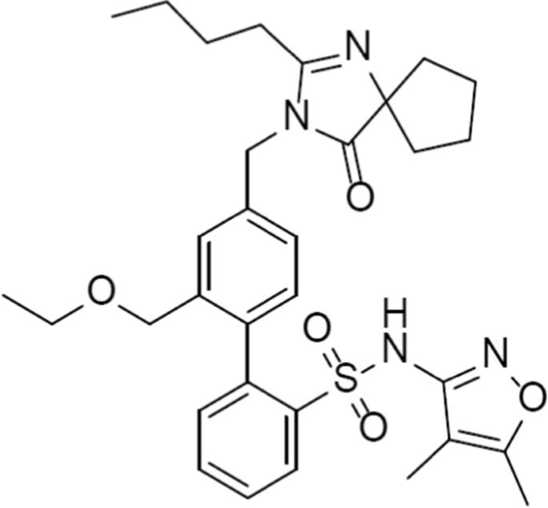**Information about Filsapri**:

The first and only non-immunosuppressive treatment authorized for the treatment of IgAN is Filsapri (sparsentan), an oral medication taken once daily that is specifically designed to target two important pathways in the disease progression of IgAN: endothelin-1 and angiotensin II. A prescription medication called FILSPARI is meant to lessen proteinuria in persons with primary IgAN who are at risk of the disease progressing quickly; typically, a UPCR of ≥1.5 g/g is required.(29,33)

**# A few ongoing trials with sparsentan are shown in this figure(2)**

# **Clinical trial:** 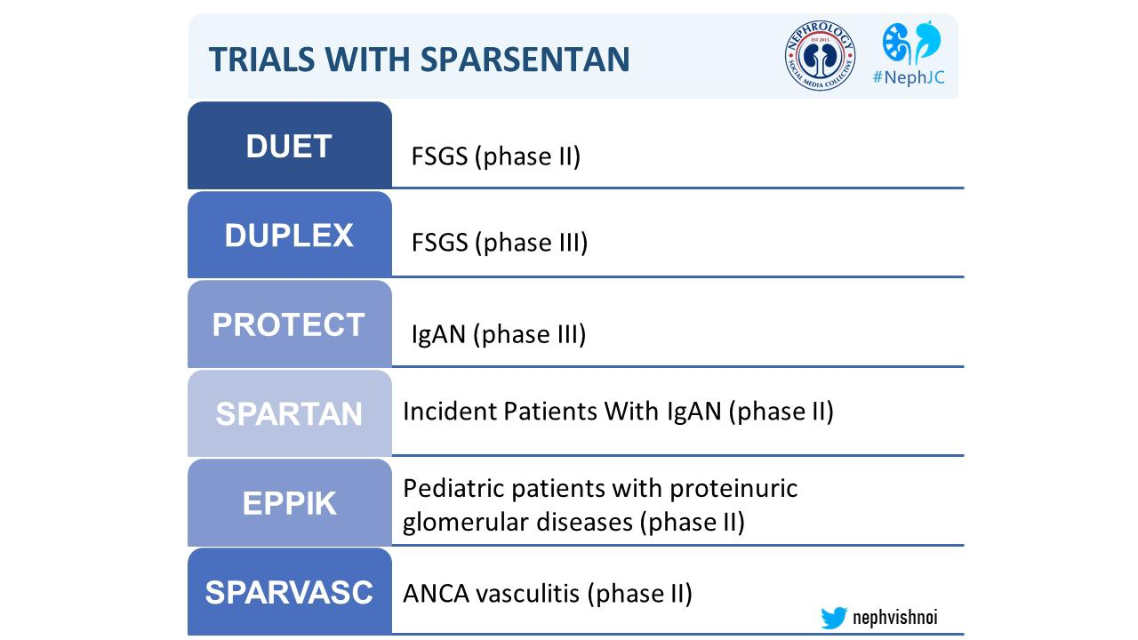

**Conclusion**:

Based on this research, it can be stated that FILSAPRI (Sparsenten) is primarily useful for treating IgAN, FSGA, and primary proteinuria. Comparing FILSAPRI against other drugs reveals that it is a safe and effective medication. For example, Transverse Therapeutics may approve Filsapri in February 2023. Irbesartan is an orphan medication.

The primary efficacy objective is to test the hypothesis that sparsentan over the dose range (200 mg, 400 mg, or 800 mg daily) is superior to irbesartan (300 mg daily) in decreasing the urinary protein-to-creatinine ratio (UPC) from baseline to 8 weeks postrandomization. As secondary objectives, the trial will evaluate the proportion of patients who achieve prespecified targets of UPC reduction, changes in laboratory and quality-of-life indices, and detailed safety analysis. Analyses will be conducted at the end of the double-blind (week 8) and open-label (week 144) periods.(32)

**Reference:**

1)Traverse Therapeutics Announces Topline results from two year primary efficacy endpoint in pivotal phase 3 Duplex study of Sparsenten in focal segment glomerulosclerosis ( Global Newswire).

2) Sparsenten in patients with IgA nephropathy a prespecified interim analysis of from a randomised double-blind, active controlled clinical trial. Prof.Hiddo JL Heerspink PhD,Prof Jai , MD. Prof Charles E Alpers, MD .Prof Jonathan Barratt, PhD . April 01 2023

3)The incidence of primary glomerulonephritis world wide a systematic review of the literature. Anita MC. Grogan, Casper F.M Franssen,Corinne. S. De vries .

4) FDA needs additional time to review Sparsentan,Tofersen application Diana Ernst RPh, October 17,2022

5)Traverse Therapeutics shares Touch 52 weeks low on FSGS study data ( morning star)

6)Travere Therapeutics Shares Touch 52-Week Low on FSGS Study Data 02 Maggio 2023 Dow Jones News ,By Colin Kellaher

7) Tesar V, Troyanov S, Bellur S, et al. Corticosteroids in IgA Nephropathy: a retrospective analysis from the VALIGA Study. J Am Soc Nephrol. 2015;26:2248–2258.

8) Berthoux F, Mohey H, Laurent B, Mariat C, Afiani A, Thibaudin L. Predicting the risk for dialysis or death in IgA Nephropathy. J Am Soc Nephrol. 2011;22:752–761

9)Traverse Therapeutics stocks slides 35% after announcing disappointing results from 2 year trial of kidney drug ( markets watch)

10) Study de design of the phase 3 Sparsenten versus Irbesartan( Duplex) study in patient with focal segmental glomerulosclerosis. Radko Komers, Ulysses Dive etc. 2019 12. 2017

11)Jarrick S, Lundberg S, Welander A, et al. Mortality in IgA Nephropathy: a nationwide population-based cohort study. J Am Soc Nephrol. 2019;30:866–876.

12) Interim analysis of the phase 3 protect study of FILSAPRI (Sparsenten) in n IgA nephropathy presented by Traverse Therapeutics at NKF spring clinical meeting – 13 April 2023.

13)IgA neuropathy patient baseline characteristics in the Sparsenten and protect study Jonathans Barratt ,Brad Rovin ,Muth Geot Wong etc.

14)population pharmacokinetic analysis of Spartansen and healthy volunteer and patients with focal segment glomerulosclerosis. Russell Wada ,Huub Jan Kleijn,LU Zhang ,Shang Chiung Chen 2023-05-23

15)Endothelin antagonist and kidney disease , Irene Martinez – Diaz ,Nerea Martos etc, 2023-02-08

16)Traverse Therapeutics provide regulatory update on its patterns and program for the IGI Neuropathy October 13 ,2023

17) Syed, Y.Y. Sparsentan: First Approval. Drugs 83, 563–568 (2023). <https://doi.org/10.1007/s40265-023-01864-x>

18) Filsapri (Sparsenten) for the reduction of proteinuria in IgA Nephropathy USA June 22 ,2023

19) Traverse: Sparsenten approval is likely but future in uncertain Stephen February 13 2023

20)FDA needs additional time to review Sparsentan,Tofersen application Diana Ernst RPh, October 17,2022

21) Ligands’ partners Traverse Therapeutics announce FDA accelerated approval of FISPARI (Sparsenten) the only non immuno suppressive therapy for the reduction of proteinuria in IgA neuropathy , February 17.2023

22)) Traverse IgA nephropathy effort with Sparsenten has tenuous link to drugs performance in another kidney disorder, efficacy conclusions arduous ,Manasi Vaidya February 05 2021

23)Teasar V, Troyanov S, Bellur S, et al. Corticosteroids in IgA Nephropathy: a retrospective analysis from the VALIGA Study. J Am Soc Nephrol. 2015;26:2248–2258. <https://doi.org/> 10.1681/ASN.2014070697

24)Lal KN ,Tang Sc schema F.P et al Ig A neuropathy Nat Rev Dis primers 2016 ; 2 16001

25)Berthoux F, Mohey H, Laurent B, Mariat C, Afiani A, Thibaudin L. Predicting the risk for dialysis or death in IgA Nephropathy. J Am Soc Nephrol. 2011;22:752–761

26) Jwon CS, Daniele P, Forsythe A, Ngai C. A systematic literature review of the epidemiology, health-related quality of life impact, and economic burden of immunoglobulin A nephropathy. J Health Econ Outcomes Res. 2021;8:36–45.https://doi.org/10.36469/001c.26129

27)D’Agati V.D.Kaskel F.J.Falk R.J.Focal segmental glomerulosclerosis.N Engl J Med. 2011; 365: 2398-2411

28)Campbell KN, Griffin S, Trachtman H, Geletka R, Wong MG. Practical Considerations for the Use of Sparsentan in the Treatment of Patients with IgAN in Clinical Practice. Int J Nephrol Renovasc Dis. 2023 Dec 22;16:281-291. Doi: 10.2147/IJNRD.S430377. PMID: 38149041; PMCID: PMC10750480.

29)Travere Therapeutics Submits Supplemental New Drug Application to the U.S. Food and Drug Administration Seeking Full Approval of FILSPARI® (sparsentan) for the Treatment of IgA Nephropathy (IgAN) Mar 11, 2024

30)Murugesan N, Gu Z, Fadnis Ll et.al Dual angiotensin II and endothelin A receptor antagonists: synthesis of 2’-substituted N-3-isoxazolyl biphenylsulfonamides with improved potency and pharmacokinetics. J Med Chem. 2005 Jan 13;48(1):171-9. Doi: 10.1021/jm049548x.

31)Komers R, Gipson DS, Nelson P, E, et .al Efficacy and Safety of Sparsentan Compared With Irbesartan in Patients With Primary Focal Segmental Glomerulosclerosis: Randomized, Controlled Trial Design (DUET). Kidney Int Rep. 2017 Mar 4;2(4):654-664. Doi: 10.1016/j.ekir.2017.02.019. 2017 July

32)Davenport AP, Kuc RE, Southan C, Maguire JJ: New drugs and emerging therapeutic targets in the endothelin signaling pathway and prospects for personalized precision medicine. Physiol Res. 2018 Jun 27;67(Suppl 1):S37-S54. Doi: 10.33549/physiolres.933872.

33)FDA Approved Drug Products: FILSPARI (sparsentan) tablets for oral use (February 2023)