**Formulation and Evaluation of Multipurpose Traditional Herbal Shampoo and their Comparative Analysis**

Ms.Snehal Prakash Bongarde*, Ms.Sanika R. Parmaj, Mr. Shivprasad V. Yetale, Ms. Ashlehsya A. Patil, Ms. Mangal Kamble

**Abstract:**

In recent years, there has been a growing interest in the development of multipurpose herbal shampoos due to their potential benefits and reduced side effects compared to conventional synthetic products. The goal of the study was to formulate a pure herbal shampoo and assess and contrast its physicochemical characteristics with those of commercially available synthetic and herbal shampoos. The multipurpose traditional herbal shampoo was formulated by adding the extracts of Hibiscus rosa simcensis, Ocimum sanctum, Trigonella foenum graceum, Acacia concinna, Sapindus mukoross, and Aloe barbadensis, which are renowned for their hair nourishing, anti-dandruff, and scalp-soothing effects. As a preservative, a small amount of citrus lemon, tragacanth gum, and gelatin were added, and the pH was corrected with citrus lemon. A number of tests were conducted to ascertain the physicochemical characteristics of shampoos that were formulated and commercialized, including visual inspection, pH, wetting time, percentage of solid contents, foam volume and stability, surface tension, detergency, viscosity profile, dirt dispersion, etc. The shampoo demonstrated significant improvement in hair texture, reduced dandruff, and enhanced scalp health in a user trial over four weeks.

Keywords: Herbal, polyherbal, Detergent, pH. Shampoo, Methyl paraben, Physicochemical properties

**Introduction:**

In recent years, the beauty and personal care industry has witnessed a significant shift towards natural and organic products. Since the dawn of time, humans have been borrowing extensively from nature to maintain their health, skin, and hair using polyherbal ingredients [1]

Shampoos are most probably used as cosmetics. It is a hair care product that are used to clean the scalp and hair in our daily life. The use of shampoos that are completely made of herbal ingredients is becoming increasingly popular due to their association with a healthy lifestyle [2] Surfactants are added in synthetic shampoos mainly for their cleansing and foaming properties, but their continuous use can cause severe problems if they are continuously used such as eye irritation, scalp irritation, loss of hair, and dryness of hairs. Alternative to synthetic shampoo we can use shampoos containing natural herbals. [3] A multipurpose herbal shampoo is designed to address various hair and scalp issues simultaneously. [4]

n the current study, herbal shampoo was designed using relevant ingredients such as Hibiscus for the Conditioning agent shikakai and Reetha, which when shaken with water create rich foam due to their high saponin content Aloe Vera acts as a coolant, while methi promotes new hair development and reduces hair loss. Tulsi rejuvenates hair follicles and strengthens the root, reducing hair loss. This preparation has multiple benefits. Indian ladies have utilized herbs like Shikkakai and Reetha for centuries as natural cleansing agents with no negative side effects. The formulation is made from pure and organic ingredients with no side effects no petroleum based ingredients and is environmentally friendly. [5,6]

Ingredients [7]: Table No 1

|  |  |  |  |  |  |  |  |  |
| --- | --- | --- | --- | --- | --- | --- | --- | --- |
| **S. No.** | | **Common name** | **Pictures** | | | **Botanical name** | **Function/Use** | **Category** |
| 1 | | Hibiscus | C:\Users\Zebion\AppData\Local\Microsoft\Windows\Temporary Internet Files\Content.Word\Hibiscus-1.jpg | | | *Hibiscus rosa-sinensis* | Prevents hair loss and hair growth promoter | Conditioning agent |
| 2 | | Shikakai |  | | | *Acacia concinna* | Retains natural  oil of hair, keeps hair lustrous & healthy. | Detergent |
| 3 | | Soapnut |  | | | *Sapindus indica* | Detergent and antidandruff | Detergent |
| 4 | | Tulsi |  | | | *Ocimum sanctum* | Antimicrobial and anti-lice property | Anti-microbial agent |
| 5 | | Methi |  | | | *Trigonella foenum graceum* | Cleansing and softening | Detergent |
| 6 | AloeVera | | |  | *Aloe barbadensis* | | conditioning | Coolant |

Materials and Methods:

Table No 2:

|  |  |
| --- | --- |
| **Materials required** | **Quantity to be weighed** |
| Reetha extract | 5 gm |
| Shikakai extract | 5 gm |
| Hibiscus extract | 5 gm |
| Methi extract | 5 gm |
| Tulsi extract | 5 gm |
| Aloevera extract | 5 gm |
| Lemon juice | 5 ml |
| Tragacanth gum | 0.1 gm |
| Gelatin | q.s |
| Rose water | q.s |

**Methods:**

**Sample collection:**

All plant materials except methi, tulasi were obtained from Bawdekar Ayurvedic store-Kolhapur and were authenticated by the [Pharmacognosy](https://www.sciencedirect.com/topics/medicine-and-dentistry/pharmacognosy" \o "Learn more about Pharmacognosy from ScienceDirect's AI-generated Topic Pages) professor, at Sanjay Ghodawat University- Kolhapur. Commercially available shampoos namely Pathanjali kesh kanti were purchased from the local super market.

## Preparation of extract

Approximately 50g of each powdered plant materials, namely*,* *Hibiscus rosa-sinensis*, *Acacia concinna,*  *Sapindus indica,* Ocimum sanctum, Trigonella foenum graceum,  *Aloe barbadensis* were homogenized. The powdered material was extracted with distilled water by boiling for 4 h. The extract of each plant material was separated and evaporated. [8]

## Formulation of herbal shampoo

Formulation of the herbal shampoo was done as per the formula given in Table 1. To the gelatine solution (q.s), added the herbal extract and mixed by shaking continuously at the time interval of 20 min. 5 ml of lemon juice was also added with constant stirring. To improve aroma in the formulation, sufficient quantity of rose water was added and made up the volume to 50 ml with gelatin.[9]

## Evaluation of herbal shampoo:

To evaluate the quality of commercial and created formulations, many quality control tests were done, including visual assessment, physicochemical controls, conditioning, and performance testing. [10]

**1.Physical Appearance/Visual Inspection**

Were performed on the prepared formulations to evaluate their clarity, foam-producing ability, and fluidity.**2.**

**2. Determination of pH**

At a room temperature of 25°C, the pH of 10% shampoo solution in distilled water was measured.

**3. Determine percent of solids contents**

The dish was weighed and the shampoo was added to a dish that was clean, dry, and evaporating. The exact weight of the shampoo was calculated only and put the evaporating dish with shampoo was placed on the hot plate until the liquid portion was evaporated. After drying, the weight of the shampoo alone (solids) was calculated

**4. Rheological evaluations**

An Ostwald viscometer was used to determine the viscosity of the shampoos, and spindle T95 was used to measure it.The temperature and sample container’s size was kept constants during the study

**5. Dirt dispersion:** A large test tube was filled with 10 ml of distilled water and two drops of shampoo

were added. After adding one drop of India ink, the test tube was closed and shaken ten times. The ink content in the foam was estimated to be None, Light, Moderate, or Heavy.

**6. Skin sensitization test:**

The purpose of this test is to examine the skin of volunteers to determine if it causes irritation or not.

**7. Stability test**

During the storage period of 2 months, formulations retain their organoleptic properties and are acceptable indicated that they are chemically and physically stable

**8. Foaming Index:**

By adding water to each test, cm was used to measure the foam and calculate the foaming index. Index = 1.000/A where A= volume of decoction having exact 1cm height foaming Index=500

**9.Surface tension measurement :** The shampoo prepared with distilled water (10% w/v) was evaluated for surface tension using a stalagmometer at room temperature.

**Results:**

**Table 3: Physicochemical study of the herbal shampoo**

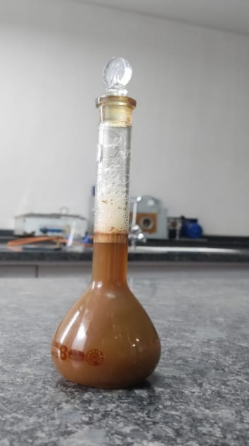

|  |  |
| --- | --- |
| **Evaluation test** | **Formulated shampoo** |
| Colour | Dark brown |
| pH | 5.4 |
| Odour | Pleasant |
| Rheological evaluations | 1.3 Poise |
| Dirt dispersion | Moderate |
| Skin sensitization | No irritation on skin |
| Foaming Index | 500 |
| Nature of hair after washes | Shiny, Dandruff free |
| Percent of solids contents | 22.55% |

Formulated Multipurpose Herbal Shampoo

**Comparative Analysis: [11]**

**Table No.1: pH determination of marketed sample and prepared formulation of herbal shampoo**.

|  |  |  |
| --- | --- | --- |
| **Sr.no.** | **Sample** | **pH** |
| 1 | Keshkanti herbal shampoo | 5.7 |
| 2 | Prepared herbal shampoo | 5.4 |

**Table No.2: Percentage of solids in marketed sample and prepared formulation of herbal shampoo**

|  |  |  |
| --- | --- | --- |
| **Sr.no.** | **Sample** | **% of solids** |
| 1 | Keshkanti herbal shampoo | 22.69% |
| 2 | Prepared herbal shampoo | 22.55% |

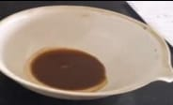

Marketed shampoo solid content Test

Formulated shampoo solid content Test

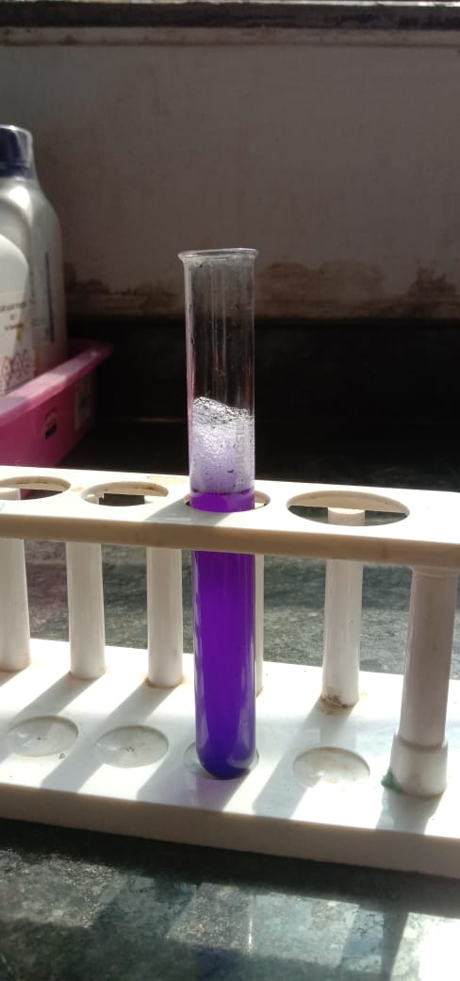**Table No.3: Dirt dispersion in marketed sample and prepared formulation of herbal shampoo [12]**

|  |  |  |
| --- | --- | --- |
| **Sr.no.** | **Sample** | **Dirt dispersion** |
| 1 | Keshkanti herbal shampoo | light |
| 2 | Prepared herbal shampoo | moderate |

Dirt Dispersion Test

**Table No. 4: Foam formation in marketed sample and prepared formulation of herbal shampoo.**

|  |  |  |  |
| --- | --- | --- | --- |
| **Sr.no.** | **Sample** | **Foam volume** | **Bubble size** |
| 1 | Keshkanti herbal shampoo | 370 ml | small |
| 2 | Prepared herbal shampoo | 350 ml | Small |

**Table No. 5: Viscosity Profile of marketed sample and prepared formulation of herbal shampoo.**

|  |  |  |
| --- | --- | --- |
| **Sr.no.** | **Sample** | **Viscosity** |
| 1 | Keshkanti herbal shampoo | 1.3 poise |
| 2 | Prepared herbal shampoo | * 1. poise |

**Table No.6: Determination of surface tension in marketed sample and prepared formulation of herbal shampoo.**

|  |  |  |
| --- | --- | --- |
| **Sr.no.** | **Sample** | **Surface tension (dy/cm)** |
| 1 | | Keshkanti herbal shampoo | 31.25+0.001 |
| 2 | | | Prepared herbal shampoo | 33.17+0.01 |

|  |  |  |
| --- | --- | --- |
| **Quantity** | **Prepared Herbal shampoo** | **Keshkanti herbal shampoo** |
| 1ml | 0.7ml | 0.5ml |
| 2ml | 1.1ml | 0.7ml |
| 3ml | 1.5ml | 1.2ml |
| 4ml | 1.8ml | 1.5ml |
| 5ml | 2.1ml | 2ml |
| Result | 500 | 333 |

**Table no.7: Foaming index [13]**

Foaming index =1000÷A

(A)= foam at 1 cm

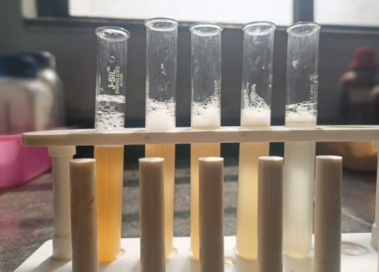

**Foaming Index Tests**

**Discussion:**

The present review focused on the uses and importance of herbal shampoo. It includes the awareness and need for the cosmetics with herbal ingredients, as it is strongly believed that the herbal products are safe and free from side effects [14,15]. It emphasizes on types, methods of preparation and evaluation of polyherbal shampoos. The present study was carried out with the aim of preparing the herbal shampoo that reduces hair loss during combing, safer than the chemical conditioning agents as well as to strengthen the hair growth. Herbal shampoo was formulated with the aqueous extracts of medicinal plants that are commonly used for cleansing hair traditionally; Use of conditioning agents (synthetic) reduces the hair loss [16] To provide the effective conditioning effects, the present study involves the use of shikakai, Hibiscus, Tulsi, Methi, Shikakai, Soapnut, Alovera and other plant extracts instead of synthetic cationic conditioners[17]

A form of shampoo known as herbal shampoo uses natural elements as its main ingredients, including plant extracts, essential oils, and botanical compounds. [18] These shampoos are frequently promoted as an eco-friendly, milder, and more natural substitute for regular shampoos, which could include harsh surfactants and artificial chemicals. [19]

Hair growth can be enhanced and scalp-related problems and hair loss can be prevented by traditional herbal formulations. [20] Essentialingredients in herbal formulations are necessary for moisturizing the scalp, promoting hair growth, maintaining normal function of sebaceous glands, and reversing scalp infections to normal [21]

Natural ingredients, such as plant extracts, essential oils, and botanical substances, are the primary ingredients of herbal shampoo Conventional shampoos may contain synthetic chemicals and harsh surfactants, but these shampoos are often touted as a more natural, gentle, and environmentally friendly alternative. [22]

The main purpose behind this investigation was to develop a stable and functionally effective shampoo by excluding all types of synthetic additives, which are normally incorporated in such formulations. [23] To evaluate for good product performance of the prepared shampoo, many tests were performed. [24] The results of the evaluation study of the developed shampoo revealed comparable results for quality control test, but further scientific validation is needed for its overall quality [25]

Key Ingredients in Herbal Shampoos:

1) Aloe vera –Known for its soothing and moisturizing properties, aloe vera helps calm the scalp and add hydration to the hair.

2) Methi –Hair masks, hair rinses, shampoos, and conditioners can be applied topically to your hair and scalp with fenugreek [26]

3) Tulsi-Tulsi is an amazing herb that helps to achieve lustrous shiny and healthy hair.

4) Shikakai -Since ancient times, this has been used to cleanse the scalp, strengthen the hair from the roots, offer relief from scaling, and reduce irritation, dryness, greasiness, and scaling of the scalp [27]

5) Reetha-Mainly used as a foaming agent. It can be used as a shampoo, conditioner, and hair mask.

6) Hibiscus-Promotes hair growth and provides a soft and silky texture while nourishing your hair. [28]

Benefits of Multipurpose Herbal Shampoo [29, 30]:

1. Comprehensive Hair Care:

The combination of cleansing agents (soapnut, shikakai), conditioners (tulasi, aloe vera), and therapeutic herbs (Hibiscus, methi) addresses multiple hair concerns in one product. This eliminates the need for multiple hair care products, offering a convenient and holistic solution.

2. Reduced Chemical Exposure:

By incorporating natural and herbal substances, the formulation reduces exposure to synthetic chemicals that might cause irritation or long-term harm to the hair and scalp.

3. Environmental Sustainability:

Herbal shampoos are an ecologically conscious alternative to conventional shampoos, which frequently contain non-biodegradable chemicals, because they are made with biodegradable and sustainably derived ingredients.

The development of a multipurpose herbal shampoo is a viable approach to current hair care, in line with customer demands for natural, effective, and ecologically friendly goods. By combining the therapeutic capabilities of various herbs and natural substances, it is possible to develop a shampoo that not only cleanses and conditions but also supports overall hair health. However, issues such as stability, user experience, and regulatory compliance must be carefully controlled to ensure the product's success in a competitive market.

**Conclusion:**

The development of a multipurpose herbal shampoo underscores the importance of combining traditional herbal wisdom with modern formulation technology. This synergy results in a product that is not only effective in promoting healthy hair but also safe and sustainable, making it a valuable addition to the personal care market.

**References:**

1. Al Badi K, Khan SA. Formulation, evaluation and comparison of the herbal shampoo with the commercial shampoos. Beni-Suef University Journal of Basic and Applied Sciences. 2014 Dec 1;3(4):301-5.
2. Pradhan A, Bhattacharyya AM. Shampoos then and now: synthetic versus natural. J. Surf. Sci. Technol. 2014;30:59-76.
3. Gubitosa J, Rizzi V, Fini P, Cosma P. Hair care cosmetics: From traditional shampoo to solid clay and herbal shampoo, a review. Cosmetics. 2019 Feb 19;6(1):13.
4. Patel IM, Talathi AD. Use of traditional Indian herbs for the formulation of shampoo and their comparative analysis. International Journal of Pharmacy and Pharmaceutical Sciences. 2016;8(3):28-32.
5. Vijayalakshmi A, Sangeetha S, Ranjith N. Formulation and evaluation of herbal shampoo. Asian J Pharm Clin Res. 2018;11(4):121-4.
6. Mohammad Azmin SN, Abdul Manan Z, Wan Alwi SR, Chua LS, Mustaffa AA, Yunus NA. Herbal processing and extraction technologies. Separation & Purification Reviews. 2016 Oct 1;45(4):305-20.
7. Sharma R, Shah K, Patel J. Evaluation of prepared herbal shampoo formulations and to compare formulated shampoo with marketed shampoos. Int J Pharm Pharm Sci. 2011;3(4):402-5.
8. Srivasuki KP. Nutritional and health care benefits of amla. J Pharm .
9. Roy RK, Thakur M, Dixit VK. Hair growth promoting activity of Eclipta alba in male albino rats. Arch Dermatol Res.
10. AlQuadeib BT, Eltahir EK, Banafa RA, Al-Hadhairi LA. Pharmaceutical evaluation of different shampoo brands in local Saudi market. Saudi pharmaceutical journal. 2018 Jan 1;26(1):98-106.
11. Pretorius E. DNA barcoding and phytochemical analysis in quality control of herbal medicine: a case study of Devil’s Claw (Harpagophytum spp) and Buchu (Agathosma spp). University of Johannesburg (South Africa); 2021.
12. Tarun J, Susan J, Suria J, Susan VJ, Criton S. Evaluation of pH of bathing soaps and shampoos for skin and hair care. Indian J Dermatol.
13. Ramadevi B, Battu G. A holistic approach for formulation and evaluation of poly herbal shampoos. Journal of Pharmacognosy and Phytochemistry. 2019;8(2):829-35. 14.Gaud RS, Gupta GD. Practical Physical Pharmacy. 1st ed. New Delhi: C.B.S. Publisher and Distributer; .
14. Bijauliya RK, Alok S, Kumar M, Chanchal DK, Yadav S. A comprehensive review on herbal cosmetics. International Journal of Pharmaceutical Sciences and Research. 2017 Dec 1;8(12):4930-49.
15. Lodha G. Formulation and evaluation of polyherbal shampoo to promote hair growth and provide antidandruff action. Journal of Drug Delivery and Therapeutics. 2019 Aug 30;9(4-A):296-300.
16. Okole B, Pillai SK, Ndzotoyi P, Phasha V. Use of herbal extract-based nanoemulsions for hair care application. InNanotechnology for the preparation of cosmetics using plant-Based extracts 2022 Jan 1 (pp. 203-233). Elsevier.
17. Gupta P, Tiwari MY, Mukopadayay S. Formulation and evaluation of herbal hair dye: A review article.
18. Desam NR, Al-Rajab AJ. The importance of natural products in cosmetics. Bioactive natural products for pharmaceutical applications. 2021:643-85.
19. Sutar NG, Kakade VV, Desai S, Palghdmal PS, Patel VP, Patel VK, Patel AS, Shah T. Standardization and Comparison of the Herbal Shampoo with the Commercial Shampoos. Journal of Coastal Life Medicine. 2023 Jan 11;11:680-8.
20. Avalaskar AN, Choudhari LS, Punmiya AH, Ranvare SS, Polawar RA, Honkalas KG. Formulation and evaluation of herbal hair emulgel. J Emerg Tech Innov Res. 2020 Feb;7(2):161-6
21. Kole PL, Jadhav HR, Thakurdesai P, Nagappa AN. Cosmetic potential of herbal extracts.
22. Lochhead RY. The role of polymers in cosmetics: recent trends..
23. Sang SH, Lee SK, Keng JW, Lim HC, Farrukh MJ, Tan CK, Liew KB, Lee SK, Chew YL. A Review on Synthetic Shampoo Ingredients and Their Adverse Health Effects. Current Trends in Biotechnology and Pharmacy. 2023 Dec 13;17(4A (Supplement)):50-60.
24. Sharma R, Shah K, Patel J. Evaluation of prepared herbal shampoo formulations and to compare formulated shampoo with marketed shampoos. Int J Pharm Pharm Sci. 2011;3(4):402-5.
25. Bakr RO, Amer RI, Fayed MA, Ragab TI. A completely polyherbal conditioning and antioxidant shampoo: A phytochemical study and pharmaceutical evaluation. Journal of Pharmacy and Bioallied Sciences. 2019 Apr 1;11(2):105-15.
26. Rajeswari R, Umadevi M, Rahale CS, Pushpa R, Selvavenkadesh S, Kumar KS, Bhowmik D. Aloe vera: the miracle plant its medicinal and traditional uses in India. Journal of Pharmacognosy and Phytochemistry. 2012;1(4):118-24.
27. Bijauliya RK, Alok S, Kumar M, Chanchal DK, Yadav S. A comprehensive review on herbal cosmetics. International Journal of Pharmaceutical Sciences and Research. 2017 Dec 1;8(12):4930-49.
28. Cream HW. Our latest news on skincare, hair, clean beauty & sustainable style. Clean Beauty Clean & Green Beauty. Food and Chemical Toxicology. 2000 Jan(1):79-96.
29. Makone KS, Deokar Rani M, Salve M. AN OVERVIEW ON HERBAL SHAMPOO FORMULATION AND DEVELOPMENT.
30. Khandagale SS, Sarukh VS, Satpute JB, Pavse RB, Sayyad SG, Shaikh SM. PHARMACEUTICAL SCIENCES.