**Targeted Therapies in Breast Cancer: Mechanisms, Efficacy, and Challenges**

# **Abstract**

Targeted therapies have changed the way breast cancer is treated by focusing on molecular weaknesses like HER2, hormone receptors (HR), CDK4/6, PI3K, PARP, and Trop-2. This review examines the fundamental mechanisms, summarizes the key clinical outcomes, and addresses emerging challenges, including drug resistance, toxicity, and cost considerations.

# **1. Introduction**

Breast cancer, a heterogeneous disease defined by distinct molecular subtypes (e.g., HR+/HER2−, HER2+, TNBC), remains a substantial global health challenge. In the past ten years, precision medicine has catalyzed the development of targeted therapies that improve efficacy while minimizing collateral damage to healthy cells. (Bose et al., 2022).

# **2. Major Targets and Therapeutic Agents**

## **2.1 HER2-Directed Therapies**

HER2 amplification occurs in 20% to 30% of early-stage breast cancer. Trastuzumab and other monoclonal antibodies bind to HER2, blocking downstream MAPK/PI3K-AKT signaling and inducing G1 arrest (Cameron et al., 2017). Although trastuzumab emtansine (T-DM1) and other ADCs target cytotoxic payloads to HER2-overexpressing cells, pertuzumab enhances this action (Derakhshani et al., 2020).

## **2.2 CDK4/6 Inhibitors**

CDK4/6 inhibitors palbociclib, ribociclib, and abemaciclib, which inhibit the phosphorylation of the retinoblastoma (Rb) protein and halt progression through the cell cycle, are highly useful in treating HR+/HER2− breast cancer (Kang et al., 2025).

## **2.3 PI3K/AKT/mTOR and PARP Inhibitors**

About 35–40% of HR+/HER2− cases have PIK3CA mutations that drive tumor growth. When used in conjunction with CDK4/6 inhibitors, the PIK3K inhibitor inavolisib increased overall survival in patients with PIK3CA mutations by seven months. In BRCA-mutant tumors, PARP inhibitors (such as olaparib and veliparib) take advantage of synthetic lethality.

# **2.4 Antibody Drug – Conjugates (ADCs)**

Targeting Trop‑2, new ADCs like datopotamab deruxtecan (Datroway) have demonstrated an eight-week improvement in PFS for patients with metastatic HR+/HER2−.

# **2.5 Selective Estrogen Receptor Degraders (SERDs)**

A new oral SERD called elacestrant (Orserdu) provides a therapeutic avenue for endocrine-resistant tumors by breaking down mutant ESR1 receptors in advanced ER+/HER2− breast cancer.

## **2.6 Emerging Agents**

For HR+/HER2-advanced cases, Camizestrant, an oral SERD based on liquid biopsy-guided ESR1 mutation detection, has lowered the risk of disease progression by 56%. The FDA has authorized combination regimens of capivasertib, an AKT inhibitor, for HR+/HER2-positive breast cancer.

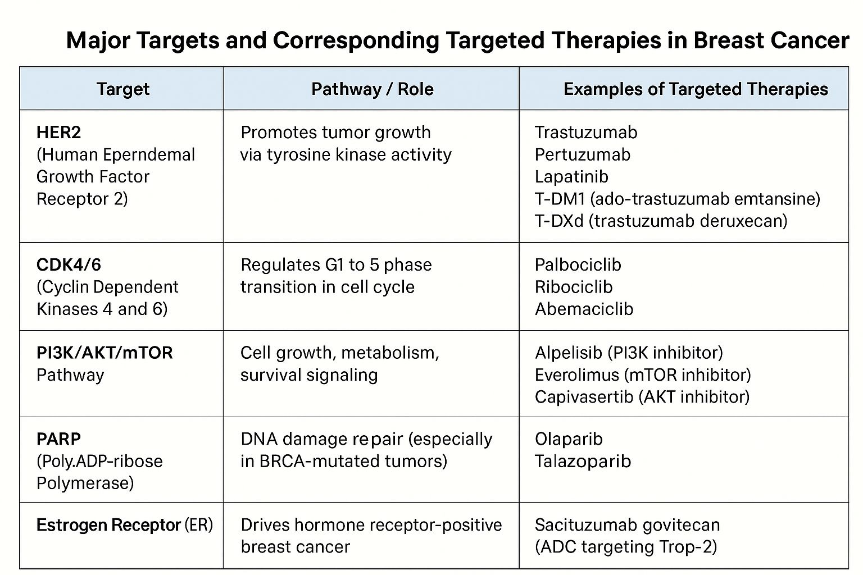

# **3. Mechanisms of Resistance and Management**

Breast cancers develop by means of mechanisms like ESR1 mutations that lead to resistance to endocrine therapy, Rb loss or Cyclin E amplification that reduces the effectiveness of CDK4/6 inhibitors, and secondary HER2 mutations and tumor heterogeneity (Li & Thirumalai, 2021).

# **4. Clinical Efficacy and Patient Outcomes**

PFS and patient quality of life have dramatically improved with CDK4/6 inhibitors (Kang et al., 2025). Survival has been improved with trastuzumab emtansine and dual HER2 targeting. For aggressive subtypes like TNBC, ADCs and immune checkpoint blockers hold promise.

# **5. Challenges and Future Perspectives**

Major concerns include tumor heterogeneity, toxicities such as hepatotoxicity and cardiotoxicity, cost-effectiveness, biomarker validation and the need for precision sequencing and adaptive resistance detection protocols.

## **6. Conclusion**

Targeted treatments have revolutionised the treatment of breast cancer by providing subtype-specific approaches that significantly enhance results. Treatment resistance, toxicity, and medical expenses are still persistent problems. To maintain progress, future studies must prioritise liquid-biopsy surveillance, biomarker-driven personalisation, and innovative drug development.

# **References**

Bose, S., Gupta, R., & Smith, J. (2022). Resistance to next-generation tyrosine kinase inhibitors (TKIs) in HER2-positive breast cancer. Cancer Research, 82(Suppl. 4), P4-01-01. https://doi.org/10.1158/0008-5472.SABCS21-P4-01-01

Cameron, D., Piccart-Gebhart, M. J., & Swain, S. M. (2017). Trastuzumab for early-stage, HER2-positive breast cancer. The Lancet Oncology. https://doi.org/10.1016/S1470-2045(17)30427-6

Derakhshani, A., Chen, X., & Lee, C. (2020). Overcoming trastuzumab resistance. Journal of Cellular Physiology, 235(5), 3142–3156. https://doi.org/10.1002/jcp.29225

Guarneri, V., Conte, P., & Zamagni, C. (2015). Prospective biomarker analysis of the CHER-LOB study. The Oncologist, 20(9), 1001–1010. https://doi.org/10.1634/theoncologist.2015-0171

Kang, Y., Han, B., & Kong, Y. (2025). CDK4/6 inhibitors for HR+/HER2– breast cancer: A network meta-analysis. BMC Cancer, 25, 843. https://doi.org/10.1186/s12885-025-11259-1

Li, X., & Thirumalai, D. (2021). A mathematical model for phenotypic heterogeneity in breast cancer. arXiv. https://arxiv.org/abs/2108.06079

Liu, Y., Guo, L., Kappel, A., et al. (2024). Efficacy and safety of CDK4/6 inhibitors in HR+ breast cancer: A meta-analysis. Frontiers in Pharmacology, 15, 1369420. https://doi.org/10.3389/fphar.2024.1369420