Assessment of Fog Condensation Mechanism on Contaminated Ceramic and Composite Insulators

M. Mataei Moghaddama, S. Mohammadnabia, Kh. Rahmania,[1], F. Khabbazi poura

aEnergy and Mechanical Engineering Department, Shahid Beheshti University, Tehran, P.O. Box 16765-1719, Iran

Abstract

Environmental pollutants, such as fine dust, can increase the leakage current and lead to flashover when combined with fog and dew. This can ultimately result in failures in transmission lines. By predicting the time, it takes for fog to condense, the outage time of the transmission line can be determined. There are two main conventional solutions to prevent insulator failure: regular washing and replacing traditional insulators with glazed ones. Glazed insulators have a low level of leakage current, which keeps them warm and prevents fog from condensing on their surface. In this paper, the mechanism of fog condensation and fine dust deposition on insulator surfaces were investigated. The results showed that the number of insulator damages and failures directly corresponds to the amount of fog condensation and the duration of exposure to fog. In similar conditions, ceramic insulators tend to have more condensed fog compared to composite insulators. Therefore, it is recommended to use composite insulators in regions with high levels of pollution. However, experiments on dust-contaminated composite insulators demonstrated that they are not completely immune to clean fog condensation.

**Keywords:** Contaminated insulator; Flashover; Silicone rubber; Leakage current; Fog condensation.

1- Introduction

The contamination of insulator surfaces is a significant issue in power distribution and transmission lines. Pollution-related failures can result in prolonged outages and expensive maintenance procedures. Various studies [1-5] have identified three types of pollution: industrial, marine, and desert pollution. Industrial pollutants in the atmosphere include carbon, scattered metal particles, carbon monoxide, sulfur oxides, and other chemicals. Desert pollution occurs when dust with salt particles settles on the insulator surface [6]. Marine pollution occurs in coastal environments where a conductive layer can form on the insulator surface due to the presence of salt [7]. In all these pollution types, the problem becomes more severe in highly humid weather conditions, such as rain, dew, and fog [8, 9]. The mechanism of insulator pollution is primarily influenced by wind forces, electrostatic forces on neutral and charged particles, aerodynamics and surface factors of the insulators, humidity, chemical composition, and particle size of pollutants [10]. Contamination dissolved in air humidity, along with fog condensation, is the main cause of potential flashovers in desert-like regions. This increases the conductivity of the contaminated insulator surface, leading to an uncontrollable leakage current that may cause flashovers and short circuits [11-13]. Moisture condensation occurs because the surface temperature of the insulator is lower than that of the surrounding fog. Therefore, increasing the surface temperature of the insulator prevents condensation. The concept of insulator warm-up, based on joule heat generation, has been previously introduced [14-16] to prevent ice formation by adding conductive additives like ZnO, carbon black, and carbon fibers. However, this idea has been mainly applied in cold regions to reduce or prevent ice formation on insulators. Additionally, semiconductor glazes were proposed to work in contaminated areas, but they did not perform well [17, 18]. However, there have been no studies on converting silicone rubber into a partially-conducting insulator material for anti-condensation purposes. Many researchers have focused on improving the functionality of RTV silicone rubber by introducing fillers such as TiO2 and ZnO [19].

While industrial pollution can be reduced, marine and desert pollution are difficult to eliminate completely. Many researchers have focused on selecting appropriate materials and designing insulators, as well as implementing continuous washing as a method to reduce insulator failures in contaminated areas [20]. However, due to the strong adhesion of contaminants to the insulator surface, washing them becomes a challenging task. To minimize the likelihood of insulator failures, the use of glazed semiconductor insulators has been proposed, although this solution is time-consuming and costly. By considering weather forecast data, operators of high-voltage lines can reduce the occurrence of accidents. Some studies have provided information on fog condensation, but they have not thoroughly explained the computational and quantitative aspects of power line insulator failures [20, 21]. Additionally, the critical time of day for insulators has been identified by analyzing meteorological data and describing the mechanism of moisture condensation on insulator surfaces. This information allows for precautionary measures to be taken by predicting and preparing for specific climatic conditions.

Previous research has explored the wetting procedure for contaminated insulators [22-24]. However, this study takes a unique approach by applying actual fine dust to the insulator surface using a water spray and sieving technique (particles less than 50 µm). The insulator was moisturized multiple times to facilitate the deposition of soil, resulting in a uniform contamination layer with a thickness of 0.2 mm. Surprisingly, despite extensive research on the impact of contamination on leakage current, no studies have investigated the artificial application of contaminants on large-sized insulators. Additionally, this study considers the mechanism of fog condensation on the surfaces of composite and ceramic insulators due to radiative cooling.

2- Problem Statement

In February 2013 and 2017, Khuzestan province experienced an unprecedented crisis. During this time, high-voltage line failures occurred between 0:00 A.M. and 09:30 A.M., resulting in electricity outages for over 90% of the province's subscribers. Composite insulators proved to be more resilient to power arcs, with only superficial burning or ablation of the housing. No significant surface damage was observed on these insulators. Fog had condensed on various objects during this period, and the accumulation of dust particles containing specific salty compounds was identified as the cause of the accidents.

The phenomenon of radiative cooling plays a crucial role in the process of fog condensation and subsequently makes the contamination layer on insulators wet [25]. As the temperature difference increases, more water is absorbed by the polluted layer, leading to increased dissolution of solvent salt and resulting in a higher leakage current [26]. Wang et al. [27] categorized water absorption on insulators into two independent parts: absorption caused by humidity and condensation fog resulting from temperature differences. Therefore, climatic changes significantly contribute to insulator failures. Moisture in the form of light rain, fog, and dew deposits on the insulator surface due to radiative cooling. This moisture then makes the pollution layer wet, ultimately dissolving any soluble electrolytes and creating a thin conducting layer on the insulator surface. Various types of fog exist, including radiation fog, precipitation fog, advection fog, steam fog, upslope fog, valley fog, freezing fog, and ice fog [21].

**2-1- Geographical Features of Khuzestan**

* 1. Khuzestan province, situated in the southwest of Iran, is known for its fog, humidity, severe industrial pollution, and dust storms. These dust storms result in the formation of fine dust particles that settle on the surface of transmission line equipment (Fig. 1). The province utilizes 11-, 20-, and 33-kV electric lines for distribution networks, while transmission lines employ 400-, 230-, 132-, and 60-kV lines. These lines are often surrounded by seven dust centers (Fig. 2). Insulators used in both distribution and transmission lines are made of porcelain and composite materials.

In February 2017, the combination of intense fine dust windstorms and the presence of fog near center No. 2 resulted in significant damage to insulators. Studies have revealed that high-voltage line accidents occurred between midnight and 08:30 A.M. During this time, fog condensed on all objects, and this phenomenon persisted for twenty consecutive days. Upon reviewing accident reports, the authors found a direct correlation between the number of accidents and the number of damaged insulators with the timing and extent of fog condensation on the insulator surface (Fig. 3). The main cause of these accidents was the high conductivity of the insulators, brought about by their wetting mechanism.

**2-2- Formation of Fine Dust**

The process of fine dust accumulation on the surface of insulators involves several complex stages. Firstly, the dust particles are lifted from the ground through aeolian processes. These processes can occur in various environments such as coastal zones, semi-arid and arid regions (e.g., cold and hot deserts), and even agricultural fields in different climates [28]. The aeolian transport of dust particles can be categorized into three distinct modes, depending on the grain size of the sediment. For very small particles, typically around 60-70 μm in size, they are transported in suspension. These particles are kept aloft for relatively long distances due to turbulent eddies in the wind. Suspension transport occurs when the wind is strong enough to lift these lightweight particles and carry them along with the air currents. On the other hand, larger particles, ranging from approximately 60-1000 μm in size, are transported through a process called saltation. In saltation, these particles move downwind by bouncing and hopping along the surface. The impact of these saltating particles with the surface can also cause adjacent grains to move short distances. This mode of transport is particularly effective for particles of intermediate size. For even larger particles (> 500 μm) or those that are less exposed, they may be pushed or rolled along the surface by the impact of saltating grains. This phenomenon is known as surface creep and can contribute to the transport of these particles over relatively short distances [29]. It is worth noting that fine dust particles, with diameters typically less than 10 μm and often less than 2 μm, exhibit unique characteristics. Due to their small size and low mass, they can remain suspended in the air for extended periods and be dispersed over vast distances. However, it is important to consider that non-mineral particles, which may have lower densities, can be even more easily transported by wind due to their lightweight nature.

Subsurface water reaches the surface through capillary action, and as surface water evaporates, salt crystals form in the gaps between soil particles, causing the soil texture to gradually disintegrate. This leads to soil swelling up to a depth of 5-10 cm and makes it highly susceptible to erosion by wind (aeolian erosion). During stormy conditions in Khuzestan province, wind speeds can reach up to 30 m/s, which is capable of lifting fine dust particles with an average size of 50 μm to the height of installed insulators. The aerodynamic characteristics of the insulator sheds, surface roughness from previous dust depositions, wind speed, amount of fine dust, and the presence of fog after the storm all play significant roles in the formation of a contamination layer on the insulators' surface. Images in Fig. 3 depict insulators contaminated with fine dust after the storm subsides. Investigations have revealed three important facts about the insulators following dust storm subsidence.

- Horizontal or vertical position of insulator installation has a little effect on the amount of fine dust deposited on the insulator surface.

- The electrostatic field has a little effect on the amount of fine dust deposited on the insulators, because whole part of lines is contaminated with fine dust.

- Polymeric insulators have been less contaminated compared with ceramic insulators, but their contamination level is still high. However, this issue can be linked to the Low Molecular Weight (LMW) migration mechanism. LMW components are short length backbone chains of silicone polymer which tend to migrate from the bulk to the surface and further within the deposited contamination film [29].

**3- Theoretical approach**

Boltzmann equations, as shown in equations (1) to (3), provide an explanation for the phenomenon of radiative cooling [30]. These equations pertain to the outgoing radiation (in the upward direction), the downward thermal radiation during nighttime, and the radiative cooling time for an object with outgoing radiation [30].

|  |  |
| --- | --- |
|  | (1) |
|  | (2) |
|  | (3) |

In equation (1), the radiated power (P) in watts from a body with an area (A) in square meters and temperature (T) in Kelvin can be calculated. The emissivity (ε) is a dimensionless number between 0 and 1 that determines the efficiency of a body to radiate and absorb energy. For porcelain ceramic, ε is 0.92, and for silicone rubber, ε is 0.86. The emissivity of the night sky is approximately 0.74. The Stefan-Boltzmann constant (σ) is 5.67×10-8 W/m2T4. It is important to note that all bodies with a temperature above absolute zero (-273.15 ℃) radiate power.

Equation (2) calculates the down-going thermal night sky radiation (Pthermal) in W/m2. The parameters K, C, T, and RH are used in the equation, where K is a coefficient that depends on the height of clouds, with values of 0.34 for cloud height less than 2 km, 0.18 for cloud height between 2 km and 5 km, and 0.06 for cloud height greater than 5 km. C represents the cloud cover, ranging from 0.0 for clear sky to 1.0 for totally overcast. T is the temperature in Kelvin, and RH is the relative humidity expressed as a percentage.

Equation (3) calculates the cooling time (tcooling) in seconds for an object with mass (m) in kilograms. NA is Avogadro's number (6.02×1023), k is the Boltzmann constant (1.38×10-23 m2kg/s2T), and M is the molar mass in kilograms.

Due to the geographical location of Khuzestan province, the concentration of fog (RH > 80%) in this area is typically high. The average amount of cloud cover (C = 0.5) at night can be used to estimate the temperature of the insulator surface. Additionally, considering the high relative humidity in Khuzestan (> 80%), the temperature of the insulator surface can be determined by taking into account the average level of night cloud cover.

4- Experimental procedure

The study focused on the electrical conductivity, elemental composition, and phase analysis of insulator surface contamination. In the seven different centers, a variety of contaminants were found to be deposited on the insulator surface, influenced by the environmental conditions. Soil samples from these centers were analyzed for electrical conductivity using the Senso-Direct SN 652162 conductivity meter device. The chemical composition of the samples was determined through the Inductively Coupled Plasma-Optical Emission Spectrometry (ICP-OES) method. Phase analysis was conducted using the STOE-STADV X-ray diffraction (XRD) apparatus.

To investigate the main cause of accidents, 230-kV composite insulators were exposed to real dust. The soil particles were reduced to a size smaller than 50 μm using a ball mill apparatus. The amount of condensed fog on the insulators contaminated with fine dust was measured by exposing silicone rubber and ceramic sheets, with and without dust, to weather conditions similar to February 16th, 2017. The insulator surfaces were covered with real fine dust using a four-step process: 1) surface contaminants were removed through washing and cleaning, 2) soil deposition was facilitated by moisturizing the insulator surface, 3) the soil sample was applied to the insulator surface, and 4) the insulator was left to dry in the air for at least 24 hours. Step 3 was repeated multiple times to achieve a contamination layer with a thickness of 0.2 mm and ensure uniformity. The equivalent salt deposit density (ESDD) and the electrical conductivity of the accumulated layer on the composite and ceramic insulators' surfaces were determined based on IEC 60507-04 [31]. One of the sheds' contamination layers was carefully collected and dissolved in 1500 ml of distilled water to measure the electrical conductivity of the solution using the Senso-Direct SN 652162 conductivity meter device, allowing for the determination of ESDD. By comparing the calculated ESDD with available references, the pollution category can be determined.

Leakage current tests were conducted on the contaminated insulators under humid air and radiative cooling conditions, similar to the weather conditions on February 15th and 16th, 2017. The composite insulators, known for their superior performance in contaminated environments compared to ceramic insulators, underwent more accurate tests, including leakage current measurements. Figs. 4 and 5 depict the polluted and non-contaminated ceramic and silicone rubber insulators, respectively. After drying the insulator in the air for at least 24 hours, leakage current was measured under fog-salt conditions by applying a voltage of 20-kV, following the guidelines of [32]. Simultaneously, the surface temperature of the insulator was recorded using a thermo-vision camera.

5- Results and Discussion

Fig. 6 illustrates the number of transmission line failures that occurred on February 15th and 16th, 2017. The results of the ICP-OES analysis and electrical conductivity measurements of soil samples collected from the seven dust centers are presented in Table 1. It can be observed that dust center No. 2 has the highest concentration of metal elements, particularly Na and S, compared to the other centers. Additionally, sample No. 2 exhibits the highest electrical conductivity, making it the most critical and the main cause of insulator failure. This sample was chosen for the experimental process. The pollution primarily consists of soluble salt, such as sodium chloride (NaCl), a mixture of non-soluble materials, and dissolved acids. The diffractogram of the soil sample from center No. 2 is shown in Fig. 7. Through XRD analysis and ICP-OES results, it was determined that the sample contains compounds such as NaCl, Na2SO4, CaSO4, MgSO4, MgCO3, CaCO3, and Al2O3. Therefore, this soil sample was applied to the insulator surface for the empirical test due to its ability to create the worst conditions.

Table 2 provides the equivalent salt deposit density (ESDD) and electrical conductivity of the artificially applied contamination layer. The results indicate that the contamination layer falls under the 4th category of pollution level (very heavy). Hence, the introduced process and the current results cover the most critical conditions of insulators and can be considered in future studies. The mass weight variations of fine dust on the contaminated insulator surfaces between 00:00 and 08:30 A.M. were measured and presented in Table 3. The results show that the amount of condensed fog on ceramic insulators is higher compared to composite insulators.

Figs. 8 and 9 display the changes in temperatures during the critical days of February 2017. The minimum difference between the dew point and the temperatures of the ceramic and composite insulator surfaces is approximately 6.5 and 9 ˚C, respectively. This significant difference causes moisture condensation on the insulator surface. According to the amount of condensed fog on the sheets, Figs. 8 and 9, the surface conductivity of contaminated insulators is predicted to be approximately 4 and 4.5 S/cm for composite and ceramic insulators, respectively. Fig. 10 demonstrates that the composite insulator performs better against fine dust pollution, consistent with previous studies [33-35].

The results of the leakage current for non-contaminated and contaminated insulators are shown in Figs. 11 and 12. However, the current study reveals that the composite insulator is not efficient in conditions where moisture condensation on the surface is combined with fine dust accumulation. Based on Figs. 11 and 12, the leakage current of the insulators increases from 10 μA to approximately 250 μA after 1 hour of clean fog testing for both contaminated and non-contaminated conditions. When fog condenses on the insulator surface, leakage current flows on the surface, leading to the formation of dry bands. Dry bands can be represented by a capacitor and a resistance, as shown in Fig. 13 (c), which depicts an equivalent circuit of a polluted insulator with a dry band under snow conditions. The dry band is represented by a nonlinear resistor (Rdb) and a nonlinear capacitor (Cdb) in parallel.

5- Conclusion

- Due to the wind speed of 30 m/s, the fine dust rises from the ground and deposits on the surface of the insulators. The fine dust contains the elements of Al and Fe, and the compounds of CaSO4, NaCl, Na2SO4, MgSO4 and CaCO3.

- Polymeric insulators have been less contaminated with fine dust than ceramic insulators.

- The studies showed that difference between the surface temperature of ceramic and composite insulators and the dew point are about 9 ℃ and 6.5 ℃ respectively and this is the major reason for the condensation of moisture on the surface of insulators.

- The mass weight changes of fine dust on the insulators contaminated surfaces between 00:00 and 8:30 am showed that the amount of condensed fog on the ceramic and composite insulator is about 29.4 (mg/cm2) and 14.5 (mg/cm2) respectively. Conductivity of the contaminated composite and ceramic insulator surfaces can be predicted to be about 4, 4.5 S/cm for composite and ceramic insulators.

- Most fog condensation occurs on contaminated insulators around 00:00 to 08:30 A.M. Fine dust in presence of fog increases leakage current, flashovers and finally transmission line failures. As the sun rises, the mechanism of fog condensation does not occur and the number of accidents decreases.

- The results of this research show that the composite insulator is not effective in the conditions of fine dust with fog condensation. The leakage current of insulators increased from 10 μA to about 250 μA after 1h of clean fog test for without and with fine dust. Conductive areas due to contaminated with dust and fog are heated, and dry bands are formed, leading to possible surface flashover.

Acknowledgements

The authors would like to gratitude L. Aslanpoor, A. Jaafari and A. A. Farrokhi for their partnership in the study.

**References**

1. Hernanz R, Martin JJC, Gogeascoechea JM, Belver IZ. Insulator pollution in transmission lines. Renewable Energy & Power Quality. 2006;1(4):124-30.

2. Khalifa M, Morris R. Performance of line insulators under rime ice. IEEE Transactions on Power Apparatus and Systems. 1967(6):692-8.

3. Maadjoudj D, Mekhaldi A, Teguar M. Flashover process and leakage current characteristics of insulator model under desert pollution. IEEE Transactions on Dielectrics and Electrical Insulation. 2018;25(6):2296-304.

4. Mahmoodi J, Mirzaie M, Shayegani Akmal AA. Effect of accumulated surface charges on DC flashover of SiR insulators under pollution and aging conditions. Electrical Engineering. 2020;102(4):2123-33.

5. Salem AA, Lau KY, Abdul-Malek Z, Al-Gailani SA, Tan CW. Flashover voltage of porcelain insulator under various pollution distributions: Experiment and modeling. Electric Power Systems Research. 2022;208:107867.

6. Hamza A-SH, Abdelgawad NM, Arafa BA. Effect of desert environmental conditions on the flashover voltage of insulators. Energy Conversion and Management. 2002;43(17):2437-42.

7. Kumara S, Fernando M. Performance of outdoor insulators in tropical conditions of Sri Lanka. IEEE Electrical Insulation Magazine. 2020;36(4):26-35.

8. Jiang Z, Jiang X, Guo Y, Hu Y, Meng Z. Pollution accumulation characteristics of insulators under natural rainfall. IET Generation, Transmission & Distribution. 2017;11(6):1479-85.

9. Mohammadnabi S, Rahmani K. Influence of humidity and contamination on the leakage current of 230-kV composite insulator. Electric Power Systems Research. 2021;194:107083.

10. Salem AA, Abd Rahman R, Kamarudin M, Othman N, editors. Factors and models of pollution flashover on high voltage outdoor insulators. 2017 IEEE Conference on Energy Conversion (CENCON); 2017: IEEE.

11. Qiao X, Zhang Z, Jiang X, He Y, Li X. Application of grey theory in pollution prediction on insulator surface in power systems. Engineering Failure Analysis. 2019;106:104153.

12. Fahimi N, Sezavar H, Shayegani-Akmal A. Flashover Prediction of Polymer Insulators based on Dynamic Modeling of Pollution Layer Resistance using ANN. IEEE Transactions on Dielectrics and Electrical Insulation. 2022.

13. Hu X, Xu K, Lai B, Wu D, Hao C, editors. Monitoring method for leakage current of transmission line insulators under typical environmental conditions. Journal of Physics: Conference Series; 2021: IOP Publishing.

14. Forrest J. The characteristics and performance in service of high-voltage porcelain insulators. Journal of the Institution of Electrical Engineers-Part II: Power Engineering. 1942;89(7):60-80.

15. Liao W, Jia Z, Guan Z, Wang L, Yang J, Fan J, et al. Reducing ice accumulation on insulators by applying semiconducting RTV silicone coating. IEEE Transactions on Dielectrics and Electrical Insulation. 2007;14(6):1446-54.

16. Momen G, Farzaneh M, editors. Study of ice accumulation on nanocomposite semiconducting coatings. 2010 Annual Report Conference on Electrical Insulation and Dielectic Phenomena; 2010: IEEE.

17. Matsui S, Suzuki Y, Nakashima N, Kasaki F, Fujii O, Matsuda E, editors. State of the art of semiconducting glazed insulators for transmission lines in heavily contaminated area. Proceedings of 5th International Conference on Properties and Applications of Dielectric Materials; 1997: IEEE.

18. Shinoda A, Okada H, Nakagami M, Suzuki Y, Ito S, Akizuki M, editors. Development of high-resistance semiconducting glaze insulators. IEEE Power Engineering Society General Meeting, 2005; 2005: IEEE.

19. Mohammadnabi S, Rahmani K, Mataei Moghaddam M. Electrical Conductivity Modeling and Fabrication of Carbon Nanotubes/Silicone Rubber Composites for High Voltage Insulators in Regions With a Polluted Atmosphere. Journal of Reinforced Plastics and Composites. 2022:07316844221136065.

20. Gandom Zadeh M, Malandish E, Tajik A, Taherpour F, Mohammadpour M, Modarres Gheisari SMH, et al. Washing Insulators by Ultrasound Sonication Method to Remove Hard Sediments Caused by Dust and Aerosols. Journal of Novel Researches on Electrical Power. 2017;6(1):41-7.

21. Tamosiunas S, Tamosiunaite M, Zilinskas M, Tamosiuniene M. The influence of fog on the propagation of the electromagnetic waves under Lithuanian climate conditions. PIERS online. 2009;5(6):576-80.

22. Mei H, Wang L, Guan Z, Mao Y. Influence of sugar as a contaminant on outdoor insulation characteristics of insulators in a substation. IEEE Transactions on Dielectrics and Electrical Insulation. 2012;19(4):1318-24.

23. Leclerc M, Bouchard R-P, Gervais Y, Mukhedkar D. Wetting processes on a contaminated insulator surface. IEEE Transactions on Power Apparatus and Systems. 1982(5):1005-11.

24. Wang L, Cao B, Mei H, Zhao C, Guan Z. Effects of natural contamination components on the surface conductivity under saturated moisture. IEEE Transactions on Dielectrics and Electrical Insulation. 2017;24(5):2945-51.

25. Khalil B, Adamowski J, Shabbir A, Jang C, Rojas M, Reilly K, et al. A review: dew water collection from radiative passive collectors to recent developments of active collectors. Sustainable Water Resources Management. 2016;2(1):71-86.

26. Li J, Sun C, Sima W, Yang Q, Hu J. Contamination level prediction of insulators based on the characteristics of leakage current. IEEE transactions on power delivery. 2009;25(1):417-24.

27. Wang L, Cao B, Guan Z, Wang K. Influence of temperature difference on wetting characteristics of insulators. IEEE Transactions on Dielectrics and Electrical Insulation. 2017;24(6):3622-9.

28. Goudie AS. Aeolian processes and landforms. Geological Society, London, Memoirs. 2022;58(1):299-312.

29. Lancaster N. Geomorphology of desert dunes: Routledge; 2013.

30. Eriksson T, Granqvist C. Radiative cooling computed for model atmospheres. Applied Optics. 1982;21(23):4381-8.

31. IEC 60507-04. Artificial pollution tests on high-voltage insulators to be used on a.c. systems. Proceedings of the International Electrotechnical Communication; 1991.

32. IEC TS 61245. Artificial pollution tests on high-voltage ceramic and glass insulators to be used on d.c. systems. International Electrotechnical Commission; 2015.

33. Cheng L, Shao S, Zhang S, Liao R, Yang L, Guo C. Research on the long‐time operation performance of composite insulator shed hydrophobicity under hydrothermal conditions. High voltage. 2018;3(1):67-72.

34. Zhang Z, Qiao X, Zhang Y, Tian L, Zhang D, Jiang X. AC flashover performance of different shed configurations of composite insulators under fan‐shaped non‐uniform pollution. High voltage. 2018;3(3):199-206.

35. Zhao M, Li W, Wu Y, Zhao X, Tan M, Xing J. Performance investigation on different designs of superhydrophobic surface texture for composite insulator. Materials. 2019;12(7):1164.

36. Taheri S, Farzaneh M, Mirzaei B, Fofana I, editors. Leakage current simulation of a pre-contaminated insulator covered with snow. Proceedings of the 14th International Workshop on Atmospheric Icing of Structures (IWAIS); 2011.

37. Pakpahan PM, editor Study on the electrical equivalent circuit models of polluted outdoor insulators. 2006 IEEE 8th International Conference on Properties & applications of Dielectric Materials; 2006: IEEE.

38. Palangar MF, Mirzaie M, Mahmoudi A. Improved flashover mathematical model of polluted insulators: A dynamic analysis of the electric arc parameters. Electric Power Systems Research. 2020;179:106083.

39. Rachmawati MW, Wakhidin S, editors. Study on leakage current characteristics and electrical equivalent circuit properties of aged polymer insulator under artificial environmental condition. The 4th IEEE Conference on Power Engineering and Renewable Energy (ICPERE); 2018.

**Table 1. Electrical conductivity and chemical composition of soil samples from seven dust centers in Khuzestan**

|  |  |  |  |  |  |  |  |
| --- | --- | --- | --- | --- | --- | --- | --- |
| Center No. | Cond. (S/m) | Al (ppm) | Fe (ppm) | Na (ppm) | S (ppm) | Mg (%) | Ca (%) |
| 1 | 2.25 | 19593 | 11742 | 23496 | 21121 | > 2 | > 10 |
| 2 | 4.3 | 30188 | 18579 | 67536 | 12693 | > 2 | > 10 |
| 3 | 1.1 | 32678 | 17510 | 7685 | 3480 | 0.18 | > 10 |
| 4 | 2.2 | 28527 | 17712 | 18985 | 1278 | > 2 | > 10 |
| 5 | 2.35 | 26046 | 14046 | 21943 | 11456 | 0.18 | > 10 |
| 6 | 3.4 | 26519 | 14245 | 36761 | 1317 | 0.20 | > 10 |
| 7 | 1.2 | 26539 | 15041 | 9019 | 2748 | 0.19 | > 10 |

**Table 2. Conductivity parameters acquired for composite insulator**

|  |  |  |  |  |
| --- | --- | --- | --- | --- |
| θ ($℃$) | $$σ_{20}$$ (S/m) | Sa (kg/m3) | ESDD (mg/cm2) | Pollution Category [18] |
| 24.6 | 1.97×10-2 | 0.105 | 0.824 | IV- Very Heavy |

**Table 3. Mass weight changes of fine dust on the insulators surface between 00:00 and 08:30 A.M.**

|  |  |  |  |  |  |  |  |
| --- | --- | --- | --- | --- | --- | --- | --- |
| Date* | Mass Increased (gr) | | | | Average Parameters | | |
| Silicone Rubber | | Ceramic | | Humidity (%) | Env. Temp. ($℃$) | Dew Point ($℃$) |
| Clean | Dusty | Clean | Dusty |
| 2021-01-26 | 0.27 | 1.67 | 11.71 | 15.51 | 65 | 9 | 2.7 |
| 2021-01-27 | 0.66 | 3.01 | 6.58 | 13.37 | 62 | 10 | 2.98 |
| 2021-01-28 | 1.44 | 3.77 | 12.64 | 19.66 | 74 | 9 | 4.5 |
| 2021-01-29 | 0.64 | 3.47 | 7.98 | 12.48 | 48 | 16 | 4.9 |
| 2021-01-30 | 1.13 | 4.31 | 7.72 | 12.81 | 71 | 15 | 9.7 |
| 2021-01-31 | 1.78 | 4.71 | 9.77 | 14.72 | 52 | 13 | 3.2 |
| 2021-02-01 | 2.61 | 3.62 | 11.46 | 18.33 | 48 | 9 | -1.5 |
| 2021-02-02 | 3.55 | 4.19 | 11.44 | 16.17 | 56 | 12 | 3.4 |
| 2021-02-03 | 2.1 | 3.53 | 12.72 | 17.9 | 67 | 14 | 7.9 |
| 2021-02-04 | 2.18 | 4.06 | 8.31 | 13.71 | 69 | 11 | 5.4 |
| 2021-02-05 | 1.05 | 3.63 | 8.64 | 16.81 | 66 | 15 | 8.6 |
| 2021-02-06 | 1.05 | 3.63 | 10.76 | 15.37 | 44 | 17 | 4.58 |
| 2021-02-07 | 1.37 | 3.74 | 7.18 | 13.49 | 85 | 16 | 13.4 |
| 2021-02-08 | 1.28 | 4.05 | 4.67 | 9.09 | 99 | 12 | 11.8 |
| 2021-02-09 | 1.24 | 3.41 | 8.14 | 16.91 | 95 | 14 | 13.2 |
| 2021-02-10 | 1.36 | 3.97 | 7.44 | 9.01 | 85 | 15 | 12.4 |
| 2021-02-11 | 1.37 | 3.73 | 8.12 | 12.25 | 84 | 14 | 11.3 |

*Similar weather conditions to Feb. 17th, 2017

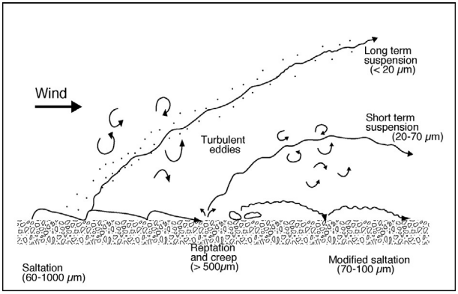

**Fig. 1. Modes of sediment transport by the wind [22].**

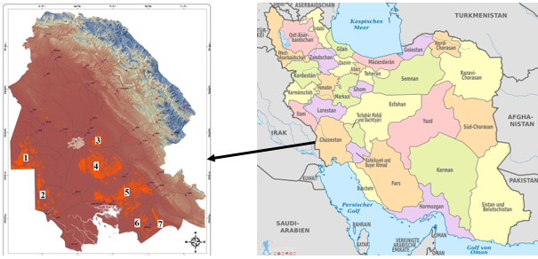

**Fig. 2. Position of seven dust centers in Khuzestan province.**

|  |  |
| --- | --- |
| **a** | **b** |

**Fig. 3. (a) Image of contaminated insulator with fine dust after the storm subsides; (b) Image of damaged ceramic insulators due to the simultaneous impacts of fine dust and fog.**

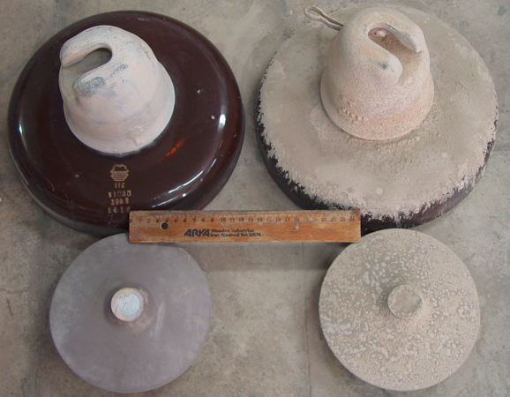

**Fig. 4. Images of insulators contaminated with fine dust of silicone rubber (about 254 cm2) and ceramic (about 500 cm2).**

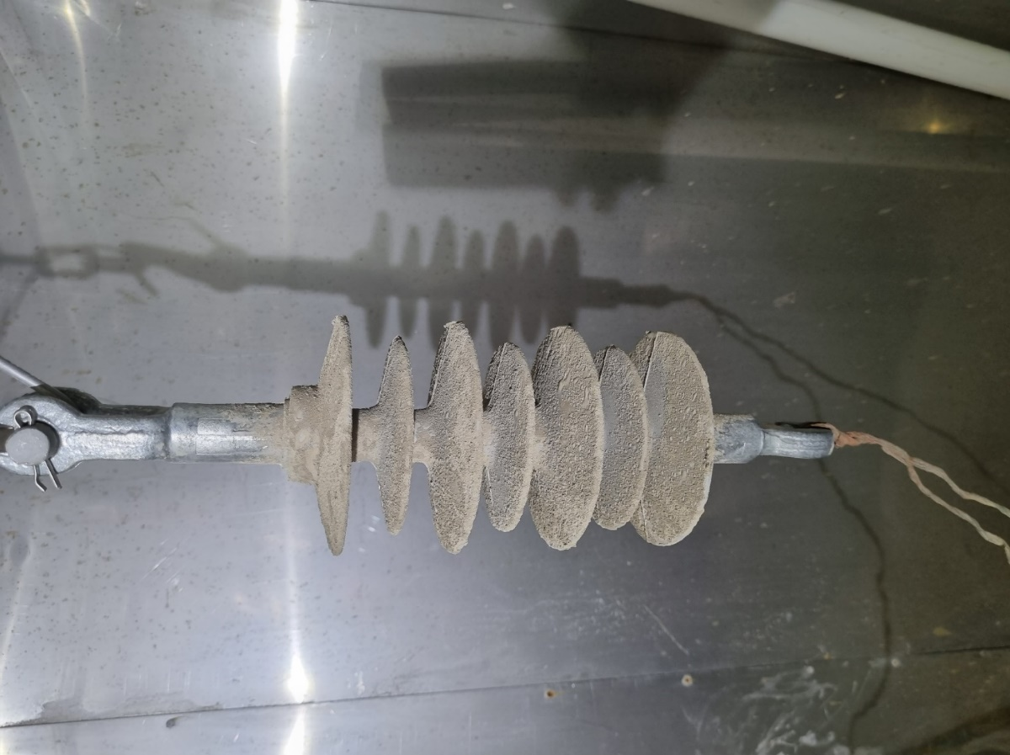 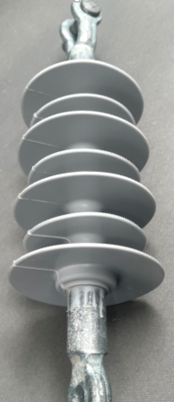

**Fig. 5. Images of the composite insulator a) without and b) with fine dust.**

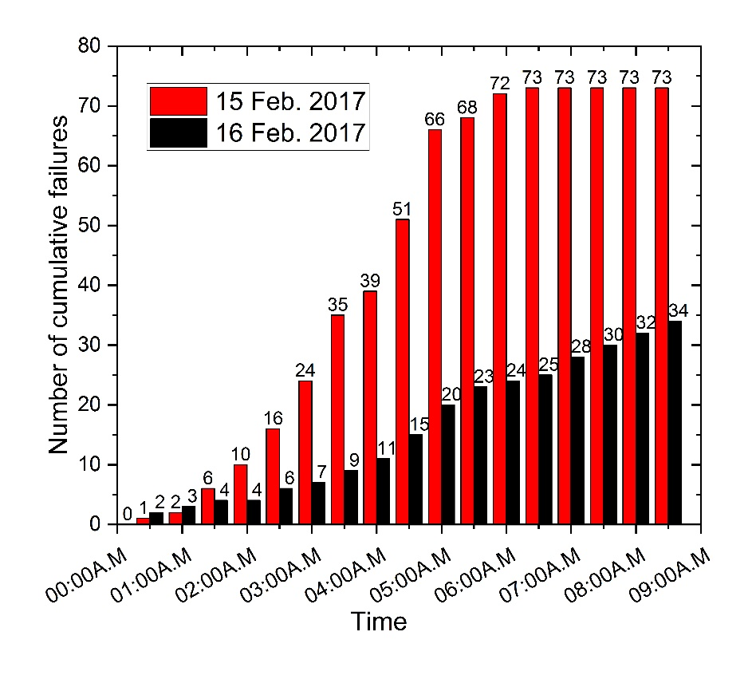

**Fig. 6. Number of transmission lines failures during Feb. 15th and 16th, 2017.**

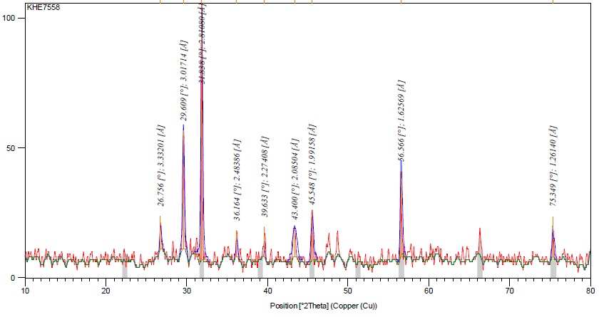

**Fig. 7. XRD Diffractogram of the soil sample from dust center No. 2 [9].**

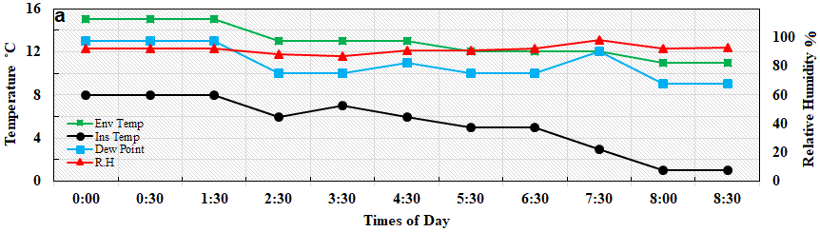

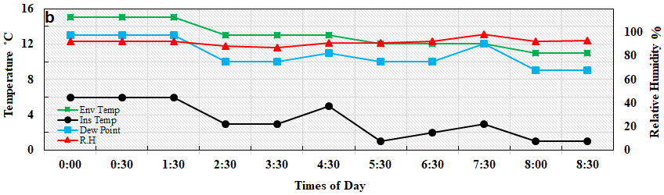

**Fig. 8. Surface, ambient and dew temperature of a) composite insulator and b) ceramic insulator on Feb. 15th, 2017.**

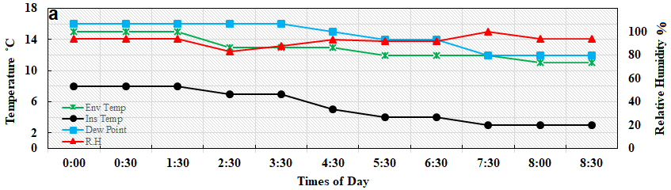

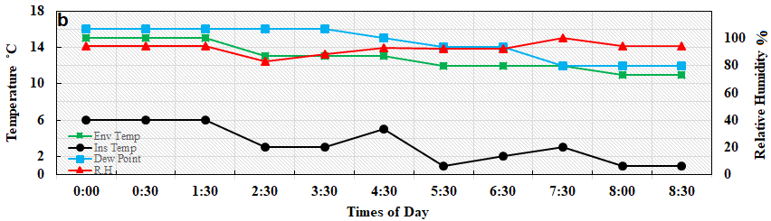

**Fig. 9. Surface, ambient and dew temperature of a) composite insulator and b) ceramic insulator on Feb. 16th, 2017.**

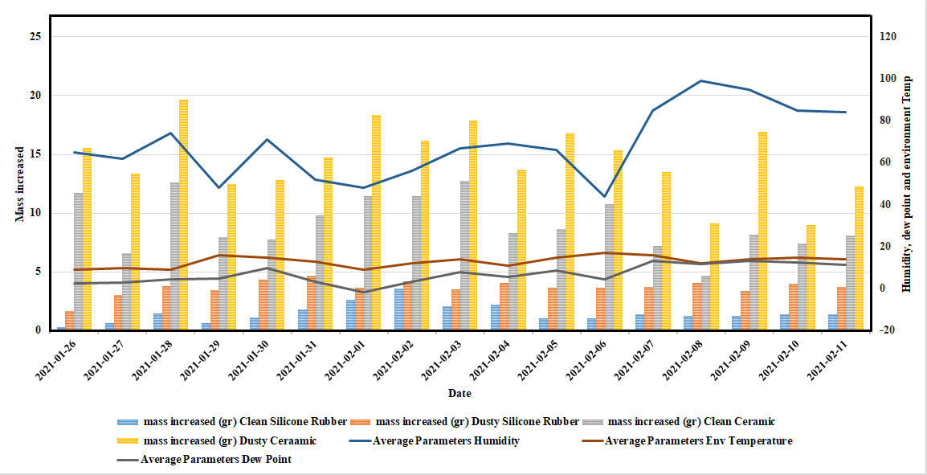**Fig. 10. Condensation amount on the ceramic and silicone rubber sheet.**

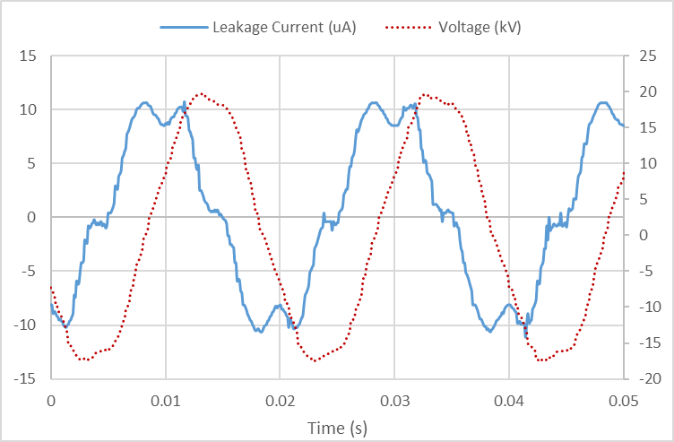

**Fig. 11- Leakage current of the composite insulator without fine dust in the clean fog.**

|  |  |
| --- | --- |
|  |  |
|  | |

**Fig. 12. Leakage current and thermography of composite insulator contaminated with fine dust after 1 h of clean fog test.**

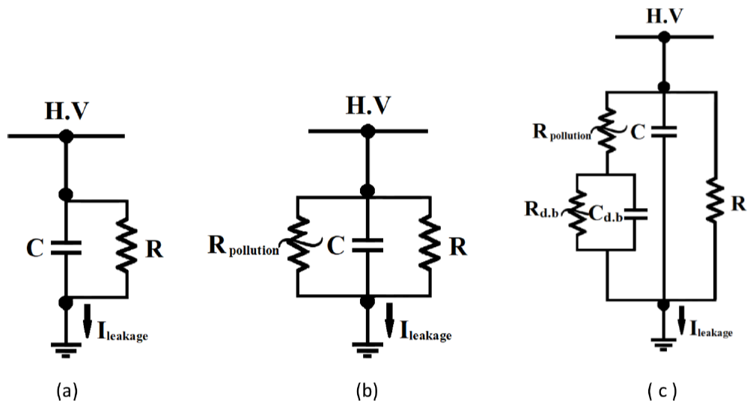

**Fig. 13. The equivalent circuit of a) a composite insulator without pollution, b) a polluted composite insulator, and c) a polluted insulator with considering of a dry band.**

1. * Corresponding author. Tel.: +98-21-73932675; fax: +98-21-77311446.

   *E-mail address:* kh_rahmani@sbu.ac.ir