FORMULATION DEVELOPMENT AND EVALUATION OF TOPICAL NANOEMULGEL OF CRISABOROLE

Pooja Birari

ABSTRACT
Topical Nanoemulgel usage has expanded in recent years because to the preparation's better patient acceptance due to its non-greasy, convenient Spread ability, easy administration, and good therapeutic and safety profile. Nanoemulgel has a strong potential of being the primary topical delivery route for lipophilic medications in the future, despite several challenges. Amongst all the formulations, Nanoemulsion loaded emulgel prepared with the tween 80, Almond Oil was found to be better with the drug diffusion. Zeta potential of optimized formulation (Nanoemulsion) -32 mV which indicates the thermodynamic instability of the dispersion. The percentage of drug content was found to be in 64-96% hence, uniformity of content was maintained. When the improved formulation was compared to the marketed formulation for in-vitro drug release, it was discovered that the optimized batch (F1) had regulated release in 24 hours. In addition, the formulation was launched in 12 hours. The formulation followed the Higuchi Kinetic model of drug release. Accelerated stability study showed no significant change in the formulation upto 3 months. Finally, it can be summarized and concluded that the Nanoemulsion loaded emulgel of Crisaborole can be one of the promising tool in controlling the drug release via. Percutaneous mechanism for effective and longer treatment required for fungal infections with increased stability.

KEYWORDS: Crisaborole, Topical Emulgel, Atopic Dermatitis, Nanoemulsion.

INTRODUCTION
Atopic dermatitis (eczema) is a condition that makes your skin red and itchy. It's common in children but can occur at any age. Atopic dermatitis is long lasting (chronic) and tends to flare periodically. It may be accompanied by asthma or hay fever. No cure has been found for atopic dermatitis. But treatments and self-care measures can relieve itching and prevent new outbreaks. For example, it helps to avoid harsh soaps, moisturize your skin regularly, and apply medicated creams or ointments. [34]
Thus, the goal of the current study was to create Crisaborole (2% w/w) in the form of an emulgel that contained the drug's nanoemulsion.
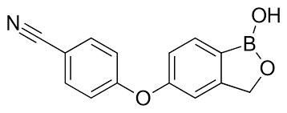
Figure 1: Structure of Crisaborole
Crisaborole is a novel oxaborole approved by FDA on December 14, 2016 as Eucrisa, a topical treatment of for mild to moderate atopic dermatitis. This non-steroidal agent is efficacious in improving disease severity, reducing the risk of infection and reducing the signs and symptoms in patients 2 years old and older. It reduces the local inflammation in the skin and prevents further exacerbation of the disease with a good safety profile. Its structure contains a boron atom, which facilitates skin penetration and binding to the bimetal center of the phosphodiesterase 4 enzyme. It is currently under development as topical treatment of psoriasis. [34,36]

MATERIALS AND METHODOLOGY
Materials
Crisaborole was purchased from Pharmatech solutions, Almond Oil (Research -lab Fine Chem Industry, Mumbai), Propylene glycol and Tween 80 also from Research -lab Fine Chem Industry. Carbopol 934 was from Molychem, Mumbai. All other reagents used were of analytical grade.
Methodology
High pressure homogenization methods are used for the formulation of nanoemulgel. There are three steps involved in the formulation of nanoemulgel which are given follows.
- Preparation of Nanoemulsion
- Preparation of hydrogel and
- Finally, nanoemulgel will be produced by the incorporation of Nanoemulsion into gel with continuous stirring.

Table 1: Composition of Nanoemulsion formulation
Formulation code | F1 | F2 | F3 | F4 | F5 | F6 | F7 | F8 | F9
Ingredients | %
Crisaborole (w/w) | 10 | 10 | 10 | 10 | 10 | 10 | 10 | 10 | 10
Almond Oil (v/v) | 3 | 3 | 3 | 2 | 2 | 2 | 1 | 1 | 1
Tween 80 (v/v) | 5.25 | 4.50 | 3.75 | 5.25 | 4.50 | 3.75 | 5.25 | 4.50 | 3.75
Propylene glycol (v/v) | 1.75 | 1.50 | 1.25 | 1.75 | 1.50 | 1.25 | 1.75 | 1.50 | 1.25
Methyl Paraben (w/w) | 0.03 | 0.03 | 0.03 | 0.03 | 0.03 | 0.03 | 0.03 | 0.03 | 0.03
Propyl Paraben (w/w) | 0.01 | 0.01 | 0.01 | 0.01 | 0.01 | 0.01 | 0.01 | 0.01 | 0.01
BHT | 0.1 | 0.1 | 0.1 | 0.1 | 0.1 | 0.1 | 0.1 | 0.1 | 0.1
Water Q.S (v/v) | 100 | 100 | 100 | 100 | 100 | 100 | 100 | 100 | 100

METHOD OF PREPARATION FOR NANOEMULSION:
Preparation of aqueous phase ‘A’: A precisely weighed amount of Propylene glycol was added to distilled water. (80⁰c).
Preparation of Oil phase ‘B’: A weighed amount of Almond Oil and tween 80 were mixed together in a heated condition, then a weighed amount of Crisaborole was added, followed by the addition of methyl paraben, propyl paraben, and BHT.
Incorporation of solution ‘A’ in dispersion ‘B’: Both the phases were mixed properly with the help of High-pressure Homogenizer maintaining the respective rpm.
Preparation of gel
Table 2: Composition of gel
Sr. No. | Ingredients (% w/w) | Quantity
1 | Carbopol 934 | 1%
2 | Triethanolamine | 0.1%
3 | Water (q.s.) | 100

The weighed quantity of carbopol 934 was mixed in distilled water (40⁰c) further addition of triethanolamine to maintain the desired pH range of the solution. The uniformity in the stirring was maintained and then the gel was kept in the refrigerator for 24 hrs.
Preparation of Emulgel:
Further incorporation of 20 % nanoemulsion was incorporated to obtain 100 % (w/w) emulgel which contains 2% of drug.
Filling to container:
The formulation was transferred into previously cleaned and dry containers.

EVALUATION OF NANOEMULSION
Scanning Electron Microscopy
Scanning electron microscopy (SEM) may be used to analyze the morphology of a nanoemulsion. A three-dimensional picture of the particle is produced using SEM. The samples are inspected at various magnifications and an appropriate accelerating voltage, typically 20 kV. [4]
Particle Size Analysis
Developed Nanoemulsion's hydrodynamic particle size has to be examined. In most cases, the dynamic light scattering method for measuring particles and further particle size distribution is utilized with nanoemulsions. [4]
Zeta potential measurements
Zetasizer hsa 3000 (Malvern Instrument Ltd., UK) was used to calculate the zeta potential for nanoemulsion. Results were obtained after samples were put in transparent disposable zeta cells. Before each experiment, cuvettes were cleaned with methanol and rinsed with the sample to be analyzed before adding the fresh sample. [5]

EVALUATION OF NANOEMULGEL
Physical Appearance
Visual examination of the produced nanoemulgel formulations was done to check for color, homogeneity, consistency, and pH. [4]
Determination of pH
With the use of a digital pH meter, the formulation's pH was determined. The pH meter electrode was cleaned with distilled water before being put into the mixture to test the pH. [6, 7]
Measurement of viscosity
A Brookfield Viscometer (RVDV-I Prime, Brookfield Engineering Laboratories, USA) with spindle 63 was used to determine the viscosity of the prepared batches. The viscosity-to-be-determined formulation was added to the beaker and left to settle for 30 minutes at the assay temperature (25±1ºC) before testing. [6, 7]
Drug content study
A drug content analysis was carried out to assess the amount of drug contained in a certain quantity of the formulation. 1 g of the formulation was placed in a 10 ml volumetric flask.
Methanol was added to it, and it was shaken thoroughly to make up the volume. The Volumetric flask was maintained for 2 hours and well mixed in a shaker. The solution was passed through filter paper and filtered the mixer before measuring absorbance at 252 nm with a spectrophotometer. [6, 7, 9]
In-vitro Drug release study
Emulgel in-vitro drug release investigations were conducted on Diffusion cells employing egg membrane. This was gently clamped to one end of the dialysis cell's hollow glass tube. On the surface of the egg membrane dialysis membrane, 1gm of emulgel was placed. The receptor chamber was filled with freshly produced PBS solution (pH 7.4). The total amount of gel used to solubilize the medication in the tube. The magnetic stirrer was used to agitate the receptor chamber. After proper dilutions, samples (1ml aliquots) were collected and tested for drug content using a UV visible spectrophotometer at 252 nm. [6, 7, 10]
Release kinetics of selected formulation
The cumulative release data were fitted to models representing Zero order (cumulative% drug release v/s. time), First order (log cumulative% drug retained v/s. time), and Higuchi model (cumulative% drug retained v/s. square root of time) to investigate the drug release kinetics and mechanism. [6, 7]
Accelerated stability studies of Emulgel [3, 5]:
Guidelines govern the conduct of stability studies. For three months, the organized emulgels were filled in aluminum collapsible tubes (5 g) and subjected to strength leans at 5°C, 25°C/60% RH, 30°C/65% RH, and 40°C/75% RH and 60 ± 2°. Tests were drawn back at 15-day intervals and inspected for physical appearance, pH, rheological characteristics, and medicinal content. [11,12]

RESULT AND DISCUSSION
Determination of (λ _{max}) of Crisaborole in Methanol:
The UV spectrum of Crisaborole solution scanned between 400-200 nm using UV spectrophotometer exhibited wavelength of absorbance maxima at 252 nm.

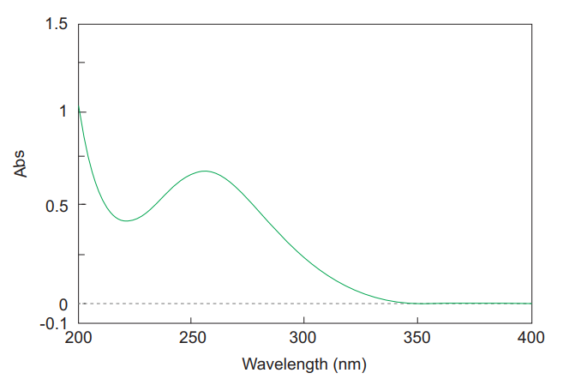
Figure 2: Ultraviolet Spectra of Crisaborole in Methanol

Calibration of Crisaborole in Methanol
Crisaborole calibration curve was produced in methanol because Crisaborole is soluble in methanol. The drug solution in methanol was highly transparent and easily analyzed using a UV-visible spectrophotometer. The calibration curve was determined to be linear in the concentration range of 2-10 µg/ml, as shown in the table below. [14]
Table 3: Calibration Curve of Crisaborole in Methanol
Sr. No. | Conc.(ppm) | Absorbance
1 | 2 | 0.2286
2 | 4 | 0.4184
3 | 6 | 0.6116
4 | 8 | 0.8015
5 | 10 | 0.9731

Figure 3: Calibration curve of Crisaborole in Methanol

Solubility study of drug in different oils:

Table 4: Solubility of Crisaborole in different oils:
Sr. No. | Oils | Solubility
1 | Castor oil | 12.19
2 | Oleic acid | 18.38
3 | Almond oil | 29.20
4 | Liquid paraffin | 8.19
5 | Isopropyl myristate | 22.16

Solubility determination of Crisaborole in surfactants and co-surfactant
Table 5: Solubility of Crisaborole in different surfactants and cosurfactant
Sr. No. | Excipients | Solubility (mg/ml)
1 | Tween 20 | 17.28
2 | Span 20 | 9.46
3 | Tween 80 | 38.25
4 | Span 80 | 31.44
5 | Propylene glycol | 36.02

Fourier Transform Infrared Spectroscopy
The FTIR spectrum of Crisaborole has been shown in below figure. The major peaks observed, and corresponding functional groups are given in below Table. The spectrum shows characteristic peaks for Crisaborole. [16,18]
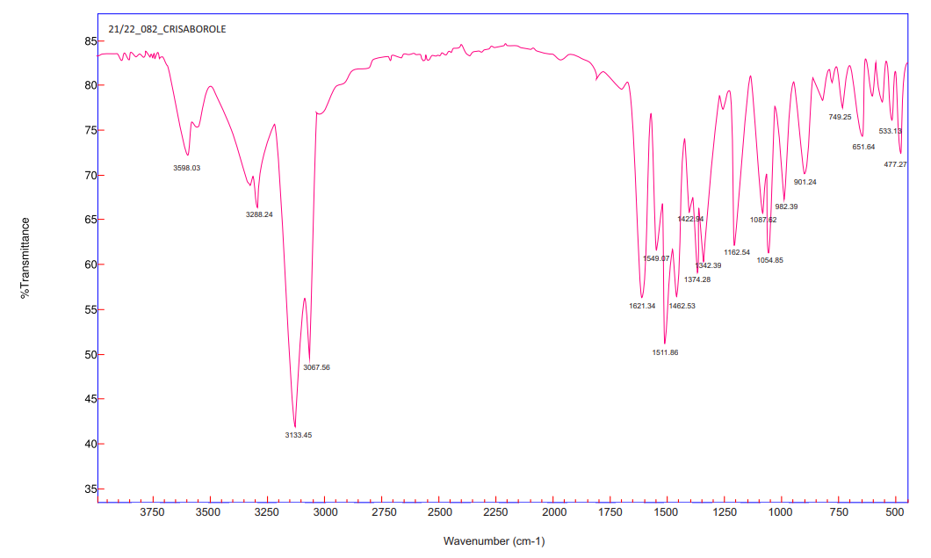
Figure 4: Representative IR spectrum of Crisaborole
The absorption bands shown by Crisaborole are characteristics of the groups present in its molecular structure. The presence of absorption bands corresponding to the functional groups present in the structure of Crisaborole confirms the identification and purity of the Crisaborole sample used in the study. [19,20]
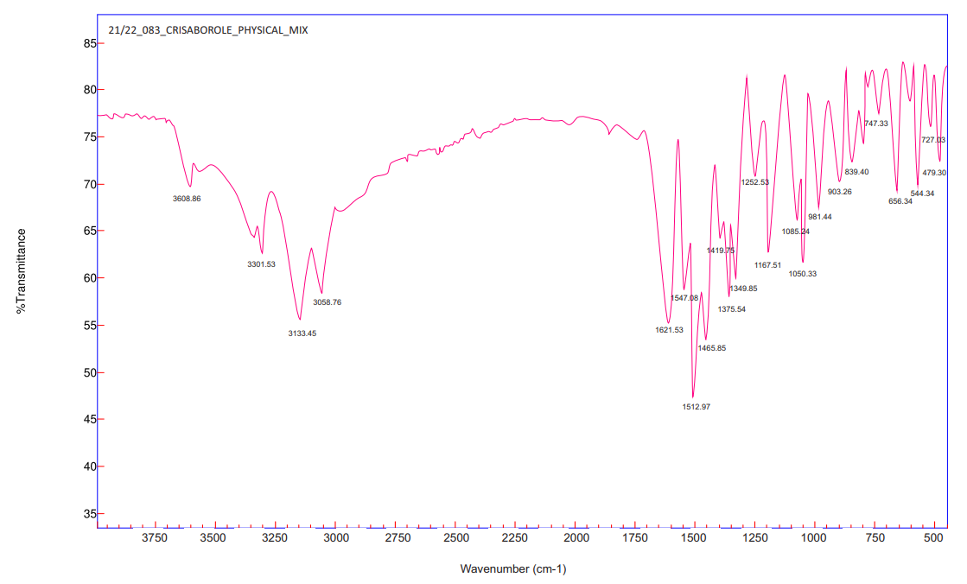
Figure 5: FTIR of Physical mixture

Table 6: Interpretation of FTIR Spectrum of physical mixture
Functional Group | Peaks
 | Pure Drug | Physical Mixture
O-H Stretch | Yes | Yes
C-H Stretch | Yes | Yes
C=N | Yes | Yes
C=C | Yes | Yes

EVALUATION OF NANOEMULSION
Scanning Electron Microscopy
The micrograph exhibited some nanoemulsion agglomeration, which might be related to the evaporation of water contained in the formulation during sample preparation prior to SEM examination. The particle size of the optimized batch's nanoemulsion was determined to be 100 nm. It is observed that when the concentration of Almond Oil increases with the speed of the homogenizer, the particle size decreases. [28-30]

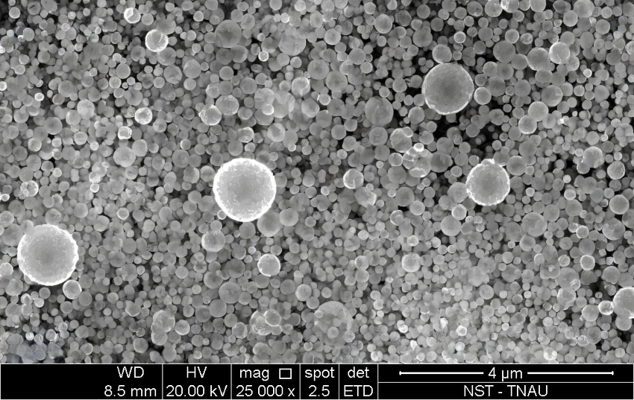
Figure 8: Scanning Electron Microscopy

Particle size and polydispersibility index
The particle size of the optimized batch's nanoemulsion was determined to be 100 nm. It is observed that when the concentration of Almond Oil increases with the speed of the homogenizer, the particle size decreases.
Table 8: Size distribution and PDI
Formulation code | Particle size (nm) | PDI
Optimized Batch (F1) | 100 | 0.194

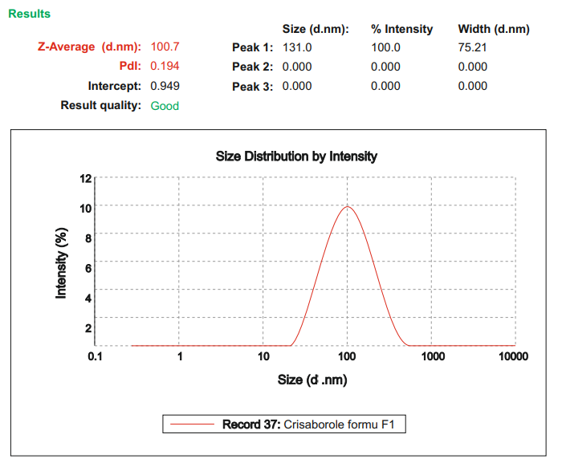
Figure 9: Particle Size of Optimized Formulation

Zeta Potential
According to the ICH recommendations for stability tests of different pharmaceutical formulations, zeta potential indicates the stability of the (colloidal dispersion) nanoemulsion under stress testing conditions. The zeta potential is altered by particle size; the lowest particle size in nano size, i.e., 50, exhibits -32 mV. The zeta potential implies thermodynamic instability of the dispersion.
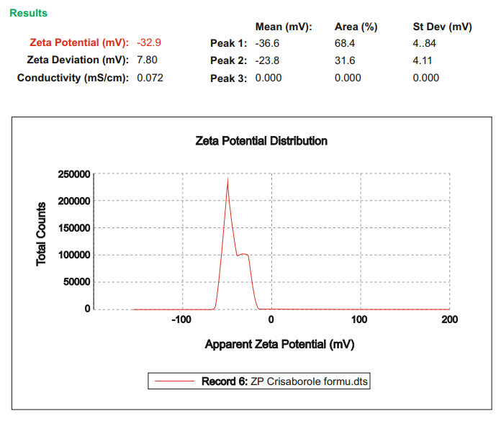
Figure 10: Zeta Potential of Optimized formulation

EVALUATION OF NANOEMULGEL
Physical Appearance
The emulgel formulation's physical characteristics were determined to be transparent, homogenous, and consistent. [18]
pH
pH of various emulgel is shown in the following table 9 which was found to be in range of 5.31 to 5.75 pH values indicate the suitability of emulgel for topical application, so as to minimize discomfort or irritation due to acidic pH and microbial growth due to basic pH.
Viscosity
The viscosity values of formulations are shown in the Table 10.
Spreadability
Spreadability and emulgel viscosity exhibit an inverse connection. The spreadability of Formulation F1 is 17.77 gm.cm/sec, which is the formulation's ideal viscosity. Spreadability is shown in Table 11.
Drug Content
Table No. 12 displays the formulation's medication composition. All produced emulgel formulations were found to have a medication content that ranged from 64 to 96%.
In-vitro drug release
The in-vitro release of Crisaborole from its various emulgel formula are represented in Table 13.
Table 9: pH values of formulation
Sr. No. | Formulation code | Observed pH (± SD)
1 | F1 | 5.60±0.025
2 | F2 | 5.75±0.018
3 | F3 | 5.55±0.011
4 | F4 | 5.45±0.011
5 | F5 | 5.43±0.0158
6 | F6 | 5.33±0.011
7 | F7 | 5.31±0.005
8 | F8 | 5.40±0.018
9 | F9 | 5.53±0.026

Table 10: Viscosity of formulations
Rpm | Viscosity (cP) at Room Temperature
 | Formulation Code
 | F1 | F2 | F3 | F4 | F5 | F6 | F7 | F8 | F9
10 | 14960 | 13450 | 14500 | 13750 | 12500 | 13500 | 14500 | 13500 | 12000
20 | 14200 | 12390 | 14000 | 13400 | 12250 | 12440 | 14250 | 12500 | 11709
30 | 13050 | 12050 | 13445 | 12350 | 11200 | 12203 | 13900 | 12000 | 10500
40 | 13000 | 11500 | 12230 | 12010 | 11000 | 11253 | 12750 | 11500 | 9850
50 | 12350 | 10420 | 11520 | 11250 | 10950 | 10504 | 12520 | 11200 | 9230

Table 11: Spreadability values of formulation
Sr. No. | Formulation code | Spreadability (g.cm/sec)± S.D.
1 | F1 | 17.77 ± 0.025
2 | F2 | 16 ±0.035
3 | F3 | 15.38 ±0.028
4 | F4 | 15.68 ±0.018
5 | F5 | 15.09 ±0.032
6 | F6 | 14.81± 0.012
7 | F7 | 15.53± 0.012
8 | F8 | 15.23± 0.011
9 | F9 | 15.84 ±0.018

Table 12: Drug content of formulation
Sr. No. | Formulation code | Drug content (%)± SD
1 | F1 | 96±0.5
2 | F2 | 91.91±0.7
3 | F3 | 95±0.7
4 | F4 | 93.91±0.7
5 | F5 | 94±0.7
6 | F6 | 72±0.7
7 | F7 | 68±1.09
8 | F8 | 82±1.07
9 | F9 | 64.91±1.43

Table 13: Cumulative amount of Crisaborole diffused (%) from all the emulgel formulations through egg membrane using Modified Franz diffusion cell
Time  hrs | F1 | F2 | F3 | F4 | F5 | F6 | F7 | F8 | F9
0 | 0 | 0 | 0 | 0 | 0 | 0 | 0 | 0 | 0
1 | 9  ±0.70 | 8.17  ±0.76 | 7.14  ±0.22 | 6.25  ±0.071 | 6.13  ±0.75 | 5.34  ±0.82 | 5.01  ±0.70 | 3.41  ±0.85 | 2.31  ±0.53
2 | 17  ±0.70 | 14.08  ±0.73 | 12.96  ±0.51 | 15.22  ±0.24 | 11.13  ±0.75 | 12.96  ±1.06 | 16.74  ±0.97 | 19.15  ±0.75 | 16.24  ±0.79
3 | 25  ±1.07 | 24.21  ±0.74 | 23.01  ±0.16 | 22.11  ±0.17 | 23.12  ±0.74 | 19.6  6±0.39 | 21.30  ±0.81 | 18.12  ±0.74 | 20.11  ±0.74
4 | 34  ±1.06 | 32.65  ±0.38 | 31.09  ±0.12 | 28.23  ±0.79 | 26.61  ±0.84 | 25.66  ±0.64 | 23.49  ±0.88 | 22.44  ±0.31 | 20.66  ±0.94
5 | 41  ±0.70 | 40.42  ±0.85 | 40.97  ±0.52 | 35.49  ±0.88 | 30.99  ±0.50 | 32.67  ±0.95 | 34.69  ±095 | 39.45  ±0.69 | 39.41  ±0.85
6 | 50  ±0.53 | 48.57  ±0.38 | 47.87  ±0.47 | 45.66  ±0.72 | 45.35  ±0.83 | 40.19  ±0.19 | 38.09  ±0.75 | 35.66  ±0.94 | 30.11  ±0.74
7 | 59  ±1.06 | 57.45  ±0.31 | 55.13  ±0.94 | 52.79  ±0.99 | 48.49  ±0.88 | 44.09  ±0.10 | 41.49  ±0.88 | 38.09  ±0.73 | 37.71  ±0.96
8 | 68  ±1.07 | 65.15  ±0.27 | 62.14  ±0.16 | 60.49  ±0.32 | 57.18  ±0.76 | 54.66  ±1.2 | 51.78  ±0.66 | 48.83  ±1 | 49.89  ±1.03
12 | 78  ±1.41 | 72.30  ±0.28 | 74.25  ±0.32 | 64.49  ±0.33 | 62.16  ±0.75 | 58.19  ±0.19 | 56.99  ±1.07 | 54.97  ±1.04 | 52.31  ±0.81
16 | 85  ±1.04 | 81.89  ±0.50 | 73.41  ±0.64 | 70.89  ±1.05 | 68.12  ±0.74 | 64.69  ±0.45 | 61.44  ±0.86 | 58.10  ±0.73 | 54.14  ±0.54
24 | 96  ±0.66 | 90  ±0.38 | 87.42  ±0.30 | 78.94  ±0.50 | 72.09  ±0.73 | 69.99  ±1.0 | 65.05  ±0.72 | 61.19  ±0.76 | 58.45  ±1.21

Comparative Study
Table 14: Cumulative drug release of formulation F1 and Marketed formulation (Eucrisa Ointment)
Time  (hours) | % Cumulative drug Release  (F1 formulation) | Time  (hours) | % CDR Marketed formulation  (Eucrisa ointment)
0 | 0 | 0 | 0
1 | 9±0.70 | 1 | 8±0.77
2 | 17±0.70 | 2 | 15±0.707
3 | 25±1.07 | 3 | 24±0.70
4 | 34±1.06 | 4 | 34±0.70
5 | 41±0.07 | 5 | 42±0.72
6 | 50±0.77 | 6 | 55.57±0.91
7 | 59±0.70 | 7 | 60.45±0.83
8 | 68±0.71 | 8 | 69±0.707
12 | 78±0.70 | 9 | 76.90±705
16 | 85±0.77 | 10 | 82±0.73
24 | 96±0.71 | 12 | 92±0.76

Figure 11: In-Vitro Drug release profile of optimized formulation (F1) and Marketed formulation.
It was observed that the release of the drug from optimized (F1) emulgel formulation was higher than the commercial gel. (2 % gel). The drug release of optimised formulation shows the controlled release up to 24 hrs (96 %) and marketed formulation shows (92 %) drug release upto 12 hrs. Formulation F1 showed steady state release upto 24 hours which also indicates that this formulation would show better contact with biological membrane. The drug is entrapped in the oil phase, hence when formulation was applied on egg membrane the penetration takes place upto 24 hrs. This phenomenon of drug release also suggests that when such formulations would be applied on skin surface the drug diffusion follows mechanisms.

Drug release Kinetics
The drug release was studied in this work to determine the kinetics of the drug release mechanism. Figures 12 and 13 demonstrate the results for zero order model kinetics and Higuchi model kinetics, respectively. [31]

Figure 12: Model graph for comparative evaluation of Zero order Kinetics

Figure 13: Model graph for comparative evaluation of Higuchi Kinetics

Stability study:
The improved formulation was tested after accelerated storage and at room temperature. Stability experiments revealed that the formulation was stable at accelerated temperatures (40⁰C± 2⁰C, 75 % RH ± 5% RH). At room temperature, the stability of the optimized batch F1 was investigated. [19]

Table 15: Stability Study data for F1 formulation at Accelerated condition
(40⁰ C± 2⁰ C, 75 % RH±5% RH)
Sr. No. | Observations |  | Before Stability Testing | During study
 |  |  |  | 3rd month
1 | Clearity |  | Translucent | Translucent
2 | pH |  | 5.60±0.006 | 5.41±0.025
3 | % Drug content |  | 96±0.5 | 95.97± 0.5
4 | Viscosity | 14960 | 14846 | 15132±63.93
 |  | 14200 | 14152 | 14886±32.67
 |  | 13050 | 12948 | 13425±38.53
 |  | 13000 | 12794 | 13021±27.57
 |  | 12350 | 12015 | 12463±32.92

CONCLUSION
Before formulating this formulations Preformulation testing were performed for drug characterization and to analyse its purity and compatibility. Organoleptic properties, melting point, solubility testing, UV spectroscopy studies and FTIR were performed for the Crisaborole and the drug sample procured were found to be and compatible with the excipients used in formulation. The drug loaded Nanoemulsion’s were evaluated for Particle size, Poly-dispersibility index, Zeta potential and scanning electron microscopy analysis. Drug loaded emulgel were evaluated for physical appearance, pH, viscosity, spreadability, drug content, in vitro drug release study (diffusion study), antibacterial activity and Accelerated stability studies. After accelerated storage and room temperature, the improved formulation was assessed. Stability tests revealed that the formulation was stable at accelerated temperatures (40⁰C±2⁰ C, 75% RH 5% RH). At room temperature, the stability of Optimized batch F1 was studied.
REFERENCES
- Pavia DL, Lampman GM, Kriz GS. Introduction to Spectroscopy A Guide for Student of Organic Chemistry. 4th ed. Cennage Learning Pvt.Ltd. 2007:13-27.
- Patel CJ, Tyagi S, Gupta AK, Sharma P, Prajapati PM, Potdar MB. Emulgel: A Combination of Emulsion and Gel. Journal of Drug Discovery and Therapeutics. 2013;1(6):72-76.
- Subramanian S. Biostatistics. Career Publications 1st ed. 2005:145-159.
- Shaikh YI, Paradkar AR, Dhayugade MG. Introduction To Biostatistics and Computer Science.11th ed, Nirali Prakashan 2009:7.1-7.10.
- G. Aiswarya, Kh. Hussan Reza1, R. Kumaravelrajan Development, Evaluation, and Optimization of Flurbiprofen nano emulsions Gel Using Quality by Design Concept Asian Journal of Pharmaceutics 2015: 37.
- Verma S, Singh AK, Mukharjee A, Formulation and Evaluation of Ketoconazole Nanoemulgel. World Journal of Pharmacy and Pharmaceutical Sciences 2016;5 (2):899-911.
- Jaiswal M, Dudhe R, Sharma PK. Nanoemulsion Advanced Mode Of Drug Delivery System. Springer 2015; 5:123-127.
- Chavda VP, Shah D. A Review on Novel Emulsification Technique: A Nanoemulsion Research and Reviews. Journal of Pharmacology and Toxicology Studies 2007;5(1):31,32.
- Dhas A, Deshmukh G, Andhale V. Review on Nanoemulsion A Novel Drug Delivery System. European Journal of Biomedical and Pharmaceutical Sciences 2016;3(4):160.
- Vijaya R, Kumar SS, Kannan SK. Preparation and In Vitro Evaluation of Miconazole Nitrate Nanoemulsion Using Tween 20 as Surfactant For Effective Topical / Transdermal Delivery. Journal of Chemical and Pharmaceutical Sciences 2015;8(1):92-93.
- Aarora R, Aggarwal G, Harikumar SL, Kaur K. Nanoemulsion Based Hydrogel for Enhanced Transdermal Delivery of Ketoprofen. Advances In Pharmaceutics: 3.
- Shahavi MH, Hosseini M, Jahanshani M. Evaluation of Critical Parameters for Preparation of Stable Clove oil Nanoemulasion. Arabian Journal of Chemistry 2015; 8(24):1878-1882.
- Kute SB, Saudagar RB. Emulsified Gel A Novel Approach for Delivery of Hydrophobic Drugs An Overview. Journal of Advanced Pharmacy Education and Research 2013;3(4):368-376.
- Bolton S, Charles B. Pharmaceutical Statistics Practical and Clinical Applications. 4 ed. Marcel Dekker Inc 2005: 265-281.
- Banker GJ, Rhodes CT. Modern Pharmaceutics, Marcel Dekker Inc. New York Edition 2008: 265-266, 121-611.
- International Conference on Harmonization Steering Committee, ICH Harmonized Tripartite Guideline- Stability Testing of New Drug Substances and Products, ICH Q1A (R2); February 6, (2003).
- Patel MR, Patel MH, Patel RB. Preparation and in vitro/ex vivo evaluation of nanoemulsion for transnasal delivery of paliperidone. Springer 2016;6:1098.
- Jivani MN, Patel CP, Prajapati BG. Nanoemulgel Innovative Approach for Topical Gel based formulation. Research and Review on Healthcare, Open Access Journal 2018;1(2):05.
- Bhattacharya S, Prajapati BG. Formulation and Optimization of Celecoxib Nanoemulgel. Asian Journal of Pharmaceutical and Clinical Research 2017;10(8):355-356.
- Alam S, Ali S, Alam N, Alam I, Anwer T. Design and Characterization of Nanostructure Topical Gel of Betamethasone Dipropionate for Psoriasis. Journal of Applied Pharmaceutical Science 2012;2(10):150.
- Nawaz A, Jan SU, Khan NR, Hussain A, Khan JM. Formulation and In vitro Evaluation of Clotrimazole gel containing Almond Oil and tween 80 as penetration enhancer for topical application. Pak. J. Pharm. Sci 2013;26(3):617-622.
- Lachman l, lieberman ha, kanig jl. Theory and practice of industrial pharmacy. 3 ed. Varghese publishing house mumbai 1991:502-508.
- K. Raju *, g. Sneha, formulation and evaluation of ornidazole topical emulgel, world journal of pharmacy and pharmaceutical sciences, volume 8, issue 7, 1179-1197
- Pavani et al., design, formulation and in vitro evaluation of microsponges based gel for topical delivery of ketoconazole, ijpsr, 2017; vol. 8(10): 4222-4229.
- Karade Preeti G1 , Shah Rohit R, Formulation and evaluation of celecoxib gel, Journal of Drug Delivery & T0herapeutics; 2012, 2(3): 132-135
- Swati Verma, Formulation and evaluaton of ketoconazole nanoemulgel, wjpps, Volume 5, Issue 2, 899-911.
- Jignesh modi, Nanoemulsion-Based Gel Formulation of Aceclofenac for Topical Delivery, International Journal of Pharmacy and Pharmaceutical Science Research 2011, 1 (1) 6-12.
- Urmilasri Syamala, Development & Optimization Of Allyl Amine Antifungal Nanoemulgel Using 23 Factorial Design: For The Treatment Of Tinea Pedis, European Scientific Journal December 2013 /SPECIAL/ edition vol.4.
- Sankha Bhattacharya, Formulation and optimisation of celecoxib nanoemulgel, Asian J Pharm Clin Res, Vol 10, Issue 8, 2017, 353-365.
- Hiba Harshan, Emulgel: an advance technique for penetration of hydrophobic drugs, wjpps, Volume 5, Issue 3, 343-358..
- Hemendrasinh J Rathod and Dhruti P Mehta. “A Review on Pharmaceutical Gel”. International Journal of Pharmaceutical Sciences 1.1 (2015): 33-47.
- Ashni Verma, Topical Gels as Drug Delivery Systems: A Review, Int. J. Pharm. Sci. Rev. Res., 23(2), Nov – Dec 2013; nᵒ 60, 374-382.
- Nitin Sharma, Nanoemulsion: A new concept of delivery system, Chronicles of Young Scientists 1(2) 2010: 2-6.
- URL: https://go.drugbank.com/drugs/DB05219

