**Dexamethasone in the COVID-19 Era: Efficacy, Challenges, and Future Directions**

**Maghchiche Abdelhak**

Laborotary of Analytical chemistry, Department of pharmacy, University Batna2-Algeria

Email: [amaghchiche@yahoo.fr](mailto:amaghchiche@yahoo.fr)

**Abstract:**

Dexamethasone, a synthetic glucocorticoid, has shown promise as a treatment for hyper-inflammatory responses to COVID-19. It is widely used due to its anti-inflammatory properties and rapid immune response and has been shown to reduce mortality in severe cases through cytokine storms, acute respiratory distress syndrome (ARDS), and reducing lung injury. Dexamethasone is effective in terms of its anti-inflammatory and immunosuppressive properties as well. Used clinically to reduce long-term health effects after recovery from COVID-19. Uncontrolled cytokine storms and dampening of immunosuppressive pathways have shown therapeutic promise in reducing mortality, especially in severe cases with 6 mg of dexamethasone daily. This therapy and mortality are remarkably low in mechanically ventilated patients. Further studies and trials are needed to identify subgroups of patients for whom this may be beneficial. In addition, dexamethasone nano-formulations may enhance its potential efficacy and offer a promising strategy for improved therapeutic outcomes.

**Keywords:**Antiviral treatment, Corticosteroids, Covid-19, Dexamethasone, Sars-CoV-2

**Introduction**

Dexamethasone, known for its anti-inflammatory and immunosuppressive properties, is used to treat COVID-19 patients1,2. The integration of dexamethasone into COVID-19 remedy protocols stems from its endorsement in September 2020 via the World Health Organization (WHO)1. The drug`s capacity to deal with immune responses and restore stability in excessive instances is underscored by its anti-inflammatory and immunosuppressive qualities1, 2. In a large-scale clinical trial in the United Kingdom, dexamethasone demonstrated a significant one-third reduction in the risk of death for severe COVID-19 patients, though its impact was not statistically significant for those with a mild or moderate infection1. The urgency for effective treatments arises from the global impact of COVID-19, which has surpassed previous pandemics, necessitating the exploration of novel remedies3,4. Dexamethasone, a potent corticosteroid with strong anti-inflammatory properties, plays a pivotal role in modulating inflammation associated with respiratory complications, reducing mortality rates among patients requiring mechanical ventilation5. However, its benefits come with potential risks, leading to its reserved use in severe cases characterized by respiratory complications.This in-depth examination of the role of dexamethasone in treating COVID-19, taking into account its immuno-modulatory effects and practical implications, makes a substantial contribution to the ever-evolving field of COVID-19 therapeutics. Research findings project that dexamethasone adoption could prevent around 12,000 deaths in the United Kingdom and save approximately 650,000 lives globally within a specified timeframe6,7.Additionally, antiviral medications like Paxlovid and Molnupiravir show promise in reducing illness duration and complications for individuals at an elevated risk of severe infection or with other indications warranting treatment8.

**The Worldwide Consequences of the SARS-CoV-2 Pandemic**

A serious global public health emergency has been brought on by the emergence and rapid spread of the 2019 novel coronavirus (2019-nCoV), commonly known as coronavirus 2, that causes severe acute respiratory syndrome (SARS-CoV-2). Initially detected in bats in Wuhan, Hubei Province, China, the virus transitioned to humans through an intermediary species (Table 1)10 in December 2019. The main mode of transmission is through inhaling or coming into contact with infected droplets, and the incubation period varies from 2 to 14 days. While the majority of cases result in mild illness, some individuals may progress to pneumonia or acute respiratory distress syndrome (ARDS). In rare instances, particularly among the elderly and those with underlying health conditions, the infection can culminate in multi-organ failure. The expected case fatality rate falls within the 2-3% range. On January 30, 2020, the World Health Organization declared the SARS-CoV-2 outbreak a global public health emergency. Globally, as of February 8, 2021, there were 2,309,370 - recorded deaths and 105,658,476 verified COVID-19 cases9.

**Table 1:** Zoonotic Coronaviruses: threat from animal transmission to severe human illness 10.

|  |  |  |  |  |  |
| --- | --- | --- | --- | --- | --- |
| Coronavirus | Affected host | Intermediate host | Potential reservoir host | Disease | Cell receptor |
| Sars-Cov -1 Humans himalayan palm Bat Sars ACE2  Civet Cat /Raccon  MERS-Cov Humans Dromedary Camels Bat MERS DPP4  SARS-Cov-2 Humans N R NR COVID-19 ACE2 | | | | | |

**Structure and Classification of Coronaviridae**

Mammals, birds, and amphibians can all contract enclosed, positive-stranded RNA viruses from the Coronaviridae family (Figure 1)12.The coronavirinae and torovirinae are the two subfamilies that make up this family. The former is further divided into four genera: coronaviruses of the alpha, beta, gamma, and delta types. These viruses are distinguished by their extensive genomes, spanning from 25 to 32 kb, and virions with diameters ranging between 118 and 140 nm. Notably, their virions feature large spike (S) glycoproteins extending from the viral membrane (Figure2)12. While human severe acute respiratory syndrome (SARS) and Middle East respiratory syndrome (MERS) coronaviruses usually cause mild or asymptomatic intestinal and respiratory infections, coronaviruses and Toro viruses can cause serious respiratory diseases. The novel coronavirus (SARS-CoV-2) belongs to the beta coronavirus group, akin to MERS-CoV and SARS-CoV, and is associated with more fatal diseases9, 11.

**Figure 2:**Toro virus particle structure (left) and transmission electron micrograph (right) 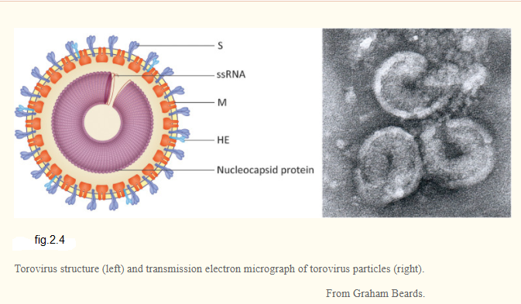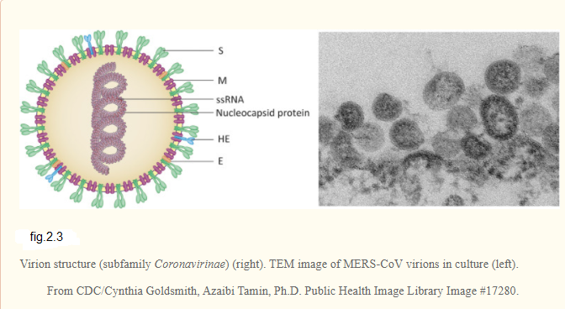12

**Figure 1:** (subfamily Coronavirinae) Virion Structure (right). MERS-CoV virions in vitro as seen under a TEM microscope (left) 12

Figure 1: Figure 2: Virion structure (subfamily Coronavirinae) (right). TEM image of MERS-CoV virions in culture (left) [12].

**Corticosteroid: Benefits, Risks, and Clinical Considerations**

Corticosteroids are commonly used to reduce lung damage caused by severe community-acquired pneumonia (sCAP). This is because of their powerful ability to manage and regulate systemic inflammation, as supported by numerous studies13. However, the use of corticosteroids for treating novel coronavirus pneumonia (NCP), including the new coronavirus (SARS-CoV-2), has been a subject of debate among some experts. This skepticism stems from variable clinical data found in observational studies and comprehensive reviews involving viral pneumonia cases (such as SARS, MERS, and H1N1), potentially raising concerns about inconsistent outcomes14. Moreover, there is a recognized risk associated with early high-dose pulse therapy or prolonged administration of corticosteroids, which could be hazardous15.Nevertheless, it is important to recognize that the therapeutic benefits of corticosteroids may be obscured in certain patient subgroups, especially those with severe symptoms. Factors such as the severity of the illness, timing of intervention, and dosage and duration of corticosteroid treatment can significantly affect clinical outcomes16. Notably, low or physiological doses of corticosteroids may not reduce mortality in cases of septic shock stemming from primary lung infections, as demonstrated in a series of randomized clinical trials (RCTs).

However, they may offer clinical advantages in terms of secondary outcomes, including early shock reversal, shorter ICU stays, and a reduced need for mechanical ventilation. Additionally, corticosteroids can lessen lung fibrosis and impede its clinical progression in patients with severe acute respiratory distress syndrome (ARDS) when used as a salvage medication. This has provided valuable insights into the potential benefits of rescue corticosteroids for patients with severe conditions, such as those with SARS16. Most notably, low-dose corticosteroids have been incorporated as supplementary therapy, and favorable mortality outcomes have been observed, particularly in cases of severe H1N1 illness. These findings strongly suggest that judicious use of low-dose corticosteroids may enhance survival rates among critically ill patients infected with the 2019-nCoV. However, it is essential to emphasize that corticosteroid treatment should be reserved for patients with NCP who meet specific clinical indications, such as refractory ARDS, sepsis, or septic shock, as outlined in established protocols 16.

**Corticosteroid Side Effects**

Adverse effects of corticosteroids In addition to specific adverse effects, this category includes a variety of adverse effects characteristic of this family of drugs. Corticosteroids may induce fluid retention, alter glucose tolerance, cause shifts in behavior and mood, lead to weight gain, elevate blood pressure, and increase appetite, among other potential side effects. Notably, corticosteroids can influence various bodily systems, resulting in a spectrum of adverse reactions. A wide range of potential side effects are linked to the use of this medication, affecting various bodily systems such as the cardiovascular, dermatological, endocrine, fluid and electrolyte balance, gastrointestinal, renal, metabolic, musculoskeletal, nervous, ophthalmic, reproductive systems, and even causing allergic reactions17, 18.(Figure3)19 refers to a comprehensive overview of these reactions and their associated symptoms.

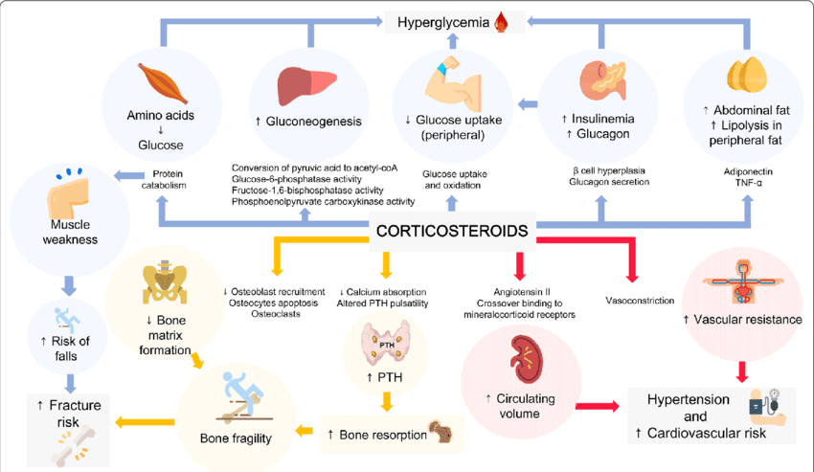

**Figure 3:** Impact of corticosteroid usage on various bodily functions19.

**Corticosteroids in COVID-19**

Corticosteroids, which mimic the body's natural adrenal cortex hormones, encompass synthetic compounds like glucocorticoids (GC) and mineralocorticoids (MC). Mineralocorticoids are responsible for regulating ion transport in renal tubule epithelial cells, crucial for maintaining electrolyte and water balance. On the other hand, GCs possess anti-inflammatory, immunosuppressive, anti-proliferative, and vasoconstrictive properties, along with influencing glucose, lipid, and protein metabolism (Table 2)20. Despite well-documented long-term adverse effects, systemic corticosteroids have been utilized since the 1940s to treat various inflammatory and immunological disorders. GCs mainly modulate the synthesis of substances downstream by either enhancing anti-inflammatory gene transcription (transactivation) or suppressing inflammatory gene transcription (trans repression), thereby impacting the body's inflammatory response relies on the production of important enzymes, such as pro-inflammatory cytokines, chemokines, cell adhesion molecules, and other crucial molecules20.

**Table 2:** The Principal Effects of Glucocorticoids (GCs) 20

|  |
| --- |
| Anti-inflammatory : Block the action of inflammatory mediators (trans repression) or induce  Anti-inflammatory mediators to reduce inflammation.  Immunosuppressive : By treating T-lymphocytes directly, you can suppress delayed  Hypersensitivity reactions.  Contra-proliferative: DNAsynthesis and epidermal cell turnover are both inhibited.  Vasoconstrictive: Histamine and other vasoconstrictive mediators are inhibited. |

**Corticosteroids and Dexamethasone: Crucial Players in Treating Inflammation**

Corticosteroids (CS) constitute a class of steroids employed to treat inflammation across a spectrum of medical conditions by emulating the actions of anti-inflammatory hormones naturally present in the body. These conditions encompass rheumatoid arthritis, systemic lupus erythematosus, asthma, and certain types of cancer21. One well-known member of this class, dexamethasone, has been included on the Model List of Essential Medicines by the World Health Organization since 1977. It is currently accessible without patent restrictions in the majority of nations, making it a cost-effective option22.

**Corticosteroids and COVID-19 Immune Response**

In the context of combating coronavirus infections, the body's immune system is activated, triggering inflammation as an essential immunological response. However, at times, an overly vigorous immune response can lead to a cytokine storm, characterized by excessive immune reactions that attack the body's own cells. COVID-19, in particular, can result in end-organ damage, coagulopathy, and respiratory failure as consequences of these inflammatory responses. Given the association of CS with immune system suppression, their early use in the course of COVID-19 has been met with caution23.CS demonstrates efficacy in addressing inflammation associated with asthma, allergic reactions, arthritis, and various autoimmune disorders. They function by blocking two key inflammatory pathways: immune cell migration and vasodilation.

**Dexamethasone in COVID-19: Cytokine and Macrophage Modulation**

In the case of dexamethasone, this molecule traverses host cell membranes and binds to glucocorticoid receptors located in the cytoplasm. This interaction initiates a sequence of immune cell responses that suppress pro-inflammatory cytokine activity (Figure4)26.

Notably, five pro-inflammatory cytokines have been linked to COVID-1924. Additionally, dexamethasone enhances the expression of the IL-10 gene, which, in turn, reduces neutrophil adherence to endothelial cells. IL-10 acts as an anti-inflammatory cytokine mediator, inhibiting the secretion of lysosomal enzymes and reducing chemotaxis at the site of infection25. Furthermore, corticosteroids hinder the activation of macrophages, a key contributor to the cytokine storms observed in COVID-19 patients.

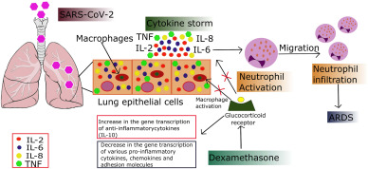**Figure4:** Dexamethasone Mechanism in COVID-19-Related ARDS Cytokine Storm26

**Dexamethasone**

Dexamethasone, with the molecular formula C22H29FO5, is a synthetic glucocorticoid medication. It is used to prevent many conditions, including arthritis, skin infections, acute allergies, asthma, chronic bronchitis, epilepsy, brain swelling, eye pain after eye surgery, and specific types of cancer. Available in many forms, including oral medications, injections, eye drops, and nasal sprays, dexamethasone (Figure 5)27, 28 is characterized by limited mineralocorticoid activity but potent inhibitory effects and anti-inflammatory and immunosuppressive importance. Its widespread application in treating various conditions stems from its potent effects on immune responses and inflammation. Particularly valuable in palliative treatment, dexamethasone's influence on the immune system extends through the circulatory and lymphatic systems27, 28.

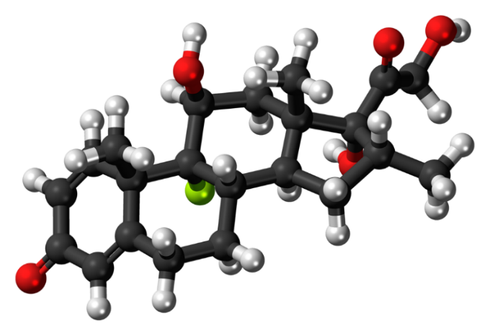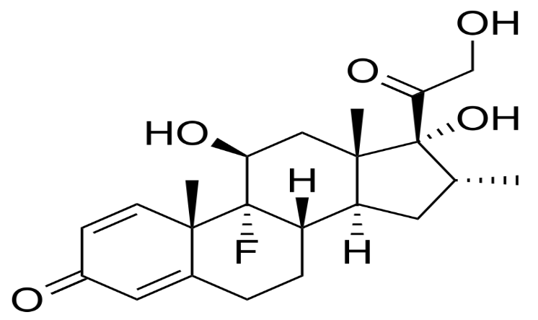**Figure 5:** Dexamethasone (9-fluoro-16-methylprednisolone) molecule structure 27, 28

Dexamethasone has garnered attention due to its convenient once-daily administration, but to effectively replace cortisol, it should be given twice daily. You can find the attributes of dexamethasone illustrated in (Figure 6)29.

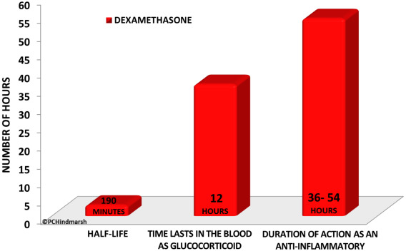

**Figure 6:** Pharmacological Profiles of Dexamethasone: Half-Life, Glucocorticoid Presence, and Anti-Inflammatory Duration 29

**Synthesis of Dexamethasone: Chemical Processes and Improvements**

Dexamethasone, a potent synthetic glucocorticoid, undergoes a multistage synthesis from 3α-acetoxy-16, 17α-epoxy-5α-androstan-11, 15-dione, involving various chemical reactions such as ethynylation, esterification, oxidation, and rearrangement. It was first synthesized by Philip Showalter Hench in 1957.Dexamethasone is available as a generic formulation whose synthesis requires extensive and specific processes to obtain a final product.

**Pharmacokinetics**

**Absorption**

The anti-inflammatory effect of dexamethasone extends for approximately 2.75 days, aligning closely with the duration it takes to suppress the HPA axis following a single 5-mg oral dose. Notably, systemic absorption occurs more gradually after intramuscular (IM) injection compared to intravenous (IV) administration 30.

**Distribution**

The bloodstream efficiently transports the majority of glucocorticoids to various tissues, including muscles, liver, skin, intestine, and kidneys. These substances are also detectable in breast milk and the placenta. Notably, approximately 77 % of the proteins in the plasma exhibit a weak binding affinity to transcortin 31.

**Metabolism**

Dexamethasone undergoes metabolism in the liver through the action of CYP3A4. In comparison to other steroids, dexamethasone's metabolic profile is relatively straightforward 32.

**Elimination**

While corticosteroids usually undergo primary excretion through urine, dexamethasone departs from this norm, with less than 10% of it being expelled through urine (approximately 65%) 31.

**Medical applications of Dexamethasone**

Dexamethasone serves the same purpose as other corticosteroids, but it distinguishes itself by exhibiting a significantly more potent anti-inflammatory and anti-allergic effect 33.

**Actions**

Dexamethasone, a potent glucocorticoid medication, finds extensive applications across various medical fields, including the management of severe COVID-19 cases. Its diverse actions encompass34:

* Typically employed as an anti-inflammatory or immunosuppressive agent.
* It lowers inflammation, stops leukocytes from releasing harmful acid hydrolases, and stops leukocytes from adhering to capillaries by stabilizing their lysosomal membrane.
* It inhibits the accumulation of macrophages in inflamed areas.
* It minimizes edema formation and reduces the permeability of capillary walls.
* Suppresses the release of kinin from substrates and the effects of histamine.
* Decreases the production of scar tissue, collagen deposition, and fibroblast proliferation.
* Reduces cerebrospinal fluid inflammation caused by antibiotics, cytokine release, and bacterial toxins induced by cell wall components
* Induces effects such as stimulation of bone marrow erythroid cells, prolongation of erythrocyte and platelet survival, and the occurrence of eosinopenia and neutrophilia as side effects.
* Promotes gluconeogenesis and results in fat redistribution from the body's periphery to its center, along with protein catabolism leading to a negative nitrogen balance.
* Alters calcium absorption in the intestine, increasing it in the kidneys.
* It decreases vascular function and lymph node volume, causing lymphocytopenia, and suppresses the immune system.
* Reduces immunoglobulin and complement levels, as well as impedes the transit of immune complexes across basement membranes.
* Reduces tissue responsiveness to antigen-antibody interactions.
* Inhibit pituitary corticotropin (ACTH) release at doses that do not significantly affect urinary hydroxyl-corticosteroids and reduce endogenous corticosteroids synthesis.

**Dexamethasone in the management of COVID-19**

Dexamethasone possesses dual attributes of anti-inflammatory and immunosuppressive properties, rendering it a valuable therapeutic option for severe cases of COVID-19. Its documented efficacy in mitigating uncontrolled cytokine storms, severe acute respiratory distress syndrome, and lung injury further underscores its significance in treatment2, 8.The immunosuppressive effects of the medication are believed to be pivotal in mitigating the excessive activation of the immune system in severe COVID-19 patients, consequently enhancing their overall prognosis2, 35.

**Dexamethasone Immunosuppression Power**

Antibodies emerge as a defining sign in severe COVID-19, especially in critically ill patients admitted to the ICU35, 36. Dexamethasone's key advantage in severe COVID-19 is believed to lie in its ability to suppress cytokine storms and immune exhaustion pathways.Nevertheless, the use of systemic corticosteroids such as dexamethasone in individuals with COVID-19 infection should be cautiously considered on an individual basis, given the potential for adverse effects such as hyperglycemia because of neurological symptoms and secondary infection8.

**Dexamethasone in Hospitalized COVID-19**

In a controlled, open-label trial, 2,104 patients were randomly assigned to receive 6 mg of dexamethasone daily for up to 10 days (either orally or intravenously), while 4,321 patients received standard care. At randomization, 16% were on invasive mechanical ventilation (ECMO), 60% were on oxygen therapy alone (with or without noninvasive ventilation), and 24% did not require oxygen. Over 28 days, 22.9% in the dexamethasone group and 25.7% in the standard care group succumbed. After adjusting for age, the rate ratio was 0.83 (95% confidence interval [CI], 0.75 to 0.93; P < 0.001), indicating a significantly lower mortality rate in the dexamethasone group.

The results were significantly influenced by the state of respiratory assistance at randomization. Patients on invasive mechanical ventilation (29.3% vs. 41.4%) and those receiving oxygen without invasive mechanical ventilation (23.3% vs. 26.2%) had significantly lower death rates in the dexamethasone group. Nevertheless, there was no discernible difference in death rates (17.8% vs. 14.0%) for patients who did not need breathing help at the time of randomization 16.

Secondary outcomes revealed shorter hospital stays and a higher likelihood of discharge alive after 28 days in the dexamethasone group, particularly for patients receiving oxygen at randomization. Compared to normal care, there was a decreased likelihood of moving to invasive mechanical ventilation in the dexamethasone group. (Table 3)37.

**Dexamethasone in COVID-19: Efficacy and Concerns**

Dexamethasone, employed in treating diverse viral diseases, including COVID-19, has been extensively investigated for its immunomodulatory effects within the context of COVID-19 treatment. Although it has demonstrated efficacy in reducing mortality and hospitalization in severe COVID-19 cases, its application to other viral diseases raises apprehensions about nosocomial infections and potential delays in viral clearance.

**Table 3:** Primary and Secondary Outcomes: A Comprehensive Analysis 37

|  |
| --- |
| Outcome Dexamethasone Usual Care Rate or Risk Ration  (N=4321) (N=4321) (95% CI)  No/total no. of patient (%)    Primary outcome  Mortality at 28 days 482/2104 (22.9) 1110/4321(25.7) 0.83(0.75-0.93)  Secondary outcomes  Discharged from hospital 1413/2104(67.2) 2745/4321(63.5) 1.10(1.03-1.117)  within 28 days  Invasive mechanical ventilation 456/1780(25.6) 994/3638(27.3) 0.92(0.84-1.01)  Or death  Invasive mechanical ventilation 102/1780(5.7) 285/3638 (7.8) 0.77(0.62-0.95)  Death 387/1780(21.7) 827/3638(22.7) 0.93(0.84-1.03) |

**Dexamethasone’s benefits**

**Dexamethasone Impact on Mortality in the Oxford RECOVERY Trial**

The initiation of a randomized evaluation on June 16, 2020, marked a pivotal moment in the battle against COVID-19. Notably, dexamethasone demonstrated a remarkable reduction in mortality, lowering it by one-third in ventilator-dependent patients and one-fifth in those reliant on oxygen therapy38. In ventilated patients, dexamethasone lowered the risk of mortality from 40% to 28% over 28 days, while for patients on oxygen therapy; it reduced the mortality risk from 25% to 20%, as indicated by preliminary findings. It is essential to note that dexamethasone showed no major adverse effects under mild conditionsbut was found to be ineffective. Nevertheless, the Oxford RECOVERY trial possesses certain limitations, including a lack of data on crucial secondary endpoints, potential harmful effects, and questions regarding dexamethasone's effectiveness in individuals with comorbidities. Therefore, corticosteroids should be reserved for individuals displaying severe cytokine storm symptoms such as acute cardiac damage, acute respiratory distress syndrome (ARDS), renal failure, and elevated D-dimer levels in the bloodstream39.

**Dexamethasone: Targeting COVID-19 Cytokine Storms**

Dexamethasone, a broad-spectrum immunosuppressant, surpasses cortisone in terms of activity andduration40. It exerts its influence through a multitude of mechanisms, influencing various bodily systems. By reducing the transcription of various pro-inflammatory cytokines, corticosteroids like dexamethasone possess anti-inflammatory properties, influencing adhesion molecules and chemokines41. The ability of dexamethasone to lower cytokine production and mitigate adverse consequences makes it a potential asset in combating COVID-19-related cytokine storms42.

**Balancing Inflammation Control and Immunological Challenges in COVID-19 Treatment**

Short-term dexamethasone therapy is employed in COVID-19 patients who develop pneumonia, effectively curbing the intensity of the inflammatory response by suppressing the hyper-inflammatory or severe cytokine storm phase43. However, it is important to recognize that dexamethasone, being a broad-spectrum immunosuppressant, hampers the production of antibodies by B cells, diminishes T-cell protective functions, and limits macrophage-mediated apoptotic cell clearance. This could result in a higher viral load in the bloodstream, elevating the risk of subsequent infections 42. The efficacy of corticosteroid therapy in the management of viral respiratory infections hinges on factors such as dosage, timing of administration, and patient characteristics, as high doses may produce contrary effects37. Consequently, the therapeutic utility of dexamethasone is primarily reserved for individuals with COVID-19 who progress to the stage of requiring respiratory support 37.

**Optimizing treatment strategies**

Hence, we posit that the immunomodulatory effects of glucocorticoids offer the greatest advantage in the advanced stages of the disease. A safer approach involves administering a pulse dose of intravenous dexamethasone, followed by nebulized triamcinolone (another corticosteroid), with the aim of targeting the effects specifically on the lungs40. Another strategy involves the simultaneous administration of intravenous immunoglobulins and interferonbeta to mitigate the adverse effects of corticosteroid treatment44.The potential of intravenously delivered dexamethasone was explored in a multicenter randomized controlled trial conducted between April 18, 2020, and June 19, 2020, in conjunction with intravenous immunoglobulin and interferon-beta44.

**Dexamethasone Trial: Unveiling Lessons and Challenges**

The randomized evaluation of the COVID-19 treatment trial, conducted in a high-income nation, has provided hope to millions of individuals worldwide, but caution is warranted45. Thus, extrapolating these findings to update guidelines in regions with vastly different healthcare systems may pose challenges. Dexamethasone serves as a potent anti-edema medication, and its anti-swelling properties are believed to underlie its efficacy in various diseases, including high-grade inflammatory conditions and glioblastoma, which may contribute to its effectiveness against COVID-19.

**Dexamethasone nanoformulations**

Dexamethasone nanoformulation may enhance this effect by increasing drug availability and activity in the immune cell, resulting in hyperactivity in pulmonary fibrosis.Formulations containing dexamethasone nanomedicine may help maintain anti-inflammatory and anti-edema benefits after hospital discharge46. Furthermore, dexamethasone exhibits powerful anti-fibrotic properties, which can be further potentiated through reformulation as a nanomedicine, as evidenced by preclinical studies across different disease contexts. Nano medicines containing dexamethasone have demonstrated particular efficacy in preventing fibrosis, a significant complication in the long-term management of COVID-19, especially in individuals who have undergone prolonged ventilation46. It is important to note that dexamethasone is an affordable, over-the-counter medication in some countries, leading to reports on social media highlighting its positive effects and, consequently, the risk of self-medication and shortages. Therefore, exercising extra caution is essential to avoid potential harm. It is crucial to remember that dexamethasone is not an antiviral or a cure for COVID-19. Improper use of broad-spectrum immunosuppressive medications can compromise a patient's immune system, making them more susceptible to infections. Further research is needed to determine the optimal dosage and timing for dexamethasone administration before it can be integrated into COVID-19 treatment guidelines for maximum benefit.

**Dexamethasone in COVID-19: Efficacy and Mechanisms**

Dexamethasone exhibits significant therapeutic efficacy in combating COVID-19 by mitigating myocardial edema and reducing vascular permeability. Recent research proposes that pro-resolving lipid mediators, such as protectins, resolvins, maresins, and lipoxins, may increase following viral infections via a different pathway. In fact, there is speculation that the use of dexamethasone could influence their effectiveness. Additionally, computer models indicate that dexamethasone could hinder viral entry by attaching to the ACE2 virus-binding site on the SARS-CoV-2 spike pseudo typed-virus.In a randomized controlled trial involving 2104 hospitalized patients, it was discovered that dexamethasone reduced mortality, albeit with efficacy primarily observed in patients requiring oxygen support and mechanical ventilation. When dexamethasone is combined with long-acting beta-2 adrenergic agonists like salmeterol and formoterol, it not only alleviates respiratory symptoms but also enhances anti-inflammatory and anticoagulant effects synergistically47. Assessing blood ferritin levels can be valuable in determining the optimal timing for dexamethasone treatment and assessing cytokine storms, especially since patients who succumb to the illness tend to have significantly higher ferritin levels compared to those who recover48. In vitro studies have shown promising results with the use of the leukosomal form of dexamethasone, which is encapsulated in nano-vesicles, indicating superior therapeutic potential in this formulation49. It is worth noting that dexamethasone binds to serum albumin, facilitating its distribution throughout the body. However, clinicians should be mindful of potential competition for binding sites, as the binding site for dexamethasone in albumin is the same as that for testosterone and NSAIDs50.

**Side effects and tolerance of dexamethasone**

Dexamethasone, a commonly employed corticosteroid, exhibits good tolerance when used briefly or in single doses. However, with increased dosage or prolonged therapy, a range of side effects may manifest. These may consist of hyperglycemia, glucose intolerance, increased susceptibility to infections (especially fungal infections), joint avascular necrosis, adrenal suppression, delayed wound healing, restlessness, flushing, and, to a lesser degree, nausea and vomiting51. Dexamethasone produces a few minor adverse effects, such as poorer sleep, anxiety, insomnia, hirsutism, increased sweating, cutaneous purpura, and face rounding52. In comparison to other corticosteroids, dexamethasone is less prone to inducing advanced hypertension, edema, hyperglycemia, and glycosuria53. Notably, COVID-19 patients using dexamethasone may face a heightened risk of severe eosinophilia, which can be mitigated by considering the use of Ivermectin, a compound known for its anti-coronavirus properties 54.

**Self-Medication Risks: Dexamethasone and Corticosteroids**

One of the most concerning aspects of utilizing dexamethasone and other corticosteroids is the potential for patients to engage in self-medication to prevent illness, which can lead to adverse effects. Consequently, healthcare professionals must exercise vigilance to mitigate potential risks and anticipate the negative consequences associated with these treatments.

**Corticosteroids in COVID-19: Navigating Uncertainties in Treatment**

Despite numerous research studies examining the use of steroids in COVID-19, there is still insufficient compelling evidence supporting the efficacy of corticosteroid treatment for SARS. While randomized controlled trials are necessary to establish its positive impact and determine the most suitable dosage regimen, numerous researchers have stressed the importance of judiciously administering corticosteroids. Nevertheless, it is crucial to carefully consider potential benefits in light of the associated risks, such as secondary infections and delayed virus clearance.

**Insights from the RECOVERY Trial and National Cohort Study**

The RECOVERY trial offers compelling evidence indicating that administering dexamethasone at a dosage of 6 mg once daily for duration of up to 10 days results in a reduction of 28-day mortality among hospitalized patients grappling with COVID-19 respiratory illness55. While the anti-inflammatory properties of the drug are crucial in easing the significant respiratory distress linked to COVID-19, caution is advised due to the potential adverse effect of dexamethasone in non-severe cases of the illness. This underscores the need for careful consideration when prescribing systemic corticosteroids to patients exhibiting mild-to-moderate pulmonary. In a comprehensive national cohort study including 80,699 patients, early administration of dexamethasone demonstrated a statistically significant reduction in the combined outcome of in-hospital death or discharge patients requiring supplemental oxygen, mechanical ventilation, and/or extracorporeal oxygen. In a comprehensive national cohort study including 80,699 patients, early administration of dexamethasone demonstrated a statistically significant reduction in the combined outcome of in-hospital death or discharge patients requiring supplemental oxygen, mechanical ventilation, and/or extracorporeal oxygen. Following adjustment through propensity score overlap weighting, the early administration of dexamethasone was linked to a decrease in the composite outcome for patients receiving supplemental oxygen (adjusted odds ratio [aOR], 0.92; 95% confidence interval [CI], 0.86-0.98) and those on mechanical ventilation and/or extracorporeal membrane oxygenation (aOR, 0.82; 95% CI, 0.68-0.99). However, neither the no supplemental oxygen group (adjusted odds ratio [aOR], 0.90; 95% confidence interval [CI], 0.78–1.03) nor the NIPPV (Non-Invasive Positive Pressure Ventilation) group (aOR, 0.87; 95% CI, 0.73–1.04) showed a decrease in the overall inpatient mortality or hospice discharge rates among patients who received dexamethasone. [56]. The efficacy of dexamethasone in reducing mortality rates and providing benefits to COVID-19 patients, especially those reliant on supplemental oxygen or mechanical ventilation, has been well established. However, the scope of its advantages may be restricted to patients not requiring supplemental oxygen or to specific patient subgroups. There is a crucial need for further research to delve into the effects of dexamethasone across diverse patient populations and disease severities. Additionally, exploring potential synergies with other therapeutic agents, assessing long-term impacts, and evaluating its efficacy against emerging variants are essential areas that require investigation.

**Relevance and Impact**

Dexamethasone has received significant attention in connection with the treatment of coronavirus disease (COVID-19). In the RECOVERY trial, this widely available and inexpensive drug significantly lowered the risk of death in patients with COVID-19 by 35% in patients on ventilators and 20% in those receiving supplemental oxygen without invasive mechanical ventilation. However, the immunosuppressive effects of dexamethasone raise concerns about the potential for delayed viral clearance, especially in the setting of viral infection. Nevertheless, studies on nano- medical formulations of dexamethasone show promise in improving their delivery and therapeutic efficacy.

**Acknowledgment**

The author expresses gratitude to the members of Pharmacy University Batna2 for their invaluable support.

**Conflict of interest**

The author declare that I have no known competing financial interests or personal relationships that could have appeared to influence the work reported in this paper

**Funding statement**

This research did not receive any specific grant from funding agencies in the public, commercial, or not-for-profit sectors.

**Conclusion**

Dexamethasone, a potent corticosteroid with anti-inflammatory and immunosuppressive properties, has a significant impact on the care of COVID-19 patients who are in critical condition, especially those with respiratory complications. This review highlights its effectiveness in alleviating breathlessness but also highlights the complexity of its dual action of balancing the suppression of cytokine storms with the potential for impairment of immune function. This study highlights the importance of customized treatment strategies based on the stage of COVID-19 and advocates precise and individualized interventions. Given the cost-effectiveness and widespread availability of dexamethasone, the global impact is significant, influencing clinical practice and public health strategies. Although promising, caution is advised, as there may be long-term effects, such as an increased viral load after recovery. The study recommends judicious use, especially in severe respiratory diseases, including optimal dosing, synergy with other drugs, long-term efficacy, global access, and efficacy against emerging variants, suggesting avenues for future research. While recognizing the importance of dexamethasone, the study also highlights the continued need for research to refine its use, ensure its adaptability to the challenges of the COVID-19 pandemic, and strengthen preparedness for future viral threats. Further studies may also elucidate the long-term effects of dexamethasone and evaluate its compatibility with other immunomodulatory agents.

**References**

1.Cârstea AP, Mită A, Fortofoiu MC, Doica IP, Cârstea D, Beznă CM, et al. How Dexamethasone Used in Anti-COVID-19 Therapy Influenced Antihypertensive Treatment in Patients with SARS-CoV-2. In: Healthcare. 2023; 11(10):1399. MDPI.

2. Ahmed MH, Hassan A. Dexamethasone for the treatment of coronavirus disease (COVID-19): a review. SN Compr Clin Med. 2020; 2:2637-2646.

3. Wahab S, Ahmad I, Usmani S, Ahmad M. Efficacy of Dexamethasone for the Treatment of COVID-19 Infection: A Perspective Review. Curr Drug Deliv. 2021; 18(5):546-554.

4. Noreen S, Maqbool I, Madni A. Dexamethasone: Therapeutic potential, risks, and future projection during COVID-19 pandemic. Eur J Pharmacol. 2021; 894:173854.

5.Villar J, Añón JM, Ferrando C, Aguila G, Muñoz T, Ferreres J, Slutsky AS. Efficacy of dexamethasone treatment for patients with the acute respiratory distress syndrome caused by COVID-19: study protocol for a randomized controlled superiority trial. Trials.2020; 21:1-10.

6. Kearney C, Lesieur M, Bosch NA, Walkey AJ. Corticosteroid Uptake for COVID-19 after Publication of RECOVERY: A Difference in Difference Model. Ann Am Thorac Soc. 2023; 20(3):473-476.

7. RECOVERY Collaborative Group. Dexamethasone in hospitalized patients with Covid-19. N Engl J Med.2021; 384(8):693-704.

8.Chen F, Hao L, Zhu S, Yang X, Shi W, Zheng K, et al. Potential adverse effects of dexamethasone therapy on COVID-19 patients: review and recommendations. Infect Dis Ther. 2021; 10:1907-1931.

9. Fagbule OF. 2019 novel coronavirus. Ann Ibadan Postgrad Med. 2019; 17(2):108-110.

10. He F, Deng Y, Li W. Coronavirus disease 2019: What we know? J Med Virol.2020; 92(7):719-725.

11. Holmes KV. Coronaviruses (Coronaviridae). Encyclopedia of Virology. 1999:291.

12. Payne S. Family Coronaviridae. Viruses. 2017:149.

13. Jiang S, Liu T, Hu Y, Li R, Di X, Jin X, et al. Efficacy and safety of glucocorticoids in the treatment of severe community-acquired pneumonia: a meta-analysis. Medicine. 2019; 98(26).

14.Arabi YM, Mandourah Y, Al-Hameed F, Sindi AA, Almekhlafi GA, Hussein MA, Fowler RA. Corticosteroid therapy for critically ill patients with Middle East respiratory syndrome. Am J Respir Crit Care Med. 2018; 197(6):757-767.

15. Moreno G, Rodríguez A, Reyes LF, Gomez J, Sole-Violan J, Díaz E, Martín-Loeches I. Corticosteroid treatment in critically ill patients with severe influenza pneumonia: a propensity score matching study. Intensive Care Med. 2018; 44(9):1470-1482.

16. Marik PE. Steroids for sepsis: yes, no or maybe. J Thorac Dis. 2018; 10(Suppl 9):S1070.

17. Yasir M, Goyal A, Sonthalia S. Corticosteroid adverse effects.

18. Hodgens A, Sharman T. Corticosteroids. In: StatPearls [Internet]. StatPearls Publishing; 2022.

19.Alessi J, de Oliveira GB, Schaan BD, Telo GH. Dexamethasone in the era of COVID-19: friend or foe? An essay on the effects of dexamethasone and the potential risks of its inadvertent use in patients with diabetes. Diabetol Metab Syndr.2020; 12:1-11.

20.Liu D, Ahmet A, Ward L, Krishnamoorthy P, Mandelcorn ED, Leigh R, et al. A practical guide to the monitoring and management of the complications of systemic corticosteroid therapy. Allergy, Asthma & Clin Immunol. 2013; 9(1):1-25.

21. Rhen T, Cidlowski JA. Anti-inflammatory action of glucocorticoids-new mechanisms for old drugs. N Engl J Med. 2005;353(16):1711-1723.

22.Broccoli MC, Pigoga JL, Nyirenda M, Wallis LA, Hynes EC. Essential medicines for emergency care in Africa. Afr J Emerg Med.2018; 8(3):110-117.

23. Isidori AM, Arnaldi G, Boscaro M, Falorni A, Giordano C, Giordano R, Lenzi A. COVID-19 infection and glucocorticoids: update from the Italian Society of Endocrinology Expert Opinion on steroid replacement in adrenal insufficiency. J Endocrinol Invest.2020; 43(8):1141-1147.

24.Lammers T, Sofias AM, van der Meel R, Schiffelers R, Storm G, Tacke F, et al. Dexamethasone Nano medicines for COVID-19. Nat Nanotechnol.2020; 15(8):622-624.

25. Coutinho AE, Chapman KE. The anti-inflammatory and immunosuppressive effects of glucocorticoids, recent developments and mechanistic insights. Mol Cell Endocrinol.2011; 335(1):2-13.

26. Youssef J, Novosad SA, Winthrop KL. Infection risk and safety of corticosteroid use. Rheum Dis Clin. 2016; 42(1):157-176.

27. Wikipedia. Dexamethasone [Internet].Available from:<https://en.wikipedia.org/wiki/Dexamethasone>

28. PubChem.Dexamethasone [Internet]. Available from: <https://pubchem.ncbi.nlm.nih.gov/compound/Dexamethasone>

29. Dumontet T, Martinez A. Adrenal androgens, adrenarche, and zona reticularis: A human affair? Mol Cell Endocrinol. 2021; 111239.

30. Kintzel PE, Zhao T, Wen B, Sun D. Stability of admixture containing metoclopramide, diphenhydramine hydrochloride, and dexamethasone sodium phosphate in 0.9% sodium chloride injection. Am J Health-Syst Pharm. 2014; 71(23):2061-2065.

31. Esmaili N, Harris GJ. Langerhans cell histiocytosis of the orbit: spectrum of disease and risk of central nervous system sequelae in unifocal cases. Ophthalmic Plast Reconstr Surg. 2016; 32(1):28-34.

32. Merck & Co. Decadron (dexamethasone) tablets prescribing information. Whitestation, NJ: Merck & Co.; 2001.

33. Vardanyan R, Hruby V. Synthesis of essential drugs. Elsevier; 2006.

34. McEvoy GK, ed. Dexamethasone. In: AHFS Drug Information. Bethesda, MD: American Society of Health-System Pharmacists; 2004:2906-8.

35. Asif S, Frithiof R, Larsson A, Franzén S, Anderberg SB, Kristensen B, Lipcsey M. Immuno-Modulatory Effects of Dexamethasone in Severe COVID-19- A Swedish Cohort Study. Biomedicines. 2023; 11(1):164.

36. Chimote AA, Alshwimi AO, Chirra M, Gawali VS, Powers-Fletcher MV, Hudock KM, Conforti L. Immune and ionic mechanisms mediating the effect of dexamethasone in severe COVID-19. Front Immunol. 2023; 14:1530.

37. Dhasmana DJ. Dexamethasone in hospitalized patients with Covid-19. N Engl J Med. 2021.

38. Noreen S, Maqbool I, Madni A. Dexamethasone: therapeutic potential, risks, and future projection during COVID-19 pandemic. Eur J Pharmacol. 2021; 173854.

39. Soy M, Keser G, Atagündüz P, Tabak F, Atagündüz I, Kayhan S. Cytokine storm in COVID-19: pathogenesis and overview of anti-inflammatory agents used in treatment. Clin Rheumatol. 2020; 39:2085-2094.

40. Theoharides TC, Conti P. Dexamethasone for COVID-19? Not so fast. J Biol Regul Homeost Agents. 2020; 34(3):10-23812.

41.Rhen T, Cidlowski JA. Anti-inflammatory action of glucocorticoids-new mechanisms for old drugs. N Engl J Med. 2005; 353(16):1711-1723.

42. Lim MA, Pranata R. Worrying situation regarding the use of dexamethasone for COVID-19. Ther Adv Respir Dis. 2020; 14.

43. Selvaraj V, Dapaah-Afriyie K, Finn A, Flanigan TP. Short-term dexamethasone in Sars-CoV-2 patients. RI Med J. 2020; 103(6):39-43.

44. Abdolahi N, Kaheh E, Golsha R, Khodabakhshi B, Norouzi A, Khandashpoor M, Roshandel G. Letter to the editor: efficacy of different methods of combination regimen administrations including dexamethasone, intravenous immunoglobulin, and interferon-beta to treat critically ill COVID-19 patients: a structured summary of a study protocol for a randomized controlled trial. Trials. 2020; 21(1):1-3.

45. Brotherton H, Usuf E, Nadjm B, Forrest K, Bojang K, Samateh AL, Roca A. Dexamethasone for COVID-19: data needed from randomized clinical trials in Africa. Lancet Glob Health. 2020; 8(9):e1125-e1126.

46.Lammers T, Sofias AM, van der Meel R, Schiffelers R, Storm G, Tacke F, Metselaar JM. Dexamethasone nanomedicines for COVID-19. Nat Nanotechnol. 2020; 15(8):622-624.

47. Hajjo R, Sabbah DA, Bardaweel SK. Chemocentric Informatics Analysis: Dexamethasone versus Combination Therapy for COVID-19. ACS omega. 2020; 5(46):29765-29779.

48. Burugu HR, Kandi V, Kutikuppala LVS, Suvvari TK. Activities of Serum Ferritin and Treatment Outcomes among COVID-19 Patients Treated With Vitamin C and Dexamethasone: An Uncontrolled Single-Center Observational Study. Cureus. 2020; 12(11).

49. Molinaro R, Pasto A, Taraballi F, Giordano F, Azzi JA, Tasciotti E, Corbo C. Biomimetic Nanoparticles Potentiate the Anti-Inflammatory Properties of Dexamethasone and Reduce the Cytokine Storm Syndrome: An Additional Weapon against COVID-19? Nanomaterials. 2020; 10(11):2301.

50. Shabalin IG, Czub MP, Majorek KA, Brzezinski D, Grabowski M, Cooper DR, Minor W. Molecular determinants of vascular transport of dexamethasone in COVID-19 therapy. IUCrJ. 2020; 7(6).

51. De Gans J, Van de Beek D. Dexamethasone in adults with bacterial meningitis. N Engl J Med. 2002; 347(20):1549-1556.

52. Bunim JJ, Black RL, Lutwak L, Peterson RE, Whedon GD. Studies on dexamethasone, a new synthetic steroid, in rheumatoid arthritis: a preliminary report. Arthritis Rheumatism. 1958; 1(4):313-331.

53. Dinan TG, Lavelle E, Cooney J, Burnett F, Scott L, Dash A, Berti C. Dexamethasone augmentation in treatment-resistant depression. Acta Psychiatr Scand. 1997; 95(1):58-61.

54. Stauffer WM, Alpern JD, Walker PF. COVID-19 and dexamethasone: a potential strategy to avoid steroid-related strongyloides hyperinfection. JAMA. 2020; 324(7):623-624.

55. Horby P, Lim WS, Emberson J, Mafham M, Bell J, Linsell L, RECOVERY Collaborative Group. Effect of dexamethasone in hospitalized patients with COVID-19: preliminary report. MedRxiv. 2020.

56. Mourad A, Thibault D, Holland TL, Yang S, Young AR, Egloff SAA, Thomas LE. Dexamethasone for Inpatients with COVID-19 in a National Cohort. JAMA Netw Open. 2023; 6(4):e238516-e238516.