**The Role of Clinical Pharmacology in the Healthcare Sector: Scope**

**and Future Outlook: A Review**

# ABSTRACT

Once thought of as harmful, drugs are today essential for controlling diseases and maintaining good health. The study of how organ systems work, how in-vivo homeostasis is regulated, the pathophysiology of disease states, and the appropriate administration of medications is the focus of clinical pharmacology, a branch of medicine that draws upon biology, medicinal chemistry, biochemistry, and other medical disciplines. Research on novel medications and better ways to utilize them safely and rationally requires collaboration across disciplines and schools of thought. Clinical pharmacology data may also impact patients' rational medication usage in real practice. Clinical trials encourage patients to utilize drugs optimally and give comparative data to back reasonable prescribing. The change of clinical operations from institutional drug research centers to academic disciplines has resulted in the formation of drug use review committees at both institutional and national levels.

Due to its role in drug approval procedures and postgraduate training, clinical pharmacology is an integral part of the healthcare system. The following domains benefit greatly from it: counselling, prescription analysis, patient care, adverse impact management, reporting of adverse medication reactions, and the creation of centres to monitor these reactions. As part of their work in drug discovery and clinical trials, clinical pharmacologists assess pharmacogenetic data, adverse drug responses, and drug interaction reactions in human volunteers.

Clinical pharmacology stands out among the subfields of pharmacotherapeutics due to its impact on healthcare delivery and patient outcomes. It develops new therapeutics, ensures medication safety, and is intimately tied to other advancements. By highlighting clinical pharmacology education, researchers, health workers, administration, and policymakers, the field hopes to contribute to the creation of healthcare that is inexpensive, effective, and grounded in science. Reasonable diagnostic and treatment regimens tailored to each patient's specific requirements will be used to accomplish this.

**Key words** – Clinical Pharmacology, Clinical Trials, Research Portfolio, Precision medicine, Pharmacogenomics.

**INTRODUCTION -**

Clinical Pharmacology is Important Because it provides important information and direction for the safe and effective administration of pharmaceuticals, medical supplies, and medical equipment, clinical pharmacology is an important and vital field in healthcare lists a wide variety of services and activities provided by clinical pharmacists within this specialty. These include taking medication histories, counselling patients, reviewing treatment regimens, monitoring drug therapy, providing drug information, reporting adverse drug reactions, and aiding with poison control (Abu-Elmagd et al., 2015). As Lampert et al point out, clinical pharmacology plays a crucial role in healthcare by helping to ensure that pharmaceuticals are administered safely and effectively. This, in turn, improves patient outcomes and quality of life. Clinical pharmacists' roles in India's healthcare system have been changing over the years, following a global trend toward more innovative practises spearheaded by academic institutions(Al Ammari et al., 2020). Even yet, clinical pharmacology in India is still far from reaching its full potential, especially in community settings. One of the main problems with incorporating clinical pharmacology into the Indian healthcare system is the lack of minimal requirements for community pharmacists, which has prevented clinical pharmacy practices from being widely used.(Alkharfy et al., 2017).

Regardless of these challenges, there are signs of progress, as more and more students see the potential for community-based patient counselling and illness treatment and are setting loftier educational goals in this area (Al-Shaqha et al., 2015). In the past, people thought of drugs as poisons that may have bad effects. Patients in need cannot be served without these pharmaceuticals, which are vital for illness treatment and have positive effects when administered appropriately. In recent decades, pharmaceuticals have advanced to the point that they are useful tools for the healthcare system, including the detection, evaluation, and treatment of illness (Alsultan & Peloquin, 2014). Given the wide variety of vital advantages they provide, it is critical for society to make full use of medicines' considerable therapeutic potential. So, among the most important areas of study in science and technology are pharmaceuticals—their discovery, development, and use(Ashbee et al., 2014). In the present day, the main health profession that deals with the practical uses of chemicals and pharmaceuticals is medicine. Therefore, it is critical for all medical practitioners to have an in-depth understanding of clinical pharmacology, the study of how drugs work in the body. This article takes a look at where clinical pharmacology is at the moment and where it may go in the healthcare industry(Orme & Sjçqvist, 2010).

**1. WHAT IS CLINICAL PHARMACOLOGY?**

As a field of study, clinical pharmacology draws from a wider variety of resources and expertise in the biological, pharmacological, biochemical, and medical branches. This field combines elements of applied molecular pharmacology with research into the pathophysiology of various diseases, the regulation and control of in-vivo homeostasis, the mechanisms of organ system function and dysfunction, the rational use of drugs, and design and implementation of a sensible medication research and introduction program for these disorders (Bjornsson et al., 2003). One end of the clinical pharmacology spectrum is the integrated activity of multi-faculty and multidisciplinary efforts to develop more drugs and improved ways to use these molecules for their safe and reasonable consumption. On the other end of the scale, the field's foundational in vitro and in vivo research approaches biophysics and psychopharmacology (Bonate, 2000).

Additionally, it is useful for gathering information that might help doctors decide whether it's reasonable to give patients these drugs in the hospital, taking into account the patient's specific set of symptoms. Our academic and pharmaceutical expertise, together with our promotional efforts, set us apart from many other more conventional fields, all due to the proper mandate for clinical pharmacology (Bukhari et al., 2019). This sets us apart from the fields of medical pharmacology and toxicology, which are concerned with the study and creation of novel pharmaceuticals.

So, clinical research helps us with our goal of finding the best way to give patients their drugs. In a larger context, it provides comparative information to support reasonable prescribing. Recognizing these unique obligations, clinical operations have been moved from institutional drug research divisions to academically based disciplines; as a consequence, drug usage review committees have been established at both the institutional and national levels(Caudle et al., 2014).

## 2. MODERN CLINICAL PHARMACOLOGY APPLICATIONS

Postgraduate education and active participation in all stages of drug regulation constitute supplementary responsibilities of clinical pharmacology services. Training as a clinical pharmacologist enables a substantial contribution to healthcare by advocating for the safe, effective, and rational utilization of pharmaceuticals, even in the absence of direct patient interaction (Chien et al., 2005). Patient care, counselling, analysis of prescriptions for drug-drug interactions, reporting of adverse drug reactions, management of side effects, administration of drugs, management of disease through a phased treatment approach (involving the introduction of drugs and monitoring of different combinations at the individual patient level throughout the disease's progression), and poisoning case resolution are all part of a clinical pharmacologist's routine duties(Chow, 2014) Training and retraining programs are offered to professional groups including dentists, doctors, nurses, and students of medicine and paramedicine so that they may stay up-to-date with the latest developments. Furthermore, research endeavours including drug use studies, stat lab and drug information setup, vital drug list and formulary preparation, and database creation for rational drug use are carried out(Collins & Varmus, 2015). In postgraduate training requirements, the Medical Council of India recommends allocating one to two hours each week for six to twelve months to a department of clinical pharmacology. Clinical pharmacologists often take on the role of statistician and co-guide in a plethora of clinical trials, the bulk of which take place in laboratories under the supervision of highly trained research scientists. Furthermore, the Medical Council states that every postgraduate must be capable of autonomously overseeing 100-bed days. Members of the faculty must hold a position at a nationally renowned medical college, hospital, or health service institution and hold a minimum of a medical degree (Crews et al., 2012).

### 2.1. DRUG DEVELOPMENT AND CLINICAL TRIALS

Clinical pharmacology is essential for medication research and clinical application. The investigation of the impacts of novel substances on the body constitutes a component of clinical pharmacology. Investigating how medications function on the body in different contexts is what clinical pharmacology is all about. Clinical pharmacists are taught to systematically monitor and evaluate pharmacogenetic data, adverse drug responses, and drug interaction reactions in human volunteers receiving the pharmacological substances during all phases of clinical trials as shown in figure 1 below (Phase I, II, &III) (Darwich et al., 2017).

All health professionals face a major issue in the healthcare business today. Environmental, nutritional, genetic, infectious, and non-infectious variables are among the many that contribute to the wide range of diseases that it aims to treat, manage, or cure. We are aware that genetic differences are the root cause of patients' uneven medication reactions. Implementing patient-oriented experimental therapy that takes into account the patient's clinical state, pharmacokinetics, pharmacodynamics, and genetic background is crucial for optimizing the therapeutic efficacy and preventing unwanted medication effects (Darwich et al., 2017)

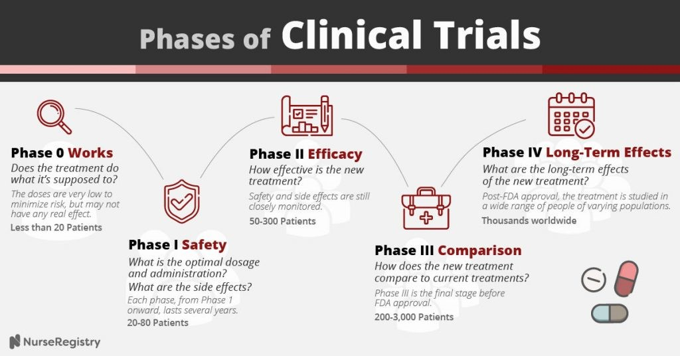

#### FIGURE – 1 Shows different phases of Clinical trials conducted for any new drug

**2.2 THERAPEUTIC DRUG MONITORING**

With the help of TDM, patients get tailored treatment plans. Medications with a small therapeutic window or high inter-subject variability are common candidates for this method. Knowledge of the concentration-response relationship and quick, inexpensive drug testing are also important. For valproic acid, cyclosporine, aminoglycosides, tacrolimus, and vancomycin, TDM is the gold standard. It is becoming more common to use TDM as a framework to modify dosages of various drugs. Think twice before using any antimicrobial or anti-cancer medication, such as an anti-HIV medicine, an antifungal, a beta-lactam, an anti-TB medicine, busulfan, or an inhibitor of tyrosine kinase. There is no obvious PD or clinical metric to evaluate therapy response, however these drugs cure serious illnesses. Despite meeting the criteria, TDM is not commonly used for a number of these drugs due to the lack of readily available assays. Our TDM approach must also be improved. The prior approach involved assessing a trough concentration by employing a solitary sample and contrasting it with a reference range. This method presents several limitations, such as reliance on simplistic pharmacokinetic models and additional patient data, suboptimal drug testing precision, variability in laboratory reporting, and the difficulty of monitoring the drug or its metabolites within a clinically relevant timeframe. Therapeutic drug monitoring with computer software or model-informed precision dosage represents an alternative approach.

Patients undergo personalized therapy with therapeutic drug monitoring (TDM). It has been utilized for medications with narrow therapeutic indexes or high intersubject variability. Understanding the concentration–response relationship and rapid, affordable drug tests are essential. Therapeutic Drug Monitoring (TDM) is standard for vancomycin, phenytoin, aminoglycosides, tacrolimus, cyclosporine, and valproic acid. The expansion of Therapeutic Drug Monitoring (TDM) to inform changes in doses for various drugs is more prevalent, as illustrated in figure 2 below. Antimicrobials and anticancer agents, including anti-HIV medications, antifungals, beta-lactams, anti-tubercular medicines, busulfan, and tyrosine kinase inhibitors, are particularly significant. These drugs address life-threatening conditions lacking a definitive pharmacodynamic or clinical metric to evaluate therapy efficacy. The lack of assay availability hinders the widespread application of TDM for several of these drugs, despite the relevant criteria being applicable. Our TDM methodology need enhancement. Previously, a single sample was used to monitor trough concentration and compare it to a reference range. This method has various drawbacks, that include reliance on basic pharmacokinetic models and patient data, suboptimal drug testing precision, laboratory reporting heterogeneity, and difficulty tracking the drug or its metabolites within a clinically relevant timeframe. Software-based therapeutic medication monitoring or model-informed precision dosing are alternatives. (de Velde et al., 2018).

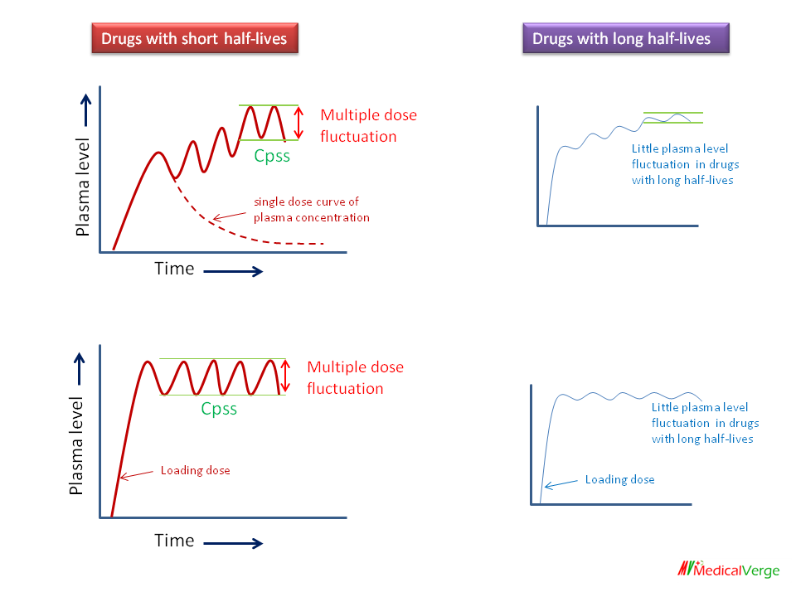

**FIGURE – 2 Depicts there is a small difference between peak and trough plasma concentration for drugs with long half lives and large difference between peak and trough plasma concentration for drugs with short half lives.**

## 3. WHY CLINICAL PHARMACOLOGY MATTERS FOR HEALTHCARE

Clinical pharmacology stands out when compared to other fields of pharmacotherapeutics. Both medical practice and patient care are affected. There is a tight relationship between it and developments in other fields, such as basic medicine and medical therapy. Moreover, it is essential for guaranteeing the safe and effective administration of pharmaceuticals and for facilitating research into novel medicines (Debouck, 2009). Affordable, cost-effective, and scientifically based healthcare that utilizes rational diagnostic and therapeutic regimens that are specifically tailored to individual patients' medicinal needs can be developed if all stakeholders in healthcare—researchers, health workers, administrators, and policymakers—focus on expanding clinical pharmacology education and the real benefits of good clinical pharmacology for patients and the public (Dodds et al., 2013).

### 3.1. RAISING THE BAR ON MEDICATIONS

The bulk of therapeutic drugs utilized in modern medicine were discovered by clinical pharmacologists, who have made substantial scientific contributions to this field. Research in clinical pharmacology focuses on optimizing pharmacological therapy through areas such as

anti-infective treatment of infections, medication interactions, toxicity, clearance, metabolism, and drug interactions (Egelund et al., 2014). Discoveries of drug-action receptors and potential receptor molecules for a wide variety of common diseases have laid the groundwork for a theoretical framework for pharmacological treatment (CHMP, 2014). However, there isn't a perfect, exact treatment regimen as many existing medications don't have rational targets. So, clinical pharmacology is all about making sure a patient has the same reaction to common and rare drugs by optimizing their therapy procedures using substances (CDER,2005).

Consideration of treatment procedures' financial impacts has received more attention in recent years. Due to the major shifts brought about by the molecular biology revolution, many patients with gene-dependent disorders may now be accurately managed. It is a fortuitous turn of events. The new discipline of pharmacogenomics, which combines molecular biology with clinical pharmacology, has undoubtedly allowed for more accurate predictions of the treatment response of individuals with "disease genes’ (Zhang et al., 2008).

## 4. NEW DEVELOPMENTS AND EMERGING PATTERNS IN CLINICAL PHARMACOLOGY

The path that medical science and research take in the future will determine the trajectory of clinical pharmacology. This trajectory will be shaped by several new and exciting fields, such as genetics, gene therapy, stem cell research and clinical applications, induced pluripotent stem cell (iPS) and genetic engineering, and nanotechnology-based drug innovation, as shown in Figure 3. Without a doubt, clinical pharmacologists will play an integral role in the following pharmacological domains: drug transport and metabolism; drug accumulation; and drug prediction, research, and accumulation (Fukudo et al., 2009). However, traditional drug development approaches will have to be partially or entirely scrapped if new medications are to be used. The fundamental ideas supporting the clinical pharmaceutical research program will become irrelevant, and most ongoing programs will scale down their current methodology as a result. Further, the discovery of yet undiscovered severe mechanisms of the body's reaction to medicines is intricately related to the launch of these pharmaceuticals (Gal et al., 2017).

Personalized medicine, which uses a patient's genetic profile to select the best treatment, is under study. Some pharmaceutical firms are working on proteomic and metabolomic technologies to augment the standard blood and urine testing with a more in-depth examination of the pharmacogenomic impact (Gonzalez et al., 2017). Modern clinical pharmacology is facing the daunting task of deciphering the role of human gene polymorphism variants and the proteins they produce, and then using this information to determine the optimal dosage of drugs for individual patients.

Progress in this field of pharmacogenomics may lead to better methods of medication safety regulation, which in turn might lessen the occurrence of side effects and drug interactions. This is of the utmost importance when trying to forestall potentially lethal situations, including unexpected death (*Evolution of Biomarker Qualification at the Health Authorities*, n.d.).

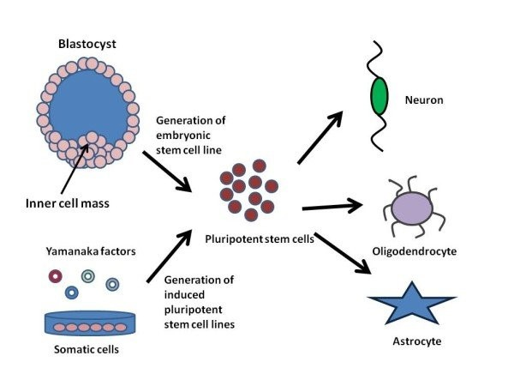

**FIG – 3 Shows how different cells are made up of pluripotent stem cells and their further synthesis.**

**4.1. CARE THAT IS PERSONALIZED FOR EACH PATIENT**

Recent technology breakthroughs have had a substantial impact on medical practice in the clinic. Collaboration and multidisciplinary efforts are key to the discovery of new drug targets and selective therapeutic molecules, as well as the continuous improvement of customized treatment made possible by comparing biochemical genetic data. Numbers and statistics drive them most of the time as well (Verbelen et al., 2017).

The continual growth of clinical experience that is likely to assist statistically justified regulation and quality of therapeutic decision-making, as well as the translation of these research improvements into practice, are both greatly aided by clinical pharmacologists. This article offers some thoughts on what makes a clinical pharmacology section good for healthcare facilities and medical research (Holford et al., 2010).

**4.2. FUTURE PERSPECTIVES**

The field of customized medicine is one that is seeing tremendous growth in the biomedical industry. The ability to genotype or sequence individuals has made it much easier to identify: 1) hereditary genetic variability that influences a person's propensity to get sick or how a disease develops after it has already begun to manifest; and 2) hereditary genetic variability that influences how a person reacts to certain treatments. To accurately characterize a drug's clinical pharmacologic effects, researchers must often combine data from pharmacodynamics, clinical pharmacologic assessments, bioanalytical studies, and multivariate evaluations of clinical phenotypes (Howard et al., 2018). Ensuring the right therapy goes to the right patient at the right time with the right dosage is the goal of customized medicine. This set of goals requires pharmacological researchers to describe the multivariate structure of in vivo clinical disease characteristics and the complex mechanisms by which drug exposure modifies this balance with therapeutic efficacy and adverse outcomes(Huang et al., 2013).

They must also incorporate practically any useful bioinformatic and quantitatively motivated conclusions that interpret measured in vitro biological function (Duggan et al., 2001).

**Translational Research** -

Translational research, or "bench-to-bedside," describes the intersection of fundamental science, mostly conducted by academic laboratories, and clinical research undertaken by doctors, biotechnology firms, and pharmaceutical businesses (Sudlow et al., 1983). The FDA's 2004 “Critical Path Initiative (CPI)” identified basic science-applied research gaps. The FDA produced a list of six essential subjects in 2006 to overcome this gap, including clinical trial optimization. (The Alpha Trial: European/Australian Randomized Double-Blind Trial of Two Doses of Didanosine in Zidovudine-Intolerant Patients with Symptomatic HIV Disease. Alpha International Coordinating Committee Link Out-More Resources Full Text Sources, n.d.). Since 2017, a minimum of 30 “Public-Private Partnerships (PPPs)” have collaborated with the “Centre for Drug Evaluation and Research (CDER)” of the FDA to address these challenges.(Evans & Ildstad, 2001). Fifty percent of the deliverables pertained to clinical trials, being the most extensively supported focus, encompassing the defining of new therapeutic area data standards, the establishment of standardized clinical trial techniques, and the design and use of patient-reported metrics.(Mathieu et al., 2012). The European Union, in collaboration with European pharmaceutical businesses, initiated the “Innovative Medicines Initiative (IMI)” to promote translational research aimed at improving therapies. (Mathieu et al., 2012). The identification of patient groupings, therapy candidates, optimal endpoints, statistical methodology, and use of real-world evidence for comparative effectiveness studies had been resolved (Petkova et al., 2020).

**AI Connection In Drug Development -**

Artificial intelligence and machine learning in medication development are growing rapidly. In addition to employing AI/ML methodologies for protein structure prediction(Laine et al., 2007), the application of AI/ML has lately broadened to encompass the optimization of patient selection and monitoring in clinical trials, in addition to target identification and medication discovery. (Skipper et al., 2020). Probabilistic data-driven archetype analysis with AI approaches has effectively enhanced the differentiation of diagnostic and prognostic characteristics in patients. Colorectal cancer outcomes have recently been estimated using deep learning and digital scanning of traditional hematoxylin and eosin-stained tumor tissue samples from individuals with varying disease progressions (Boulware et al., 2020). This provides chances to identify high-risk patients who will derive the greatest benefit from treatment, as well as to predict pharmacological responses in specific patient groups, as recently proved in those who received kidney transplants (Woosley & Cossman, 2007). Similarly, AI/ML has improved drug pharmacological prediction (Maxfield et al., 2017), clinical medication toxicity, and trial results prediction utilizing clinical trial data (Laverty & Meulien, 2019). The growth of AI/ML methodologies in clinical pharmacology and research is being driven by advancements in software and hardware, including interconnected devices that produce vast quantities of data (Ritchie et al., 2016). To assess the fate of colorectal cancer, deep learning and digital scanning of traditional hematoxylin and eosin-stained tumor tissue samples from individuals with varying disease progressions were recently employed (Makady et al., 2017).

Conversely, prediction algorithms will necessitate clinical validation using traditional clinical trial methodologies. The same observation pertains to linked devices, which must exhibit their efficacy and advantages regarding patient outcomes in the relevant phase I/III trials (Thomas et al., 2017, Jovin et al., 2016). Consequently, the educational curriculum for aspiring clinical pharmacologists must incorporate specialized training to enhance comprehension of AI/ML methodologies and the application of technological equipment in clinical trials. (Ludolph et al., 2007).

### 5. FINDINGS AND CONCLUSIONS

It is imperative that medical institutions' academic, administrative, and scientific local clinical pharmacology departments conduct SWOT analyses. We will arrange for you to meet with clinical pharmacologists who are experts in their fields, both in terms of therapy and research. Regardless of their degree of experience, clinical pharmacologists must take part in personality and practice development courses, and their strengths and weaknesses must be consolidated.

National and international stakeholders, including regulatory bodies and health departments at the state and federal levels, must be regularly communicated with. A great degree of knowledge is required to read and teach the rules and regulations. The pharmacovigilance specializations must be nurtured and advanced. Obtaining contracts and convincing economic analysis of settings are also necessary.

Clinical trial processes require significant advancement to realize their full potential. Relative to other Arab nations, excluding Egypt, the “Food and Drug Administration (FDA)” oversees a minimal percentage of global clinical trials (0.21%). Since the FDA's participation in clinical studies is insufficient in comparison to the country's resources, research committees must be formed to identify problems and create a long-term framework for clinical research. Sponsors are drawn to the healthcare system's growth, yearly healthcare spending, availability of first-rate medical facilities, presence of researchers with both domestic and foreign experience, and the pharmaceutical industry's explosive expansion.

Clinical pharmacology knowledge is essential in healthcare settings for meeting documentation, regulatory, and guideline requirements. Effective healthcare is ensured by this, which includes planning, capacity development, education, and judgment. Hospitals should employ clinical pharmacologists and other allied health professionals. In partnership with rural institutions, universities should offer postgraduate medical degrees.

For knowledge settings and feedback, it is vital to use cyber NPs and electronic health records. Compliance with rules and relationships is of the utmost importance. It is important to punish dishonest and materialistic behaviour in order to preserve resources.

This article takes a look at where clinical pharmacology is at the moment and where it may go in the healthcare industry.

**References** –

Abu - Elmagd M., Assidi M., Schulten H.J. Individualized medicine enabled by genomics in Saudi Arabia. *BMC Med. Genomics.*2015;8( Supp 1):S3.

Al Ammari M., AlBalwi M., Sultana K. The effect of the VKORC1 promoter variant on warfarin responsiveness in the Saudi Warfarin Pharmacogenetic (SWAP) cohort. *Sci. Rep.*2020;10:11613.

Alkharfy K.M., Jan B.L., Afzal S. Prevalence of UDP-glucuronosyltransferase polymorphisms (UGT1A6∗2, 1A7∗12, 1A8∗3, 1A9∗3, 2B7∗2, and 2B15∗2) in a Saudi population. *Saudi Pharm J.*2017;25:224–230.

Al-Shaqha W.M., Alkharfy K.M., Al-Daghri N.M., Mohammed A.K. N-acetyltransferase 1 and 2 polymorphisms and risk of diabetes mellitus type 2 in a Saudi population. *Ann Saudi Med.*2015;35:214–221.

Alsultan A., Peloquin C.A. Therapeutic drug monitoring in the treatment of tuberculosis: an update. *Drugs.*2014;74:839–854.

Ashbee H.R., Barnes R.A., Johnson E.M., Richardson M.D., Gorton R., Hope W.W. Therapeutic drug monitoring (TDM) of antifungal agents: guidelines from the British Society for Medical Mycology. *J. Antimicrob. Chemother.*2014;69:1162–1176.

Birkett D., Brøsen K., Cascorbi I. Clinical pharmacology in research, teaching and health care: Considerations by IUPHAR, the International Union of Basic and Clinical Pharmacology. *Basic Clin. Pharmacol. Toxicol.*2010;107:531–559.

Bjornsson T.D., Callaghan J.T., Einolf H.J. The conduct of in vitro and in vivo drug-drug interaction studies: a Pharmaceutical Research and Manufacturers of America (PhRMA) perspective. *Drug Metab. Dispos.*2003;31:815–832.

Bonate P.L. Clinical trial simulation in drug development. *Pharm. Res.*2000;17:252–256.

Bukhari N., Azam F., Alfawaz M., Zahrani M. Identifying a Novel DPYD polymorphism associated with severe toxicity to 5-FU chemotherapy in a Saudi patient. *Case Rep Genet.*2019;2019:5150725.

Caudle K.E., Klein T.E., Hoffman J.M. Incorporation of pharmacogenomics into routine clinical practice: the Clinical Pharmacogenetics Implementation Consortium (CPIC) guideline development process. *Curr. Drug Metab.*2014;15:209–217.

Chien J.Y., Friedrich S., Heathman M.A., de Alwis D.P., Sinha V. Pharmacokinetics/Pharmacodynamics and the stages of drug development: role of modeling and simulation. *AAPS J.*2005;7:E544–E559.

Chow S.C. Bioavailability and bioequivalence in drug development. *Wiley Interdiscip. Rev. Comput. Stat.*2014;6:304–312.

Collins F.S., Varmus H. A new initiative on precision medicine. *New Engl. J. Med.*2015;372:793–795.

Crews K.R., Hicks J.K., Pui C.H., Relling M.V., Evans W.E. Pharmacogenomics and individualized medicine: translating science into practice. *Clin. Pharmacol. Ther.*2012;92:467–475.

Darwich A.S., Ogungbenro K., Vinks A.A. Why has model-informed precision dosing not yet become common clinical reality? lessons from the past and a roadmap for the future. *Clin. Pharmacol. Ther.*2017;101:646–656.

Darwich A.S., Ogungbenro K., Vinks A.A. Why has model-informed precision dosing not yet become common clinical reality? lessons from the past and a roadmap for the future. *Clin. Pharmacol. Ther.*2017;101:646–656.

de Velde F., Mouton J.W., de Winter B.C.M., van Gelder T., Koch B.C.P. Clinical applications of population pharmacokinetic models of antibiotics: Challenges and perspectives. *Pharmacol. Res.*2018;134:280–288.

Debouck C. Integrating genomics across drug discovery and development. *Toxicol. Lett.*2009;186:9–12.

Dodds M., Chow V., Markus R., Pérez-Ruixo J.J., Shen D., Gibbs M. The use of pharmacometrics to optimize biosimilar development. *J. Pharm. Sci.*2013;102:3908–3914.

Egelund E.F., Barth A.B., Peloquin C.A. Population pharmacokinetics and its role in anti-tuberculosis drug development and optimization of treatment. *Curr. Pharm. Des.*2011;17:2889–2899.

European Medicines Agency, 2012. Guideline on the Use of Pharmacogenetic Methodologies in the Pharmacokinetic Evaluation of Medicinal Products. www.ema.europa.eu.

Food and Drug Administration, 2005 Jul. Guidance for industry: estimating the maximum safe starting dose in initial clinical trials for therapeutics in adult healthy volunteers. Center for Drug Evaluation and Research (CDER).

Food and Drug Administration. Clinical Pharmacogenomics: Premarket Evaluation in Early-Phase Clinical Studies and Recommendations for Label use.

Fukudo M., Yano I., Shinsako K. Prospective evaluation of the bayesian method for individualizing Tacrolimus dose early after living-donor liver transplantation. *J. Clin. Pharmacol.*2009;49:789–797.

Gal J., Milano G., Ferrero J.M. Optimizing drug development in oncology by clinical trial simulation: Why and how? *Brief Bioinform.*2018;19:1203–1217.

Gonzalez D., Rao G.G., Bailey S.C. Precision dosing: public health need, proposed framework, and anticipated impact. *Clin. Transl. Sci.*2017;10:443–454.

Goodsaid F., Papaluca M. Evolution of biomarker qualification at the health authorities. *Nat. Biotechnol.*2010;28:441–443.

Haycox A., Pirmohamed M., McLeod C., Houten R., Richards S. Through a glass darkly: economics and personalised medicine. *Pharmacoeconomics.*2014;32:1055–1061.

Holford N., Ma S.C., Ploeger B.A. Clinical trial simulation: a review. *Clin. Pharmacol. Ther.*2010;88:166–182.

Howard M., Barber J., Alizai N., Rostami-Hodjegan A. Dose adjustment in orphan disease populations: the quest to fulfill the requirements of physiologically based pharmacokinetics. *Expert Opin. Drug Metab. Toxicol.*2018;14:1315–1330.

<https://clinicaltrials.gov/ct2/results?cond=&term=&cntry=SA&state=&city=&dist=>.

Huang S.M., Abernethy D.R., Wang Y., Zhao P., Zineh I. The utility of modeling and simulation in drug development and regulatory review. *J. Pharm. Sci.*2013;102:2912–2923.

Duggan S, Eccles MP, Steen N, Jones S, Ford GA. Management of the older patient with hypertension in primary care: improvement on the rule of halves. Age Aging. 2001;31:73–76. doi: 10.1093/ageing/30.1.73.

Sudlow M, Thomson R, Thwaites B, Rodgers H, Kenny RA. Prevalence of atrial fibrillation and eligibility to anticoagulant treatment. Lancet. 1998;352:1167–1171. doi: 10.1016/S0140-6736(98)01401-9.

Alpha Co-ordinating Committee. The Alpha Trial: European/Australian randomised double-blind trial of two doses of didanosine in zidovudine-intolerant patients with symptomatic HIV disease. AIDS. 1996;10:867–880.

Institute of Medicine. Small Clinical Trials: Issues and Challenges. Washington DC: National Academy Press; 2001

Mathieu E, Barratt A, Carter SM, Jamtvedt G. Internet trials: par ticipant experiences and perspectives. BMC Med Res Methodol. 2012;12:162.

Mathieu E, McGeechan K, Barratt A, Herbert R. Internet-based randomized controlled trials: a systematic review. J Am Med Inform Assoc JAMIA. 2013;20(3):568-576. 467

Petkova E, Antman EM, Troxel AB. pooling data from individual clinical trials in the COVID-19 era. JAMA. 2020;324(6):543-545.

Laine C, Goodman SN, Griswold ME, Sox HC. Reproducible research: moving toward research the public can really trust. Ann Intern Med. 2007;146(6):450-453.

Skipper CP, Pastick KA, Engen NW, et al. Hydroxychloroquine in nonhospitalized adults with early COVID-19: a randomized trial. Ann Intern Med. 2020;173(8):623-631. https://doi.org/10. 7326/M20-4207

Boulware DR, Pullen MF, Bangdiwala AS, et al. A randomized trial of hydroxychloroquine as postexposure prophylaxis for Covid-19. N Engl J Med. 2020;383(6):517-525.

Woosley RL, Cossman J. Drug development and the FDA’s critical path initiative. Clin Pharmacol Ther. 2007;81(1): 129-133.

Maxfield KE, Buckman-Garner S, Parekh A. The role of public private partnerships in catalyzing the critical path. Clin Transl Sci. 2017;10(6):431-442.

Laverty H, Meulien P. The innovative medicines initiative—10 years of public-private collaboration. Front Med. 2019;6:275.

Ritchie CW, Molinuevo JL, Truyen L, et al. Development of inter ventions for the secondary prevention of Alzheimer’s dementia: the European Prevention of Alzheimer’s Dementia (EPAD) pro ject. Lancet Psychiatry. 2016;3(2):179-186.

Makady A, Stegenga H, Ciaglia A, et al. Practical implications of using real-world evidence (RWE) in comparative effectiveness research: learnings from IMI-GetReal. J Comp Eff Res. 2017; 6(6):485-490.

Thomas A, Detilleux J, Flecknell P, Sandersen C. Impact of stroke therapy academic industry roundtable (STAIR) guidelines on peri-anesthesia care for rat models of stroke: a meta-analysis comparing the years 2005 and 2015. PLoS ONE. 2017;12(1): e0170243.

Jovin TG, Albers GW, Liebeskind DS, STAIR IX Consortium. Stroke treatment academic industry roundtable: the next genera tion of endovascular trials. Stroke. 2016;47(10):2656-2665.

Ludolph AC, Bendotti C, Blaugrund E, et al. Guidelines for the preclinical in vivo evaluation of pharmacological active drugs for ALS/MND: report on the 142nd ENMC international workshop. Amyotroph Lateral Scler Off Publ World Fed Neurol Res Group Mot Neuron Dis. 2007;8(4):217-223.