Evaluation of the Analgesic Potential of *Moringa oleifera* Leaf Extract in Mice

**Megha S. Gajale1, Varsha Kadam2, Vaishnavi Khandre3**

1Megha Gajale , Vidyabharti College of Pharmacy,

SGBAU Amravati, Maharashtra, India

*mgajale@gmail.com*

2 Varsha Kadam School of Pharmacy, SRTM Nanded University,

Nanded,Maharashtra, India

*Varshakadam169@gmail.com*

3Vaishnavi Khandre SRTMU Nanded University, Department of Pharmacology,

Nanded,Maharashtra, India

*vaishnavikhandre11@gmail.com*

Abstract: A highly prized plant found in many tropical and subtropical nations is Moringa oleifera. The leaves of *Moringa oleifera* may include phytochemical components with analgesic effects, such as antioxidant and anti-inflammatory qualities. Pain is a disagreeable, unpleasant, and annoying sensation that is frequently the sole symptom used to diagnose a number of illnesses and conditions. Using the acetic acid-induced writhing test, Eddy's hot plate test, and the tail flick method, the current study aims to assess the analgesic potential of *Moringa oleifera*. The three tests used in this investigation of analgesic action detection are:1) Eddy's Hot Plate Test; 2) Acetic Acid Induced Test; and 3) Tail Flick Method. In both models, the ethanolic leaf extract of Moringa oleifera demonstrated both cerebral and peripheral analgesic effects. Research is required to identify the active ingredients causing the effect that has been seen and to uncover the potential mechanism of action that underlies its anti-nociceptive properties.

Keywords: Acetic Acid Induced Writhing Test, Analgesic, Eddy’s Hot Plate Method, Ethanolic Extract of *Moringa Oleifera.*

# **Introduction**

Pain is an unpleasant sensation but a protective mechanism of our body. Analgesics are defined as substances,which decrease pain sensation by increasing pain threshold to external stimuli without altering consciousness. Therefore, analgesic drugs lacking the side effect as alternative to nonsteroidal anti- inflammatory drugs(NSAIDs) and opiates are in demand for the society.[1]Different parts of this plant contain a profile of important minerals, and good source of proteins, vitamins, beta-carotene, amino acids and various phenolics. Other than having a high concentration of vitamin A, vitamin C, potassium and calcium. The drumstick tree was used as food and medicine since centuries. Varieties of phytocostituents such as alkaloids(moringine and moringinine), phenolics, several procinidin were reported in the plant.[2]*Moringa oleifera* is the most widely cultivated species ofthe monogeneric family Moringaceae (order Brassicales), which includes13 species of trees and shrubs distributed in sub-Himalayan ranges of India, Sri Lanka, North-eastern and Southwestern Africa, Madagascar and Arabia.[3]The genus is well known for its multiple uses. The seeds are used for puriflying water, the leaves as nutrition supplements, the oil as a biofuel, the trunks as gum, the flowers as honey and all of the plant parts can also be used for medicinal purposes. *Moringa oleifera* which isalso known as the “Miracle Tree” and “Mother‟s Best Friend” has been named the most nutrient-rich plant. Various research has been conducted on this genus to study its biological properties, especially on *Moringa oleifera* that has been under study since the 1970s. Currently, it is well known that the plant has anti- inflammatory, antioxidant, anticancer and antidiabetic activities. Recently, more research has been conducted on other species such as *M*. *concanensis*, *M*. *stenopetala* and *M*. *peregrine*. However, no profound research on other species has been found.[2]

Pain is a very uncomfortable feeling, one may feel being conscious. There has been agreat progress made in recent years in the development of pain therapy, still there is needed for effective, safe and potent analgesic, particularly which can be used for chronic pain. The analgesics used to alleviate chronic pain are related to various serious complications, such as liver dysfunction, kidney damage etc which necessitate the finding of safe option from nature as many plant derived compounds present potential. analgesic effects. For this reason, they can be used as promising mother molecules for the development of new drugs, specifically designated to be designed for the treatment or control of chronic inflammatory and painful states.[5]

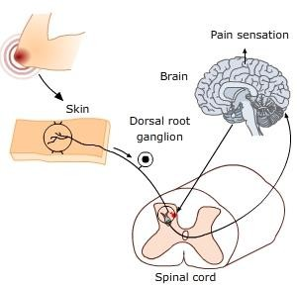

**Figure 1. Pain Sensation**

## PLANT PROFILE :-

Moringa oleifera (Moringaceae) is a highly valued plant, distributed in many countries of the tropics and subtropics. It is well known as the “Drumstick” or “horseradish” tree. The Moringa genus comprises 13 species distributed through southwest Asia, southwest Africa, northeast Africa and Madagascar. Among the 13 species, current research is limited to Moringa oleifera, Moringa stenopetala, Moringa Concanensis and Moringa peregrina. As the other species are endemic to Madagascar and Northeast Africa, they are being evaluated less as there is less exploration for naturally occurring bioactive substances in these locations. In contrast, Moringa oleifera which is native to india, is being studied widely.[2]

## 

## **Figure 2. Moringa oleifera Powder And leaves.**

The Moringa plant is a perennial, evergreen tree that grows up to 20 ft (6.1) tall, with a straight trunk with corky, whitish bark. The tree has tuberous taproot and brittle stem with corky bark. The leaves are pale green,compound, tripinnate, 30-60cm (11.8 to 23.6 in) in lengh, with many small leaflets.[6]

|  |  |
| --- | --- |
| **Characteristic** | **Description** |
| Colour | ColorFresh green (dark green on top, lighter underside) |
| Shape | Ovate or elliptical |
| Size | 1–2 cm long, 0.5–1 cm wide (leaflets) |
| Apex | Entire (smooth)Rounded or slightly pointed |
| Base | Rounded |
| Venation | Pinnate (midrib with secondary veins) |
| Texture | Smooth, soft, and delicate |
| Arrangement | Alternate and compound (imparipinnate) |
| Petiole | Slender, short, and slightly hairy |
| Odor | Characteristic, mild, and grassy |
| Taste | Slightly bitter and pungent |
| Surface | Upper surface glossy, lower surface dull |

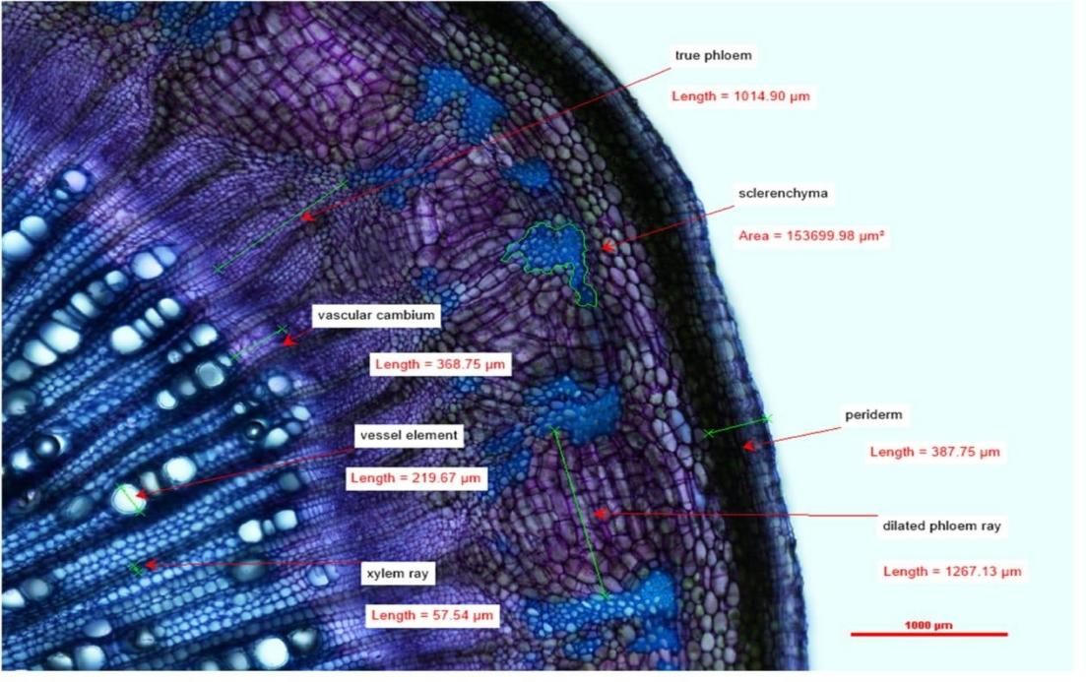

**Figure 3 :- Microscopic Structure of *Moringa olifera***

## **Medicinal properties of moringa oleifera:**-

The plant is considered as antidepressant, antimicrobial, antioxidant, antihyperglycemic, antitumor, an Arora DS, JM, Kuar H (2013). Bioprospecting of Moringa (Moringaceae): microbiological perspective. J. Pharmacog Phytochem, 1, 193-215. 14. Mishra G., et al. “Traditional uses, phytochemistry and pharmacological properties of Moringa oleifera plant: An overview”. Der Pharmacia Lettre 3.2 (2011): 141-164.ticancer, anticlastogenic, antiarrhythmic, antitonicity, reducing oxidative stress, increases protein contain in the liver, cardiovascular,Hepatoprotective,antiulcer,diuretic,antiulcer,antihelmithics,analegesic,antipyr etic analgesic[30]

## **Description of plant [31]**

Moringa Oleifera Lam. (M. Oleifera) is a cruciferous plant that belongs to the Moringaceae family. M. Oleifera is commonly called horseradish tree or drumstick tree by locals and is a popular staple in different parts of the world. M. Oleifera is consumed not only for its nutritional values but also its medical benefits.

## Binomial name

## **Synonyms:**

## Horseradish Tree,*Vahl Moringa pterygosperma*

## **Botanical description**

*Moringa oleifera* is a fast-growing, drought-resistant tree of the family Moringaceae, native to the Indian subcontinent and used extensively in South and Southeast Asia.

|  |  |
| --- | --- |
| Kingdom | Plantae |
| Order | Brassicales |
| Family | Moringaceae |
| Species | M.Oleifera |
| Genus | Moringa |

**Table 2. Botanical description**

**Vernacular classification:**

|  |  |
| --- | --- |
| Marathi | Shevga |
| Assamese | Saijana, sohjna |
| Gujarati | Midhosaeagavo, saeagavo |
| Sanskrit | Shobhanjana |
| Punjabi | Sainjna,soanjna |
| Tamil | Moringa,murungai |
| English | Drumstick,ben tree |

**Table 3. Vernacular classification**

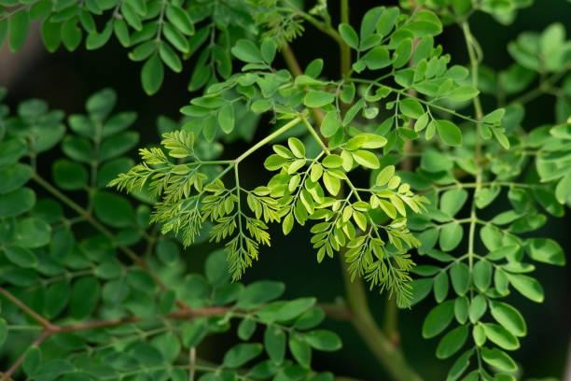

**Figure 4:-Moringa Oleifera Plant Leave**

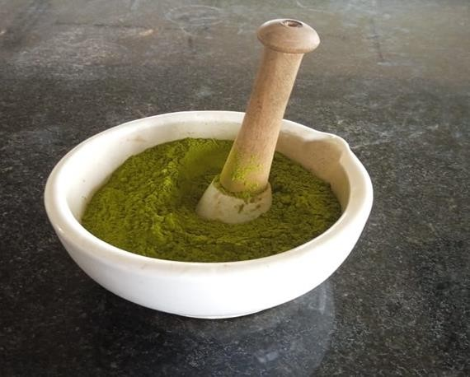

**Figure 5 :- Powder of Moringa Oleifera leaves**

**Drug profile :-**Drug Name – Aspirin

Chemical Name –Acetoxybenzoic Acid Molecular Formula –C9H8O4

Molecular Weight –180.158 g/mol Melting Point –135o C

Drug class – Non-steroidal anti-inflammatory drug (NSAID).

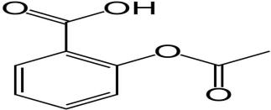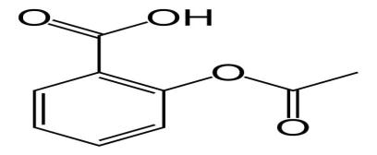

**Figure 6 :- Structure Of Aspirin**

# **MATERIALS AND METHOD :-**

**Materials :-** Powder form of Moringa Oleifera leaf.

**Drug :-** Aspirin.

|  |  |  |
| --- | --- | --- |
| Sr.no | Drug | Pharmacutical Industries |
| 1 | Aspirin | Oxford Lab Chem LLP .Vasai East,Mumbai,Maharahstra. |

**Solvent:** Ethanol, Methanol, distilled water, moringa oleifera leaves,etc.

**Instrument :** Eddy’s hot plate, string, Thermometer, stopwatch,etc.

**Equipment:** Disposal syringe, water bath, mechanical grinder, weighing balance, Beaker, Soxhlet apparatus, conical flask, glass rod ,etc.

**Animal**: Swiss Albino mice (35 - 40) of either sex procured for studying the ability of ethanolic extract and aqueous extract of moringa oleifera and Aspirin to check the analgasic activity on mice. .

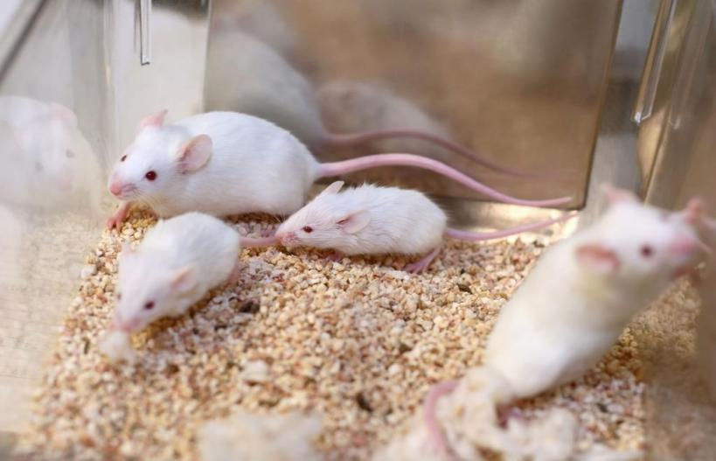

**Species** – mice. **Strain** – Wister. **Sex** - either sex. **Age** - 12-15 week.

**Body weight** - 35-40gm.

**Figure 7 :- Swiss Albino mice**

**Method of extraction**: By using soxlet apparatus sample collection and processing.

Preparation of moringa oleifera leaf extract.

**Method of analgesic activity detection:-** Eddy’s hot plate method .

## **Housing and keeping:-**

The animal was housed in six group comprising of three animals in each under standard laboratory condition of temperature (250 C) and 12/12hr light/dark cycle.

## **Diet and water:-**

Diet had free access to standard pellet diet and water ad libitum. The experimental protocol was approved by Institutional Animal ethics committee (IAEC) and the laboratory animals were taken care according to the guideline of CPCSEA, ministry of forest and Environmental (MoEF), government of India

## Collection and authentication of plant materials :-

*Moringa oleifera* leaves (family- Moringaceae) were collected from farm (Wai TQ. Mudhkhed) Dist. Nanded, (month: January2024). Authenticated on the date 14January N.E.S, Science College Nanded,Maharastra, India.

## Preparation of plant extract :-

The freshly collected leaves of Moringa oleifera were first washed with fresh water and then shed dried after the leaves of Moringa oleifera completely dried in shed under room temperature then were triturate to obtained its powered from. The size will reduce and made to coarse powder and then further passed through the appropriate sieve.

## Chemicals used :-

Aspirin was used as standard drug for evaluating the Analgesic activity. Aspirin was powdered and made into suspension in distilled water.

Aspirin (Oxford Lab Chem LLP .Vasai East,Mumbai,Maharahstra),

Aqueous extract of Moringa oleifera, Alcohol extract of Moringa oleifera.

# EXPERIMENTAL :-

## Extraction of plant material Selection of solvent:-

As per literature review & the nature of phytochemicals present in drug as well as on the basis of their polarity, the solvents were selected for the extraction of the leaves of moringa oleifera are – ethanol,distilled water .

## Selection of Extraction:-

Method According to the literature survey & nature of phytochemicals present in drug, the extraction method was selected. The extraction method selected for extraction from the leaves of moringa oleifera was continuous hot extraction method using Soxhlet apparatus. The method was selected for its efficiency. Factors which are considered for selection of extraction method were temperature, time, economy, completion of extraction etc. Out of these temperature is the rate-limiting factor for the extraction method. Constant temperature would increase the efficiency of the extraction by increasing the infusibility of the solvent. (V. Karadi, A. Shah et. al., 2011).

## Material used :-

Soxhlet apparatus, heating mental, powdered drug, Pet.Ether, Ethyl acetate, Methanol.

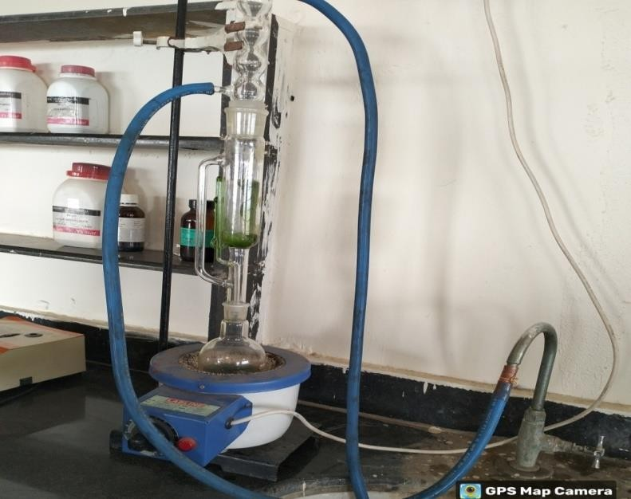

## **Figure 8 :- Extraction of plant material by using Soxhlet apparatus**

Extraction of leaves of moringa olifera was carried out by continuous hot extraction method in Soxhlet extractor. Firstly 200 gm of coarse powder of leaves of moringa olifera was extracted with 1300 ml of ethanol(60-800C) according to the standard method till colorless solution was observed in siphon tube. After completion of extraction extract was collected, cooled & solvent was allowed to evaporate in order to get ehanol (60-800C) extract.

The marc remained after petroleum ether (60-800C) extraction, was then extracted with Ethyl acetate. Ethyl acetate was taken in ml three times quantity of weight of marc. After completion of extraction, extract was collected, cooled & solvent was allowed to evaporate in order to get Ethyl acetate extract. After Ethyl acetate extraction, remaining marc was extracted with methanol in the same way as that of Ethyl acetate. All the extracts were stored in air tight container for further use.

**Method :**- ***Eddys Hot Plate Method.***

Twenty-four Albino mice of either sex, weighing 20- 30gram were selected for the experiment, and divided into 4 equal groups. To the mice of control group distilled water was given, for the standard group mice aspirin at the dose of 35mg/kg was given. And for the test groups, aqueous and ethanolic extracts were given at 100mg/kg dose.

They are then placed on the hot plate through the upper lid. Paws of mice are very sensitive to the temperature. Responses like jumping, withdrawal of the paws and licking of the paws were observed. By using a stop watch, reaction time for these responses to occur were noted. The animals were tested, and results were noted at 0, 30,60 and 90min. A constant temperature of 550C was maintained throughout the experiment. And the cut off time to prevent damage to the paws was 15sec

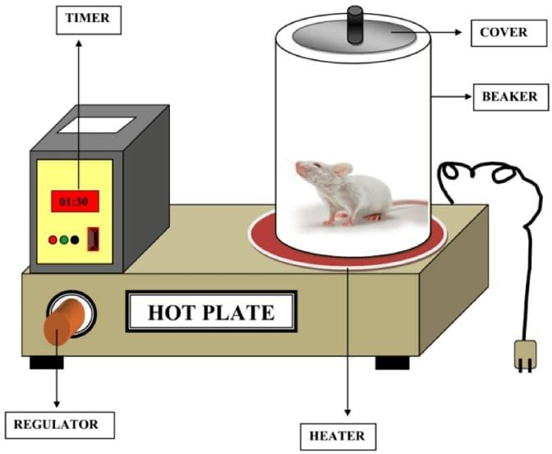

**Figure 9 :- Eddys Hot Plate.**

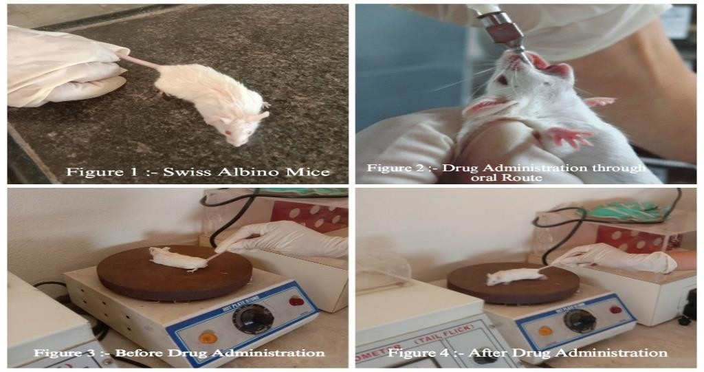

**Figure 10. Real time Experiment**

# RESULT :-

The effects of drugs on mice were observed and recorded as follows. Analgesic activity of the drugs was based on increase in the mean reaction times to the response for a noxious stimulus. Behavioural components like paw licking, jumping are observed as a response to the noxiou stimulus (hot plate) in terms of their reaction times.

**Table 4** :- : Mean reaction times expressed as mean ±standard deviation of different groups, at different time intervals.

|  |  |  |  |  |
| --- | --- | --- | --- | --- |
| **TIME**  **(In Minutes**) | **CONTROL** | **STANDARD**  **(Aspirin)** | **AQUEOUS EXTRACT**  **(Test 1st)** | **ETHANOLIC EXTRACT**  **(Test 2nd)** |
| 0 | 3.03±5 | 3.59±5 | 2.58±5 | 3.09±5 |
| 30 | 4.03±5 | 5.10±5 | 4.05±5 | 4.58±5 |
| 60 | 3.08±5 | 6.30±5 | 5.20±5 | 4.43±5 |
| 90 | 2.58±5 | 8.00±5 | 6.59±5 | 7.41±5 |

**Table 4. Observation Table**

# **DISCUSSION**

The leaves of Moringa oleifera have been found to contain phenolics and flavonoids.23,24 Five major flavonoids like gallic acid, chlorogenic acid, rutin, quercetin, and kaempferol are identified in the leaf extracts.25 These compounds have various biological activities, including analgesic, anti-inflammatory, antioxidant, anticarcinogenic, immunomodulatory, antidiabetic, antiatherogenic, and hepatoprotective functions . Based on the reported compounds isolated from M. oleifera leaves, several mechanisms of action related to those types of compounds could be used to explain the observed antinociceptive properties26. Flavonoids have also been proposed to inhibit the proinflammatory activity of enzymes involved in free radical production, such as cyclooxygenase, lipoxygenase or inducible nitric oxide synthase.27

In earlier studies, analgesic effects of Moringa were proved in ethanolic extracts of leaves. In the present study, two types of Moringa leaf extracts were chosen for the present study and the nociceptive properties of aqueous and ethanolic extracts of Moringa oleifera were assessed in thermal (i.e., hot-plate test) model of nociception and compared with aspirin. The increase in the reaction time in response to a drug, denotes analgesic effect of the drug. And the results of the Hot plate method were expressed as mean ±SD.28 Ethanolic group showed almost similar response like standard group but not as effective as standard. In other studies, it was proved that, ethanolic extracts of moringa have more flavonoids and other chemical components when compare to aqueous extracts because of more solubility. In the present study mice treated with ethanolic extract showed statistically significant mean reaction time compare to aqueous group.29

# CONCLUSION

Earlier studies proved the presence of flavonoids, saponins, tannins in the leaf extracts of Moringa oleifera, which indicates the nociceptive activity of the Moringa oleifera. In the present study, only one method is used. Further studies are essential to elucidate the detailed and other possible mechanisms of action for antinociceptive activities by using different analgesic models. Within the limitations of the present study it was found that aqueous and ethanolic leaf extracts of Moring oleifera possess antinociceptive activities. The plant has to be further explored for its phytochemical profile to identify the active constituent responsible for the above-mentioned activities.

# REFERENCES :-

1. Zulfiker AH, Mahbubur R, Kamal H, Hamid K, Mazumder ME, Rana MS. In vivo analgesic activity of ethanolic extracts of two medicinal plants — Scoparia dulcis L. and Ficus racemosa linn. Biol Med 2010;2:42-8.
2. Nur Zahirah Abd Rani, Khairana Husain and Endang Kumolosasi, Moringa genus: A Review of Phytochemistry and Pharmacology. Frontiers in pharmacology. Drug and Herbal Research 4. Fahey JW. A review of the medical evidence for its nutritional.
3. Fahey JW. A review of the medical evidence for its nutritional, therapeutic, and prophylactic properties: Part 1. Trees Life J 2005;1:5–15.
4. B.Vinoth, R. Manivasagaperumal and S. Balamurugan. Phytochemical Analysis and antibacterial activity of Moringa olifiera. International Journal of Research in Biological Sciences2012; 2(3): 98-102.
5. Vinı´cius M. Gadotti, Leonardo O. Schmeling, Cla´ udia Machado, Fernanda H. Liz, Valdir Cechinel Filho, Christiane Meyre-Silva and Adair R. S. Santos. Antinociceptive action of the extract and the flavonoid quercitrin isolated from Bauhinia microstachya leaves. JPP 2005, 57: 1345–1351.
6. Patel, A. S. Thakur, A Chandy and A. Manigauha. Moringa oleifera : A review of there Medicinal and Economical Importance to the Health and Nation. Drug Invention Today ISSN, 0975-7619. S. Patel, A. S. Thakur, A Chandy and A. Manigauha. Moringa oleifera : A review of there Medicinal and Economical Importance to the Health and Nation. Drug Invention Today ISSN, 0975-7619.
7. Rang HP, Dale MM, Ritter JM, Flower RJ, Henderson G. Rang and Dale’s pharmacology, 7th ed. London: Elsevier Churchill Livingstone; 2012. p. 106.
8. In: Jerry JB, editor. Methods of behaviour analysis in neuroscience, 2nd ed. New York: CRC Press; 2009. p. 108.
9. Vogel HG. Drug discovery and evaluation: Pharmacological assays, 3rd ed. New York: SpringerVerlag Berlin Heidelberg; 2008. p. 1103.
10. Woolfe G. MacDonald AD. The evaluation of the analgesic action of pethidine hydrochloride (DEMEROL). J Pharmacol Exp Ther 1944;80:300-5.
11. Deraedt R., Joughney S., Delevakee F. and Falhour M. Release of prostaglandin E and F in an algogenic reaction and its inhibition. Eur. J. Pharmacol.1980; 51: 17-24.
12. The Ayurvedic pharmacopoeia of India. 1st ed. New Delhi: Ministry of health and family welfare, Govt of India; 2004. p. 110-5.
13. Yadu ND, Shankhajit D, Ajoy KG. Evaluation of Analgesic activity of methanolic extract of Amorphophalus paeonifolius tuber by tail flick and acetic acid- induced writhing response method. Int J Pharm Biosci 2010;1:662-8.
14. Ghule RS, Venkatanarayan R, Thakare SP, Jain H, Ghule PR. Analgesic activity of Cuscuta campestris Yuncker a parasitic plant grown on Nerium indicum Mill. J Adv Pharm Educ Res 2011;1:45-51.
15. Ahmadiani A, Fereidoni M, Semnanian S, Kamalinejad M, Saremi S. Antinociceptive and antiinflammatory effects of Sambucus ebulus rhizome extract in rats. J Ethnopharmacology 1998;61:229-35.
16. Azim S. A. A., Abdelrahem M. T., Said M. M., Khattab A. (2017). Protective effect of Moringa peregrina leaves extract on acetaminophen -induced liver toxicity in albino rats. Afr. J. Trad. Complement. Altern. Med. 14, 206–216.
17. Medhi B., Khanikor H.N., Lahon L.C., Mohan P. and et al., Analgesic, antiinflammatory and local anaesthetic activity of Moringa in laboratory animals. Int.

J. Pharmacogn. 1996; 34: 3: 207-212.

1. Tende J.A., Ezekiel I., Dikko A.A.U. and Goji A.D.T. Effect of Ethanolic Leaves Extract of Moringa oleifera on Blood Glucose Levels of Streptozocin-Induced Diabetics and Normoglycemic Wistar Rats. Br. J. Pharm. Toxicol. 2011; 2:1: 1-4.
2. Raimunda samia Nogueira Brilhante, Jamille Alencar Sales, Vandbergue Santos Pereira. Research advances on the multiple uses of Moringa oleifera : A sustainable alternative for socially neglected population. ELSEVIER Asian Pacific Journal of Tropical Medicine.
3. Santosh Kumar Maurya and Anil Kumar Singh. Clinical Efficacy of Moringa oleifera stem bark in Urinary Tract Infections. International Scholarly Research Notices, Volume 2014. Ayurvedic pharmacy laboratory, Banaras Hindu University, Mirzapur 231001, India.
4. Chakaborty A, Devi RK, Rita S, Sharatchandra K, Singh TI. Preliminary studies on antiinflammatory and analgesic activities of Spilanthes acmella in experimental animal models. Indian J Pharmacol 2004;36:148–50.
5. Dharmasiri JR, Jayakody AC, Galhena G, Liyanage SS, Ratnasooriya WD. Anti- inflammatory and analgesic activities of mature leaves of Vitex negundo. J Ethnopharmacol 2003;82:199–278.
6. Mishra G, Singh P, Verma R, Kumar S, Srivastav S, Jha KK, Khosa RL. Traditional uses, phytochemistry and pharmacological properties of Moringa oleifera plant: An overview. Der Pharmacia Lettre. 2011;3(2):141-64.
7. Kumbhare M, Sivakumar T. Anti-inflammatory and analgesic activity of stem bark of Moringa oleifera. Pharmacologyonline. 2011;3:641-50.
8. Mensah JK, Ikhajiagbe B, Edema NE, Emokhor J. Phytochemical, nutritional and antibacterial properties of dried leaf powder of Moringa oleifera (Lam) from Edo Central Province, Nigeria. J Nat Prod Plant Res. 2012;2:107-12.
9. Sulaiman MR, Zakaria ZA, Bujarimin AS, Somchit MN, Israf DA, Moin S. Evaluation of Moringa oleifera aqueous extract for antinociceptive and antiInflammatory activities in animal models. Pharmaceutical Biology. 2008;46(12):838845.
10. Izzi V, Masuelli L, Tresoldi I, Sacchetti P, Modesti A, Galvano F, Bei R. The effects of dietary flavonoids on the regulation of redox inflammatory networks". Frontiers in Bioscience. 2012;17(7):2396-418.
11. Bhattacharya A, Agrawal D, Sahu PK, Kumar S, Mishra SS, Patnaik S. Analgesic effect of ethanolic leaf extract of moringa oleifera on albino mice. Indian J Pain. 2014;28:89- 94
12. Vongsak B, Sithisarn P, Mangmool S, Thongpraditchote S, Wongkrajang Y, et al. Maximizing total phenolics, total flavonoids contents and antioxidant activity of Moringa oleifera leaf extract by the appropriate extraction method Ind. Crops Prod. 2013;44:566-71.
13. Arora DS, Ons are JM, Kuar H (2013). Bioprospecting of Moringa (Moringaceae): microbiological perspective. J. Pharmacog Phytochem, 1, 193-215.
14. Mishra G., et al. “Traditional uses, phytochemistry and pharmacological properties of Moringa oleifera plant: An overview”. Der Pharmacia Lettre 3.2 (2011): 141-164.

**References**

1. A. Bonnaccorsi, “On the Relationship between Firm Size and Export Intensity,” Journal of International Business Studies, XXIII (4), pp. 605-635, 1992. (journal style)
2. R. Caves, Multinational Enterprise and Economic Analysis, Cambridge University Press, Cambridge, 1982. (book style)
3. M. Clerc, “The Swarm and the Queen: Towards a Deterministic and Adaptive Particle Swarm Optimization,” In Proceedings of the IEEE Congress on Evolutionary Computation (CEC), pp. 1951-1957, 1999. (conference style)
4. H.H. Crokell, “Specialization and International Competitiveness,” in Managing the Multinational Subsidiary, H. Etemad and L. S, Sulude (eds.), Croom-Helm, London, 1986. (book chapter style)
5. K. Deb, S. Agrawal, A. Pratab, T. Meyarivan, “A Fast Elitist Non-dominated Sorting Genetic Algorithms for Multiobjective Optimization: NSGA II,” KanGAL report 200001, Indian Institute of Technology, Kanpur, India, 2000. (technical report style)
6. J. Geralds, "Sega Ends Production of Dreamcast," vnunet.com, para. 2, Jan. 31, 2001. [Online]. Available: <http://nl1.vnunet.com/news/1116995>. [Accessed: Sept. 12, 2004]. (General Internet site)

**Author Profile**

**<Author Photo>**

**Taro Denshi** received the B.S. and M.S. degrees in Electrical Engineering from Shibaura Institute of Technology in 1997 and 1999, respectively. During 1997-1999, he stayed in Communications Research Laboratory (CRL), Ministry of Posts and Telecommunications of Japan to study digital beam forming antennas, mobile satellite communication systems, and wireless access network using stratospheric platforms. He now with DDI Tokyo Pocket Telephone, Inc.