**Introduction**

* Now a days, Maximum people really have a busy schedule. No one is actually taking of his/her Skin Care and decent immunity . This haphazard scene is creating a issue of many disease like Ringworm,Chicken Pox, Eczema, Scabies, Acne may cause because of bacterial, Parasitic and Viruses from which we considered Scabies. Scabies is considered an external parasite notorious for its high prevalence, causing severe and contagious skin lesions in humans and animals worldwide ( 1 - 6 ). Several species of scabies, including Demodex, Sarcoptes, Psoroptes, and Otodectes, infect hosts, including humans and animals (e.g., dogs, cats, and rabbits) ( 7 - 10 ). When it settles on the skin, it burrows and forms channels in the skin causing hair loss, itching, pustules, skin inflammation, and dark skin color (11 - 16). Nowadays, in order to eliminate and control the population of these microscopic organisms, chemical poisons, such as carbamates, organophosphate, and pyrethroid compounds, are used ( 17 - 19 ), which not only require daily and long-term application but also cause some side effects, such as itching, urticaria, angioedema, poisoning, central nervous system stimulation, depression, coma, and even death in some breeds, which has led to the prohibition of the use of some of these agents in some countries ( 20 ). In addition, the disproportionate use of these poisons has led to widespread resistance. The use of potentially safe botanical to replace injectable and oral drugs, sprays, synthetic insecticides, and pesticides without worrying about dosage would help protect the environment and is a practical step for the health of other living things ( 21 - 23 ).
* In recent years, numerous techniques have been employed to eliminate and control populations of microscopic organisms, such as scabies, which not only required daily and long-term applications but also caused side effects and even death in some breeds ( 19 - 22 ).
* To overcome from this disease we formulate a herbal anti-scabies soap which helps in preventing the causing agents of sacabies. Our Formulation is branded as “HERBIS SOAP”

**MOST COMMON SKIN DISEASE**

* Eczema
* Acne
* Rashes
* Scabies
* Chicken Pox
* Allergy
* Psoriasis
* Ringworm
* Dry Skin
* Wart
* Ulticarial
* Vitiligo
* Dermititis
* Melanoma

**SCABIES**

Scabies (also sometimes known as the seven-year itch) is a human skin infestation by the tiny (0.2–0.45 mm) mite Sarcoptes scabiei,[1][3] variety hominis. The word is from Latin: scabere, lit. 'to scratch'.[11] The most common symptoms are severe itchiness and a pimple-like rash. Occasionally, tiny burrows may appear on the skin. In a first-ever infection, the infected person usually develops symptoms within two to six weeks. During a second infection, symptoms may begin within 24 hours. These symptoms can be present across most of the body or just certain areas such as the wrists, between fingers, or along the waistline. The head may be affected, but this is typically only in young children. The itch is often worse at night. Scratching may cause skin breakdown and an additional bacterial infection in the skin.[2]

Newly formulated product performed by us to treat Scabies disease named as **Herbal Scabiecure soap.**

Ingredients contain in formulation :-

* Manjistha powder
* Karanj oil
* Tea tree oil
* Neem powder
* Tulsi powder
* Ritha powder
* Clove oil
* Vitamin E
* Chicory
* **Manjistha**

Scientific name :- Rubia cordifolia

Common name :- Manjistha in bengali, Manjith in hindi

Family :- Rubiaceae

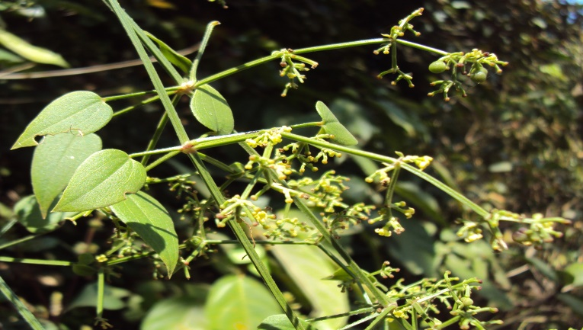

Fig Plant of Rubia Cordifolia

Uses :-

* It is used to treat skin disease like scabies.
* It is used to purify the blood.
* Its bark used as an natural hair dye.
* Its root is used as an food colorant.
* **Karanj**

Scientific name :- Millettia pinnata/ Pongamia pinnata

Common name :- Indian beech tree, Honge tree, Pongam tree

Family :-  Fabaceae

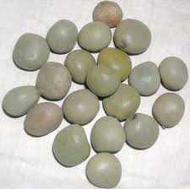

Fig. Seed of Millettia pinnata plant

Uses :-

* It is mainly used in treatment of skin disease like scabies, eczema.
* It contains many phytochemicals that have anti-inflammatory, anit-bacterial, anti-viral, and may others therapeutic properties
* It is also used in constipation.
* **Tea tree**

Scientific name :- Melaleuca alternifolia

Common name :- Melaleuca cajaputi

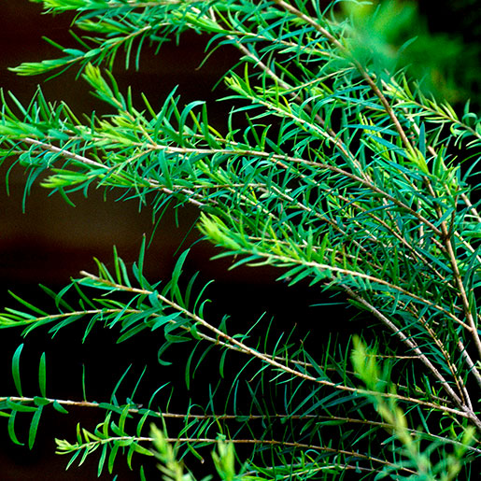Family :- Myrtaceae.

Fig. Plant of Tea Tree

Uses :-

* It is mainly used as an antimicrobial agents .
* It having properties to reduce acne and irritation of skin.
* It also helps to stronger the hair by cleaning the scalp.
* **Neem**

Scientific name :- Azadirachta indica

Common name :- Indian lilac, nim tree, margosa tree

Family :-  Meliaceae

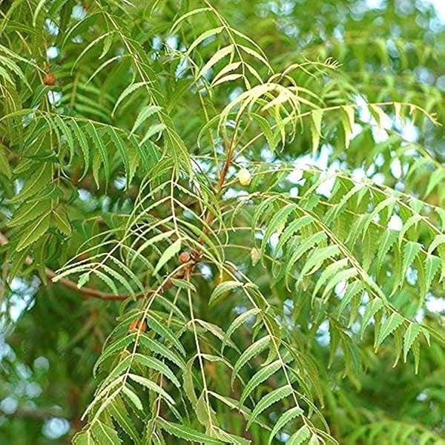

Fig. Plant of Neem Tree

Uses :-

* Neem has antibacterial properties that can reduce inflammation, infections, and other skin issues.
* It is also used in treating cancer.
* Neem leaves have antiseptic properties that can help heal wounds.

* **Tulsi**

Scientific name :- Ocimum sanctum

Common name :- Holy basil, Sacred basil

Family :- Labiatae

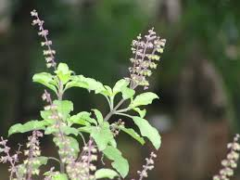

Fig. Plant of Ocimum sanctum

Uses :-

* Tulsi helps in acne treatment.
* Tulsi contain anti oxidant that can help prevent skin damage and sign of ageing like Wrinkles and dark spot.
* Tulsi anti biotic property that can help to treat skin infection.
* **Reetha seed powder**

Scientific name :- Sapindes mukorossi

Common name :- Soapberry, Soapnut,Washnut

Family :- Sapindaceae

