**BIOPROSPECTING AND MOLECULAR IDENTIFICATION OF *ACTINOMYCETES* SPECIESWITH BROADSPECTRUM ANTIBIOTICS PRODUCING POTENTIALS FROM DIFFERENT WASTE DUMPSITES IN ABAKALIKI EBONYI STATE**

**1Nweze Nwabueze P., 2Afiukwa Felicitas N., 3Afiukwa Celestine A. and 1Ogah Onuchekwa**

1Department of Biotechnology, Faculty of Science, Ebonyi State University, P.M.B. 053 Abakaliki, Nigeria

2Department of Applied Microbiology, Faculty of Science, Ebonyi State University, P.M.B. 053 Abakaliki, Nigeria

3Department of Biotechnology, Faculty of Biological Sciences, Alex Ekwueme Federal University, Ebonyi State, P.M.B. 1010 Abakaliki, Nigeria

**Corresponding Author:** [nwabuking36@gmail.com](mailto:nwabuking36@gmail.com)

**ABSTRACT**

The evolution of new strains of infectious agents and the increased prevalence of multidrug-resistant pathogens have become a global threat to public health. Hence, this study was carried out to bioprospect for Actinomycetes species from refuse dumpsites in Abakaliki for broadspectrum antibiotics producing potentials. A total of 40 dumpsites were sampled and 68 Actinomycetes isolates were obtained using Actinomycetes Isolation Agar. The antimicrobial-producing potentials of the isolates were tested against six lab strains of human pathogens including *E. coli, S. aureus,* MRSA, ESBL+ *E. coli, Candida albicans* and *Klebsiella* species. Ten of the isolates showing greater broadspectrum antibiotic activities were selected for true-to-type identification based on their 16S rRNA gene sequences amplified using a set of primers (F-Act 243 (5'-GGATGAGCCCGCGGCCTA-3') and R-Act A3 (5'-CCAGCCCCACCTTCGAC-3')). The colony count of the isolates ranged from 0.2x106±0.5x103 to 14.8x106±0.7x103 *CFU/g* across the dumpsites. Their inhibition zone diameter ranged from 0 to 25mm against *E. coli,* 0 to 35 mm against *S. aureus,* 0 to 38mm against MRSA, 0 to 28mm against ESBL+ *E. coli,* 0 to 40mm against *C. albicans* and from 0 to 25mm against *Klebsiella* species. Thegelresult of the amplified 16sRNA gene of theisolates showed two distinct bands of 1.4 kb and 3 kb. About 70% of the isolates profiled had sequence similarity values ranging from 78.75% to 99.51% to already known Actinomycetes species on NCBI database while the remaining 30% may be novel Actinomycetes species. Phylogenetic result based on their 16S rRNA gene sequences grouped the isolates into 3 main clusters with the novel Actinomycetes being clustered close to each other. This study was able to identify novel Actinomycetes species with broadspectrum antibiotics producing potentials. These promising isolates can be further studied and exploited in the fight against multidrug resistant pathogens.

**Keywords:** *Abakaliki/ Actinomycetes/ antibiotics/ Multidrug-resistance/ Refuse dumpsites*

**1.0 Introduction**

Antibiotics are secondary metabolites produced by microorganisms which possess the peculiar properties of inhibiting the growth of other microorganisms. According to Elma *et al.* (2016) and Cherif *et al.* (2008), these metabolites have been implicated to be responsible for regulating and controlling microbial populations in the soil, compost and water. Many microbial species has the ability to produce microorganisms naturally via biosynthetic pathways. The commercial exploitation of different microorganisms for the production of antibiotics began after penicillin was discovered by Alexander Flemming, followed by the works of Florey and Chain in 1938. Similar to the discovery of penicillin, some other antibiotics were also discovered by happenstance (Bisacchi, 2015). Most antibiotic substances are toxic in nature and only a few find any use in medicine for the treatment of multiple ailments/diseases since they possess a high margin of safety or therapeutic window. Methods of antibiotics production can be by natural fermentation, semi-synthetic, or synthetic process. Based on their range of activities antibiotic substances can be classified into narrow spectrum, moderate spectrum, narrow-broad spectrum, broad spectrum and anti-mycobacterial antibiotics (Etebu and Arikekpa, 2016).

In the past two decades, there have been global outbreak of new forms of infectious organisms which are resistant to conventional antibiotics. The world has also witnessed the widespread of multiple antibiotic resistant strains of previously known pathogens. Infact, antimicrobial resistance (AMR) has now become a global threat, reducing the possibilities for preventing and treating infectious diseases caused by viruses, bacteria, parasites and fungi (Jim, 2014; WHO, 2021). A World Health Organization (WHO, 2021) report indicated an increase of morbidity and mortality caused by infectious diseases due to AMR. It is estimated that as high as 700,000 global deaths are attributed to antimicrobial resistance, with a potential leap to 10 million in 2050 (Jim, 2014). Just between the year 2013 and 2020, there have been emergence and spread of deadly infectious diseases such as Lassa fever, Ebola virus disease, meningitis and Covid-19 pandemics in different parts of the globe. These emerging diseases together with other known multidrug resistant pathogens have become major threat to public health globally. Antimicrobial resistance (AMR) is a response of microorganisms against antimicrobial compounds.

Different soil-living bacteria are known to produce secondary metabolites that suppress other microorganisms competing for the same resources (Velayudham and Murugan, 2012). Actinomycetes are the most widely distributed microbes inhabiting the soil environment. They have been reported to comprise of about 50 % of the uncultivable soil microbes and therefore, form the most dominant and significant group among the soil microbial community (Rotich *et al.,* 2017; Waithaka *et al.,* 2017). Actinomycetes are known to secrete different valuable secondary metabolites including antibiotics, nutritional materials, cosmetics, and enzymes. Approximately two-thirds of the commercially available antibiotics are from Actinomycetes, most of which are from the genera Actinomyces and Micromonospora (Pandey *et al.,* 2011). *Actinomycetes* is a well-known genus of *Actinobacteria* which is the largest number of species and varieties in nature. Soil is the main source of *Actinomycetes,* although this group of bacteria can be found in aquatic habitats, they are mainly transient in nature in aquatic habitat (Takahashi and Omura, 2003). The genus *Actinomycetes* has become very important for the production of antibiotics in treating human and almost all *Actinomycetes* species have been proved to be antibiotic producers (Rotich *et al.,* 2017), hence, this study was aimed at isolating *Actinomycetes* species with novel but broadspectrum antibiotic producing potentials from soil samples collected from waste dumpsites in Abakaliki, Nigeria.

**2.0 Materials and Methods**

**2.1 Study Area**

The study was carried out in Abakaliki, the capital city of the present-day Ebonyi State in Southeast Nigeria. It is situated 64 kilometres (40 mi) southeast of Enugu (Hoiberg, 2010). Its geographical coordinate is 6.3231° N, 8.1120° E. The inhabitants are primarily members of the Igbo nation (Oriji, 2011).

**2.2 Collection and processing of soil samples**

A total of forty (40) soil samples were randomly collected at a depth of approximately 10 – 16 cm from the surface of the soil where *Actinomycetes* are abundant according to Chaudhary *et al.* (2013). The soil samples were scooped using a sterile spoon from the designated dumpsites and put in labeled sterile sample bags. The sampled locations are listed in Table 1. The soil samples were processed by air-drying at room temperature for two weeks to reduce the population of gram negative bacteria (Jeffrey, 2008).

**2.3 Isolation, Culture of *Actinomycetes* species and Microbial count determination**

*Actinomycetes* species were isolated from the soil samples following the serial dilution method (Gebreselema *et al*., 2013). Exactly 1 g of each soil sample was dissolved in 9 mL of sterile water and 1 mL transferred to subsequent tube containing 9 mL of sterile water until the 5th dilution. Then, 0.5 mL of the 5th dilutions of each soil sample was pipetted using sterile syringe and dispensed evenly on freshly prepared Actinomycetes Isolation Agar (AIA) plate. The plates were incubated at 30 ˚C for 24 hours and observed for growth of *Actinomycetes*. Distinct colonies were counted and the total microbial count (colony forming units) estimated using the formula below.

$cfu/ml =\frac{No. of colonies x dilution factor}{volume of culture plate}$

The distinct colonies were counted, then picked and sub-cultured for purity by streaking on freshly prepared Actinomycetes Isolation Agar. Pure colonies were then aseptically inoculated into 5 mL of nutrient broth and allowed to grow for 10 days.

**2.5 Identification of *Actinomycetes* isolates**

The isolates were identified following standard microbiology procedures as follows;

**2.5.1 Morphological identification of the *Actinomycetes* isolates**

The isolates were identified by their morphology such as their chalky, firm and leathery texture as described by Rao *et al.* (2012).

**2.5.2 Gram staining**

Gram staining was conducted to differentiate the isolates into Gram positive and Gram negative bacteria. A smear of each of the isolates were made on sterile glass slide and was allowed to air dry. The smears were heat-fixed by passing it through Bunsen burner flame and then flooding with crystal violet for about 60 seconds. A mordent, lugols Iodine was added to help cell wall of the bacteria absorb the dye. Another dye, safranin was applied as secondary dye. After which, the slides were blotted dry and viewed under the microscope using x100 objective lens (Cappuccino and Sherman, 2002).

**2.5.3 Biochemical characterization of the *Actinomycetes* isolates**

**2.5.3.1 Catalase test**

A sterile loop was used to transfer a small amount of each bacteria colony in the surface of a clean, dry sterile glass slide. Then, a drop of 3 % H2O2 was placed in the glass slide. The presence or absence of air bubble indicates positive or negative isolate, respectively (Cappuccino and Sherman, 2002).

**2.5.3.2 Coagulase test**

Glass slides were divided into two sections with grease pencil. One end was labeled as “test” and the other as “control. A small drop of distilled water was place on each area. Each colony of the *Actinomycetes* isolates were emulsified on each drop to make a smooth suspension. The test suspension was treated with a drop of plasma and mixed well with a needle. The control suspension serves to rule out false positivity due to auto agglutination. The presence of clumping within 5-10 seconds was taken as positive (Cappuccino and Sherman, 2002).

**2.5.3.3 Indole test**

The *Actinomyces* isolates were inoculated in a test tube containing 5 mL of sterile tryptone water. This was then incubated at 35-37 oC for 48 hours. Exactly 0.5 ml of Kovac’s reagent was added. A positive result was shown by the presence of a red or red-violet color in the surface alcohol layer of the broth, while yellow color indicates negative result (Bachoon and Wendy, 2008).

**2.5.3.4 Oxidase test**

A piece of filter paper was placed into a clean petri dish and 2 to 3 drops of freshly prepared oxidase reagent was added (Tetramethy_p_ phenylenediamine dihydrochloride). Using a glass rod, a colony of the test isolate was collected and smeared on the filter paper. The development of blue – purple color within a few seconds indicates oxidase positive (Isenberg, 2004).

**2.5.3.5 Citrate utilization test**

Simmons citrate agar slant was prepared and was streaked back and front with a light inoculum picked from the center of a well isolated colony. It was incubated aerobically at 35-37oC for 48 hours. Color change from green to blue along the slant indicated citrate utilization positive isolates (Cappuccino and Sherman, 2002).

**2.6 Preparation of 0.5 McFarland Turbidity Standard**

Turbidity standard equivalent to 0.5 McFarland was prepared by inoculating each of the test organisms into 5 mL of freshly prepared nutrient broth. This was allowed to stand for 15 minutes and the reaction mixture mixed well to form 0.5 McFarland turbidity standard.

**2.7 Screening for *Actinomycetes*** ***isolates* with antimicrobial activities**

The culture broth was used for antimicrobial screening using Agar Disc Diffusion method as described by Kirby-Bauer (1979). Sterilized cork borer was used to bore wells (6 mm in diameter) on Mueller Hinton Agar inoculated with the test microorganisms’ equivalent to 0.5 McFarland standard and the wells were impregnated with 10 days old culture broth. The plates were then incubated at 37 ˚C for 24 hours. Isolates with antimicrobial activity were identified by the presence of inhibition zone around the wells, while the level of activity were determined by measuring the inhibition zone diameter (Kirby-Bauer, 1979). Conventional antibiotics were used as positive controls namely: Chloramphenicol (30 μg) for bacteria and fluconazol (2 μg) for *Candida albicans.* The isolates that showed antimicrobial activity were further screened for activity against Extended Spectrum BetaLactamase(ESBL) positive *E. coli* and *Klebsiella* species also using Kirby-Bauer disc diffusion technique.

**2.8 Confirmatory Molecular Identification of *Actinomycetes* Isolates**

Pure cultures of the *Actinomycetes*isolates with broad spectrum antimicrobial activities were freshly sub-cultured broth culture for 24 hours. Then the overnight culture was centrifuged at 3000rpm for 10 minutes and the pellet used for DNA extraction.

**2.8.1 Extraction of Genomic DNA**

The extraction process was based on Qiagen DNA Extraction kit protocol. The extracted DNA samples were further amplified in a PCR machine.

**2.8.2 PCR Amplification of the *Actinomyces* DNA samples**

The extracted genomic DNA sample from each isolate was used as a template for amplification of 16S rRNA gene. The 16S rRNA gene is a conserved gene in the bacteria (Kumar *et al.,* 2010). The full length of the 16S rRNA gene sequence was amplified using the specific pair of primers; F-Act 243 (5'-GGATGAGCCCGCGGCCTA-3') and R-Act A3 (5'-CCAGCCCCACCTTCGAC-3') as described by Monciardini *et al.* (2002). A final reaction volume of 50 μl was prepared containing; 1 μL of genomic DNA, 5 μL of 10x Genescript Taq Buffer containing MgCl2, 3 μL of 2.5 mM dNTPs, 0.4 μL of 20 mg/mL BSA, 0.5 μl of 5U Genescript Taq polymerase and 1 μL of 20 pmole of each primer. Amplification was carried out at 95oC for 10 min, followed by 35 cycles of 94oC for 1 min, 60oC for 1 min and 72oC for 2 min with a final extension at 72oC for 10 min. The PCR amplification products were separated by electrophoresis in 2% (w/v) agarose gels stained with ethidium bromide.

**2.8.3 Sequencing of the amplified 16S rRNA gene**

The PCR products were purified using the QIAquick® PCR purification Kit from Qiagen and sequenced using Applied Biosystem DNA sequencer. The primers used in amplification were also used in sequencing of both forward and reverse strands. The consensus sequence of both forward and reverse sequence, was generated for each amplicon using BioEdit software aligner (Hall, 1999).

**2.9 Statistical Analysis**

The antimicrobial activities data were analyzed using one way ANOVA to compare the level of significance between the isolates’ antimicrobial activities and that of the control drug (p<0.05) using SAS software version 9. The 16S rDNA sequences generated were compared to sequences in the NCBI GenBank database using the Basic Alignment Search Tool (BLAST). Phylogenetic or molecular evolutionary analysis was conducted using MEGA version 6 (Tamura *et al.,* 2013). The sequences were also aligned using the MUSCLE program against the nearest neighbours and the evolutionary history was inferred using the Neighbor-Joining method as described by Saitou and Nei (1987). Evolutionary distance was computed using Maximum Composite Likelihood model of Tamura *et al.* (2004). Bootstrap consensus tree inferred from 1000 replicates as described by Felsenstein (1985) was used to represent the evolutionary history of the taxa analyzed.

**3.0 Results**

**3.1 Relative Abundance of Actinomycetes in the refuse dumpsites**

The result of the colony count expressed as colony forming units showed that out of the 40 dumpsites sampled, sample 39 from Ishieke dumpsite recorded the highest colony counts (14.8x106±0.7x103 *cfu/g*) followed by sample 13 from Haraca (13.8x106±1.3x102 *cfu/g*), samples 2 and 27 from Azuegu Mgbabor and Ogoja road respectively recorded 12.8x106±0.5x103 *cfu/g* and 12.8x106±0.3x103. Samples 19, 11 and 18 from Presco dumpsite, Abakaliki rice mill dumpsite 3 and Presco market recorded 12.4x106±2.3x102 *cfu/g*, 12.2x106±2.1x103 *cfu/g* and 12.0x106±2.5x103 *cfu/g* respectively. However, samples 7 (Presco campus, CO2), 32 and 33 from Azuiyiokwu and St. Theresa Catholic Church or ???? recorded the least number of colonies of 0.2x106±0.5x103 *cfu/g,* 1.4x106±0.6x102 *cfu/g* and 1.6x106±1.0x102 *cfu/g* respectively as shown in Figure 1. The representative plates of colony formed on ActinomycesIsolation Agar plates is shown in Plate 1.

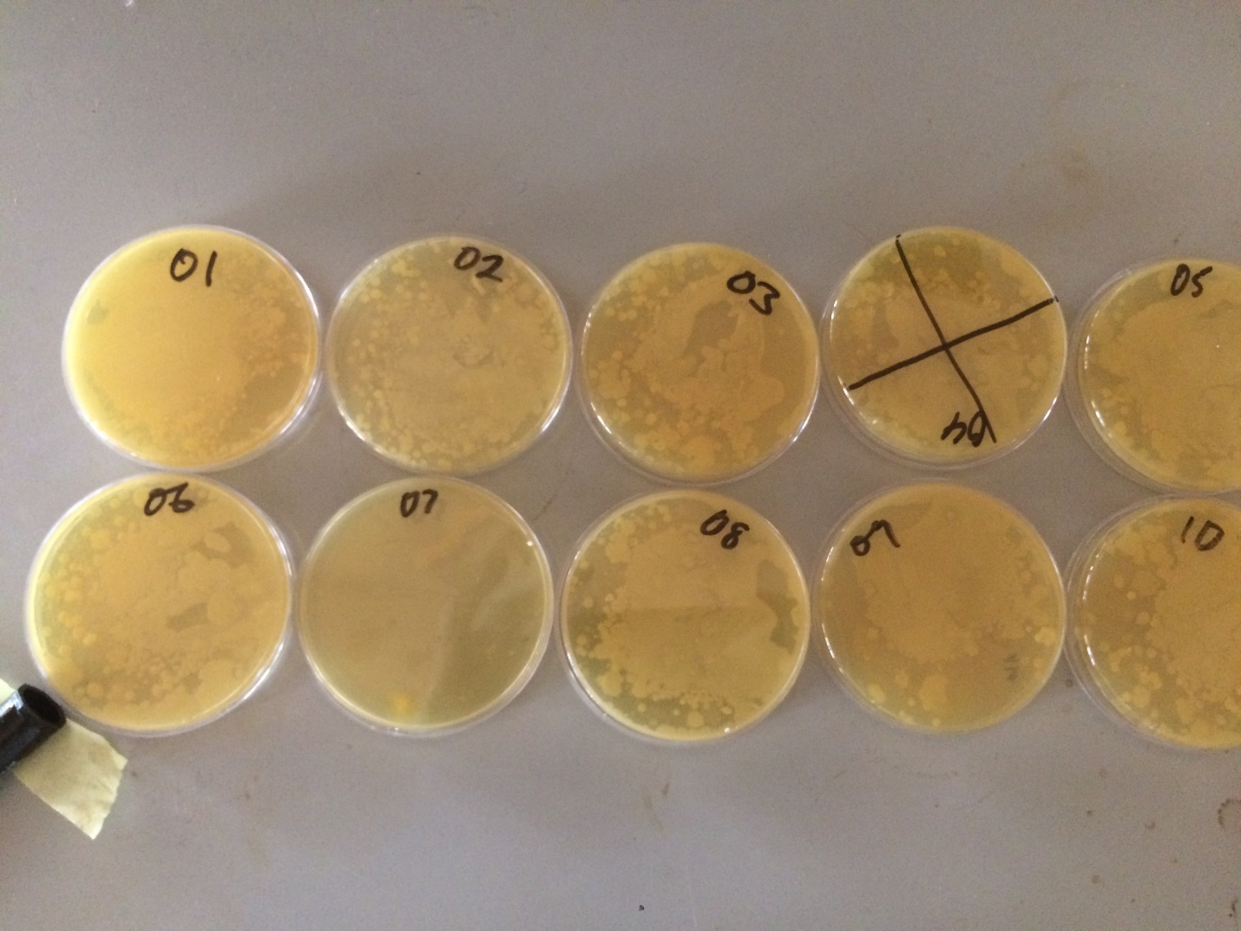

**Plate 1: Colonies formed on Actinomyce Isolation Agar plate**

Figure 1: Number of colonies formed per soil sample collected from different waste dumpsites

**Note:**. The sample serial number, sample name and name of location is presented in Table 1

**Table 1: Information of sample sources**

|  |  |  |
| --- | --- | --- |
| **S/No** | **Sample** | **Name of dump location** |
| 1 | Smpl 1 | Compound Refuse Dump |
| 2 | Smpl 2 | Nwibo N. Street |
| 3 | Smpl 3 | CAS dump1 |
| 4 | Smpl 4 | CAS dump2 |
| 5 | Smpl 5 | Abakaliki Rice mill1 |
| 6 | Smpl 6 | Abakaliki Rice mill2 |
| 7 | Smpl 7 | Presco Campus1 |
| 8 | Smpl 8 | Presco Campus2 |
| 9 | Smpl 9 | Akudo Farm |
| 10 | Smpl 10 | Presco Dump3 |
| 11 | Smpl 11 | Abakaliki Rice mill3 |
| 12 | Smpl 12 | Iboko Rice mill1 |
| 13 | Smpl 13 | Haraca 1 |
| 14 | Smpl 14 | Mgbabor Primary School |
| 15 | Smpl 15 | St. Theresa's Cathedral Ai |
| 16 | Smpl 16 | St. Benedict waste bin |
| 17 | Smpl 17 | St. Luke's |
| 18 | Smpl 18 | Presco market |
| 19 | Smpl 19 | Oversea hostel |
| 20 | Smpl 20 | Onueke Rice mill |
| 21 | Smpl 21 | Onueke Dumpsite |
| 22 | Smpl 22 | Haraca 2 |
| 23 | Smpl 23 | Highway Dump |
| 24 | Smpl 24 | Ahiaofu1 |
| 25 | Smpl 25 | Ahiaofu butcher Dump |
| 26 | Smpl 26 | Isiukwuator Street |
| 27 | Smpl 27 | Ogoja Road |
| 28 | Smpl 28 | Cmpton hostel |
| 29 | Smpl 29 | Holyland lodge |
| 30 | Smpl 30 | Ebonyi Hatchery |
| 31 | Smpl 31 | Behind Presco campus |
| 32 | Smpl 32 | Azuiiyikwu |
| 33 | Smpl 33 | St. Theresa's Cathedral Ai2 |
| 34 | Smpl 34 | Kpiri-kpiri Dump |
| 35 | Smpl 35 | Ogbaga Rd |
| 36 | Smpl 36 | Azugwu CAS |
| 37 | Smpl 37 | Haraca Axis |
| 38 | Smpl 38 | Isiukwuator Street2 |
| 39 | Smpl 39 | Isieke1 |
| 40 | Smpl 40 | Isieke2 |

**3.2 Morphological characteristics of the isolated Actinomycetes isolates**

A total of 68 Actinomycetes species were isolated from the waste dump samples. The morphological appearance of the different isolates after growing for 24 hours on Actinomyces Isolation Agar medium revealed colours ranging from white, chalky–white, yellow, creamy or shiny yellow, golden yellow, yellow to dull yellow as shown in Plate 2.The textures of the aerial mycelium of the isolates were hard to scrap except for a few which were easier to collect. Some of the *Actinomyces* isolates also had highly intertwined hyphae while others showed clusters and chains of spores. This is not clear. Now that you have samples 1 to 40, which of the samples exhibited which morphological characteristics? You can present this in a table showing clearly the morphological characteristics of each isolate.

**Biochemical characteristics of the isolated *Actinomyces* species**

The result of the biochemical tests carried out on the isolates showed that all the isolates were Gram positive, catalase positive, oxidase positive and indole negative while all, except isolates 3, 7, 18 and 28, were positive to starch hydrolysis (Table 2).

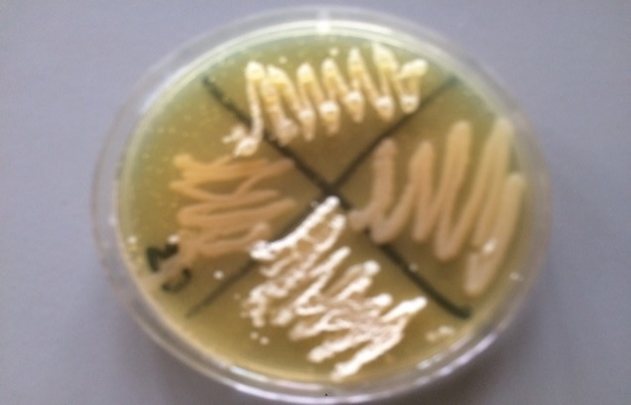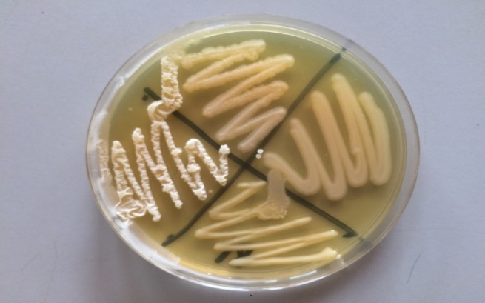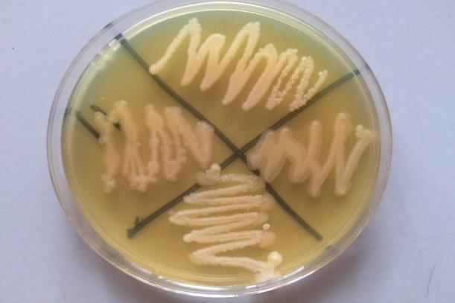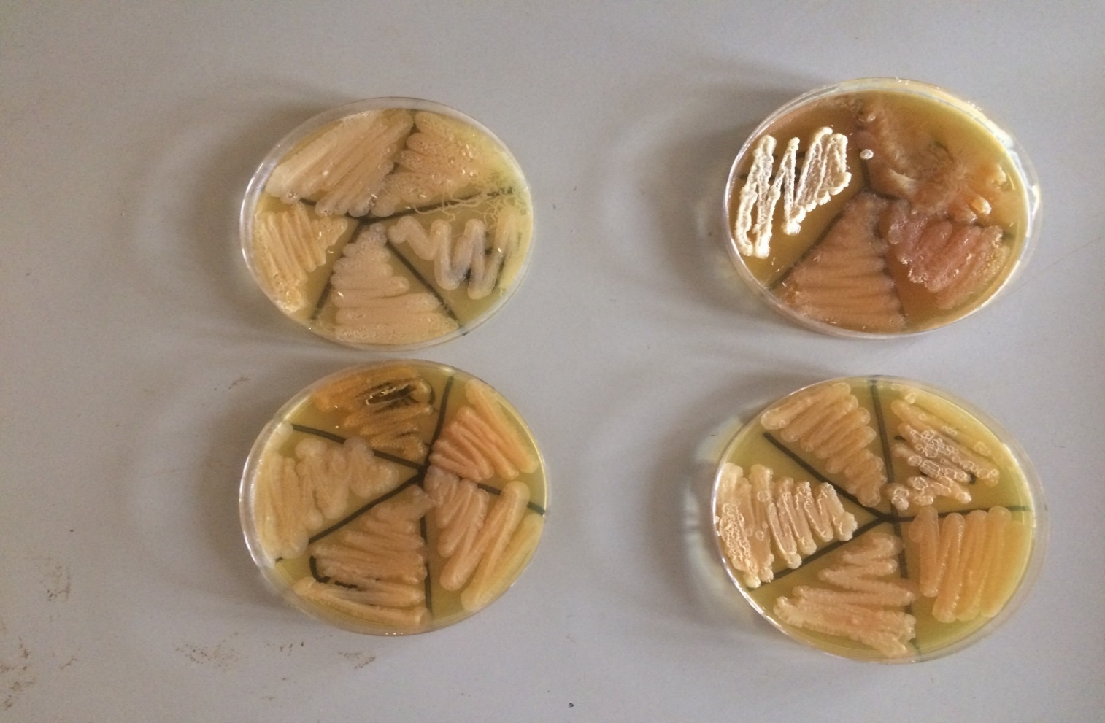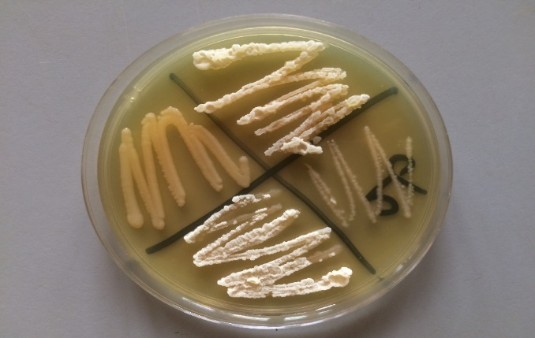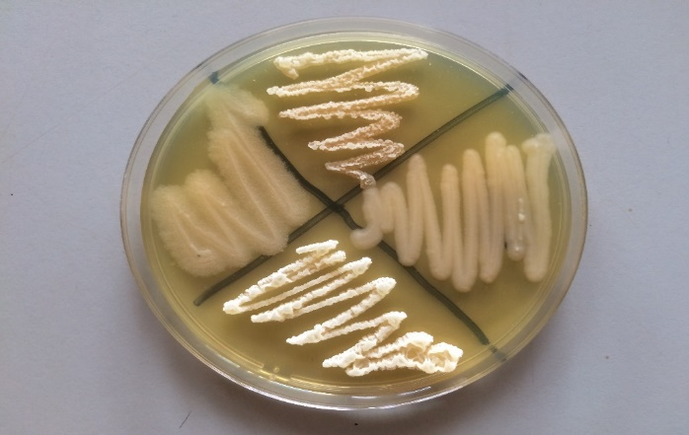

**Plate 2: Morphological Appearance of ActinomycetesIsolates on Actinomycetes Isolation Agar**

**Table 2: Morphological and biochemical characteristics of Actinomycetes isolates from refuse dumpsites in Abakaliki, Nigeria**

|  |  |  |  |  |  |  |
| --- | --- | --- | --- | --- | --- | --- |
| **Isolate** | **Gram staining** | **Morphology** | **Calatase** | **Indole** | **Starch hydrolysis** | **Citrate** |
| 1 | +ve | Long rod, white spore forming | +ve | -ve | -ve | +ve |
| 2 | +ve | Long rod, white spore forming | +ve | -ve | -ve | +ve |
| 3 | +ve | Long rod, cluster of hyphae | +ve | -ve | -ve | +ve |
| 4 | +ve | Smooth, yellow, non-spore forming | +ve | -ve | +ve | +ve |
| 5 | +ve | Short rod | +ve | -ve | +ve | +ve |
| 6 | +ve | Golden color, white spores | +ve | -ve | -ve | +ve |
| 7 | +ve | Rod shape, cluster of hyphae | +ve | -ve | -ve | +ve |
| 8 | +ve | Rod, Chained hyphae | +ve | -ve | +ve | +ve |
| 9 | +ve | Grouped and single spores | +ve | -ve | -ve | +ve |
| 10 | +ve | Long branching hyphae | +ve | -ve | +ve | +ve |
| 11 | +ve | Long branching hyphae | +ve | -ve | +ve | +ve |
| 12 | +ve | Smooth, yellow, non-spore forming | +ve | -ve | +ve | +ve |
| 13 | +ve | Smooth, yellow, non-spore forming | +ve | -ve | +ve | +ve |
| 14 | +ve | Grouped and single spores | +ve | -ve | -ve | +ve |
| 15 | +ve | Creamy white with spores | +ve | -ve | +ve | +ve |
| 16 | +ve | Chalky white with spore | +ve | -ve | +ve | +ve |
| 17 | +ve | Creamy white with spores | +ve | -ve | +ve | +ve |
| 18 | +ve | Golden color, white spores | +ve | -ve | -ve | +ve |
| 19 | +ve | Golden color, white spores | +ve | -ve | -ve | +ve |
| 20 | +ve | Short rod, white mycelium | +ve | -ve | +ve | +ve |
| 21 | +ve | Short rod | +ve | -ve | +ve | +ve |
| 22 | +ve | Short rods with spores | +ve | -ve | +ve | +ve |
| 23 | +ve | Short rods with spores | +ve | -ve | +ve | +ve |
| 24 | +ve | Deep yellow, without spore | +ve | -ve | +ve | +ve |
| 25 | +ve | Long branching hyphae | +ve | -ve | +ve | +ve |
| 26 | +ve | Long branching hyphae | +ve | -ve | +ve | +ve |
| 27 | +ve | Short rod | +ve | -ve | +ve | +ve |
| 28 | +ve | Short rod | +ve | -ve | +ve | +ve |
| 29 | +ve | Grouped and single spores | +ve | -ve | -ve | +ve |
| 30 | +ve | Grouped and single spores | +ve | -ve | -ve | +ve |
| 31 | +ve | Short rods with spores | +ve | -ve | +ve | +ve |
| 32 | +ve | Chalky white, branched hyphae with spores | +ve | -ve | +ve | +ve |
| 33 | +ve | white, branched hyphae with spores | +ve | -ve | +ve | +ve |
| 34 | +ve | Golden colored rod, aerial mycelium | +ve | -ve | +ve | +ve |
| 35 | +ve | Creamy white with spores | +ve | -ve | +ve | +ve |
| 36 | +ve | Creamy white with spores | +ve | -ve | +ve | +ve |
| 37 | +ve | Creamy white with spores | +ve | -ve | +ve | +ve |
| 38 | +ve | Branched hyphae with spores | +ve | -ve | +ve | +ve |
| 39 | +ve | Smooth, yellow, non-spore forming | +ve | -ve | +ve | +ve |
| 40 | +ve | Short rod, white mycelium | +ve | -ve | +ve | +ve |
| 41 | +ve | Smooth, yellow, non-spore forming | +ve | -ve | +ve | +ve |
| 42 | +ve | Smooth, yellow, non-spore forming | +ve | -ve | +ve | +ve |
| 43 | +ve | Long branching hyphae | +ve | -ve | +ve | +ve |
| 44 | +ve | Creamy yellow | +ve | -ve | +ve | +ve |
| 45 | +ve | Chains of spores | +ve | -ve | +ve | +ve |
| 46 | +ve | Yellow colonies with shiny mycelia | +ve | -ve | +ve | +ve |
| 47 | +ve | Yellow with shiny mycelia | +ve | -ve | +ve | +ve |
| 48 | +ve | Yellow with shiny mycelia | +ve | -ve | +ve | +ve |
| 49 | +ve | Golden colored rod, aerial mycelium | +ve | -ve | +ve | +ve |
| 50 | +ve | Creamy white with spores | +ve | -ve | +ve | +ve |
| 51 | +ve | Chalky white with spore | +ve | -ve | +ve | +ve |
| 52 | +ve | Creamy/opaque yellow | +ve | -ve | +ve | +ve |
| 53 | +ve | Creamy yellow with mycelium | +ve | -ve | +ve | +ve |
| 54 | +ve | Creamy yellow | +ve | -ve | +ve | +ve |
| 55 | +ve | Creamy yellow | +ve | -ve | +ve | +ve |
| 56 | +ve | Golden yellow, no mycelium | +ve | -ve | +ve | +ve |
| 57 | +ve | Golden yellow, no mycelium | +ve | -ve | +ve | +ve |
| 58 | +ve | Chalky white with spore | +ve | -ve | +ve | +ve |
| 59 | +ve | Chalky white with mycelia | +ve | -ve | +ve | +ve |
| 60 | +ve | Deep yellow | +ve | -ve | +ve | +ve |
| 61 | +ve | Golden yellow | +ve | -ve | +ve | +ve |
| 62 | +ve | Golden yellow | +ve | -ve | +ve | +ve |
| 63 | +ve | Golden yellow | +ve | -ve | +ve | +ve |
| 65 | +ve | Chalky white with spore | +ve | -ve | +ve | +ve |
| 66 | +ve | Smooth, yellow, non-spore forming | +ve | -ve | +ve | +ve |
| 67 | +ve | Smooth, yellow, non-spore forming | +ve | -ve | +ve | +ve |
| 68 | +ve | Chalky white with spore | +ve | -ve | +ve | +ve |

**3.3 Broad spectrum Antimicrobial activities of the ActinomycetesIsolates**

The result of the analysis of the isolated 68 Actinomycetes for broad spectrum antimicrobial activities showed that all the isolates had broad spectrum activities against the 6 human pathogens except isolate NP47. The result also showed that out of the 68 isolates, the isolates with the highest zones of inhibition against *E. coli* includes isolates NP49 (39 mm), NP55 (35 mm), NP46 (34 mm) and NP51 (32 mm). Others include isolates NP3, NP26, NP45, NP58 and NP65 which gave inhibition zones of 30 mm each. Isolates with low antibiotic activities against *E. coli* include NP47 (12 mm), NP15 (13 mm) and NP1 (14 mm) as shown in Figure 2.

Meanwhile, Isolates with high antibiotic activity against *Staphylococcus aureus* include isolates NP34 (35 mm), NP51 (34 mm) and NP52 (32 mm) as well as isolates NP55, NP26 and NP28 which recorded inhibition diameter of 30 mm each. Meanwhile, isolates with low activities against *S. aureus* includes isolates NP47 (8 mm), NP58 (9 mm) NP9 (10 mm) and NP61 (12 mm) as shown in Figure 3 and appendix 1.

**Figure 2: Antimicrobial activities of the isolates against *E. coli***

**Figure 3: Antimicrobial activities of the isolates against *S. aureus***

Similarly, 86.76 % of the isolates showed zones of inhibition against methicillin resistant *Staphylococcus* *aureus* (MRSA)*.* Isolates with highest zones of inhibition against MRSA includes isolates NP55 (38 mm), NP51 (35 mm), NP56, NP34 and NP27 (30 mm each) which was higher than that of the control drug (chloramphenicol; 16 mm). Isolates with the lowest antibiotic activities against MRSA includes NP61 (11 mm), NP4 (12 mm) and NP40 (13 mm) which is lower than that of the standard control drug (16 mm). Meanwhile, 8/68 (11.76 %) of the isolates including isolates NP2, NP5, NP16, NP22, NP24, NP25, NP39 and NP53 showed no zones of inhibition against MRSA (Figure 4).

**Figure 4: Antimicrobial activities of the isolates against MRSA**

On the other hand, 45 (6617 %) of the isolates showed zones of inhibition against extended spectrum beta lactamase *E. coli* (ESBL *E. coli*). The isolates with highest zones of inhibition includes isolates NP60 (28 mm), NP34 (25 mm), NP13 and NP55 (24 mm each) which is higher than the control drug (8 mm) while those with lowest inhibition zones includes isolates NP32 (4 mm), NP61 (5 mm) and NP7, NP9, NP15, NP23, NP29, NP37 and NP47 which recorded 6 mm each lower than control drug which recorded 8 mm. About 32.35% of the isolate showed no zones of inhibition against ESBL *E. coli* (Figure 5).

More so, some of the isolates with higher antifungal activities against *Candida albicans* include isolates NP8 (40 mm), NP51 and NP56 (35 mm each) while those that showed lowest fungicidal activities includes isolates NP6 and NP10 (7 mm and 10 mm respectively) which were higher than the standard or control drug (4 mm) while 11.76 % (8/68) of the isolates including isolates NP4, NP5, NP9, NP12, NP20, NP22, NP24 and NP25 showed no antifungal activities against *C. albicans* (Figure 6) .

**Figure 5: Antimicrobial activities of the isolates against ESBL *E. coli***

**Figure 6: Antimicrobial activities of the isolates against *C. albicans***

The result also showed that most (41/68) of the isolates showed antibiotics activities against *K. pneumonia.* The isolates with high zones of inhibition includes NP55 (25mm), NP45 (24mm), NP1, NP12, NP20, NP30, NP32, NP40 and 62 which recorded 22mm inhibition diameter each. These were above the inhibition zone (14mm) recorded by the control drug (chloramphenicol). Also few isolates recorded inhibition diameter lower than the control drug while 27 of the isolates showed no inhibition zones as shown in Figure 7.

**Figure 7: Antimicrobial activities of the isolates against *K. pneumonia***

The antimicrobial activities of the top 30 isolates with wide range of inhibition against the pathogens is shown in Figure 3. The result revealed that isolates NP34, NP51, NP55, NP56, NP60 and NP67 showed considerable steady inhibitory activities against the pathogens (Figure 8).

**Figure 8: Antimicrobial activities of the isolates against the test pathogens**

**3.4 Minimum Inhibitory Concentrations of the bioactive Actinomycetes isolates**

Theresult revealed that majorityof the isolates showed inhibition zones from 75% concentration to 12.5% but none showed inhibition zones at 6.25% concentration against *E. coli* as shown in Table 3. The isolates with high inhibition zones at 75% include NP20 (15.0±0.07 mm), NP63 (14.0±0.00 mm) and NP67 (14.0±0.06 mm). But at 12.5%, only a few (30%) of the isolates showed zones of inhibition.

Table 3: Minimum Inhibitory Concentration of the Bioactive Actinomycetes Isolates

|  |  |  |  |  |  |
| --- | --- | --- | --- | --- | --- |
| **Isolates No.** | **Isolate Concentration** | | | | |
| **75 %** | **50 %** | **25 %** | **12.5 %** | **6.25 %** |
| 3 | 12.5±0.71 | 11.0±0.00 | 10.3±0.28 | 10.1±0.25 | - |
| 8 | 14.1±0.14 | 12.1±0.21 | 11.05±0.07 | 10.1±0.12 | - |
| 13 | - | - | - | - | - |
| 16 | 12.1±0.14 | 11.0±0.07 | 10.1±0.14 | - | - |
| 20 | 15.0±0.07 | 12.2±0.21 | 12.0±0.07 | 10.0±0.07 | - |
| 27 | 12.1±0.14 | 10.2±0.28 | - | - | - |
| 34 | 13.2±0.28 | 12.1±0.14 | - | - | - |
| 55 | 12.0±0.07 | - | - | - | - |
| 63 | 14.0±0.00 | 12.1±014 | 10.0±0.07 | - | - |
| 67 | 14.0±0.06 | 12.1±0.14 | 10.05±0.07 | - | - |
| Proportion | 90% | 80% | 60% | 30% | 0% |

**3.5 Molecular characteristics of the Actinomyces isolates with broad spectrum antimicrobial properties**

Thegelresult of the amplified 16s rRNA gene of the *Actinomycetes* isolates showed the presence of two bands of sizes 1.4 kb and 3 kb. IsolatesNP8, NP13, NP26, NP34, NP60 and NP67 (in lane number 2, 3, 4, 5, 10 and 11) recorded two bands of sizes 1.4 kb and 3 kb each while the rest recorded only 1.4 kb band as shown in Plate 3.

M NP8 NP13 NP26 NP34 NP42 NP45 NP51 NP55 NP60 NP65

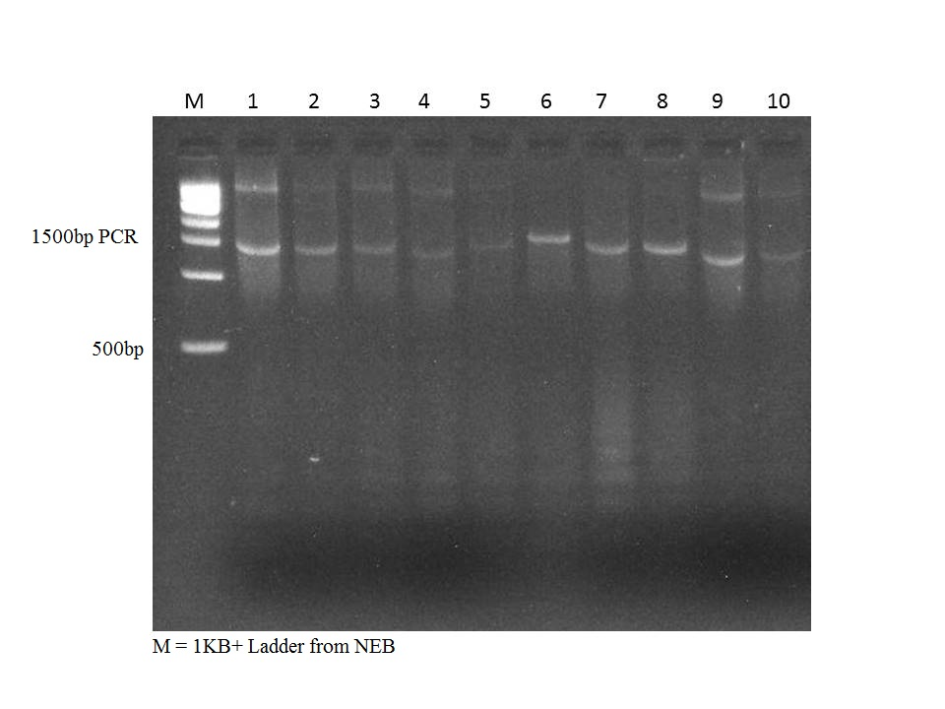

**Plate 3: Gel result of Actinomycetes isolates with broad spectrum antimicrobial activities.**

**3.6 True-To-Type Identification of ActinomycetesIsolates with Broad spectrum Antimicrobial Activities based on BLAST Results of their 16s rRNA Gene Sequences**

The BLASTresult of the obtained sequences of 16s rRNA genes of the top ten (10) performing Actinomycetes isolates in terms of broad spectrum antimicrobial activities among the obtained isolates showed that isolate NP67 has 99.51 % pairwise identity with *Streptomyces humidus* strain NBRC, NP42 has 99.05 % pairwise similarity with *Sporichithya polymorpha* DSM 43042, while NP34 was 97.0 % identical to *Asteroleplasma* *anaerobium* strain 161. Also, isolate NP8 was 85.12% identical to *Candidatus* *flaviluna* lacus strain MWH-Creno3D3, isolate NP45 has 82.17% pairwise identity with *Rubrobacter taiwanensis,* while isolate NP16 has 82.17 % pairwise identity with *Methylococcus* *capsulatus* strain Texas. Isolate NP26 is 78.75 % identical with *Streptomyces hypolithicus* strain HSM#10 with NCBI accession number NR_044431.1.

However, isolates NP45, NP55 and NP60 shared no sequence similarities with the other Actinomycetes on NCBI or EBI databases. The summary of the sequences and their percent similarity to known species is presented below.

**Table 4: Pairwise BLAST result of each isolates with Actinomycetes sequences in NCBI database**

|  |  |  |  |  |  |
| --- | --- | --- | --- | --- | --- |
| S/No | Isolate | Candidate organism | Accession number | % similarity | E value |
| 1 | NP8 | *Candidatus* *flaviluna* lacus strain MWH-Creno3D3 | NR_125496 | 85.12 % | 4e-92 |
| 2 | NP13 | *Methylococcus* *capsulatus* strain Texas | NR_029241.1 | 82.17 | 3e-47 |
| 3 | NP26 | *Streptomyces hypolithicus* strain HSM#10 | NR_044431.1 | 78.75 | 4e-135 |
| 4 | NP34 | *Asteroleplasma* *anaerobium* strain 161 | NR_044657 | 97.0 | 0.0 |
| 5 | NP42 | *Sporichithya polymorpha* DSM 43042 | NR_024727.1 | 99.05 | 0.0 |
| 6 | NP45 | No similarity found |  |  |  |
| 7 | NP51 | *Lysinibacillus* *fusiformis* strain INF-69 | KP813737 | 96.20 | 0.0 |
| 8 | NP55 | No similarity found |  |  |  |
| 9 | NP60 | No similarity found |  |  |  |
| 10 | NP67 | *Streptomyces humidus* strain NBRC 12877 | NR_112316.1 | 99.51 | 0.0 |

**3.7 Phylogenetic Relatedness among the Actinomycetes Isolates**

The cladogram result of the phylogenetic relatedness analysis of the elite Actinomycetes isolates showed presence of three (3) clades or groups. Clade 1 consist of four (4) isolates including isolates NP8, NP51, NP42 and NP67; group 2 is composed of 4 isolates including NP26, NP13, NP34 and out clade NP63, while groups 3 is made up of two isolates which include NP55 and NP45 which were the novel sequences as shown in Figure 4.

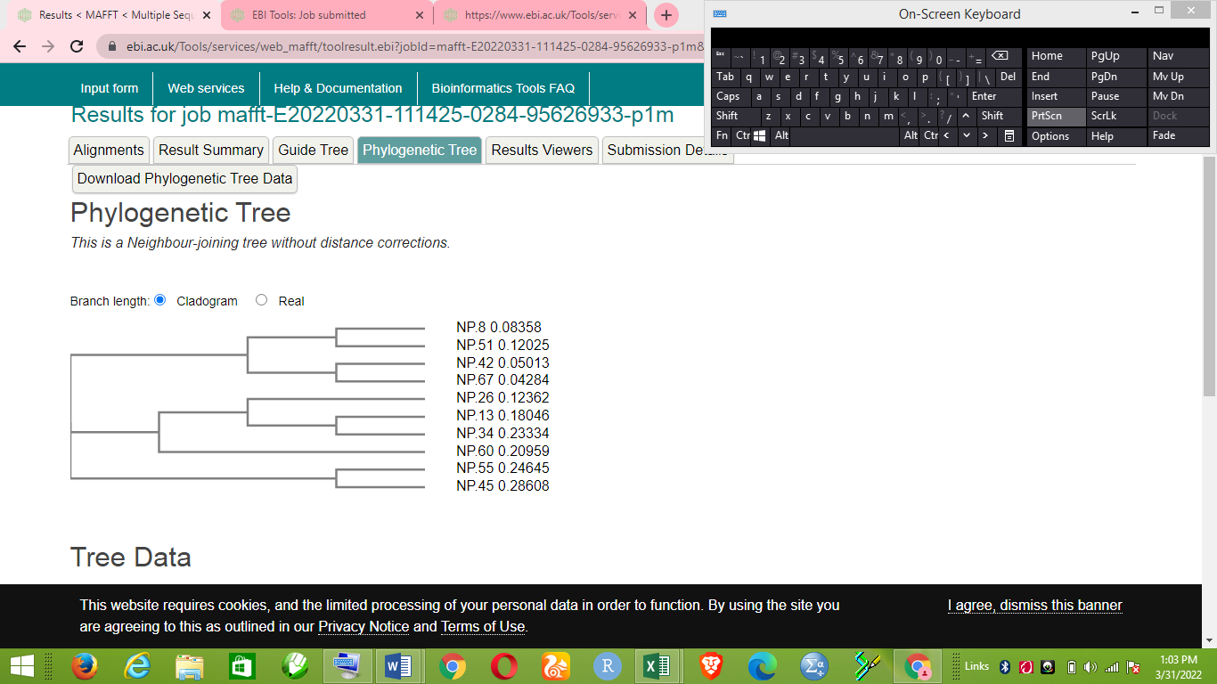

Clade1

Clade33

Clade2

Figure 4: Phylogenetic relatedness among the elite Actinomycetes isolates with broad spectrum antimicrobial production potentials.

**3.8 Sequence similarities among the Actinomycetes isolates with broad spectrum antimicrobial activities.**

The result showed high sequence similarities among isolates in each clade with isolates NP8 and NP51 being the most genetically identical (78.31% identity) followed by isolates NP8 and NP26 (74.87% identical) and between NP51 and NP26 (71.16% similarity) while the lowest percentage nucleotide sequence similarities occurred between isolates NP34 and NP45 (43.78 %) and isolates NP42 and NP45 (45.92 %) as shown in Table 4.

**Table 4: Percentage Identity among the Actinomycetes isolates**

|  |  |  |  |  |  |  |  |  |  |  |
| --- | --- | --- | --- | --- | --- | --- | --- | --- | --- | --- |
| **Isolate** | **NP.8** | **NP.51** | **NP.26** | **NP.42** | **NP.67** | **NP.60** | **NP.13** | **NP.55** | **NP.34** | **NP.45** |
| NP.8 | 100 |  |  |  |  |  |  |  |  |  |
| NP.51 | **78.31** | 100 |  |  |  |  |  |  |  |  |
| NP.26 | **74.87** | **71.16** | 100 |  |  |  |  |  |  |  |
| NP.42 | 66.38 | 69.62 | 65.42 | 100 |  |  |  |  |  |  |
| NP.67 | 68.68 | **70.39** | 66.43 | 90.18 | 100 |  |  |  |  |  |
| NP.60 | 66.79 | 61.59 | 66.63 | 57.09 | 59.32 | 100 |  |  |  |  |
| NP.13 | 65.00 | 58.42 | 68.63 | 56.34 | 56.92 | 53.5 | 100 |  |  |  |
| NP.55 | 63.01 | 58.49 | 55.62 | 51.53 | 52.71 | 46.94 | 48.64 | 100 |  |  |
| NP.34 | 56.41 | 53.09 | 56.41 | 53.09 | 59.14 | 50.43 | 50.34 | 52.02 | 100 |  |
| NP.45 | 59.93 | 51.15 | 50.05 | 45.92 | 47.05 | 49.22 | 48.20 | 47.04 | 43.78 | 100 |

**4.0 Discussion**

Given the current upsurge in antimicrobial resistant pathogens and the emergence of new forms of infectious pathogenic organisms globally, natural products have been identified as the most promising sources for developing future antibiotics (Cragg and Newman, 2013; Sharma *et al.,* 2011). It has been estimated that about 70% of antibiotics in use have been isolated from Actinomycetes species and are known to be the main sources of lead compounds for antimicrobial drugs (Gurung *et al.,* 2009). The dominance of different Actinomycetes species in soil has been earlier reported (Han *et al.,* 2013; Priyadharsini and Dhanasekaran, 2015). In fact, some Actinomycetes species have also been reported to be the most important bacteria in soil as they carries out different ecological functions such as degradation of organic matter and helping in the formation of compost (Adegboye and Babalola, 2012). These information sources helped in focusing the present study on Actinomycetes from waste dumpsites with a view to identify some novel Actinomycetes with antimicrobial potentials.

This study was carried out to isolate and characterize pure cultures of Actinomycetes species with broad spectrum antimicrobial production potential from different waste dumpsite in Abakailiki and its surrounding satellite towns. Waste dumpsite was chosen as source of the Actinomycetes for this study because of the competitive nature peculiar to waste dump environment. There is regular inflow of waste materials from different sources into the dump and each sample may contain different species of microorganisms some of which may be pathogenic, commensals, symbiotic or possess antimicrobial productions capabilities. The interactions among these species ensures the survival of the fittest.

A total of 40 waste dumpsites were sampled which gave large number of colonies. The result of the colony count showed that number of colonies ranged from 0.2x106 *cfu/g* to 14.8x106 *cfu/g* (Figure 1). Out of the 68 isolates purified by sub-culturing on Actinomycetes Isolation Agra (AIA), most of them showed morphological and growth characteristics ranging from white to grayish color of the aerial mycelium with yellow substrate mycelium or chalky-white to shiny golden aerial mycelium with dull white to yellow substrate mycelium (Plate 2). Some of the isolates were sticky and difficult to pick using wire loop while majority of them formed spores which are a characteristics of Actinomycetes species as earlier documented by different researchers (Taddei *et al.,* 2006; Salam and Rana, 2014; Rotich *et al.,* 2017).

The biochemical tests showed that all the isolates showed the ability to utilize citrate as the main carbon source and were catalase positive. This is similar to the results shown for *Streptomyces* species isolated in India (Dileep *et al.,* 2013). Also, the isolates were indole negative and were able to hydrolyze starch as the only carbon source (Table 2). Most of the isolates were observed to have the ability to produce catalase enzymes. This observation is in agreement with the report of Sharmin *et al.* (2005), Saadoun *et al.* (2007) and Rotich *et al.* (2017) who stated that their Actinomycetes isolates were able to produce catalase and urease enzymes and further reported that this ability could be attributed to similar metabolic pathways among the different isolates (Sharma, 2014). Also, other researchers have stated that the ability of Actinomycetes to produce a wide varieties of hydrolytic enzymes extracellularly is of great importance and normally the natural source from which it is isolated influences the kind of enzymes produced by the Actinomycetes strain (Saadoun *et al.,* 2007; Sharmin *et al.,* 2005).

The result of the antimicrobial activities of the isolates showed that out of the total of 68 isolates, almost all (except NP47) showed varying zones of inhibition against the test pathogens. This is an indication that majority of the isolate possess antimicrobial producing potentials. About 95.58% was active against *E. coli* with inhibition diameter ranging from 12 mm in NP47 to 39 mm in NP49. Exactly, 58% of the isolates had antimicrobial properties greater than the control drug (22 mm). Meanwhile, 66.18 % of the isolates were active against ESBL positive *E. coli* with inhibition diameter ranging from 6 mm to 28 mm (NP60) while control drug recorded 8 mm inhibition zone (Plate 4 and appendix 2). Similarly, as high as 94.12% of them showed antimicrobial activity against *S. aureus* with 28 (41.17%) of these having a higher potency than the standard drug Chloramphenicol (30 μg). These isolates therefore showed potent ability of producing effective antibiotics since they were able to perform very well at their crude state. *S. aureus* isknown to be the leading cause of nosocomial infections (Lowy, 2003). Previous study showed that *S. aureus* was the prevalent cause of blood stream infections, skin and soft tissue infection and pneumonia (Diekema *et al.,* 2001; Rotich *et al.,* 2017). In this study, 86.76 % showed antimicrobial activity against Methicillin Resistant *S. aureus* (MRSA). It showed an inhibition zone of 20 mm at its crude state as opposed to the standard drug Chloramphenicol (30 μg) which showed clear zones of 16 mm. Similar results have been reported in a study done at Mt. Everest (Gurung *et al.,* 2009) and in Kenya (Rotich *et al.,* 2017). Rotich *et al.* (2017) observed that some of their isolates were more active than their control drug (Chloramphenicol; 30 μg). MRSA is any strain of *S. aureus* that has developed, through horizontal gene transfer and natural selection, multiple drug resistance to beta-lactam antibiotics and is responsible for several difficult-to-treat infections in humans (Gurusamy *et al.,* 2013). This tells the difficulty in the treatment of infections caused by MRSA. Hence, the metabolites from these isolates could be purified further to get its potency at minimum inhibitory concentration. Furthermore, 58.82 % of the isolates showed zones of inhibition against *Klebsiella pneumonia* with inhibition diameter between 6 mm (NP28) to 25 mm (NP55). *K. pneumonia* is the major cause of pneumonia in human which is marked by high body temperature and shivering cold. Some of the isolates showed antibiotic activities greater than the control antibiotics disc.This suggests that some of the isolates could be exploited for developing potent drugs for treatment of *Klebsiella pneumonia* infections.

Also, most of the isolates (85.29 %) also showed antifungal activities against *Candida albicans* with inhibition diameter ranging from 12 mm (NP29) to 40 mm (NP8) which were higher than control drug (Fluconazol). The result is in agreement with the reported by Rotchi *et al.* (2017)who stated that most of their isolates (84.6 %) had activity against *T. mentagrophyte*, 30.8 % on *M. gypseum* and 5.1 % on *C. albicans*. *C. albicans* mostly cause opportunistic infections (Rotchi *et al.,* 2017). Another study done in Brazil in which six *Candida* species and 5 dermatophytes were tested showed antibiotic activity only on the *Candida* species (Spadari *et al.,* 2013). Most of the isolates in this study showed promising result more than the control drug (Fluconazol). Isolates NP8, NP11, NP12, NP27, NP31, NP35, NP38, NP45, NP51, NP55 and NP60 showed good antifungal activity with inhibition diameter between 24 to 40 mm against *C. albicans*. Therefore, these isolates with potent activity could be further purified and exploited for more effective treatment of this fungal infection. The search for antifungals active agents against dermatophytes has faced difficulties in the past (Spadari *et al.,* 2013). In previous studies, few isolated Actinomycetes have shown activity against fungus (Guo *et al.,* 2015). Hence, this research serves as breakthrough in antifungal drug development in recent time. These isolates with antifungal properties can be harnessed in antifungal drug development.

The true-to-type molecular identification (BLAST analysis of the 16s rRNA genes) showed that most of the isolates (70%) were aligned to other known Actinomycetes species and had similarity values of between 78.75 % to 99.51 %, while only 30% were not similar to any known species, yet exhibited broad spectrum antimicrobial activities. Although this is one of the earliest report on antimicrobial activities of Actinomycetes isolates from Abakaliki refuse dumpsite soils, previous study on soil samples from a reserved area in Kenya reported similar results (Nonoh *et al.,* 2010). The molecular typing of the isolates showed that only NP67 aligned 99.51 % with *Streptomyces humidus* while NP42 was recognized to be *Sporichithya polymorpha* with 99.05 % similarity. These isolates had broad spectrum antimicrobial activities against the six pathogens. One of the isolates (NP34) was identified to be a strain of *Asteroleplasma* *anaerobium* with 97.0% similarity, while NP51 was identified to be a strain of *Lysinibacillus* *fusiformis* with similarity index of 96.20%. Meanwhile, three isolates including NP45, NP55 and NP60 did not align reasonably with any know organisms in NCBI database, yet the isolates demonstrated remarkable broad spectrum antimicrobial activity. This suggest that they may belong to rare species of Actinomycetes or novel species. Only one isolate aligned with *Rhodococcus* *opacus* with a similarity of 99% and is the first report of this species in Nigeria soil. Similarly, this species was the first recorded species of *Rhodococcus* species on Kenya soil and was also isolated from Lake Magadi (Ronoh *et al.,* 2013). They further reported that the *Rhodococcus* species had antimicrobial activity only on *T. mentagrophyte* as opposed to the one isolated in Lake Magadi that showed activity on *E. coli* and *P. aeruginosa*, hence, the authors therefore concluded that the *Rhodococcus* species were of different strains.

The fight against pathogenic microorganisms has been a continual phenomenon with the continued emergence of multidrug resistant strains of previously susceptible pathogenic species as well as the evolution of new forms of pathogenic organisms that have proved resistant to conventional antibiotics available in market worldwide. Hence the need for more active metabolites from relatively underutilized strains of antimicrobial producing microorganisms. The Actinomycetes from these waste dump sites could also be good for production of broad spectrum antimicrobials especially those active against all the test pathogens. This suggest that they could be potential sources of antimicrobial agents against emerging pathogen as well as multidrug resistant pathogens. Soil samples from waste dumpsite is known to have acidic pH (Obianefu *et al.,* 2017), and acidic soils have been reported to harbor Actinomycetes with antimicrobial activity (Guo *et al.,* 2015; Rotich *et al.,* 2017). Hence, the choice of Actinomycetes from waste dumps may have been crucial to the result of this study.

**Conclusion**

This study demonstrated that most of the Actinomycetes isolates from the refuse dumpsites of Abakaliki area of Nigeria possess fantastic broad spectrum antimicrobial production potential against common bacterial and fungal pathogens including multi-drug resistant strains. It also revealed the presence of some rare or previously unknown Actinomycetes which equally showed high potentials to produce antimicrobials with broad spectrum effect. Hence, these isolates can be further studied and harnessed for the production of novel antibiotics, antifungal and possibly antiviral agents which could play crucial roles in the fight against emerging diseases and multidrug resistant pathogens.

**Acknowledgement of Funding**

This research did not receive any external funding.

**Conflicting Interest**

The authors declare that there is no conflict of interest.

**References**

Adegboye, M.F. and Babalola, O.O. (2012). Taxonomy and ecology of antibiotic producing Actinomycetes. *African Journal of Agricultural Research*, **7:** 2255-2261.

Bachoon, D.S. and Wendy, A. D. (2008). Microbiology Laboratory Manual. Ed. Michael Stranz. Mason, OH: Cengage Learning. Exercise 15, "Normal Flora of the Intestinal Tract"

Basilio, A., Gonzalez, I., Vicente, M.F., Gorrochategui, J., Cabello, A., Gonzalez, A. and Genilloud, O. (2003). Patterns of antimicrobial activities from soil Actinomycetes isolated under different conditions of pH and salinity. *Journal of Applied Microbiology*, **95:** 814-823

Bisacchi, G.S. (2015). Origins of the quinolone class of antibacterials: An expanded “discovery story. *Journal of Medical Chemistry,* **58** (12): 4874–4882

Cappuccino, J. G., and Sherman, N. (2002). Microbiology : a laboratory manual. Benjamin Cummings.

Chaudhary, H.S., Yadav, J., Shrivastava, A.R., Singh, S., Singh, A.K. and Gopalan, N. (2013). Antibacterial activity of actinomycetes isolated from different soil samples of Sheopur (A city of central India). *Journal of Advanced Pharmaceutical Technology Research*, **4**(2): 118–123.

Cherif A, Rezgui W, Raddadi N, Daffonchio D, Boudabous A. Characterization and partial purification of entomocin 110, a newly identified bacteriocin from Bacillus thuringiensis subsp. entomocidus HD110. Microbiol Res 2008; 163:684–692

Cragg, G.M. and Newman, D.J. (2013). Natural products: A continuing source of novel drug leads. *Biochimica et Biophysica Acta*, **1830**, 3670-3695.

Davies, J. and Davies, D. (2010). Origins and evolution of antibiotic resistance. *Microbiology and Molecular Biology Reviews,* **74** (3): 417–433.

Diekema, D.J., Pfaller, M.A., Schmitz, F.J., Smayevsky, J., Bell, J., Jones, R.N., Beach, M. and SENTRY Participants Group (2001). Survey of infections due to *Staphylococcus* species: Frequency of occurrence and antimicrobial susceptibility of isolates collected in the United States, Canada, Latin America, Europe, and the Western Pacific Region for the SENTRY Antimicrobial Surveillance Program, 1997-1999. *Clinical Infectious Diseases,* **32:** 114-132.

Dileep, N., Junaid, S., Rakesh, K.N., Kekuda, P. and Onkaraa, R. (2013). Antibacterial activity of three Strepyomyces species isolated from soils of Shikaripura, Kanataka, India. *Journal of Biological and Scientific Opinion*, **1:** 173-177.

Elma, L.S., [Luis, J.G.](https://pubmed.ncbi.nlm.nih.gov/?term=Gal%C3%A1n-Wong%20LJ%5BAuthor%5D), [Víctor, R.M.](https://pubmed.ncbi.nlm.nih.gov/?term=Moreno-Medina%20VR%5BAuthor%5D), [Miguel, Á.R.](https://pubmed.ncbi.nlm.nih.gov/?term=Reyes-L%C3%B3pez%20M%C3%81%5BAuthor%5D) and Benito, P.A. (2016). Bacteriocins synthesized by *Bacillus thuringiensis*: generalities and potential applications. *Reviews in Medical Microbiology,* **27**(3): 95–101.

Etebu, E. and Arikekpa, I. (2016). Antibiotics: Classification and mechanisms of action with emphasis on molecular perspectives. *International Journal of Applied Microbiology and Biotechnology Research*, **4:** 90-101

Felsenstein, J. (1985). Confidence limits on phylogenies: an approach using the bootstrap. *Evolution*, **39**(4): 783-791

Gebreselema, G., Feleke, M., Samuel, S. and Nagappan, R. (2013). Isolation and characterization of potential antibiotic producing actinomycetes from water and sediments of Lake Tana, Ethiopia. *Asian Pacific Journal of Tropical Biomedicine,* **3**(6): 426-435

Guo, X., Liu, N., Li, X., Ding, Y., Shang, F., Gao, Y., Ruan, J. and Huang, Y. (2015). Red soils harbor diverse culturable Actinomycetes that are promising sources of novel secondary metabolites. *Applied and Environmental Microbiology*, **81:** 3086-3103.

Gurung, T.D., Sherpa, C., Agrawal, V.P. and Lekhak, B. (2009). Isolation and characterization of antibacterial Actinomycetes from soil samples of Kalapatthar, Mount Everest Region. Nepal *Journal of Science and Technology*, **10:** 173-182.

Hall, T. A. (1999). BioEdit: a user-friendly biological sequence alignment editor and analysis program for Windows 95/98/NT. *Nucleic acids symposium series*, **41**(41): 95-98

Han, N.Y., Yi, T.J. and Chia, Y.T. (2013). Antimicrobial activity of Actinomycetes isolated from Paya Maga, Sarawak. *Journal of Sciences and Engineering Technology*, **62:** 17-19

Hoiberg, D. H. (2010). "Abakaliki". *Encyclopedia Britannica*. Vol. 1: A-ak Bayes (15th ed.). Chicago, IL: Encyclopedia Britannica, Inc. ISBN 978-0-85229-961-6.

Isenberg, H.D. (2004) Clinical Microbiology Procedure Handbook. Vol. 2, American Society for Microbiology, ASM Press.

Jeffrey, L.S.H. (2008). Isolation, characterization and identification of Actinomycetes from agriculture soils at Semongok, Sarawak. *African Journal of Biotechnology*, **7:** 3697-3702.

Jim, O. (2014). Antimicrobial Resistance: Tackling a crisis for the health and wealth of nations. Available at https://amr-review.org/sites/default/files/AMR%20Review%20Paper%20-%20Tackling%20a%20crisis%20for%20the%20health%20and%20wealth%20of%20nations.

Kumar, V., Bharti, A., Gusain, O., and Bisht, G. S. (2010). An improved method for isolation of Genomic DNA from Filamentous Actinomycetes. *Journal of Science, Engineering and Technology Management*, **2**(2), 10–13.

Lowy, F.D. (2003) Antimicrobial Resistance: The Example of Staphylococcus aureus. J*ournal of Clinical Investigation*, **111:** 1265-1273.

Monciardini, P., Sosio, M., Cavaletti, L., Chiocchini, C. and Donadio, S. (2002). New PCR primers for the selective amplification of 16S rDNA from different groups of actinomycetes. *Microbiology Ecology*, **42**(3), 419-429.

Nonoh, J.O., Lwande, W., Masiga, D., Herrmann, R., Presnail, J.K. and Schepers, E. (2010). Isolation and characterization of Streptomyces species with antifungal activity from selected National Parks in Kenya. *African Journal of Microbiology Research*, **4:** 856-864.

Obianefu, F.U., Agbagwa, I.O. and Tanee, F.B.G (2017). Physicochemical characteristics of soil from selected solid waste dump site in Port Harcourt, River State, Nigeria. *Journal Applied Science and Environmental Management,* **21** (6):1153-1156.

Oriji, J. N. (2011). Political organization in Nigeria since the last stone age: A history of the Igbo people. Palgrave Macmillan. New York, USA. Pp.  978-981

Pandey, A., Ali, I., Butola, K.S., Chatterji, T. and Singh, V. (2011). Isolation and characterization of Actinomycetes from soil and evaluation of antibacterial activities of Actinomycetes against pathogens. *International Journal of Applied Biology and Pharmaceutical Technology,* **2**(4): 384-392

Priyadharsini, P. and Dhanasekaran, D. (2015). Diversity of soil allelopathic Actinobacteria in Tiruchirappalli District, Tamilnadu, India. *Journal of the Saudi Society of Agricultural Sciences,* **14:** 54-60

Rao, R.K.V., Rao, R.T., Kumar, S.K. and Rao, B.D. (2012). Isolation and screening of antagonistic Actinomycetes from Mangrove Soil. *Journal of Biochemical Technology*, **3**(4): 361–365

Ronoh, R.C., Budambula, N.L.M., Mwirichia, R.K. and Boga, H.I. (2013). Isolation and characterization of Actinobacteria from Lake Magadi, Kenya. *African Journal of Microbiology Research*, **7:** 4200-4206.

Rotich, M. C.,  Magiri, E., Bii, C. and Maina, N. (2017): Bio-Prospecting for Broad Spectrum Antibiotic Producing Actinomycetes Isolated from Virgin Soils in Kericho County, Kenya.*Advances in Microbiology*, **7:** 56-70

Saadoun, I., Rawashdeh, R., Dayeh, T., Ababneh, Q. and Mahasneh, A. (2007). Isolation, characterization and screening for fiber hydrolytic enzymes-producing *Streptomycetes* of Jordanian forest soils. *Biotechnology*, **6:** 120-128.

Saitou, N. and Nei, M. (1987). The Neighbor-joining Method: a new method for reconstructing phylogenetic trees. *Molecular Biology and Evolution*, **4**(4): 406–425.

Salam, D.M. and Rana, S. (2014) Antimicrobial potential of actinomycetes isolated from soil samples of Punjab, India. *Journal of Microbiology and Experimentation*, **1:** 1-6.

Sharma, D., Kaur, T., Chadha, B.S. and Manhas, R.K. (2011). Antimicrobial Activity of Actinomycetes against multidrug resistant *Staphylococcus aureus*, *E. coli* and various other pathogens. *Tropical Journal of Pharmaceutical Research,* **10:** 801-808.

Sharma, M. (2014) Original research article actinomycetes: source, identification, and their applications. *International Journal of Current Microbiology and Applied Sciences*, **3:** 801-832.

Sharmin, S., Hossain, T.M. and Anwar, M.N. (2005). Isolation and characterization of protease producing bacteria *Bacillus* *amovivorus* and optimization of some factors of culture conditions for protease production. *Journal of Biological Sciences*, **5:** 358-362.

Spadari, C., Antunes, T., Teixeira, R., Minotto, E., Fuentefria, A.M. and Sand, S. (2013). Antifungal activity of Actinobacteria against fungus isolates of clinical importance. *Revista Brasileira de Biociências* (*Brazillian Journal of Biosciences*), **11:** 439-443.

Taddei, A., Rodriguez, M.J., Marquez-Vilchez, E. and Castelli, C. (2006). Isolation and identification of Streptomyces spp. from Venezuelan soils: Morphological and biochemical studies. *Microbiological Research*, **161:** 222-231.

Tamura, K., Nei, M. and Kumar, S. (2004). Prospects for inferring very large phylogenies by using the neighbor-joining method. *Proceedings of the National Academy of Sciences of the United States of America,* **101**(30): 11030-11035

Velayudham, S. and Murugan, K. (2012). Diversity and antibacterial screening of actinomycetes from Javadi hill forest soil, Tamilnadu, India. *Journal of Microbiology Research*, **2**: 41-46.

Waithaka, P.N., Mwaura, F.B., Wagacha, J.M. and Gathuru, E.M. (2017). Isolation of Actinomycetes from the Soils of Menengai Crater in Kenya. *Greener Journal of Microbiology and Antimicrobials,* **3**(2): 8-17.

WHO (2021). Antimicrobial resistance.<https://www.who.int/news-room/fact-sheets/detail/antimicrobial-resistance> Accessed on 21st February, 2022