## RutujaDagale* Vaidya Anuja, ,Pallavi Phalke

DepartmentofPharmacy Matoshri Radha College of Pharmacy,Virgaon, Akole,Dist-Ahmednagar, Maharastra-411041.

Clove: A review of a precious Spice

## *Abstract*:— clove are the Aromatic flower buds of tree in Family Myrtaceae, (syzygiumaromaticum). clove may be looked upon as champion of all the antioxidant known till date. Clove is one of most valuable spices that have been use traditionally as food preservative and many therapeutic purpose. .clove is use in antioxidant help protect against cancerit can also killbacteria

**,help ful in liver health and regular blood sugar. clove have essential oil extract named Eugenol comprises 72-90%,this plant represent one of the richest sources of phenolic constituent as Eugenol .the clove tree is evergreen that grow upto 8-12 meter tall with large leaves and crimson flower grouped in terminal clusters.**

***Keywords***—syzgiumaromaticum,spiecantioxidant.

# Introduction:

1. Clove is the common name for the herb Eugenia caryophyllata, belonging to the Myrtaceae family.Arange of bioactive compounds, including some potent antioxidantsand antimicrobials, are present in cloves, which are the dried flower buds of the clove tree [1]. Scientists reportedthat clove essential oil (CEO) is primarily composed of phenylpropanoids namely eugenol and its derivatives, with low amounts of humulene and caryophyllene chemical components [2]. CEO's biologicalqualities, which include antioxidant,antibacterial,antiseptic,pesticide,analgesic,andanticarcinogenic activity, make it useful in numerous industries such as food, biomedical, packaging, sanitary, cosmetics, and pharmaceuticals [3]. CEO is often used in food as natural preservative, colorant, and a spice [4]. Essential oils comprise both labile and volatile substances that dissolve or evaporate easily during processing, usage, and storage, or while added into food or packaging materials, among other conditions, such as low pressures, high temperatures, the presence of light and air, and others [5]. Due to its exceedingly volatile and low water-soluble components, such as eugenol , the CEO's antibacterial and antioxidant capabilities are severely limited [6]. Encapsulating bioactive substances like essential oils can be an efficient way to protect them from deterioration in harsh environments and be potentially utilized to increase the shelf life of essential oils and provide delivery systems with the controlled release [7].

Clove is mainly used in Ayurvedics ,it is a precious and valuable spice of the world ,it is usually known as “lavang”it ismember of Myrtaceae[8] . Syzygium aromaticum (s.aromaticum )(synonym : Eugenia cariophyta) commonly knownclove ,is an median size tree (8-12)meterfrom mitraceae[9].clove is mainly used for preparation of food . Clove oil is used for antimicrobial, antiviral, anti-inflammentary, anti-diabeties and antioxidant properties [10]. Eugenol the most important composition of clove oil has been accepted as food preservative by china[11] . Clove was originated from Indonesia. In Latin word “clou” meaning nail.[12] Desiccant dehumidifier wheel is the crucial alternative for conventional components used in HVAC system. Desiccant dehumidifier wheel is an essential and Pivotal component that can be used in building heating, ventilating, and air conditioning systems in order to reach significant energy savings and to use renewable sources [13]. It is very complicated to optimize the air handling units based on desiccant wheels instead of conventional components and it requires Suitable simulation tools. In the present paper Simulation is carried out with different temperature and different relative humidity. One-dimensional models are considered for developing temperature and velocity profiles.

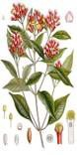**Synonyms:-**clovos,caryophyllus,lavang,laung,Grambu,krambu

**ClassificationAccordingtobiology:- kingdom:-**plantae**,**Class-

Mangnoliopsida

**kingdom-**plantae

**Sub-kingdom-**Tracheobionta,**Subclass**-Rosidae

**Class–**Mangnoliopsida,**Species**-aromaticum,**Genus**-Syzgium

**Division-**Magnoliphyta **Subclass** -Rosidae **Genus** -Syzgium **Species** -aromaticum

# History:-

Clove is one of most ancient and valuable species ,originated in first century before christ.the first clueabout clove fragrancegivenbyancient chines (207B.Cto220A.D)[20].clovewere introducedto Shri Lanka In 18 th century A.D. were established in India by East indian company[16].the use clove as spice reached Europe around 4 th century A.D[25].

2

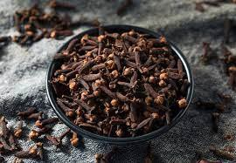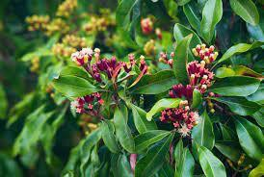

Pic–[1]Dryclove,[2]clovePlant.

For over 2000 year both Indian and chinese fractional medicine made extensive use of clove flowers and clove oil [4]. the clove trees cover thousant ofacres of the island .historically clove originating from madagascar have been considered superior[10] .In 2009 clove cigarettes were banned in U.S. however they are still marketed with new label as filtered clove cigars [25]

# CultivationMethod:-

The cultivation method employed in agriculture plays a vital role in determining crop yield, quality, and overall sustainability. With the global population continuously increasing and the demand for food surging, it becomes imperative to explore and implement cultivation methods that optimize productivity while minimizing negative environmental impacts. This research paper examines various cultivation methods, including traditional and modern techniques, and evaluates their efficacy in achieving sustainable agriculture. The paper also highlights the importance of incorporating technological advancements and innovative practices to address the challenges faced by conventional farming methods. By understanding and implementing effective cultivation methods, we can strive towards a more productive, resilient, and environmentally friendly agricultural system.

# TraditionalCultivationMethods:-

## ConventionalTillage:

Conventionaltillage is atraditionalcultivation methodthat involves mechanicallyplowing and turning the soilto prepare it for planting. This method has been widely used for centuries and is characterized by the use of heavy machinery, such as plows, to break up the soil, remove weeds, and incorporate organicmatter.Whileconventionaltillageoffersimmediatebenefitslikeweedcontrolandsoil

3

aeration, it also has several drawbacks. Excessive tillage can lead to soil erosion, loss of organicmatter, and disruption of soil structure. It can also contribute to the release of carbon dioxide into the atmosphere and decrease water infiltration, leading to water runoff and potential pollution.

## CropRotation:

Croprotation is a traditionalcultivation methodthat involves the systematic rotationofcrops ina field over time. This practice helps break the life cycles of pests and diseases and reduces the depletion of specific nutrients from the soil. By alternating crops with different nutrient requirements, the soil can maintain its fertility, reduce the buildup of pests and diseases, and improve overall crop yield. Crop rotation also promotes biodiversity and can help in weed control. However, effective crop rotation requires careful planning and knowledge of plant families, nutrient requirements, and pest cycles.

## Intercropping:

Intercropping is a traditionalcultivation method where twoor more crops are grownsimultaneously in the same field. Thispractice maximizes land utilizationand enhancesproductivitybytaking advantage of the complementary characteristics of different crops. For example, a nitrogen-fixing crop like legumes can be intercropped with a nitrogen-demanding crop to improve soil fertility. Intercropping can also provide natural pest control by attracting beneficial insects and disrupting pest cycles. Furthermore, it helps in weed suppression and reduces soil erosion. However, intercropping requires careful selection of compatible crops, proper spacing, and consideration of competition for resources like light, water, and nutrients.

## FloodIrrigation:

Flood irrigation is a traditional method ofwater application that involves flooding the entire field with water. This method has been practiced for centuries in areas with ample water resources. Flood irrigation is simple and inexpensive, requiring minimal infrastructure. It provides uniform water distributionand canbe beneficialinareas withhighwatertables. However, flood irrigationhas several drawbacks. It can lead to water wastage due to evaporation, runoff, and deep percolation. Excessive irrigation can cause waterlogging, soil salinization, and nutrient leaching. Moreover, uneven distribution of water can result in uneven crop growth and yield variability.

While traditional cultivation methods have been widely practiced and have their advantages, it is crucial to consider their limitations and explore alternative approaches that promote sustainability and addressenvironmentalconcerns.Moderncultivationmethodsandsustainablepracticesoffer

4

innovative solutions to overcome the challenges faced by traditional methods, aiming for increased productivity, resource efficiency, and long-term ecological balance.

# ModernCultivationMethods:-

## ConservationTillage:

Conservation tillage is a modern cultivation method that minimizes soil disturbance by reducing or eliminating tillage operations. This approach aims to preserve soil structure, moisture, and organic matter, thereby improving soil health and reducing erosion. Conservation tillage practices include techniques suchas minimumtillage, no-till, and strip-till, where onlya portionofthe field is tilled. By leaving crop residues on the soil surface, conservation tillage helps prevent soil erosion, conserve soil moisture, and enhance carbon sequestration. It also reduces fuel consumption, machinery wear, and labor requirements. However, successful adoption of conservation tillage requires proper weed management, residue management, and adaptation to specific cropping systems and soil conditions.

## PrecisionFarming:

Precision farming, also known as precision agriculture, utilizes advanced technologies and data-driven approaches to optimize crop production. This method involves the use of GPS (Global Positioning System), remotesensing, and GIS (Geographic Information System) to collect and analyzedataonsoil conditions, crop health, and environmental factors. Precision farming enables farmers to apply fertilizers, water, and pesticides precisely where and when they are needed, thereby minimizing waste and improving resource efficiency. It also facilitates variable rate application, site-specific management, and real-time monitoring of crops. By optimizing inputs and reducing environmental impacts, precision farming can enhance crop yield, quality, and profitability.

## Hydroponics:

Hydroponics is a soilless cultivation method that involves growing plants in nutrient-rich water solutions. This technique utilizes controlled environments, such as greenhouses or indoor facilities,and provides plants with the necessary nutrients directly through water. Hydroponics offers several advantages, including water efficiency, precise nutrient control, and year-round production. It eliminates the need for soil, reduces the risk of soil-borne diseases, and allows for optimal root oxygenation. Additionally, hydroponics enables vertical farming, where plants are stacked vertically, maximizing landutilization.However,hydroponicsrequirescarefulmonitoringofnutrient balance,pH levels, and water quality to ensure plant health and productivity

5

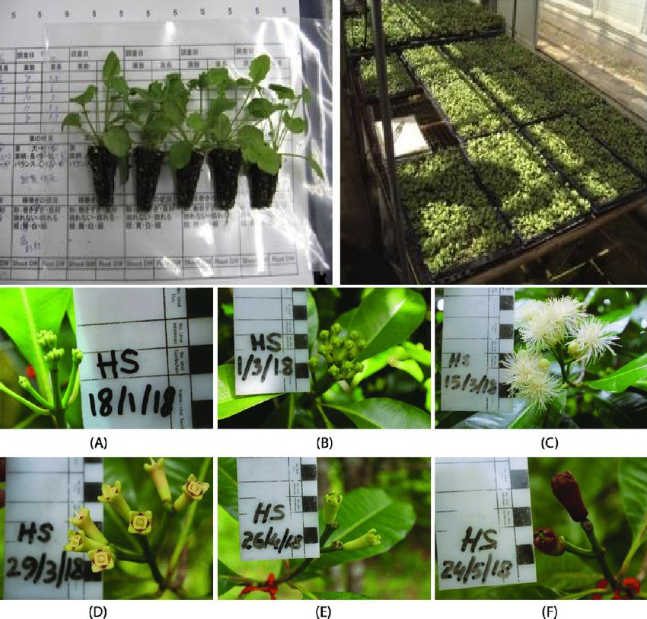

## VerticalFarming:

* Vertical farming is a modern cultivation method that involves growing crops in vertically stacked layersor racks. Thisapproachoptimizes spaceutilizationbyutilizingartificiallighting, climate control, and hydroponic or aeroponic systems. Vertical farming can be implemented in urban areas, reducing the need for large land areas and transportation costs. It also allows for year-round production and eliminates the dependence on seasonal variations and weather conditions. Vertical farming offers benefits like reduced water usage, efficient nutrientdelivery,andminimalpesticideuse.However,itrequiressignificantinitialinvestmentin

6

infrastructure, energy for lighting, and specialized knowledge for system setup and management.

## Aquaponics:

* Aquaponics is an integrated cultivation method that combines hydroponics and aquaculture. It involves cultivating plants and rearing aquatic animals in a symbiotic system. Fish or other aquatic organisms provide nutrients through their waste, which are then used by plants as a nutrient source. In turn, the plants filter the water, purifying it for the aquatic animals. Aquaponics offers benefits like efficient water use, nutrient recycling, and reduced reliance on external fertilizers. Italso providesa diversified production system, allowing for the cultivation of both crops and fish. However, aquaponics requires careful management of water quality, nutrient balance, and system monitoring to ensure the well-being of both plants and aquatic animals.

Modern cultivation methods offer innovative approaches to improve productivity, resource efficiency and sustainability in agriculture. These methods leverage technology, data-driven decision- making, and optimized resource utilization to overcome the limitations of traditional cultivation practices. By implementing modern cultivation methods, farmers can enhance crop yields, conserve resources, reduce environmental impacts.

# CloveMarketSizeAndForecast:-

Clove Market size is growing at a moderate pace with substantialgrowth rates over the last few years and is estimated that the market willgrow significantly in the forecasted period i.e. 2021 to 2028.

The top drivers of the Clove Market are personal and cosmetics products, Medicinal and pharmaceutical products, and it is also considered as an important ingredient in various food items.The Global Clove Market report provides a holistic evaluation of the market. The report offers a comprehensive analysis of key segments, trends, drivers, restraints, competitive landscape, and factors that are playing a substantial role in the market.

# GlobalCloveMarketOverview

Clove is one ofthe most valuable species by contributing its fragrance and benefits in personal products, healthcare products, as well as a very important ingredient in cooking several dishes allaroundtheworld,drivestheGlobalCloveMarkethigherwiththeincreasingdemandfor

7

Cloves becauseoftheapplicationoffoodandbeverage industry, perfumes, toothpasteanda lot more.

# GlobalCloveMarketOverview

Clove is one of the most valuable species by contributing its fragrance and benefits in personal products, healthcare products, as well as a very important ingredient in cooking several dishes all around the world, drives the Global Clove Market higher with the increasing demand for Cloves because of the application of food and beverage industry, perfumes, toothpaste and a lot more.

The worldwide demand for Clove has been increasing with the increased production andManufacturers are focusing on various R&D activities to find out more benefits related to Clove. The focus is now on creating awareness about the medicinal properties of Clove reason being It is High in antioxidantsalongwithvitaminsand minerals, helpsto protect against cancer, improves liver healthas well as improves blood sugar levels.

There are a few risks associated withClove and Clove oilas well. According to the NationalCentreof BiotechnologyInformation. HighamountsofCloveoil maycause liver damage, especially in children, and before consuming too much of it discussing it with medicalprofessionals is preferred.

# GlobalCloveMarket:SegmentationAnalysis:-

The Global Clove Market is Segmented on the basis of Product Type, Application, Distribution Channel and Geography.

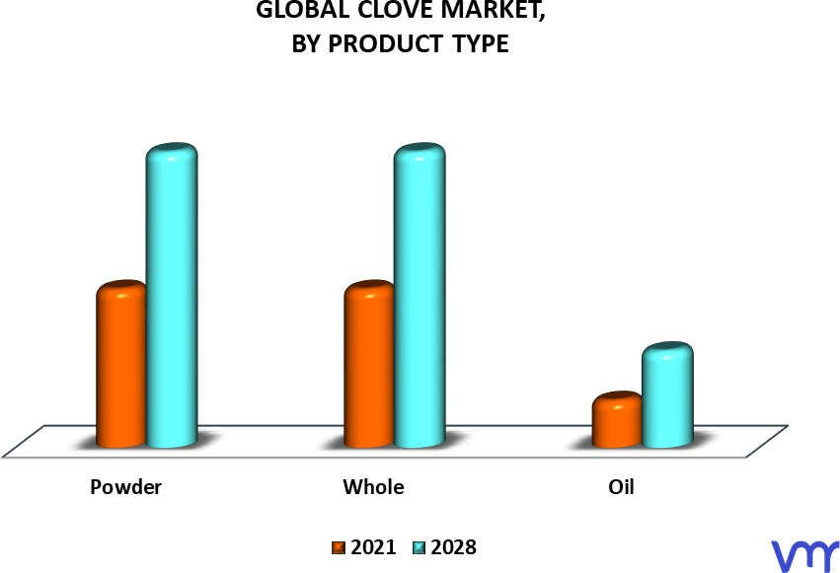

8

## CloveMarket ,ByProductType:-

* powder
* Whole
* Oil

## CloveMarket,ByApplication:-

* localGroceryshop
* Ecommerce
* Department stores

## CloveMarket,ByGeography:-

* + north America
  + Europe
  + RestoftheWorld

# Chemicalcomposition:-

Clove is a vital spharmacological activities and ource of phenolic compound such as flavonoid hydroxycinamicacid , hydroxybenzoic acid and hydroxyphenylpropenes[33]. It consists of 82- 88%Eugenol [31]. eugenol is the main bioactive compound of clove,which found in concentration ranging from 9381.70to 14650.00m[19]

**Stucture of Eugenol:-**

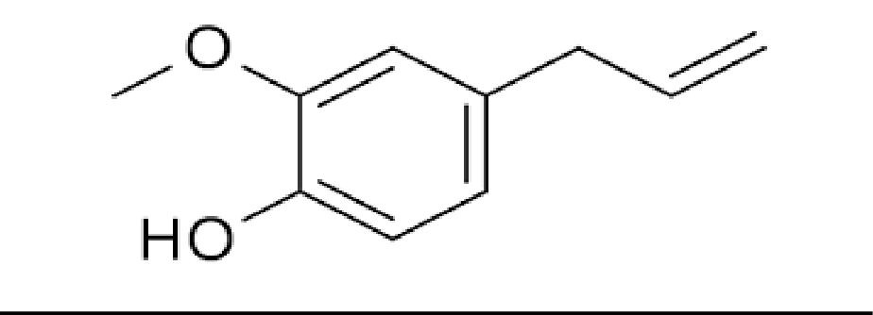

9

# pharmacological activities and uses of clove:-

**Antimicrobial Activity-**cloveoil usedAntisepticin oral infection,Eugenol contain highlevel ofin clove essential oil are responsible for its strong biological and Antimicrobial activities[32]

* **Analgesic Activity-** eugenolwas administrated intravenouslyand intragasticallyto examine its analgesic effect.it having an natural anesthetic,it showed greater fever reducing potential than paracetamol[34] **Antiviral Activity**: -eugenin isolated from clove bud essential oil exhibited a potent inhibiting effect against herpes simplex virus [32] .
* **Antioxidant Activity**- All spices inhibited lipid oxidation in dose depend manner.essential oil were added to soyabean oil at doses of 0.006and 0.0191 ml for 30days, [35]alcohol extract of some selected spices like onion,garlic,pepper,cinnamon,mint,ginger and clove[36].
* **Anticancer avtivity**: -to study protected from cancer eat more cloves as eugenol in clove passes strong anticarcinogenic properties and help control Lung cancer[27]
* **HepatoprotectiveActivity:-**Hepatoprotectivepotentialcloveaquaousextractwasevaluatedat doses of 0.1and 0.2 g/kg using paracetamol in toxicated hepatic damage assay in wistar albino rats [37]

# Side effects of clove:-

it generally not recommended to ingest clove oil inmore amount clove may cause burning sensation . Applying to skin or using it wash recommended instead[22-24].

* Increase bleeding.
* Cause respirotary problem
* Itchin grash
* Loss of sensation
* Allergic issue
* Toxicity
* Mouth irritation

10

* liver damage
* fluid imbalance
* seizures
* clove oil might cause bleeding
* too much clove cause hypoglycemia

# Conclusion:-

based on information presented it. clove represent a very interesting plant with enormous potential food preservative. Clove flower bud at flowering stage had highest yeild ,rich source of antioxidant compound.

**REFERENCE**

1. Milind P. and Deepa K. :clove: A Champion spice , Int J. of Res Ayu & Pharm, 2011, 2(1) 47-54.
2. Merr .(L) & perr . Myrtaceae, Syzygium aromaticum, Agroforestry Database 4.0 (Orwa et al. 2009) page no.1to5.
3. Ms. RD. Link R., 8 Surprising health benefits of cloves : Nutrition.
4. Agrawal M., agrawal s.,[....]:A review on uses of clove in oral and general health: IJRPB 2(4),2014.
5. Gopalakrishnan N. and Narayanan C.S. composition of clover leaf oil during leaf grow thindian perfumers 1998; 12:45-51
6. CaiLCDWucompound from syzygiumaromaticum possessing growth inhibitory activity against oral pathogen.J Nat.prof 1996 ;59(10);987-900.
7. Sallie R,tredger JM william Rdrugs and liver biopharmaceutics and drug diposition 1991 ;12:251-

259

1. Wong C., : The health benefits of cloves, Holistic health : Aromatherapy & essential oils.
2. Nassar M., Gaara A. H.,[...] :chemical constituent of clove (Syzygium aromaticum, Fam. Myrtaceae) and their Antioxidant activity: Mahmoud I. Nassar, Et AL. (2007).
3. Shan B,CaiYZ,SunM,CorkeH. antioxidantcapacity of 26 spice extracts and charactrization of their phenolic constituents. J agric food chem.2005;539(20):7749-7759. [PubMed] [Google scholar]
4. Kamatou GP,Vermaak I,Viljoen AM.Eugenol-from the remote MalukuIslands of a international market place:a review of a remarkable and versatile molecules .2012;17(6):6953-6981. [PMC free article][PubMed] [Google Scholar]
5. Filho GA,Cesar JO,Ramos JV.Itabuna:CEPLAC;2013. [Cravo from India] [Online] Available from:

11

[http://www.ceplac.gov.br/radar.htm.](http://www.ceplac.gov.br/radar.htm) [Accessed on 21st April,2013].portuguese.[Google Scholar]

1. Oliveira RA,OliveiraFF,SacramentoCK.[Essential oils: prospects for agribusiness spices in Bahia]Bahia Agric.2007;8(1):46-48. portuguese.[Google]
2. Oliveira RA, Reis TV, Sacramento CK, Duarte LP, Oliveira FF. Volatile chemical constituents of rich spices in eugenol. Rev Bras Farmacognosia. 2009;19(3):771-775. [Google Scholar]
3. Sofia PK, Prasad R, Vijay VK, Srivastava AK.Evalution of antibacterial activity of Indian spices against common foodborne pathogens. Int J Food Sci Technol.2007;42(8):910-915. [Google Scholar]
4. Hussain S. , Rahman R. , Mushtaq A. , [….] : Clove: A Review of a precious with multiple uses: Int J. of Che & Bio Sci, 2017.
5. Cock I. E., Cheesman M.9(2018), plant of the genus syzygium(Myrtaceae) : A review on ethnobotany , medicinal properties & Phytochemistry.Bioactive comps. Of Med. Plant. Ed Goyal MR, Ayeleso A AppleAcademic press , USA.
6. Hu Q., Zhou M., & Wei S.: progess on the Antimicrobical Activity research of clove oil and eugenol in thefood antisepsisfield:JOfFood Sci ,

Vol83,Iss6,2018

1. Yadav S., Gupta S.K., Bharti D., & Yogi B.: SyzygiumAromaticum(clove):AReviewon

Various phytochemicals and pharmacologicalactiviesin medicinal plants,World J. Pharmaceutical Research,9(11),2020.

1. [http://en.](http://en/) wikipedia. Org/W/index.php? title=Clove& oldid=99768494
2. Dr. Verma S.K.,Dr. Garg A.K. ,[…]: World J pharmaRes. : Vol .7 (5)2018
3. Mittal m. , Gupta N. , […]: Phytochemical evalution and pharmacological activity of Syzygium aromaticum: A comprehensive review: Int J Pharm pharm sci, 6(8).
4. Dua Anita, Singh Avtar , Mahajan Ritu: Antioxidants of clove (syzygium aromaticum) prevent mental induced oxidative damage of biomolecules: Int. Res j. Pharm. 2015, 6 (4).
5. Cortes-Rojas D. F. , Souza C. R.F. , […] : clove (Syzygium aromatium): a precious spice: Asian Pac J. Of Trop Biomed 2014: 4(2).
6. Pulikottil SJ, Nath S. : Potential of clove of syzgium aromatium in development of a therapeutic agent for periodontal disease . A review, SADJ 2015, Vol 70 , p.108-115.
7. Batiha G. E-S. , Alkazmi L. M. , …]: syzygium aromaticum L. (Myrtaceae): Traditional uses , Bioactive chemical constituents, pharmacological and toxicological activities : 2020.
8. jirovetzL.,BuchbauerG.,[…]:chemicalcompositionandantioxidantpropertiesofcloveleafEssentialoil,J Agric & Food chem., 2006 ,54,17.
9. Alfikri F.N., pujiarti R.,[…]: yield, Quality, andantioxidant activityofclove( syzygiumaromaticumL. Bud oil at the differentphenologicalstages in young and mature Tree(2020)
10. Halder S, Mehta AK, Kar R, Mustafa M, Mediratta PK, Sharma KK. Clove oil reverses learning and memory deficits in scopolamine-treated mice.planta Med .2011;77(8):830-834. [Pub Med] [Google Scholar]
11. DormanHJ,DeansSG.Antimicrobialagentfromplants:antibacterialactivityofplantvolatileoils.JAPPL Microbial.2003;88(2):308-316. [PubMed][Google Scholar]
12. Md. Uddin A., Md . Shahinuzzaman, Md . Rana S., & YaakobZ . : study of chemical composition and medicinal properties of volatile oil from clove buds : IJPSR, 2017; Vol.8(2).

12

1. Chaieb ,K.,Hajlaoui ,H., Zmantar ,T., Kahla-Nakbi,A .B., Rouabhia ,M., Mahdouani,K. and Bakhrouf ,a. the chemicalcomposition and biological activityof clove essential oil,eugenia caryophyllata (syzygium aromaticum L.). Phytother.Res.2007,21,501-506.
2. Neveu V, Perez –Jimenez J, Vos F, Crespy V, duChaffaut L, Mennen L, et al. et al. phenol-Explorer :an online comprehensive database on polyphenol content in foods. Doi:10.1093/database /bap024. [PMC free article] [PubMed][CrossRef][Google Scholar]
3. J.Feng,J.Lipton(1987).Eugenol:antipyreticactivityinrabbits. Neuropharmacology.26(12):1775-1778.
4. S. Shobana, K.A. Naidu. (2000). Antioxidant activity of selected Indian spices. Prostaglandins, Leukotriene and essential Fatty acids (PLEFA). 62(2):107-110.
5. M.M.Khan ,M. Iqbal , M.A. Hanif , M.S. Mahmood,S.A . Naqvi, M.Shahid, M.J. Jaskani .(2012)Antioxidant and antipathogenicactivitiesof citrus peel oils. Journal of Essential Oil-Bearing Plants .15(6):972-979.
6. M. Thuwaini, M. Abdul –Mounther ,H . Kadhem.(2016). Hepatoprotective Effect of the Aqueous Extract of colve (Syzygiumaromaticum ) against paracetamolInduced Hepatotoxicity and Oxidative stressin Rats . European Journal of pharmaceuticalandMedical Research .3(8):36-42.
7. Kafle L,Shih CJ. toxicity and repellency of compounds from clove (Syzygiumaromaticum)to red imported fire ants solenopsisinvicta (hymenpetra:Formicidea ) J Econ Entomol. 2013;106 (1):131-135.[Pub Med][googlescholar ]
8. Nam H Kim MM .Eugenol with antioxidant activity inhibit MMP-9 related to metastasis in human fibrosarcoma cells Food chem toxicol .2013;55:106-112[PubMed][google scholar].
9. Abdel-Wahhab MA, Aly SE. Antioxidant property of Nigella sativa (black cumin )and Syzygium aromaticum(clove)in rats during .J Appl Toxicol .2005;25(3):218-223.[PubMed ][google scholar].
10. Ohkubo T, Shibata M. the selective capsaicin antagonist capsazepineabolishaes the antinociceptive action of eugenol and guaiacol J Dent Res .1997;76(4):848-851.[PubMed][google scholar].
11. JavaherySNekobinH,MoradluAH.Effectofanaesthesiawithcloveoilin(review)Fishphysiolbiochem

.2012;38(6):1545-1552.[PubMed][googlescholar].

1. GargA,Singh S. Enhancement in antifugalactivity of eugenol in immuosuppressed rats through lipid nanocarriers. Colloids SurfB Biointerface.2011;87(2):2.80-288.[PubMed][google].
2. Healthcare.TPDRforherbalmedicines.4thed.Montvale:Thomson Healthcare;2004.[googlescholar]
3. Burt SA,Reinders RD. Antibacterial activityof selected plant essential oils against Escherichia coli O157:H7. Lett Appl Microbial.2003;36(3):162-167[PubMed][googlescholar]
4. I.Shahzadi,R. Nadeem M.A.Hanif,S. Mumtaz , M.I. Jilani,S. Nisar. chemistryandbiosynthesispathwayofplant oleresins: Importantdrug sources .

13