**Antibiotic Sensitivity Profile of Uropathogenic bacteria from HIV Positive and HIV Negative Participants with Urinary Tract Infection in Imo State, Nigeria.**

**Ohalete, Chinyere N1, Anyanwu, Gladys O2and Korie, Maximus C3**

1. Department of Microbiology, Imo State University, Owerri, Imo State, Nigeria.
2. Department of Biology/Microbiology, Federal Polytechnic Nekede Owerri, Nigeria
3. Department of Science Laboratory Technology (Microbiology option), Imo State Polytechnic Omuma, Imo State Nigeria

Correspondence Author’s email: justglady@gmail.com

**ABSTRACT**

This study was carried out to evaluate the prevalence of Uropathogenic bacteria in HIV positive and HIV negative participants. A total of 400 randomly selected participants comprising 200 HIV positive and 200 HIV negative participants at General hospital Awo-Omamma and Imo State Specialist hospital Umuguma, Owerri, Imo State were enrolled for the study. Specimens were collected from Out-patients ward of both hospitals between September and November 2019. Midstream urine samples were aseptically collected and analyzed following standard microbiological methods. The Statistical Package for the Social Sciences version 21.0 was adopted to analyze data. For HIV positive participants, result showed that a total of 62(31%) had the highest infection rate (37%) observed within the 37-47 age bracket. In HIV negative participants, 41(20.5%) had UTI infection with the highest infection rate (40%) observed within the 70 and above age bracket. Bacteria isolates comprising *Escherichia coli*, *Klebsiella pneumonia, Pseudomonas aeruginosa, Staphylococcus aureus, Proteus mirabilis and Enterobacter spp* were identified*. Escherichia coli* was the most predominant organism in both HIV positive participants (28%) and HIV negative participants (34.2%). *Proteus mirabilis* was the least bacterial isolated from both HIV positive participants (12%) and HIV negative participants (5.3%). The study will expand the knowledge base on bacterial agents of urinary tract infections.

**Key words:** Uropathogenic, prevalence, isolates, infection, bacteria, midstream urine.

**INTRODUCTION**

The Human Immunodeficiency Virus (HIV) causes acquired immunodeficiency syndrome (AIDS), a serious illness where opportunistic infections that can be fatal can proliferate due to gradual immune system breakdown. Most untreated HIV-1-infected people eventually get AIDS, according to Miguelles (2010).

Individuals with HIV often experience opportunistic infections or cancers due to the immune system's gradual malfunction, affecting dendritic cells, macrophages, and CD4+ T cells.

CD8 cytotoxic lymphocytes destroy CD4+ infected cells, increasing apoptosis rates and viral attack. Low CD4+ cells reduce immunity to opportunistic infections, including urinary tract infections.

HIV-positive individuals often suffer from urinary tract infections (UTIs), a prevalent bacterial illness, leading to increased hospitalization and morbidity. Low CD4+ cell counts can cause renal syndromes, neurological issues, and even mortality.

The outbreak is linked to *Salmonella*, *Staphylococcus* *aureus*, *Pseudomonas* *aeruginosa*, *Streptococcus* *pneumoniae*, and *Haemophilus* *influenza*, with opportunistic infections accounting for 60% of AIDS-defining diseases.

According to Iroha et al. (2013), urinary tract infections (UTIs) are prevalent among HIV-positive individuals in poor countries like Nigeria, with many hospitalized daily due to antibiotic use. Recent resistance to antibiotics has raised global concerns. [Nigussie](https://pubmed.ncbi.nlm.nih.gov/?term=%22Nigussie%20D%22%5BAuthor%5D)  [and Amsalu](https://pubmed.ncbi.nlm.nih.gov/?term=%22Amsalu%20A%22%5BAuthor%5D) (2017) state that the rising incidence of uropathogen resistance to widely given infections has made urinary tract infections extremely concerning.   
The widespread use of antibiotics globally leads to an increase in antibiotic resistance in both developed and developing countries (Frank-Peterside et al., 2013). The isolated uropathogens have been extremely concerning due to their strong resistance to almost all antibiotics (Ayesha et al., 2024).

These multidrug-resistant (MDR) infections are a major circulating infection vector for HIV patients and are constantly growing. These multidrug-resistant (MDR) microorganisms become a major circulating source of infection, especially in impoverished nations like Nigeria since they multiply rapidly in HIV-positive individuals.

**MATERIALS AND METHOD**

**Study population:** The study involved 200 HIV positive and 200 HIV negative patients from General Hospital Awo-Omamma and Imo State Specialist Hospital Umuguma.

**Method of collection and processing:**

Patients consented to a study, and clean-catch midstream urine was collected from each patient-capped universal tank, labelled, and processed at Balm of Gilead laboratories.

**Microscopy**

Urine samples were centrifuged at 500rpm for 5 minutes, then aliquots were placed on glass slides, stained, and viewed under a microscope.

**Culturing of the Urine Samples**

A urine sample was streaked onto Nutrient, blood, and MacConkey agar plates, incubated for 24 hours at 370c. Counts were expressed in CFU per milliliter. Pure cultures were generated, identified based on morphological and biochemical characteristics, and confirmed using 16sr RNA sequencing.

Bacterial isolates were identified using standard microbiological methods, Gram staining, morphological and cultural characteristics, and biochemical tests like motility, catalase, indole production, sugar fermentation, citrate utilization, and urease.

Isolates were repeatedly sub-cultured on MacConkey Agar and incubated at 30°C for 48hours.

**Antibiotic Susceptibility Test**

The antibiotic susceptibility test was conducted using disc diffusion method on Mueller-Hinton agar, following the Clinical Laboratory Standards Institute's guidelines, using a sterile swab stick.

Cipro (10mcg), Norfloxacin (10mcg), Gentamycin (10mcg), Amoxicillin (20mcg), Streptomycin (30mcg), Rifampicin (20mcg), Erythromycin (30mcg), Chloramphenicol (30mcg), Ampiclox (20mcg), Levofloxacin (20mcg), Ofloxacin (10mcg), Pefloxacin(10mcg), amoxicillin/clavulanic acid (30mcg), Ampicillin (30mcg), Nalidixic acid (30mcg)and cotrimoxazole (30mcg) were applied onto the inoculated plates maintaining a distance of 30mm edge to edge Plates were incubated at 37°C for 24 hours, examining for zones of inhibition surrounding the disc. The diameter of these zones was measured using a ruler.

**MOLECULAR CHARACTERIZATION**

**Extraction of genomic DNA**

Genomic DNA was extracted using ZR Soil Microbe DNA Mini-Prep extraction kit (Zymo Research Corporation, Irvine, CA, USA) without modifications. DNA quantification was done using the Qubit2.0 Fluorometer (Q32867, Life Technologies, Grand Island, NY, USA) Aliquots of 2µl of template DNA was used for PCR.

**Determination of DNA purity**

DNA integrity was determined using an automated Nanodrop spectrophotometer (3300) connected to a computer. Samples with an optical density of 1.40-2.0 were used for PCR reactions, with all samples below this range repeated.

**Preparation of Agarose Gel Electrophoresis**

Agarose powder was melted in microwave oven, cooled, and placed on a micro titre tray. The gel was then poured into a TBE buffer tank, covered, and samples loaded into the wells using a pipette.

**PCR and Sequencing**

The PCR reaction was performed using primers 27F 5' and 1492R 5', with genomic DNA as the template. Amplicons were purified and sequenced using the Sanger sequence approach at Inquaba Biotech (Albright *et al*., 2015).

**STATISTICAL ANALYSIS**

GraphPad Prism version 6.01 was used for statistical analysis, displaying quantitative data like mean and standard deviation, and qualitative data like number and percentages. The Chi-Square test was used to compare factors.

**RESULTS**

A total of 400 persons were enrolled for this study. Two hundred confirmed HIV positive participants (100 each from General hospital Awo-Omamma and Imo State Specialist hospital Umuguma) and a total of two hundred HIV participants (100 each from General hospital Awo-Omamma and Imo State Specialist hospital Umuguma) all in Imo state. Out of 200 confirmed HIV/AIDS positive participants, a total of 62(31%) were infected with UTIs while 41(20.5%) of HIV negative participants were infected. According to the prevalence of UTIs in relation to age (Tables 1 and 2), age bracket 37-47 years had the highest rate of Urinary tract infection (40%) in HIV positive participants. This was followed by age bracket 15-25with (35%) while 59-69 age bracket had an infection rate of 9.5%. For HIV negative participant, the highest prevalence of Urinary tract infection was observed within the 70 and above age bracket with (40%). This was followed by age bracket 59-69 with (31.1%), while the 26-36 age bracket had the lowest UTI infection (8.7%) (Table 2). There was no statistical relationship between ages of respondents and prevalence of UTI at p >0.05 for both HIV positive patients and HIV negative groups. The Prevalence of UTIs in relation to sex is presented in Tables 3 and 4. Result show that the female sex had a higher infection rate in both HIV positive and HIV negative groups. However, prevalence was higher in HIV positive participants (37.2%) as compared to HIV negative participants (22%). There was no statistical association between sex of respondents and prevalence of UTI for both HIV positive and HIV negative group sat p>0.05.

**Table 1: Prevalence of UTIs in relation to age of the HIV positive participants from Awo-Omamma General hospital**

|  |  |  |  |  |
| --- | --- | --- | --- | --- |
| Age | Number of Participant | Number positive (%) | X² | P value |
| 15-25 | 20 | 7(35) | 1.361 | 11.07 |
| 26-36 | 30 | 9(30) |  |  |
| 37-47 | 73 | 27(37) |  |  |
| 48-58 | 46 | 15(32.6) |  |  |
| 59-69 | 21 | 2(9.5) |  |  |
| 70 and above | 10 | 2(20) |  |  |
| Total | 200 | 62(31) |  |  |

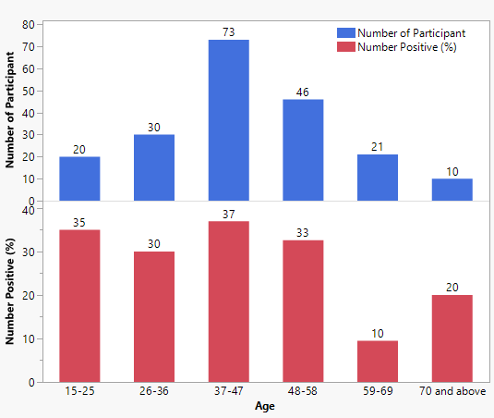

**Table 2: Prevalence of UTIs in relation to age of the HIV negative participants from Specialist hospital Umuguma.**

|  |  |  |  |  |
| --- | --- | --- | --- | --- |
| Age | Number of participants | Number positive (%) | X² | P value |
| 15-25 | 68 | 10(14.7) | 1.307 | 11.07 |
| 26-36 | 23 | 2(8.7) |  |  |
| 37-47 | 38 | 7(18.4) |  |  |
| 48-58 | 21 | 6(28.6) |  |  |
| 59-69 | 45 | 14(31.1) |  |  |
| 70 and above | 5 | 2(40) |  |  |
| Total | 200 | 41(20.5) |  |  |

**Table 4: Prevalence of UTIs in relation to sex of the HIV negative participants**

|  |  |  |  |  |
| --- | --- | --- | --- | --- |
| Age | Number of participants | Number positive (%) | X² | P value |
| Male | 74 | 13(17.6) | 0.199 | 3.84 |
| Female | 126 | 28(22.2) |  |  |
| Total | 200 | 41(20.5) |  |  |

**Table 5: Prevalence of UTIs in relation to educational qualification of HIV positive participants in both hospitals**

|  |  |  |  |  |
| --- | --- | --- | --- | --- |
| Educational qualification | Number of participants | Number positive (%) | X² | P value |
| Primary education | 55 | 21(38.2) | 0.428 | 5.99 |
| Secondary education | 101 | 31(30.7) |  |  |
| Tertiary education | 44 | 10(22.7) |  |  |
| Total | 200 | 62(31) |  |  |

Table 9**:** Molecular identification of bacterial isolates

|  |  |  |  |
| --- | --- | --- | --- |
| Sample | Organism identity | Percentage (%) | Corresponding organism from NCBI database |
| 1 | *Escherichia coli* | 93 | *Escherichia coli* KY417135 |
| 2 | *Klebsiella pneumonia* | 99 | *Klebsiella pneumonia* MK719814 |
| 3 | *Pseudomonas aeruginosa* | 96 | *Pseudomonas aeruginosa*WE41437 |
| 4 | *Staphylococcus aureus* | 97 | *Staphylococcus aureus* |
| 5 | *Proteus mirabilis* | 98 | *Proteus mirabilis KY*417134 |
| 6 | *Enterobacter* spp | 99 | *Enterobacter* spp KT150211 |

**Table 10: Distribution of bacterial isolates among HIV positive UTI participants in both hospitals**

|  |  |  |  |
| --- | --- | --- | --- |
| Bacterial isolates | HIV positive (n=200) |  | Percentage (%) |
| *Escherichia coli* | 21 |  | 28 |
| *Klebsiella pneumonia* | 19 |  | 25.3 |
| *Pseudomonas aeruginosa* | 9 |  | 12 |
| *Staphylococcus aureus* | 7 |  | 9.33 |
| *Proteus mirabilis* | 9 |  | 12 |
| *Enterobacterspp* | 10 |  | 13.3 |
| Total | 75 |  |  |

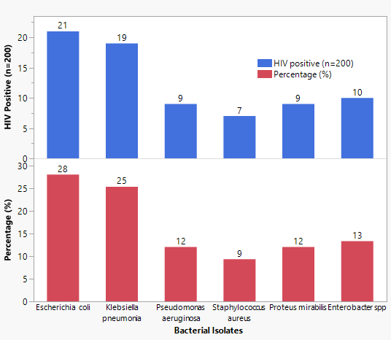

**Table 11: Distribution of bacterial isolates among HIV negative UTI participants in both hospitals**

|  |  |  |  |
| --- | --- | --- | --- |
| Bacterial isolates |  | HIV negative (n=200) | Percentage (%) |
| *Escherichia coli* |  | 13 | 34.2 |
| *Klebsiella pneumonia* |  | 11 | 28.9 |
| *Pseudomonas aeruginosa* |  | 4 | 10.5 |
| *Staphylococcus aureus* |  | 3 | 7.9 |
| *Proteus mirabilis* |  | 2 | 5.3 |
| *Enterobacterspp* |  | 5 | 13.2 |
| Total |  | 38 |  |

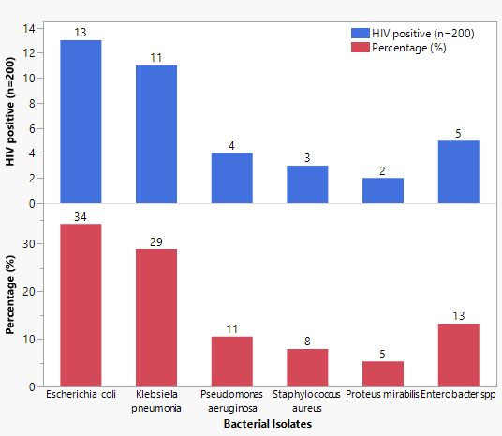

**Table 12: Antibiotic sensitivity profile of Gram-negative bacterial from HIV positive and HIV negative participants with urinary tract infection in both hospitals**

|  |  |  |  |  |  |  |
| --- | --- | --- | --- | --- | --- | --- |
| Isolates | n | Antibiotic susceptibility profile | | | | |
|  |  | Pattern | OFX | NA | PEF | CN | CPX | COT | S | SP | AU | CEP |
|  |  |  |  |  |  |  |  |  |  |  |  |  |
| *E. coli* | 29 | S | 10(34.5) | 6(20.7) | 6(20.7) | 11(37.9) | 20(70) | 22(75.9) | 9(42.9) | 26(89.7) | 16(55.2) | 10(34.5) |
|  |  | I | 1(3.4) | 3(10.3) | 3(10.3) | 0(0) | 5(17.2) | 3(10.3) | 5(17.2) | 3(10.3) | 5(17.2) | 6(20.7) |
|  |  | R | 18(62.1) | 20(70) | 18(44.8) | 18(62.1) | 4(13.8) | 4(13.8) | 16(55.2) | 0(0) | 8(27.6) | 19(65.5) |
|  |  |  |  |  |  |  |  |  |  |  |  |  |
| *K. pneumonia* | 19 | S | 16(84.2) | 6(31.6) | 12(63.2) | 15(78.9) | 2(10.6) | 13(68.4) | 16(84.2) | 15(78.9) | 9(47.4) | 6(31.6) |
|  |  | I | 1(5.3) | 3(15.8) | 2(10.5) | 1(5.3) | 1(21.1) | 0(0) | 3(15.8) | 2(10.5) | 4(21.1) | 3(15.8) |
|  |  | R | 2(10.5) | 12(63.2) | 5(26.3) | 3(15.8) | 16(84.2) | 6(31.6) | 0(0) | 2(10.5) | 5(26.3) | 10(52.6) |
|  |  |  |  |  |  |  |  |  |  |  |  |  |
| *P. mirabilis* | 9 | S | 6(66.7) | 4(33.3) | 3(33.3) | 1(11.1) | 6(66.7) | 3(33.3) | 6(66.7) | 3(33.3) | 3(33.3) | 6(66.7) |
|  |  | I | 3(33.3) | 2(21.2) | 2(22.2) | 2(2.2) | 2(2.2) | 1(11.1) | 3(33.3) | 1(11.1) | 0(0) | 0(0) |
|  |  | R | 0(0) | 3(33.3) | 4(44.4) | 6(66.7) | 2(22.2) | 3(33.3) | 2(22.2) | 4(44.4) | 6(66.7) | 4(44.4) |
|  |  |  |  |  |  |  |  |  |  |  |  |  |
| *E. aurogens* | 15 | S | 5(33.3) | 4(26.7) | 0(0) | 5(33.3) | 9(60) | 7(46.7) | 11(73.3) | 8(53.3) | 6(40) | 9(60) |
|  |  | I | 3(20) | 3(20) | 2(13.3) | 2(20) | 3(20) | 3(20) | 1(6.7) | 5(33.3) | 5(33.3) | 2(20) |
|  |  | R | 7(46.7) | 8(53.3) | 13(86.7) | 8(53.3) | 3(20) | 5(33.3) | 3(20) | 2(13.3) | 4(26.7) | 4(26.7) |

KEY: OFX=Ofloxacin, NA=Nalidixic acid, PEF=Pefloxacin, CN=Gentamycin, SP=Sparfloxacin

CPX=Ciprofloxacin, COT= Co-trimaxole, CEP=Cephalexin S=Streptomycin, AU=Amoxiclav

**Table 13: Antibiotic sensitivity profile of Gram-positive bacterial from HIV positive and HIV negative participants with urinary tract infection in both hospitals**

*S. aureus*10 Pattern CPX E LEV CN APX R AMX S NB CH

S 5(50) 6(60) 6(60) 5(50) 1(10) 9(90) 6(60) 3(30) 2(20) 3(30)

I 1(10) 3(30) 4(40) 3(30) 3(30) 1(10) 2(20) 4(40) 2(20) 2(20)

R 4(40) 3(30) 0(0) 2(20) 6(60) 0(0) 2(20) 3(30) 6(60) 5(50)

_____________________________________________________________________________________________________________________

**KEY**: **G+ve**: **CN =** Gentamycin, **APX** = Ampiclox, **CPX** = Ciprofloxacin, **S**=Streptomycin, **E** = Erythromycin, **AMX** = Amoxicillin, **LEV** = Levofloxacin, **CN** = Gentamycin, **CH** = Chloramphenicol, **R** = Rocephin

**Percentage multidrug resistant bacteria (MDR) among different bacterial isolates**

|  |  |  |  |  |
| --- | --- | --- | --- | --- |
|  | HIV positive participants |  | HIV negative participants |  |
| Isolates | No of isolates examined | MDR isolates (%) | No of isolates examined | MDR isolates (%) |
| *Escherichia coli* | 29 | 11(37.9) | 18 | 6(33.3) |
| *Klebsiella pneumonia* | 19 | 7(36.8) | 9 | 4(25) |
| *Pseudomonas aeruginosa* | 9 | 3(33.3) | 5 | 2(12.5) |
| *Staphylococcus aureus* | 10 | 3(30) | 3 | 19(6.3) |
| *Proteus mirabilis* | 9 | 2(22.2) | 0 | 0 |
| *Enterobacteraerogenes* | 15 | 3(7.3) | 6 | 2(12.5) |
|  |  |  |  |  |

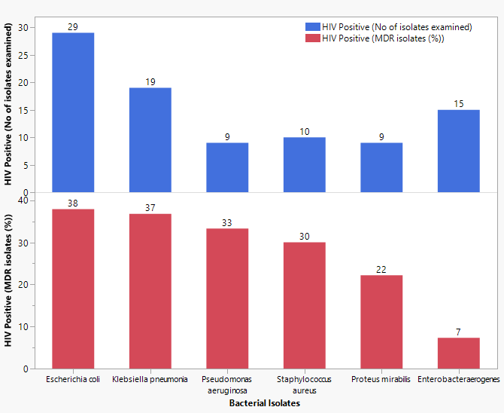

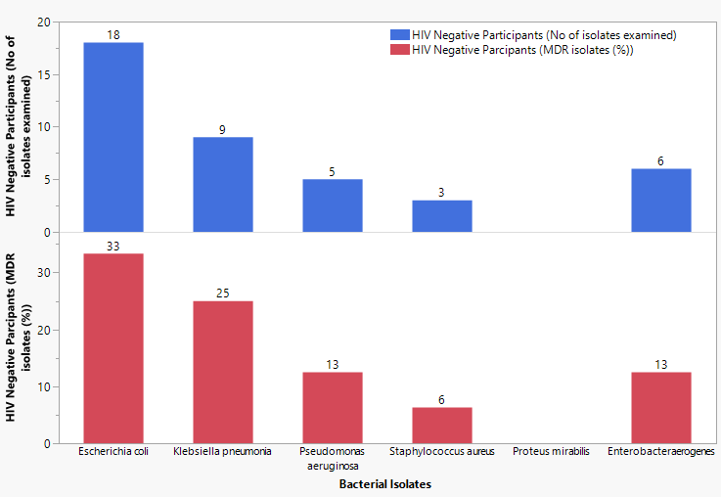

**Discussion**

A study involving 400 HIV positive and 200 HIV negative individuals from two hospitals found that 31% of HIV positive participants were infected with UTIs, while 20.5% of HIV negative participants were infected. This finding is consistent with previous studies. (Alemu *et al*., 2013), and Harar, Ethiopia (18%)([Marami *et al*., 2019) Jos, Nigeria (23.5%) (Bigwan and Wakjissa, 2013), Mysore india (24%) (Muruges *et al*., 2014) but lower than reported from Ebonyi State, Nigeria (93.8%) (Iroha *et al*., 2013), Tamil Nadu, India (77.5%) (Xavier *et al*., 2015), Portharcourt, Nigeria (85.5%) (Kemajou *et al*., 2016) Aba, Nigeria (40.39%) (Kanu *et al*., 2016).

HIV negative individuals' prevalence is lower (14.5%), possibly due to sample sizes, faulty specimen collection, regional variation, and socioeconomic situations, as reported by John-Onwe et al. (2022)

The study found a higher UTI prevalence (37% for HIV-positive patients, 40% for HIV-negative ones) in the age group 37-47, contrasting with previous studies (32.9% for 24-30 years, 29% for 17-23 years) and (2012). Samuel *et al*., (2012).

The study reveals a higher prevalence of UTI in HIV positive participants due to suppressed immunity, while poor hygiene and lower immunity in HIV negatives and the female gender (37.2%) are also affected. Mugresh, (2012) reported a prevalence rate of 55% in females, Tula and Iyoha (2014) reported a prevalence of 74% in UTI infection from Yola, Nigeria. The study reveals that females are more likely to contract UTIs due to their short female urethra, which may lead to ascending infections. This is due to the fact that sexual activity transmits microbes from the intestine to the vaginal cavity, increasing the risk of UTI.

Males are less vulnerable to UTIs due to antimicrobial substances and longer urethra in prostatic fluid, contradicting previous research showing a lower prevalence rate in females, Tula and Iyoh (2014). The study found that primary education respondents had the highest UTI prevalence in both HIV positive (38.2%) and negative (30.2%) groups, possibly due to increased awareness and understanding. No significant difference was found with p>0.05.

The study found that business owners/traders in HIV-positive groups and unemployed individuals had the highest prevalence of UTIs (40.6%), possibly due to socioeconomic status. Six bacterial genera were isolated, including Escherichia coli (31.9%) and Klebsiella pneumoniae (26.5%).

Escherichia coli is the most common cause of UTI, according to numerous studies, with 38.1% reported in Marami et al.'s 2019 study, and similar findings in Gondar, Ethiopia, Port Harcourt, Nigeria, Jimma, Amassoma, Ibadan, and Tertiary Care Hospital, India.

Frank-Peterside et al. (2013) found Enterococcus species as predominant urinary isolates, while Kemajou et al. (2016) and Ifeanyichukwu et al. (2013) identified Staphylococcus aureus as the most common uropathogen. E. coli's dominance may be due to a specific structure allowing adhesion to uroepithelial cells. Staphylococcus aureus showed no resistance to Levofloxacin and Rifampicin, but 40% were resistant to ciprofloxacin, 60% to Ampiclox, and Norfloxacin, similar to Kemajou et al.'s (2016) findings.

HIV-positive individuals are more susceptible to opportunistic pathogens, including multiple drug resistance bacteria, E. coli 11(37.9%), *K. pneumoniae* 7(36.8%) *P. aeruginosa* (33.3%), *Staphylococcus aureus* 3(30%), *Proteus mirabilis* 2 (22.2%) and *Enterobacter spp* (3.7%), making them a hotbed for these diseases to spread quickly, posing a severe health problem.

Multiple drug resistance in HIV treatment is a global concern, particularly in developing countries with high poverty, ignorance, and inadequate hygiene standards, and a high level of antibiotic misuse (Alemu et al, 2013). This study confirms Adegoke et al.'s 2010 report on antibiotic resistance, highlighting the role of antibiotic abuse and self-medication in bacterial strain selection. HIV-positive individuals face increased risk of opportunistic infections, requiring longer procedures and culture-specific treatment.

**CONCLUSION**

This work reports a higher prevalence of UTI in HIV positive participants than HIV negative participants, thus highlighting the importance of testing patients with HIV for UTI. The result of this finding emphasizes the need for adequate enlightenment campaigns to discourage self-medication and drug misuse. These findings also point to the need for more research on mechanism of drug resistance especially in immune compromised individuals.

**REFRENCES**

Abebe Alemu1, Yitayal Shiferaw, Zelalem Addis, Biniam Mathewos and Wubet Birhan (2013) Effect of malaria on HIV/AIDS transmission and progression. *Parasites & Vectors in BioMed Central* **(6)** 18: 1-8.

Adegoke AA, Tom Mvuyo, Okoh A, Steve J (2010) Studies on multiple antibiotic resistant bacteria isolated from surgical site infections. *Scientific Research and Essays* 5: 3876-3881

Ayesha Khan, Viqar Sayeed Saraf, Fariha Siddiqui, Tahira Batool, Zobia Noreen, Sundus Javed, Aftab Ahmad, Wadi B. Alonazi, Muhammad Ibrahim, Sandra Pucciarelli and Habib Bokhari. Multidrug resistance among uropathogenic clonal group A E. Coli isolates from Pakistani women with uncomplicated urinary tract infections *BMC* *Microbiology* (2024) 24:74 https://doi.org/10.1186/s12866-024-03221-8

Bigwan E. I. and Wakjissa F. D. (2013). Prevalence of Urinary Tract Infections among HIV Patients Attending a Non- Governmental Health Facility in Jos, Plateau State, Nigeria. *International Journal of Biomedical and Advance Research*. Pp 528-533

[Demiss Nigussie](https://pubmed.ncbi.nlm.nih.gov/?term=%22Nigussie%20D%22%5BAuthor%5D) and [Anteneh Amsalu](https://pubmed.ncbi.nlm.nih.gov/?term=%22Amsalu%20A%22%5BAuthor%5D) (2017) Prevalence of uropathogen and their antibiotic resistance pattern among diabetic patients. Turk J Urol. (2017 Jan 27);43(1):85–92. doi: [10.5152/tud.2016.86155](https://doi.org/10.5152/tud.2016.86155).

Frank-Peterside N, Okerentugba PO, Akpan HR, Okonko IO. Prevalence of HIV-1 and HIV-2 Antibodies among Secondary School Students in Port Harcourt, Nigeria *Researcher* 2013;5(12).

Idris Nasir Abdullahi, Rabeb Issaoui and Yahaya Usman (2022). Prevalence and genetic lineages of Staphylococcus aureus nasal colonization and urinary tract infection among people living with HIV/AIDS in Nigeria: A systematic review. *Elsevier* 4 (2022): 17-24

Iroha Ifeanyichukwu, Okoh Inya, Ejikeugwu Chika, Nwakaeze Emmanuel, Nwuzo Agabus, Afiukwa Ngozi, and Udu-Ibiam Esther. Prevalence of methicillin-resistant S. aureus (MRSA) among apparently healthy students in Afikpo, Ebonyi State, Nigeria. *Issues in Biological Sciences and Pharmaceutical Research* Vol.3(1), pp.1-4

John-Onwe B. N., Iroha I. R., Moses I. B., Onuora A. L., Nwigwe J. O., Adimora E. E., Okolo I. O., Uzoeto H. O., Ngwu J. N., Mohammed I. D. and Oladimeji A. S. (2022).Prevalence and multidrug-resistant ESBL-producing E. coli in urinary tract infection cases of HIV patients attending Federal Teaching Hospital, Abakaliki, Nigeria. *African Journal of Microbiology Research.*

Vol.16(5), pp. 196-201

Tchounga S Kemajou, Anslem O Ajugwo, Cyprian E Oshoma and Enabulele OI (2016). Antibiotic Resistance of Bacterial Isolates from HIV Positive Patients withUrinary Tract Infection (UTI) in Portharcourt, Nigeria *Journal of AIDS & Clinical Research* 7 (8): pp 1-4

.