***In silico* and *in vitro* studies of Anthelminthic Activity of *Punica Granatum* Leaves and Peel**

A. SUDHEER KUMAR*1, RAYADURGAM NAVEEN*1, G.V. PARAMESWAR,

K. LAVANYA, S.R. KIRAN, B. BALAJI, P. BALAJI

1Department of Pharmacology, Raghavendra Institute of Pharmaceutical Education and Research (RIPER) – Autonomous, Krishnam Reddy Palli Cross, Chiyyedu (Post), Anantapuramu, Andhra Pradesh - 515721, India.

1Department of Pharmacology, Raghavendra Institute of Pharmaceutical Education and Research (RIPER) – Autonomous, Krishnam Reddy Palli Cross, Chiyyedu (Post), Anantapuramu, Andhra Pradesh - 515721, India.

**\*Address for correspondance:**

E-mail: [sudheerlegend@gmail.com](mailto:sudheerlegend@gmail.com)

Abstract:

It is estimated that more than a billion people are infected with helminths, and most of them live in poor areas. Pomegranate was chosen because it contains medicinal essential plant compounds that exhibit anthelmintic activity. The anthelminthic activity was tested on the Indian earthworm *Pheretima Posthuma* because of its resemblance with the intestinal roundworms. The designed library was docked to the 3VRA and 1OJ0 crystal structures. Based on the docking score using Schrodinger, the potential chemical constituents were found to be luteolin, quercetin, gallic acid and kaempferol. This study aims to investigate the potential activity of butanol extract from pomegranate for anthelmintic activity. The extract's potency was observed to be inversely related to the worm's paralysis and death time.

**Keywords:** Anthelminthic, Helminths, Molecular docking, Ligand, *Punica granatum*.

Infections with worm parasites are a worldwide problem with major social and economic repercussions in developing nations [1]. The majority of people, as well as animals, are affected by these diseases [2][3]. Parasitic helminths are parasitic worms that cause substantial suffering and stunting in both animals and humans. The majority of helminth-related disorders are chronic and disabling. They have a higher frequency and economic as well as societal consequences for people and animals than a single parasite group. Helminthiasis is particularly common in Anantapuramu (a provincial district in Andhra Pradesh, India), especially during the rainy season when cattle illnesses exceed 100%. Anthelminthic medicines are the major control method for helminthic parasites in Anantapur.

On the other hand, the high cost of modern anthelmintics limits their effectiveness in controlling these parasites. In other cases, extensive and intensive usage of inferior anthelmintic medications led to resistance, lowering the effectiveness of available anthelmintic treatments. Alternative medications have been recommended as a strategy to prevent the development of helminthiasis-resistant bacteria while also lowering the cost of helminthic disease control, but we would like to investigate the emergence of pathogenic helminthiasis-resistant bacteria. Stimulated the desire. An additional chemotherapeutic agent that can control helminthic parasites more efficiently. The development of effective medications from relatively affordable and readily available basic ingredients is a viable answer to this problem. This can be handled appropriately by research into indigenous traditional herbal treatments [4][5]. The *Punica granatum* is a herbaceous shrub of the Lythraceous family that yields the fruit. It is found all over the world and grows to a height of 5-10 meters (16-33 ft). These herbs are used in traditional medicine to treat gastrointestinal, cardiovascular, and endocrine diseases, among other diseases [6].

Plants have been shown to contain flavonoids, alkaloids, lignans, and triterpenes. Flavanols and flavones found in pomegranate leaves and peel include epicatechin, apigenin, kaempferol, Gallo catechin, quercetin, and catechin, which can be detected by IR and NMR [7]. These chemical components are involved in anthelmintic action. Natural products have played a vital role in medicine development and drug guidelines for a variety of diseases, including cancer. Many plants, animals, and humans are affected by parasitic nematodes, which pose a major threat to their health and well-being. In poor nations, gastrointestinal parasites are a severe concern for livestock. Despite the development of anthelmintic resistance to the economically critical parasite, chemotherapy remains the most widely used option for combating helminths [8][9]. Use the Schrodinger Glide software (Maestro 2020_1) to assess the binding capacity of the molecule.

**MATERIALS AND METHODS**

**Proteins:**

**1OJ0:** (Haemonchus contortus beta-tubulin bound to Albendazole sulfoxide)

**3VRA:** (MRFR) Mitochondrial Rhodoquinol-fumarate reductase from the parasite nematode Ascaris suum survival.

***In silico* methodology**

**Molecular docking studies:**

1. Protein preparation

By the well-known method, the Glide protein preparation wizard is utilized to make the energy-minimized protein, suitable for the virtual screening. Directly from the protein data bank, the proteins were into the workspace by giving its PDB codes 3VRA and 1OJ0. The protein is first pre-processed with Epik, which assigns bond ordering, adds hydrogens, creates disulphide bonds, and generates heat states. Next, in the review and Modify tab, Co-crystal ligand Albendazole was kept as much in 1OJ0. Further, the selected protein is then optimised and then minimised in the refine tab.

2. Receptor grid generation

In the maestro task, receptor grid generation is used to make the grid at the active binding site of the proteins by selecting any one atom of the co-crystal ligand molecule on the workspace.

3. Ligand preparation

2D of the Maestro Schrödinger software (version 2020_1) was used to import structures into the workspace via the composite SMILES notation. Glide Ligprep puts all ligands into energy minimization by complying with the required constraints, ionization (neutralization), chirality, computation and more.

4. Docking of Ligand

The glide grid and ligand out mega zip files were imported from the working directory, and ligand docking (virtual screening) was selected for docking. Then, under the settings, choose to write XP descriptor information to the dock. In Tables 1 and 2, the virtual screening findings of 3VRA and 1OJ0 proteins were indexed from least binding energy to highest binding energy.

***In vitro* methodology**

**Chemicals:**

The various chemicals were used to perform the project work. The chemicals were procured from SRL Company laboratory-grade butanol, Petroleum ether, Distilled water, Sulfuric acid, Alpha naphthol, hydrochloric acid, Fehling’s reagent A and B, Benedict’s reagent, 40% sodium hydroxide, 1% Copper sulphate, Ninhydrin reagent, Potassium hydroxide, Diethyl ether, Chloroform, Bromine water, pyridine, Sodium nitroprusside, Ammonia, Lead acetate solution, Mayer’s reagent, Dragendorff’s reagent, Ethyl acetate, Hager’s reagent, Albendazole, Butanol.

**Plant material collection, identification, and processing:**

The leaves of *Punica Granatum* were collected from S.K. University, Anantapuramu dist. The plant was identified and authenticated by Dr B. Ravi Prasad Rao, Professor, Dept. Of Botany, SK University, Anantapuramu. *Punica granatum* leaves and peel were dried in the shade, separated, pulverised with a mechanical grinder, and sieved through a 40-mesh sieve.

**Extraction:**

The leaf and peel extraction process were carried out for 16 hours using 80% butanol and water. 25 g of dry powder was extracted into 250 ml butanol at 350 ° C by continuous heat percolation with a Soxhlet extractor. After the extraction process was completed, the residue was completely dried to remove the solvent used. The extract was concentrated using the distillation method. The crude extract was kept in an airtight container at 0–4 °C after the solvent was evaporated. Before being used in further research, the dry extract was dissolved in distilled water.

**Yield of Extraction**

The formula is used to calculate the yield percentage.

$$Percentage of Yield \left(\%\right)=Amount of extract yield (g)÷Amount of dried plants used (g)×10$$

**RESULTS AND DISCUSSION**

*In silico* analysis of Anthelminthic activity shows the binding affinities of certain *Punica granatum* chemical compounds to Ascaris suum Mitochondrial Rhodoquinol Fumarate Reductase (MRFR) (PDB: 3VRA), an important enzyme for Ascaris survival and 1OJ0 (Haemonchus contort us beta-tubulin bound to Albendazole sulfoxide) were investigated.

In vitro analysis of anthelminthic activity states that appreciable amounts (within five minutes, positive), considerable amounts (after five minutes, positive, but after ten minutes, negative), trace amounts (positive after ten minutes, but negative after fifteen minutes), and wholly absent are denoted by the notations +++, ++, +, and –, respectively. Some of the therapeutic effects of pomegranate are due to the phytochemicals present in different parts of the pomegranate. Secondary metabolites are involved in biological activities such as antibacterial, pesticide, malaria, hypoglycaemia, anti-diabetes, anti-inflammatory, anticholinergic and antidepressant drugs. *Punica granatum* was extracted by using butanol and the percentage of yield of the Leaves and Peel are 1.92% and 1.08% respectively.

According to the docking scores which chemical constituents having the more negative values show the higher inhibition rate towards the disease. From the above observations Gallic acid, Pelletierine, Kaempferol and Quercetin show more inhibition rate than the other constituents and less inhibition rate than the standard drug i.e., Albendazole with protein 1OJ0. The molecular interactions were made with ARG 318, SER 165, SER 230 and PHE 167 amino acids. Luteolin, Quercetin and Kaempferol show more inhibition rate than other constituents with protein 3VRA. The molecular interactions were made with HIS 131, HIE 75, ASP 142, ARG 76, GLY 79 and ARG 137 amino acids. Hydrophobic interactions, Vander walls forces, and hydrogen bonds are all examples of intermolecular forces and they proceeded to show that in cases where the donor-acceptor had stronger or weaker oxygen and hydrogen than the surrounding water, hydrogen bonds improved molecular interactions and increased receptor-ligand interactions. When chemical components attach to their receptors, the arrangement with the lowest binding energy is thought to have the most energetically favourable spatial arrangement, and it has a greater binding affinity.

Anthelmintic resistance in antiparasitic animals is a serious and exacerbating problem worldwide, its development is a natural evolutionary process, and it is difficult to prevent if anthelmintic drugs are abused/abused on the farm[10]. The assay was performed on adult Indian earthworms. Anatomical and physiological Pheretima Posthuma Similarity to Ascaris lumbricoides (large roundworms of humans). [11]. Because of easy availability, earthworms have been used widely for the initial evaluation of anthelmintic compounds [12]. From the above in vitro results, the various plant products have different chemical constituents and the yield of the extract is also varying to plant part and also the solvent. From the above results percentage yield for the butanol extract of leaf is more when compared to the butanol extract of peel. From the above result, the anthelminthic activity of the butanoic leaf extract has shown better performance.

The existence of chemical elements such as saponins, tannins, phenolic acids, flavonoids, and alkaloids was discovered in previous studies on early phytochemical analyses of *Punica granatum* leaves. In addition, as shown in Table 4, the alkaloid extract from the leaf extract exhibited considerable anthelmintic activity (p<0.001) in a dose-dependent manner. Albendazole's main impact on the worm is to create flaccid paralysis, which leads to the worm's expulsion via peristalsis [13]. Albendazole causes muscular relaxation and flaccid paralysis by increasing the chloride ion conductance of the worm muscle membrane. This causes hyperpolarization and decreased excitability. The ethanolic, methanolic, butanolic, and chloroform leaf extracts of *Punicagranatum* paralysed and killed the worms in the same amount of time as Albendazole, especially at a higher dose of 30 mg/ml. Pheretima Posthuma has an anatomy and physiology similar to Helminthes. As a result, earthworms were employed in this research. All anthelmintics have been shown to be toxic to earthworms. Moreover, you can use this simple test to determine if a particular substance has anthelmintic properties. It can also be used to determine the relative activity of different samples of a particular drug [14]. Therefore, any drug that is toxic to earthworms should be investigated as an anthelmintic. More research is required to determine the method of activation. The drug's anthelmintic activity may be determined by testing it on additional helminth species, which is our study strategy.

The results of docking studies on MRFR (3VRA) [Table 1] reveal that the Luteolin (-5.048) and Quercetin (-4.937) show good binding affinity as compared to other constituents. Good interactions reflect the more negative values in the docking score. The interactions (3D) of the active ligands are represented in Figure 1. A**.** The results of docking studies on beta-tubulin (1OJ0)[Table 1]reveal that Gallic acid (-6.925), Pelletier Ine (-6.311) and Kaempferol (-5.248) show good binding affinity as compared with the standard drug Albendazole (-7.999). The interactions (3D) of the active ligands are represented in Figure 1. B**.** The findings in Figure 2 show that at a concentration of 30mg/ml, butanolic extract of leaves caused paralysis and death in 1.42 and 30.50 minutes, respectively, but a butanoic extract of peel caused paralysis and death in 4.06 and 25.51 minutes, respectively. The butanol extract of *Punica granatum* possessed powerful anthelmintic action, and the impact increased with concentration.

At all dosage levels examined, the extract resulted in worm paralysis followed by death. The extract's efficacy was shown to be inversely linked to the time it took for the worms to be paralysed and die. The activity validates the extract's dose-dependent nature. The anthelmintic characteristics of the plant are supported by the aforesaid finding. In addition, research on the isolation and characterisation of luteolin, gallic acid, ellagic acid, kaempferol and quercetin active principles which have the more binding energy towards the targets an investigation into who is accountable for the anthelmintic activities is presently underway.

**Acknowledgements:** Authors are thankful to the S.K. University, Anantapuramu district, Andhra Pradesh, India.

**Conflict of Interest:** The authors declare that they have no conflict of interest. The authors alone are responsible for the content and writing of the paper.

**REFERENCES**

1. Fenton A. Worms and germs: the population dynamic consequences of microparasite-macroparasite co-infection. Parasitology. 2008 Nov;135(13):1545-60.
2. Sastravaha G, Yotnuengnit P, Booncong P, Sangtherapitikul P. Adjunctive periodontal treatment with Centella asiatica and Punica granatum extracts. A preliminary study. J Int Acad Periodontol. 2003 Oct;5(4):106-15.
3. Selvam TP, Ramu P, KUMAR AS. Synthesis, characterization and anthelmintic activity of novel 3-benzyl-2-(4'-substituted phenyl)-4 (5H)-(4''-nitrophenyl amino)-1, 3-oxazolidines derivatives. Asian Journal of Pharmaceutical Research and Health Care. 2011;3(1).
4. Sollmann, T. (1919). Anthelmintics: Their efficiency as tested on earthworms. *The Journal of Pharmacology and Experimental Therapeutics*, *12*(3), 129-170.
5. Anu, V., & Pavithra, P. (2019). *In vitro* anthelmintic activity of macerated ethanolic extracts of roots of *Holestemma Ada Kodien*. *International Journal of Pharmacognosy and Phytochemical Research*, *6(1)*, 30-32.
6. Shaygannia E, Bahmani M, Zamanzad B, Rafieian-Kopaei M. A Review Study on Punica granatum L. J Evid Based Complementary Altern Med. 2016 Jul;21(3):221-7.
7. Bagri, P., Ali, M., Sultana, S. *et al.* New flavonoids from *Punica granatum* flowers. *Chem Nat Compd* 46**,**201–204 (2010).
8. Colley DG, Bustinduy AL, Secor WE, King CH. Human schistosomiasis. Lancet. 2014 Jun 28;383(9936):2253-64.
9. Pullan RL, Smith JL, Jasrasaria R, Brooker SJ. Global numbers of infection and disease burden of soil transmitted helminth infections in 2010. Parasit Vectors. 2014 Jan 21;7:37.
10. Kaplan RM. Biology, Epidemiology, Diagnosis, and Management of Anthelmintic Resistance in Gastrointestinal Nematodes of Livestock. Vet Clin North Am Food Anim Pract. 2020 Mar;36(1):17-30.
11. Khan R, Soni LK, Jain S. Anthelmintic Activity of Leaves of Cajanus Cajan Linn on Indian Earthworm. Asian Journal of Pharmaceutical and Health Sciences. 2015;5(4).
12. Gupta SS. Prospects and perspectives of natural plant products in medicine. Indian J Pharmacol. 1994 Jan 1;26(1):1-2.
13. Martin RJ. Modes of action of anthelmintic drugs. Vet J. 1997 Jul;154(1):11-34.
14. Sollmann, T. (1919). Anthelmintics: Their efficiency as tested on earthworms. *The Journal of Pharmacology and Experimental Therapeutics*, *12*(3), 129-170.

**Table 1: Docking score and other descriptors of chemical constituents with protein 3VRA and 1OJ0**

|  |  |  |  |  |  |
| --- | --- | --- | --- | --- | --- |
| **Docking score and other descriptors of chemical constituents with protein 3VRA** | | | | | |
| **Chemical constituent** | **Docking score (D.S)** | **Glide energy** | **Interactions** | **Hydrogen bond acceptor** | **Hydrogen bond donor** |
| Luteolin | -5.048 | -42.884 | ASP 142, GLY 79, ARG 76, HIS 75, HIS 131 | 6 | 4 |
| Quercetin | -4.937 | -41.94 | GLY 79, ARG 76, ASP 142, HIE 75, HIE 131 | 7 | 5 |
| Kaempferol | -4.689 | -39.874 | ARG 76, HIE 75, HIS 131, ASP 142 | 6 | 4 |
| Pelletierine | -4.411 | -35.352 | ARG 137, THR 68 | 2 | 1 |
| Ellagic acid | -4.368 | -39.481 | HIS 131, HIE 75, ARG 76, ASP 142 | 8 | 4 |
| Gallic acid | -4.147 | -30.848 | THR 68, ARG 137 | 5 | 4 |
| Ellagitannin | -3.847 | -43.302 | ASP 142, THR 68 | 27 | 13 |
| Albendazole | -3.271 | -33.374 | TYR 63 | 4 | 2 |
| Atpenin | -3.079 | -33.374 | ------------ | 5 | 2 |
| Epigallocatechin 3- gallate | -2.616 | -36.158 | TYR 69, TYR 63 | 11 | 8 |
| **Docking score and descriptors of chemical constituents with protein 1OJ0** | | | | | |
| Albendazole | -7.999 | -47.395 | PHE 167, GLN 134, SER 165, VAL 236 | 4 | 2 |
| Gallic acid | -6.925 | -45.937 | MET 233 | 5 | 4 |
| Pelletierine | -6.311 | -32.778 | ---------- | 2 | 1 |
| Kaempferol | -5.248 | -36.869 | SER 230, ARG 318 | 6 | 4 |
| Quercetin | -5.122 | -39.075 | HIS 227, SER 230, ARG 318 | 7 | 5 |
| Luteolin | -5.0 | -45.952 | ARG 318, SER 230 | 6 | 4 |
| Ellagic acid | -4.529 | -37.368 | ARG 318, SER 234, ASP 26 | 8 | 4 |
| Epigallocatechin 3- gallate | -0.57 | -41.599 | GLU 27, SER 230 | 11 | 8 |

**Table No. 2: Anthelminthic activity of butanoic extract of *Punica granatum* of leaves, peel.**

|  |  |  |  |
| --- | --- | --- | --- |
| **Treatment** | **Concentration (mg/ml)** | **Time is taken for**  **paralysis (min)**  **X ± S. D** | **Time is taken for death**  **(min)**  **X ± S. D** |
| Control | -- | -- | -- |
| Standard  (Albendazole) | 10mg/ml | 15.33 ± 0.570 | 34.30 ± 0.320 |
| 80%Butanoic extract (Leaves) | 05mg/ml | 21.13±0.360 | 24.08±0.320 |
| 10mg/ml | 16.15±0.341 | 8.75±0.322 |
| 20mg/ml | 5.45±0.407 | 21.85±0.702 |
| 30mg/ml | 1.42±0.46 | 30.50±0.862 |
| 80%Butanoic extract (Peel) | 05mg/ml | 31.29±0.360 | 35.47±0.322 |
| 10mg/ml | 30.23±0.311 | 33.32±0.320 |
| 20mg/ml | 7.36±0.407 | 28.16±0.702 |
| 30mg/ml | 4.06±0.461 | 25.51±0.862 |

All data is shown as Mean SEM after a one-way ANOVA and Dunnett's test n= 5, * p<0.05, ** p<0.01, *** p<0.001

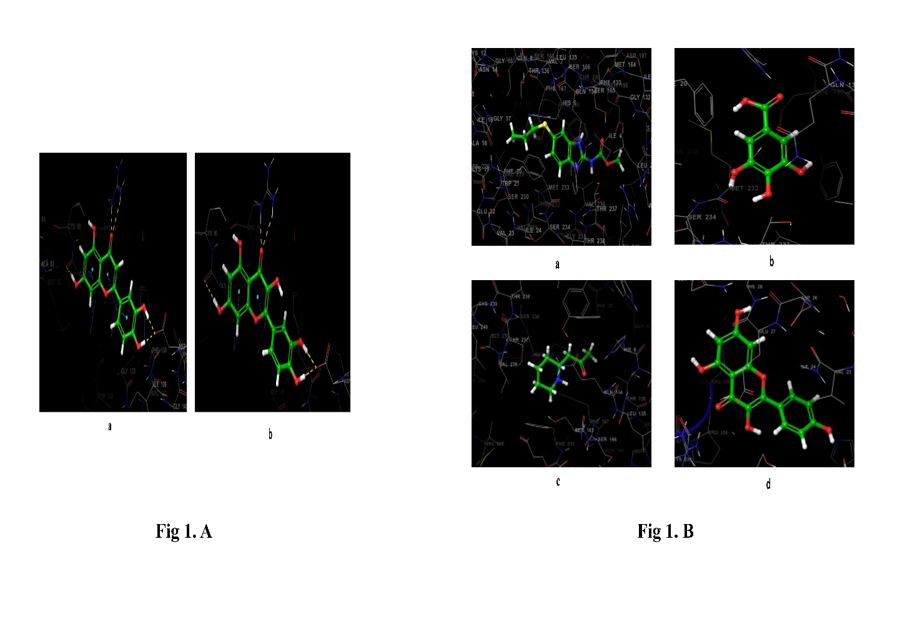

**Fig 1. A:** 3D docking confirmations of a. Luteolin (-5.048) and b. Quercetin (-4.937)

**Fig 1. B:** 3D docking confirmations of a. Albendazole (-7.999), b. Gallic acid (-6.925),

c. Pelletierine (-6.311) and d. Kaempferol (-5.248) respectively.

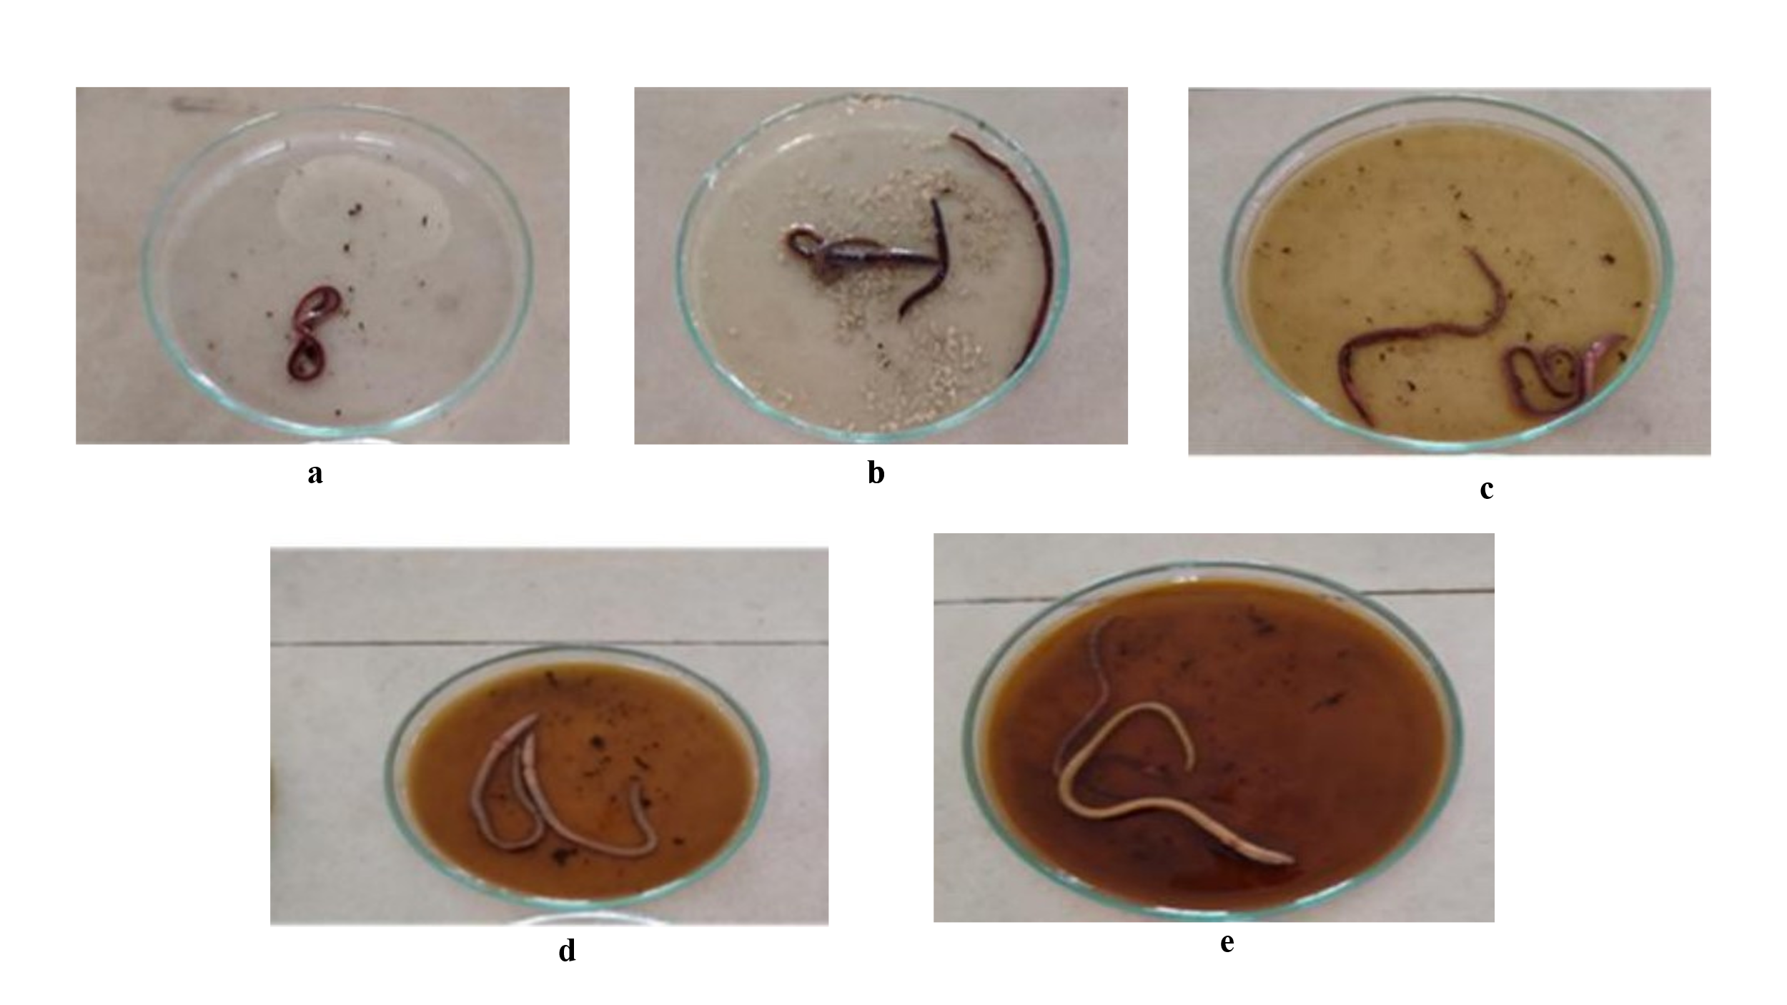

**Fig 2:** a, b, c, d and e are the concentrations of Control, Albendazole, 10mg/ml, 20mg/ml and 30mg/ml respectively.

**Tables and Figure title and legend:**

Table 1: Docking score and other descriptors of chemical constituents with protein 3VRA and 1OJ0

**Table No. 2: Anthelminthic activity of butanoic extract of *Punica granatum* of leaves, peel.**

All data is shown as Mean SEM after a one-way ANOVA and Dunnett's test n= 5, * p<0.05, ** p<0.01, *** p<0.001

**Fig 1. A:** 3D docking confirmations of a. Luteolin (-5.048) and b. Quercetin (-4.937).

**Fig 1. B:** 3D docking confirmations of a. Albendazole (-7.999), b. Gallic acid (-6.925),

c. Pelletierine (-6.311) and d. Kaempferol (-5.248) respectively.

**Fig 2:** a, b, c, d and e are the concentrations of Control, Albendazole, 10mg/ml, 20mg/ml and 30mg/ml respectively.