**MILK THISTLE AS LIVER CLEANSER**

**Author**

**Priyanka S. Somkuwar Isha R. Singh Achal D. Rahate**

**(Assistant Professor) (student) (student)**

**Shri sadguru datta institute of pharmacy**

|  |
| --- |
| *ABSTRACT: This present review is focused on medicinal importance of milk thistle.it is a gold medicinal herb in traditional folk medicine for treatment of liver diseases and other health benefits. Silymarin is active constituents of milk thistle mainly present seeds which contain three Flavonolignans viz. silychristin, silybinin, and silidianin. Milk thistle seed extract (silymarin) and its constituents (mainly silibinin) act as liver tonic, hepatoprotective, cirrhosis, treating liver poisoning and other health beneficial like in blood disease, mushroom poisoning, lactation etc. Milk thistle seed is very promising herbal drug. More research is warranted to substantiate its broad ranging phytotherapeutic effects.* |

**KEY WORDS:** Milk thistle ,Silymarin,, Liver cleanser, Liver detoxification, Liver disease.

**INTRODUCTION:** The European native milk thistle was brought to North America by the first settlers. Asia, Africa, Australia, South America, and the eastern United States are all home to milk thistle plants. The terms "silymarin" and "milk thistle" are frequently used synonymously**.**

*Silybum marianum (L.) Gaertn*. is a member of the Asteraceae family; it was formerly known as *Carduus marianus.* This herbaceous plant has some unique therapeutic qualities and can serve as a host for certain infections. The white veins on the leaves make it simple to recognize the plant (Figure 1). The purple blossoms are produced at the branch's tip (Figure 2). (Figure 3 ) show that the seeds are black to dark brown in color and have white, silky pappus on them shown in( figure 4) .

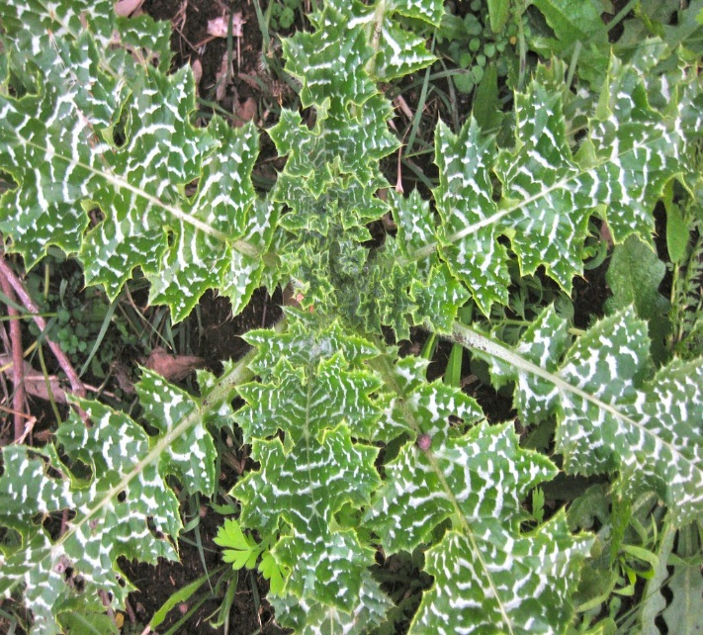

**FIGURE.1**

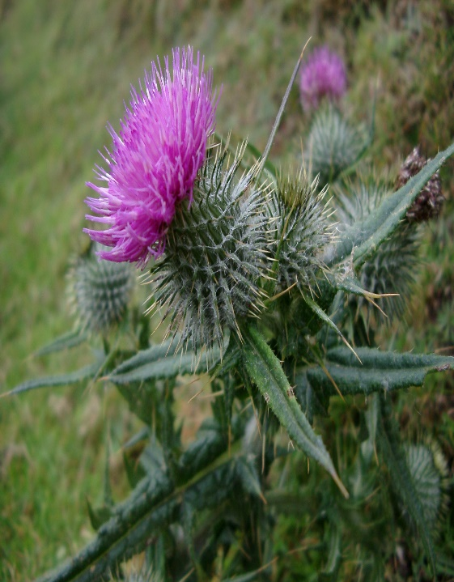

**FIGURE.2**

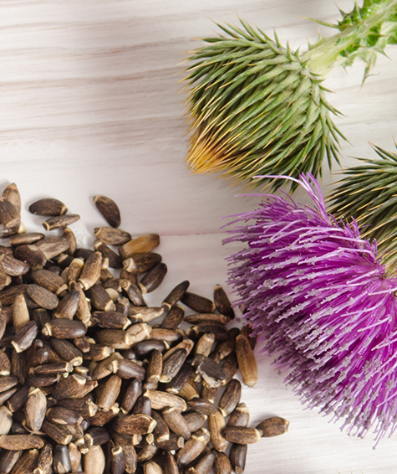 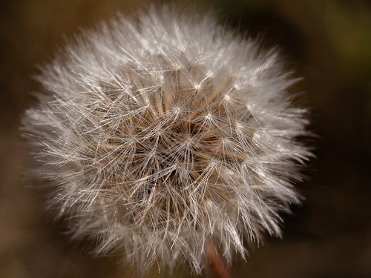

**FIGURE.3 FIGURE.4**

The distinctive feature of the milk thistle flower head is the thick, leathery bracts that are ¾ to 2 inches long and have stiff spines at the tips, setting it apart from other thistles. The seeds are round, smooth, shiny, hefty, and ¼ inch long. They have a tuft of minutely barbed bristles that is deciduous and falls off in a ring when the seeds develop. The color of the seeds varies from black to brown mottled.

Milk thistle has long been used by people to treat gallbladder and liver issues. According to experts, silymarin is the herb's main active component. Milk thistle seeds are a source of the antioxidant chemical silymarin. It's occasionally used as a natural cure for conditions like cirrhosis, jaundice, hepatitis, and gallbladder issues, though it's unknown what advantages, if any, it may have in the body.

For thousands of years, people have utilized the seeds of the milk thistle plant as a herbal treatment, primarily for ailments of the liver. The medicinal and health-promoting properties of milk thistle seeds are mediated by multiple molecular pathways. The medicinal and health-promoting properties of milk thistle seeds are mediated by multiple molecular pathways.

**HISTORY:** The origin of the name "milk thistle" is rooted in the legend of the Virgin Mary, who took refuge behind the prickly leaves of the plant while tending to the infant Jesus. The characteristic white veins on milk thistle leaves are the result of a drop of Mary's milk falling**.** Dioscorides is credited with the first known usage of milk thistle, when he suggested using the herb to heal snake bites. The plant's juice combined with honey was recommended for "carrying off bile," according to Pliny the Elder .The British herbalist Culpepper utilized milk thistle to treat liver blockages after it was first prized as a cure for liver poisons in the Middle Ages. The herb was found to be beneficial for "congestion" of the liver, spleen, and kidney by eclectic doctors Felter and Lloyd in 1898.

**TAXANOMIC HIERARCHY:**

|  |
| --- |
| Kingdom _ Plantae |
| Subkingdom – Viridaeplantae |
| Infrakingdom –Streptophyta |
| Division – Tracheophyta |
| Subdivision – Spermatophytina |
| Infradivision – Angiospermae |
| Class – Magnoliopsida |
| Superorder – Asteranae |
| Order – Asterales |
| Family – Asteraceae |
| Genus – *Silybum* |
| Species – *Silybum marianum (L.) Gaertn*. |

**PHYTOCHEMISTRY:**

**1.FLAVONOIDS:**

Several flavonolignans, including silybin, dehydrosilybin, isosilybin, silydianin, and silicristin, are combined to form silymarin; silybin has the largest concentration of these substances. Silymarin compounds are commonly referred to as flavonolignans. The compound's molecular structure can be divided into two components based on even its fundamental name: hybrid and non-conventional lignans, which belong to the silymarin compounds group more appropriately. Because flavonolignans' core structure has several symmetrical centers, they are naturally found as stereoisomers. Figure 1 described the chemical structure of milk thistle.

According to scientific literature, taxifolin, silybin A and B, silychristin, isosilychristin, silydianin, and silychristin are the principal silymarin compounds. Iso- and trans-diastereoisomers of silibinin (silybin A and B) and isosilibin (issilybin A and issilybin B) that exist naturally. The different biological components of silymarin are composed of 10% silydianin, 5% isosilybin, and between 10% and 30% of an unknown organic polymer fraction. Other flavanols such kaempferol, quercetin, taxifolin, 2,3-dehydrosilybin (DHSB), and others are also present in trace amounts.

**2.OIL COMPONENTS:**

Milk thistle seed oil contains a high concentration of unsaturated fatty acids, particularly oleic and linoleic acid, which are good for human health since they can prevent cancer, diabetes, and arteriosclerosis. A significant percentage of S. marianum achenes are made up of oil compounds, perhaps 25% to 30%, of which 46.46% ± 0.26% is made up of linoleic acid.

**3.SILYBIN CHEMISTRY:**

Pelter and Hansel initially determined the chemical structure of silybin in 1968 through a thorough analysis of 1H-NMR (100 MHz, DMSO-d6) and MS spectra; however, in 1975, the same researchers used a degradative approach to identify the absolute silybin configuration at positions C-2 and C-3. The chemical formula of silybin, also known as flavobin, silliver, silybine, silymarin I, silybina, and silybin, is C25H22O10; its CAS number is 22888-70-6. There are two primary components to the silybin structure. The first is based on a flavononol group found in flavonoids called a taxifolin. Conyferil alcohol is an example of a phenyllpropanoid unit, which is the second. An oxeran ring connects these two components to form a single structure.

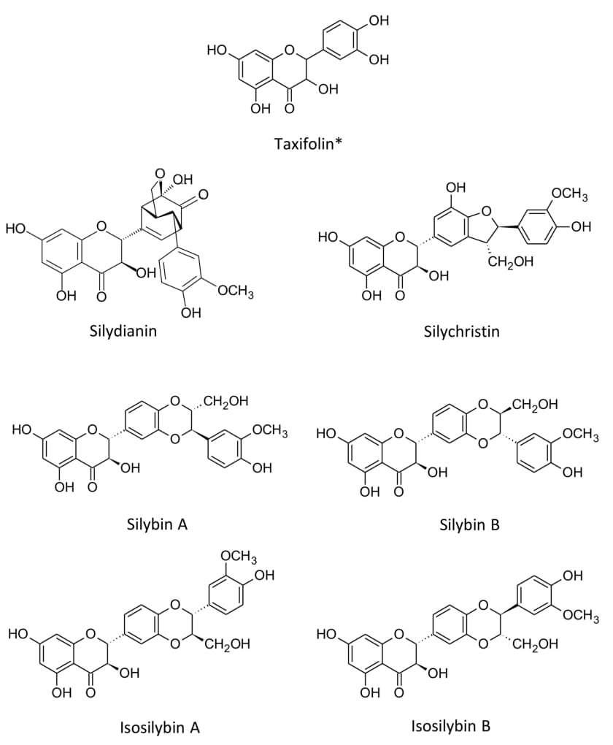

**FIGURE 5- CHEMICAL STRUCTURE OF MAJOR CONSTITUENT OF SILYMARIN**

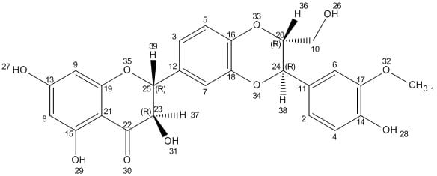

**FIGURE.6 STRUCTURE OF SILYMARIN**

**USES OF MILK THISTLE:**

**1.EFFECT ON LIVER**:

Milk thistle seeds have been used for liver protection since the first century. One of the crucial elements of hepatoprotection is antioxidant activity. Potential to be antihepatotoxic: Silymarin shields animal and human liver cells from a variety of hepatotoxins. Amanita phalloides, the death cup fungus, and A. virosa are among the mushrooms that contain toxins called phalloidine and α-amanatine. These toxins cause serious damage to the liver and even death by destroying the cell membrane of the hepatocyte and preventing the formation of liver proteins.

For many centuries, milk thistle extracts have been used as "liver tonics”.Since the 1970s, research has been done in various nations on the biological activity of silymarin and its potential medical applications; nevertheless, the quality of the research has varied. There are reports that milk thistle protects the liver and significantly enhances its function. Generally speaking, it is used to treat gallbladder issues, liver cirrhosis, chronic hepatitis (liver inflammation), toxin-induced liver damage (particularly preventing severe liver damage from Amanita phalloides, or "death cap" mushroom poisoning).

The ability of silymarin to scavenge free radicals and increase cellular glutathione levels is the main source of its hepatoprotective effects. These effects lead to higher membrane stability and the prevention of lipid peroxidation when exposed to xenobiotics. Furthermore, silymarin inhibits the development of stellate hepatocytes into myofibroblasts and regulates nuclear expression, both of which reduce the amount of collagen fibers that are deposited. This gives silymarin steroid-like properties. Furthermore, silymarin and silybinin, the primary constituent, stimulate RNA polymerase I, hence enhancing ribosomal protein production.

|  |  |
| --- | --- |
| ETIOLOGY | LIVER DISEASE STAGE |
| Viral hepatitis | Acute,Chronic,Liver failure,and cirrhosis |
| Alcoholic liver disease | Acute,Chronic,Liver failure,and cirrhosis |
| Nonalcoholic liver disease | Acute,Chronic, and cirrhosis |
| Cholestasis | Pregnancy and nonpregnancy related |
| Drug and toxin-induced liver disease | Acute,Chronic,liver failure,and cirrhosis |
| Primary liver malignancy | Hepatocellular carcinomaand cholangiocarcinoma |

**TABLE 1. LITERATURE EVIDENCE ON THE CLINICAL APPLICATION OF MILK THISTLE IN THE TREATMENT OF DIFFERENT LIVER DISEASE**

**2. EFFECT ON LIVER TOXICITY**

Numerous scientific studies indicate that components of milk thistle, particularly a flavonoid known as silymarin, shield the liver from toxins and medicines like acetaminophen (Tylenol), which when taken in excess can harm the liver. Silymarin contains anti-inflammatory and antioxidant qualities.

**3.OTHER USES :**

**1)USE IN BLOOD DISORDER**

A blood disorder called beta-thalassemia that causes the blood's levels of the protein hemoglobin to drop. Preliminary research on children with this blood condition suggests that using a specific milk thistle extract for six to nine months along with normal medical care may help lower iron levels more effectively than standard care alone.

**2)USE IN MUSHROOM POISOING**

According to preliminary studies, administering the milk thistle compound silibinin may reduce liver damage resulting from poisoning with Amanita phalloides, also known as death cap mushrooms. Still, it is difficult to find silibinin in the United States. Hospitals and medical facilities frequently use milk thistle as an antidote for Death Cap mushroom poisoning. It has been demonstrated that intravenous Milk Thistle, administered in a timely manner, will reduce the fatality rate of this fungal infection.

**3)USE IN LACTATION**

MT has historically been used by nursing mothers to promote the production of milk, and recent research has shown that it also increases lactation in women and cows. The MT mechanism of action hasn't been determined yet, though. The primary lactogenic hormone is prolactin, and MT was found to dramatically raise prolactin levels in the bloodstream of female rats .Dopamine D2 receptors appear to be involved in this impact, at least in part. Based on these findings, MT, also known as silymarin, may be a viable option for treating lactation insufficiency.

**ADVERSE EFFECT**

The following are side effects of ingesting milk thistle orally: digestive issues such as gas, nausea, diarrhea, dyspepsia, bloating, fullness, or pain in the abdomen, anorexia, and changes in bowel patterns. ache.

Skin responses, include eczema, rash, pruritus, and urticaria. occurrences related to neuropsychology, such as malaise, sleeplessness, and asthenia.

Pain in the joints. contact lens irritation. impotence. Anaphylaxis

Still, few of the publications that are currently accessible discuss causality. The incidence of side effects was roughly identical in the control and milk thistle groups for randomized trials that reported them**.**

**CONCLUSION:**

A useful natural medicine for promoting liver health and cleansing is milk thistle. It is a powerful liver cleaner due to its hepatoprotective qualities, antioxidant activity, and capacity to encourage liver cell regeneration. The benefits of milk thistle as a liver cleanser are well-established, and when used under medical supervision, it can be a helpful supplement to conventional treatments, though additional research is necessary**.** According to the outlook for the future Research on milk thistle is promising; it is being done to see if it can be fully utilized to treat liver disease and improve general health.

**REFERENCES**

1. Medically Reviewed by Minesh Khatri, MD on September 11, 2023Written by WebMD Editorial Contributors.
2. *M. C. Sidhu, Punima Saini2 SILYBUM MARIANUM: A PLANT OF HIGH MEDICINAL IMPORTANCE-A REVIEW World Journal of Pharmaceutical Research Volume 1, Issue 2, 72-86. Review Article.
3. Sanjib Bhattacharya* Phytotherapeutic properties of milk thistle seeds: An overview Bengal School of Technology (A College of Pharmacy), Delhi Road, Sugandha, Hooghly 712102, West Bengal, India*Corresponding author: [sakkwai@yahoo.com](mailto:sakkwai@yahoo.com) Journal of Advanced Pharmacy Education & Research 1:69-79 (2011).
4. Ajit Kiran Kaur*1, A.K.Wahi 2, Brijesh kumar 1, Anil Bhandari 1, Neelkant Prasad3 MILK THISTLE (SILYBUM MARIANUM) : A REVIEW International Journal of Pharma Research and Development – Online [www.ijprd.com](http://www.ijprd.com).
5. Xiaozhuang Zhang, Meiqi Liu A review of the botany, phytochemistry, pharmacology, synthetic biology and comprehensive utilization of Silybum marianum Front. Pharmacol., 11 July 2024 Sec. Ethnopharmacology Volume 15 - 2024 |
6. Abenavoli, L., Capasso, R., Milic, N., and Capasso, F. (2010). Milk thistle in liver diseases: past, present, future. Phytother. Res. 24 (10), 1423–1432. doi:10.1002/ptr.3207
7. Abenavoli, L., Izzo, A. A., Milić, N., Cicala, C., Santini, A., and Capasso, R. (2018). Milk thistle (Silybum marianum): a concise overview on its chemistry, pharmacological, and nutraceutical uses in liver diseases. Phytother. Res. 32 (11), 2202–2213. doi:10.1002/ptr.6171
8. Alarcon de la Lastra, C., Martin, M. J., and Marhuenda, E. (1992). Gastric anti-ulcer activity of silymarin, a lipoxygenase inhibitor, in rats. J. Pharm. Pharmacol. 44 (11), 929–931. doi:10.1111/j.2042-7158.1992.tb03239.x
9. Arnone, A., Merlini, L., and Zanarotti, A. (1979). Constituents of Silybum marianum. Structure of isosilybin and stereochemistry of silybin. J. Chem. Soc. Chem. Commun. (16), 696–697. doi:10.1039/C39790000696
10. Silymarin: a review on paving the way towards promising pharmacological agent Muhmmad Nadeem Akhtar,Rabia Saeed,Farhan Saeed,Aasma Asghar,Samia Ghani,Huda Ateeq, show all Pages 2256-2272 | Received 03 Mar 2023, Accepted 23 Jul 2023, Published online: 13 Aug 2023 Cite this article <https://doi.org/10.1080/10942912.2023.2244685>
11. Newman, D. J.; Cragg, G. M. Natural Products as Sources of New Drugs from 1981 to 2014. J. Nat. Prod. 2016, 79(open in a new window)(3(open in a new window)), 629–661. DOI: 10.1021/acs.jnatprod.5b01055.
12. Tewari, D.; Nabavi, S. F.; Nabavi, S. M.; Sureda, A.; Farooqi, A. A.; Atanasov, A. G.; Bishayee, A.; Sethi, G.; Bishayee, A. Targeting Activator Protein 1 Signaling Pathway by Bioactive Natural Agents: Possible Therapeutic Strategy for Cancer Prevention and Intervention. Pharmacol. Res. 2016, 128(open in a new window), 366–375. DOI: 10.1016/j.phrs.2017.09.014
13. Ferreira, I. C.; Martins, N.; Barros, L. Phenolic Compounds and Its Bioavailability: In vitro Bioactive Compounds or Health Promoters? Adv. Food Nutr. 2017, 82, 1–44. Academic Press
14. Constituents and thermal properties of milk thistle seed oils extracted with three methods Author links open overlay panel Zhen-Shan Zhang a Cite <https://doi.org/10.1016/j.lwt.2020.109282>
15. I.A.M. Ahmed et al.Effects of cold-press and soxhlet extraction systems on antioxidant activity, total phenol contents, fatty acids, and tocopherol contents of walnut kernel oils Journal of Oleo Science(2019)
16. J. Andrzejewska et al.Silybum marianum: Non-medical exploitation of the species Annals of Applied Biology(2015)
17. Sanjib Bhattacharya Chapter 90 - Milk Thistle (Silybum marianum L. Gaert.) Seeds in Health Nuts and Seeds in Health and Disease Prevention 2011, Pages 759-766 <https://doi.org/10.1016/B978-0-12-375688-6.10090-8>
18. Ludovico Abenavoli Milk thistle in liver diseases: past, present, future Phytotherapy Research/Volume 24, Issue 10 <https://doi.org/10.1002/ptr.3207>
19. An insight into medicinal and therapeutic potential of Silybum marianum (L.) Gaertn - Scientific Figure on ResearchGate. Available from: <https://www.researchgate.net/figure/Taxonomic-Hierarchy-of-Silybum-marianum-L-Gaertn_tbl1_303628218>
20. Milk thistle Silybum marianum; St. Mary's thistle <https://www.mountsinai.org/health-library/herb/milk-thistle>
21. Chambers 2017 Mastron 2015 Medically reviewed by Drugs.com. Last updated on Mar 21, 2024.
22. Janice Post-White, RN, PhD, FAAN, Elena J. Ladas, MS, RD, and Kara M. Kelly, MD Advances in the Use of Milk Thistle (Silybum marianum) INTEGRATIVE CANCER THERAPIES 6(2); 2007
23. Michal Bijak Silybin, a Major Bioactive Component of Milk Thistle (Silybum marianum L. Gaernt.)—Chemistry, Bioavailability, and Metabolism Molecules. 2017 Nov; 22(11): 1942. Published online 2017 Nov 10. doi: 10.3390/molecules22111942 PMCID: PMC6150307PMID: 29125572 <https://www.ncbi.nlm.nih.gov/pmc/articles/PMC6150307/>
24. Silybin, a Major Bioactive Component of Milk Thistle (Silybum marianum L. Gaernt.)—Chemistry, Bioavailability, and Metabolism - Scientific Figure on ResearchGate. Available from: <https://www.researchgate.net/figure/Chemical-structure-of-silybin-Structure-generated-from-InChI-code-from-http-pubchem_fig2_320995815>
25. Sanjib Bhattacharya* Phytotherapeutic properties of milk thistle seeds: An overview Journal of Advanced Pharmacy Education & Research 1:69-79 (2011)
26. Tahreem Riaz Milk thistle: A review of its phytochemistry, pharmacology and conventional uses <https://www.researchgate.net/publication/375239076_Milk_thistle_A_review_of_its_phytochemistry_pharmacology_and_conventional_uses>
27. Ludovico Abenavoli1 ,Angelo A. Izzo2 Milk thistle (Silybum marianum): A concise overview on its chemistry, pharmacological, and nutraceutical uses in liver diseases.
28. Artichaut Sauvage Milk Thistle - Uses, Side Effects, and More <https://www.webmd.com/vitamins/ai/ingredientmono-138/milk-thistle>
29. Ludovico Abenavoli, Raffaele Capasso, Natasa Milic, Francesco Capasso. MILK THISTLE IN LIVER DISEASES: PAST, PRESENT, FUTURE. Phytotherapy Research, 2010, 24 (10), pp.1423.ff10.1002/ptr.3207ff. ffhal-00599834ff
30. C Mulrow, V Lawrence, B Jacobs, C Dennehy, J Sapp, G Ramirez, C Aguilar, K Montgomery, L Morbidoni, JM Arterburn, E Chiquette, M Harris, D Mullins, A Vickers, and K Flora.21Milk Thistle: Effects on Liver Disease and Cirrhosis and Clinical Adverse Effects: Summary Current as of 2000.