**Development and Validation of RP-HPLC Method for Determination**

**of Leniolisib in Pharmaceutical Dosage Form**

G. Sai Teja\*, D. Archana, B. Srinu, SK. Abbas Ali, S. Siva Narayana Reddy, B. Divya, P. Srinivasa Babu, P. Ravi Sankar\*

Department of Pharmaceutical Analysis, Vignan Pharmacy College, Vadlamudi, Guntur, A.P, India.

**\*Corresponding author’s E-mail: banuman35@gmail.com**

**ABSTRACT**

A rapid, precise, and sensitive reverse phase high-performance liquid chromatography (HPLC) method has been successfully developed for the quantitative analysis of Leniolisib in pharmaceutical dosage forms. Chromatographic separation was achieved on a Waters Alliance e-2695 HPLC system, employing a Waters X-Terra RP- C18 column (150 x 4.6 mm, 3.5µ) with a mobile phase consisting of 1mL triethylamine (TEA) dissolved in 1 litre of HPLC water at pH 2.5, mixed with orthophosphoric acid (OPA) and acetonitrile (ACN) in a ratio of 60:40 % v/v. The flow rate was set at 1.0 mL/min, and detection was performed at 222 nm using a photodiode array detector at ambient temperature. The chromatographic parameters, including the number of theoretical plates (NLT 2000) and tailing factor (not exceeding 2), were within acceptable limits for Leniolisib. The % relative standard deviation of peak areas for all measurements was consistently less than 2.0, indicating high precision. The proposed HPLC method was validated according to ICH guidelines, demonstrating its simplicity, cost-effectiveness, suitability, precision, accuracy, and robustness for the quantitative analysis of Leniolisib.

**Keywords: Method Development, Validation, HPLC, Leniolisib.**

**INTRODUCTION:**

The IUPAC name of Leniolisib [1] is 1-[(3S)-3-[[6-[6-methoxy-5-(trifluoromethyl) pyridin-3-yl]-7,8-dihydro-5H-pyrido[4,3-d] pyrimidine-4-yl] amino] pyrrolidine-1-yl] propane-1-one, with a molecular formula of C21H25F3N6O2 and a molecular weight of 450.5 g/mol. It is prescribed for treating activated phosphoinositide 3-kinase delta syndrome [3-7] (APDS), a genetic condition that weakens the immune system, leading to recurrent infections, swollen lymph nodes and spleen, and a specific type of lymphoma, in adults and children aged 12 and above.

Leniolisib demonstrates pH-dependent solubility, being less soluble at higher pH values (≥5), with a solubility range from pH 1.2 to 4. Its effective half-life is approximately seven hours, while the apparent terminal elimination half-life is around 10 hours.

Literature review indicates the absence of HPLC methods and the existence of only one UV method[2] for Leniolisib analysis. Hence, this study aims to develop a straightforward, sensitive, rapid, and accurate RP-HPLC method for Leniolisib estimation. The analytical method will undergo validation following the guidelines outlined by the International Council for Harmonisation of Technical Requirements for Pharmaceuticals for Human Use (ICH).



**Figure 1: Molecular structure of Leniolisib**

**MATERIALS AND METHODS:**

**HPLC Method Development for Leniolisib**

**Instrumentation and chemicals and reagents:**

In our High-Performance Liquid Chromatography (HPLC) setup, we employ a state-of-the-art Acquity system from Waters as our primary chromatographic apparatus. This is complemented by essential instrumentation including a pH meter by Eutech for accurate pH measurements, a precise weighing balance from Sartouris for sample preparation, and a UV/VIS spectrophotometer (UV-1700) for detection purposes. We utilize a range of laboratory glassware such as pipettes, beakers, and burettes sourced from Borosil to facilitate our analytical procedures. Additionally, we employ an Ultra sonicator (UCA 701) from Unichrome to ensure thorough sample dissolution and homogeneity. Our system is driven by an Isocratic model pump, providing consistent flow rates throughout our analyses.

For our HPLC method, we utilize high-quality chemicals sourced from reputable manufacturers. Our solvents include Acetonitrile and Milli-Q water, ensuring the purity required for HPLC-grade analysis. We employ Tri Ethyl amine and Ortho Phosphoric acid as mobile phase modifiers to optimize separation and detection sensitivity. These chemicals are of HPLC grade, sourced from Rankem and Merck, guaranteeing the reliability and reproducibility of our results. Our meticulous attention to both instrumentation and chemical selection underscores our commitment to achieving precise and accurate chromatographic separations in our analytical endeavours. Chromatographic separation was performed on Thermo-scientific model C18 column (4.6 mm i.d. X 250 mm; 5 μm particle size) (based on 99.99 % ultra-high purity silica). using mobile phase that consisting of acetonitrile: Triethylamine pH-2.5/OPA (40:60 v/v) at a flow rate of 1.0 mL/min, the runtime was set for 6 min and the eluted drug was detected at 222 nm with PDA detector. The sample injection volume was 0 μL. The column was maintained at a constant temperature of about 25 0C.

**Method development and optimization of chromatographic conditions**

For HPLC development, various mobile phases containing HPLC grade water, acetonitrile, Tri ethyl amine in different ratios with buffers like pH-2.5/ortho phosphoric acid, and various flow rates were performed. A good symmetrical peak was found when the mobile phase comprising a mixture of acetonitrile: Triethylamine pH-2.5/OPA (40:60 v/v).

**Determination of Working Wavelength (λmax):**

In estimation of the drug isobestic wavelength was used. Isobestic point is the wavelength where the molar absorptivity is the same for the substances that are inter convertible. So, this wavelength was used in estimation of drug accurately. The wavelength of maximum absorption of the solution of the drug in mixture of Acetonitrile and 0.1 % TEA pH-2.5/OPA (40:60) were scanned using PDA Detector within the wavelength region of 200–400 nm against Acetonitrile and 0.1 % TEA pH-2.5/OPA (40:60) as blank. The absorption curve shows isobestic point at 222 nm. Thus 222 nm was selected as detector wavelength for the HPLC chromatographic method. Figure 2 shows the PDA- spectrum of Leniolisib.

**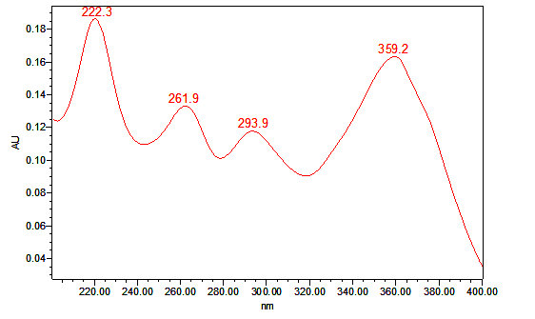**

**Figure 2: PDA - Spectrum of Leniolisib**

**Preparation of Mobile Phase:** Mobile phase was prepared by mixing 0.1 % TEA pH-2.5/OPA and ACN taken in the ratio 60:40. It was filtered through 0.45 μ membrane filter to remove the impurities which may interfere in the final chromatogram.

**Preparation of standard stock solution**

Accurately weigh and transfer 7 mg of Leniolisib working standard into a 10 mL clean dry volumetric flask add diluent and sonicate to dissolve it completely and make volume up to the mark with the same solvent. (Stock solution).

Further pipette 1 mL of the above stock solutions into a 10 mL volumetric flask and dilute up to the mark with diluent. (70 ppm of Leniolisib).

**Sample Solution Preparation:**

Accurately weighed and transfer equivalent to 15.6 mg of Leniolisib sample into a 10 mL clean dry volumetric flask add Diluent and sonicate it up to 30 min to dissolve, and centrifuge for 30 min. to dissolve it completely and make volume up to the mark with the same solvent. Then it is filtered through 0.45-micron Injection filter. (Stock solution).

Further pipette 1 mL of the above stock solutions into a 10 mL volumetric flask and dilute up to the mark with diluent. (70 ppm of Leniolisib)

The Leniolisib peak was observed at 3.978 min with peak area 3037402, tailing factor 1.06. This trial was optimized.

**Method development and optimization** [8]**:**

The optimized HPLC conditions of several mobile phases with different compositions were tested to develop an optimization of chromatographic conditions like tailing factor, peak shape, and the number of theoretical plates. Method optimized chromatographic conditions and system suitability parameters are depicted in Table 1.

**Table 1: Optimized chromatographic conditions**

|  |  |
| --- | --- |
| **PARAMETERS** | **OBSERVATION** |
| Instrument used | Waters Alliance e-2695 HPLC |
| Injection volume | 10 µL |
| Mobile Phase | Acetonitrile and 0.1 % TEA pH-2.5/OPA (40:60) |
| Column | Waters X Terra RP-18150 x 4.6 mm, 3.5 µ. |
| Detection Wave Length | 222 nm |
| Flow Rate | 1 mL/min |
| Runtime | 6 min |
| Temperature | Ambient (25 C) |
| Mode of separation | Isocratic mode |

**METHOD VALIDATION SUMMARY [9-15]:**

**SYSTEM SUITABILITY:**

The system suitability parameters like theoretical plates, retention time, tailing factor, were studied and found satisfactory. The system suitability parameters for Leniolisib results are shown in Table 2.

## 

## Table 2: System suitability parameters for Leniolisib

|  |  |  |
| --- | --- | --- |
| **S. No** | **Parameter** | **Leniolisib** |
| 1 | Retention time | 3.978 |
| 2 | Plate count | 6333 |
| 3 | Tailing factor | 1.06 |
| 4 | % RSD | 0.19 |

\* Average of five determinations, SD = Standard deviation, RSD = relative standard deviation.

**Specificity:**

Specificity of an analytical method is ability to measure specifically the analyte of interest without interference from blank and known impurities. For this purpose, blank chromatogram, standard chromatogram and sample chromatogram were recorded. The chromatogram of blank shows no response at the retention times of drugs which confirms the response of drug was specific. Figure 3 and Figure 4 shows the Chromatogram of placebo and optimized chromatogram respectively.

**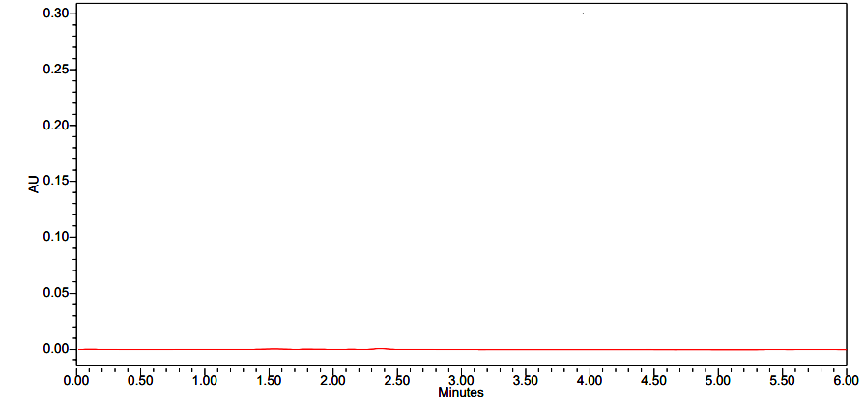**

**Figure 3: Chromatogram of placebo**

**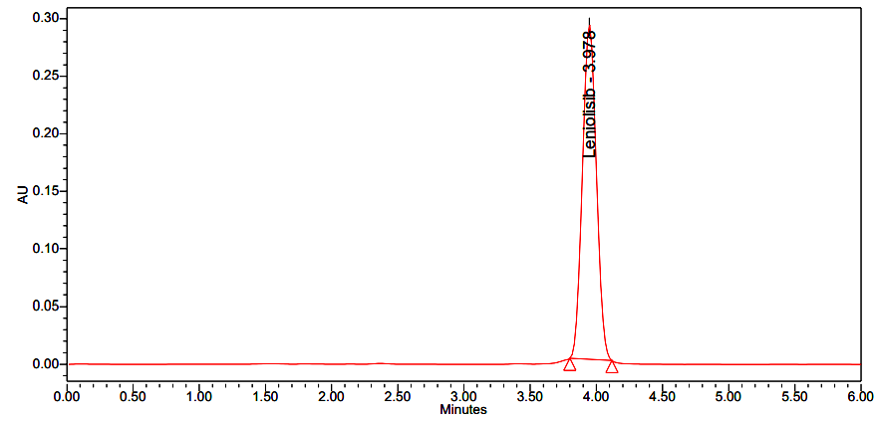**

**Figure 4: Optimized chromatogram**

**PRECISION**

Precision is the degree of repeatability of an analytical method under normal operation conditions. Precision is of 3 types

1. System precision

2. Method precision

3. Intermediate precision (a. Intra-day precision, b. Inter day precision).

**SYSTEM PRECISION**

System precision is checked by using standard chemical substance to ensure that the analytical system is working properly. In this peak area and % of drug of six determinations is measured and % RSD should be calculated. Table 3 shows the system precision of Leniolisib.

**Table 3: System precision of Leniolisib**

|  |  |  |
| --- | --- | --- |
| **S. No** | **Concentration Leniolisib (µg/ml)** | **Area of**  **Leniolisib** |
| 1. | 70 | 3037402 |
| 2. | 70 | 3044073 |
| 3. | 70 | 3032956 |
| 4. | 70 | 3029647 |
| 5. | 70 | 3031617 |
| 6. | 70 | 3041456 |
| Mean |  | 3036192 |
| S. D |  | 5753.665 |
| % RSD |  | 0.19 |

**Method precision & Intermediate precision**

In method precision, a homogenous sample of single batch should be analysed 6 times. This indicates whether a method is giving constant results for a single batch. In this analyse the sample six times and calculate the % RSD.

The precision of the instrument was checked by repeatedly injecting (n=6) solutions of 70 ppm of (Leniolisib). Table 4 and 5 represents the method precision and intermediate precision for Leniolisib.

**Table 4: Method Precision for Leniolisib**

|  |  |
| --- | --- |
| **S. No.** | **Area for Leniolisib** |
| 1 | 3039871 |
| 2 | 3016498 |
| 3 | 3046161 |
| 4 | 3050735 |
| 5 | 3029774 |
| 6 | 3054628 |
| **Average** | 3039611 |
| **Standard Deviation** | 14305.252 |
| **% RSD** | 0.47 |

## Table 5: Intermediate Precision for Leniolisib

|  |  |  |
| --- | --- | --- |
| **S. No.** | **Day 1 Area** | **Day 2 Area** |
| 1 | 3031065 | 3054489 |
| 2 | 3027198 | 3022470 |
| 3 | 3052315 | 3063521 |
| 4 | 3063422 | 3048800 |
| 5 | 3033944 | 3032258 |
| 6 | 3059887 | 3025324 |
| **Average** | 3044639 | 3041144 |
| **Standard Deviation** | 15792.711 | 16824.893 |
| **% RSD** | 0.52 | 0.55 |

## 

**LINEARITY:**

The linearity of Leniolisib was determined in the concentration range of 17.50 to 105.00 μg/mL. The linearity data, calibration curve results are shown in Table 6 and Figure 5 respectively.

**Table 6: Results of linearity for Leniolisib**

|  |  |  |
| --- | --- | --- |
| **S.No.** | **Leniolisib** | |
| **Concentration (µg/mL)** | **Peak area** |
| 1 | 17.50 | 727388 |
| 2 | 35.00 | 1531368 |
| 3 | 52.50 | 2344478 |
| 4 | 70.00 | 3041402 |
| 5 | 87.50 | 3750723 |
| 6 | 105.00 | 4487500 |
| **Regression equation** | y = 42896.33x +16922.29 | |
| **Slope** | 42896.33 | |
| **Intercept** | 16922.29 | |
| **R2** | 0.99969 | |

**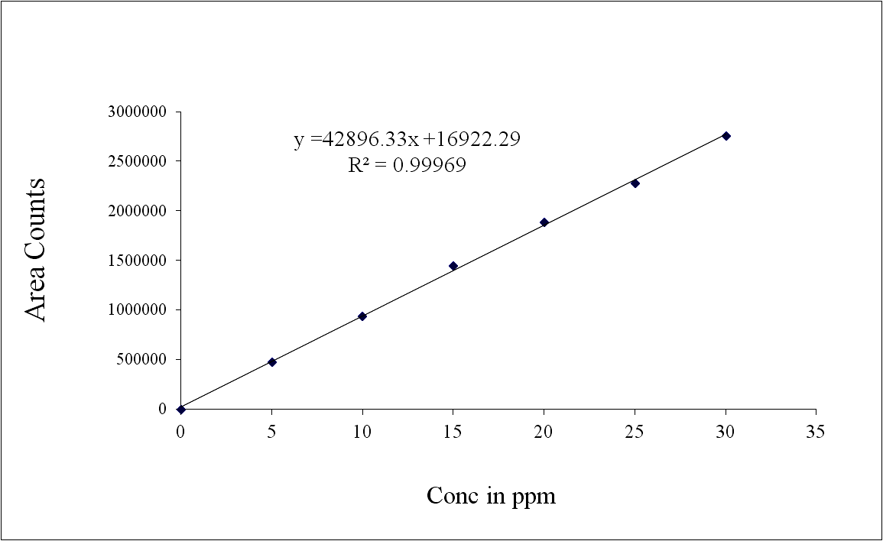**

**Figure 5: Calibration curve for Leniolisib at 222 nm**

**ACCURACY**

A known amount of drug was spiked with placebo at three different levels in triplicate preparations. The samples were then analysed as per the proposed standard method. The accuracy studies are mentioned in Table 7.

**Table 7: Accuracy results of Leniolisib by HPLC method**

|  |  |  |  |  |  |
| --- | --- | --- | --- | --- | --- |
| **Concentration**  **(at specification Level)** | **Area** | **Amount Added**  **(mg)** | **Amount Found**  **(mg)** | **% Recovery** | **Mean %Recovery** |
| 50 % | 1519657 | 3.5 | 3.504 | 99.9 | 100.1 |
| 1527840 | 3.5 | 3.522 | 100.6 |
| 1513462 | 3.5 | 3.490 | 99.7 |
| 100 % | 3035487 | 7.0 | 7.000 | 100.0 | 100.0 |
| 3026114 | 7.0 | 6.980 | 99.7 |
| 3042689 | 7.0 | 7.010 | 100.2 |
| 150 % | 4559758 | 10.5 | 10.510 | 100.1 | 100.0 |
| 4555677 | 10.5 | 10.500 | 100.0 |
| 4542103 | 10.5 | 10.470 | 99.7 |

**ROBUSTNESS:**

The robustness of the method was determined for the system suitability and assay value under variable conditions. The robustness of the analytical method was established by demonstrating its reliability against deliberate changes in the chromatographic conditions. The robustness of the method of Leniolisib is mentioned in Table 8.

**Table 8: Robustness results of Leniolisib by-HPLC**

|  |  |  |  |  |  |  |
| --- | --- | --- | --- | --- | --- | --- |
| **Parameter** | **Leniolisib** | | | | | |
| **Condition** | **Retention time (min)** | **Peak area** | **Tailing** | **Plate count** | **% RSD** |
| Flow rate  Change  (mL/min) | Less flow (0.9 mL) | 4.135 | 2836425 | 1.08 | 6485 | 0.62 |
| Actual flow (1 mL) | 3.978 | 3037402 | 1.06 | 6333 | 0.19 |
| More flow (1.1 mL) | 3.056 | 3114556 | 1.01 | 6263 | 0.43 |
| Organic Phase change | Less Org (36:64) | 4.367 | 2738487 | 1.05 | 6427 | 0.64 |
| Actual (40:60) | 3.983 | 3044073 | 1.03 | 6328 | 0.19 |
| More Org (44:56) | 3.150 | 3335602 | 1.00 | 6229 | 0.59 |

**Acceptance criteria (Limits):** #Peak Asymmetry < 1.5, $ Plate count > 2000, \* Significant change in Retention time

**Limit of detection (LOD) and limit of quantification (LOQ):**

The limit of detection (LOD) limit of quantification (LOQ) of the drug carry was calculated using the following equation as per international conference harmonization (ICH) guidelines.

LOD = 3.3 X σ /S

LOQ = 10 X σ /S

LOD for Leniolisib was found to be 0.21 µg/mL and LOQ for Leniolisib was found to be 0.70 µg/mL.

Limit of Detection is the lowest concentration in a sample that can be detected but not necessarily quantified under the stated experimental conditions. The limit of quantitation is the lowest concentration of analyte in a sample that can be determined with acceptable precision and accuracy. The LOD and LOQ are 0.21 μg/mL and 0.70 μg/mL respectively. Sensitivity parameters of LOD and LOQ are depicted in table 9.

**Table 9: Sensitivity parameters (LOD & LOQ)**

|  |  |  |  |  |
| --- | --- | --- | --- | --- |
| **Name of drug** | **LOD (µg/ml)** | **S/N** | **LOQ (µg/ml)** | **S/N** |
| Leniolisib | 0.21 | 3 | 0.70 | 10 |

**RESULTS AND DISCUSSION**

The above-mentioned Leniolisib is relatively polar, an HPLC method was used. The column for the separation was column Waters X Terra RP-18150 x 4.6 mm, 3.5 µ. Multiple numbers of trials were performed using various buffer solutions with various compositions of methanol, acetonitrile, and HPLC grade water and variable flow rates. Eventually, optimum separation was obtained with a mixture of acetonitrile and Triethylamine (40:60 v/v). The mobile phase flow rate was adjusted at 1mL/min, and the detection wavelength was set at 222 nm. Thus, a proper chromatographic peak was obtained with excellent symmetry and the least peak tailing. The analytical method was validated according to ICH validation parameters [16-17].

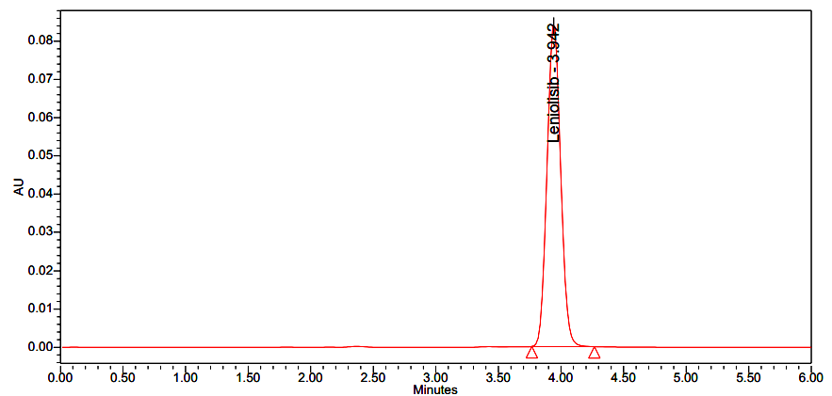

**Figure 6: Standard chromatogram of Leniolisib (17.50 μg/mL)**

**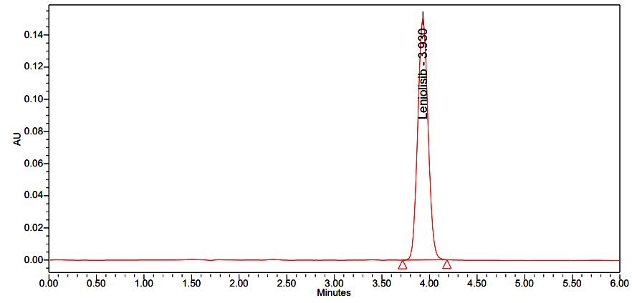**

**Figure 7: Standard chromatogram of Leniolisib (35.00 μg/mL)**

**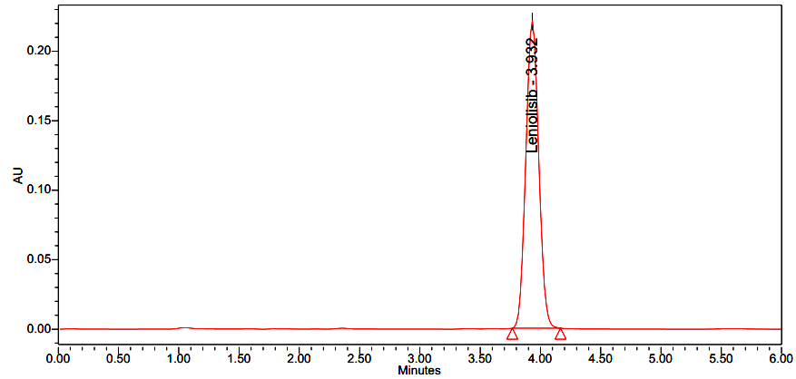**

**Figure 8: Standard chromatogram of Leniolisib (52.50 μg/mL)**

**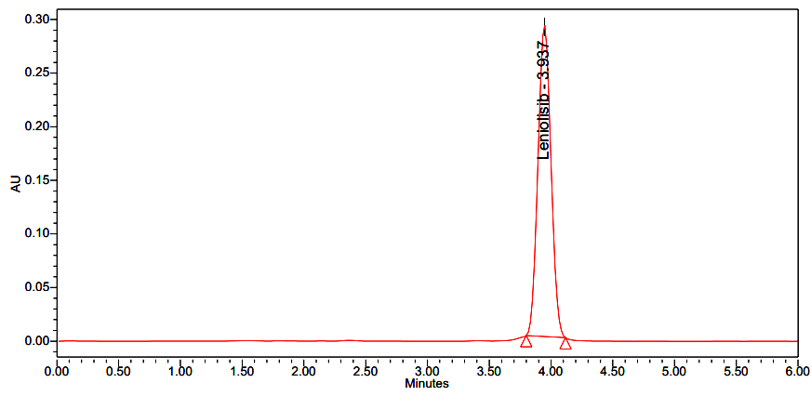**

**Figure 9: Standard chromatogram of Leniolisib (70.00 μg/mL)**

**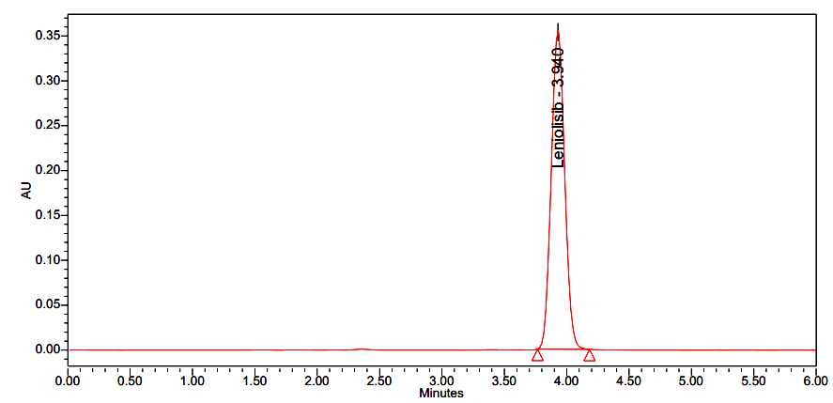**

**Figure 10: Standard chromatogram of Leniolisib (87.50 μg/mL)**

**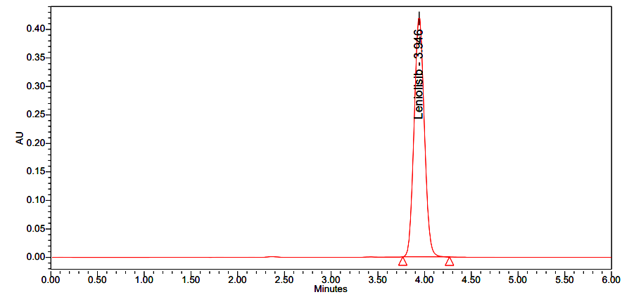**

**Figure 11: Standard chromatogram of Leniolisib (105.00 μg/mL)**

System suitability was conducted as per the methodology system suitability solution, and six replicates of standard preparation were injected into HPLC. The tailing factor was found to be 1.06. The number of theoretical plates was 6333, The retention time was found out to be 3.978 min, and the % RSD was calculated to 0.19. The results were well within the acceptance criteria, and the study concludes the suitability of the analytical system for analysis.

For specificity studies, blank, standard, system suitability, placebo, test preparations, individual impurities, placebo spiked with the analyte, and spiked test preparations were analysed to examine the interference of blank and placebo with Leniolisib peaks. No interference was observed in analyte peaks, and peak purity values comply, thus proving the specificity of the method.

The precision of the method was examined by using System precision, Method, and Intermediate precisions. Various levels of concentration were taken in six replicate samples. For Method and Intermediate precisions, the % RSD was found to be 0.47 and 0.55. The % RSD of the System precision was found to be 0.19. The results are well within the acceptance criteria, and the % RSD observed for the replicate injections indicates the precision of the HPLC used, assay values indicate the precision of the method.

The linearity of Leniolisib was determined in the concentration range of 17.50 μg/mL to 105.00 μg/mL of the test concentration. figure 6 to figure11 shows the standard chromatograms of leniolisib.

The squared correlation coefficient value was found to be 0.99969, which is well within the limit.

To determine the accuracy of the Leniolisib, the drug was spiked with a placebo at three different levels in triplicate preparations. The mean % recovery at each level was found out to be within limits i.e., 50 % to 150 %

The robustness of the HPLC was determined for the suitability and assay value under multiple variable conditions like Flow rate change, Wavelength change, and change in mobile phase composition.

The LOD and LOQ of Leniolisib were found out to be 0.21 μg/mL and 0.70 μg/mL, respectively.

**Application of the developed method for marketed formulation:**

Accurately weigh and transfer 15.6 mg of Leniolisib Sample into a 10 mL clean dry volumetric flask add diluent and sonicate to dissolve it completely and make volume up to the mark with the same solvent. (Stock solution)

Further pipette 1 mL of the above stock solutions into a 10 mL volumetric flask and dilute up to the mark with diluent. (70 ppm of Leniolisib). Table 10 represents the assay of leniolisib. Figure 12 represents the sample chromatogram of Leniolisib.

**Table 10: Assay of Leniolisib**

|  |  |  |  |  |  |  |  |  |  |
| --- | --- | --- | --- | --- | --- | --- | --- | --- | --- |
| **Brand** | **Drug** | **Sample Area** | **Avg sample area**  **(n=5)** | **Std. wt.** | **Sample wt.** | **Label amount (mg)** | **Std purity** | **Amount found (µg/ml)** | **% assay** |
| Joenja | Leniolisib | 3024237 | 3035593 | 7.0 | 15.6 | 70 | 99.9 | 7.0 | 100.0 |
| 3046948 |

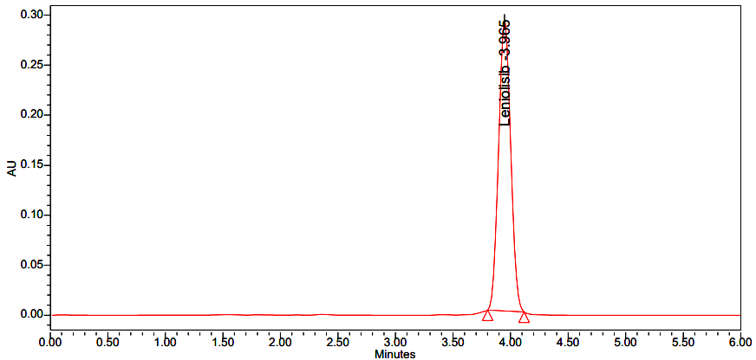

**Figure 12: Leniolisib sample chromatogram**

**CONCLUSION**

In summary, the developed HPLC method for assessing Leniolisib presents numerous advantageous qualities, rendering it highly appropriate for regular laboratory use. This method is characterized by its simplicity, speed, accuracy, precision, resilience, and cost-effectiveness. The preparation of the mobile phase and solvents is straightforward, economical, dependable, sensitive, and time-saving.

Furthermore, the sample recoveries are in line with their respective label claims, suggesting minimal interference from formulation components and ensuring precise estimations. The validation parameters of the HPLC system indicate satisfactory, accurate, and consistent results, enhancing its suitability for routine analysis.

Crucially, the stability-indicating assay method by HPLC demonstrates specificity, with no interference observed from placebo or degradation products, thus confirming its reliability in determining Leniolisib concentrations. Collectively, these findings affirm the applicability of the proposed HPLC method for routine Leniolisib analysis, providing a valuable asset for pharmaceutical laboratories.

**REFERENCES:**

1. Duggan S, Al-Salama ZT. Leniolisib: First Approval. Drugs. 2023;83(10):943-948. doi: 10.1007/s40265-023-01895-4. PMID: 37256490.

1. G. Sai Teja, D. Archana, B. Srinu, SK. Abbas Ali, S. Siva Narayana Reddy, B. Divya, Srinivasa Babu, P. Ravi Sankar P, Development and validation of UV Method for Quantitative Estimation of Leniolisib in pharmaceutical dosage form: IOSR Journal of Pharmacy,2024;14(2):22-29.
2. Rao VK, Webster S, Šedivá A, et al. A randomized, placebo-controlled phase 3 trial of the PI3Kδ inhibitor leniolisib for activated PI3Kδ syndrome. Blood. 2023;141(9):971–983.
3. Klemens Hoegenauer Discovery of CDZ173 (Leniolisib), Representing a Structurally Novel Class of PI3K Delta-Selective Inhibitors ACS Med. Chem. Lett*.* 2017, 8, 9, 975–980.
4. Bloomfield M, Klocperk A, Zachova R, et al. Natural course of activated phosphoinositide 3-kinase delta syndrome in childhood and adolescence. Front Pediatr. 2021. [https://doi.org/10.3389/fped.2021.697706](https://doi.org/10.3389/fped.2021.697706" \t "_blank) . - [DOI](https://doi.org/10.3389/fped.2021.697706) - [PubMed](https://pubmed.ncbi.nlm.nih.gov/34350147/) - [PMC](http://www.ncbi.nlm.nih.gov/pmc/articles/8326455/)
5. Barile, E., De, S. K., Carlson, C. B., Chen, V., Knutzen, C., Riel-Mehan, M., et al. (2010). Design, synthesis, and structure-activity relationships of 3-ethynyl-1H-indazoles as inhibitors of the phosphatidylinositol 3-kinase signalling pathway. J. Med. Chem. 53 (23), 8368–8375. doi:10.1021/jm100825h.
6. Pearson, D., Garnier, M., Luneau, A., James, A. D., and Walles, M. (2019). 19F-NMR-based determination of the absorption, metabolism and excretion of the oral phosphatidylinositol-3-kinase (PI3K) delta inhibitor leniolisib (CDZ173) in healthy volunteers. Xenobiotica 49 (8), 953–960. PMID: 30215545. doi:10.1080/00498254.2018.1523488.
7. P. Ravisankar, S. Gowthami, G. Rao. Devlala. A Review on Analytical Method Development. Indian Journal of Research in Pharmacy and Biotechnology. (2014).9(2):2320 – 3471.DOI: https://doi.org/10.22270/jddt.v9i2.2403.
8. Ravisankar P, Anusha S, Supriya K, Ajith Kumar U, Fundamental chromatographic parameters, Int. J. Pharm. Sci. Rev. Res. 2019; 55(2): 46-50.
9. Sharma Ajay, Sharma Rohit, Validation of analytical procedures: a comparison of ICH vs Pharmacopoeia (USP) and FDA, International research journal of Pharmacy 2012; 3(6): 39-42.
10. Lavanya Chowdary G, Ravisankar P, Akhil Kumar G, Mounika K, Srinivasa Babu, Analytical method validation parameters: An updated review. Int. J. Pharm. Sci. Rev.Res., 2020;61(2):1- 7.
11. Ravi Sankar P, Swathi Vaka, Srinivasa Babu Puttagunta, Shaheem Sulthana Md, Gousepeer SK, Current trends in performance of forced degradation studies and stability indicating studies of drugs, IOSR Journal of Pharmacy and Biological Sciences 2017; 12 (6): 17-36.
12. Ravi Sankar P, Sai Geethika A, Rachana G, Srinivasa Babu P, Bioanalytical method validation: A comprehensive review, Int. J. Pharm. Sci. Rev. Res 2019; 56(1): 50-58.
13. Gaurav Tiwari, Ruchi Tiwari, Bioanalytical method validation: An updated review, Pharm Methods 2010; 1(1):25-38.
14. Nandini Ch, Snehitha M. V, Meghana A, Sathvika K, Anvesh G, Shivani B, Srinivasa Babu, P. Ravi Sankar P, Recent advances and strategies for successful bioanalytical method development and validation: A Comprehensive Review, IOSR Journal of Pharmacy,2023;13(7):1-12.
15. Validation of analytical procedure: Methodology Q2B, ICH Harmonized Tripartite Guidelines 1996; 1-8.
16. ICH harmonized tripartite guideline, validation of analytical procedures: Text and methodology Q2 (R1), (November 2005), International Conference on Harmonization, Geneva, Switzerland.