**A VALIDATED UV SPECTROPHOTOMETRIC METHOD DEVELOPMENT FOR THE ESTIMATION OF TRIAMCINOLONE ACETONIDE TABLET AND INJECTION**

D. Nagavalli*1, J. Jayamathi1, V. Manikandan1

1Department of Pharmaceutical Chemistry, Adhiparasakthi College of Pharmacy, Melmaruvathur – 603319.

Email ID: [saravanamani481@gmail.com](mailto:saravanamani481@gmail.com)

**ABSTRACT:**

In the present work is to established simple, accurate, rapid and validated (as per ICH) spectrophotometric method developed for the quantification of Triamcinolone acetonide (TCA) tablet and injection. In the Spectrophotometric approaches first order derivative method was developed, 10 µg/ml stock standard solution was prepared by dissolving TCA with methanol. The solution was scan in the UV - visible range 200 – 400 nm. First order derivative method was measured at the wavelengths 228 nm. In method TCA followed linearity in the concentration range10 -50 µg/ml, with (r2 = 0.9999). The % purity of the drug in the tablet and injection formulation was found to be good concord with the label claim 99.539 ± 1.5035 and 100.45 ± 1.1206. The precision of the method was confined by the repeated analysis of tablet and injection formulation for six times. The % RSD values was found to be 1.3281 and 1.3478. The % RSD values for tablet and injection accuracy was found to be 0.5706 and 0.4486 respectively.

**Keywords:** Triamcinolone acetonide, Development and Validation, UV spectrophotometric method.

**INTRODUCTION:**

To determine the composition of natural and manufactured chemicals, qualitative analysis was carried out. The purpose of these tests was to determine if the chemical or compound was present in the sample or not [1-3]. Triamcinolone acetonide (TCA) is a corticosteroid with anti-inflammatory properties. These properties are used to treat inflammation in conditions that affect various organs and tissues. Triamcinolone acetonide should not be administered as an epidural injection [4]. The chemical structure of Triamcinolone acetonide shown in Figure. 1. A review of literature reveals that many methods were developed for estimation of TCA but no methods like first order derivative was developed. Hence this project attempts to develop first order derivative for TCA and also method development of UV [5-8]. Finally the developed method was validated as per ICH guidelines.

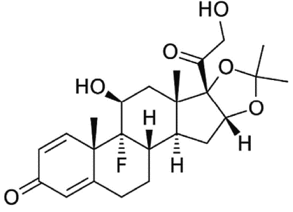

**Figure 1.** Structure of Triamcinolone Acetonide

**MATERIALS AND METHODS:**

Triamcinolone acetonide was gifted by Strides pharma science ltd, Bangalore. Methanol (AR grade and HPLC grade), Acetonitrile (HPLC grade), Water (HPLC grade), Potassium dihydrogen orthophosphate, sodium hydroxide was purchased from Loba Chemie India Ltd, Mumbai and used as such.

**UV Spectrophotometric Method:**

**Selection of solvent:**

The solubility of the drug was determined in a variety of solvent as per IP standards. Solubility was carried out in both polar and non – polar solvent [9]. The solvent was found to be methanol for the analysis of Triamcinolone acetonide for the proposed method.

**Preparation of standard stock solution:**

10 mg of Triamcinolone acetonide was weighed accurately and it transferred in to 100ml volumetric flask then volume was made with methanol up to the mark, the obtaining concentration was 100 µg/ml.

**Selection of wavelength:**

From the standard stock solution, 1ml of solution was transferred in to 10 ml volumetric flask, and volume was made up with the methanol to get concentration of 10 µg/ml. The solution was scanned in UV – visible range 400 – 200 nm using methanol as blank. For derivative spectrophotometric method, zero-order spectra were derivatized into first-order derivative spectra, the maximum absorbance of solution was measured at the wavelength 228 nm.

**Preparation of calibration graph:**

From the standard stock solution, an appropriate amount of aliquots portion in the range of 1-5 ml were transferred into a series of 10 ml volumetric flasks and diluted up to mark using the same solvent to obtain a concentration in the range of 10 – 50 µg/ml. The solutions were scanned in UV- visible range 400 – 200 nm. For derivative spectrophotometric method, the zero-order spectra were derivatized into first-order derivative spectra, the maximum absorbance of solution was measured at the wavelength 228 nm. The calibration curves were

plotted concentration Vs absorbance [10].

**Quantification of the marketed tablet formulation:**

Ten Tablets were weighed, each containing 4 mg of TCA. Tablet powdered equivalent to 10 mg was transferred in to a 10 ml clean and dry volumetric flask and dissolve with 10 ml of methanol. The contents of flask were sonicated for 15 min and methanol was added to made up to mark to get a sample stock concentration of TCA. Filtered the solution. From the filtrate pipetted 1 ml of the above sample stock solution into a 10 ml clean volumetric flask and methanol was added to made up to mark. Then, 2.5 ml was pipetted and diluted to 10 ml using methanol to get 25 µg/ml of TCA. The derivatized values were measured at the wavelength 228 nm. The concentration of the drug was determined form the respective linear regression equations. The procedure was repeated for 6 times for the same concentration.

**Quantification of the marketed injection formulation:**

One Injection, each containing 40 mg of TCA. The content of the drug equivalent to 10 mg was transferred in to a 10 ml clean and dry volumetric flask and dissolve with 10 ml of methanol. The contents of flask were sonicated for 15 min and methanol was added to made up to mark to get a sample stock concentration of TCA. Filtered the solution. From the filtrate pipetted 1 ml of the above sample stock solution into a 10 ml clean volumetric flask and methanol was added to made up to mark. Then, 2.5 ml was pipetted and diluted to 10 ml using methanol to get 25 µg/ml of TCA. The derivatized values were measured at the wavelength 228 nm. The concentration of the drug was determined form the respective linear regression equations. The procedure was repeated for 6 times for the same concentration.

**Recovery studies:**

**Recovery procedure of tablet:**

The recovery studies were done by adding known concentrations of Triamcinolone acetonide raw material to pre-analyzed tablet formulation. The tablet powdered equivalent to 10 mg of triamcinolone acetonide was weighed accurately and transferred into a series of three 10 ml standard flask. To that raw material Triamcinolone acetonide (50%, 75%, and 100%) were added, dissolved with minimum quantity of methanol and made up to the mark with the same solvent. The content was kept in a Sonicator for 15 minutes, after sonication the solutions were filtered through Whatman filter paper no.41 and from the clear solution further dilutions were made by diluting 1 ml to 10 ml volumetric flask with methanol. The derivatized values were measured at the wavelength 228 nm. The procedure was repeated for 6 times for each percentage recovery.

**Recovery procedure of Injection:**

The recovery studies were done by adding known concentrations of Triamcinolone acetonide raw material to pre-analyzed injection formulation. The content of the drug equivalent to 10 mg of triamcinolone acetonide was weighed accurately and transferred into a series of three 10 ml standard flask. To that raw material Triamcinolone acetonide (50%, 75%, and 100%) were added, dissolved with minimum quantity of methanol and made up to the mark with the same solvent. The content was kept in a Sonicator for 15 minutes, after sonication the solutions were filtered through Whatman filter paper no.41 and from the clear solution further dilutions were made by diluting 1 ml to 10 ml volumetric flask with methanol. The derivatized values were measured at the wavelength 228 nm. The procedure was repeated for 6 times for each percentage recovery.

**Validation of developed method:**

**Linearity:**

The aliquots of five different concentration ranging 10 – 50 µg/ml were prepared and calibration curve was plotted between concentration Vs first order derivative absorbance. The linearity was calculated by the least square regression method and calculated optical parameters.

**Accuracy:**

Accuracy is the nearness between the expected value and the value found. It is determined by applying the method to sample to which known amount of analyte has been added. In this case, to evaluate the accuracy of the developed method, successive analysis (n = 6) for three different concentrations. For each concentration, the procedure was repeated for six times and calculated the %RSD value.

**LOD and LOQ:**

LOD is a smallest quantity of analyte that can be detected in a sample. The quantitation limit is a lowest amount of analyte which can be quantified in a sample with the suitable accuracy and precision. These two parameters were calculated using the formula LOD = 3.3 × SD/S and LOQ = 10 × SD/S.

**Precision:**

Precision should be investigated using homogeneous and authentic sample. It consists of repeatability and intermediate precision. The intraday and inter day precision was determined by analyzing of six replicates of same concentration in same day and on three continuous days. The drug amount was estimated and calculated % RSD value.

**Ruggedness:**

Ruggedness is the measure of reproducibility of the test results obtained for identical samples under normal (but variable) test conditions. In the present study, determination of triamcinolone acetonide was carried out by using different analysts and different instruments and it was carried out in formulation.

**RESULT & DISCUSSION:**

From the solubility profile, methanol was chosen as the common solvent for the analysis of Triamcinolone acetonide. The aliquots of five different concentration ranging from 10 – 50 µg/ml were prepared and calibration curve was plotted between concentration Vs first order derivative absorbance. The correlation coefficient values for the Triamcinolone acetonide were found to be 0.9999. Hence the concentration was found to be linear.

**Figure 2. Maximum wavelength of TCA**

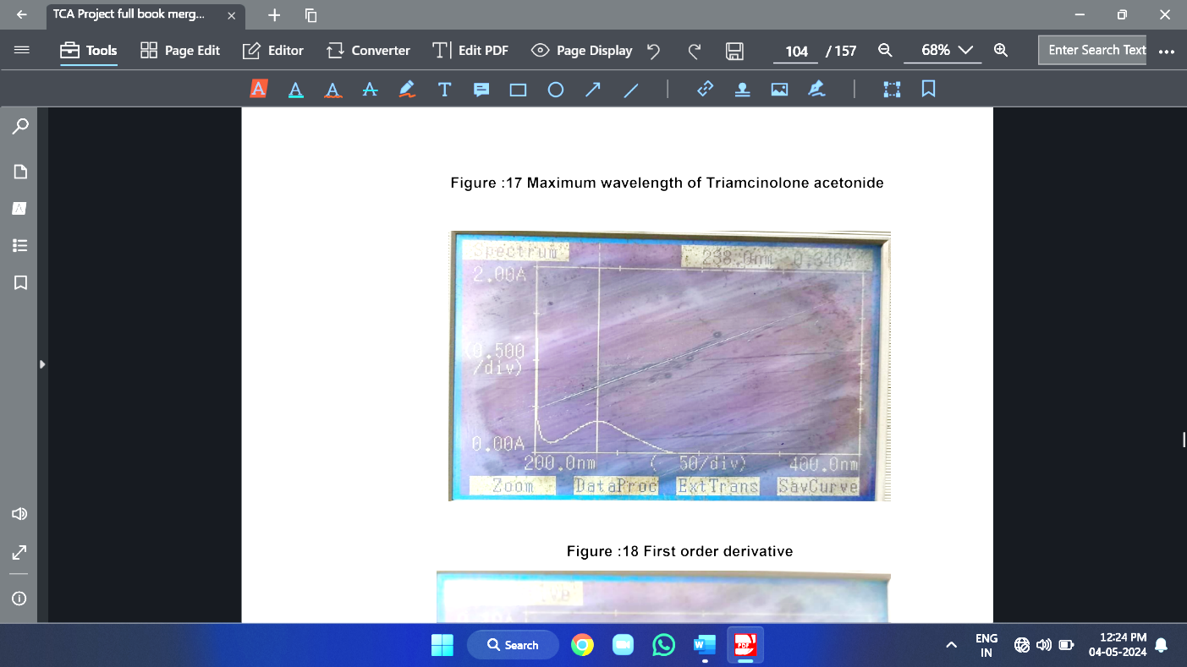

**Figure 3. First order derivative of TCA**

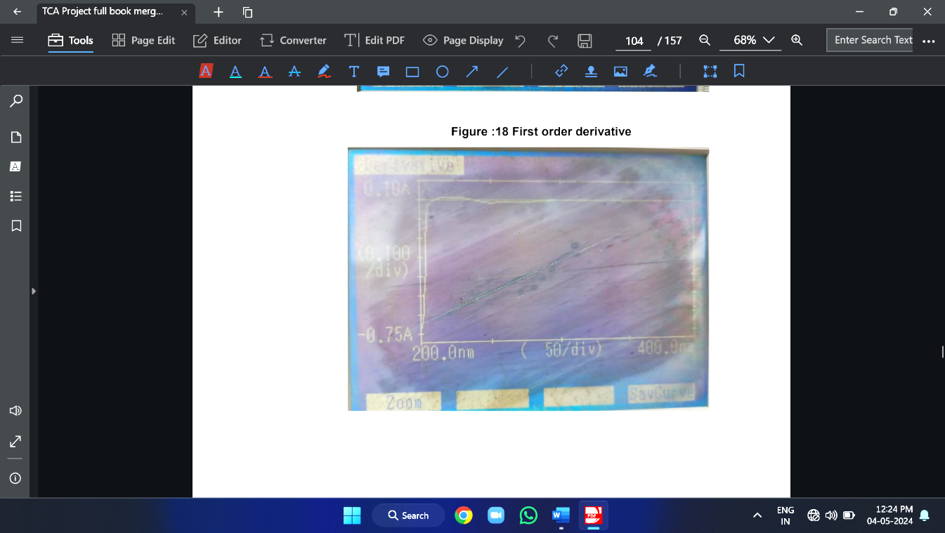

**Figure 4. Linearity of first order derivative of TCA**

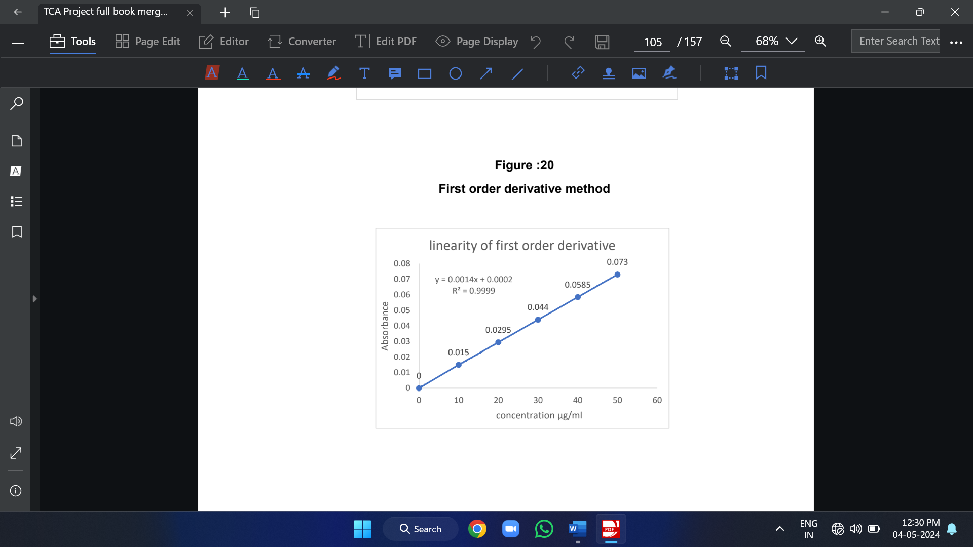

The percentage RSD value was found to be 1.1349, 0.3787 and 0.5706 for Triamcinolone acetonide tablet. The accuracy of the method was confirmed by the recovery studies. To the pre-analyzed injection formulation, a known quantity of raw material was added and the percentage recovery was calculated. The percentage of raw material added was 50%, 75% and 100% of Triamcinolone acetonide. The percentage recovery was found to be 100.28%, 99.921% and 99.921% for triamcinolone acetonide injection (Table 2).

The percentage RSD value was found to be 0.8939, 0.2990 and 0.4486 for Triamcinolone acetonide injection.

The method has the ability to give precise results in different instrument and also with different analyst. The %RSD of ruggedness (tablet) was found to be 1.4175. The method has the ability to give precise results in different instrument and also with different analyst. The %RSD of ruggedness (injection) was found to be 1.1155 (Table 4).

**Table 1. Optical characteristics of TCA**

|  |  |
| --- | --- |
| **Parameters** | **Max. wavelength at 238 nm** |
| Beer’s law limit (µg/ml) | 10-50 µg/ml |
| Correlation coefficient (r2) | 0.999 |
| Regression equation (y = mx + c) | y = 0.0014x + 0.0002 |
| Slope (m) | 0.0014 |
| Intercept | 0.0002 |
| LOD (µg/ml) | 0.0708 µg/ml |
| LOQ (µg/ml) | 0.2147 µg/ml |

**Table 2. Quantification and Recovery of Triamcinolone acetonide (TCA) tablet and injection**

|  |  |  |  |  |  |  |  |
| --- | --- | --- | --- | --- | --- | --- | --- |
| **Quantification of TCA tablet and injection** | | | | | | | |
| **Drug** | **Sample No.** | **Labelled amount (mg)** | **Amount found (mg)** | **% Obtained** | **% Average** | **SD** | **% RSD** |
| TCA Tab | 1 | 4 | 4.036 | 100.91 | 99.53 | 1.5035 | 1.5104 |
| 2 | 4 | 4.036 | 100.91 |
| 3 | 4 | 4.036 | 100.91 |
| 4 | 4 | 3.926 | 98.169 |
| 5 | 4 | 3.926 | 98.169 |
| 6 | 4 | 3.926 | 98.169 |
| TCA Inj | 1 | 40 | 40.366 | 100.91 | 100.45 | 1.1206 | 1.1155 |
| 2 | 40 | 40.366 | 100.91 |
| 3 | 40 | 40.366 | 100.91 |
| 4 | 40 | 40.366 | 100.91 |
| 5 | 40 | 40.366 | 100.91 |
| 6 | 40 | 39.267 | 98.169 |
| **Recovery of TCA tablet and injection** | | | | | | | |
| **Drug** | **Recovery %** | **Amount present (µg/ml)** | **Amount added (µg/ml)** | **Amount recovered (µg/ml)** | **Amount recovered %** | **SD** | **%RSD** |
| TCA Tab | 50 | 25 | 12.5 | 12.49 | 99.92 | 1.134 | 1.134 |
| 75 | 25 | 18.75 | 18.71 | 99.79 | 0.378 | 0.378 |
| 100 | 25 | 25 | 24.84 | 98.37 | 0.567 | 0.576 |
| TCA Inj | 50 | 25 | 12.5 | 12.53 | 100.28 | 0.896 | 0.893 |
| 75 | 25 | 18.75 | 18.73 | 99.92 | 0.298 | 0.299 |
| 100 | 25 | 25 | 24.98 | 99.92 | 0.4482 | 0.448 |

The optical parameters (Table 1) like Molar absorptivity, Sandell's sensitivity, and Correlation coefficient, Slope, Intercept, LOD and LOQ were calculated. The developed method was applied for the analysis of marketed tablet formulation to find out the developed method was correct or not. The tablet formulation KENACORT (containing triamcinolone 4 mg) and injection formulation KENACORT (containing triamcinolone acetonide 40 mg) was selected for the analysis.

The percentage purity of the drugs in the tablet formulation was found to be good concord with the label claim 99.539 ± 1.5035 for Triamcinolone acetonide. The percentage purity of the drugs in the Injection formulation was found to be good concord with the label claim 100.45 ± 1.1206 for Triamcinolone acetonide.

Further the method was validated for precision and accuracy. The precision tablet was confirmed by the repeatability studies. The percentage RSD values was found to be 1.3281 for Triamcinolone acetonide. Further the method was validated for precision and accuracy. The precision injection was confirmed by the repeatability studies. The percentage RSD values was found to be 1.3478 for Triamcinolone acetonide (Table 3).

The accuracy of the method was confirmed by the recovery studies. To the pre-analyzed tablet formulation, a known quantity of raw material was added and the percentage recovery was calculated. The percentage of raw material added was 50%, 75% and 100% of Triamcinolone acetonide. The percentage recovery was found to be 99.921%, 99.799%, and 99.372% for triamcinolone acetonide tablet.

**Table 3. Precision for TCA tablet and injection**

|  |  |  |  |  |  |  |  |
| --- | --- | --- | --- | --- | --- | --- | --- |
| **Sample** | **Label Claim (mg)** | **% Purity** | | **SD** | | **% RSD** | |
| **Intraday** | **Interday** | **Intraday** | **Interday** | **Intraday** | **Interday** |
| TCA Tab | 4 | 98.62 | 99.13 | 1.3185 | 0.7692 | 1.3281 | 0.7721 |
| 4 | 99.08 | 99.86 |
| 4 | 100 | 99.77 |
| TCA Inj | 40 | 100.45 | 99.90 | 1.3472 | 1.0055 | 1.3487 | 1.006 |
| 40 | 100 | 100.22 |
| 40 | 99.542 | 99.81 |

**Table 4. Ruggedness for TCA tablet and injection**

|  |  |  |  |  |  |  |
| --- | --- | --- | --- | --- | --- | --- |
| **Sample No.** | **TCA Tab** | | | **TCA Inj** | | |
| **% Recovery** | **SD** | **% RSD** | **% Recovery** | **SD** | **% RSD** |
| 1 | 98.62 | 1.318 | 1.328 | 99.54 | 1.347 | 1.347 |
| 2 | 99.08 | 100 |
| 3 | 100 | 100.4 |

**CONCLUSION:**

By application of newer analytical techniques, the method was found to be simple, rapid and accurate and has excellent sensitivity and reproducibility. The results obtained in recovery studies were indicating that there is no interference from the excipients undo in the formulation. Hence it is suggested that the proposed UV Spectroscopic method can be effectively applied for the routine analysis of Triamcinolone acetonide in marketed formulation and the obtained results will be presented elsewhere.

**REFERENCES:**

1. Abasi N, Sohrabi MR, Motiee F, Davallo M. Enhancement spectra resolution for spectrophotometric simultaneous determination of triamcinolone, neomycin, and nystatin based on continuous wavelet transform and first derivative transform in commercial ointment formulation. Jan 2021; 226:165315.
2. Ei ZZ, Pimthon J, Vajragupta O, Leanpolchareanchai J, Phechkrajang CM. Development and validation of high-performance liquid chromatography method for determination of miconazole, triamcinolone, methylparaben and propylparaben in cream. Mahidol Univ J Pharm Sci. 2016;43(5): p.211-221.
3. Elkady Y, El-Adl SM, Baraka M, Sebaiy MM. Literature Review of Analytical Methods for Determination of Triamcinolone Acetonide and Benzyl Alcohol. Novel Approaches in Drug Designing & Development. 2020;5(3), p.52-57.
4. El-Saharty YS, Hassan NY, Metwally FH. Simultaneous determination of terbinafine HCL and triamcinolone acetonide by UV derivative spectrophotometry and spectrodensitometry. Journal of pharmaceutical and biomedical analysis. 2002 ;28(3-4): p.569-580.
5. F.W and Kealey D. Principle and practice of analytical chemistry,5th Edition, wiley-Blackwell, 2005, p.256-286.
6. Gulati Diksha, Gupta Monika, Saini Namita, Kaur Manpreet and Kaur Amandeep. Development and Validation of HPLC method for the estimation of Triamcinolone Acetonide and 5- Fluorouracil. YMER. 2022,21(8): p.757-764.
7. Gupta SK, Kumar B, Sharma PK. Development and validation of a Spectrophometric method for estimation of Triamcinolone in solid dosage form. Asian Journal of Pharmaceutical Analysis. 2013;3(2): p.42-43.
8. Guru Deep R.Chatwal and Sham Annand K. Instrumental methods of chemical analysis, 5th Edition, Mumbai, Himalaya Publishing House, 2007,p.180-197.
9. Gurudeep R. Chatwal and Sham K Anand. Instrumental method of chemical analysis, 5th revised and enlarged edition, Mumbai, Himalaya Publishing House, 2008, p.2.149-2.170, 2.556-2.568.
10. Matysova L, Hajkova R, Šícha J, Solich P. Determination of methylparaben, propylparaben, triamcinolone acetonide and its degradation product in a topical cream by RP-HPLC. Analytical and bioanalytical chemistry. 2003; 376: p.440-443.