**A REVIEW ON THE EFFECT OF ANXIETY IN RAT USING HOLE BOARD APPARATUS**

Dr. Ziyaurraheman AR1*, Nilesh Pawar2, Prasanna Bachhav3, Sanskruti Sarode4, Sanjivni Bachhav5.

1Assosiate Professor of Pharmacology, K. B. H. S. S. Trust’s Institute of Pharmacy & Research Centre, Bhayegaon, Malegaon, Nashik, Maharashtra, India.

2,3,4,5Bachelors, Department of Pharmacology, K. B. H. S. S. Trust’s Institute of Pharmacy & Research Centre, Bhayegaon, Malegaon, Nashik, Maharashtra, India.

**ABSTRACT:** Anxiety disorders are biopsychosocial conditions involving generalized or situational responses to perceived threats. Childhood anxiety disorder affects one in four children between the ages of 13 and 18. The average age of onset is 11 years. Overall prevalence in children under 18 years of age ranges from 5.7% to 12.8%. Anxiety disorders are usually treated with medication, some form of psychotherapy, or both. The main medications used for anxiety disorders are antidepressants, anxiolytics, and beta blockers to control physical symptoms. Behavioral studies in animal subjects (mice) are important to understand this disease and to introduce new therapies from a translational perspective. The hole board apparatus has emerged as a widely used test to study anxiety-related behavior in rats. We focused on the hole apparatus as an advanced tool to measure research activity in laboratory mice. Other behavioral control mechanisms (eg, emotional responses, risk assessment, active coping) may play an additional role in shaping the animal's activity in the hole-board apparatus.

**KEYWORDS:** Anxiety, Hole Board Apparatus, Free-exploration test, Exploratory behaviour, Edge-sniff, Head dip.

**INTRODUCTION:**

Anxiety disorders are biosocial conditions associated with generalized or situational responses to perceived threats [1]. Anxiety disorders have historically attracted significant research attention [1,2]. Anxiety disorders are one of the most common mental disorders. They usually appear early in life and share common features with other psychiatric disorders, but with a markedly progressive evolution and severe functional consequences. The global prevalence of anxiety is a significant threat to human well-being and quality of life [2]. Anxiety disorders have different clinical manifestations. For some people, certain environmental stimuli are associated with causing phobias [3]. Some people experience severe and temporary problems such as panic disorder. [4] When perceived as a threat in the prefrontal cortex and amygdala, this experience triggers a fight-or-flight response that can manifest as psychophysiological effects such as dizziness, increased heart rate, and sweating [5]. If left untreated, chronic anxiety can lead to many health problems, including high blood pressure, cardiovascular disease, and dementia. [6] Current treatments for anxiety usually include medication and psychotherapy. Although the physiological reactions associated with anxiety can be treated with medication, psychological memories and triggers that cause anxiety require psychological solutions. There is a lot of evidence that psychological treatments, such as educational therapy, are more beneficial for people with anxiety disorders. Researchers need to understand the epidemiological nature of anxiety to identify trends related to demographic factors and better target prevention and control efforts in the population [7].

20% of adults experience an anxiety disorder each year. Generalized anxiety disorders cause constant feelings of fear, worry, and anxiety. Generalized anxiety disorder is characterized by persistent, excessive, and unrealistic worry about everyday things. These problems can take many forms, including financial, family, health, and future issues. It is associated with persistent and difficult to control and often non-specific mental and physical symptoms. Excessive worry is one of the main symptoms of generalized anxiety disorder [8-10]. Childhood anxiety disorder affects one in four children between the ages of 13 and 18. The average age of onset is 11 years. However, the lifetime prevalence of severe anxiety disorder in children between the ages of 13 and 18 is about 6%. Overall prevalence in children under 18 years of age ranges from 5.7% to 12.8%. The prevalence in women is twice that of men [11-13].

**Symptoms:**

Sleep disturbances and the mental experience of difficulty concentrating, social and/or work functioning are common symptoms of many anxiety disorders. Despite their similarities, these disorders often have different symptoms, course, and treatment. Patients often report poor physical health as their main concern. This can distract you from the main symptoms of anxiety temporarily. This usually occurs with short-term intense fear and panic accompanied by physical symptoms such as chest pain, dizziness, and shortness of breath. Along with agoraphobia, personal fear leads to panic attacks that prevent escape. As a result, patients avoid such situations and eventually become disengaged [14]. The ancient word "agoraphobia" is translated from Greek as "fear of the free market". Modern agoraphobia is characterized by a strong and intense reaction to situations from which escape is difficult or impossible, such as being alone outside the home, traveling in a car, bus or plane, or in crowded places for widespread attention [15].

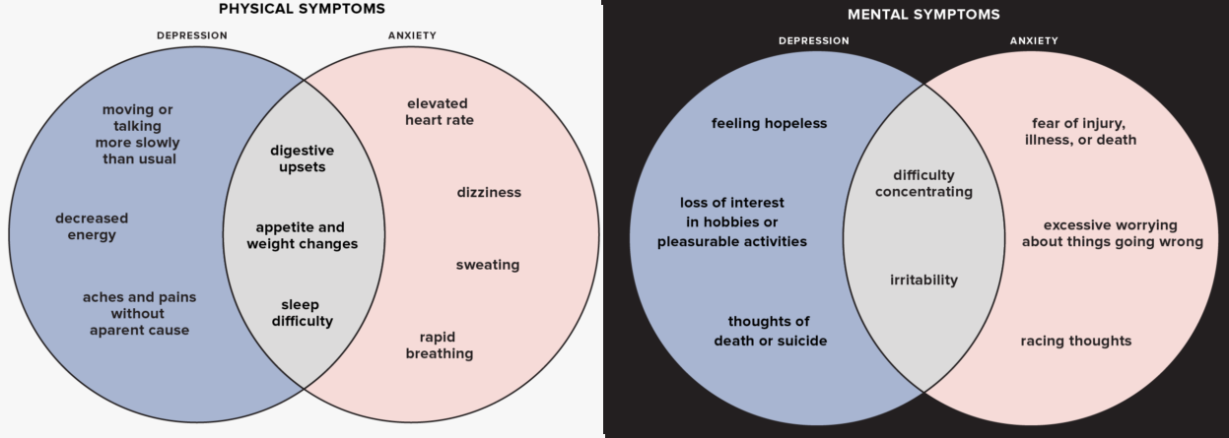

**Figure 1:** Sign and symptoms of Anxiety vs Depression

**Pathophysiology of Anxiety:**

Important mediators of anxiety in the central nervous system (CNS) are norepinephrine, serotonin, dopamine, and gamma-aminobutyric acid (GABA). The autonomic nervous system, especially the sympathetic nervous system, mediates many of these symptoms. The amygdala plays an important role in reducing fear and anxiety [16]. Patients with anxiety disorders have increased responses to anxiety in the amygdala. Amygdala and prefrontal cortex structures are connected to prefrontal cortical regions, and prefrontal cortex activation abnormalities can be reversed by psychological or pharmacological interventions [17].

**Treatments of anxiety disorder:**

Anxiety disorders are usually treated with medication, some form of psychotherapy, or both. The choice of treatment depends on the problem and your personal preferences. Before the treatment begins, the doctor must do a thorough diagnostic evaluation to determine whether the patient's symptoms are due to anxiety disorders or physical disorders. When an anxiety disorder is diagnosed, the type of disorder or combination of disorders, as well as comorbid conditions such as depression or drug addiction, must be identified. In some cases, alcoholism, depression, or other disorders affect the person so treatment for the anxiety disorder can wait until the disorder is under control [18]. People with anxiety disorders who are currently being treated should discuss the details of their treatment with their current doctor. If you are taking medication, you should tell your doctor what medication you are taking, what dose you started with, whether your dose increased or decreased during treatment, what side affects you experienced, and whether the medication helped you. whether or not. You feel less anxious. If you receive psychotherapy, you must describe the type of therapy you receive, how often you attend sessions, and how the therapy has benefited you. Many people believe that the treatment has failed or is ineffective, when in fact it is not given enough time or the treatment is wrong. In some cases, you may have to try different treatments or a combination of treatments before you find one that works for you [19,20].

Medication cannot cure panic disorder, but psychotherapy can help control it. Medication must be prescribed by a doctor (usually a psychiatrist). Clinicians can provide psychotherapy alone, or they can work as a team with psychologists, social workers, or counselors who provide psychotherapy. The main medications used for anxiety disorders are antidepressants, anxiolytics, and beta blockers to control physical symptoms. With proper treatment, many people with anxiety disorders can lead normal and fulfilling lives [20].

**Table 1:** The main types of medications used for anxiety disorders are different [21,22]

|  |  |  |  |
| --- | --- | --- | --- |
| **Classes** | **Used for** | **Mode of Action** | **Advantages** |
| Anticonvulsants | Social anxiety disorder | Affects GABA | Usually effective in 2-4 weeks |
| Azaspirones | Generalized anxiety disorder | Increases serotonin activity | Less sedative than benzodiazepines |
| Benzodiazepines | Generalized anxiety disorder,  Social anxiety disorder  Panic disorder | Increases GABA activity | Moving quickly, some people feel better on their first day |
| Beta Blockers | Social anxiety disorder | Decreased ability to produce adrenaline | To move quickly; It does not form a habit |
| Monoamine oxidase inhibitors (MAOIs) | Social anxiety disorder  Panic disorder,  Post Traumatic stress disorder | It blocks the action of brain enzymes by preventing the release of serotonin and noradrenaline. | For most people, especially patients who have not responded to other treatments, 2-6 weeks is effective until improvement |
| Serotonin reuptake inhibitors (SSRIs) | Disorder,  Obsessive compulsive disorder,  Generalized anxiety disorder,  Social anxiety disorder. | Serotonin Concentration | Fewer side effects than other drugs. 4-6 weeks until healing |
| Tricyclic antidepressants (TCAs) | Panic disorder,  Obsessive compulsive disorder,  Post Traumatic stress disorder | It regulates serotonin and/or noradrenaline in our brain | Effective for most people, improvement can take 2-6 weeks |

In people with anxiety disorders, general behavior can be characterized by avoiding anxiety-provoking activities, people, things, places, or situations, and in rare cases, excessive use of drugs or alcohol. These maladaptive behaviors persist over time and lead to adverse outcomes such as poor personal relationships, low related performance, and unintended "erosion" of quality of life. Not surprisingly, the socioeconomic burden of anxiety disorders is devastating. Finally, this problem has been observed to increase steadily in recent decades [23,24]. In this context, it is not difficult to consider that accurate studies using animal models play an important role in order to gain a deeper understanding of the behavioral characteristics of anxiety disorders [25]. Several research centers have used the hole board (HB) apparatus and various behavioral techniques to investigate anxiety-related behavior in rats after manipulation of anxiety levels. HB is basically an open field with predetermined holes where rats can poke their heads. HB is a simple tool to study different elements of the behavioral repertoire of mice related to exploration and anxiety [26,27].

**HOLE BOARD APPARATUS:**

Holeboard (HB) was developed by Boissier et al. [28] is a widely used behavioral test to assess exploratory and anxiety behaviors in rats and mice [28–30]. The hole board is a standard placeholder (figure 2). Therefore, the approach and competition to avoid the result of a simple open field can be combined by adding the variable number of environmental problems, namely holes in the ground [31,32]. There are different types of HB depending on the size and number of soil holes. Indicate that the dimensions of the holes are different for mice and rats, there are 4 holes (for example, one hole in each corner of the field or 4 holes in a row), and 16 holes per hole (for example, 4 holes in an even row) or hole board has 36 holes (i.e. 6 holes equal space) or hole board has 36 holes (i.e. 6 holes equal space each). On the one hand, these holes offer the possibility to measure the exploratory behavior of mice or rats, but on the other hand, they represent an unknown signal that can cause a conflict between approach and avoidance [34,35].

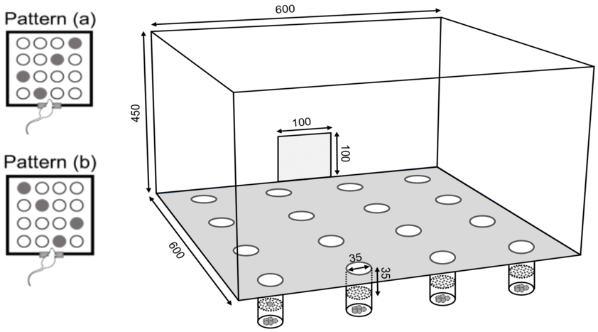

# Figure 2: Schematic representation of the hole-board apparatus.

Therefore, it is argued that this tool is designed to avoid difficulties in interpreting natural locomotor behavior that is challenging in the open field, and many studies have shown that head diving and motor movement are not separate from each other, and they are threatened with extinction change [36]. In general, a high head count is interpreted as an indication of neophilia, while a low number may be due to the absence of neophilia or indicate a severe anxiety state in the animal. The hole-board challenge is now considered a test for neophilia in many areas of behavioral pharmacology [38].

The researchers tried to validate head dipping as a measure of neophilia by using different drugs and comparing different genetic strains of mice in the hole task. For example, if head dipping is a nootropic response that is suppressed by an anxiety-like response, treatment with an anxiolytic drug would be expected to improve head dipping. Such studies have yielded conflicting evidence. For example, the treatment of anxiety with anxiolytic benzodiazepines has been reported [39]. A recent review showed that the effects of anxiolytic compounds on head-shaking behavior were independent of head-tossing motor activity with general behavioral changes. Whether head wiping can be interpreted as a valid measure of neophilia remains an open question [40].

**Procedure:**

Animals are kept in containers with regular holes in the floor. We then measure the frequency and duration of stimulated spontaneous piercing behavior in a short period of time. This test also provides a simple method for assessing unfamiliar environment anxiety in rats. In this context, the use of hole boards is based on the hypothesis that the behavior of animals exposed to novel situations is the result of competition between exploratory and withdrawal instincts. Therefore, high anxiety level reduces scalp wetting behavior and vice versa, low anxiety level increases scalp wettability. Other related behaviors such as grooming, standing, and locomotion can also be assessed during the board test [39,41].

**The Head-Dip/Edge-Sniff Ratio:**

When evaluating anxiety-related behavior and the effects of some psychoactive substances, the relationship of head tilt, especially head down, and posture should be taken into account. significantly increased (Figure 3). The current results are in good agreement with previous results showing that the use of diazepam and FG7142 decreased and increased anxiety respectively in two opposite directions [42]. The explanation lies in the strong emotional value of the relationship that links these two hole-seeking behaviors. Edge brushing is a movement by which the animal sweeps the edge of the hole. When the animal puts its head in the hole, head confusion occurs. Of course, if the animal sticks its head after sniffing, it depends on the motivation, and this motivation has a strong effect on the change in the emotional state. Therefore, if the animal bends the head several times without brushing the edge, the head bending ratio increases as the ratio increases. This happens as a result of wear and tear. For example, the level of anxiety after the administration of diazepam [41]. On the contrary, unless some edges are accompanied by some slopes, the slope ratio of the head decreases as the divisor increases. This is what happens after construction. For example, the lower level of attention FG7142 [42]. After TPA, the image is sharper, with less fine edges and a more general character architecture of head-down and flanking. By detecting and analyzing T-patterns, it is possible to assess quality characteristics that cannot be detected using conventional analysis. In fact, the synergistic use of quantitative and qualitative approaches in research can provide a more comprehensive explanation of observed phenomena than are easily discernible by the human eye [43,44].

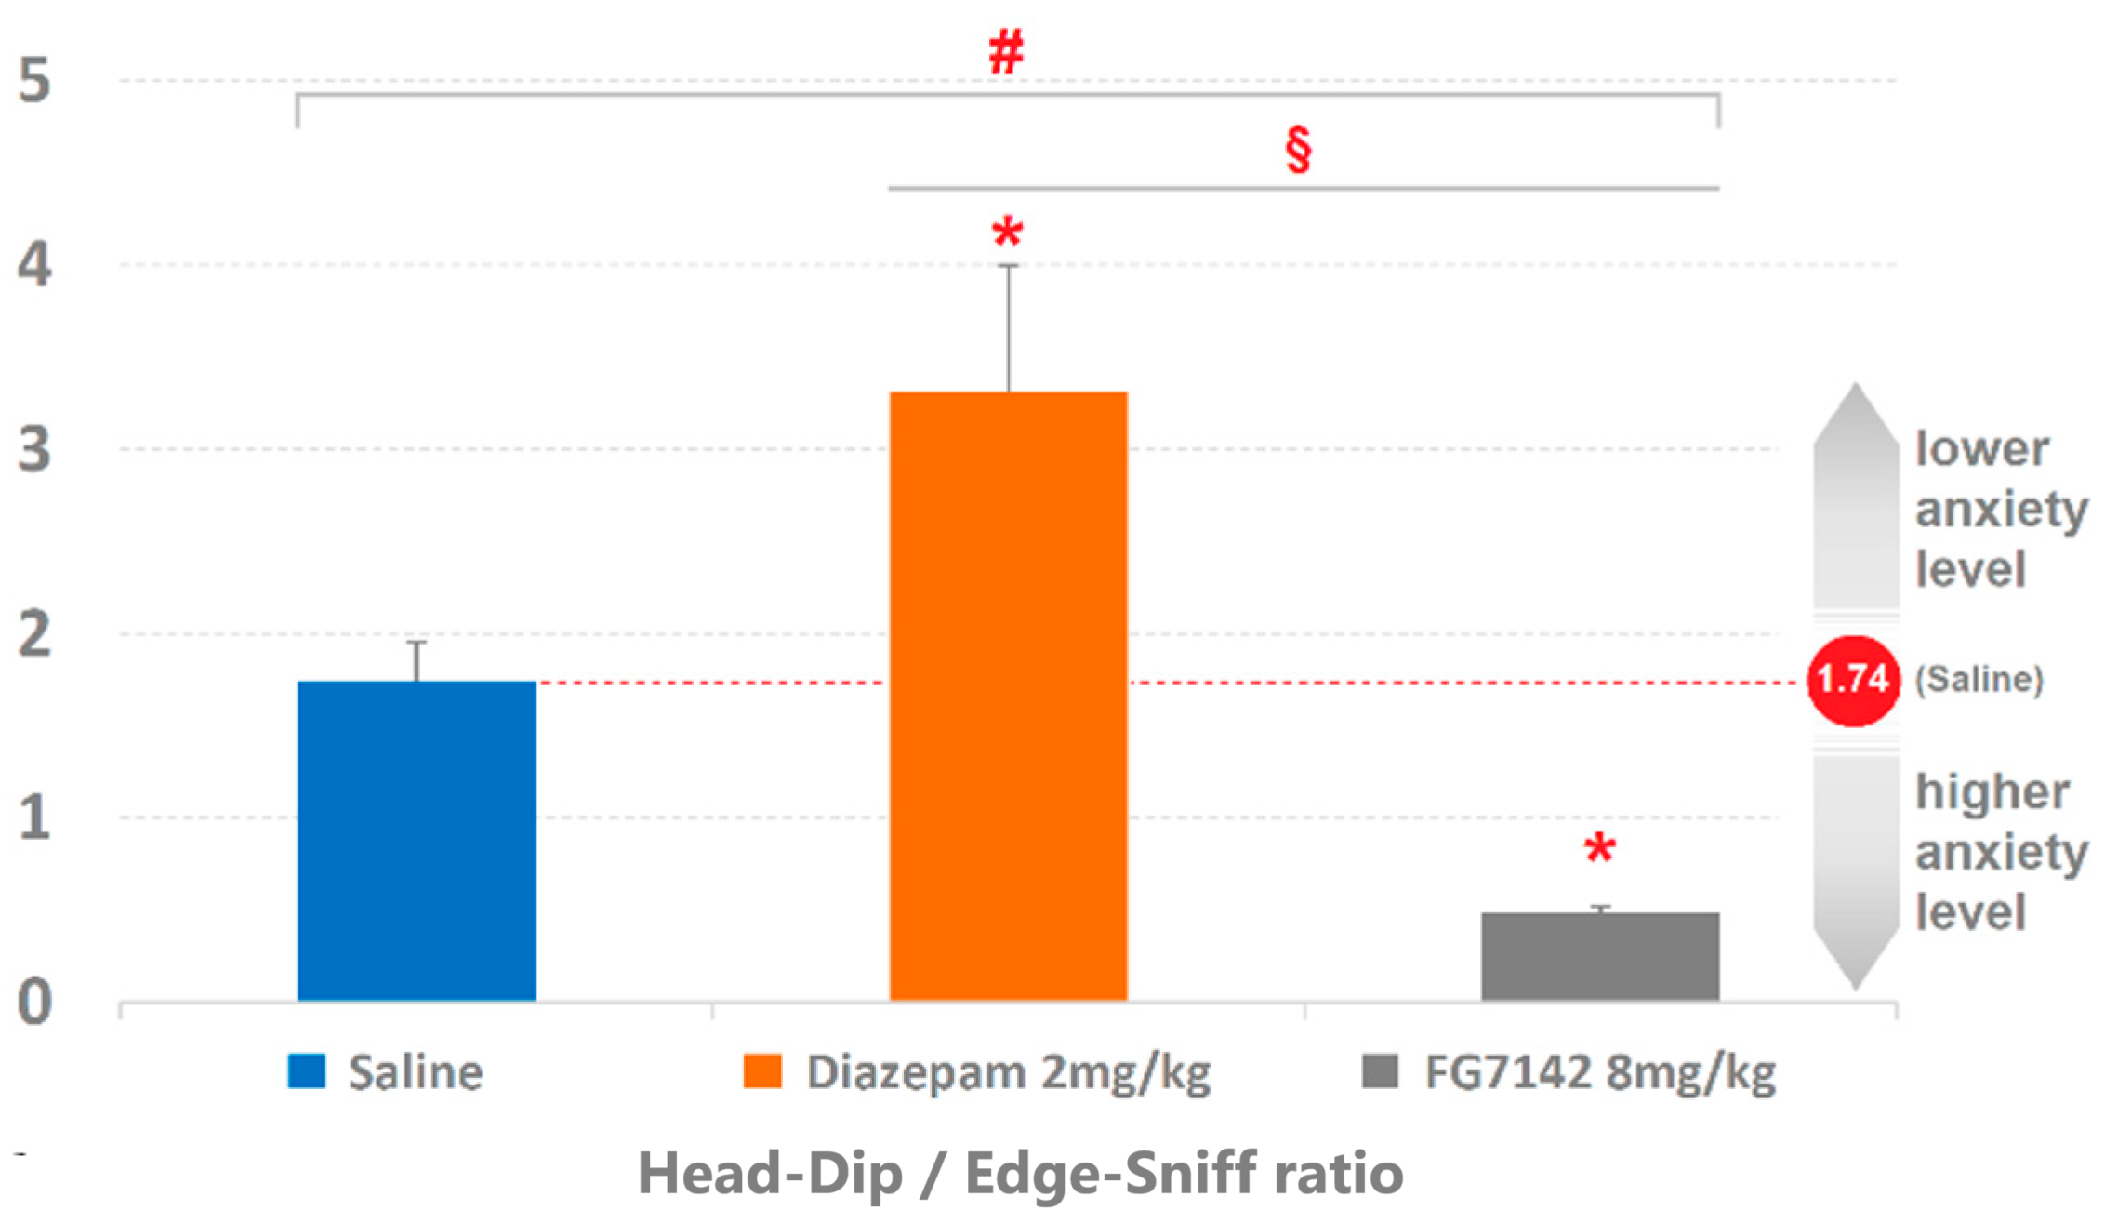

**Figure 3:** Effects of saline, diazepam, and FG7142 on head tilt velocity and edge-to-edge ratio [45].

**Modified hole board apparatus:**

A modified Hallboard apparatus can also be used to assess a variety of unconditioned behaviors, particularly in rats and mice. It includes conventional pit apparatus and open field testing, which overcomes some of the disadvantages of experimental batteries, such as reducing the number of animals used, reducing time efficiency, and cost. The main advantage is that it does not need to be given to increase the animal's desire to solve the problem. This tool has been validated in mice and rats. Various behavioral tests can be performed using the improved hole board apparatus, such as risk assessment, avoidance, stimulation, exploration, habituation, learning, social desirability, locomotor activity, social stress test, and novel object recognition test [46]. .

Other studies have shown that the Holboard device can be used to measure biologically relevant odor craving and avoidance measures. Various samples were placed in the hole, including female urine, predator urine sample, permanent urine sample and plant urine sample. Observations show complete avoidance of holes containing predator samples, and preference for holes containing female urine samples. When rats were treated with buspirone (an anxiolytic drug), avoidance of urine samples was completely eliminated, indicating the specific anxiolytic effect of predator urine samples [47]. However, this test is not suitable for evaluating compounds with high sedative effects. In another study, oral administration of the methanolic extract of Holoptera integrifolia leaves increased head-dipping latency when tested in the perforator apparatus in rodents, suggesting an anxiolytic drug effect. Procrastination has been shown to increase head immersion [48]. Previous studies have reported that dopaminergic transmission is enhanced by inhibiting D3 receptors, mainly found in the cortex and striatal system. Inhibition of monoamine oxidase, which breaks down catecholamines and serotonin in the brain, has been shown by research to increase. Therefore, research and anxiolytic drugs in the hole paradigm has intensified [49].

Currently, the use of transgenic animals is encouraged because of their accuracy and high yield. Therefore, transgenic mice can also be used to evaluate the behavioral effects of changes in specific types of neurochemical receptors, metabotropic serotonin and glutamate [50]. Anti-anxiety medication is expected to improve locomotion, head-down movement, and standing. If the animal does not show this behavior, they will be more anxious [46].

**CONCLUSION:**

Anxiety disorders are a serious problem of modern society and their impact in terms of social and economic burden is high. Behavioral studies in animal subjects (mice) are important for understanding this disease and for introducing new therapies from a translational perspective. In this context, the drinking apparatus has emerged as a widely used test to study anxiety-related behavior in rats.

Based on a literature review of previous tests of exploratory behavior in a low-stress environment, we conclude that the pinhole apparatus is the most advanced tool for measuring exploratory behavior in laboratory rats. Other behavioral control mechanisms (threat assessment, emotional responses, active resistance) may play a greater role in shaping the animal's activity in the perforator.

**REFERENCES:**

1. Quek T, Tam W, Tran B et al. The global prevalence of anxiety among medical students: a meta-analysis. IJERPH 2019;16:2735.
2. Racine N, McArthur BA, Cooke JE et al. Global prevalence of depressive and anxiety symptoms in children and adolescents during COVID-19: a meta-analysis. JAMA Pediatr 2021;175:1142.
3. Johns G, Samuel V, Freemantle L et al. The global prevalence of depression and anxiety among doctors during the covid-19 pandemic: Systematic review and meta-analysis. J Affect Disord 2022;298:431–441.
4. Santomauro DF, Mantilla Herrera AM, Shadid J et al. Global prevalence and burden of depressive and anxiety disorders in 204 countries and territories in 2020 due to the COVID-19 pandemic. The Lancet 2021;398:1700–1712.
5. Adwas A, Jbireal J, Azab A. Anxiety: insights into signs, symptoms, etiology, pathophysiology, and treatment. East African Scholars J Med Sci 2019;2:580–91.
6. Yan J, Pan Y, Cai W et al. Association between anxiety and hypertension: a systematic review and meta-analysis of epidemiological studies. NDT 2015;11:1121.
7. Javaid, S.F., Hashim, I.J., Hashim, M.J. et al. Epidemiology of anxiety disorders: global burden and sociodemographic associations. Middle East Curr Psychiatry 2023;30:44.
8. Leonard K, Abramovitch A. Cognitive functions in young adults with generalized anxiety disorder. Eur Psychiatry. 2019;56:1-7.
9. Roomruangwong C, Simeonova DS, Stoyanov DS, Anderson G, Carvalho A, Maes M. Common Environmental Factors May Underpin the Comorbidity Between Generalized Anxiety Disorder and Mood Disorders Via Activated Nitro-oxidative Pathways. Curr Top Med Chem. 2018;18(19):1621-1640.
10. Grenier S, Desjardins F, Raymond B, Payette MC, Rioux MÈ, Landreville P, Gosselin P, Richer MJ, Gunther B, Fournel M, Vasiliadis HM. Six-month prevalence and correlates of generalized anxiety disorder among primary care patients aged 70 years and above: Results from the ESA-services study. Int J Geriatr Psychiatry. 2019;34(2):315-323.
11. Silva MT, Caicedo Roa M, Martins SS, da Silva ATC, Galvao TF. Generalized anxiety disorder and associated factors in adults in the Amazon, Brazil: A population-based study. J Affect Disord. 2018;236:180-186.
12. Scheeringa MS, Burns LC. Generalized Anxiety Disorder in Very Young Children: First Case Reports on Stability and Developmental Considerations. Case Rep Psychiatry. 2018;2018:7093178.
13. Strohle A, Gensichen J, Domschke K. The Diagnosis and Treatment of Anxiety Disorders. Dtsch Arztebl Int. 2018;155(37):611-620.
14. Adwas AA, Jbireal JM, Azab AE. Anxiety: Insights into Signs, Symptoms, Etiology, Pathophysiology, and Treatment. East African Scholars J Med Sci; 2019;2(10):580-591.
15. Magee, W. J., Eaton, W. W., Wittchen, H. U., McGonagle, K. A., & Kessler, R. C. Agoraphobia, simple phobia, and social phobia in the National Comorbidity Survey. Archives of general psychiatry, 1996;53(2):159-168.
16. Avgustinovich DF, Kovalenko IL, Kudryavtseva NN (2005) A model of anxious depression: persistence of behavioral pathology. Neurosci Behav Physiol 35:917–924.
17. Persaud NS, Cates HM. The Epigenetics of Anxiety Pathophysiology: A DNA Methylation and Histone Modification Focused Review. 2022;10(4):09-21.
18. Steven L. Shearer. Recent Advances in the Understanding and Treatment of Anxiety Disorders. Prim Care Clin Office Pract. 2007; 34: 475–504.
19. Soodan S, Arya A. Understanding the Pathophysiology and Management of the Anxiety Disorders. Ijppr.Human, 2015;4(3):251-278.
20. National Institute of Mental Health (NIMH). Treatment of Anxiety Disorders.2009
21. Gorman JM. New molecular targets for anti‐anxiety interventions. J Clin Psychiatry 2003;64:28‐35.
22. Stephen B. The pharmacological management of anxiety disorders. Progress in Neurology and Psychiatry 2009;13(6):15-20.
23. Greenberg PE, Sisitsky T, Kessler RC, Finkelstein SN, Berndt ER, Davidson JR, Fyer AJ. The economic burden of anxiety disorders in the 1990s. J. Clin. Psychiatry 1999;60:427–435.
24. Garakani A, Murrough JW, Freire RC, Thom RP, Larkin K, Buono FD, Iosifescu DV. Pharmacotherapy of Anxiety Disorders: Current and Emerging Treatment Options. Front. Psychiatry 2020;11:595584.
25. Cryan JF, Sweeney FF. The age of anxiety: Role of animal models of anxiolytic action in drug discovery. Br. J. Pharmacol. 2011;164:1129–1161
26. Casarrubea M, Sorbera F, Crescimanno G. Structure of rat behavior in holeboard: II multivariate analysis of modifications induced by diazepam. Physiol. Behav. 2009;96:683–692.
27. Casarrubea M, Faulisi F, Pensabene M, Mendola C, Dell’utri R, Cardaci M, Santangelo A, Crescimanno G. Effects of the benzodiazepine inverse agonist FG7142 on the structure of anxiety-related behavior of male Wistar rats tested in hole board. Psychopharmacology 2017;234:381–391.
28. J.R. Boissier, P. Simon, J.M. Lwoff, Use of a particular mouse reaction (hole board method) for the study of psychotropic drugs, Therapie 1964;19:571–583.
29. Rodriguez Echandia E.L., Broitman S.T., Foscolo M.R., Effect of the chronic ingestion of chlorimipramine and desipramine on the hole board response to acute stresses in male rats, Pharmacol. Biochem. Behav. 1987;26:207–210.
30. Casarrubea M., Giovanni G. D, Crescimanno G., Effects of different anxiety levels on the behavioral patternings investigated through T-pattern analysis in wistar rats tested in the hole-board apparatus, Brain Sci. 2021;11(6):714.
31. File S.E., Wardill A.G., Validity of head-dipping as a measure of exploration in a modified holeboard, Psychopharmacologia 1975;44:53–59.
32. Hughes R.N., Neotic preferences in laboratory rodents: issues, assessment and substrates, Neurosci. Biobehav. Rev. 2007;31:441–464.
33. Casarrubea M. et al. The hole-board apparatus in the study of anxiety. Physiology & Behavior 2023;271:114346.
34. Casarrubea M., Sorbera F., Magnusson M.S., Crescimanno G., T-pattern analysis of diazepam-induced modifications on the temporal organization of rat behavioral response to anxiety in hole board, Psychopharmacology 2011;215(1):177–189.
35. Berl. M. Casarrubea, C. Davies, et al. Acute nicotine induces anxiety and disrupts temporal pattern organization of rat exploratory behavior in hole-board: a potential role for the lateral habenula, Front. Cell. Neurosci. 2015;9:197.
36. Abel E.L. Further evidence for the dissociation of locomotor activity and head dipping in rats. Physiol. Behav. 1995;57:529–532.
37. Crawley J.N. Exploratory behavior models of anxiety in mice. Neurosci. Biobehav. Rev. 1985;9:37–44.
38. Kliethermes C.L., Crabbe J.C. Pharmacological and genetic influences on hole-board behaviors in mice. Pharmacol. Biochem. Behav. 2006;85:57–65.
39. Brown GR, Nemes C. The exploratory behaviour of rats in the hole-board apparatus: is head-dipping a valid measure of neophilia? Behav Processes. 2008;78(3):442-8.
40. Bilkei-Gorzó A., Gyertyán I. Some doubts about the basic concept of the hole-board test. Neurobiology. 1996;4:405–415.
41. Pisula W, Modlinska K, Goncikowska K, Chrzanowska A. Can the Hole-Board Test Predict a Rat's Exploratory Behavior in a Free-Exploration Test? Animals (Basel). 2021 Apr 9;11(4):1068.
42. Casarrubea, M.; Faulisi, F, et al. Effects of the benzodiazepine inverse agonist FG7142 on the structure of anxiety-related behavior of male Wistar rats tested in hole board. Psychopharmacology 2017;234:381–391.
43. Anguera, M.T, Blanco-Villaseñor, A, Losada, J.L, Sánchez-Algarra, P, Onwuegbuzie, A.J. Revisiting the difference between mixed methods and multimethods: Is it all in the name? Qual. Quant. 2018;52:2757–2770.
44. Onwuegbuzie, A.J, Leech, N.L. Generalization practices in qualitative research: A mixed methods case study. Qual. Quant. 2010;44:881–892.
45. Casarrubea M, Giovanni GD. Effects of Different Anxiety Levels on the Behavioral Patternings Investigated through T-pattern Analysis in Wistar Rats Tested in the Hole-Board Apparatus. Brain Sci. 2021;11(6):714.
46. Wernecke KE, Fendt M. The olfactory hole-board test in rats: a new paradigm to study aversion and preferences to odors. Front Behav Neurosci 2015;9:223.
47. Kavaya Sree K, Vijusha M, Rajani A, Hemamalini K. Screening of behavioural, muscle co ordination and anxiolytic activities of methanolic extract of holoptelea integrifolia (ROXB). Int Res J Pharm 2013;4:90-94.
48. Takem LP, Eshiet GA, Ogom OG, Mbang UU. Exploratory and anxiety potentials of aqueous extract of Phragmanthera capitata. J Phytopharmacol 2014;3:400-404.
49. Brown RE, Stanford L, Schellinck HM. Developing standardized behavioral tests for knockout and mutant mice. ILAR J 2000;41:163-174.
50. Himanshi, Dharmila, et al. A Review of Behavioral Tests to Evaluate Different Types of Anxiety and Anti-anxiety Effects. Clini. Psycho. and Neuro 2020;18(3):341-351.