**ADVANCING HEALTHCARE WITH AI/ML IN MEDICAL DEVICES: AN IN-DEPTH REGULATORY PERSPECTIVE**

SIVARANJANI PS1.NAVANEEDHA KRISHNAN M2*

1Department of Pharmaceutics (Regulatory affairs), Faculty of pharmacy, Sri Ramachandra Institute of Higher Education and Research, SRMC(DU) Porur-600 116, Chennai, India.

Email id: [ranjanis011@gmail.com](mailto:ranjanis011@gmail.com)

2* Department of Pharmaceutical Analysis, Faculty of pharmacy, Sri Ramachandra Institute of Higher Education and Research, SRMC(DU) Porur-600 116, Chennai, India.

Email id: naveennaresh152@gmail.com

***Running Title:*** Advancing Healthcare with AI/MI in Medical Devices: A Regulatory Perspective

**Abstract**

Healthcare technology is transforming with the introduction of Artificial Intelligence (AI) and Machine Learning (ML) into medical equipment. The planning of treatments, patient monitoring, diagnostics, and hospital operations are all improved by this technology, but they also bring with them difficulties including the necessity for strong legal frameworks, ethical issues, and data privacy issues. We gathered publicly accessible data for the current study, up to the most recent update on March 31, 2024, about AI/ML-enabled medical devices that have been authorized by the FDA in the United States. Along with discussing the difficulties and factors to be taken into account when implementing these technologies, we also looked at how medical devices are classified, the regulatory pathways for software as a medical device (SaMD), and the FDA's regulation guidelines for AI/ML/DL-based software. We also presented a number of case studies of AI-based medical devices that has obtained FDA approval. The future directions and trends indicate a significant potential for AI to transform healthcare delivery, enhance patient outcomes, and optimize operational efficiency, provided that the associated challenges are adequately addressed.

**Key words**

Medical devices, USFDA regulations, SaMD, Artificial intelligence, healthcare, Machine Learning, Patient monitoring

1. **INTRODUCTION**

Medical devices are instruments, machines, contrivances, or implants used to treat, cure, prevent, ameliorate, or diagnose human illness [1]. The nineteenth century witnessed the emergence of manually operated medical devices such as stethoscope and thermometer. Further, technology had developed increasingly complex devices like pacemakers and X-ray equipment, which boosted diagnostic and therapeutic capacities but still needed human intervention [2]. Medical professionals may benefit from medical equipment's many features, which include improved productivity, dependability, automation, and simplicity of use. They do, however, have drawbacks, including regulatory obstacles, human errors, limited scalability, training requirements, difficulty in complex procedures and dependency on operator skills [3]. These drawbacks have led to a significant evolution in the use of Artificial Intelligence (AI) in medical devices. It took about 30 years for AI to find broad use in the healthcare industry after it was first introduced with the goal of enhancing the effectiveness of medical diagnosis and treatment. The main cause of this delay was technological constraints, which have now been resolving with the introduction of Deep Learning (DL) [4].

AI is generally characterized as the field of study and application of scientific and technical principles of developing intelligent machines, notably computer programs which is used in various fields. The phrase "machine learning," first introduced by Arthur Samuel in 1959 to refer to the branch of artificial intelligence where computers pick up knowledge on their own via data accumulation, is now often used in the processing of vast volumes of data [5]. In the realm of machine learning, deep learning has come to light as a very promising method for analysing images. Unlike other software, which requires explicit instructions to work, this system can detect patterns and forecast outcomes on its own thanks to deep learning [6].

* 1. **Integration of AI software into medical devices**

The incorporation of AI and ML-based software with medical equipment makes a significant advancement in healthcare technology, offering capabilities that enhance diagnosis, treatment planning, patient monitoring, and more [7]. It also streamlines administrative tasks, optimizes hospital operations, integrates seamlessly with existing healthcare systems, and accelerates medical research and development. Some of the applications are summarized in **Fig 1**. While offering transformative potential, AI-driven devices must navigate ethical considerations and stringent regulatory standards to ensure patient safety and maintain trust in AI applications. Looking ahead, ongoing advancements in AI technology promise to further innovate diagnostics, treatments, and healthcare delivery, shaping the future of medicine.

Medical device regulations discussed at the International Medical Device Regulators Forum (IMDRF) which aspires to lead the global push for harmonising AI/ML-based medical device regulations and to ensure the most resource-efficient design, approval, and upkeep of superior, secure, and functional devices [8]. Despite these benefits, there are still challenges to overcome, including high development costs, concerns about data privacy, and the need for robust regulatory frameworks to ensure effectiveness and security. Furthermore, major infrastructure improvements and medical staff training are needed for the integration of artificial intelligence into healthcare so that these technologies may be used effectively. To fully achieve artificial intelligence's promise to revolutionize the healthcare, these problems must be resolved entirely [9].

1. **Regulatory Framework for Medical Devices in the US**

The United States FDA is responsible for the regulation of medical devices to ensure its safety, effectiveness, and quality. Depending on their level of risk, devices are categorized as Class I, II, or III, with higher-risk items needing additional regulatory control.

**a) Class I Devices:** These devices are deemed low risk and do not typically need FDA premarket approval.

**b) Class II Devices:** These devices are referred to as Moderate risk-based medical devices. Most digital health devices fall into this category. Manufacturers typically submit a 510(k) premarket notification.

**c) Class III Devices:** These devices are considered higher risk-based, such as implantable devices, and require a more rigorous premarket approval (PMA) application [10].

**2.1. Regulatory pathways for software as a medical device (SaMD)**

The International Medical Device Regulators Forum (IMDRF) defines SaMD as software used for medical purposes without being installed in a hardware medical device. It is subjected to regulatory oversight to ensure safety, efficacy, and quality. Regulated by various health authorities around the world, such as the FDA in the United States, the European Medicines Agency (EMA) in Europe, and the International Medical Device Regulators Forum (IMDRF) Regulations governing SaMD vary by country or region but typically involve requirements related to design controls, risk management, clinical evaluation, and post-market surveillance. SaMD encompasses a wide range of software used in healthcare, including diagnostic software, clinical decision support tools, monitoring software, and treatment planning software [11].

**2.2. International Medical Device Regulators Forum: SaMD**

IMDRF promotes international cooperation in medical device regulation to ensure safety, efficacy, and quality. It develops guidance documents, recommendations, and frameworks to harmonize practices and implement international standards. It addresses aspects like pre-market assessment, post-market surveillance, quality management systems, clinical evaluation, and adverse event reporting. It also addresses emerging technologies like software as a medical device, personalized medicine, and cybersecurity [12].

**2.3. General Considerations for developing SaMD:**

To develop safe SaMD, knowledge of potential hazards and the implementation of confidence-inspiring strategies are required. It is well acknowledged that software validation alone cannot guarantee that a product is safe to use [13]. IEC 62304 is a standard for the life-cycle development of medical device software. ISO 13485 is the international standard for quality management systems for medical devices, including SaMD. Below are some things to keep in mind in the following domains:

* Technology and system environments
* Socio-technical environment
* Security of information about safety [14]

SaMD categorization principles should be presented in a structured and concise manner based on defined criteria**.**  Framework for organizing SaMD based on the components are listed **Fig 2**.

The medical device software lifecycle process adheres to industry standards like IEC 62304, requiring rigorous testing and validation. Compliance with FDA, EMA, and PMDA guidelines is crucial, with software risk management identifying potential hazards and developing mitigation strategies [15]. It also includes implementing a Quality Management System (QMS) in accordance with ISO 13485 standards [16]. The SaMD software must adhere to FDA, EMA, and PMDA guidelines for regulatory compliance. It must be robust in data protection, security measures, and incident response to protect patient data and privacy. The software should be user-centered, with usability testing for intuitive interfaces. It must meet interoperability standards like HL7, FHIR, and DICOM, ensuring seamless integration with other healthcare systems. The SaMD requires clinical evaluation, patient and user engagement, and market analysis to ensure safety and innovation. It also emphasizes the importance of feedback mechanisms and stakeholder engagement in design and development. This comprehensive approach ensures market demands and regulatory compliance [17].

**2.4. Categorization Principles:**

The following are major principles that are fundamental to the SaMD categorization process:

* To establish the categories, the patient's condition or circumstances are added to the SaMD's informative contribution to healthcare decision-making.
* To reduce public health risks, SaMDs are classified into four categories (I, II, III, and IV) based on the need for precise information to prevent death, permanent disability, or significant health decline **Fig 3** [18].
* If a manufacturer modifies a SaMD during its lifecycle, the definition statement must be reevaluated.
* SaMDs that may be utilized in several healthcare settings are given to the highest category based on the manufacturer's definition statement. The data obtained from the modified (new) SaMD defining statement is utilized to categorize the SaMD. Even if a SaMD is interfaced with another SaMD, other hardware medical devices, or employed as a module in a larger system, it will be classed individually according to the SaMD definition statement [19].

**2.5. Regulations for modification of software**

It is anticipated that SaMD manufacturers will have a suitable degree of control over alterations. Because software is not tangible, certain factors need to be considered for a software change management process to produce the desired documentation and traceability. Information security on safety-related matters is one of these variables, along with the socio-technical environment, technology, and system environment.

Change is an inevitable part of every product's existence. Failures can be brought about by mistakes, ambiguities, oversights, or misreading’s of the specifications that the programme is meant to fulfil. They may also result from inappropriate or unexpected software use, insufficient testing, negligence or inefficiency in the code's creation, or other unanticipated difficulties. Modifications to this operational environment may cause a faulty SaMD [20].

SaMD changes are any alterations made to the SaMD at any point in its lifetime, even during maintenance. Software maintenance changes can be of the following types: flawless (e.g., enhances software performance through recoding), corrective (e.g., fixes issues that are found), or preventive (e.g., resolves latent defects in the software product before they manifest as operational problems). These modifications should be explicitly documented and specified, with a way for tracking them back to the individual impacted programme.

To effectively manage these changes and their repercussions, manufacturers must undertake a risk assessment to identify the changes that will affect the SaMD category and its fundamental functioning [21].

**2.6. Principles of FDA regulation for AI/ML/DL-based software**

Medical devices must first obtain authorization from the US Food and Drug Administration (FDA) before they may be legally marketed or used in the US. Prior to the first distribution of a medical product, manufacturers file a marketing application with the FDA. The United States has varied procedures for approving and regulating medical devices **Fig 4.** Medical devices that use AI or machine learning do not have their own approval procedure in the US. Instead, the 510(k) pathway, the de-novo premarket review and the premarket approval pathway are the three distinct methods used by the central FDA to approve medical devices based on their hazards [22].

1. **USFDA approved medical devices using AI based software:**

In recent years, the U.S. Food and Drug Administration (FDA) has been at the forefront of regulating and approving a diverse array of medical devices that harness AI-based software. **Fig 5**, represents the current status of the FDA approved medical devices [23].

The exact number of unapproved AI/ML-enabled medical devices is not publicly available, as the FDA only releases information on approved devices.

Over the past few years, the development and use of these tools have significantly advanced, driven by regulatory frameworks and innovation by leading medical device manufacturers. **Fig 6**, represents AI based devices approved by USFDA since 2001 to till now. According to various market research reports, this growth is expected to continue, driven by factors such as the increasing adoption of AI technologies, the need for personalized medicine, and the demand for improved diagnostic and treatment solutions.

1. **Challenges and Considerations**

AI/ML/DL applications rely on vast amounts of sensitive patient data. Ensuring data privacy, protection against cyber threats, and compliance with regulations (e.g., HIPAA) are critical challenges for developers and healthcare providers [24]. The black-box nature of some AI/ML/DL algorithms poses challenges in understanding how decisions are made. FDA guidelines encourage transparency and explainability to enhance trust and facilitate clinical adoption [25]. Establishing the clinical validity and reliability of AI/ML/DL algorithms requires robust validation studies and real-world evidence. Regulatory bodies and healthcare stakeholders seek clear evidence of algorithm performance to support clinical decision-making [26]. Seamless integration of AI/ML/DL technologies with electronic health records (EHRs) and other healthcare IT infrastructure is crucial for usability, interoperability, and continuity of care. Challenges include compatibility issues and workflow integration [27].

**5. Case studies**

A radiological computer-aided triage and notification programme that was 510(k) certified in 2018 and used in the interpretation of nonenhanced head CT scans.

The CatBoost model, developed in 2019, beat previous models such as decision trees and SVM in terms of specificity and sensitivity for predicting severe hand, foot, and mouth disease. The effectiveness of radiation therapy may also be predicted by machine learning [28].

The AiCE, an AI/ML-based medical device, was granted 510(k) clearance in 2020 for noise reduction in various body parts using deep convolutional neural network techniques [29].

Viz.ai's AI-powered stroke detection platform exemplifies how artificial intelligence can transform medical device functionality, improving both the speed and accuracy of critical diagnoses in 2021. By integrating AI into the stroke treatment pathway, Viz.ai has shown substantial benefits in patient outcomes and healthcare efficiency [30].

The Butterfly iQ+ handheld ultrasound device (2022), with its AI-powered features, exemplifies by making high-quality ultrasound imaging accessible to non-specialists, the device has demonstrated significant potential in improving maternal and fetal health outcomes in rural settings. [31].

Aidoc's AI-powered radiology workflow optimization platform developed in 2023showcases the transformative potential of artificial intelligence in medical imaging by enhancing the speed and accuracy of radiological diagnoses, Aidoc has demonstrated significant improvements in patient care and operational efficiency. [32].

The UNiD ASI preoperative platform, developed by the Medicrea Group, uses predictive modeling for spine reconstruction [33]. Philips, a major player in the medical device industry, has invested in AI diagnostics and process improvements, purchasing Biotelemetry which specializes in cardiac diagnostics, wearable heart monitors, and AI-powered data processing for $2.8 billion in December 2020 [34].

**6. Future Directions and Trends**

The FDA has released a draft of regulatory framework that would allow software that is based on artificial intelligence and machine learning (AI/ML) to be modified as a medical device (SaMD) [35], aiming to address limitations in continuously learning systems and "locked algorithms" in AI-based medical devices. AI is expected to revolutionize healthcare by eliminating health inequalities, optimizing resources, and making more transparent choices. Implantable insulin pumps and closed-loop artificial pancreas devices are two examples of the growing number of AI applications in healthcare. [36]. Big companies are adopting data-driven manufacturing to address concerns with AI softwaares. Medtronic, which integrating AI for better surgical imaging, robotics, and navigation [37]. AI-expert systems in smart infusion pump systems ensure medication safety, and the future of AI in medical devices will include enhancing treatment accuracy, lowering medical device-related accidents, and mortality [38].

**7. Conclusion**

The application of AI and ML in medical devices has shown immense potential in advancing healthcare delivery by enhancing diagnostic accuracy, treatment efficacy, and operational efficiency. Despite the promising capabilities, the integration of these technologies requires careful navigation through ethical, regulatory, and technical challenges. Ensuring data privacy, addressing the black-box nature of some algorithms, and achieving robust clinical validation are critical for the widespread adoption of AI/ML-based medical devices. Regulatory frameworks, particularly those by the FDA, play a crucial role in ensuring the safety, efficacy, and quality of these devices. The document highlights the importance of continuous advancements in AI technology, the necessity of international cooperation in regulation, and the need for comprehensive stakeholder engagement. As the field evolves, the focus must remain on leveraging AI to deliver meaningful healthcare outcomes while maintaining trust and ensuring patient safety. The ongoing innovations and regulatory adaptations will shape the future landscape of AI/ML in medical devices, driving forward the next era of medical advancements.

**8. REFERENCES:**

1. Aronson JK, Heneghan C, Ferner RE. Medical devices: definition, classification, and regulatory implications. Drug safety. 2020;43(2):83-93.
2. Nkurunziza JM, Udahemuka JC, Dusenge JB, Umutesi F. Overview of Trending Medical Technologies. Global Clinical Engineering Journal. 2022;4(3):16-46.
3. Lee D, Yoon SN. Application of artificial intelligence-based technologies in the healthcare industry: Opportunities and challenges. International journal of environmental research and public health. 2021;18(1):271.
4. Rajpurkar P, Chen E, Banerjee O, Topol EJ. AI in health and medicine. Nature medicine. 2022 Jan;28(1):31-38.
5. Timo Minssen, Sara Gerke. Regulatory responses to medical machine learning. Journal of Law and the Biosciences. 2020; 7(1): lsaa002.
6. Sarker, I.H. Deep Learning: A Comprehensive Overview on Techniques, Taxonomy, Applications and Research Directions. SN COMPUT. SCI. 2021; 2:420.
7. Srivastava Y, Virk S, Hazra S, Ganguli S. An overview of the various medical devices for diagnosis, monitoring, and treatment of diseases. Electronic Devices, Circuits, and Systems for Biomedical Applications. 2021:379-403.
8. Aisu N, Miyake M. Regulatory-approved deep learning/machine learning-based medical devices in Japan: A systematic review. PLOS Digit Health.2020;1(1): e0000001
9. Yoon, S.; Lee, D. Artificial Intelligence and Robots in Healthcare: What are the Success Factors for Technology-based Service Encounters? Int. J. Healthc. Manag. 2019; 12:218–225.
10. Benjamens S, Dhunnoo P, Meskó B. The state of artificial intelligence-based FDA-approved medical devices and algorithms: an online database. NPJ digital medicine. 2020;3(1):118.
11. Kasoju N, Remya NS, Sasi R, Sujesh S, Soman B, Kesavadas C, Muraleedharan CV, Varma PH, Behari S. Digital health: trends, opportunities and challenges in medical devices, pharma and bio-technology. CSI Transactions on ICT. 2023;11(1):11-30.
12. Sun J, Wu K, Liu B, Zhang S. IMDRF Essential principles of safety and performance of medical devices and IVD medical devices Introduction and consideration. Zhongguo yi Liao qi xie za zhi= Chinese Journal of Medical Instrumentation. 2021;45(1):62-6.
13. "Software as a Medical Device": Possible Framework for Risk Categorization and Corresponding Considerations
14. [Sara Gerke](https://www.nature.com/articles/s41746-020-0262-2#auth-Sara-Gerke-Aff1), [Boris Babic](https://www.nature.com/articles/s41746-020-0262-2#auth-Boris-Babic-Aff2), [Theodoros Evgeniou](https://www.nature.com/articles/s41746-020-0262-2#auth-Theodoros-Evgeniou-Aff3). The need for a system view to regulate artificial intelligence/machine learning-based software as medical device. [npj Digital Medicine](https://www.nature.com/npjdigitalmed). 2020;3: 53
15. Jordan P. Standard IEC 62304-Medical device software-Software lifecycle processes.
16. Bos G. ISO 13485: 2003/2016—Medical devices—Quality management systems—Requirements for regulatory purposes. In Handbook of Medical Device Regulatory Affairs in Asia 2018:153-174
17. Ștefan AM, Rusu NR, Ovreiu E, Ciuc M. Empowering Healthcare: A Comprehensive Guide to Implementing a Robust Medical Information System—Components, Benefits, Objectives, Evaluation Criteria, and Seamless Deployment Strategies. Applied System Innovation. 2024;7(3):51.
18. Yaeger KA, Martini M, Yaniv G, Oermann EK, Costa AB. United States regulatory approval of medical devices and software applications enhanced by artificial intelligence. Health Policy and Technology. 2019;8(2):192-197.
19. Ceross A, Bergmann J. Tracking the Presence of Software as a Medical Device in US Food and Drug Administration Databases: Retrospective Data Analysis. JMIR Biomedical Engineering. 2021;6(4): e20652.
20. Zinchenko V, Chetverikov S, Akhmad E, Arzamasov K, Vladzymyrskyy A, Andreychenko A, Morozov S. Changes in software as a medical device based on artificial intelligence technologies. International Journal of Computer Assisted Radiology and Surgery. 2022;17(10):1969-1977.
21. Lee I, Pappas GJ, Cleaveland R, Hatcliff J, Krogh BH, Lee P, Rubin H, Sha L. High-confidence medical device software and systems. Computer. 2006;39(4):33-8.
22. Joshi G, Jain A, Araveeti SR, Adhikari S, Garg H, Bhandari M. FDA-Approved Artificial Intelligence and Machine Learning (AI/ML)-Enabled Medical Devices: An Updated Landscape. Electronics. 2024;13(3):498.
23. <https://www.fda.gov/medical-devices/software-medical-device-samd/artificial-intelligence-and-machine-learning-aiml-enabled-medical-devices>
24. Frank E, Olaoye G. Privacy, and data protection in AI-enabled healthcare systems.
25. Hassija V, Chamola V, Mahapatra A, Singal A, Goel D, Huang K, Scardapane S, Spinelli I, Mahmud M, Hussain A. Interpreting black-box models: a review on explainable artificial intelligence. Cognitive Computation. 2024;16(1):45-74.
26. Feng J, Phillips RV, Malenica I, Bishara A, Hubbard AE, Celi LA, Pirracchio R. Clinical artificial intelligence quality improvement: towards continual monitoring and updating of AI algorithms in healthcare. NPJ digital medicine. 2022;5(1):66.
27. Kwong JCC, Nickel GC, Wang SCY, Kvedar JC. Integrating artificial intelligence into healthcare systems: more than just the algorithm. NPJ Digit Med. 2024;7(1):52
28. Wong GLH, Ma AJH, Deng HQ, et al. Machine learning model to predict recurrent ulcer bleeding in patients with history of idiopathic gastroduodenal ulcer bleeding. Aliment Pharmacol Ther. 2019;49(7):912-918
29. Hwang TJ, Kesselheim AS, Vokinger KN. Lifecycle regulation of artificial intelligence–and machine learning–based software devices in medicine. Jama. 2019;322(23):2285-6.
30. Figurelle ME, Meyer DM, Perrinez ES, Paulson D, Pannell JS, Santiago-Dieppa DR, Khalessi AA, Bolar DS, Bykowski J, Meyer BC. Viz.ai Implementation of Stroke Augmented Intelligence and Communications Platform to Improve Indicators and Outcomes for a Comprehensive Stroke Center and Network. AJNR Am J Neuroradiol.2023;44(1):47-53.
31. Chai H, Bo X, Guo L, Peng C. Experience and Enlightenment of Handheld Ultrasound Applications in Multiple Scenarios Based on 5G Technology. Advanced Ultrasound in Diagnosis & Therapy (AUDT). 2023;7(4).
32. Chaurasia A. Algorithmic precision medicine: Harnessing artificial intelligence for healthcare optimization. Asian Journal of Biotechnology and Bioresource Technology.2023;9(4):28-43.
33. Badnjević A, Avdihodžić H, Gurbeta Pokvić L. Artificial intelligence in medical devices: Past, present, and future. Psychiatria Danubina. 2021; 33:101-106.
34. Thai MT, Phan PT, Hoang TT, Wong S, Lovell NH, Do TN. Advanced intelligent systems for surgical robotics. Advanced Intelligent Systems. 2020;2(8):1900138.
35. Bajwa J, Munir U, Nori A, Williams B. Artificial intelligence in healthcare: transforming the practice of medicine. Future Healthc J. 2021;8(2): e188-e194
36. Gabsi AE. Integrating artificial intelligence in industry 4.0: insights, challenges, and prospects–a literature review. Annals of Operations Research. 2024:1-28.
37. Badnjević A, Avdihodžić H, Gurbeta Pokvić L. Artificial intelligence in medical devices: Past, present, and future. Psychiatria Danubina. 2021;33(suppl 3):101-6.
38. Rajpurkar P, Chen E, Banerjee O, Topol EJ. AI in health and medicine. Nature medicine. 2022;28(1):31-8.

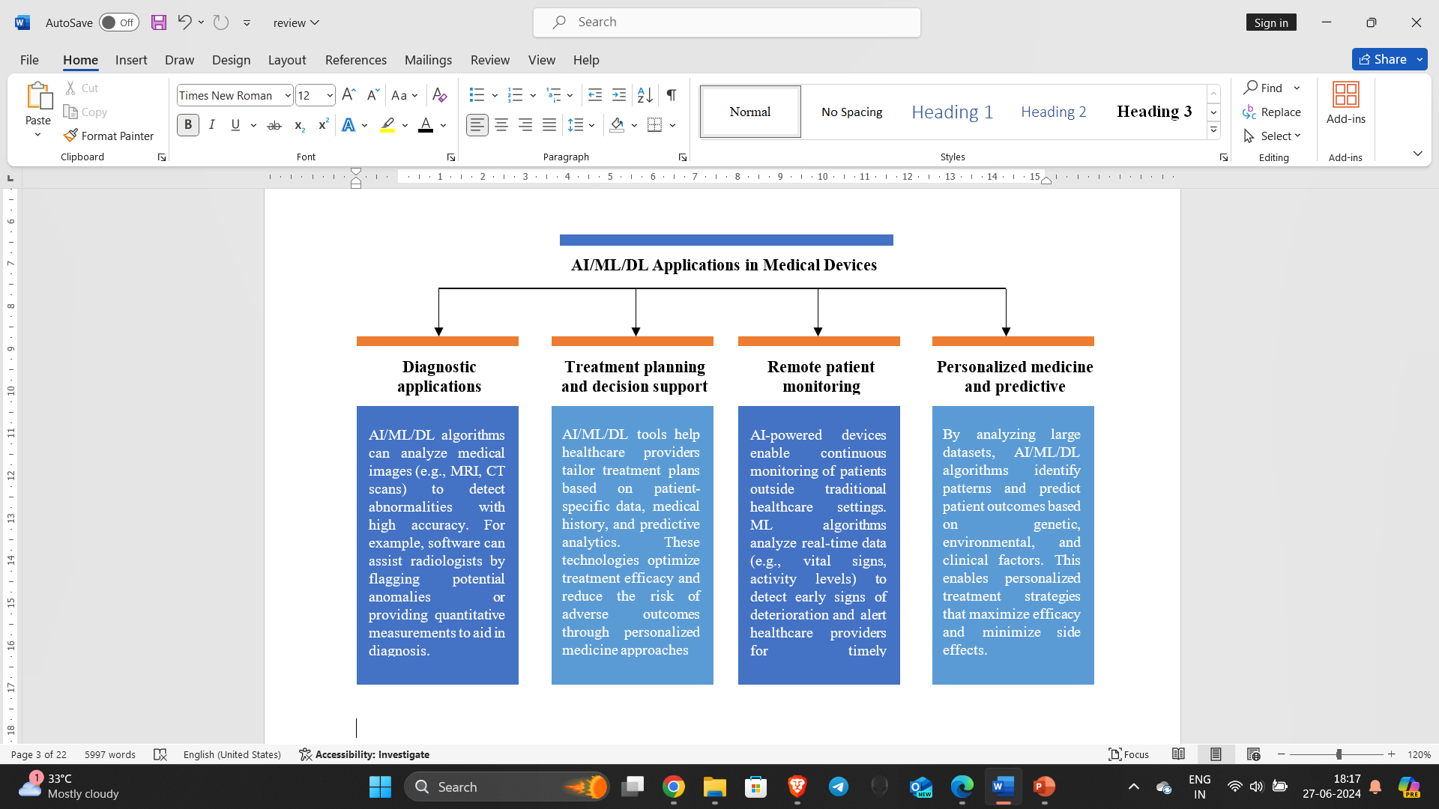 **Fig 1**: applications of AI in medical devices

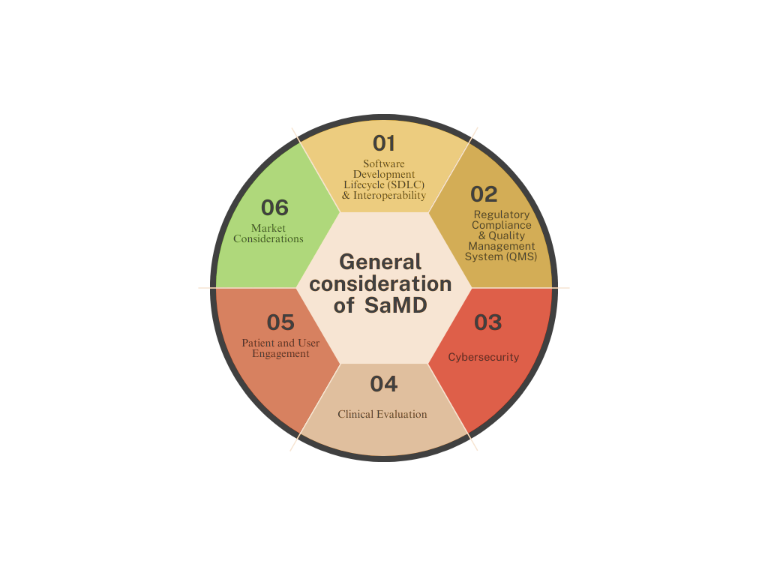

**Fig 2:** General considerations of SaMD

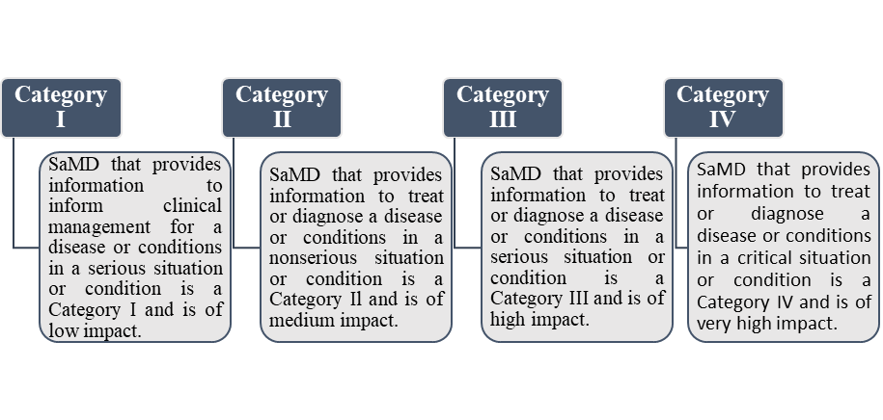

**Fig 3:** SaMD Categories

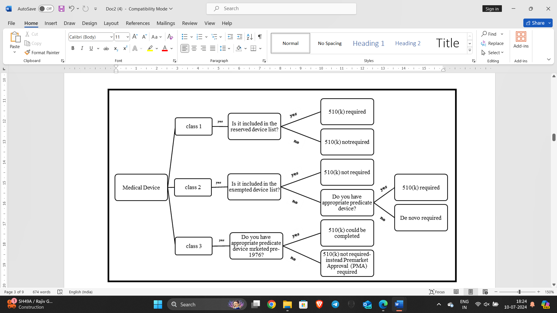

**Fig 4:** procedures for approving and regulating medical devices

**Fig 5**: current status of FDA approved medical devices

**Fig 6:** AI based devices approved by USFDA since 2001to till now