**REVIEW ARTICLE**

**Review Article**

**LRG1 AS TARGET FOR OCULAR DISEASES**

**Abstract**

The aging population and diabetes epidemic are contributing to an increase in retinal and choroidal disorders, which are leading causes of blindness and visual impairment in the developed world. A high proportion of patient non-response and gradual loss of efficacy are major hurdles to the standard of care, which is centred around blocking vascular endothelial growth factor (VEGF) and has reduced the number of patients losing their sight by half. Vision-threatening eye disorders are mostly caused by dysregulation of vascular homeostasis, in conjunction with fibrosis and inflammation. Increasing our understanding of these pathogenic mechanisms should help produce new medications that will help patients with the current clinical issues.Leucine-rich α-2 glycoprotein 1 (LRG1) is a newly discovered important participant in inflammation, fibrosis, and vascular dysfunction. Although the liver and granulocytes constitutively express LRG1 under physiological settings, little is known about LRG1's typical biological function. Its expression is ectopically elevated in pathological circumstances, such as diabetic retinopathy (DR) and neovascular age-related macular degeneration (nvAMD), and it takes on a much more clarified pathogenic role. One of LRG1's primary functions is context-dependent modulation of the transforming growth-factor β (TGFβ) pathway, but more functions have just now come to light. The objective of this review is to summarize the preclinical and clinical data supporting the pathogenic role of LRG1 in vascular retinopathies and to draw conclusions about other illnesses' roles that may apply to eye disorders.

**Keywords**LRG1,Inflammation,Fibrosis,Immunity,Vascular dysfunction,Diabetic Retinopathy,Age-related Macular degeneration

**Introduction**

First identified in human serum in 1977, leucine-rich α-2 glycoprotein 1 (LRG1) is a secreted member of the leucine-rich repeat (LRR) protein family[1]. By 2050, there will be twice as many legally blind or persons with sight-threatening diseases in the UK as there are now—2 million people. The LRR motifs are present in bacteria, fungi, plants, and animals and have been shown to be evolutionarily conserved[2]. Among its many functions, LRG1 is a multifunctional pathogenic signalling molecule that extremely context-dependently regulates the TGFβ pathway. It was initially noted that LRG1 was a significant participant in pathological angiogenesis[3].

Significant increases in LRG1 expression have been linked to infections, cardiovascular, renal, lung, neurological, and autoimmune diseases, as well as diabetes and cancer, two conditions that carry a heavy global cost of morbidity and mortality[4]. Retinopathies, or disorders of the retina, are separate pathologies; nevertheless, many of them share some similar clinical markers, including inflammation, fibrosis (or extracellular matrix remodelling), and vascular dysfunction (oedema and/or angiogenesis). Vascular endothelial growth factor (VEGF) is one important molecule that has garnered a lot of interest over the past 50 years because to its pivotal involvement in DR, diabetic macular oedema (DMO), and non-visual AMD[5,6].

VEGF is the master regulator of hyperpermeability responses and angiogenesis because it can stimulate EC survival, migration, proliferation, and junctional remodelling through its receptors, VEGFR1-3[7].

In fact, the approval of Macugen (Eyetech Inc.), the first anti-VEGF agent and the first aptamer to be licensed for clinical use, in 2004 revolutionized the treatment of some retinopathies. Other anti-VEGF drugs that were subsequently approved included Lucentis (Genentech), Eylea (Regeneron Pharmaceuticals), and Avastin (Genentech, off-label), which were administered by intra-vitreal (IVT) injection at slightly different dosage regimens (once a month, on average)[8].

Anti-VEGF medication has, in fact, achieved an efficacy ceiling, as demonstrated by clinical trials, meaning that raising the dose will not improve visual acuity any further[9].

The fact that LRG1 is pathogenic is fueling an increase in studies to understand its physiological role, pathogenic role, and potential applications as a therapeutic target or diagnostic biomarker. transforming growth-factor β (TGFβ) signaling, and as such, it is essential for fibrosis[10], as well as neovascularization[3] in these processes.

**LRG1 molecular structure**

The amino acid sequence of LRG1 was discovered in 1985 after it was initially isolated from human serum in 1977[11]. It has eight LRRs and is made up of a single polypeptide chain with 312 amino acid residues. Protein-ligand interaction motifs, or LRRs, are usually grouped in repeating segments with varying lengths. A well-conserved N-terminal stretch of 9–12 amino acids, rich in the hydrophobic amino acid leucine, makes up each of the 19–29 amino acids that make up an LRR. The C-terminal domain exhibits variation in length, sequence, and structure. A horseshoe-shaped solenoid protein domain with a concave surface that serves as a platform for protein–protein interactions is usually formed by grouping many repeats together[12].

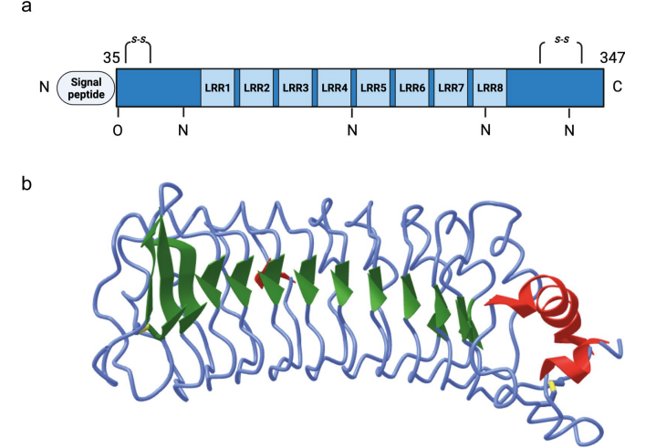

**Figure 1. LRG1 protein structure**[13]

Towards the inner of the horseshoe-shaped domain[14], the repetitions' negatively charged, leucine-rich N-terminal lengths form β-strands, which are perfect binding sites for cationic proteins like TGFβ[12]. LRG1 is thought to have a leucine-rich C-terminal domain (LRC) that is related to the LRRs by many loops, despite the fact that its crystal structure has not yet been published[3]. According to uniprot.org, LRG1 is a glycoprotein with a predicted 5 glycosylation sites and a 23% carbohydrate content[1]. In fact, a number of writers have demonstrated that variations in glycosylation cause variations in the precise molecular weight of LRG1[15,16]. The molecular weight of deglycosylated LRG1 is approximately 34–36 kDa, while glycosylated LRG1 can have a molecular weight of up to 55–60 kDa. It has been demonstrated that LRG1 produced from neutrophils is glycosylated differently than serum LRG1[15] and that LRG1 is expressed in more different molecular sizes by CD11bpos F4/80pos neutrophils than by CD11bpos F4/80pos macrophages[16]. The regulation of LRG1's glycosylation or deglycosylation in vivo and the potential effects of varying glycosylation patterns on function are unknown.

**LRG1 physiological tissue expression**

Hepatocytes and neutrophils are principally responsible for the synthesis of LRG1 under physiological settings[17]. Reports have also indicated that the lung, kidney, heart, skin, brain, and testis all exhibit marginal expression levels of LRG1. LRG1 appears to be expressed mostly as a monomer, while it's possible that other, larger molecular weight multimers are secreted as well. The low reliability of currently available antibodies and the blood-borne nature of LRG1, which causes diffuse extracellular staining in organs with limited vascular exclusion, contribute to the confusion of histological findings. LRG1 appears to locate solely in the extracellular matrix (ECM) in a testis cross-section, where seminiferous tubules are segregated from the surrounding interstitial space by the Sertoli cell barrier. This suggests that LRG1 is likely sequestered in the ECM after diffusing from the surrounding blood vessels. Alveolar epithelial cells[10,18], renal tubular epithelial cells[19], and interstitial cells[20], in tissue sections revealed by immunohistochemistry, express LRG1 in the lung, kidney, and heart, respectively. Cell-specific loss of function in vivo experiments suggested that fibroblasts could be a major source of LRG1 in normal skin[21]. Lrg1 is also a member of a group of genes that are increased in adipose tissue in the late stages of embryonic and early postnatal development, when adipocytes begin to accumulate fat[22]. LRG1 is released by both brown and white adipocytes, according to recent research[23,24]. not to mention that although Lrg1 is similarly translated in fat tissue and the liver, the latter has far larger quantities of the protein[24]. Conversely, endothelial cells seem to express low or undetectable quantities of LRG1 at various locations. For instance, independent research used immunohistochemistry on laser-captured glomeruli[25] or in situ co-hybridization for Lrg1 and Cd31 transcripts[26] to describe LRG1 expression in kidney endothelial cells. While immunohistochemistry revealed probable LRG1pos endothelial cells in lung[10] and brain[27] sections, confirmation of these findings requires co-staining for certain endothelium markers.

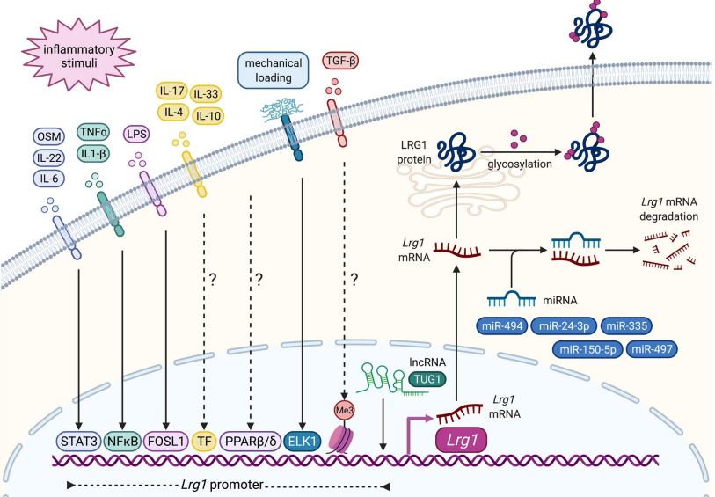

**Figure 2. Regulation of Lrg1 expression**[13]

**LRG1 PATHOGENIC MECHANISMS**

**LRG1 as a promoter of vascular dysfunction and pathological angiogenesis**

The retina is one of the body's most metabolically active tissues due to its dense neuronal layer; thus, it depends heavily on the retinal and choroidal vasculature for the proper supply of oxygen and nutrients. The basic mechanism that keeps the endothelium in a healthy state is vascular homoeostasis. The maintenance of extracellular matrix (ECM) quiescence is a dynamic process that is primarily driven by autocrine and paracrine signaling, physical interaction with perivascular cells, mechanical stress from the blood, and monitoring the composition of the ECM. Therefore, it should come as no surprise that a pathological disruption of this perfectly balanced equilibrium causes vascular instability, which can result in leakage, hypoxia, and the formation of aberrant arteries.In the initial phases of diabetic reticulum (DR), for instance, hypoglycemia-induced altered signaling causes pericytes to separate from capillaries, depriving ECs of quiescence signals and causing aneurism, hemorrhage, and microangiopathy. In the later stages of DR, poor perfusion, hypoxia, disintegration of vessels, and loss of homoeostatic signaling from pericytes will result in angiogenic sprouting[28]. Due to hypoxia, there is an increase in local VEGF expression in nvAMD. This promotes hyper-permeability, and continuous exposure to this growth factor leads to the development of new aberrant capillaries that, if they damage the macular region, impair central vision[29]. One of the most recently discovered regulators of pathological angiogenesis and vascular dysfunction is LRG1, which is up-regulated in oxygen-induced retinopathy (OIR) and laser-induced choroidal neovascularization (CNV)[3].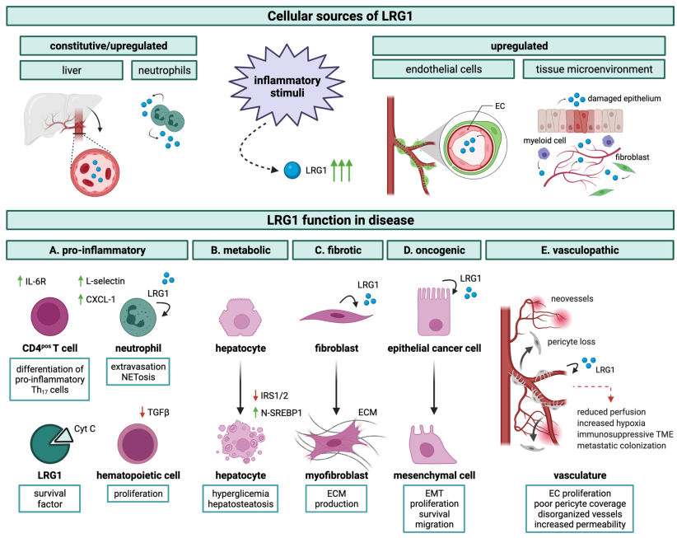

**Figure 3. LRG1 functions in disease progression**[13]

**LRG1 pro-fibrotic role**

Fibroblasts and glial cells, which include Müller cells, astrocytes, and microglia, are the two main cell types that cause fibrosis in eye diseases[30]. Glial cell activation and proliferation accompany the formation of new blood vessels, and as these vessels pierce the vitreous, they contract, resulting in retinal detachment[31]. Anomalies in blood vessel formation first multiply beneath the RPE and Bruch's membrane, then spread into the sub-retinal space, where they cause leaks, hemorrhages, serous retinal detachment, and scarring[32]. Retinopathy of prematurity is also associated with gliosis produced by angiogenesis[33,34].One common characteristic of fibrosis/gliosis in the eye and other organs is TGFβ's prominent function. This pleiotropic cytokine is a powerful inducer of cell conversion to myofibroblasts and the primary regulator of matrix deposition[35].

Recent research has demonstrated robust immunostaining of LRG1 in the neovascular lesions of individuals with nvAMD who have not received treatment, especially when myofibroblasts and ECs are present[36]. Interestingly, in a bleomycin-induced mouse model of lung fibrosis, LRG1 is also observed to be increased in infiltrating immune cells and bronchial epithelial cells, suggesting that its involvement in fibrosis may not be organ-specific. In line with LRG1's previously reported function as a TGFβ signaling modulator[3], bleomycin administration prevents the development of fibrotic lesions in Lrg1-deficient animals. Reduction of pSMAD2 signal was observed in Lrg1-deficient lungs, which is consistent with participation in the TGFβ/SMAD system[10]. This may suggest a feed-forward process involving IL-6 and LRG1 as important players and possible targets between angiogenesis and fibrosis.

**Immunomodulatory roles of LRG1**

Due to an immunosuppressive environment and the blood-retinal barrier's mechanical barrier, the eye has historically been regarded as an immune-privileged location. It is believed that this evolutionary adaptation developed to shield eyesight from the detrimental effects of swelling and heat exhaustion that come along with the flogistic reaction[37]. Another pathogenic aspect of diabetic kidney disease (DR) is inflammation, which is facilitated by chronic hyperglycemia and local production of a proinflammatory milieu that includes IL-6, IL-8, TNFα, VEGF, and MCP-1[38]. Leukocyte adhesion and trans-endothelial migration are facilitated by elevated concentrations of chemoattractant and adhesion molecules, such as ICAM-1 and VCAM-1, on the luminal side of blood arteries[39]. Leukocyte transmigration causes an increase in permeability, which can lead to the vascular leakage seen in DMO and is further maintained by an inflammatory mediator's direct impact on the integrity of the EC junction[40]. One of the most powerful vascular permeability agents, VEGF is known to play a significant role in junctional remodeling in retinopathy[41].

The application of corticosteroids has been the conventional treatment for several ocular illnesses, and therapeutically addressing the inflammatory response in the eye to restore tissue homoeostasis has enormous promise[42]. It should come as no surprise that the Lrg1 promoter's expression frequently connects to inflammatory reactions because it comprises STAT and NFκB sensitive elements.

Additionally, rheumatoid arthritis, lupus erythematosus, asthma, ulcerative colitis, psoriasis, lupus nephritis, and Still's disease have all been linked to LRG1 as a biomarker. In addition, Lrg1-deficient mice displayed a lower disease burden in a mouse model of collagen-induced arthritis (CIA).Therefore, it would be intriguing to investigate if LRG1 influences Th17 differentiation in this particular situation. It's interesting to note that research suggests LRG1 is a hallmark of high endothelial venules, a subtype of ECs that are specifically tasked with attracting blood cells to the tissue interstitium[43,44].

Additionally, LRG1 may influence neutrophil function. Its expression is activated during granulopoiesis triggered by G-CSF, and granulocytes continue to produce it as they differentiate into neutrophils[17]. By modifying leukocyte recruitment, differentiation, and quantity, as well as by directly affecting the vasculature, targeting LRG1 may have a dual impact on the inflammatory aspect of several eye disorders.

**CLINICAL AND PRE-CLINICAL EVIDENCE OF A ROLE FOR LRG1 IN EYE DISEASES**

**LRG1 in diabetic retinopathy**

DR ranks fifth globally and is the primary cause of vision loss in working-age populations in industrialized nations. It is the most prevalent diabetic consequence, and the length and severity of hyperglycemia (often greater than 20 years), smoking, hypertension, and hyperlipidemia are all highly correlated with its incidence. The early phase of DR is called the non-proliferative stage (NPDR), during which the first microvascular anomalies appear. These include retinal hemorrhages and microaneurysms, which are probably caused by pericyte loss and thickening of the basal lamina. Likewise, de-endothelialized and occluded capillaries can result from low perfusion and pericyte loss, which show up as dark patches on fluorescein angiograms. Additionally, nerve fiber ischaemia and axonal swelling—clinically known as "cotton wool spots"—are brought on by perfusion of acellular capillaries. In rare circumstances, the illness may worsen and reach a proliferative stage (PDR), in which increased proangiogenic factors are produced locally, leading to the creation of new, aberrant blood vessels that may burst and cause vision impairment. DMO, a consequence of diabetic retinal necrosis, is characterized by swelling of the macular area as a result of fluid extravasation and can arise at any point during the course of the disease[45].

According to the available data, LRG1 may have a significant role in both the early and late proliferative stages of DR illness. Studies on cancer may also teach us a lot about the proliferative stage, when newly formed defective arteries are harmful. In this case, an alternate treatment strategy has gained hold, whereby new and existing vessels' vascular normalization is encouraged through the development of methods. Such an approach is justified by the fact that normal arteries are more suited to transport medications, less prone to leakage and hemorrhage, and minimize hypoxia.Neovascularization is ideally necessary in the diabetic eye to offset damaging hypoxia, but these new vessels must be stable and functional. Therefore, we suggest that, as it occurs throughout development, new vessel construction would be more likely to proceed in a physiological manner in the absence of LRG1. Therefore, regaining quiescent endothelial cell state, blocking leukocyte EC-adhesion, reestablishing EC junctional stability, and restoring pericyte covering of arteries should remain essential goals for any new therapy targeting the vasculature.

**LRG1 in age-related macular degeneration**

The primary cause of blindness in the elderly in developed nations is age-related macular degeneration, and as life expectancy rises, so too will its occurrence. AMD has been traditionally categorized into two sub-types: a less frequent but more rapidly progressing wet/neovascular/exudative form, which accounts for around 85% of patients, and a more common but slower-progressing dry/non-exudative form. Although the exact cause of AMD is unknown, it is evidently a complicated multifactorial disease, as evidenced by its correlation with a growing number of genetic variations. RPE abnormalities, hyperpigmentation, drusen (sub-RPE deposits), and loss of choriocapillaris are the characteristic signs of the early stages of dry AMD.

These immature, leaky neo-vessels cause fluid buildup, hemorrhage, and fibrosis, all of which permanently impair central vision. As VEGF is one of the primary drivers of permeability and angiogenesis in AMD, monthly or less frequent intravenous injections of anti-VEGF pathway agents can be used to treat the neovascular form of the disease. In contrast, there is currently no treatment for dry AMD, though clinical trials using complement modulators and cell-based therapies are showing promise. LRG1 was found to be an enhanced component in vitreous humour from patients with CNV and in vitreous and Bruch's membrane biopsies from patients with dry AMD, according to proteomic analyses[46–48].

Pre-clinical data show that LRG1 is hardly expressed in a healthy retina and only becomes noticeably more so in pathological conditions[3]. In this paradigm, the angiogenic and permeability responses are both decreased by genetic depletion of Lrg1, an effect that may also be achieved by intravenous injection of antibodies that block LRG1.

Remarkably, whereas some patients in this trial did not show decreased LRG1 expression linked to myofibroblasts and the vasculature, the majority of patients treated with anti-VEGF medications did. This begs the interesting question of whether a patient is considered a non-responder if there is inadequate inhibition of LRG1 expression after VEGF-blockade and likely endothelial quiescence. If this is the case, blocking VEGF and LRG1 simultaneously would benefit a far greater number of people. Anti-VEGF medication has been shown to enhance visual function in people with non-vertebral AMD, but it can also produce sub-retinal fibrosis, which has been identified as one of the main causes of blindness in about half of these patients[49]. Therefore, it is particularly interesting to investigate novel targets like LRG1, which can address fibrosis in addition to angiogenesis and may even be able to lessen the fibrotic effect of VEGF blocking.

**LRG1 IN OTHER OCULAR PATHOLOGIES**

**Rhegmatogenous retinal detachment**

The severe ailment known as retinal detachment (RD) is brought on by the neural retina's separation from the retinal pigment epithelium. RD comes in three flavors: exudative, tractional, and rhegmatogenous[50].

LRG1 was found in both RRD samples, however it was found at higher concentrations in the vitreous than in the SRF [128]. LRG1 was found in vitreous samples from individuals with RRD (n = 4) and epiretinal membranes (MEM) (n = 4) in a follow-up study conducted in 2018 using iTRAQ quantitative proteomics[51].

**Retinoblastoma**

Retinoblastoma (RB) is the most prevalent intraocular malignancy in children, affecting approximately 7500 children globally each year[52]. A mutation in the tumor suppressor gene RB1, which predisposes retinal cells to malignancy, causes RB to develop[53]. The first type of treatment was enucleation, but with the advent of gene therapy[54], chemotherapy, focused radiation, and laser therapies[55], as well as a focus on finding novel therapeutic targets, modern medicine is shifting toward a more conservative approach.It was recently found that LRG1 might be crucial for RB tumor survival[56]. Amer et al.[56] used immunohistochemistry to find high expression of LRG1 in RB samples from 34 patients.

**Summary**

Retinopathies are a group of eye diseases that currently afflict two million people in the United Kingdom. Due to its pivotal function in permeability and angiogenesis, the VEGF pathway is the primary therapeutic target of current medications where vascular problems arise. Anti-VEGF medications have transformed the treatment of DR, DMO, and nvAMD; nevertheless, not all patients respond well to them. Furthermore, considering that VEGF functions as a survival factor in the retina, questions have been raised about the long-term safety of this treatment approach. Moreover, fibrosis and inflammation—which frequently coexist with retinal illness and significantly worsen the prognosis—are not addressed by VEGF blocking. Given that TGFβ has pleiotropic functions in angiogenesis, inflammation, and fibrosis—all of which are well-documented in ocular pathologies—targeting this growth factor may be one way to address the issue. Unfortunately, despite this compelling evidence, TGF-β's various homoeostatic housekeeping tasks, which would be inhibited by unselective TGFβ blockage with unfavorable effects, make therapeutic targeting of TGF-β (or its receptors, including ALK1 and ENG) difficult. A glycoprotein that is secreted and that is highly increased in pathological conditions, LRG1 encourages inflammation, fibrosis, and vascular destabilization. Importantly, in contrast to VEGF and TGFβ, LRG1 is not necessary for homoeostatic physiological processes or for development, as evidenced by the absence of an obvious phenotype in Lrg1-deficient animals. On the other hand, pathological levels of LRG1, which are often caused by ectopic overexpression of the protein at the pathological sites, such as in certain cancers, inflammatory diseases, and eye disorders, exhibit robust biological activity that seems to be mediated, at least partially, by coercion of TGFβ signaling (Fig. 3). Therefore, targeting LRG1 may protect the homoeostatic effects of TGFβ signaling while inadvertently impeding its pathogenic arm. Furthermore, the timing of LRG1 expression, particularly in DR, would suggest that this molecule has a function early in the disease, when microvascular damage builds up and neovascularization is not yet evident.

**References**

1. Haupt H, Baudner S, “[Isolation and characterization of an unknown, leucine-rich 3.1-S-alpha2-glycoprotein from human serum (author’s transl)].” *Hoppe. Seylers. Z. Physiol. Chem.***1977**,358(6),639–646.

2. Kobe B, Kajava A V, “The leucine-rich repeat as a protein recognition motif.” *Curr. Opin. Struct. Biol.***2001**,11(6),725–732.

3. Wang X, Abraham S, McKenzie JAG, Jeffs N, Swire M, Tripathi VB, et al., “LRG1 promotes angiogenesis by modulating endothelial TGF-β signalling.” *Nature***2013**,499(7458),306–311.

4. Kallenberg D, Tripathi V, Javaid F, Pilotti C, George J, Davis S, et al., “A Humanized Antibody against LRG1 that Inhibits Angiogenesis and Reduces Retinal Vascular Leakage.” *bioRxiv***2020**,(July),2020.07.25.218149.

5. Aiello LP, Avery RL, Arrigg PG, Keyt BA, Jampel HD, Shah ST, et al., “Vascular endothelial growth factor in ocular fluid of patients with diabetic retinopathy and other retinal disorders.” *N. Engl. J. Med.***1994**,331(22),1480–1487.

6. Krzystolik MG, Afshari MA, Adamis AP, Gaudreault J, Gragoudas ES, Michaud NA, et al., “Prevention of experimental choroidal neovascularization with intravitreal anti-vascular endothelial growth factor antibody fragment.” *Arch. Ophthalmol. (Chicago, Ill. 1960)***2002**,120(3),338–346.

7. Penn JS, Madan A, Caldwell RB, Bartoli M, Caldwell RW, Hartnett ME, “Vascular endothelial growth factor in eye disease.” *Prog. Retin. Eye Res.***2008**,27(4),331–371.

8. Adamis AP, Brittain CJ, Dandekar A, Hopkins JJ, “Building on the success of anti-vascular endothelial growth factor therapy: a vision for the next decade.” *Eye (Lond).***2020**,34(11),1966–1972.

9. Busbee BG, Ho AC, Brown DM, Heier JS, Suñer IJ, Li Z, et al., “Twelve-month efficacy and safety of 0.5 mg or 2.0 mg ranibizumab in patients with subfoveal neovascular age-related macular degeneration.” *Ophthalmology***2013**,120(5),1046–1056.

10. Honda H, Fujimoto M, Serada S, Urushima H, Mishima T, Lee H, et al., “Leucine-rich α-2 glycoprotein promotes lung fibrosis by modulating TGF-β signaling in fibroblasts.” *Physiol. Rep.***2017**,5(24).

11. Takahashi N, Takahashi Y, Putnam FW, “Periodicity of leucine and tandem repetition of a 24-amino acid segment in the primary structure of leucine-rich alpha 2-glycoprotein of human serum.” *Proc. Natl. Acad. Sci. U. S. A.***1985**,82(7),1906–1910.

12. Jemmerson R, “Paradoxical Roles of Leucine-Rich α(2)-Glycoprotein-1 in Cell Death and Survival Modulated by Transforming Growth Factor-Beta 1 and Cytochrome c.” *Front. cell Dev. Biol.***2021**,9,744908.

13. Camilli C, Hoeh AE, Rossi G De, Moss SE, Greenwood J, “LRG1 : an emerging player in disease pathogenesis.” *J. Biomed. Sci.***2022**,1–29.

14. Dolan J, Walshe K, Alsbury S, Hokamp K, O’Keeffe S, Okafuji T, et al., “The extracellular leucine-rich repeat superfamily; a comparative survey and analysis of evolutionary relationships and expression patterns.” *BMC Genomics***2007**,8,320.

15. Druhan LJ, Lance A, Li S, Price AE, Emerson JT, Baxter SA, et al., “Leucine Rich α-2 Glycoprotein: A Novel Neutrophil Granule Protein and Modulator of Myelopoiesis.” *PLoS One***2017**,12(1),e0170261.

16. Kumagai S, Nakayama H, Fujimoto M, Honda H, Serada S, Ishibashi-Ueda H, et al., “Myeloid cell-derived LRG attenuates adverse cardiac remodelling after myocardial infarction.” *Cardiovasc. Res.***2016**,109(2),272–282.

17. O’Donnell LC, Druhan LJ, Avalos BR, “Molecular characterization and expression analysis of leucine-rich alpha2-glycoprotein, a novel marker of granulocytic differentiation.” *J. Leukoc. Biol.***2002**,72(3),478–485.

18. Honda H, Fujimoto M, Miyamoto S, Ishikawa N, Serada S, Hattori N, et al., “Sputum Leucine-Rich Alpha-2 Glycoprotein as a Marker of Airway Inflammation in Asthma.” *PLoS One***2016**,11(9),e0162672.

19. Yang Y, Luo R, Cheng Y, Liu T, Dai W, Li Y, et al., “Leucine-rich α2-glycoprotein-1 upregulation in plasma and kidney of patients with lupus nephritis.” *BMC Nephrol.***2020**,21(1),122.

20. Liu C, Lim ST, Teo MHY, Tan MSY, Kulkarni MD, Qiu B, et al., “Collaborative Regulation of LRG1 by TGF-β1 and PPAR-β/δ Modulates Chronic Pressure Overload-Induced Cardiac Fibrosis.” *Circ. Heart Fail.***2019**,12(12),e005962.

21. Sng MK, Chan JSK, Teo Z, Phua T, Tan EHP, Wee JWK, et al., “Selective deletion of PPARβ/δ in fibroblasts causes dermal fibrosis by attenuated LRG1 expression.” *Cell Discov.***2018**,4,15.

22. Birsoy K, Berry R, Wang T, Ceyhan O, Tavazoie S, Friedman JM, et al., “Analysis of gene networks in white adipose tissue development reveals a role for ETS2 in adipogenesis.” *Development***2011**,138(21),4709–4719.

23. Zhang J, Ahn J, Suh Y, Hwang S, Davis ME, Lee K, “Identification of CTLA2A, DEFB29, WFDC15B, SERPINA1F and MUP19 as Novel Tissue-Specific Secretory Factors in Mouse.” *PLoS One***2015**,10(5),e0124962.

24. He S, Ryu J, Liu J, Luo H, Lv Y, Langlais PR, et al., “LRG1 is an adipokine that mediates obesity-induced hepatosteatosis and insulin resistance.” *J. Clin. Invest.***2021**,131(24).

25. Haku S, Wakui H, Azushima K, Haruhara K, Kinguchi S, Ohki K, et al., “Early Enhanced Leucine-Rich α-2-Glycoprotein-1 Expression in Glomerular Endothelial Cells of Type 2 Diabetic Nephropathy Model Mice.” *Biomed Res. Int.***2018**,2018,2817045.

26. Hong Q, Zhang L, Fu J, Verghese DA, Chauhan K, Nadkarni GN, et al., “LRG1 Promotes Diabetic Kidney Disease Progression by Enhancing TGF-β-Induced Angiogenesis.” *J. Am. Soc. Nephrol.***2019**,30(4),546–562.

27. Meng H, Song Y, Zhu J, Liu Q, Lu P, Ye N, et al., “LRG1 promotes angiogenesis through upregulating the TGF‑β1 pathway in ischemic rat brain.” *Mol. Med. Rep.***2016**,14(6),5535–5543.

28. Campochiaro PA, “Molecular pathogenesis of retinal and choroidal vascular diseases.” *Prog. Retin. Eye Res.***2015**,49,67–81.

29. Rozing MP, Durhuus JA, Krogh Nielsen M, Subhi Y, Kirkwood TB, Westendorp RG, et al., “Age-related macular degeneration: A two-level model hypothesis.” *Prog. Retin. Eye Res.***2020**,76,100825.

30. Friedlander M, “Fibrosis and diseases of the eye.” *J. Clin. Invest.***2007**,117(3),576–586.

31. Frank RN, “Diabetic retinopathy.” *N. Engl. J. Med.***2004**,350(1),48–58.

32. Ishikawa K, Kannan R, Hinton DR, “Molecular mechanisms of subretinal fibrosis in age-related macular degeneration.” *Exp. Eye Res.***2016**,142,19–25.

33. Cogan DG, “Congenital anomalies of the retina.” *Birth Defects Orig. Artic. Ser.***1971**,7(3),41–51.

34. Penn JS, Tolman BL, Lowery LA, “Variable oxygen exposure causes preretinal neovascularization in the newborn rat.” *Invest. Ophthalmol. Vis. Sci.***1993**,34(3),576–585.

35. Dejana E, Hirschi KK, Simons M, “The molecular basis of endothelial cell plasticity.” *Nat. Commun.***2017**,8,14361.

36. Mundo L, Tosi GM, Lazzi S, Pertile G, Parolini B, Neri G, et al., “LRG1 Expression Is Elevated in the Eyes of Patients with Neovascular Age-Related Macular Degeneration.” *Int. J. Mol. Sci.***2021**,22(16).

37. Nag TC, Wadhwa S, “Ultrastructure of the human retina in aging and various pathological states.” *Micron***2012**,43(7),759–781.

38. Tang J, Kern TS, “Inflammation in diabetic retinopathy.” *Prog. Retin. Eye Res.***2011**,30(5),343–358.

39. van der Wijk A-E, Vogels IMC, van Noorden CJF, Klaassen I, Schlingemann RO, “TNFα-Induced Disruption of the Blood-Retinal Barrier In Vitro Is Regulated by Intracellular 3’,5’-Cyclic Adenosine Monophosphate Levels.” *Invest. Ophthalmol. Vis. Sci.***2017**,58(9),3496–3505.

40. Bhagat N, Grigorian RA, Tutela A, Zarbin MA, “Diabetic macular edema: pathogenesis and treatment.” *Surv. Ophthalmol.***2009**,54(1),1–32.

41. Smith RO, Ninchoji T, Gordon E, André H, Dejana E, Vestweber D, et al., “Vascular permeability in retinopathy is regulated by VEGFR2 Y949 signaling to VE-cadherin.” *Elife***2020**,9.

42. Leandro L, Beare N, Bhan K, Murray PI, Andrews C, Damato E, et al., “Systemic corticosteroid use in UK Uveitis practice: results from the ocular inflammation steroid toxicity risk (OSTRICH) study.” *Eye (Lond).***2021**,35(12),3342–3349.

43. Saito K, Tanaka T, Kanda H, Ebisuno Y, Izawa D, Kawamoto S, et al., “Gene expression profiling of mucosal addressin cell adhesion molecule-1+ high endothelial venule cells (HEV) and identification of a leucine-rich HEV glycoprotein as a HEV marker.” *J. Immunol.***2002**,168(3),1050–1059.

44. Kalucka J, de Rooij LPMH, Goveia J, Rohlenova K, Dumas SJ, Meta E, et al., “Single-Cell Transcriptome Atlas of Murine Endothelial Cells.” *Cell***2020**,180(4),764-779.e20.

45. Antonetti DA, Silva PS, Stitt AW, “Current understanding of the molecular and cellular pathology of diabetic retinopathy.” *Nat. Rev. Endocrinol.***2021**,17(4),195–206.

46. Nobl M, Reich M, Dacheva I, Siwy J, Mullen W, Schanstra JP, et al., “Proteomics of vitreous in neovascular age-related macular degeneration.” *Exp. Eye Res.***2016**,146,107–117.

47. Qu S-C, Xu D, Li T-T, Zhang J-F, Liu F, “iTRAQ-based proteomics analysis of aqueous humor in patients with dry age-related macular degeneration.” *Int. J. Ophthalmol.***2019**,12(11),1758–1766.

48. Yuan X, Gu X, Crabb JS, Yue X, Shadrach K, Hollyfield JG, et al., “Quantitative proteomics: comparison of the macular Bruch membrane/choroid complex from age-related macular degeneration and normal eyes.” *Mol. Cell. Proteomics***2010**,9(6),1031–1046.

49. Daniel E, Toth CA, Grunwald JE, Jaffe GJ, Martin DF, Fine SL, et al., “Risk of scar in the comparison of age-related macular degeneration treatments trials.” *Ophthalmology***2014**,121(3),656–666.

50. Mitry D, Charteris DG, Fleck BW, Campbell H, Singh J, “The epidemiology of rhegmatogenous retinal detachment: geographical variation and clinical associations.” *Br. J. Ophthalmol.***2010**,94(6),678–684.

51. Santos FM, Gaspar LM, Ciordia S, Rocha AS, Castro E Sousa JP, Paradela A, et al., “iTRAQ Quantitative Proteomic Analysis of Vitreous from Patients with Retinal Detachment.” *Int. J. Mol. Sci.***2018**,19(4).

52. Kivelä T, “The epidemiological challenge of the most frequent eye cancer: retinoblastoma, an issue of birth and death.” Br. J. Ophthalmol.**2009**,93(9),1129–1131.

53. Dimaras H, Kimani K, Dimba EAO, Gronsdahl P, White A, Chan HSL, et al., “Retinoblastoma.” *Lancet (London, England)***2012**,379(9824),1436–1446.

54. Pascual-Pasto G, Bazan-Peregrino M, Olaciregui NG, Restrepo-Perdomo CA, Mato-Berciano A, Ottaviani D, et al., “Therapeutic targeting of the RB1 pathway in retinoblastoma with the oncolytic adenovirus VCN-01.” *Sci. Transl. Med.***2019**,11(476).

55. Fabian ID, Onadim Z, Karaa E, Duncan C, Chowdhury T, Scheimberg I, et al., “The management of retinoblastoma.” *Oncogene***2018**,37(12),1551–1560.

56. Amer R, Tiosano L, Pe’er J, “Leucine-Rich α-2-Glycoprotein-1 (LRG-1) Expression in Retinoblastoma.” *Invest. Ophthalmol. Vis. Sci.***2018**,59(2),685–692.