PREVELENCE OF ENTAMOEBA HISTOLYTICA AMONG PERSONS ATTENDING TO DOCTORS' POLY CLINIC, AL-KHOMS, LIBYA
Khaled Mohamed Blhaj ¹ and Hassan Mohammed Krima ²
1. Higher Institute of Science and Medical Technology, Al-Garaboulli, Libya
2. Higher Institute of Science and Medical Technology, Al-Garaboulli, Libya
ABSTRACT:
Entamoeba histolytica is widely recognized as a pathogen and reported that Entamoeba infections are common in the developing world, but rare in developed countries. Entamoeba histolytica has a two-stage of life cycle: an infective cyst stage and an invasive trophozoite stage. E. histolytica is associated with contaminated food or sewage, and it is transmitted by the fecal–oral route. This study was conducted in the Doctors' poly clinic, at Al–Khoms, Libya with 112 patients from May 2023 to February 2024. The results showed that parasite cysts positive in the age 3 months to 1 year were 05.88%, while 31.66%, were found in group age 2 to 10 years. In age between 3 months to 1year were 05.88% and greater than 20 were 60%. Meanwhile in female, positive cyst were found with 10.71% and 14.28% in male. In Trophozoite positive the age category 2 to 10 years were 8.33%, 11 to 20 years is 23.07% . Trophozoite is positive with 5.35% in male patients and 1.78% in female. The present study concluded that providing clean water, and promoting health education programs are essential to reduce the rate of this disease among the population. Children's health should be taken care of by ensuring a healthy environment in schools. Diligent follow-up of restaurants and spreading health awareness, and issuing preventive instructions that limit the spread of infection.
Keywords: Parasite, Entamoeba, Human infection, Libya.

INTRODUCTION:
The parasitic protozoan Entamoeba histolytica is the causative agent of amebic colitis and amebic liver abscesses in humans. The World Health Organization estimates up to 50 million invasive infections world-wide annually ⁽¹⁾. E. histolytica has a simple, two-stage life cycle, consisting of the infective cyst and colon-invasive trophozoite forms. E. histolytica infections occur when cysts are ingested through contaminated food or water ⁽²⁾. In the lower intestine trophozoites emerge from cysts (a process known as excystation). As a result of unknown stimuli in the intestine, trophozoites again can differentiate into cysts (a process known as encystation) ⁽³⁾, which may be excreted in feces to infect other humans. Although the cyst is the only form to transmit infections, most studies on E. histolytica have focused on the trophozoite form, which is the only form that can be readily cultured ⁽⁴⁾. The inability to encyst trophozoites in vitro has severely impaired our knowledge on the infectious stage of E. histolytica.
The genus Entamoeba includes unicellular, anaerobic and parasitic organisms, which infect humans, nonhuman primates and other vertebrate and invertebrate species worldwide ⁽⁵⁾. To date, this genus includes at least seven species that infect the human intestinal lumen: E. histolytica, E. dispar, E. moshkovskii, E. bangladeshi, E. coli, E. hartmanni and E. polecki. The first four species have morphologically identical cysts and trophozoites ⁽⁶⁾. Although only E. histolytica has been well recognized as a causative agent of intestinal and extraintestinal amoebiasis, E. moshkovskii has been described as a potential pathogen by the latest studies. Microscopic examination was performed for the initial detection of Entamoeba parasites ⁽⁷⁾. A multiplex PCR protocol based on the small subunit rRNA gene of E. moshkovskii, E. dispar and E. histolytica, was used for the differential detection of the three Entamoeba species (collectively referred to as Entamoeba complex).
The prevalence of each species from this complex is not well characterized in many geographic regions. It is well-established that only E. histolytica leads to invasive disease in humans. Although some reports suggest a potential role of both E. dispar and E. moshkovskii in provoking disease in humans, they are still considered to be nonpathogenic and free-living amoebas, respectively ⁽⁸⁾. Nevertheless, the differentiation of all Entamoeba species is substantial for preventing unnecessary and indiscriminate treatment with anti-amoebic chemotherapy, which could lead to drug resistance ⁽⁹⁾. The World Health Organization advises that cases determined to have E. histolytica should be treated, whether or not clinical symptoms are present. Additionally, control measures could be more efficiently applied in geographical areas with well-known epidemiological settings.
This study aimed to assess the Prevalence of Entamoeba histolytica (Cyst & Trophozoite) among persons attending to Doctors's poly clinic in Al-Khoms, Libya.

METHODOLOGY:
Study place:
This study was carried out on 112 patients in Doctors' poly Clinic, Al–Khoms, Libya.
Study period:
The study period conducted from May 2023 to February 2024.
Sample collection and Microscopic examination:
Stool samples were collected using a wide mouthed stool container and transported to the laboratory. All specimens were properly labelled with patient's code and date of collection. Two wet mount slides (saline and Lugol's iodine) were prepared directly from each sample to increase the chance of detecting protozoan trophozoites and cysts as well as red and white blood cells. The smears were covered with cover slips and examined under the microscope using 40× objective lens. Cysts and trophozoites were identified as per their characteristic morphometric features. In the results, The percentages are calculated from the total number of cases.
RESULTS AND DISCUSSION:
Entamoeba coli were the most widely distributed species with high prevalence values in several countries. Among species of the Entamoeba complex, E. dispar was the most prevalent. Moreover, it is important to point out that the prevalence of E. histolytica was high, indicating that this infection remains represent a significant health threat among Libyan. Our study was conducted in the Doctors' poly clinic, Al–Khoms, Libya with 112 patients from May 2023 to February 2023.
Table 1: Distribution of Gender of the patients who attending the hospital.
S.No. | Gender | No. of patients | Percentage
1 | Male | 64 | 57.14
2 | Female | 48 | 42.85
 | Total | 112 | 100
(% calculated from total 112 cases)
Table 1 is showed with distribution of gender of the patients, totally 112 cases participated, in that male are 64 with 57.14% and female are 48 with 42.85%.
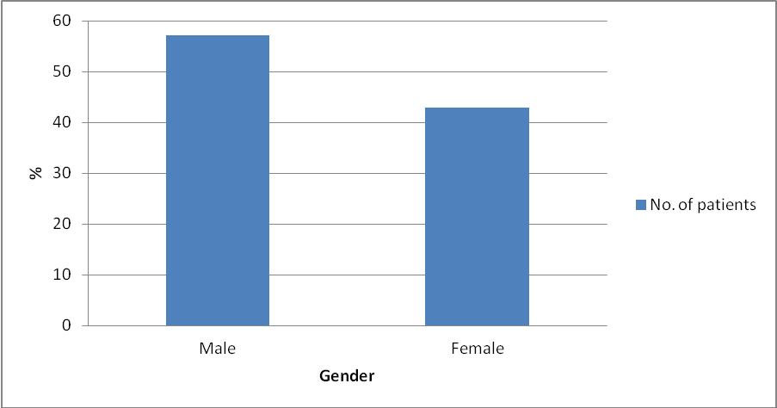
Graph 1: Distribution of Gender of the patients who attending the hospital.
Table 2: Distribution of age among the patients according to the gender.
S.No. | Age | Gender
S.No. | Age | Male | % | Female | % | Total | %
1 | 3 months to 1 year | 18 | 16.07 | 16 | 14.28 | 34 | 30.35
2 | 2 year to 10 years | 37 | 33.03 | 23 | 20.53 | 60 | 53.57
3 | 11year to 20 years | 07 | 6.25 | 06 | 5.35 | 13 | 11.60
4 | > 20 years | 02 | 1.78 | 03 | 2.67 | 05 | 4.46
 | Total | 64 | 57.14 | 48 | 42.85 | 112 | 100
(% calculated from total 112 cases)
Table 2 is summarized with distribution of age among the patients according to the gender. In our study the age is classified into four groups, they are 3 months to 1 year, 2 year to 10 years, 11 year to 20 years old and above 20 years old. In male between 3months to 1year is 16.07%, 2years to 10 years is 33.03%, 11years to 20 years old is 6.25% and >20years old is 1.78%. Meanwhile in female between 3months to 1years old is 14.28%, 2 years to 10years old is 53.57%, 11 years to 20 years old is 11.60% and >20years old is 4.46%.. The prevalence of E. histolytica is more in the age group of 2 – 10 years old (33.03%) in male and 20.53% In female. It is followed by 3 months to 1-year old male is 20.53% and female is 14.28%.
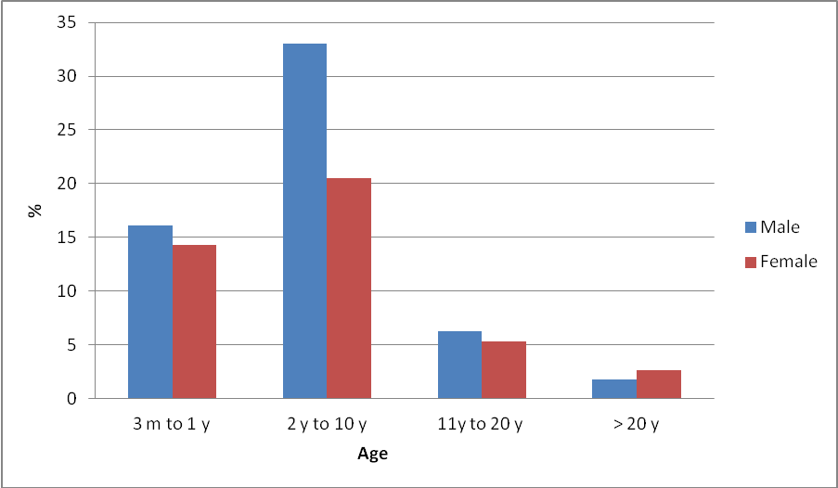
Graph 2: Distribution of age among the patients according to the gender.
Table 3: Prevalence of E. histolytica (Cyst and Trophozoite) among the patients in according to the age.
S.No. | Entamoeba histolytica | Age
S.No. | Entamoeba histolytica | 3 months to 1 year N(34) | % | 2 year to 10 years N(60) | % | 11 year to 20 years N(13) | % | > 20 years N(05) | %
1 | Cyst
 | Positive | 02 | 05.88 | 19 | 31.66 | 04 | 30.76 | 03 | 60.00
 | Negative | 32 | 94.11 | 41 | 68.33 | 09 | 69.23 | 02 | 40.00
2 | Trophozoite
 | Positive | 0 | 0 | 05 | 08.33 | 03 | 23.07 | 0 | 0
 | Negative | 0 | 0 | 55 | 91.66 | 10 | 76.92 | 0 | 0

Table 3 is tabulated with distribution of the parasites Cyst and Trophozoite among the patients according to the age. In this table is classified into four divisions according to the age from 3 months to one year, 2 to 10 years, 11 to 20 years and greater than 20 years. In Cyst positive the age category 3 months to 1 year is 5.88%, 2 to 10 years is 31.66%, 11 to 20 years is 30.76% and greater than 20 is 60%.
In Cyst negative the age 3 months to 1 year is 94.11%, 2 to 10 years is 68.33%, 11 to 20 years is 69.23% and greater than 20 is 40%. In Trophozoite positive the age 3 months to 1 year is with no patients, 2 to 10 years is 8.33%, 11 to 20 years is 23.07% and greater than 20 is with no patients. In Trophozoite negative the age 3 months to 1 year is with no patients, 2 to 10 years is 91.66%, 11 to 20 years is 76.92% and greater than 20 is with no patients respectively.
Among the four age groups represented in this study, a high prevalence 19 cases (31.66%) of intestinal infection was found in the patients aged between 2 and 10 years old. This result is in tandem with the research done by Tasawar et al and Ouattara et al who reported the elevated prevalence of infections by E. histolytica in children because they are less acquainted with hygienic habits and cleanliness. ^{(10), (11)}
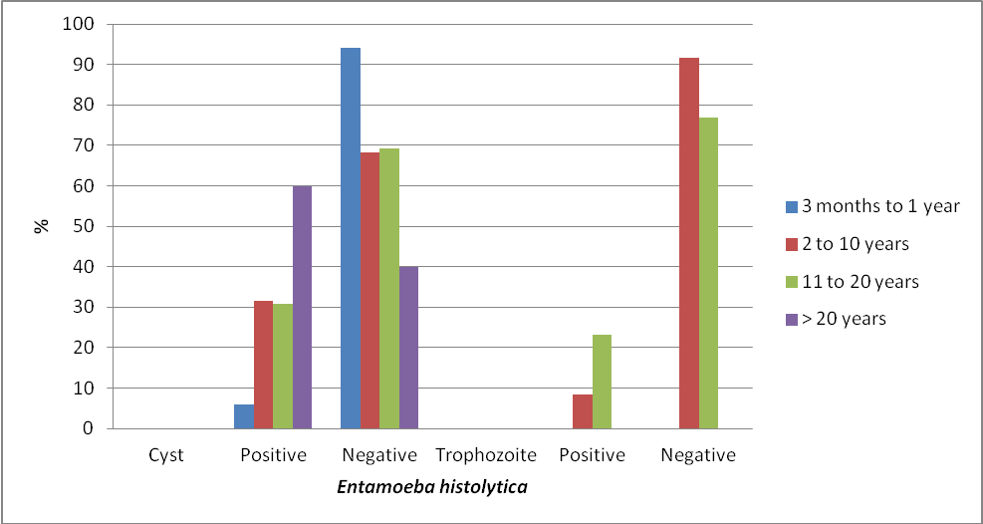
Graph 3: Prevalence of E. histolytica (Cyst and Trophozoite) among the patients in according to the age.

Table 4: Prevalence of E. histolytica (Cyst and Trophozoite) among the patients in according to the gender.
S.No. | Entamoeba histolytica | Gender
S.No. | Entamoeba histolytica | Male | % | Female | % | Total | %
1 | Cyst
 | Positive | 16 | 14.28 | 12 | 10.71 | 28 | 25
 | Negative | 48 | 42.85 | 36 | 32.14 | 84 | 75
2 | Trophozoite
 | Positive | 6 | 5.35 | 2 | 1.78 | 08 | 7.14
 | Negative | 58 | 51.78 | 46 | 41.07 | 104 | 92.85
(% calculated from total 112 cases)
Table 4 is narrated with distribution of parasites (Cyst and Trophozoite) among the patients according to the gender. In this table Cyst is positive with 14.28% in male patients and 10.71% in female patients and Cyst is negative with 42.85% in male patients and 32.14% in female patients. Trophozoite is positive with 5.35% in male patients and 1.78% in female. Trophozoite is negative with 51.78% in male and 41.07% in female respectively. E. histolytica infection was the lowest in the age groups of less than 1 year old and more than 11 years old.
Graph 4: Prevalence of E. histolytica (Cyst and Trophozoite) among the patients in according to the gender.
CONCLUSION:
In this work, it was shown that intestinal parasite infections were significantly related to age and sex, with E. histolytica infections being more common in men than women. Likewise, the prevalence of E. histolytica infection was more (31.66%) in the age groups of 2 years old and 10 years old and 30.76% in 11 to 20 years. Cyst and Trophozoite infections are especially common in young children, as they have not yet developed a fully functional immune system.
The increase in this spread is caused by health and environmental pollution which led to an increase in infection. Children's health should be taken care of by ensuring a healthy environment in kindergartens and primary schools. Diligent follow-up of restaurants and shopping stores, spreading health awareness, purification of drinking water being the key components of community health and issuing preventive instructions that limit the spread of infection.

REFERENCES:
1. Oliveira FM, Neumann E, Gomes MA and Caliari MV (2015) Entamoeba dispar: Could it be pathogenic. Trop. Parasitol, 5(1):9–14.
2. Ngobeni R, Samie A, Moonah S, Watanabe K and Petri WA (2017) Gilchrist C. Entamoeba species in South Africa: Correlations with the host microbiome, parasite burdens, and first description of Entamoeba bangladeshi outside of Asia. J. Infect. Dis, 216(12):1592–1600.
3. Stensvold CR, Winiecka-Krusnell J, Lier T and Lebbad M (2018) Evaluation of a PCR method for detection of Entamoeba polecki, with an overview of its molecular epidemiology. J. Clin. Microbiol, 56(5):e00154-18.
4. Uribe-Querol E and Rosales C (2020) Immune response to the enteric parasite Entamoeba histolytica. Physiology, 35(4):244–260.
5. Abdulhaleem N, Mahmuda A, Khadim AZKJ, Abd Majid R, Lung LTT, Abdullah WO and Unyah Z. (2017). An overview of the prevalence and distribution of gastrointestinal parasitic infections in post-war Iraq, Tropical Journal of Pharmaceutical Research,16(6):1443-1451.
6. Callixte C, Ayubu A, Lestari P, Daniel N and Budhy TI. (2019). Epidemiological Prevalence of Entamoeba histolytica Infections Among the Patients Attending Nyanza District Hospital, Rwanda in 2018, International Journal of Epidemiologic Research, 6(4):149-153.
7. Abioye JOK, Mbagwu TT and Babatunde S (2019) Prevalence of Entamoeba histolytica in Bingham University and Environs. EC Microbiology, 15(4):242-250.
8. Bahrami F, Haghighi A, Zamini G, KhademErfan M and Azargashb E (2018) Prevalence and associated risk factors of intestinal parasitic infections in Kurdistan province, northwest Iran. Cogent Medicine, 5(1):1503777.
9. Curval LG, Franca ADO, Fernandes HJ, Mendes RP, de Carvalho LR, Higa MG, Ferreira EDC and Dorval MEC (2017) Prevalence of intestinal parasites among inmates in Midwest Brazil. PLoS One, 12(9):e0182248.

10. Tasawar Z, Kausar S, Lashari MH. (2010). Prevalence of Entamoeba histolytica in humans. Pak J Pharm Sci, 23(3):344-8. 26.

11. Ouattara M, N’guéssan NA, Yapi A, N’goran EK. (2010). Prevalence and spatial distribution of Entamoeba histolytica/dispar and Giardia lamblia among schoolchildren in Agboville area (Cote d’Ivoire). PLoS Negl Trop Dis, 4(1):e574.

