A Elaborate Review on formulation of Herbal Hair Colour Shampoo

Priti Audut 1, Yugandhara Shingade 2 ,Vijay Sabale 3

Department of Pharmacognosy.

Lokmangal college of pharmacy Wadala, Solapur, Maharashtra, India.

# ABSTRACT:

To screen the hair coloring holdings of hair colorants/ herbal hair coloring formulations. The dried aqueous herbal extracts were prepared. Gudhal, jatamansi, kuth, kattha, amla, coffee and henna, was the topmost accepted formulation and advices that these herbs in combination acts synergistically in hair colouring action. It also bring to the end that jatamansi, present in different hair colorants, was responsible to provide maximum blackening on hair. The main object of this present study is to prepare an herbal Hair color Shampoo and determine physiochemical function that emphasizes on safety, Efficacy and quality of the product Herbal Shampoo is the natural haircare product Which is use to remove grease, dirt, dandruff and promote hair growth, Strengthens and darkness of the hair. Various drugs are used for the pre-mixture of cosmetics Shampoo for cosmetic and treatment purpose. Such drugs shows different side effects such as hair loss, high scaling, Scratching, discomfort, nausea and headache. Therefore, an experiment is made to prepare herbal shampoo that is free from side effects. The aim of the present study is to Formulate herbal Hair color Shampoo containing natural ingredients with an Emphasis on safety and efficacy.[1][2]

*Keywords: Herbal shampoo, Efficacy, Emphasis.*

# Introduction:

The beauty of skin and hair basically based on Individual’s health, diet, habits, job routine, climatic situation and maintenance. Synthetic hair dyes which are obtainable in the market, uses combination of peroxide and Ammonia which alters the structure of hair and damage it and also causes allergic reactions. Para- phenylenediamine (PPD), a like some ingredient of many synthetic hair dyes is called to trigger allergic skin rashes in many people. It also results dermatitis around lips, reddening and swelling of scalp and face. Plants have been used usually for their hair coloring, growth promoting and anti-aging characters. It has been noticed in the local market survey that the most of the marketed herbal formulations in India, though declare to be natural, safe and effective may actually contain the severe synthetic agent. As global scenario is now changing towards the use of Safer, nontoxic natural product with traditional use, Attempts have been made in the present investigation to improve herbal hair color shampoo devoid of any chemical, containing few traditionally used herbs and modifiers; and compare it with marketed purely herbal hair color shampoo. Hair is consisting of protein and water. The water/moisture content is responsible for suppleness of hair. Hair is dead and damage cannot be permanently recovered. You can maintain and preserve your hair but once it is damaged, it cannot be recovered. Hair growth begins inside the hair follicles. Hair fibres have a structure consisting of several layers, starting from the outside cuticle, cortex, medulla. A liquid or cream preparation of detergents wash the hair is called as shampoo. Shampoo is a hair care product, typically in the form of a viscous liquid that is used for cleansing hair and maintain hygienic hairs. The goal of using shampoo is to remove the unwanted expansion in between the hair without stripping out so much sebum as to make hair demanding

Shampooing is the most common form of hair treatment. In current condition, it seems improbable that herbal shampoo, although better in performance and safer than the synthetic ones, will be well known consumers. As the number of demanders who want to easily cover gray hair improves, the demand market is rapidly exploring along with the demand for coloring shampoos that can be dyed while shampooing. Among these coloring shampoo ingredients, it is required to differentiate products that are safe and harmless to the human body in consideration of hair loss or skin problems caused by trihydroxybenzene (THB) ingredients. The correct selection criteria were presented by observing the problems, effectiveness, and side effects when used in relation to the skin barrier through previous studies by consideration of the ingredients of the coloring shampoo and the skin problems of the scalp.[2][3]

# Basic Information of 1.Shampoo

Shampoo is one of the most important cosmetics since it helps clean the hair and scalp. A shampoo is a preparation of a surfactant (i.e.surface active Material) in a suitable form – liquid, solid or powder – which when used under the Specified conditions will remove surface grease, dirt, and skin debris from the hair shaft And scalp without negatively affecting the user. The skin of our head produces greasy a fluid called Sebum. It produce to protect the hair by coating a layer of itself all over the head. This give the hair a healthy shine but when sebum secrets in large amount it makes hair look dirty. To prevent over dryness due to regular usage of chemical shampoos.

IDEAL PROPERTIES of A SHAMPOO -: 1. It should effectively and fully remove dust or soil, inordinate sebum or other adipose substances and loose corneal cells from the hair. 2. It should produce a good amount of froth to satisfy the cerebral conditions of the user/consumer. 3. It should be fluently removed on irrigating with water. 4. It should leave the hair non ‐ dry, soft, lustrous with good manageability and minimal fly down. 5. It should conduct affable scent to the hair. 6. It shouldn't beget any side ‐goods/vexation to skin or eye.[4]

Herbal hair color shampoo is a natural hair care solution that is used to remove grime, dandruff, and grease as well as to encourage hair color, hair growth, strength, and blackness.

Advantages of Herbal Shampoo:

* Cleansing properties, improving hair hygiene.
* Treating scalp conditions, Treatment for dry scalp.
* Treatment for hair loss.
* Relieves itch and irritation.
* Repairs damaged hair and keeps hair silky or smooth.
* Keeps your hair beautiful and blossomed.[5]

Herbal shampoos are shampoos made up with extracts of natural ingredients. The best thing about

these shampoos is that they yield the best and long-lasting results. These Shampoos are free of

dangerous chemicals and cause no damage to the hair. In the present study, herbal shampoo was

formulated containing suitable ingredient such as Hibiscus rosa-sinensis, Emblica officinalis,

Acacia concinna, Sapindus indica, Eclipta prostrata, Aloe barbadensis, and Cassia auriculate in

different proportions to formulate and evaluate its physicochemical characters. The pericarp of S. indica Poir. (Soapnut), products of Phyllanthus emblica (Amla), and units of dried A. concinna (Shikakai) have been used customarily as old stories framework for purging hair. Cleanser nut and shikakai when shaken with water create more amount of foam due to their high saponin content it indicates frothing impact.[6]

**2.Herbal Exicipients:**

Henna (Madayantika):

The botanical name of Henna is *Lawsonia inermis* which is the only species of the genus *Lawsonia* and belongs to the family *Lythraceae*. The leaves of this plant possess a red dye molecule called Lawsone (2- Hydroxy-1yl- naphthoquinone). The Henna balances the pH of the scalp preventing premature hair fall and graying of hair. Henna is used as a dye either alone or in combination.

Chemical Constituent: Lawsone, Esculentin, Fraxetin, Isoplumbagin, Scopoletin, Betulin, Betulinic acid, Hennadiol, Lupeol, Lacoumarin, Laxanthone i, ii and iii, Flavone glycosides, Two pentacytic triterpenes.

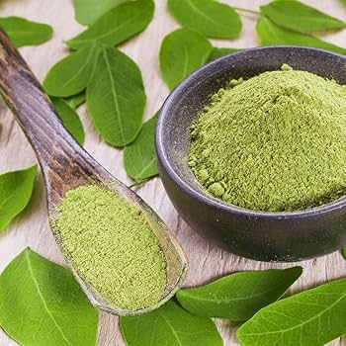

Nilika: Indigo

The botanical name of nilika is *Indigo-fera tinctories* which is also known as true indigo. It imparts the blue dye. It acts as a great conditioner to get smoothen hairs. It promotes hair growth and prevent itching on scalp and reduces dandruff.

Chemical Constituent: Indigo dye contains flavonoids, terpenoids, alkaloids, glycosides, indigotine, indirubin, rotenoids. From a complex method of extraction and purification, Indirubin, a pink colored pigment by-product of indigo.

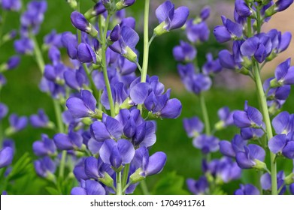

Amla (Indian Gooseberry):

Its botanical name is dried powder of *Embilica officinalis*. Family is *Euphorbiaceae*. It is used to promote hair growth. The herb is also used in shampoo, hair oil and hair dyes. Amla also used to against hair fall.

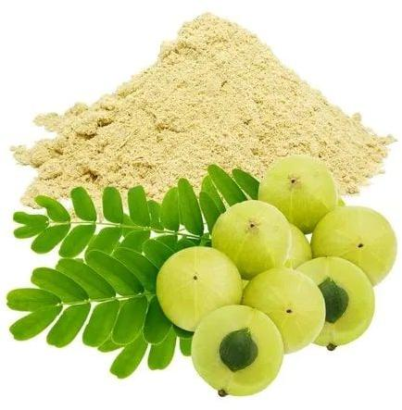

Pumpkin:

It is also called as summer squash. Scientific name is *Cucurbita pepo*. Its family is *Cucurbitaceae*. It consists of colouring characteristics. Cucurbita pepo has creeping plants that are compact or semi-shrubby, annual, with broadly ovate-cordate to triangular-cordate leaves, with or without white spots, often with three to five deep lobules. Majorly used for medicinal purpose.

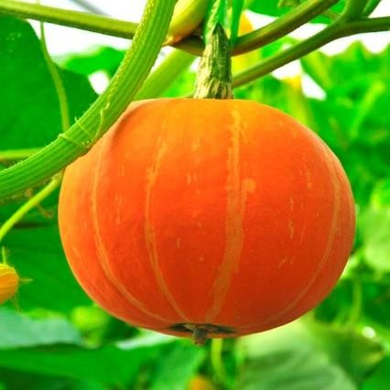

Tea:

Scientific name of tea is *Camellia sinensis*. It is an evergreen shrub falling under the genus *Camellia* and the family *Theaceae*. Being rich in polyphenols, selenium, copper, phytoestrogens, melatonin, tea also has been used in traditional Chinese medicine and in Ayurvedic medicine has been used since long as hair colorant.

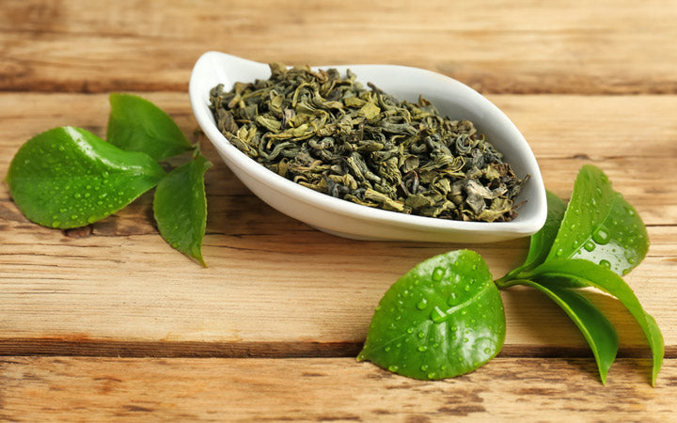

Coffee:

The botanical name of the coffee is *Coffea arabica*. There are many species under the genus, however, only two are cultivated for the production of coffee – *Coffea* arabica and *Coffea canephora*. In hair colorants, herbs can be used in the form of powder, aqueous extract or their

seed oil to impart shades of different color varying from reddish brown to blackish brown. The herbal drugs like coffee powder obtained from its seeds are used as hair colorants. [2][7][8][9]

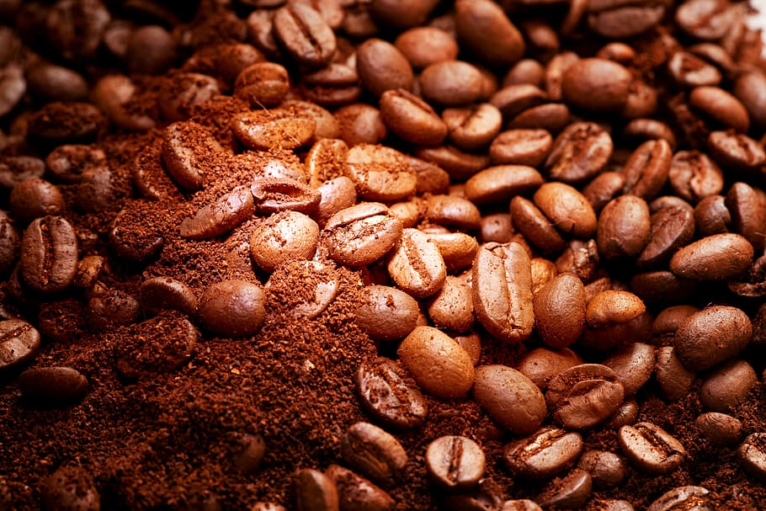

# Importance of Herbal hair Color Shampoo:

Everybody wants their hair to look fresh and smell glorious all the time. But washing it every day can damage the natural and essential oils it needs to stay healthy. So instead of jumping in the shower every day and using shampoo, you can use a DIY dry shampoo solution to remove dirt, grease, and build up without leaving your hair dry or weak. All diy shampoos, whether obtained in a store or homemade, serve the same purpose. The components within them are designed to soak up oil quickly and effectively. In homemade solutions, the starch absorbs lubricant and any excess oils. Within store bought solutions, alcohol is used to soak up the unwanted oil. They also contain drying agents to cancel out the chemicals being sprayed into your hair. If you use it to replace shampooing altogether or use it way too much, then yes, DIY dry shampoo can cause damage to your hair. Even though it soaks up excess grease, it can remove too much of the good and healthy oil your hair needs too. Shampoos are very likely the most widely used cosmetic products for cleansing hairs and scalp in our daily life. Herbal hair color shampoos are the cosmetic preparations that with the use of traditional ayurvedic herbs are meant for cleansing the hair, coloring hair and scalp just like the regular shampoo. They are used for removal of oils, dandruff, dirt, environmental pollutions and gives us healthy colorful hairs. Herbal shampoo is a type of cosmetic preparation that uses herbs from plants as an alternative to the artificial shampoo available in the market. The herbal shampoo is most important, as people nowadays choose herbal products than chemical ones for they proved to enhance health. The awareness and need for cosmetics with herbs are on the rise, primarily because it is believed that these products are safe and free from side effects. Dyeing has defined a group of humans in its history, and sometimes defined group intolerance. The outcome on the human body has been studied from the manufacturing method made by mixing different chemical components to make dyeing colorful. Herbal hair color is made from natural plant-based ingredients that are safe and chemical-free and more long lasting. It is a healthier and safer option for coloring hair than chemical-based hair dyes. The ingredients used in herbal hair color include henna, indigo, cassia, amla, and other natural extracts that are gentle on the hair and scalp. [11]

Benefits of Herbal Hair Color Shampoo:

The following are some of the benefits of using herbal hair color over traditional chemical-based hair dyes:

* No Chemicals
* Safe for Sensitive Scalps.
* No Side Effects.
* Long-Lasting Color.
* Prevents Premature Greying. [10]

# Methodology:

Material-

Fenugreek (Promoter hair growth), Ritha (Detergent), Amla, Shikakai (Help inhance hair Texture), Distilled water (For soaking), Methyl paraben (Preservative), tea (coloring agent)

Preparation:

* The method for preparing the hair dye shampoo according to the present formulation includes the following steps. 400 kg black vinegar pulverized powder per 1 liter of water was added to the reaction vessel and observed for 12 hours while maintaining 65 to 75 ° C. to prepare a nasturtium extract. Preparing black rice extract by storing 400 kg of black rice crushed product per 1 liter of water in a reaction container for 12 hours while maintaining 65 to 75 ° C. Preparing a mixed extract by mixing astronomical dong, sewage, mulberry and iris powder with 120 kg per 1 liter of water in a reaction vessel and storing it for 12 hours while maintaining 65 to 75 ° C; and 15 to 25% by weight of the nasturtium extract, 15 to 25% by weight of black rice extract, 40 to 55% by weight of mixed extract, 10 to 15% by weight of surfactant, 1 to 2% by weight of hydroxyethyl cellulose, and hematoxylin or hematin Mixing 1 to 2% by weight.
* Assembly of materials Ingredients necessary for the preparation are collected and washed completely and dried. Weighing ingredients are weighed individually and soaked overnight. Decoction preparation Ingredients are boiled in the same water used for soaking on medium flame, then allow it to cool and filter. Filter it by using muslin cloth, and collect the filtrate. Then add accommodate preservative (eg: Methyl paraben) to alter microbial growth.

Methods:

* 1. Standardization of inoculums:
  2. Antimicrobial studies of herbal protein shampoo:
  3. Determination of minimum inhibitory concentrations (MIC) of herbal: [12]

# Evaluation Study:

The set expression was estimated for product performance which includes organoleptic characters, pH, physicochemical characterization, and for solid content. To guarantee the nature of the particulars, tests were performed for face pressure, froth volume, froth stability, and wetting down time using standard protocol.

1. Visual assessment:

The set expression was assessed for color, clarity, odor, and frot content.

1. pH determination:

The pH of the set herbal soap in distilled water (10 v/ v) was estimated by means of pH analyzer at room temperature.

1. Determination of solid content chance:

The chance of solid substance was determined by importing about 4 g of soap in a dry, clean, and sinking dish. To confirm thef the particulars, particular tests were performed for face pressure, froth volume, froth stability, and wetting down time using standard protocol.

1. Stability test:

The stability of the sample was determined by using cylinder shake system. About 50 ml of formulated sample result was taken in a graduated cylinder of 250 ml capacity and shaken for 10 times circularly with uniformity. Froth stability was measured by recording the froth volume of shake test after 1 min and 4 min, independently. The total sample volume was measured after 1 min of shaking.

1. Dirt Dissipation test:

To 10 ml of refined water two drops of cleaner were included and taken in a wide- mouthed test tube. To the formulated soap, added one drop of Indian essay and shaken for 10 min after closing the test tube with a breach. The volume of essay in the head was measured and the result was graded in terms of none, slight, medium, or heavy.

1. Exertion performance evaluation:

An artificial hair perm of Indian women was entered from a salon and divided into two tapes of length 10 cm roughly, importing 5 g. The control belt was the one without washing and the test belt using the formulated soap was washed with. Each perm was added for 2 min to the combination of soap in water in the proportion 10:15 taken in a conical beaker and washed using 50 ml of distilled water. Each perm was air dried at room temperature and the procedure was repeated for outside of 10 times. The exertion effect of the set soap in terms of wimpiness and smoothness was determined using a eyeless touch test using levies of pupil 20 figures named arbitrary.

1. Foaming Index:

Cylinder Shake method was used for detecting foaming index. 5 ml of shampoo was taken into measuring Cylinder and Volume was make upto 25 ml and shaken Properly for ten times. Then 5 lest tubes were taken and add stock Solution was measured as given in. following observation table And each test tube was adjusted for volume upto 10 ml. by adding water. Then foam in each testing sample was measured in cm and foaming index was calculated.[13][14]

# Result:

The set expression was assessed for color, clarity, odor, and head content. Mild acidity prevents swelling and promotes tightening of the scales, there by converting shine. all the detergents were acid balanced and were ranged5.5 to5.9, which is near to the skin pH. The chance of solid substance was detected by importing about 4 gof shampoo in a dry, clean, and vanishing dish. To confirm thef the particulars, particular tests were performed for surface pressure, foam volume, head stability, and wetting down down time using standard protocol. A point to be noted then's that there does not feel to be any direct correlation between detergency and raging, which only confirms the fact that a soap that foams well

need not clean well. The final expression produced stable Lathers there was little bet change in froth volume. The herbal hair shampoo medication was formulated grounded upon traditional knowledge and emphasis was to formulate a stable and functionally effective. The formulated shampoo weren't only safer than the chemical conditioning agents, but also greatly reduce the hair loss during digging as well as strengthen the hair growth. The pH of the shampoo was acclimated to5.5, to retain the acidic mantle of crown. It was set up to be inoffensive, more effective and provident.[15][16]

# Limits and Challenges:

* 1. Natural products pretend product uniformity, quality control.
  2. Uncertain or unpredictable so, preservatives should be added.
  3. Seasonal variation of plant constituents.
  4. Some herbs are to scalp. Ex: lemon, menthol, peppermint and papaya etc. 5.Vary in consistency from batch to batch.

1. Hair loss shampoos contain essential vitamins and minerals, which supposedly can stop your receding hairline with regular usage.
2. Most of these color shampoos are priced in between $10-200 per bottle, which is why they are such an appealing choice to treat hair loss. Plus, unlike other hair treatments, you can get shampoos in just about any retail store or online, which is convenient. However, while low price shampoos may seem promising as a simple solution to male pattern balding, many of them cannot back up their hold for the most part.
3. Additionally, many of the hair color shampoo products on the market today contain sodium lauryl sulfate, which has been linked to a worsening of thinning hair in men.
4. Hair loss is a complicated situation and can be caused by any one of many things.
5. Allergic reactions to hair dye shampoo can range from mild to severe and include symptoms such as itching, redness, swelling, and even trouble breathing.
6. Second, in terms of carcinogenicity, some hair dyes shampoo contains chemicals classified by the International Agency for Research on Cancer (IARC) as possibly carcinogenic to humans.
7. Colors do not come together as a single color, and if you try to have several colors, the colors will bring about a process of mixing with each other.[17][18]

# Future Prospective:

The future of the color protection shampoo markets looks promising, driven by the increasing popularity of hair coloring, rising beauty consciousness, and technological advancement. The demand for color protection shampoo is expected to grow as consumers priorities the maintenance of vibrant and long-lasting hair color. Manufacturers will continue to invest in research and development to introduce creative formulations and advanced technologies. Customized solution, natural and sustainable ingredients, and multifunctional products will gain traction among consumers. Expending into new markets, diversifying product portfolios, and leveraging digital platforms will be key strategies for industry participants to capture market share and remains competitive. The main aim on sustainability will continue to effect product development and packaging design. Overall, the color protection shampoo markets present market trend are likely to thrive in the coming year.[19][20]

# References

1. Mohammed Ali et al; Study of coloring effect of Herbal hair formulation on graying hair- Pharmacognosy Research, volume 7, Issue 3, pp: 259, July-2015.
2. Amle R. Madhav et al; Formulation & Evaluation of Herbomineral Hair dye- ww.jrps.com Volume 7, Issue 12,2021, pp:01-11.
3. Pooja L. Ghansarwad et al; Formulation of Herbal Protein Shampoo, [www.ijnrd.org.com,](http://www.ijnrd.org.com/) Volume 8, Issue 6, June 2023, ISSN: 2456-4184.
4. Priti S. Narkhedkar et al, Preparation & Evaluation of Herbal Hair Shampoo -ESB, section A, Research Paper, doi:10,48047/ecb/2023.12,si4.927.
5. Soundarya, M., & Ravichandran, S. (2023). FORMULATION AND EVALUATION OF POLY-HERBAL SHAMPOO.
6. Dzomba, P. (2022). Formulation and evaluation of a herbal shampoo using flavonoid glycosides from Dicerocaryum senecioides. East African Journal of Science, Technology and Innovation, 3.
7. Sittichok, S., Wongnet, O., & Soonwera, M. (2018). New Thai herbal shampoos as pediculicides for killing head louse, Pediculus humanus capitis De Geer (Phthiraptera). Asian Pacific Journal of Tropical Biomedicine, 8(2), 106.
8. Mancon, S., Mondelli, A., & Secchi, G. (2012). Hair conditioning effect of vegetable native protein in shampoo formulations. SOFW Journal-Seifen Ole Fette Wachse, 138(1), 38.
9. Al Badi, K., & Khan, S. A. (2014). Formulation, evaluation and comparison of the herbal shampoo with the commercial shampoos. Beni-Suef University Journal of Basic and Applied Sciences, 3(4), 301-305.
10. www.luxy Hair, Co/ All rights Reserved, January 2024.
11. Pawan Maurya, et al, A review article on Herbal Shampoo- JETIR, Volume 8, Issue 5,May 2021, Issn-2349-5162.
12. Jooyoung Lee et al, Considering the Risk of Shampoo with the function of gray hair- [www.doi.org.com](http://www.doi.org.com/) 10.1002/hrs 2.1271- May 2023.
13. [www.ifi.claims.com](http://www.ifi.claims.com/) Hair dye shampoo using natural material and methods, KR101227214B1, Patent by Korean.
14. Nikhil M. Shejal Formation of Herbal shampoo -Review, [www.irjmets.com](http://www.irjmets.com/), Volume 5, Issue 2, February 2023.
15. 1. Barel AO, Maibach HI, Paye M. Handbook of Cosmetic Science and Technology. New York: Marcel Dekker, Inc; 2001. p.575.
16. 2. Sagarin E, Balsam MS, Cosmetics Science and Technology. Wiley: India Edition; 2 ed (Vol2). p.73-75.
17. Nikita S. Khairnar, Formulation and Evaluation of Herbal Shampoo- [www.ijprajournal.com,](http://www.ijprajournal.com/) Volume 8, Issue 3, May-June 2023. Pp:1869-1882.
18. Altaf S. Shaikh, Formulation and Evaluation of Herbal Shampoo- [www.ijcrt.com](http://www.ijcrt.com/) Volume 11, Issue 5, May 2023. ISSN-2320-2882.
19. Guerra‐Tapia A, Gonzalez‐Guerra E. Cosméticos capilares: tintes. Actas Dermosifiliogr. 2014;105(9):833‐839. 10.1016/j.adengl.2014.02.003.
20. Health sciences Reports, PMID-37216053, Volume 6, Issue 5, May 2020.