Market Survey of Antacid Drugs in Rural Areas of Western Uttar Pradesh
Ankit Kumar¹, Aayush Kumar², Aaditya Jha², Abhay Singh²
1. Faculty of Department of Pharmaceutical Technology, Meerut Institute of Engineering and Technology, Meerut
- Student of Department of Pharmaceutical Technology, Meerut Institute of Engineering and Technology, Meerut

Abstract
Acid-related disorders such as heartburn, acid reflux, gastritis, and indigestion are prevalent health concerns in rural areas of Western Uttar Pradesh due to dietary habits, lifestyle choices, and a lack of awareness about healthcare. This study aims to understand the availability, preference, affordability, and knowledge of antacid medications in these rural regions.[1]
By conducting surveys and interviews with local residents, pharmacists, and healthcare professionals, we gathered insights into the most commonly used antacids, prescription patterns, and challenges related to medicine accessibility. The study reveals that over-the-counter (OTC) antacids like Digene, Eno, and Pudin Hara are widely preferred for immediate relief, while doctors often recommend proton pump inhibitors (PPIs) such as Pantoprazole and Omeprazole for chronic acidity issues. Additionally, traditional home remedies remain popular, influencing people’s choices regarding pharmaceutical antacids. The findings highlight the need for improved healthcare awareness, better medical accessibility, and cost-effective treatment options for rural populations.[2]

Keywords: Acid reflux, Gastritis, antacids medications, Proton pump inhibitors (PPIs), Rural health etc.

Introduction
Acidity and indigestion are among the most commonly reported digestive disorders in India. In rural areas, factors such as irregular meal timings, excessive consumption of spicy and fried foods, high dependence on tea and tobacco, and lack of healthcare awareness contribute to widespread acid-related problems. While antacids are a quick solution to manage symptoms, many people are unaware of their proper usage, potential side effects, or the differences between various types of acid-suppressing medications.[3]
The healthcare infrastructure in rural areas often faces challenges such as a shortage of doctors, lack of well-equipped pharmacies, and high treatment costs. As a result, people rely on self-medication, local pharmacies, or traditional home remedies. This study aims to analyze which antacid brands are readily available, what factors influence people’s choices, and the role of pharmacists and doctors in guiding medication use. Through this research, we seek to provide insights that can help improve access to affordable and effective treatment for acid-related disorders in rural populations.[4]

Objectives of the Study
- Identify the most commonly available antacid brands in rural pharmacies and general stores.
- Understand the factors that influence people's decisions when purchasing antacids.
- Analyze the role of healthcare professionals, including doctors and pharmacists, in recommending antacids.
- Identify challenges related to the accessibility and affordability of antacids in rural areas.
- Examine the impact of socioeconomic conditions on the consumption of antacids.
- Assess the role of traditional home remedies and their influence on pharmaceutical antacid usage.
- Provide recommendations to improve awareness, access, and affordability of acidity treatment in rural areas.[5]

Methodology

Study Area
This survey was conducted in several villages across Western Uttar Pradesh, including districts such as Baghpat, Bulandshahr, Meerut, Aligarh, Muzaffarnagar, Saharanpur, and Shamli. These locations were selected to ensure diversity in population demographics and varying levels of healthcare accessibility.[6]

Data Collection
- Primary Data: Surveys and structured interviews were conducted with 300 individuals, including residents, pharmacists, and medical practitioners.
- Secondary Data: Additional insights were gathered from pharmacy sales records, government health reports, published research papers, and market reports.[7]

Findings and Analysis

1. Availability of Antacids
- Popular OTC antacids such as Gelusil, Digene, Eno, and Pudin Hara are widely available in pharmacies, medical stores, and even grocery shops.[8]
- Prescription medications such as Pantoprazole, Omeprazole, Ranitidine, and Famotidine are primarily stocked in pharmacies but are less available in general stores.[9]
- In remote villages, inconsistent supply chains often lead to a shortage of essential medicines, including antacids, making access to treatment difficult.[10]

2. Consumer Preferences
- Rapid Relief Options: Most consumers prefer OTC antacids like Eno and Digene for their fast-acting effects.[11]
- Herbal Preference: Many individuals choose herbal-based antacids like Pudin Hara due to the perception that they are safer and have fewer side effects.[12]
- Affordability Considerations: People from lower-income backgrounds often purchase generic versions of antacids instead of branded ones to save money.[13]
- Forms of Antacids: Tablets and syrups are preferred over powders or effervescent formulations because of their convenience and taste.[14]

3. Prescription Trends
- Doctors most frequently prescribe PPIs (Pantoprazole, Omeprazole) for long-term acidity issues.
- Pharmacists play a key role in advising patients, as many individuals purchase medicines without a prescription.
- Word-of-mouth recommendations from family, friends, and neighbors heavily influence medication choices in rural areas.[15]

4. Challenges in Rural Areas
- Limited Awareness: A lack of proper knowledge about different types of antacids and their side effects leads to misuse.
- Dependency on Home Remedies: Many rural residents continue to rely on traditional home remedies instead of medical treatments.
- Limited Access to Medicines: Certain villages do not have consistent pharmacy supplies, making it difficult for residents to obtain necessary drugs.
- High Costs of Branded Medicines: Many people prefer cheaper, unbranded alternatives due to economic constraints.
- Risks of Self-Medication: Unsupervised consumption of antacids without proper medical guidance can lead to potential health risks such as kidney damage and long-term gastric issues.[16]

Comparative Analysis with Urban Areas
- Availability of Medicines: Urban areas have a higher variety of antacids available, including international brands.
- Healthcare Accessibility: Urban residents have better access to medical professionals who can prescribe the right medication.
- Affordability Factor: While rural consumers focus on cost, urban consumers prioritize quality and brand reputation.
- Lifestyle Differences: Urban populations have different dietary habits, consuming more processed food, leading to different acidity patterns.[17]

Government Policies and Support
- Ayushman Bharat Scheme: The government initiative aims to make healthcare more affordable in rural areas.[18]
- Jan Aushadhi Stores: These stores provide generic medicines at lower costs, making treatment more accessible.[19]
- Health Awareness Programs: The government has been conducting campaigns to educate rural populations on safe medication use.[20]
Market Survey Questionnaire: Antacid Usage in Rural Areas of Western Uttar Pradesh

Section 1: General Information

1. Name (Optional): _______________
2. Age: ____
3. Gender: ☐ Male ☐ Female ☐ Other
4. Education Level: ☐ No formal education ☐ Primary ☐ Secondary ☐ Higher education
5. Occupation: ☐ Farmer ☐ Laborer ☐ Business ☐ Student ☐ Other: __________
6. Monthly Household Income: ☐ < 5,000 ☐ 5,000 - 10,000 ☐ 10,000 - 20,000 ☐ > 20,000

Section 2: Awareness and Usage of Antacids

7. Have you ever experienced acidity or indigestion? ☐ Yes ☐ No
8. How frequently do you experience acidity or indigestion? ☐ Rarely ☐ Occasionally ☐ Frequently ☐ Daily
9. What do you usually do to relieve acidity? (Select all that apply)
☐ Home remedies ☐ Ayurvedic medicine ☐ Allopathic antacids ☐ Do nothing ☐ Other: __________
10. Are you aware of antacid medicines? ☐ Yes ☐ No
11. If yes, how did you come to know about them?
☐ Doctor ☐ Pharmacist ☐ Advertisement ☐ Friends/Relatives ☐ Other: __________

Section 3: Purchasing Behavior

12. Have you ever purchased an antacid? ☐ Yes ☐ No
13. If yes, which brand do you usually buy? ☐ Digene ☐ Gelusil ☐ Eno ☐ Pudin Hara ☐ Other: __________
14. Where do you usually buy antacids? ☐ Pharmacy ☐ General store ☐ Online ☐ Other: __________
15. How often do you buy antacids? ☐ Occasionally ☐ Monthly ☐ Weekly ☐ Daily
16. What influences your purchase decision? (Select all that apply)
☐ Doctor’s recommendation ☐ Price ☐ Advertisement ☐ Availability ☐ Brand preference ☐ Other: __________

Section 4: Effectiveness and Satisfaction

17. How effective do you find antacids in relieving acidity? ☐ Very effective ☐ Somewhat effective ☐ Not effective
18. Have you ever experienced any side effects from using antacids? ☐ Yes ☐ No
19. If yes, what were the side effects? __________
20. Would you recommend antacids to others? ☐ Yes ☐ No

Section 5: Suggestions and Preferences

21. What improvements would you like to see in antacid products? __________
22. Do you prefer antacids in a particular form? ☐ Tablet ☐ Syrup ☐ Powder ☐ Other: __________
23. Are you willing to try new antacid brands? ☐ Yes ☐ No

Thank you for your participation!

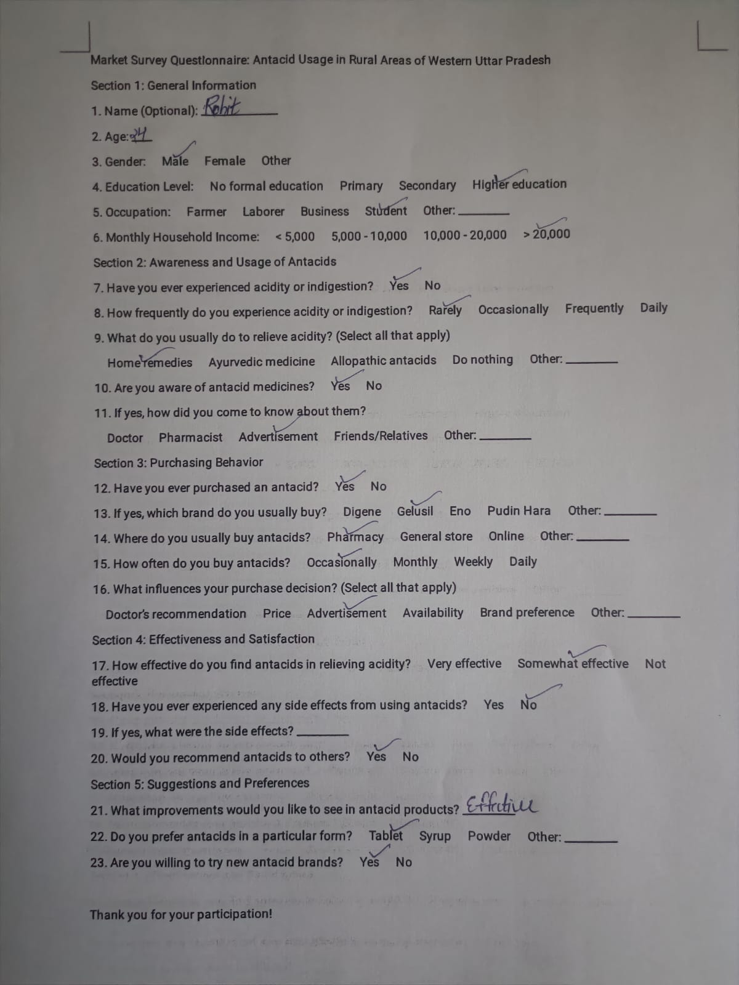

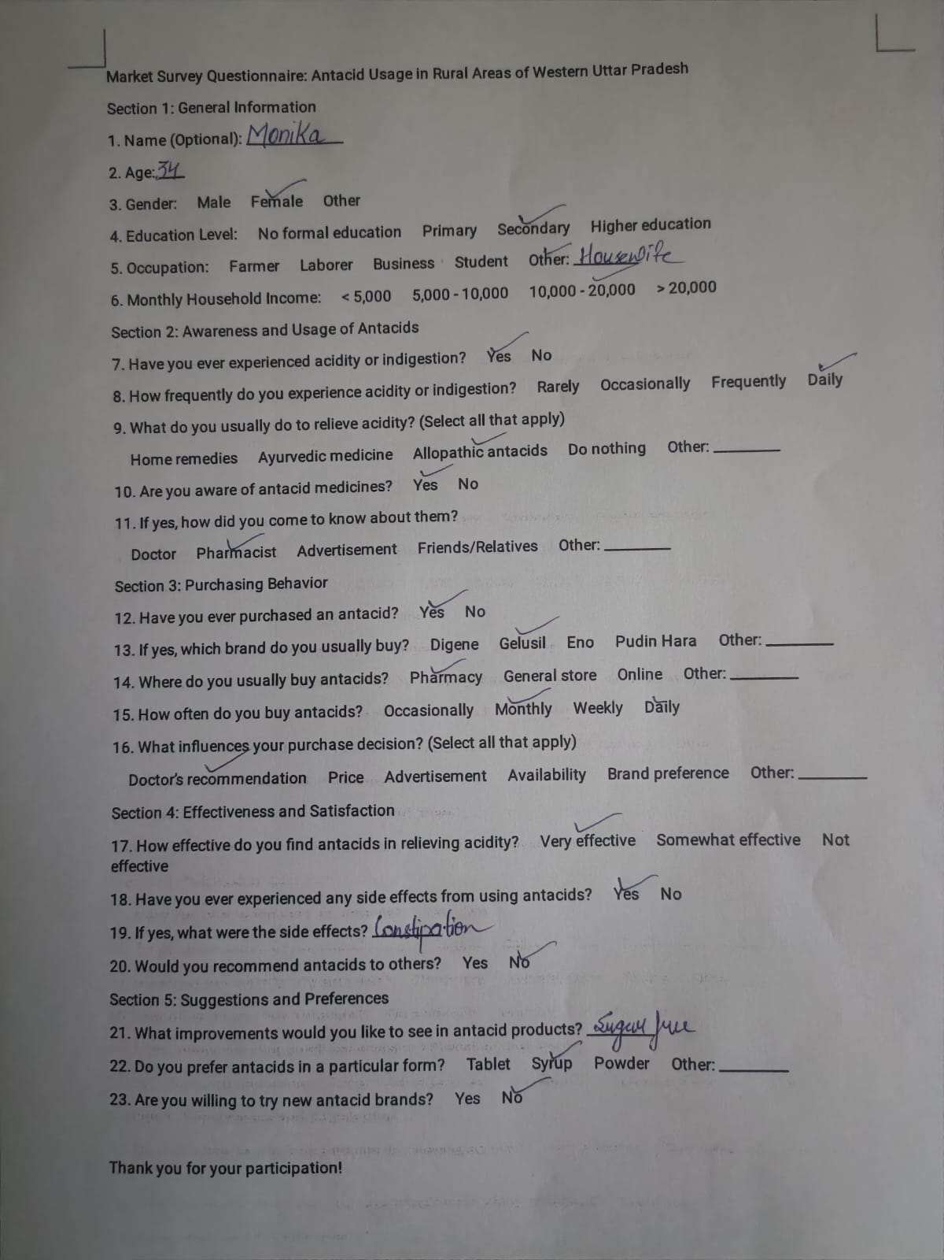

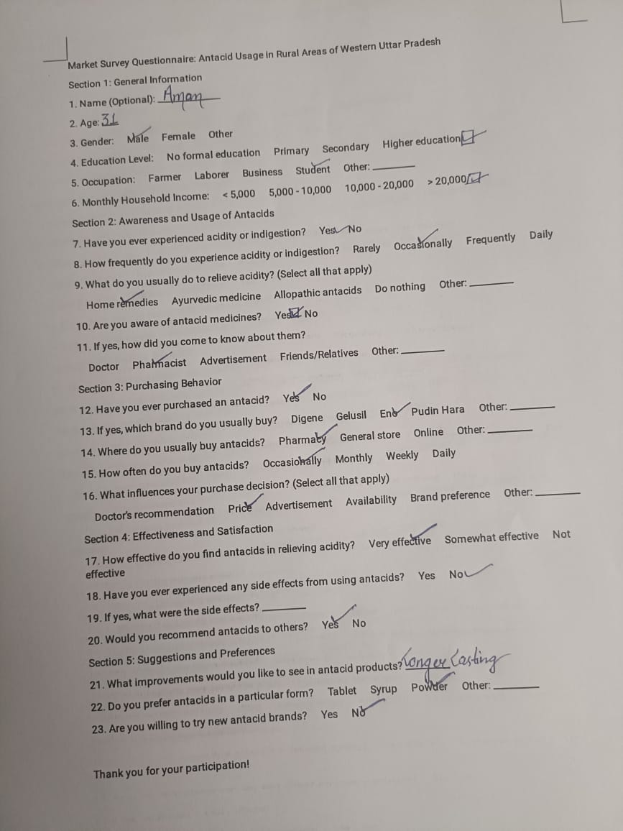
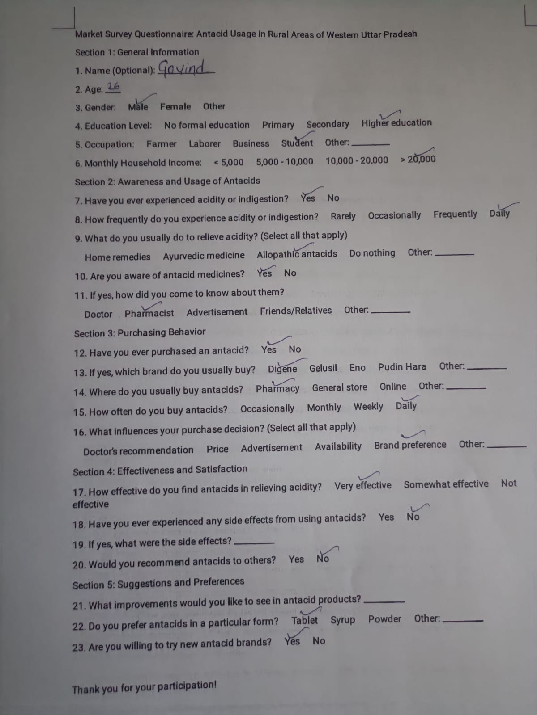

Conclusion & Recommendations
Our survey revealed that while antacids are widely used in rural Western Uttar Pradesh, there is a lack of awareness regarding their correct use. People primarily rely on OTC medications and home remedies, while doctors prescribe PPIs for more severe cases. However, barriers such as affordability, availability, and insufficient healthcare access prevent effective treatment for many individuals.

Recommendations for Improvement
- Health Education Initiatives: Conduct awareness programs about acidity causes, prevention, and safe medication use.
- Improving Medicine Accessibility: Strengthen supply chains to ensure a steady availability of antacids in rural areas.
- Government Support: Encourage the distribution of affordable generic medicines to make treatment more accessible.
- Training for Pharmacists & Health Workers: Educate medical professionals to better guide patients on appropriate antacid use.

Acknowledgments
We express our gratitude to all participants, including pharmacists, healthcare providers, and rural residents, for their valuable input. Special thanks to medical professionals for their expert guidance.

References
[1] Ravisankar P, Koushik O, Reddy A, Kumar AP, Pragna P. A detailed analysis on acidity and ulcers in esophagus, gastric and duodenal ulcers and management. IOSR Journal of Dental and Medical Sciences (IOSR-JDMS). 2016;15(1):94-114.
[2] Garg V, Narang P, Taneja R. Antacids revisited: review on contemporary facts and relevance for self-management. Journal of International Medical Research. 2022 Mar;50(3):03000605221086457.
[3] Joshi P, Jaid R, Wagh S, Jadhav P, Bhagwat M, Chakorkar S, Shelar S. Assessment of prevalence and practices of the general population towards hyperacidity: a cross-sectional survey.
[4] Swati P. Strategy formulation for unconventional media in the rural areas of Central Uttar Pradesh.
[5] Furu K, Straume B. Use of antacids in a general population: the impact of health-related variables, lifestyle and sociodemographic characteristics. Journal of clinical epidemiology. 1999 Jun 1;52(6):509-16.
[7] Warner JA, Yirga CH, Gameda SA, Rashid SH, Alemu DA. Soil Acidity Problems in Ethiopia: Magnitude, Current Awareness and Practices, and Policy Actions. Proceedings of the Research for Ethiopia’s Agricultural Policy Presented for EIAR 50th Anniversary, Addis Ababa, Ethiopia. 2016 Jul 1;1.
[8] [5] Kumar S. The Socioeconomic Conditions of Agricultural Women Labourers in Uttar Pradesh: A Case-Study of Muzaffarnagar and Baghpat District. International Journal of Social and Economic Research. 2013;3(1):30-48.
[9] Braun LA, Tiralongo E, Wilkinson JM, Spitzer O, Bailey M, Poole S, Dooley M. Perceptions, use and attitudes of pharmacy customers on complementary medicines and pharmacy practice. BMC Complementary and Alternative Medicine. 2010 Dec;10:1-7.
[10] Ritchey M, Tsipas S, Loustalot F, Wozniak G. Use of pharmacy sales data to assess changes in prescription-and payment-related factors that promote adherence to medications commonly used to treat hypertension, 2009 and 2014. PLoS One. 2016 Jul 18;11(7):e0159366.
[11] Moossaddee A. Key influencers of purchase decisions in the OTC Category (Master's thesis, MICA (Mudra Institute of Communications, Ahmedabad)(India)).
[12] Hossain T. Prescription Pattern of Acid Suppressive Medications in Bangladesh (Doctoral dissertation, East West University).
[13] Kohli E, Buller A. Factors influencing consumer purchasing patterns of generic versus brand name over-the-counter drugs. South Med J. 2013 Feb 1;106(2):155-60.
[14] Singh N, Sharma U, Mishra B, Kandalkar AM, Jain SK. Herbs and herbal formulations for the management and prevention of gastrointestinal diseases. InHerbal Medicine Phytochemistry: Applications and Trends 2024 Jul 10 (pp. 657-691). Cham: Springer International Publishing.
[15] Danzon PM, Towse A, Mulcahy AW. Setting cost-effectiveness thresholds as a means to achieve appropriate drug prices in rich and poor countries. Health Affairs. 2011 Aug 1;30(8):1529-38.
[16] Mössner J. The indications, applications, and risks of proton pump inhibitors: A review after 25 years. Deutsches Ärzteblatt International. 2016 Jul 11;113(27-28):477.
[17] Maganty A, Byrnes ME, Hamm M, Wasilko R, Sabik LM, Davies BJ, Jacobs BL. Barriers to rural health care from the provider perspective. Rural and Remote Health. 2023 Jun;23(2):1-1.
[18] Ranjana V, Sasanka K, Gayathri R, Ramanadhan V. Awareness on Application of Antacids among Undergraduate Students. Indian Journal of Forensic Medicine & Toxicology. 2020 Oct 1;14(4).
[19] Houghton PJ. The role of plants in traditional medicine and current therapy. The Journal of Alternative and Complementary Medicine. 1995 Jun 1;1(2):131-43.
[20] Kotwani A, Bhanot A, Singal GL, Gandra S. Marketing and distribution system foster misuse of antibiotics in the community: insights from drugs wholesalers in India. Antibiotics. 2022 Jan 13;11(1):95.

