**Studies on Newly Synthesized Ester Derivatives of 5 - Amino Salicylic acid.**

**J. G. GURJAR**

Chemistry Department, C. U. Shah Science College, Ahmadabad, Gujarat, INDIA

Email: jagdishgurjar72@yahoo.com

**ABSTRACT**

In the present investigation Synthesis, spectral analysis and Biochemical studies on some newly derivative of 5 – Amino Salicylic acid. A newly ester derivative was synthesized by reflux method. The resulting crude precipitates were recrystallized from the organic solvent. The derivative was Characterized using Elemental Analysis, Infrared spectra, Proton and 13C NMR spectroscopic. This compound has been screened for their biochemical activities.

**Key words:** Synthesis, Spectral analysis, biochemical and 5 -ASA derivative.

**INTRODCTION**

5 –Amino salicylic acid also known as mesalamine or mesalamine, is an anti- inflammatory drug used to treat inflammation of the digestive treat Ulcerative colitis [1]and mild – to – moderate Crohn’s disease [2]. It is also recommended therapy for the induction and maintenance of remission of ulcerative colitis (UC) [3-4]. The drug acts topically at the colonic mucosa to reduce mucosal inflammation [5] yet because the active drug is rapidly absorbed in the stomach and small intestine [6] a number of oral formulations have been developed to deliver 5-ASA to the colon [5,7]. The most common side effects of 5-ASA are headache and flatulence. Hair loss and itching also may occur. Infrequent side effects include increased hearth rate, Pancreatitis, back pain, fatigue, tremor, and ear pain and blood disorders.

The most important bimolecular, now a day with drastically different properties is required for various applications. Chelates of biologically important molecules are also being investigated for various requirements of human life. Organic molecules with donor atoms like N, O etc. are very good examples that can form coordination compounds. They show important biological and chemical properties. The derivatives of 5 – Amino salicylic acid is used of medicinal purpose. Practically only few scientists have made attempt to study with 5 – Amino salicylic acid derivatives or biochemical formation and catalytic behavior of 5 –Amino salicylic acid derivatives.

Looking to the literature survey carried out as well as the significance of the 5 – Amino salicylic acid derivatives as well as its coordination compounds, it is quite likely to give modified and improvised biochemical. Prompted by the above biological properties of 5 – Amino salicylic acid, it was contemplated to synthesize a novel series of 5 – Amino salicylic acid derivatives. Antibacterial and antifungal activities of the newly synthesized compounds are discussed in this paper.

**EXPERIMENTAL**

All chemicals used were of A.R. grade and used as such without further purification except for ethanol. 5 – Amino salicylic acid was obtained from S-d fine chemical company (Properties: White to pink crystals, dec ~ 280°, Slightly soluble in cold water, more soluble in hot water.

Melting points were determined in open capillary tubes and are uncorrected. IR spectra (4000 – 400 cm-1) were recorded on Shimadzu Perkin – Elmer 8201 FT-IR with KBr pellets. The electronic spectra were recorded on Shimadzu- 1800 PTE Ltd. Japan. The 1H-NMR spectra and 13CMR spectra were recorded on BRUKER AVANCE II 400 MHz Spectrometer. Chemical shift values are reported as values in ppm relative to TMS (δ = 0) as internal standard in CDCl3 solvent. Elemental analyses were performed on Vario MICRO C, H, N, S Elemental Analyzer system. Thermogravimetric analysis was carried out under atmospheric condition with heating rate 50 – 1000 @ 10 ̊C min-1 on Mettler Toledo.

**Synthesis of n- propyl 5 -amino-2 hydroxy benzoate**



**5- amino salicylic acid n-propyl 5-amino 2-hydroxy benzoate**

A solution of 5-amino salicylic acid (10gm, 65.3 mmol) and concentrated sulfuric acid in n-propyl alcohol was heated under reflux for 15 – 18 hrs. in water bath. After addition of sodium bicarbonate (until the evolution of carbon dioxide). The reaction mixture was filtered. The filtrate was poured into water and extracted with solvent. The combine organic layer was dried over magnesium sulphate and the solvent was removed [8-10].

**SPECTRAL ANALYSIS:**

**5 – Amino Salicylic acid**

**1H-NMR:** δ =8.585 (1H, - COOH), δ =8.077 (1H, -OH), δ = 2.412 (2H, -NH2, Primary amine), δ = 6.431 – 7.531 (6H, Aromatic**).**

**IR Spectra:** (KBr) 3100 (N-H), 3160 (O-H), 2850 (C-H),1650 (C=O), 1370 - 1600 (C=C & C-N)

**13C-NMR:** (Solvent CDCl3) δ = 176.05(-COOH), δ = 112.10 – 138.27 (Aromatic – C), and δ = 170.01 (-C=O)

**n-propyl 5-amino 2-hydroxy benzoate**

**1H-NMR: δ =** 10.315 (1H, -OH), δ = 3.336-3.31 (2H, -NH2, Primary amine), δ = 6.820 – 7.279 (6H, Aromatic**),** δ =4.277- 4.309(2H, CH2), δ = 1.764 -1.851(Multiple 2H, CH2), δ = 1.024-1.061(3H**,** CH3).

**IR Spectra:** (KBr) 3360 (N-H), 3230 (O-H), 2890-2930 (C-H), 1870 (C=O), 1295(C-O), 1690 (C=C & C-N) and 725-720 (C-C-C).

**13C-NMR:** (Solvent DMSO)δ = 10.49 (-CH3), δ = 21.97 (– CH2), δ = 66.81 (-CH2), δ = 112.45-154.87(Aromatic - C), δ = 170.06(-C=O)

**ANALYTICAL DATA AND PHYSICAL PARAMETERS**

**Name of Compounds:** **5-amino salicylic acid** and n**-PROPYL 5-AMINO 2-HYDROXY BENZOATE**

**Molecular formula:**  C7H7NO3  and C10H13NO3

**Color:** Light pink and reddish black

**Molecular weight**: 153 gm and 195 gm

**Elemental analysis:** found calculated and found calculated

%C --- 54.90 60.50 61.53

%H --- 4.61 6.17 6.72

%N --- 9.15 6.98 7.17

Melting point: 151 and ----

**BIOCHEMICAL PROPERTIES**

n-propyl 5-amino 2-hydroxy benzoate compound was screened for their antimicrobial and antifungal activity by Agar diffusion method [11]. n-propyl 5-amino 2-hydroxy benzoate synthesized compound was evaluated for antimicrobial activity by E. coli, S. aureus, B. subtilis and S. typhi by measuring the zone of inhibition in mm. The activities were performed at a conc. of 50 μg / ml. Streptomycin sulphate (20 μg / ml.) was used as a standard drug for antimicrobial and antifungal activity respectively. Alcohol was used as solvent control for antimicrobial activity.

For the biochemical activity the n-propyl 5-amino 2-hydroxy benzoate compound show antibacterial activity and show maximum inhibitory activity against S. aureus. Results of sensitivity against B. subtilis is lower. Again, the inhibitory activity good against E. coli where slightly poor sensitive against Typhi. The assay of bacterial sensitivity was conducted under standard conditions of antibacterial assay technique (Methods in microbiology, A/P, 1978). The results were averaged from the duplicate plates of the concerned set of experiment.

**Table – 1**

**Antimicrobial activity data**

|  |  |  |  |  |
| --- | --- | --- | --- | --- |
| Compounds | Diameter of zone of inhibition in (mm) | | | |
| Escherichia  Coli | Staphylococcus  Aureus | Bacillus  Subtilis | Salmonella  Typhi |
| n**-PROPYL 5-AMINO 2-HYDROXY BENZOATE** | 20 | 22 | 16 | 18 |
| Streptomycin sulphate  (std. drug) | 11 | 11 | 11 | 11 |

**RESULT AND DISCUSSION**

A newly synthesized derivative of 5 – amino salicylic was reported in this paper. The target compound was synthesized by reflux method in water bath at room temperature. The structure of the newly synthesized derivative has been elucidated on the basis of Elemental, 1H-NMR, 13C-NMR, IR Spectra and biochemical activities. See spectral analysis.

**ACKNOWLEDGEMENT**

The author is grateful to the principal, C. U. Shah Science College, Ahmadabad for laboratory facilities. Our thanks are also due to great financial support of U.G.C. for minor research project. The author also thankful to Ex. Vice chancellor, Dr. J. J. Vora, Hemchandracharya North Gujarat University, Patan for critical valuable suggestion from time to time. I also thankful to CIMF Hemchandracharya North Gujarat university Patan, M.S. University Baroda and M.G. Science institute for antimicrobial analysis.

**Fig: 1 (a) 1HNMR Spectrum of 5 – amino salicylic acid**



**fig: 1(b) 1HNMR spectrum of** n**-propyl 5-amino 2-hydroxy benzoate**

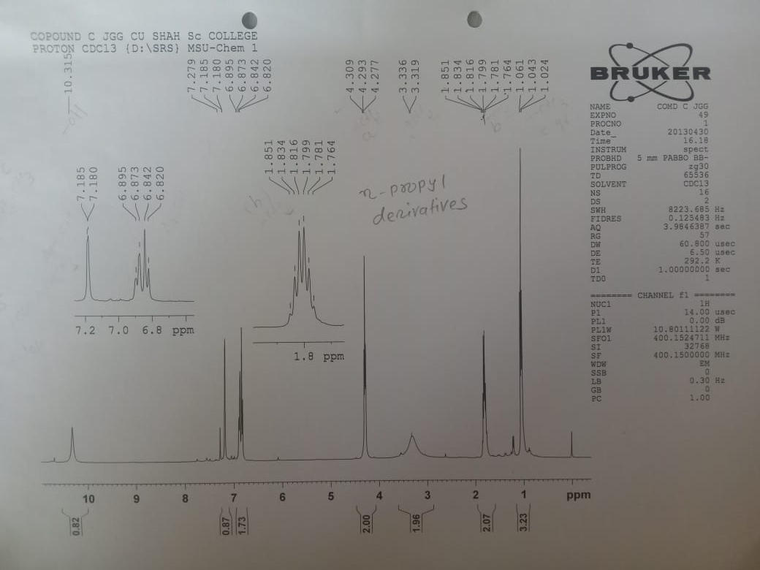

f**ig: 2 (a) IR Spectra of 5 – amino salicylic acid**



**fig:2(b) IR spectra of** n**-propyl 5-amino 2-hydroxy benzoate**

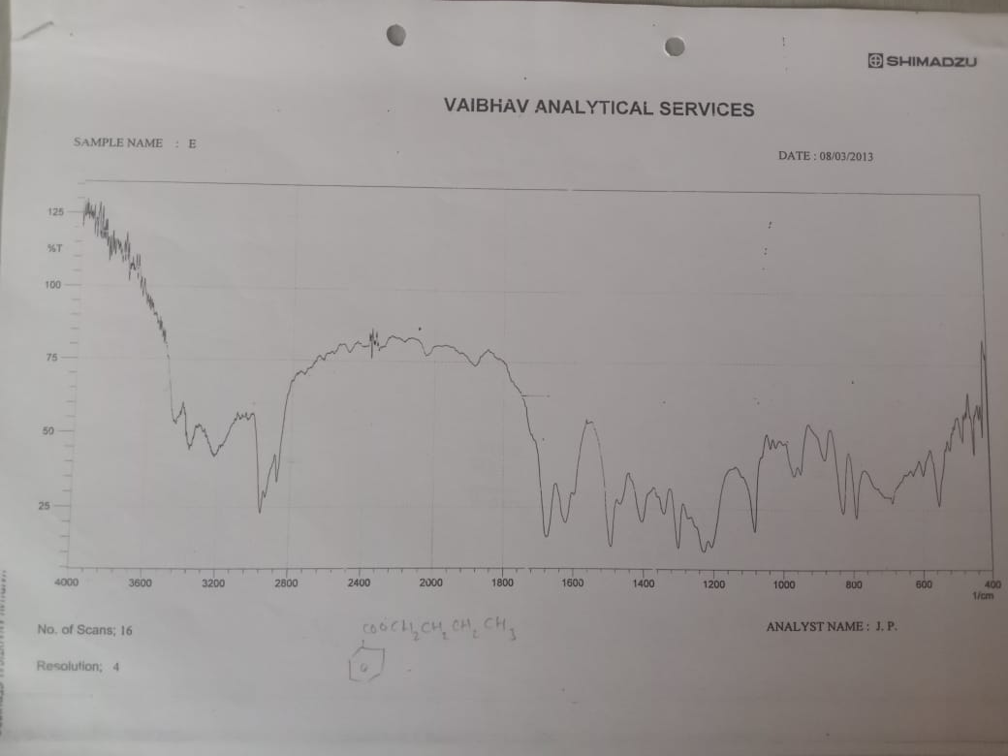

**REFERENCES**

[1] Kruis W., Schreiber I., Theuer, Schutz., Howaldt., Krakamp., Hamling et al.,

[*http://en.wikipedia.org/wiki/mesalazine*](http://en.wikipedia.org/wiki/mesalazine)*.*

[2] Sandborn W J., Feagan B G., Liechtenstein G R.,

h*tpp://www.interscience.wiley.com/legibin/fulltex.* ***2009-12-20***

[3] Kombucha A, Sachar D.B.,

[*www.medscape.com/viewarticle/711314*](http://www.medscape.com/viewarticle/711314)

[4] Travis SPL, Strange FF.,

Journal of Chron’s and Colitis: **(2008)**

[*www.medscape.com/viewarticle/711314*](http://www.medscape.com/viewarticle/711314)

[5] Qureshi A.T., Cohen R.D.,

Mesalamine delivery system, Adv Drug Deliv. Rev, 57, 281,302, **(2005)**

[*www.medscape.com/viewarticle/711314*](http://www.medscape.com/viewarticle/711314)

[6] Myers B, Evans D.N., Rhodes J., et al.

[*www.medscape.com/viewarticle/711314*](http://www.medscape.com/viewarticle/711314)

[7] Cohea R.D.,

Aliment pharmacology Therapy **(2006), 24:4657, (2010).**

[8] Merck Index 14 th Edition Page - 80

[9] Vogel A. I., “Textbook of Practical Organic Chemistry” The ELBS & Longmans Green and Co., Ltd. London, Page 840-842, 4th Edition **(1979).**

[10] Knoller H. J; Bauermeister M;

*J. Indian Chem. Soc. 71, 345* ***(1994).***

[11] Cruichshank R., Duguid J.P., Marmion B.P., Swan H.A.,

The Practice of Medical Microbiology, Vol, 12th edition,

Churchill Livingstone, London, page – 190, (**1975).**