**“Development And Evaluation of Herbal Facial Stick”**

SURBHI GUPTA

ASSISTANT PROFESSOR

PHARMACEUTIC DEPARTMENT

Progressive Education Society’s Modern College of Pharmacy Sector 21, Yamunanagar, Nigdi, Pune – 411044

ADITI NAGLE

PHARMACEUTICS DEPARTMENT

Progressive Education Society’s Modern College of Pharmacy Sector 21, Yamunanagar, Nigdi, Pune – 411044

Abstract..

Generally speaking, a herbal facial stick is a skincare product intended for precise application on the face. It often consists of a concoction of natural substances with skincare advantages, such as essential oils and plant extracts. The stick format makes it handy for use when traveling because it makes application simple and mess-free. These products are frequently advertised as offering skin nourishment, hydration, and calming properties. Depending on the components used, they may also make the claim to aid with particular skin issues like dryness, irritation, or acne. Nonetheless, the efficacy of herbal face sticks may differ based on the specific skin type and formulation.   
The herbal face stick with extracts of Moringa oleifera and Bael fruit combines the advantages of two strong botanical substances that are well-known for

Key words:- facial stick, moringa olifera ,bael fruit , skin nourishment

1.Introduction

The biggest organ of the integumentary system and the outermost layer of the human body is the skin. The ectodermal tissue that covers the muscles, bones, ligaments, and internal organs is present in up to seven layers of the skin.[1] The epidermis, dermis, and hypodermis are its three constituent layers, and each has a distinctly different architecture and function [3].   
The complex network that makes up the skin acts as the body's first line of defence against viruses, UV rays, toxins, and mechanical trauma. It also controls the volume of water released into the environment and the temperature. [2] The pertinent anatomical structures of the epidermal layer of the skin, together with its structure, function, embryology, vascular supply, innervation, surgical considerations, and clinical significance, are covered in this article.[4]

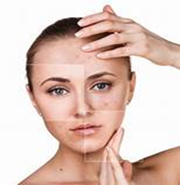 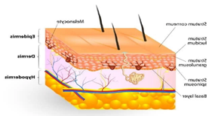

**Figure no.1 :Image showing various skin problems Figure no.2: skin anatomy**

There are three primary layers that adhere to the skin. The epidermis is the top layer, the dermis is the layer underneath the epidermis, and the subcutaneous tissue is the third and deepest layer [3].   
 Underneath the epidermis is the dermis, which is home to sweat glands, blood vessels, lymphatic vessels, connective tissue, and hair follicles. The epidermis is the outermost layer of skin and serves as a waterproof barrier.[3]   
Fat and connective tissue make up the hypodermis, the deeper subcutaneous tissue.   
In addition, most young adults today experience skin problems due to the fast-paced nature of today's world. [2] Numerous factors, including weakened immune systems, allergies, irritants, and hereditary diseases, can result in various skin disorders.[2] Furthermore, many disorders can be associated to skin issues[5].

The US is constantly acquiring Korean skincare trends. There's always a new product or approach available to make your skincare routine simpler, like sheet masks or charcoal toothpaste. Face cleansing sticks are a new product that's receiving a lot of attention right now, at least among men.[3]  
"Traveling with facial cleansing sticks is a terrific idea. Dr. Debra Jaliman, a board-certified dermatologist in New York City and the author of the book "Skin Rules:[4] Trade Secrets from a Top New York Dermatologist," stated that as they are not liquids, they cannot be seized.[4]

2.MATERIAL AND METHOD

2.1Materials:

|  |  |  |  |  |  |
| --- | --- | --- | --- | --- | --- |
| **Sr No.** | **List of Ingredients** | **Name of Supplier** | **Measures** |  |  |
| 1 | Bees Wax | Palmar’s | 1.5gm |  |  |
| 2 | Cocoa butter | Palmar’s | 1.5gm |  |  |
| 3 | Glycerine | Indian pharmaceuticals | 1gm |  |  |
| 4 | Methyl cellulose | Linco pharmaceutiucs | 1gm |  |  |
| 5 | Methyl paraben | Uicare ingredients | 0.5gm |  |  |
| 6 | Coconut oil | Nutiva pharmaceutics | 0.5gm |  |  |
| 7 | Vitamin E | Cipla pharmaceutics | 1.2gm |  |  |
| 8 | Bael fruit extract | From plant extract | 5gm |  |  |
| 9 | Moringa olifera leaf | From plant extract | 5gm |  |  |
| 10 | Rose oil | Nutria pharmaceutics | Q.S. |  |  |

*Method:

1. Melt the our stabilizing agents in water bath at 70 degree which our base of stick is started to build. (first bees wax then coca butter)

2. Add film formers agent which we have that is glycerine and methyl cellulose

3. After that our next step to add emollients which coconut oil and vitamin E drop by drop then add our main drugs that is bael fruit and moringa olifera leaf exttract

4. Add preservative and last perfume which rose oil while this step makes sure to keep flame at low and drop water into water bath

5. Then above prepation drop it in container keep it cool 6. Cool at -10 degree in deep cool then at -2 degree

3.Evaluation parameter

3.1 Preformulation Studies:

* PURITY OF DRUG :

1. Determination of moisture content of crude drug
2. Loss on drying method**:**

A material's weight, density, viscosity, refractive index, and electrical conductivity are all affected by its moisture content.

1. .Bulk density of moringa olifera: The bulk density of instant mixes ranged from 0.72 to 0.80 g/ml in Moringa leaf powder
2. Bulk density of beal fruit powder:- The bulk density of extrudates ranged from 0.13 to 0.50 g/cm 3 When it comes to powders, the bulk density can be used as essential factor in packing and storage.
3. Solubility**: -** The relation between the **solute** and solvent is very important in determining solubility. Strong solute-solvent attractions equate to greater solubility while weak solute-solvent attractions equate to lesser solubility.
4. Calibration Curve:

Calibration curves are used to predict the concentration of analyte in a sample. To study the calibration curve UV Visible Spectrophotometer model UV 1800 was used. Samples of concentration 2,4,5,6,8,10,12,microgram were used and there absorbance was reported

3.2 Organoleptic studies:

Organoleptic tests are sometimes conducted to determine if food or pharmaceutical products can transfer tastes or odors to the materials and components they are packaged in. Shelf-life studies often use taste, sight, and smell (in addition to food chemistry and toxicology tests) to determine whether a food product is safe to consume

1. pH:- pH plays a crucial role in the cosmetic and skincare industry as it measures the acidity or alkalinity of a substance.
2. TLC:- Thin layer chromatography (TLC) is a chromatographic technique used to separate the components of a mixture using a thin stationary phase supported by an inert backing.
3. TLC of moringa olifera:- while determination of TlC sees the present of flavonoid which have anti-inflammatory properties
4. TLC of Beal Fruit :- while determination of TLC sees the present of tannins which have tan removal and protect from protection from uv rays properties
5. Melting Point: in which state of condition chances of facial stick get melts for that find out the temperature when stick gets melts
6. Irritation Test**: -** Irritant reactivity tests measure visible signs of irritation, such as erythema and dryness
7. Spreadability test :-to analysed the spreaba ability of drugs by using parallel plate method
8. Stability**: -**aim of the stability testing process is to produce data that demonstrates whether any physical, chemical, or microbiological changes affect the efficiency and integrity of a pharmaceutical product, its under the pH ,structure, organoleptic properties irritation.

4. Result and Discussion

* 1. Preformulation studies
* Determination of moisture content of crude drug Loss on drying method:

1. For moringa olifera :-

Calculation:

MC=W1-W2/W1*100

=47.54 -46.04/47.54*100

=3.1%

1. For bael fruit :-

Calculation:

MC=W1-W2/W1*100

= 46.02-45.04/46.02*100

=2.01%

STANDARD VALUE OF MORINGA =2.3-4.0%

STANDARD VALUE BAEL FRUIT= 1.5-2.9%



Fig no.3 solubility of drug

Fig no.4calibration curve reading and their graphs

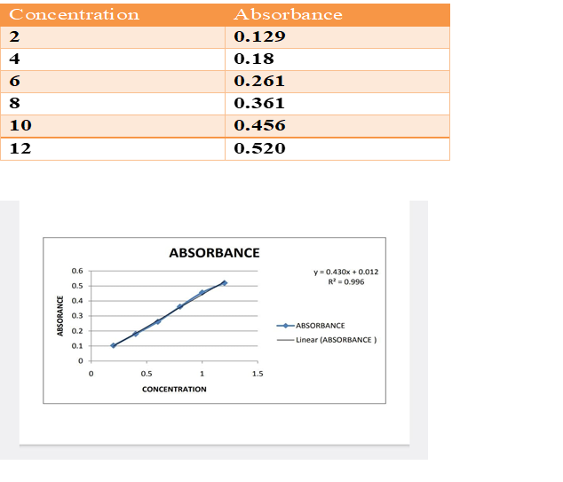

4.2 . Organoleptic Studies:

• Colour= white

• Odour =odourless

• State=solid

4.3.Thin Layer Chromatography(TLC):

Fig no.5 TLC reading of components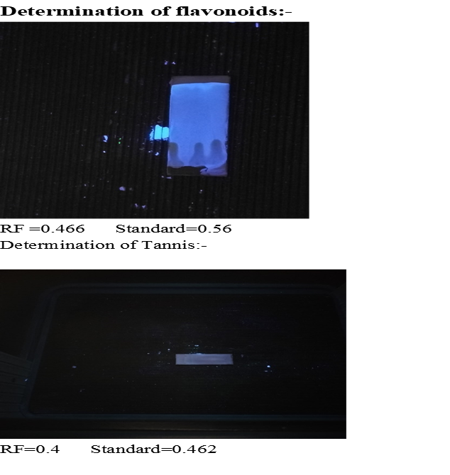

4.4 Melting point: Melting point of the herbal stick was carried out on the following apparatus and the readings were found to be as: 100-120oC

4.5 irritancy test :-



Fig no.6 irritation test of facial stick.

4.6 Spreadability test:-

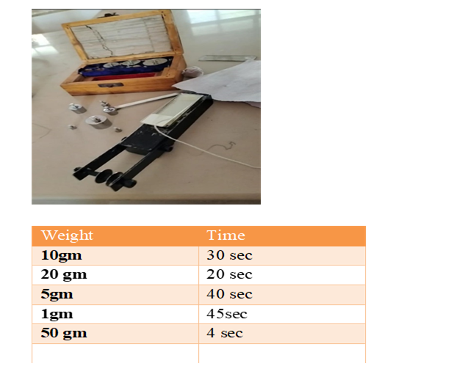

Fig no.7 Spreadability test

SUMMARY

A herbal facial stick typically refers to a skincare product designed for targeted application on the face. It usually contains a blend of herbal extracts, essential oils, and other natural ingredients known for their skincare benefits. The stick format allows for easy and mess-free application, making it convenient for on-the-go use. These products are often marketed as providing hydration, soothing effects, and overall skin nourishment. They may also claim to help with specific skin concerns such as acne, inflammation, or dryness, depending on the ingredients used. However, the effectiveness of herbal facial sticks can vary depending on the formulation and individual skin type.

The Moringa oleifera extract and Bael fruit extract herbal facial stick combines the beneficial properties of two potent botanical ingredients known for their anti-inflammatory actions.

The Moringa oleifera extract and Bael fruit extract herbal facial stick combines the beneficial properties of two potent botanical ingredients known for their anti-inflammatory actions. Moringa oleifera, often referred to as the "miracle tree," is rich in antioxidants, vitamins, and minerals. Its extract is believed to possess anti-inflammatory properties, helping to soothe and calm irritated skin. Additionally, Moringa extract is known to promote skin hydration and overall skin health.

Bael fruit extract, derived from the Aegle marmelos tree, is renowned for its medicinal properties in traditional Ayurvedic medicine. It contains compounds such as flavonoids and tannins, which exhibit anti-inflammatory effects. Bael fruit extract is often used topically to alleviate skin conditions like redness, itching, and inflammation.

When combined in a herbal facial stick, these two extracts work synergistically to provide potent anti-inflammatory action. The stick format allows for convenient and targeted application, making it ideal for soothing inflamed areas on the face. Regular use of this herbal facial stick may help to reduce redness, calm irritated skin, and promote a healthier complexion overall

CONCLUSION

the Moringa oleifera extract and Bael fruit extract herbal facial stick offers a promising solution for individuals seeking anti-inflammatory skincare benefits. By harnessing the potent properties of Moringa oleifera and Bael fruit extracts, this product aims to soothe irritated skin, reduce redness, and promote overall skin health. The combination of these botanical ingredients provides a synergistic effect, enhancing the anti-inflammatory action of the facial stick. With its convenient stick format, users can easily target areas of concern on the face, making it a practical addition to their skincare routine. Regular use of this herbal facial stick may lead to calmer, healthier-looking skin, making it a valuable option for those with sensitive or inflamed skin conditions.

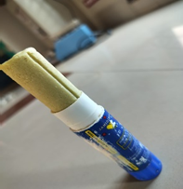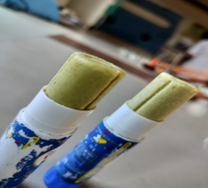

Fig no.8 final product

FUTURE SCOPE

The future scope of the Moringa oleifera extract and Bael fruit extract herbal facial stick holds several promising opportunities:

1. Further Research and Development: Continued research into the bioactive compounds present in Moringa oleifera and Bael fruit extracts can uncover new benefits and applications for skincare. This may lead to the development of enhanced formulations with even greater efficacy.

2. Expanded Product Range: Companies may explore the incorporation of these botanical extracts into a broader range of skincare products, such as creams, serums, or masks, to cater to diverse consumer preferences and needs.

3. Animal study: on skin of animal for protecting the uv rays because of in both bael fruit and moringa olifera there are area tannis are present which responsible for the protecting uv rays

REFERENCE

1. A text book of pharmacognosy s.b.gokhale,c.k.kokate ,Nirali prakashan edition 1st ,published 2007

2. Phytochemistry and medicinal uses of the bael fruit (Aegle marmelos Correa): A concise review Manjeshwar Shrinath Baliga a, Harshith P. Bhat b, Nandhini Joseph a, Farhan Fazal

3. 4. C Jacobs; O Kayser; R.H Muller; Int. J. Pharma2000, 196,161–164

4. A comprehensive review on Moringa oleifera nanoparticles: importance of polyphenols in nanoparticle synthesis, nanoparticle efficacy and their applications Haribalan Perumalsamy, Sri Renukadevi Journal of Nanobiotechnology volume 22, Article number: 71 (2024) Cite this article 2934 Accesses 1 AltmetriMetricsdetails

5. Extraction Techniques of Herbal Drugs

October 2019 DOI:10.22271/ed.book.415

In book: Research Trends in Medicinal Plant Sciences (Volume - 5) (pp.17-33)Publisher: AkiNik Publication

6. Moringa oleifera: An Updated Comprehensive Review of Its Pharmacological Activities, Ethnomedicinal, Phytopharmaceutical Formulation, Clinical, Phytochemical, and Toxicological aspects,

Int J Mol Sci. 2023 Feb; 24(3): 2098. Published online 2023 Jan 20. doi: 10.3390/ijms24032098

7. NATIVE AMERICAN HERBAL PRESCRIPTION STICKS. Publication herbalgram2008 ,ISSN 77 pg.no.78

8. e-ISSN: 2582-5208International Research Journal of Modernization in Engineering Technology and Science( Peer-Reviewed, Open Access, Fully Refereed International Journal0Volume:06/Issue:01/January-2024 Impact Factor- 7.868

9. Durable Moisturizing Herbal Lip Balm with Honey, HyaluronicAcid, and SPF

Hafizh Fadhullah*, Anisa Megantika, Kanya Citta Hana Alifia, Pandu Nugroho, Talitha Zada Gofara

10. Department of Chemical Engineering, Faculty of Engineering, University of Indonesia, Depok, 16424, Indonesia

11. *e-mail: hafizh.fadhullah1@gmail.com Extraction of Protein from Moringa oleifera Leaves for Facial Mask Production

12. Shahidah Irsalina Mustafa Kamal Israka

13. , Norliza Abd Rahmana,b,*, Mohd Nazri FuadaJarinah Mohd Alia,

14. Department of Chemical Engineering and Process (JKKP), b

15. Research Centre for Sustainable Process Technology (CESPRO),Faculty of Engineering & Built Environment, Universiti Kebangsaan Malaysia, Malaysia Corresponding author: norlizajkkp@ukm.edu.my Received 30 December 2020, Received in revised form 09 June 20Accepted 8 July 2021, Available online 30 November 2021