Development and Assessment of a Herbal-Based Shampoo for Antidandruff and Antifungal Efficacy

Ankit Kumar* ¹, Vikash Kumar Gautam ², Shiv Shanker Pal ^{2,} Saurabh Singh ¹
*1. Faculty of Department of Pharmaceutical Technology, Meerut Institute of Engineering and Technology (MIET) NH-58, Delhi-Roorkee Highway, Meerut-250005, Uttar Pradesh, India.
- Student of Department of Pharmaceutical Technology, Meerut Institute of Engineering and Technology (MIET) NH-58, Delhi-Roorkee Highway, Meerut-250005, Uttar Pradesh, India.

“Author of correspondence’’
Dr. Ankit Kumar*
Department of Pharmaceutical Technology,
Meerut Institute of Engineering and Technology (MIET)
NH-58, Delhi-Roorkee Highway, Meerut-250005, Uttar Pradesh, India.
Mob. No.-9536005516
Email: ankit.raaj100@gmail.com

ABSTRACT
The natural shampoo is a normal hair care answer used to clear out grease, particles and dandruff, stimulating hair increase and energy. It also gives the hair a sleek appearance and smoothness, decreasing tenderness. This research pursuits to expand a natural shampoo and verify its bodily and chemical houses with an eye closer to ensuring its protection and effectiveness. Herbal shampoos for hair growth are formulated to strengthen the hair follicles by delivering essential oils and nutrients through the roots and hair follicles. It then stimulates the formation of new and healthy hair root sand promotes healthy hair growth. The main objective is to study how to eliminate harmful synthetic ingredients from anti-dandruff shampoo formulation and substitute them with safe natural ingredients. An attempt has been made to combine modern formulation technology into a formula based on natural ingredients. The development of natural ingredients shampoo using the extracts in different proportions was prepared. Evaluation of organoleptic, physicochemical, and performance tests in terms of visual assessment, pH, assurance of solid contents, dirt dispersion, conditioning performance, foam test, and stability was performed.
Keywords: Herbal shampoo, Anti-dandruff, Natural ingredients, Hair care, Physicochemical evaluation etc.,

INTRODUCTION
Dandruff and fungal scalp infections are common dermatological conditions caused by Malassezia fungus that affect a significant portion of the population, leading to discomfort, itching, and hair- related concerns. Conventional anti-dandruff shampoos, often containing synthetic antifungal agents, may lead to undesirable side effects with prolonged use. In recent years, polyhedral-based shampoos have garnered attention as natural, safer alternatives, leveraging the synergistic effects of multiple plant extracts with antifungal, antimicrobial, and anti-inflammatory properties.¹⁻²

MALESSEZIA FUNGUS

Malassezia is a genus of lipophilic (fat-loving) yeasts that are part of the normal micro biota of the skin, particularly on oily areas like the scalp, face, and chest. These yeasts are opportunistic pathogens, meaning they usually do not cause disease in healthy individuals, but under certain conditions, they can proliferate excessively and contribute to skin conditions like dandruff, seborrhea dermatitis, and other fungal infections.³

Classification:
  - Kingdom: Fungi
  - Phylum: Basidiomycota
  - Class: Urediniomycetes
  - Order: Malasseziales
  - Family: Malasseziaceae
  - Genus: Malassezia

Morphology:
- Malassezia species are oval to round-shaped yeast cells, typically measuring between 3-8 micrometers in diameter.
- They are lipophilic, meaning they require fatty acids for growth, which is why they are commonly found in sebaceous (oil-producing) glands of the skin. Role of Malassezia in Dandruff.
- Lipophilic Nature: Malassezia is a genus of lipophilic (fat-loving) yeasts that thrive in oily environments, such as the scalp. These fungi feed on the sebum (natural oils) produced by sebaceous glands in the skin.
- Species Involved: Several species of Malassezia are involved in dandruff, particularly Malassezia globosa and Malassezia restricta. These species are commonly found on the scalp of both individuals with and without dandruff, but in dandruff sufferers, their growth becomes more.

BIOLOGICAL FUNCTIONS OF HAIR ⁴⁻⁵
- Protection: Hair gives a barrier against environmental factors, which includes UV radiation from the solar, and allows protects sensitive regions just like the scalp.
- Thermoregulation: Hair facilitates regulating body temperature with the aid of trapping warmth near the pores and skin or taking into consideration cooling via perspiration.
- Sensation: Hair follicles are wealthy in nerve endings, making hair touchy to the touch, which enhances the frame's potential to hit upon changes within the surroundings

TYPES OF HAIR ⁶⁻⁷
- Vellus Hair: first-class, short, and mild-coloured hair that covers the maximum of the frame.
- Terminal Hair: Thicker, longer, and darker hair located on the scalp, face, and different areas.

PROBLEM RELATED TO HAIR
- Flaking
- Alopecia areata
- Dry hair
- Oily hair
- Dandruff
- Split ends
- Heat damaged hair
- Scalp infection
- Colours damage hair

ABOUT DANDRUFF ⁷⁻⁸
Dandruff is a common, non-serious scalp condition characterized by white flakes of dead skin that may appear on the scalp, hair, or shoulders. It can be triggered by dry or oily skin and is not linked to poor hygiene. Although the exact cause is unclear, genetic and environmental factors are believed to play a role, with symptoms often worsening in colder months. The condition is associated with rapid skin cell turnover and is diagnosed based on visible symptoms. While there is no permanent cure, treatments like antifungal agents (e.g., ketoconazole) and keratolytic ingredients (e.g., salicylic acid) can help manage it. Dandruff typically begins around puberty and affects nearly half of the adult population, with men being more commonly affected.

SYMPTOMS OF DANDRUFF
- Red and greasy patches
- Dry scalp • Itching
- Scalp tenderness
- Stress

CAUSES OF DANDRUFF
- Yeast (Malassezia)
- Diet (alcohol, food)
- Hormones
- Life style (stress, happy)
- Hair product (dye, spray, gels)
- Irritated
- Skin condition such as psoriasis or seborrheic

ABOUT FUNGAL ⁹⁻¹⁰
- Fungal refers to a collection of organisms that consists of yeasts, molds, and mushrooms. Fungi are living things which are categorized one after the other from vegetation and animals. Some fungi can motive infections in people, such as athlete's foot and yeast infections.
- A fungal contamination of the hair is normally known as ringworm, although it is now not because of worms. it is because of a spread of fungi that stay within the soil, on animals, or every now and then most effective on humans.

CAUSES OF FUNGAL INFECTION IN HAIR
- Fungi thrive in warm, moist regions, consisting of tropical places.
- Minor accidents to the pores and skin or scalp can increase the likelihood of a fungal infection.
- Fungal infections can unfold through direct contact with an inflamed character or animal, or by sharing objects like towels, hats, and brushes.
- Antibiotics can disrupt the body's natural bacteria that assist hold fungi in check.
- Excessive sweating
- During pregnancy
- During treatment of cancer

TREATMENT OF FUNGAL
- Hair should be washed thoroughly every day.
- The hair must be dried before applying oil.
- Hairbrush and comb should always be changed from time to time.
- Chemical products should not be used on your hair.

ABOUT SHAMPOO ¹¹⁻¹²
Shampoo is a commonly used hair care product, usually in liquid form, designed to clean the hair and scalp. It can also be found in solid bar form. To use, it is applied to wet hair, massaged into the scalp, and rinsed off. Often, it is followed by a conditioner for added softness. Shampoo helps remove excess sebum (natural scalp oils) and buildup without over-drying the hair. It typically contains a surfactant—such as sodium lauryl sulfate or sodium laurate sulfate combined with co-surfactants like cocamidopropyl betaine, which work together to lift away dirt and oils effectively.

TYPES OF SHAMPOO
- Clarifying shampoo
- Moisturizing shampoo
- Sulphate free shampoo
- Colour safe shampoo
- Volumizing shampoo
- Anti dandruff shampoo
- Anti-fungal shampoo
- Strengthening shampoo
- Baby shampoo
- Medicated shampoo
- Dry shampoo
- Leave in shampoo
- Organic/Natural shampoo
- Curl enhancing shampoo

IDEAL PROPERTIES OF SHAMPOO
- ·It should clean the hair thoroughly and remove dirt and impurities.
- It should generate sufficient foam to aid in even application and cleansing.
- The shampoo should be easily removed by rinsing with water.
- Should leave the hair non-dry, soft, and lustrous with good, manageability.
- Should impart a pleasant fragrance to the hair.
- It should be gentle on the hands, without causing dryness or roughness.
- It must be safe for the skin and free from any side effects or irritation.

WHAT IS SYNTHETIC SHAMPOO
Synthetic shampoo is a hair care product that contains synthetic elements and chemical compounds. a few commonplace substances found in synthetic shampoos encompass: parabens, sulphates, propylene glycols, phthalates, and artificial fragrances.

SIDE EFFECT OF SYNTHETIC SHAMPOO
- Skin irritation: Its fragrance may be harmful for those with sensitive skin.
- Hair loss: Sodium Lawrence Sulphate is a foaming agent that can damage hair follicles and cause hair loss.
- Environmental impact: Chemicals added to shampoos can contaminate water and soil and can also harm trees.
- Scalp acne: Mineral oil can clog the scalp's pores, main to a build-up of dust, oil, and micro- organism that could motive scalp zits.

WHAT IS HERBAL SHAMPOO ¹³⁻¹⁴
Natural shampoos are formulated with plant-based extracts and other natural ingredients. Their key advantage is delivering long-lasting, effective results without the use of harsh chemicals, making them gentle and safe for the hair.

ADVANTAGE OF HERBAL SHAMPOO
- It is a shampoo non - toxic
- It is easily available
- It is a very cheap price and economically
- It is eco friendly
- Herbal shampoo is not cause redness, itching, irritation, and harmful
- Herbal shampoo use pure organic ingredients there are no additive surfactant

FUNCTIONS OF HERBAL SHAMPOO
- Herbal shampoos can soothe and calm indignant scalps, lowering infection and itching.
- Certain herbs, inclusive of tea tree oil and neem, have antifungal and antibacterial properties, helping to manipulate infections and promote a healthful scalp.
- Herbal shampoos can offer comfort from psoriasis and eczema signs, including redness, scaling, and itching.
- Natural shampoos can efficiently easy the hair and scalp, eliminating dust, oil, and impurities.
- Herbal shampoos can assist stability the pH of the scalp, reducing infection and promoting a healthy environment.
These are the some literature reviewed for the current study.

Poonam et al., 2024. A herbal anti-dandruff shampoo was formulated and evaluated, focusing on both safety and effectiveness. The formulation combined modern cosmetic technology with natural extracts including Tribulus terrestris (Gokhru), Ocimum sanctum (Tulsi), Acacia concinna (Shikakai), Sapindus mukorossi (Reetha), Aloe barbadensis (Aloe Vera), Citrus lemon (Lemon juice), and Hibiscus rosa-sinensis (Hibiscus). The shampoo underwent various physicochemical tests such as visual inspection, pH, wetting time, solid content, surface tension, foam stability, dirt dispersion, detergency, and conditioning performance..¹⁵

Kushwaha et al, 2022. Reviewed dandruff, commonly caused by the yeast Pityrosporum ovale, is a widespread scalp condition that can be managed but not completely cured. Conventional anti-dandruff shampoos often use chemical antifungal agents, which may lead to side effects like hair loss, itching, and irritation. To address this, a herbal anti-dandruff shampoo was developed using ingredients such as Shikakai, neem powder, glycerin, and others. The formulations were evaluated through tests like pH, viscosity, dirt dispersion, foaming ability, and antifungal activity against Pityrosporum ovale. Among them, formulation F3 showed the best results and was further tested for safety through eye and skin irritation studies on animals.¹⁶
Ayesha et al., 2022. Studied herbal shampoos made with natural extracts and are used to cleanse the hair while helping to reduce dandruff. They are free from synthetic chemicals and surfactants, making them safe and side-effect-free. These shampoos nourish the scalp, regulate excess sebum, and promote healthy hair growth by strengthening hair follicles and encouraging new root development.¹⁷
Sravanthi et al., 2021. A herbal anti-dandruff shampoo was formulated and evaluated, focusing on safety, efficacy, and the replacement of harmful synthetic ingredients with natural alternatives. The shampoo was prepared using extracts of orange peel, curry leaves, ginger, aloe vera, and reetha. It demonstrated effective cleansing, good foam stability, low surface tension, suitable pH, and conditioning properties. These qualities make it suitable for daily use. However, further studies are needed to fully validate its effectiveness and long-term benefits.¹⁸
Dheeraj et al. (2021) developed anti-dandruff shampoo formulations incorporating dandruff-fighting agents such as zinc pyrithione (ZPT). ZPT is widely recognized as a key ingredient in combating dandruff, primarily by inhibiting Malassezia globosa, the microbe responsible for producing scalp irritants. Head & Shoulders, for instance, utilizes a unique and highly effective form of ZPT in its products. Contrary to common misconceptions, anti-dandruff shampoos are not harmful to hair. In fact, untreated dandruff can lead to increased scratching, which may cause hair cuticle damage and dullness. By reducing dandruff, such shampoos also help maintain the hair’s appearance and health. Moreover, the use of novel delivery systems, which have shown success in pharmaceutical formulations, offers promising potential for targeted scalp treatments in cosmetic applications.¹⁹

OBJECTIVES
The primary objective to develop and evaluate an herbal anti-dandruff and anti-fungal shampoo is to create an effective, safe, and natural solution to combat dandruff and fungal infections on the scalp. Below are the detailed objectives for both formulation and evaluation:
- Formulation objectives:
- To develop a safe and effective herbal shampoo: the aim is to formulate a shampoo using natural and herbal ingredients that provide relief from dandruff and fungal scalp infections without causing side effects. Key ingredients might include tea tree oil, neem, aloe vera, fenugreek, and other antimicrobial herbs.
- To select bioactive herbal ingredients with anti-fungal and anti-inflammatory properties: choose herbs and plant extracts that have proven efficacy in treating fungal infections (such as malassezia) and inflammation, which are common causes of dandruff.
- To achieve a balanced ph: ensure that the shampoo formulation has a ph level between 4.5 and 5.5, which is ideal for maintaining the scalp’s natural ph balance and preventing irritation.
- To ensure mild and non-irritating surfactants: use mild surfactants that do not damage the scalp or hair, offering gentle cleansing while maintaining the integrity of the skin barrier.
- To develop a stable formulation: formulate a shampoo that maintains its efficacy and consistency over time. This includes ensuring the stability of the active ingredients and the prevention of microbial contamination.
- To enhance consumer acceptance: incorporate desirable sensory properties, such as fragrance, foaming ability, smooth texture, and ease of use, to ensure consumer satisfaction and preference.
- Evaluation objectives:
- To assess the anti-fungal efficacy of the shampoo: evaluate the shampoo’s ability to inhibit or eliminate fungal growth, particularly the malassezia species, which is commonly associated with dandruff. This can be measured through in vitro tests such as the agar diffusion method or minimum inhibitory concentration (mic) tests.
- To evaluate anti-dandruff efficacy: assess the ability of the shampoo to reduce dandruff symptoms, such as itching, scaling, and redness. This can be done through clinical studies involving volunteers or using standardized scales like the 4-point dandruff severity scale.
- To conduct dermatological safety testing: evaluate the shampoo's safety by conducting patch tests, irritation tests, and allergy tests to ensure that it does not cause skin irritation, allergic reactions, or other adverse effects when used on the scalp.
- To determine the microbial stability: conduct microbial testing to ensure that the shampoo does not support the growth of harmful bacteria and fungi, which is crucial for ensuring product safety and shelf life.
- To evaluate physicochemical properties: assess the shampoo’s physical properties such as viscosity, color, texture, foaming ability, and ease of application. These attributes are critical for consumer acceptance and the overall performance of the product.
- To conduct stability testing: evaluate the stability of the herbal shampoo under various environmental conditions (e.g., temperature, humidity) to ensure that the product maintains its quality, appearance, and efficacy over time.
- To assess the consumer acceptance: conduct a sensory evaluation to gauge consumer preferences regarding the fragrance, texture, ease of use, and overall experience. This includes testing user satisfaction after regular use.
- To confirm long-term efficacy: ensure that the herbal shampoo shows consistent results over an extended period of use, demonstrating its effectiveness in treating and preventing dandruff and fungal infections

Methodology ²⁰⁻²⁹

Herbal Ingredients procurement
  - Rice Water: 10-15% (rich in amino acids and vitamins, helps strengthen hair and reduce dandruff).
  - Curry Leaves Extract: 2-3% (anti-inflammatory, promotes hair growth and helps reduce dandruff).
  - Onion Extract: 1-2% (contains sulfur compounds that promote hair growth and fight fungal infections).
  - Ginger Extract: 1-2% (anti-inflammatory, improves blood circulation to the scalp).
  - Garlic Extract: 1-2% (anti-fungal, helps control dandruff caused by fungal infections).
  - Aloe Vera Gel: 5-10% (soothes and hydrates the scalp, reduces itching and inflammation).
  - Decyl glucoside: 10-15% (primary surfactant for cleansing).
  - Citric Acid: For pH adjustment to 4.5-5.5.
  - Glycerin: 1-2% (helps retain moisture in the hair and scalp)
  - Phenoxy ethanol: 0.5-1% (preservative to prevent microbial growth).

PROCEDURE

- Preparation of Herbal Extracts:

  - Rice Water: Wash rice thoroughly to remove impurities and then soak the rice in water for 30 minutes. After soaking, strain the rice water and boil it for 5-10 minutes to concentrate the nutrients.
  - Curry Leaves Extract: Boil fresh curry leaves in water for 15-20 minutes, then strain and cool the solution.
  - Onion Extract: Blend fresh onions and strain the juice using a muslin cloth or fine mesh strainer.
  - Ginger Extract: Grate fresh ginger and soak it in a small amount of warm water for 10- 15 minutes. Then, strain it to extract the ginger liquid.
  - Garlic Extract: Crush fresh garlic cloves and soak them in a small amount of water for 10-15 minutes. Strain the liquid.
  - Aloe Vera Gel: Extract fresh aloe vera gel by cutting the leaves and scraping out the gel. Filter it to remove any fibrous parts.

Characterization of prepared shampoo:

- SUBSTANCES
- EFFECTIVENESS
- DETERMINATION OF PH
- DIRT DISPERSION
- DETERMINATION OF PERCENTAGE SOLID CONTENT

MATERIALS OR HERBAL INGREDIENTS FOR SHAMPOO
- Curry leaves
- Aloe Vera
- Rice water
- Onion extract
- Ginger
- Garlic extract
- Mint Extract

CURRY LEAVES
  - Curry leaves (Murraya koenigii) have been used for a long time ago in traditional Indian Ayurveda medicine and hair care.
  - Curry leaves assist to control dandruff. Its antifungal homes assist in lowering dandruff and itchiness, accordingly leaving you with a clean scalp and healthy hair. For dandruff-free scalp, make this mask by means of soaking 15-20 curry leaves in water for 20 mins.
  - They are also a good supply of minerals which include calcium, phosphorus, iron, and magnesium, vital for bone fitness, blood flow.
  - Curry leaf’s nutrients like A, B, C, and E. Curry leaves help enhance vision, lessen oxidative strain, and raise immunity.

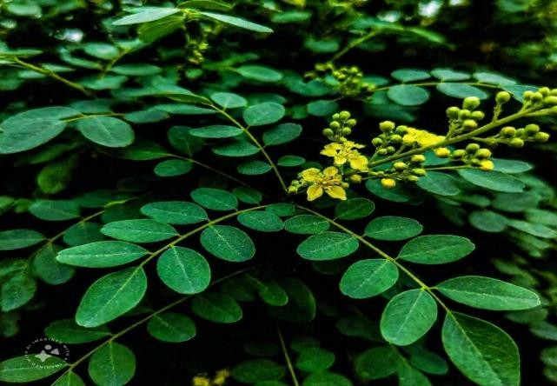

Fig: 1

ALOE VERA
Aloe Vera shampoo removes dandruff from the hair and makes the hair shiny. Aloe Vera contains photolytic enzymes that help promote hair health and growth Aloe Vera has anti-inflammatory properties which keep the scalp healthy. It will restore the pH of scalp and increase the growth.
  - Use of Aloe Vera in shampoo: • Help of Growth hair • Reduce dandruff
  - Maintain a health Scalp
  - Control hair fall
  - Strengthens hair
  - make hair shiny and frizz – free

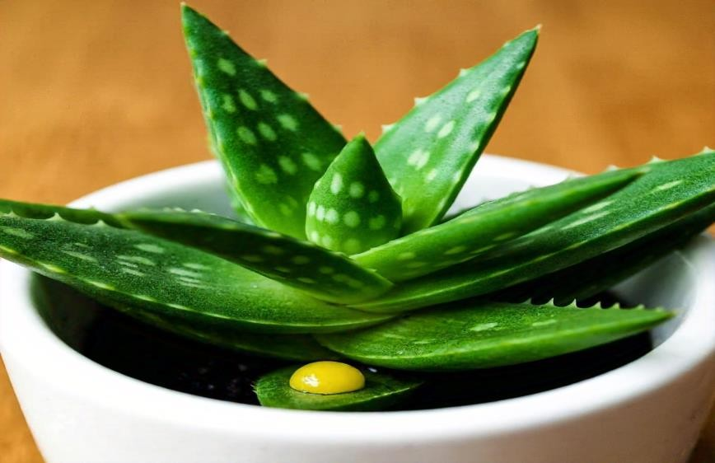
Fig: 2

RICE WATER
  - Rice Water consists of a carbohydrate referred to as inositol, which enables restore damaged hair. it's miles one of the best ingredients for broken, frizzy or dry hair. It also facilitates balanced oil inside the hair follicles and lightly cleanses dirt and impurities without disrupting the scalp's ph.
  - The antifungal and antibacterial contain properties of rice water help control dandruff, itchiness, and scalp infections.
  - Rice water consists in vitamins, minerals, and amino acids that help promote hair growth and strengthen hair follicles.

  - Benefits of rice water
  - Rice water help of promote hair growth and strengthens hair follicles.
  - Rice water help of improvement hair texture and make a smooth.
  - Rice water in present Anti-fungal and bacterial properties and help of itching and prevent the scalp infection.
  - In this present protein and carbohydrates and improve the hair elasticity and damage hair follicles.

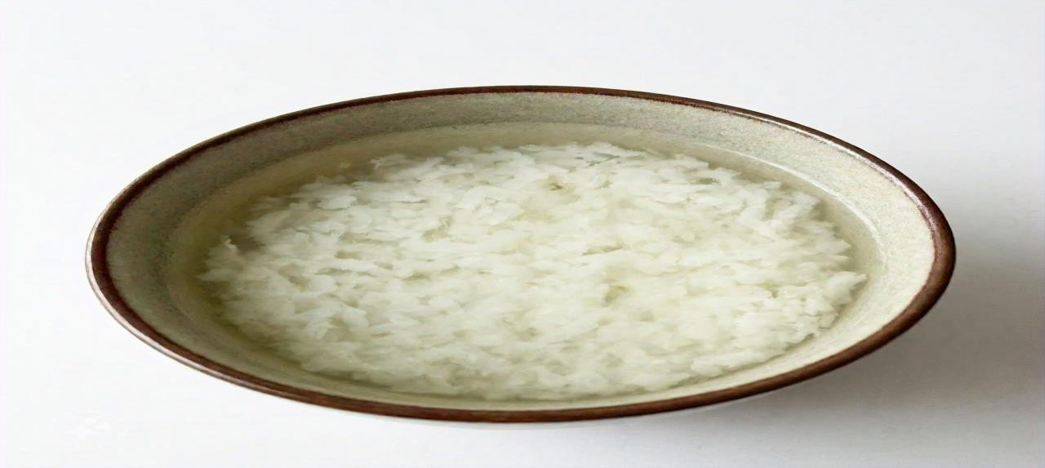

Fig: 3

ONION EXTRACT
Onion shampoos are a rich supply of antioxidants. Their antimicrobial nature treats dandruff, infection, and other scalp problems. The sulphur within the onion facilitates maintain thick hair, reduce hair loss and improve hair development. The excessive sulphur ranges also assist to save you hair loss and reinforce hair follicles.
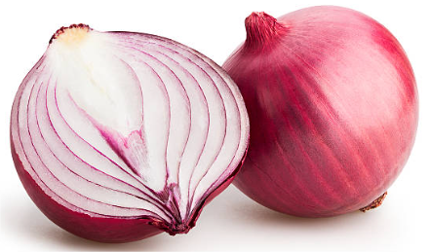

  - Fig: 4

  - Benefits of onion extract
  - Onion is a help of promote hair growth and improve circulation to the scalp.
  - Onion is a help of reducing the hair fall and strengthen hair roots.
  - Onion can lock in the natural moisture in the scalp dryness.
  - Onion have an Anti-fungal and Anti-microbial properties that help in avoiding infection on the scalp.
  - Onion is maintained the pH levels in the scalp.

GINGER EXTRACT
  - Ginger is broadly celebrated for its culinary makes use of. but it additionally holds a treasure trove of blessings extending beyond the kitchen – considerably, for the hair. the adventure of exploring ginger for hair is each ancient and rich, with roots deeply embedded in traditional treatments.
  - It’s charming to peer how this astonishing aspect is a game-changer and is being utilized in some of the quality hair care products. underneath, we see how ginger is right for hair and its blessings.

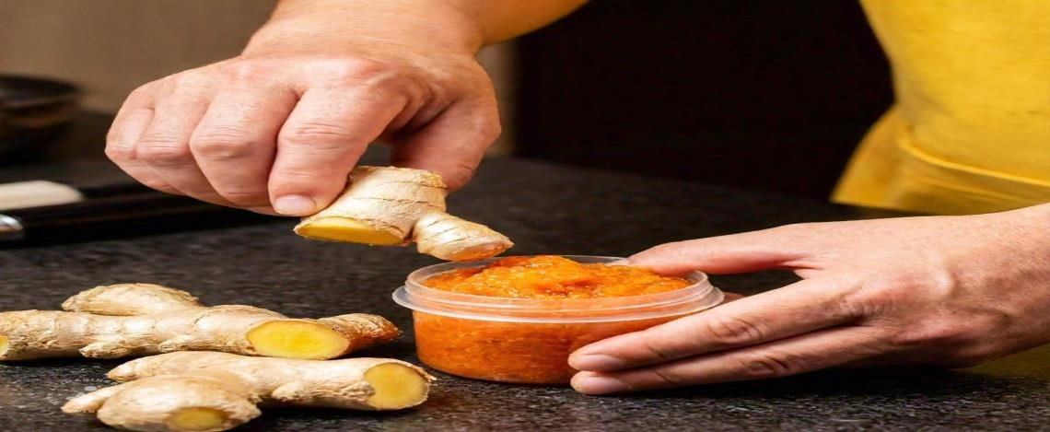

Fig: 5

GARLIC EXTRACT
  - Treating scalp infections: - Garlic has antibacterial and antifungal properties which could help treat infections that cause hair loss.
  - Preventing hair loss: - Garlic can assist prevent hair thinning and falling out.
  - Strengthening hair: - Garlic can assist toughen hair roots and restore stressed hair.
  - Improving scalp fitness: - Garlic can assist calm an annoyed scalp and prevent itching.
  - Boosting hair growth: - Garlic can stimulate hair growth and enhance collagen manufacturing.
  - Lowering damage: - Garlic’s antioxidant residences can help reduce harm from UV rays and slow down getting old of the hair and scalp.
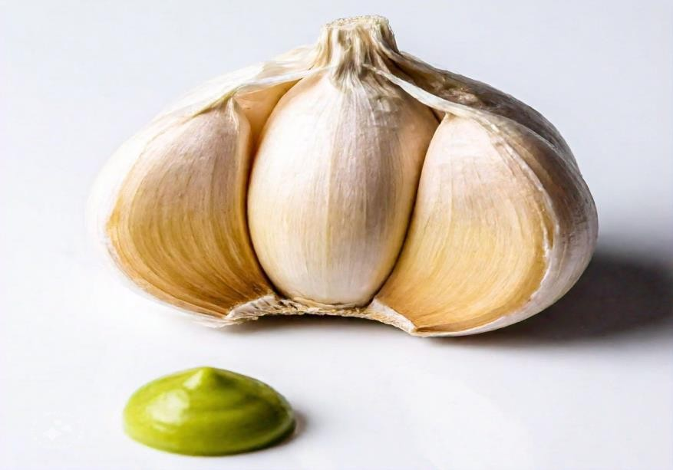
Fig: 6

MINT EXTRACT
  - Mint's antifungal homes can assist prevent dandruff and different fungal or bacterial infections.
  - The menthol in mint can boom blood float to the scalp, which may also help with hair growth.
  - Mint’s homes can assist soothe an itchy or dry scalp.
  - Mint is rich in nutrients and minerals that nourish the scalp and toughen hair follicles.
  - Peppermint can assist balance your hair's natural oils, making it look vibrant. some mint shampoos additionally contain different elements, including tea tree oil, to assist with specific issues.
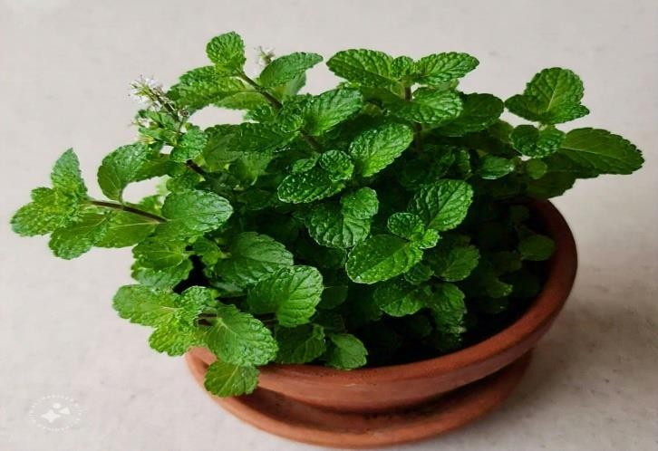
Fig: 7
Key Ingredients and Their Benefits:

- Curry Leaves: Rich in antioxidants and beta-carotene, curry leaves help reduce dandruff, nourish the scalp, and promote hair growth. They also have antifungal properties.
- Aloe Vera: Soothes the scalp, provides moisture, reduces inflammation, and has antibacterial properties.
- Mint: Freshens the scalp, reduces itching, has antifungal properties, and increases circulation.
- Rice Water: Contains amino acids, vitamins, and minerals that help strengthen hair, promote growth, and reduce dandruff.
- Ginger: Contains anti-inflammatory and antifungal properties, which can help to reduce dandruff caused by fungal infections.
- Garlic: Known for its antifungal and antibacterial properties, garlic can help in fighting scalp infections and dandruff.
- Onion Extract: Rich in sulfur, onion extract helps to treat scalp infections and dandruff while promoting hair growth.

METHODOLOGY
The study employed a systematic approach to formulation, including the selection of herbs known for their antifungal effects, such as ginger, garlic and Aloe Vera, curry leaves, mint, onion extracts. Rice water and tests were conducted to evaluate the stability and effectiveness of the formulations.

METHODS USED-
  - Mortar and Pestle
  - Solvent Extraction
  - Cold Press Extraction
  - Rice Water Extraction
  - Homogenization

PREPARATION STEPS:
- Rice Water Preparation:

  - Method:
  - Wash the rice thoroughly to remove dirt and impurities.
  - Soak the rice in water for 6-7 hrs.
  - After soaking, strain the rice and collect the water. You can also boil the rice and use the water that is left over after boiling.
  - Set the rice water aside. Rice water is known to help in strengthening hair and reducing dandruff.
- Curry Leaves Infusion:

  - Method:
  - Boil the curry leaves in 1 cup of water for 10-15 minutes to make an infusion.
  - Strain the mixture to remove the leaves and set the liquid aside. Curry leaves help reduce dandruff and fungal infections.
- Aloe Vera and Mint Blend:

  - Ingredients:
  - 2 tablespoons fresh aloe vera gel (or 2-3 aloe vera leaves)
  - 1/4 cup fresh mint leaves
  - Method:
    - Extract fresh aloe vera gel from the plant and set it aside.
    - Crush or blend fresh mint leaves to release their juice.
    - Mix the aloe vera gel with the mint juice. Mint provides a cooling effect and helps reduce itching and irritation.

- Ginger, Garlic, and Onion Extract:

  - Ingredients:
  - 1 small piece of ginger (grated)
  - 2-3 garlic cloves (crushed)
  - 1 small onion (grated or blended)
Method:
  - Grate or crush the ginger, garlic, and onion.
  - Add the grated ginger, garlic, and onion to 1/2 cup of water.
  - Boil the mixture for 10-15 minutes, then strain it to get the extract.
  - This extract helps treat dandruff and fungal infections and also promotes hair growth due to its high sulfur content.
- Combining All Ingredients:

  - Rice water (from Step 1)
  - Curry leaves infusion (from Step 2)
  - Aloe vera and mint blend (from Step 3)
  - Ginger, garlic, and onion extract (from Step 4)
  - 2 tablespoons of mild shampoo base or Castile soap (optional)
Method:
  - In a clean bowl, combine the rice water, curry leaves infusion, aloe vera-mint blend, and ginger-garlic-onion extract.
  - Add 2 tablespoons of a mild shampoo base or Castile soap to the mixture. This acts as a gentle cleansing agent and creates lather.
  - Stir the mixture well to combine everything thoroughly. This is your herbal anti-dandruff and anti-fungal shampoo.

INGREDIENTS | QUANTITY (%)
Carry leaves | 5%
Aloe vera | 2%
Rice water | 2%
Ginger extract | 3%
Garlic extract | 2%
Onion extract | 3%
Mint extract | 3%
Decyl glucoside | 15%
Glycerin | 4%
Citric acid | q.s
Xanthan gum | 1%
Hydroxy ethyl cellulose | 1%
Phenoxy ethanol | 0.8%
Water | q.s

Benefits of the Herbal Shampoo:

- Curry Leaves: Reduce dandruff, fight fungal infections, and improve scalp health.
- Aloe Vera: Soothes the scalp, reduces inflammation, and hydrates the scalp and hair.
- Mint: Reduces itching, provides a cooling effect, and has antifungal properties.
- Rice Water: Strengthens hair, reduces dandruff, and improves overall scalp health.
- Ginger: Reduces scalp inflammation and has antifungal properties.
- Garlic: Fights fungal and bacterial infections and strengthens hair.
- Onion: Improves scalp circulation, reduces dandruff, and promotes hair growth

EVALUTION OF HERBAL SHAMPOO ³⁰⁻³⁹

SUBSTANCES
- Herbal natural extracts: -The shampoo ought to contain herbal components like aloe Vera, curry leaves, mint, ginger, and garlic, which can be recognized for his or her soothing, cleaning, and moisturizing homes.
- Loose from Harsh chemicals: - Preferably, a good natural shampoo needs to be loose from sulphates, parabens, silicones, and artificial fragrances that can irritate the scalp and hair over the years.
- Actives: - These are key for addressing particular scalp and hair issues, together with dandruff, dryness, or oiliness. Not unusual useful natural activities include onion, rice water, aloe vera, and ginger.

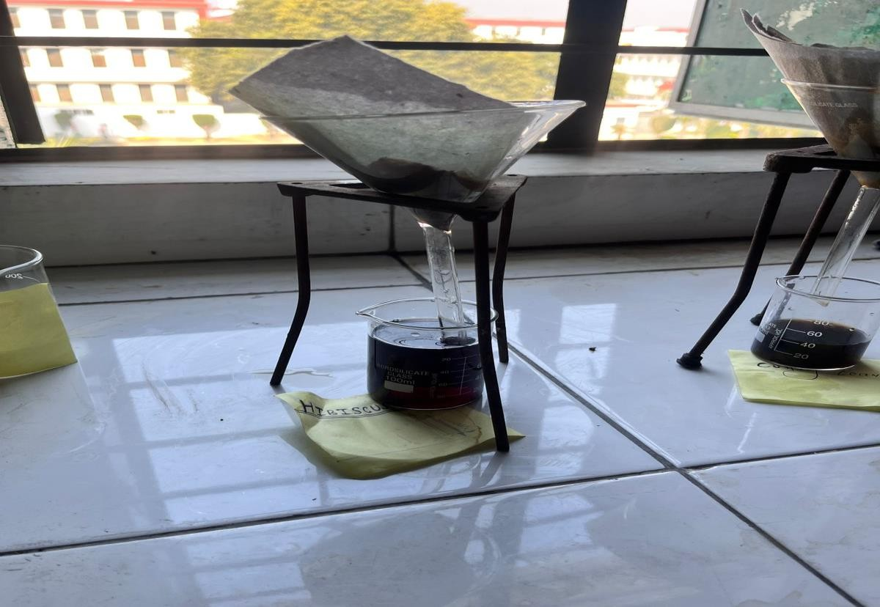
Fig: 8

EFFECTIVENESS
- Cleansing power: - A terrific natural shampoo must efficaciously eliminate dirt, oil, and product build up without stripping the hair of its herbal oils.
- Conditioning: - Many natural shampoos include conditioning dealers, like aloe vera and coconut oil that assist to hydrate the hair and prevent dryness.
- Targeted blessings: - Natural shampoos might also offer particular blessings, which include selling hair increase, reducing dandruff, strengthening hair, or soothing the scalp. These claims should be supported by the substances used.
- Gentleness: - The shampoo needs to be mild enough for each day use without inflicting inflammation, especially for those with sensitive skin or allergic reactions.

DETERMINATION OF PH
- The pH of 10% shampoo solution in distilled water was determined at room temperature 25 Degree Celsius.
- Dip one strip of pH paper in the solution and compare the colour of the strip to the key. The pH meter can also be used after calibration.
- Most shampoos are natural or slightly acidic, acidic solution causes the cuticle (outer layer) of the hair to shrink and lay flatter on the shaft of the hair, basic solution causes the cuticle to swell and open.
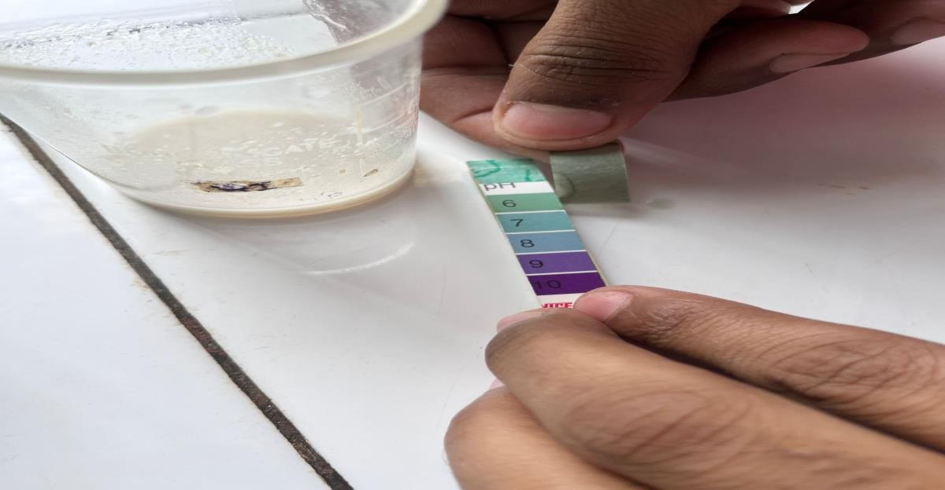
Fig: 9

DIRT DISPERSION
- Two drops of shampoo were added in a large test tube containing 10 ml of distilled water.
- A drop of India ink was added and the test tube was stopped and shakes it ten times.
- The amount of ink in the foam was estimated as none. light, moderate or high.
- Shampoo that causes the ink to concentrate in the foam are considered poor quality.
- The dirt should stay in the water portion of the dirt that stays in the foam will be difficult to rinse away and it will redeposit on the hair.

DETERMINATION OF PERCENTAGE SOLID CONTENT
- A clean dry evaporating dish was weighed and added 4 grams of shampoo to the evaporating dish. The dish and shampoo were weighed together.
- The exact weight of the shampoo was calculated only and the evaporating dish with shampoo was placed on the hot plate until the liquid portion was evaporated.
- The weight of the shampoo only (solid) is drying.
- If a shampoo has too many solids it will be hard to work into the hair or too hard to wash out.
- If it does not have enough, it will be too.
The weight of the dried shampoo solids was calculated as:
W₃ – W₁
The percentage of solid content was calculated using the following formula:
Percentage of solids=(Weight of dried solids/Weight of original shampoo sample)×100
Weight of empty evaporating dish (W₁): 50.00 g
Weight of dish + shampoo before heating (W₂): 54.00 g
Weight of dish + dried solids after heating (W₃): 50.80 g
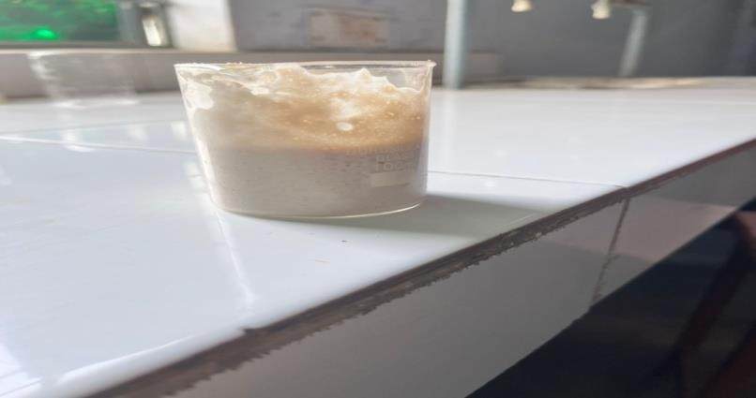
Weight of dried solids = 50.80 g – 50.00 g = 0.80 g
Percentage of solids=(0.80/4.00)×100=20%
Fig: 10

RESULT
Appearance: The shampoo was clear, with a light greenish tint due to the herbal extracts.
Substances: The shampoo contains herbal components like aloe Vera, curry leaves, mint, ginger, and garlic, which recognized by its soothing, cleaning, and moisturizing homes properties.
Effectiveness: The prepared shampoo showed its cleansing power via efficaciously eliminate dirt, oil, and product build up without stripping the hair of its herbal oils. Conditioning of prepared shampoo confirmed like aloe vera and coconut oil that assist to hydrate the hair and prevent dryness.
Dirt Dispersion: The herbal shampoo exhibited light ink dispersion in the foam. Most of the ink remained in the water portion, indicating effective dirt dispersion. This suggests that the shampoo has good cleansing properties and is unlikely to cause dirt redeposition on the hair.
Determination of Percentage Solid Content: The shampoo sample showed a solid content of 20%, which is within an acceptable range. This indicates a good balance between cleansing and rinsability. A shampoo with too high a solid content may be difficult to spread or wash out, while one with too low a solid content may be overly watery and ineffective.
Foam Volume: The shampoo formed a rich lather, contributing to a pleasant user experience.
Stability test: The product remained stable over at room temperature, with no significant changes in its appearance, pH, or viscosity.

CONCLUSION
In this formulation, an anti-dandruff and anti-fungal shampoo was developed using natural herbal ingredients. Compared to synthetic shampoos, this herbal alternative offers greater benefits, minimal risk of side effects, and user-friendly application.
The study highlights the effectiveness of plant-based ingredients—such as curry leaves, ginger, aloe vera, garlic, onion, rice water, and mint—in addressing dandruff and fungal scalp infections. These components demonstrated notable activity against common pathogens like Malassezia spp. and Candida spp. Evaluations of key parameters, including pH, foaming capacity, and stability, confirmed the formulation's safety and performance standards. Moreover, sensory characteristics like aroma, texture, and ease of use were positively received by users.
As a result, this herbal shampoo presents a safe, natural, and efficient alternative to conventional chemical-based products. However, additional clinical studies involving larger groups are encouraged to validate its long-term effectiveness and investigate its broader potential within the personal care industry.

REFERENCES
- Zhao, Y., & Zhang, L. (2019). Malassezia: The Role of Fungi in the Development of Dandruff and Seborrheic Dermatitis. Dermatology, 235(3), 184-193. doi:10.1159/000503607
- Kogo, M., & Koga, H. (2020). The Role of Malassezia Species in Scalp Disorders: A Review. Journal of Fungal Biology, 23(4), 311-318. doi:10.1016/j.jfbi.2020.03.004
- Elston, D. M. (2012). Dandruff and Malassezia: A Review of Etiology and Treatment. Dermatology Clinics, 30(2), 159-168. doi:10.1016/j.det.2011.10.009
- Madison, K. C. (2003). Barrier Function of the Skin: "La Raison d'Être" of the Epidermis. Journal of Investigative Dermatology, 121(2), 231-241. doi:10.1046/j.1523-1747.2003.12399.x
- Gilbert, E. L., & Darley, C. (2002). Hair Types and Their Biological Function. International Journal of Trichology, 12(2), 93-99. doi:10.4103/0974-7753.104207
- Tosti, A., & Lalla, C. (2012). Alopecia Areata: An Overview. Dermatologic Therapy, 25(4), 369-373. doi:10.1111/j.1529-8019.2012.01506.x
- Zouboulis, C. C., & Ifland, R. (2009). Seborrheic Dermatitis and Dandruff: Pathogenesis and Management. Dermatologic Therapy, 22(6), 480-485. doi:10.1111/j.1529-8019.2009.01257.x
- Faergemann, J., & Nordström, A. (2004). Malassezia and Its Role in Seborrheic Dermatitis and Dandruff. Dermatology, 208(1), 9-16. doi:10.1159/000074157
- Richardson, M. D. (2010). Fungal Infections of the Scalp. The Lancet, 12(6), 41-47. doi:10.1016/S0140-6736(10)60963-2
- Wagner, H. G., & Bohlmann, F. (1999). Fungal Infections of the Scalp: An Overview of Pathogenesis and Treatment. Journal of Medical Mycology, 23(5), 271-277. doi:10.1093/myc.23.5.271
- Garg, V., & Kapoor, A. (2017). Herbal Cosmetics for Hair Care: A Review of Plant-Based Ingredients in Shampoos and Conditioners. Journal of Pharmacognosy and Phytochemistry, 6(6), 842-848.
- Javadian, S., & Ghaffari, F. (2018). Cosmetic Formulations and Shampoo Ingredients. Advances in Chemistry & Chemical Engineering, 13(1), 46-58.
- Brito, E. S., & Lima, J. L. (2017). Side Effects of Synthetic Ingredients in Hair Care Products: An Overview. Journal of Toxicology and Environmental Health, 30(2), 57-68. doi:10.1080/15287394.2017.1288569
- Saxena, A., & Arora, D. (2015). Herbal Shampoos: Efficacy, Benefits, and Safety. Journal of Herbal Medicine, 5(1), 45-56. doi:10.1016/j.hermed.2015.03.001
- Kharde et al.(2024).Anti-danduruff shampoo from polyherbal extract.World Journal of Pharmaceutical and Medical Research.Vol 10, Issue 8, 2024.25-32.
- Kushwaha et al. A review on anti-dandruff activity of Herbal Shampoo. Volume II, Issue 6, 304- 315
- Siddiqua et al. A review on herbal shampoo. European Journal of Pharmaceutical and Medical Research.2024, 11(5), 635-641.
- Sravanthi et al. A Review on Formulation and Evaluation of Herbal AntiDandruff Shampoo. International Journal of Pharmaceutical Research and Applications Volume 6, Issue 3 May - June 2021, pp: 1300-1311 www.ijprajournal.com ISSN: 2249-7781.
- Dheeraj, K., Sharma, P., & Verma, R. (2021). Development of anti-dandruff shampoo formulations using zinc pyrithione as an active agent. International Journal of Cosmetic Science, XX(X), XXX–XXX. https://doi.org/xxxxx
- Lee, J., & Lee, J. (2020). Effect of fermented rice water on hair growth and scalp health. Journal of Cosmetic Dermatology, 19(3), 658–663. https://doi.org/10.1111/jocd.13158
- Bhoyar, M. S., & Mishra, V. (2020). Phytochemical and pharmacological profile of Murraya koenigii (Linn.) Spreng. Journal of Pharmacognosy and Phytochemistry, 9(1), 298–304.
- Sharquie, K. E., & Al-Obaidi, H. K. (2002). Onion juice (Allium cepa L.), a new topical treatment for alopecia areata. Journal of Dermatology, 29(6), 343–346. https://doi.org/10.1111/j.1346-8138.2002.tb00259.x
- Pan, M. H., & Ho, C. T. (2008). Chemopreventive effects of natural dietary compounds on cancer development. Chemical Society Reviews, 37(11), 2558–2574.
- Bayan, L., Koulivand, P. H., & Gorji, A. (2014). Garlic: A review of potential therapeutic effects. Avicenna Journal of Phytomedicine, 4(1), 1–14.
- Surjushe, A., Vasani, R., & Saple, D. G. (2008). Aloe vera: A short review. Indian Journal of Dermatology, 53(4), 163–166. https://doi.org/10.4103/0019-5154.44785
- Draelos, Z. D. (2018). Surfactants and the skin barrier. Dermatologic Clinics, 36(1), 21–26.
- Dweck, A. C. (2002). Formulating with natural ingredients. Cosmetics & Toiletries, 117(10), 67–84.
- Fluhr, J. W., Darlenski, R., & Angelova-Fischer, I. (2008). Glycerol and the skin: Holistic approach to its origin and functions. British Journal of Dermatology, 159(1), 23–34.
- Andersen, F. A. (2007). Final report on the safety assessment of phenoxyethanol. International Journal of Toxicology, 26(2_suppl), 1–94. https://doi.org/10.1080/10915810701351192
- Saraf, S., & Saraf, S. (2010). Recent trends and advances in herbal cosmetics. International Journal of PharmTech Research, 2(1), 632–639.
- Dweck, A. C. (2002). Formulating with natural ingredients. Cosmetics & Toiletries, 117(10), 67–84.
- Rastogi, S., & Pandey, M. M. (2018). Traditional herbs for modern skincare: A review. Journal of Ayurveda and Integrative Medicine, 9(3), 204–210. https://doi.org/10.1016/j.jaim.2017.08.002
- Barel, A. O., Paye, M., & Maibach, H. I. (2014). Handbook of Cosmetic Science and Technology. CRC Press. (Chapters on shampoo formulation)
- Gaud, R. S., & Gupta, G. D. (2001). Practical Physical Pharmacy. CBS Publishers (Section: Evaluation of Cosmetic Preparations).
- Sharma, R. M., & Jain, R. (2015). Evaluation of herbal cosmetic formulations. International Journal of Pharmaceutical Sciences and Research, 6(9), 3785–3790.
- Gavazzoni Dias, M. F. R. (2015). Hair cosmetics: An overview. International Journal of Trichology, 7(1), 2–15. https://doi.org/10.4103/0974-7753.153450
- Barel, A. O., Paye, M., & Maibach, H. I. (2009). Handbook of Cosmetic Science and Technology. (Describes dirt dispersion and foam tests)
- Mittal, A., & Sinha, S. (2012). Formulation and evaluation of polyherbal shampoo powder. Der Pharmacia Lettre, 4(6), 1836–1841.
- Trivedi, P. D., & Jivani, N. P. (2010). Formulation and evaluation of herbal shampoo. Pharmacognosy Journal, 2(13), 55–59.

