**A single centric non-interventional observational study to define correlation between Vitamin–D levels and Thyroid levels in newly diagnosed confirmed hypothyroid patients and Normal Healthy Volunteers**

1.Mr. Koyya Gowtham Kumar (Main-Author), 2. Mrs.Jessie Kopelli (Co-Author), 3) Kolusu Ramya (Co-Author), 4.Chitta Sri Durga Padma Gowthami (Co-Author),5.Kunchala Ashok (Co-Author)

-------------------------------------------------------------------------------------------------------------------------------------

**ABSTRACT**

**I. Background:** The thyroid gland, shaped like a butterfly is located in the midline of the neck inferior and adjacent to our neck muscles, but anterior to the trachea or airway. Although the thyroid is one single gland it is anatomically divided into right and left lobes,

with the middle of the gland between the two lobes referred to as the isthmus. Within the thyroid, there are four small independent glands that control calcium metabolism, known as the Parathyroid glands, due to their anatomical coexistence within the thyroid.

The principal function of the thyroid gland is the synthesis and secretion of thyroid hormones, which circulates in the body through the blood stream and exert their effects through interaction with specific cellular proteins known as thyroid hormone receptors. There are two principal thyroid hormones made and secreted by the thyroid, thyroxine (commonly known as T4) and triiodothyronine (T3). The majority of hormone secreted by the thyroid is T4, but the major active form of thyroid hormone is T3. T4 that circulates in the blood can be converted into T3 in many tissues by a specific enzyme known as a deiodinase, that removes one of the 4 iodine molecules from T4.

**II.Aim:** The main aim of this study is to determine the vitamin D (Vit-D) insufficiency and TSH levels among newly diagnosed confirmed hypothyroid patients and Normal Healthy Volunteers

**III.Method:**

**Primary Objective:**

To provide the evidence pointing towards vitamin D significant role to maintain Thyroid levels in confirmed hypothyroid patients.

**Secondary Objective:**

* To analyze the Vitamin- D levels in confirmed hypothyroid study population.
* To analyze the Vitamin- D levels in Normal Population
* To correlate Vitamin–D levels and Thyroid levels study population

**Inclusion Criteria:**

* Male or female patients with 18 years or above
* Patients who have provide written Informed Consent
* Patients with previously diagnosed with hypothyroidism and normal Healthy Volunteers for comparison
* BMI (Body Mass Index)
* Complete TSH Profile report available within past month Laboratory Test (Vitamin D report)

**Exclusion Criteria:** None

**Keywords:** Thyroid patients; Observational data collection, Vitamin -D Levels.

**IV.Results & Summary:**

The summary and conclusion for the below mentioned study is as follows

For the study title “A single centric non-interventional observational study to define correlation between Vitamin–D levels and Thyroid levels in newly diagnosed confirmed hypothyroid patients and Normal Healthy Volunteers” we have collected the data of total 10 populations after getting the institutional Ethics committee approval.

In the total study population 5 subjects are confirmed Hypothyroidism patients and 5 subjects are Normal Healthy Volunteers. All the 10 subjects are accepted to participate in the study and signed in Informed Consent Form and accepted to donate their clinical data and required medical report. In this Non–Interventional study we collected the following data and analyzed and concluded the following

Total No of Population: n =10

Group: A (Diseased Population) n= 5

Group B: (Normal Healthy Volunteers) n =5

We have collected the following data

Values of T3,T4.TSH and Vitamin-D

**Conclusion:** Based up the above study population data observed and concluded that there is a drastic change in vitamin D levels between two groups i.e. when compared with healthy volunteers there is a deficiency of Vitamin D levels for Thyroid patients, finally concluded that Vitamin D is correlated with Thyroid Hormone

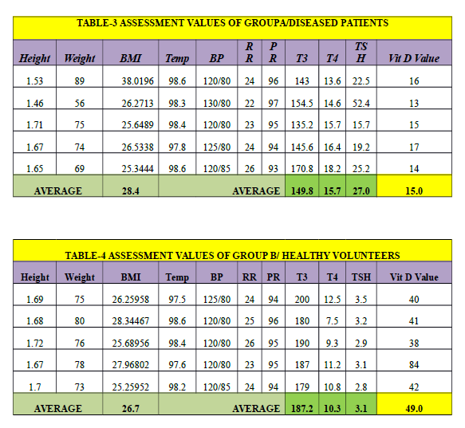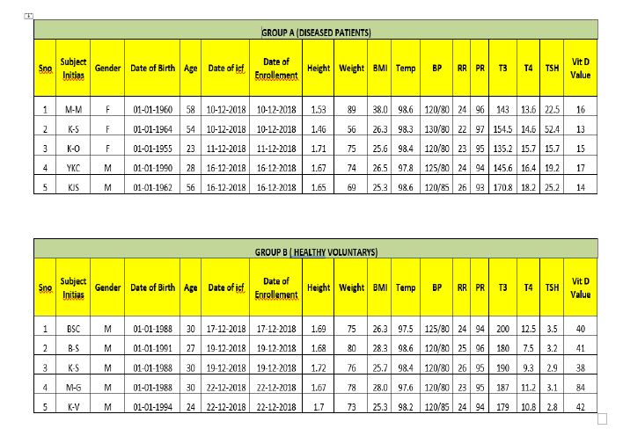

**Graphical Representation of Normal Ranges of Thyroid Profile**

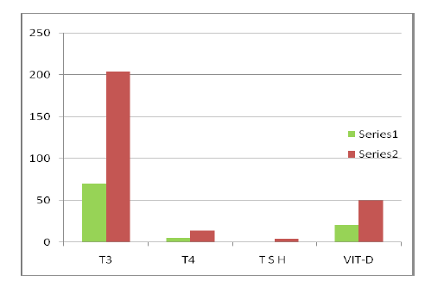

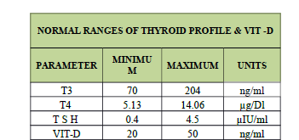

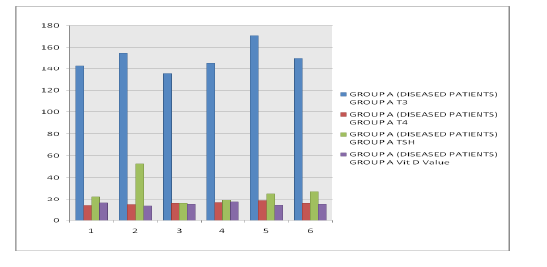**Graphical Representation of Average Values of Thyroid and Vit D Levels in Diseased Patients**

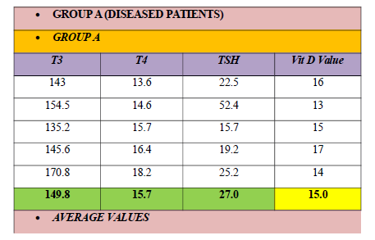

**REFERENCES:**

Hollick MF, Chen TC. Vitamin D deficiency a worldwide problem with health

consequences. Am J Clin Nutr. 2008;87:10805–68.

2. Naeem Z. Vitamin D Deficiency- An Ignored Epidemic. Int J Health Sci

(Qassim) 2010;4(1):5–6.

3. Deluca HF. Evolution of our understanding of vitamin D. Nutr Rev. 2008;66(10):73–87.

4. Baeke F, Takiishi T, Korf H, Gysemans C, Mathieu C. Vitamin D: modulator of the

immune system. Curr. Opin Pharmacol. 2010;10(4):482–96.

5. Tamer G, Arik S, Tamer I, Coksert D. Relative vitamin D insufficiency in Hashimoto’s

thyroiditis. Thyroid. 2011;21(8):891–96.

6. Cranney A, Horsley T, O’Donnell S. Effectiveness and Safety of Vitamin D in Relation to

Bone Health. Evidence Reports/Technology Assessments. 2008;158:543–50.

7.Dawson-Hughes B, Heaney RP, Holick MF, et al. Estimates of optimal vitamin D

status. Osteoporos Int. 2005;16(7):713–16.

8. Friedman Theodore C. Vitamin D Deficiency and Thyroid

Disease.www.goodhormonehealth.com/VitaminD.

9 Nicholas M, Robert H, Raynolds J. Spectroscopic Method for Quantitative Estimation of

vitamin D. Ind Eng, Chem, Anal. ed. 1941;13940:227–31.

10.Sadat-Ali M, AlElq A, Al-Turki H, Al-Mulhim F, Al-Ali A. Vitamin D levels in healthy

men in eastern Saudi Arabia. Ann Saudi Med. 2009;29(5):378–82.

11. Weybrew JA, Matrone G, Baxley HM. Spectrophotometric Determination of Serum

Calcium. Anal Chem. 1948;20(8):759–62.

12. Vilarrasa N, Vendrell J, Maravall J, Elıo I, Solano E, San Jose E. Is plasma 25(OH) D

related to adipokines, inflammatory cytokines and insulin resistance in both a healthy and

morbidly obese population? Endocrine. 2010;38(2):235–42.

13. Institute of Medicine, Food and Nutrition Board. Dietary Reference Intakes for Calcium

and Vitamin D.Washington, DC: National Academy Press; 2010.

14. Jones G. Pharmacokinetics of vitamin D toxicity. Am J Clin Nutr. 2008;88:582–6.

15. Elizabeth A, Brulé Danielle, Cindy D, Krista A, Peter WF, Friedl Karl E, et al. Dietary

Reference Intakes for vitamin D: justification for a review of the 1997 values. Am J Clin

Nutr. 2009;89(3):719–727.

16. Wolpowitz D, Gilchrest BA. The vitamin D questions: How much do you need and how

should you get it? J Am AcadDermatol. 2006;54(2):301–17.

17. Elsammak MY, Al-Wossaibi AA, Al-Howeish A, Alsaeed J. High prevalence of vitamin D

deficiency in the sunny Eastern region of Saudi Arabia: a hospital-based study. East Mediterr

Health J. 2011;17(4):317–22.

18. Lippi G, Montagnana M, Meschi T, Borghi L. Vitamin D concentration and deficiency

across different ages and genders. Aging Clin Exp Res. 2012 Feb 6;

19. Hashemipour S, Larijani B, Adibi H, Ebrahim J, Mojtaba S, Mohammad P. Vitamin D

deficiency and causative factors in the population of Tehran. BMC. 2004;4:38.

20. Sedrani SH. Low 25-hydroxyvitamin D and normal serum calcium concentrations in

Saudi Arabia: Riyadh region. Ann Nutr Metab. 1984;28(3):181–85.

21. Al-Jurayyan NA, El-Desouki ME, Al-Herbish AS, Al-Mazyad AS, Al-Qhtani MM.

Nutritional rickets and osteomalacia in school children and adolescent. Saudi Med

J. 2002;23:182–85.

22. Fida NM. Assessment of nutritional rickets in Western Saudi Arabia. Saudi Med

J. 2003;24:337–40.

23. Naeem Z, AlMohaimeed AbdulRahman, Khalil FS, Ismail, Faiza Sh, Inam SN. Vitamin D

status among population of Qassim Region, Saudi Arabia. International Journal of Health

Sciences, Qassim University. 2011;(5):2.

24. Kobayashi T, Okano T, Shida S, Okada K, Suginohara T, Nakao H, Kuroda E, et al.

Variation of 25-hydroxyvitamin D3 and 25-hydroxyvitamin D2 levels in human plasma

obtained from 758 Japanese healthy subjects. J Nutr Sci Vitaminol (Tokyo) 1983;29:271–81.