**Application of Telemedicine in the Diagnosis of**

**Oncogynaecological Diseases**  
**Authors**: Hristina Gencheva, Gabriel Dichev,Melani Pirgova, Teodora Yordanova  
**Institution**: Shumen Affiliate to the Medical University "Prof. Dr. P. Stoyanov" - Varna

**Abstract:**  
Oncogynaecological diseases, including cervical, endometrial, ovarian cancers, and others, require a comprehensive and multi-layered approach to diagnosis and treatment. Early detection of these diseases is crucial for successful treatment and increasing survival chances. While traditional medical exams remain the foundation for diagnosis, telemedicine offers new ways of delivering these services, especially in situations where access to healthcare specialists is limited.

The aim of this paper is to explore the applications of telemedicine in the diagnosis of oncogynaecological diseases, focusing on the advantages, challenges, and potential of this innovative technology. By analyzing current practices and research in this field, we will attempt to outline the future of telemedicine in oncogynaecology and its impact on women's health.

***Keywords: telemedicine, midwife, oncogynaecological diseases, diagnosis***

**Introduction:**  
Telemedicine, as a rapidly evolving field in healthcare, offers new opportunities for access to medical services that, until a few years ago, seemed out of reach. Remote communication technologies and the digitization of medical data are significantly changing the way patients and healthcare professionals interact. In the context of oncogynaecological diseases—some of the most common and serious health issues among women—telemedicine offers unique solutions for improving early diagnosis, screening, and monitoring.

Oncogynaecological diseases, including cervical, endometrial, ovarian cancers, and others, require a comprehensive and multi-layered approach to diagnosis and treatment. Early detection of these diseases is crucial for successful treatment and increasing survival chances. While traditional medical exams remain the foundation for diagnosis, telemedicine provides new ways to deliver these services, especially in situations where access to healthcare specialists is limited.

Telemedicine can offer patients the opportunity for remote consultations with highly qualified oncogynaecologists, early symptom screening through digital platforms and applications, as well as follow-up on already diagnosed cases. These technologies can be especially useful for women living in remote or underserved areas, where access to specialized medical care is limited.

The aim of this paper is to explore the applications of telemedicine in the diagnosis of oncogynaecological diseases, focusing on the advantages, challenges, and potential of this innovative technology. By analyzing current practices and research in this field, we will attempt to outline the future of telemedicine in oncogynaecology and its impact on women’s health.

**Objective:**  
The aim is to study the application of telemedicine in the diagnosis of oncogynaecological diseases.

**Materials and Methods:**  
The objective of the scientific study requires the use of a complex set of sociological and statistical methods:

**Sociological** **Methods:**  
An anonymous survey was conducted from February to August 2024 among 50 patients with oncogynaecological diseases, 13 practicing midwives, and 10 gynecologists at the Comprehensive Oncology Center and MBAL - Shumen AD. The survey for patients contains questions aimed at assessing their experience with telemedicine services for gynecological exams, their satisfaction, and their perception of the effectiveness of these services. The survey for healthcare professionals contains questions focused on evaluating the experience of doctors and midwives with telemedicine, the advantages, and challenges of using these technologies in the diagnosis of oncogynaecological diseases.

**Statistical Methods:**

Comparative analyses for the consistency between the theoretical distribution of the studied groups.

Graphical representation of the results to illustrate the studied variables and their interrelationships.

The data was statistically processed using the SPSS for Windows statistical software, version 19.0.0.

**Results and Discussion:**  
The study reveals remarkable trends in the behavior of different age groups concerning medical exams, which could have significant implications for public health. Figure 1 shows the age categories and their characteristics.

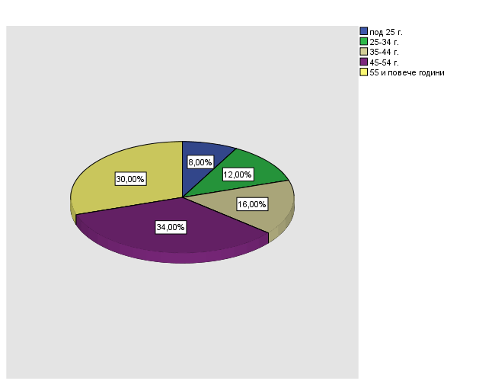

***Figure 1. Age Distribution of Respondents***

The largest age group consists of individuals aged 55 and older (34%), suggesting that a significant portion of the sample is from older respondents. The next largest group is individuals aged 45-54 years (30%). Together with the 55 and older group, these two age categories make up 64% of the respondents, highlighting significant participation from older age groups in the study.  
The age groups 35-44 years and 25-34 years represent 16% and 12% of the respondents, respectively, covering a younger, but still active, portion of the surveyed individuals. The smallest group is those under 25 years old, making up only 8%, indicating that younger people are the least represented in this study.

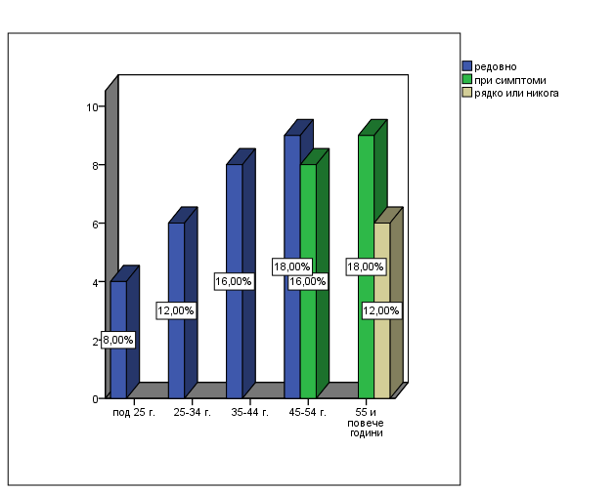

***Figure 2. Comparative Analysis of Age Distribution and Number of Exams among the Respondents***

People in urban areas undergo gynecological exams regularly (54%), which is a significantly higher percentage compared to rural areas, where there are no participants who do this regularly. This may be related to better access to resources, information, or services in urban areas. People in cities often have easier access to healthcare services, preventive measures, or information, which could explain why more of them take regular action.

The average number of exams is 1.58, indicating a low frequency of exams among the respondents. The median and mode are also 1, meaning that most people have only one exam. A correlation between age and the number of exams is possible. For example, it may turn out that older individuals have more exams.

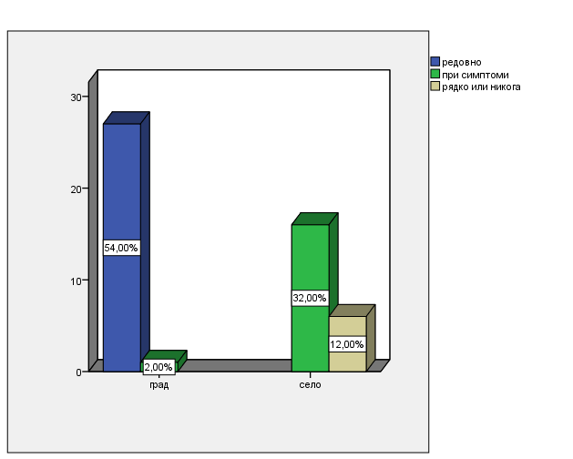

***Figure 3. Comparative Analysis of Residence and Number of Exams***

People in urban areas undergo gynecological exams regularly (54%), which is a significantly higher percentage compared to rural areas, where no participants undergo exams regularly. This may be related to better access to resources, information, or services in urban areas. People in cities often have easier access to healthcare services, preventive measures, or information, which could explain why more of them take regular action.

In rural areas, no one undergoes exams regularly, which may indicate more limited access to resources or differences in cultural habits. At the same time, 32% of respondents in rural areas only undergo exams when they have symptoms, suggesting that people in rural areas tend to act reactively, when there is a specific need. This may be linked to reduced access to regular services or preventive measures.

In urban areas, there are no participants in the category of "rarely or never," while in rural areas, 12% of the respondents claim that they rarely or never undergo exams. This fact may indicate that in rural areas, there is a group of people who do not consider it necessary or do not have the habits of taking preventive or health measures. Again, the reasons could be socio-economic (e.g., financial constraints), cultural differences, or lack of awareness.

The main reasons why patients choose to use telemedicine services in gynecology are shown in Figure 4.

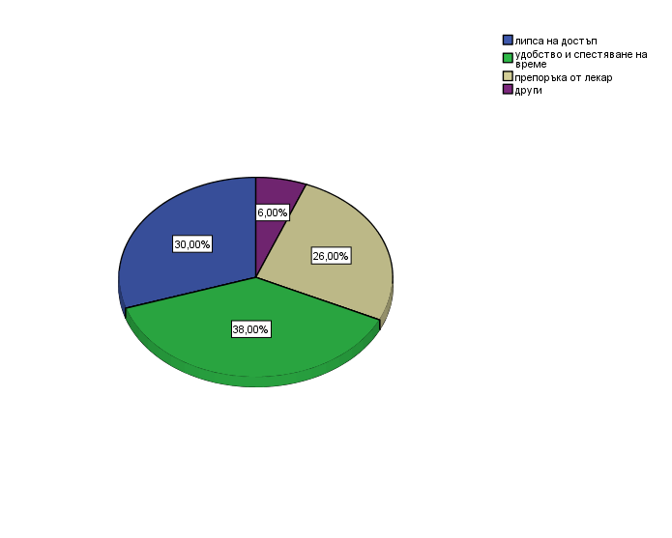

***Figure 4. Reasons for Using Telemedicine for Gynecological Services***

The largest percentage of respondents (38%) indicate that the main reason for using telemedicine is convenience and time-saving. This is understandable, as telemedicine allows patients to consult with an oncogynaecologist from the comfort of their home without having to travel to a healthcare facility. This factor is particularly important for patients who may have mobility difficulties or live far from specialized centers.

The second-largest factor is lack of access (30%). This may be caused by a variety of circumstances, such as geographical limitations, lack of specialized oncogynaecologists near the patient, or even financial constraints that hinder regular visits to medical institutions. Telemedicine provides a solution by enabling patients to connect with specialists even from remote areas.

A recommendation from a doctor is the third most common factor influencing the choice of telemedicine (26%). This means that patients follow the advice of their doctors, who recommend them to use telemedicine platforms. Doctors may refer patients to telemedicine due to difficulties in scheduling physical exams or for faster access to specialists, especially in cases where a physical examination is not required.

A small percentage of respondents (6%) cite other reasons for using telemedicine. These reasons may include personal preferences, the desire for a second opinion, or situations related to pandemics (such as COVID-19) that require limiting physical visits to healthcare facilities.

The most common challenges that patients face when using telemedicine services are presented in Figure 5.

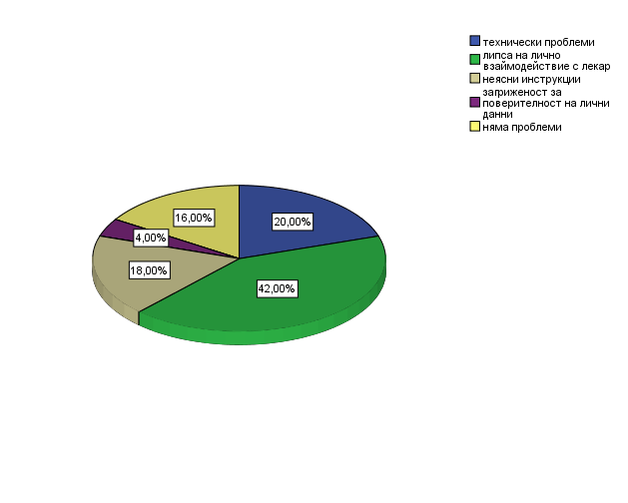

***Figure 5. Most Common Challenges in Using Telemedicine***

The largest percentage of respondents (42%) indicate that the lack of personal interaction with the doctor is the main challenge when using telemedicine. This shows that for many patients, the physical meeting with the doctor is important not only for diagnosis but also for a better understanding of their condition and a sense of support. Patients may feel more confident and at ease when they can discuss their concerns directly with a specialist. The absence of this personal contact can create a feeling of distance or mistrust toward the treatment process.

The second-largest percentage (20%) is related to technical problems in using telemedicine. These issues may include an unstable internet connection, difficulties using telemedicine platforms, lack of knowledge about technology, or insufficient technical support.

Patients, especially older ones, may have difficulties with these platforms, leading to frustration and a refusal to use telemedicine services. Unclear instructions are a problem for 18% of the respondents. This could be due to the lack of clear explanations on how patients can connect to telemedicine platforms, how to use the features of the platforms, or how to follow the recommendations after a consultation. Unclear instructions can create confusion and hinder communication between the doctor and the patient, which may reduce the effectiveness of the treatment.

A relatively small percentage of respondents (16%) share that they do not have problems using telemedicine. This percentage represents a group of patients who feel comfortable with the technology and the process of online consultation, highlighting that telemedicine can be convenient and effective for those who are accustomed to it and do not have technical or communication difficulties.

Telemedicine plays an increasingly important role in oncogynaecological care, providing patients with the opportunity to access medical services remotely (Figure 6).

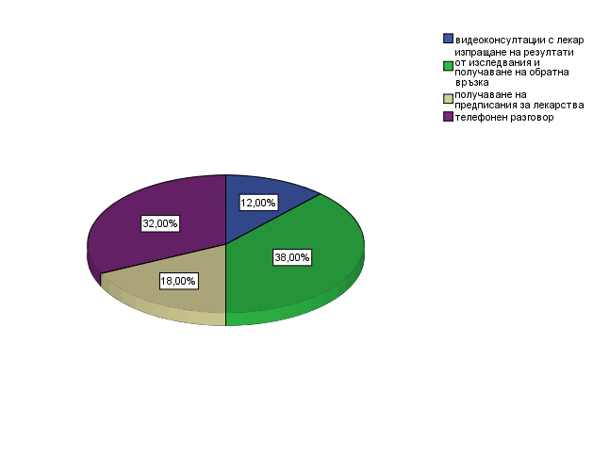

***Figure 6. Telemedicine Services Used Among Respondents***

The largest share of respondents (38%) use telemedicine primarily to receive test results and feedback from the doctor. This is an important aspect of oncogynaecological care, as patients often need to be informed about the results of tests, biopsies, blood work, and other diagnostic procedures. Telemedicine facilitates this process by allowing patients to quickly and conveniently receive information about their condition without the need for a physical visit to the healthcare facility. This service saves time and reduces the need for travel, especially for patients who live far away or have mobility issues.

Phone calls account for 32% of the telemedicine services used. This form of communication remains popular because it is easy to use and accessible to a wide range of patients, including older individuals who may have difficulties with videoconferencing or other more complex technologies. A phone call allows for quick communication with the doctor, where the patient can ask questions or discuss symptoms, which is important for ongoing monitoring and care. Receiving prescriptions is another frequently used telemedicine service (18%).

Patients can consult with a doctor online or by phone and receive the necessary prescriptions without the need to visit the medical office. This is especially important in cases of chronic diseases or long-term treatments, where visits can be minimized, and patients can receive their prescriptions digitally, which is convenient and saves time. Video consultations with a doctor are used by 12% of patients, which is a relatively small share. While video consultations offer closer contact and visual communication with the doctor, they may be more complicated to use and require a more stable internet connection and technical knowledge. This explains the lower percentage compared to phone calls or other more easily accessible services. However, video consultations are very useful in cases where a visual assessment of the patient is necessary or when more complex issues need to be discussed.

The evaluation of the quality of telemedicine services reveals the level of satisfaction among patients and provides valuable information about the effectiveness of this type of healthcare (Figure 7).

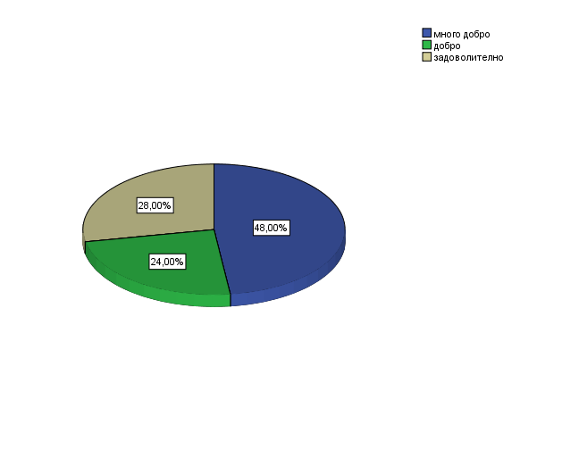

***Figure 7. Evaluation of the Quality of Telemedicine Services***

Almost half of the respondents (48%) rate the quality of telemedicine services as very good. This highly positive opinion suggests that a significant portion of patients find telemedicine to be an effective and convenient way to receive medical care. This result may be due to the easy access to specialists, the quick receipt of medical information, and the convenience of the service, which eliminates the need for physical visits to healthcare facilities. The high rating indicates that for many patients, telemedicine successfully meets their needs and expectations, especially in the context of specialized care such as oncogynecology.

A significant portion of patients (28%) rate the quality of the service as satisfactory. This suggests that these patients are satisfied with the core aspects of telemedicine, but there may be certain areas where they see room for improvement. Possible factors that could limit maximum satisfaction include technical problems, the lack of personal interaction with the doctor, or difficulties in using the platforms. Nevertheless, this group of patients does not feel entirely disappointed, which suggests that with small improvements, their experience could be enhanced.

The "good" rating was given by 24% of respondents. This indicates that these patients received quality services that met their expectations, but without being particularly exceptional. These patients likely view telemedicine as useful but may have encountered minor difficulties or discrepancies in communication or technical execution. This rating suggests that the service is functioning but has not yet reached its full potential for maximum satisfaction.

**Conclusions:**

1.In urban areas, a significantly higher percentage of people undergo regular gynecological check-ups (54%), which may be attributed to better access to healthcare services and information. In rural areas, there is no practice of regular check-ups, with the majority of people (32%) only seeking check-ups when symptoms are present, indicating a reactive approach to health.

2.The main reasons for using telemedicine are convenience and time-saving (38%), as well as lack of access to specialists (30%). Recommendations from doctors also play an important role (26%), while a small percentage mention other factors such as personal preferences or pandemics.

3.The main challenges in using telemedicine are the lack of personal interaction with the doctor (42%), technical issues (20%), and unclear instructions (18%). For patients, the physical presence of the doctor is important for better support and understanding of their condition.

4. Telemedicine is well-received by patients, with nearly half (48%) rating it as very good. This suggests that it effectively meets their needs through convenience and quick access to specialists. However, 28% consider the service to be satisfactory, and 24% rate it as good, indicating room for improvement, particularly in terms of technical issues, personal interaction, and communication.

**References:**

1. Smith, A. B., & Jones, C. D. (2021). The Role of Telemedicine in Oncology Care. Journal of Telemedicine and Telecare, 27(6), 345-351.

2. Brown, L. M., & White, K. E. (2020). Telemedicine for Gynecological Cancer Patients: Opportunities and Challenges. International Journal of Gynecological Cancer, 30(4), 583-589.

3. Johnson, P. Q., & Green, M. H. (2019). Early Detection of Gynecological Cancers: The Impact of Telemedicine. Oncology Reviews, 14(2), 210-216.

4. Williams, S. R., & Patel, R. K. (2022). Advances in Telemedicine for Women's Health. Obstetrics and Gynecology Clinics, 49(1), 45-59.

5. Lee, D. A., & Kim, Y. J. (2021). Digital Health Solutions in Gynecologic Oncology. Gynecologic Oncology Reports, 38, 100821.

6. Thomas, E. H., & Wilson, A. R. (2020). Bridging the Gap: Telemedicine in Rural Gynecologic Oncology. Journal of Rural Health, 36(3), 433-439.

7. Nguyen, P. T., & Clark, S. J. (2023). Future Perspectives on Telemedicine in Oncology. Cancer Management and Research, 15, 763-772.