**REVIEW ON DIFFERENT PREPARATION METHODS USED FOR DVELOPMENT OF CURCUMIN NANOPARTICLES**

ABOUT AUTHOR

A.C. POTRAJE

B.Y. ZADE

GUIDED BY

ASST.PROF G . N. GUJATWAR

DR.N. O . CHACHDA [ Principal]

INSTITUTE OF PHARMACY ,

MAREGAON 445303

**ABSTRACT** :

A design and development of herbal (i.e. Curcumin) nanoparticles it has become a extremes research in the Nano formulation field. Curcumin, an orange crystalline powder which derived from the herbs of curcuma longa linn (Zingiberaceae), it is natural hydrophobic polyphenol compound mainly applied in Chinese medicine and some of the food industries, which supply different biological and pharmacological activity including antioxidant, anti-inflammatory, anti-microbial, anti-neoplastic, anti-diabetic and chemo preventive properties. Curcumin (diferuloylmethane) is one of the potent, nontoxic, and major bioactive components pre sent in turmeric. The major drawbacks of curcumin are low absorption and poor bioavailability. The present review highlights on the methods for the fabrication of curcumin nanoparticles and their applications in treatment of cancer and wound infections. Curcumin nano particles possess remarkable antibacterial, antiviral, and antiprotozoan activity. hence, curcumin nanoparticle loaded nano-gel, microemulsion, and nano-cream can be used for drug delivery. Curcumin shows therapeutic efficacy against many human illness and diseases but clinical application of this compound is limited due to its poor bioavailability, poor water solubility, fast metabolism, susceptibility to degradation in the alkaline medium. One of the most important technique/ method to improve the poor biopharmaceutical properties of the curcumin is to enhance aqueous solubility, bioavailability by using nanotechnology and nanoparticles, having a small size in nanometer range. In this review, there are various methods used for preparation of curcumin nanoparticles are briefly discussed

**KEYWORDS** :

Curcumin, Curcumin nanoparticles, methods of preparation of curcumin, Zingiberaceae, turmeric,antimicrobial activity.

1. **INTRODUCTION:**

The active ingredient in turmeric, a common Indian spice that is a member of the ginger family (Zingiberaceae), is curcumin, also known by its chemical name (E, E)-1,7-bis (4-hydroxy-3-methoxy phenyl)-1,6 heptadiene-3,5-dione. Its molecular formula is C21H20O6, its melting point is between 179 and 183 C, and its molecular weight (MW) is 368.38 (1). A polyphenol chemical called curcumin is derived from the rhizome of the plant Curcuma long Linn (Zingiberaceae). In Indian cooking, it is also referred to as turmeric. Three to five percent of turmeric preparations contain curcumin longa, which also contains the three primary curcumminiods: curcumin, desmethoxycurcumin, and bismethoxycurcumin. 75–80% curcumin, 15-20% desmethoxycurcumin, and 3-5% bis-desmethoxycurcumin are practically present in the curcumin that is currently available. This has been used for thousands of years in Chinese medicine and Indian traditional medicine (Ayurveda) to treat a variety of illnesses, including rheumatism, skin conditions, bodily aches, hepatic disorders, inflammation, and asthma. It is currently employed as a flavoring, preservative, and coloring agent in the food sector. This is widely grown in Southwest India and Africa. Because of its flavor, it is frequently used as a spice in South and Asian nations (2). Curcumin was isolated for the first time in 1815, while its chemical structure was determined in 1973 by Rough ley and Whiting. The melting point of curcumin is 176–177°C, and it forms red to brown-colored salts when treated with alkalis (3). Curcumin is a natural product that possesses several pharmacological properties. Especially, it has been demonstrated to be a superior anticancer agent against several types. These activities have been demonstrated after parenteral or oral administrations in animal models or using in-vitro assays. In animals, curcumin reduced carcinogen induced tumorigenesis and inhibited the growth of implanted human tumors. Curcumin is a polyphenolic compound that is found in turmeric Curcuma longa pharmacological has many varieties of activities, including anti inflammatory, anticancer, antibacterial, antioxidant. Curcumin acts as a promising agent for Alzheimer’s disease. Nanotechnology is a field of modern applied science that aims to develop materials and devices with unique and inherent, in their size of1−100nm, at least in one dimension. Nanoparticles are defined as particulate or solid dispersion with the size lying 10-100nm range. By designing nanoparticles, control release of active agents, surface properties, and particle size can be manipulated. An antiviral drug, tenofovir disoproxil fumarateen capsulated with chitosan nanoparticles, can potentially be used as a drug delivery system with hepatic targeting and controlled release properties. Nanoparticles-loaded anti-retroviral drugs may be a new promising drug delivery system for managing HIV-1 infected patients (4). Nanoparticles also increase their solubility, permeability and also increase the permeability of the curcumin towards the metabolic processes. It also produces longer circulation times, protects the molecule from incomplete degradation and develops controlled Drug release and drug targeting (5). The promising approaches to increasing bioavailability of curcumin include the use of nanoparticles, liposomes, micelles and phospholipid complexes. The application of nanoparticle formulation to enhances of solubility, stability, bioavailability, pharmacological activity, and ability to avoid physical and chemical degradation. In the introduction of nanotechnology in curcumin provides a solution to increase its bioavailabilty and therapeutic efficacy (6),(7).

1. **APPARATUS AND MATERIALS:**

Analytical grade dichloromethane was utilized in the preparation of the nanoparticles. The Roop Telesonic TPC-25 ultrasonic cleaner was the ultrasound instrument utilized in the preparatory process. Using Buchi rotavapor (R-210) the solvent was eliminated. Alumina sheets coated with silica gel (Merck, Germany) were subjected to thin-layer chromatography (TLC) examination, with 1% methanol in chloroform serving as the developing solvent. For the microbiological investigations, all of the chemicals and Petri plates were obtained from HiMedia, Ltd., Mumbai, India (8).

1. **STUCTURE:**

The structure of curcumin:

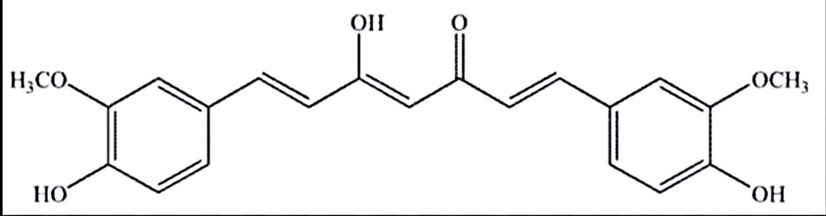

Enol form

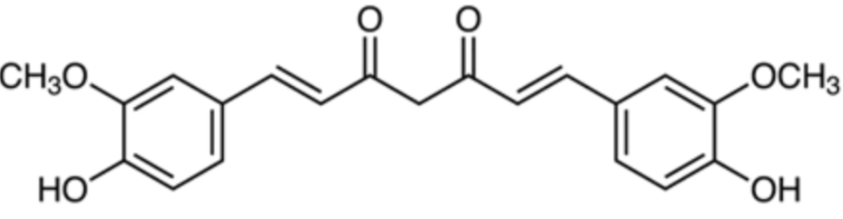

Keto form

1. **METHOD OF PREPARATION**:
2. Single Emulsion-Solvent Evaporation Technique.
3. Thin Film Hydration Method.
4. Micro Emulsion-sonication Method.
5. Desolvation Method.
6. Agitation and Sonication Method.
7. Cross Linking Method.
8. Freeze Dried Anti Solvent Crystallisation And High Pressure Homogenizer Method.
9. Co-Precipitation Method.
10. Coacervation techniques.
11. Nanoprecipitation method.
12. Spray drying method.
13. Single emulsion method.
14. Solvent evaporation method.
15. Microemulsion.
16. Wet milling method.
17. Thin film hydration method.
18. Solid dispersion method.
19. Emulsion polymerization method.
20. Fessi method.
21. Ionic gelation method.
22. Ultrasonication
23. **Emulsion-Solvent Evaporation Single Technique:**

The single emulsion solvent evaporation method is a conventional method used to create curcumin-loaded nanoparticles.

**Procedure**:

1. First in glass tube, 100–200 mg of PLGA polymer were dissolved in 5 ml of dichloromethane (DCM), followed by 10 or 20 mg of curcumin powder dissolved in solvent mixture and intermittent vortexing for 30 minutes.
2. Next, the drug/polymer mixture was added to a glass tube that contained 10 ml of aqueous PVA solution, and then vortexing for an additional 10 seconds at high speed.
3. The polymer mixture was then emulsified in an ice water bath for 7 minutes at 40% amplitude using a probe sonicator, and finally, the emulsified mixture was transferred into 30 ml of 0.5% aqueous solution while being stirred magnetically.
4. Three hours of intense magnetic stirring at 800 rpm were used to evaporate dichloromethane.
5. Centrifugation at 20,000 rpm for 15 minutes was used to gather the nanoparticles, which were then rinsed three times with distilled water. After collecting the supernatants, the nanoparticle pellets were resuspended in five milliliters of distilled (5).

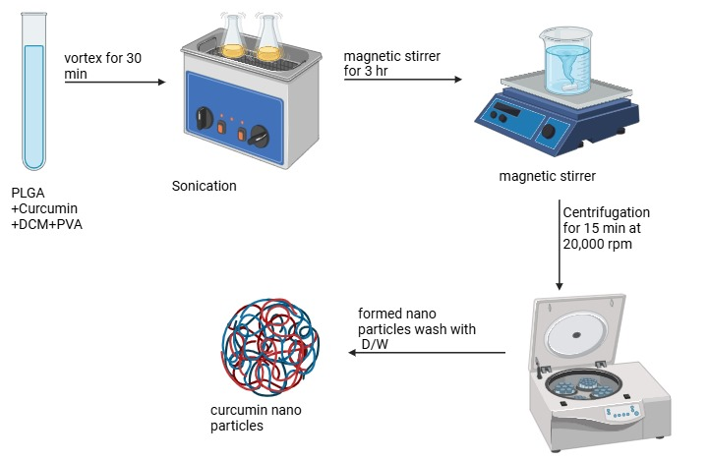



Figure 1: Schematic diagram for preparation of curcumin nanoparticle by Single Emulsion Solvent Evaporation Technique

1. **Thin Film Hydration Method**

The drug loaded lipid nanoparticles was prepared by using a thin film hydration method.

**Procedure**:

1. The desired ratio of methanol and chloroform is combined with lipidphosphatidylcholine, cholesterol, and curcumin.
2. The solvent mixture is then evaporated under reduced pressure for 15 minutes at 45°C and 70 rpm using rotatory evaporator equipment.
3. After three to four hours of vacuum pumping to extract the components from the solvent mixture, a thin film forms.
4. Lastly, a pH 7.4 phosphate buffer solution is used to hydrate the thin layer of drug-loaded lipid nanoparticles for one hour.
5. Finally, well-appropriated drug-loaded lipid nanoparticles are generated and stored at 4°C after this lipid mixture is sonicated for probe sonication and filtered via a 0.45 μm membrane filter (9).

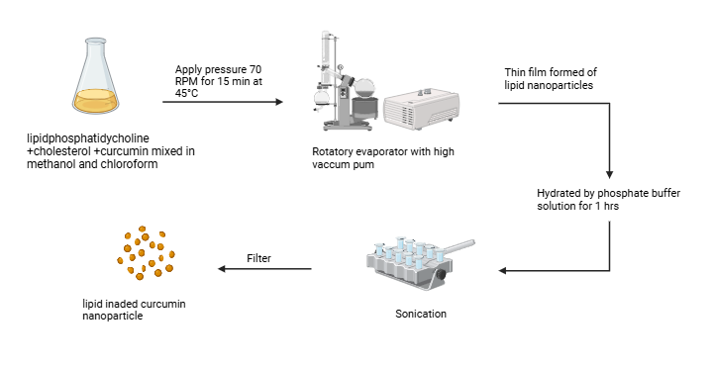

Figure 2: Schematic diagram of lipid loaded Curcumin nanoparticles by thin film hydration method

1. **Micro Emulsion-Sonication Method:**

Using the microemulsion process, curcumin nanostructure lipid carriers (NLC) are made. This technique makes use of a sonicator.

**Procedure**:

1. Steric acid (SA) and capric triglycerides (CA) lipids are heated to 75 °C.
2. Tween 80 and plutonic F127 surfactants are then added to the melted lipid solution until it becomes transparent.
3. Under constant stirring, a melted lipid solution containing curcumin is heated to 75 °C with an additional milliliter of distilled water and non-ionic surfactants.
4. After the produced emulsion is mixed with cold water at 2 to 4°C, it solidifies and is homogenized for five minutes at 8000 rpm.
5. Ultimately, lipid carriers with a welldispersed curcumin nanostructure are  created (10).

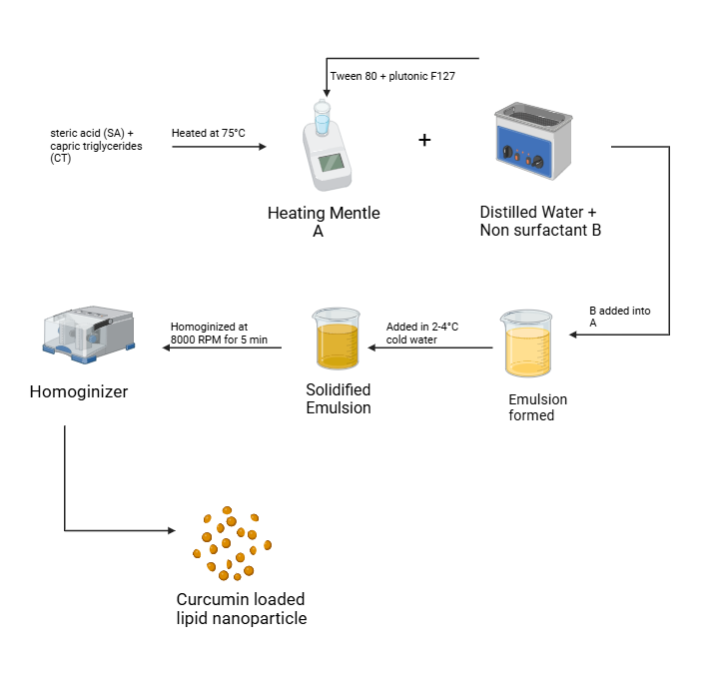

Figure 3: Schematic diagram of lipid loaded Curcumin nanoparticles by Micro emulsion method

1. **Desolvation Method:**

To prepare the curcumin nanoparticles, the desolvation process is employed. Curcumin polysaccharide nanoparticles are prepared using this method by precipitating an ethanol-based aqueous polysaccharide solution. In essence, absolute ethanol serves as a desolving agent, curcumin is the active ingredient, and the concentration of absolute ethanol is arranged, with 0.1% tween 20 emulsifying agent added.

**Procedure**:

1. Using deionized water and constant stirring, dissolve 5 mg/ml of chitosan and 0.1% tween 20 for one hour at 90°C.
2. The chitosan solution is then mixed at 70°C while the desolving agent, 100% ethanol, is added drop by drop.
3. The suspension of nanoparticles is centrifuged for two minutes at 10,000 rpm. Following centrifugation to separate the larger particles, the supernatant is collected and centrifuged once more for 15 minutes at 15,000 rpm.
4. The precipitate of the resultant nanoparticles is then cleaned with 1 milliliter of 100% ethanol desolving solution to eliminate any remaining curcumin.
5. To create evenly distributed curcumin nanoparticles, the generated nanoparticles are certainly resuspended in deionized water and freeze-dried to form a well distributed polysaccharide curcumin nanoparticles(11).
6. **Agitation and Sonication Method:**

The curcumin nanoparticles are obtained by two methods one as Agitation and second as sonication.

**Procedure**:

**In agitation Method:**

0.05g mL−1 of curcumin are added in ethanol then 100 ml of this solution are added in predefined volume of deionised water. Then this solution is agitated for 2 hrs at 200-1000 rpm for 50°C. After agitation this solution is lyophilised to obtain a yellow colour TY] powder of curcumin nanoparticles. The nanoparticles are obtained from ethanol and agitation process is known as NEA.

**In Sonicaton Process:**

0.10 gmL−1of curcumin are added in ethanol then 100 ml of this solution are added in predefined volume of deionised water. Then this solution was sonicated (120W) for 2 hrs at 50°C. After sonication this are lyophilised to obtain well distributed yellow colour curcumin nanoparticles and second part are maintained as solution. The nanoparticles are obtained from chloroform and sonication is known as NES (2).

1. **Cross Linking Method:**

The cross-linking technique is used to create the curcumin-loaded human serum albumin (HSA) nanoparticles.

**Procedure**:

1. To create curcumin-loaded HSA nanoparticles, first make the human serum albumin nanoparticles. Next, load the curcumin into the human serum albumin nanoparticles.
2. In this method, 1% solution human serum albumin added in 2 ml of phosphate buffer saline and to prepare different concentration of dithiothretol (DTT 1-10 mM) and Sodium deoxycholate (NaDS 5-30 mM).
3. Then this solution was incubated for 1 hrs at 30 °C. After, incubation of this solution 1 ml of ethanol was added drop by drop to the solution and constant stirring.
4. After the addition of ethanol the solution are again incubated for 10 min at 37 °C, then solution are stored at room temperature for 2 hrs.
5. Thereafter, dialysis is performing for 24 hrs under the constant stirring and to remove the unbound or unreacted DTT and NaDS using PBS dialysing agent.
6. After dialysis, take 0.2-2 mg of curcumin mix in 1 ml of ethanol and they are added in alternately to HSA nanoparticle solution. This solution is equilibrated for 15 min and then performs the dialysis process for 12 hrs to remove the unbounded or unreacted curcumin. Finally curcumin loaded human serum albumin (HSA) nanoparticles are form (12).

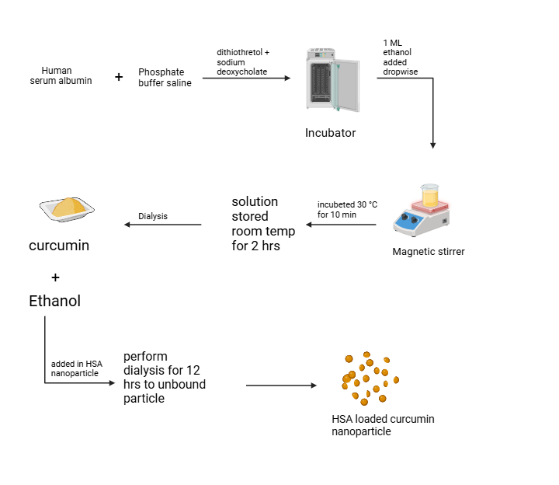

Figure 6: Schematic diagram of HSA loaded Curcumin nanoparticles by cross-linking method

1. **Freeze dried anti solvent crystallization method (CRS-FD), Freeze dried Anti solvent crystallisation method followed by high pressure homogenizer :**

Curcumin nanoparticles loaded with stabilizer are made using the anti-solvent crystallization technique.

**Procedure**:

1. Using this approach, 20 milliliters of acetone were mixed with 1 gram of curcumin and allowed to dissolve.
2. Then, using a burette, this solution is added to 200 ml of aqueous solution with varying weight concentrations of stabilizers, such as PVP and HPMC, at a rate of 5 ml per minute.
3. The final concentration of curcumin and stabilizer suspension was then created in a different ratio after this solution was agitated for 600 rpm at 25 °C.
4. The resulting suspension is then immediately freeze-dried for 48 hours at -70°C. The freeze-dried antisolvent crystallization procedure is then used to create stabilizer-loaded curcumin nanoparticles.
5. Curcumin and stabilizer suspensions at varying ratios are homogenized in a high pressure homogenizer.
6. The first step involves adjusting the pressure to 500 bars and passing the suspension through a homogenizer five times. The last step involves adjusting the pressure to 1000 bars and passing the suspension through a homogenizer ten times.
7. The finished suspension is then immediately freeze-dried for 48 hours at -70°C. Curcumin nanoparticles loaded with stabilizer are created using a high pressure homogenizer and a freeze-dried anti-solvent crystallization process (13).

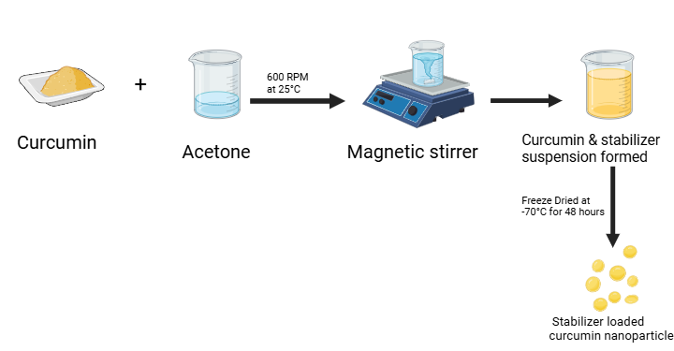Figure 7: Schematic diagram of Stabilizer loaded Curcumin nanoparticles by anti solvent crystallisation method.

1. **Co-Precipitation Method:**

Amorphous Calcium Phosphate (ACP) loaded curcumin nanoparticles are formed by co-precipitation method.

**Procedure**:

1. To create a 1 mM aqueous solution, calcium nitrate is first dissolved in 29 milliliters of deionized water.
2. A white suspension was then created by gradually adding ammonium hydrogen phosphate to this mixture.
3. The raw materials are placed in a calcium and phosphate ratio of 1.5, and a 1 M sodium hydroxide solution is added at 30°C to maintain a pH of 8. The resulting nanoparticles are then cleaned with deionized water to get rid of any remaining ions, and the samples are centrifuged and freeze-dried.
4. Following the formation of ACP nanoparticles, 5 mg/ml of curcumin is added to a calcium nitrate solution. The mixture is then stirred for one hour while sodium hydrogen phosphate is gradually added, and it is stirred once more for fifteen minutes at 30°C. The suspension is then centrifuged to create ACP-loaded curcumin nanoparticles (6).

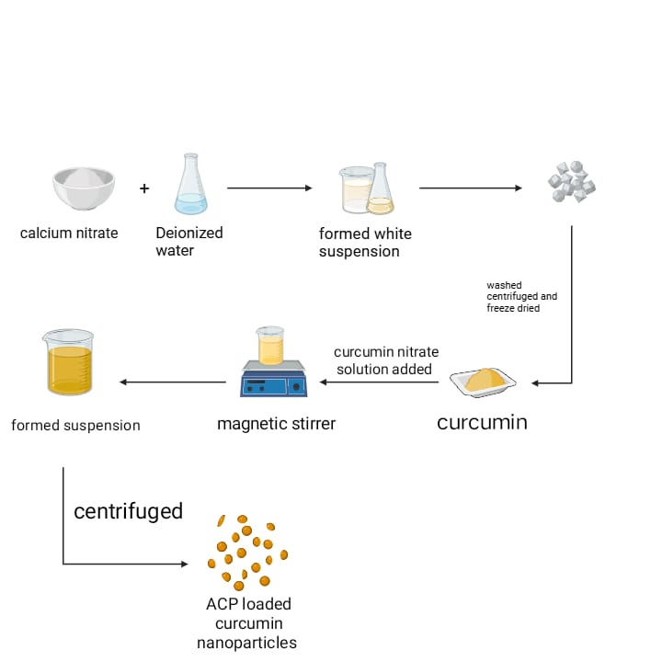

Figure 8: Schematic diagram of ACP loaded Curcumin nanoparticles by co-precipitation method

1. **Coacervation Techniques:**

The Coacervation techniques are used to synthesis of curcumin nanoparticles. The coacervation technique's primary disadvantage is that it uses a lot of solvent, but it is also inexpensive and does not employ dangerous solvents (14).Using this method, Chirio et al. created curcumin-loaded nanoparticles (15).

**Procedure**:

1. When a polymer dissolves in an organic solvent (such as acetonitrile, dichloromethane, or ethyl acetate), the hydrophobic Curcumin, which resembles a medication, is suspended in the polymeric solution, and it is given time to thoroughly mix and stir.
2. The nano-particles are collected by centrifugation (15).

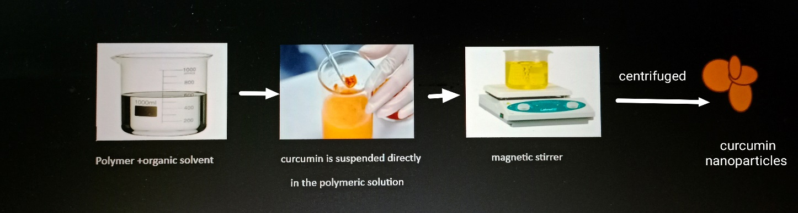

Figure 9: Schematic diagram of Curcumin nanoparticles by Coacervation techniques

1. **Nanoprecipitation Method:**

Another name for the nanoprecipitation technique is the solvent displacement method. The Nano precipitation method is a simple and inexpensive.

**Procedure**:

1. To create a polymeric solution, the necessary polymer is suspended in the appropriate solvent, and then curcumin, a herbal medication, is added.
2. Following that, this drug-polymer solution is added to water while being constantly stirred, which causes precipitation. Hot air flow is then used to allow the solvent to evaporate.
3. Drugs in an amorphous state were formed by spray drying and may partially crystallize during processing (16).
4. **Spray Drying Method:**

A single-step manufacturing process called spray drying turns a liquid feed into dried particle matter.

**Procedure**:

1. This synthesis process involves dissolving curcumin and a polymer in the same solvent or combination of solvents. Following that, heated air flow is used to allow the solvent to evaporate (17).
2. Drugs formed by spray drying emerged in an amorphous condition that could partially crystallize during processing (18). Curcumin nano-crystals can be formulated by spray drying method (19).
3. **Single Emulsion Method:**

The traditional technique for creating curcumin nanoparticles is the single emulsion method.

**Procedure**:

1. Curcumin nanoparticles are made by dispersing them in an appropriate solvent, then homogenizing or ultrasonically forming the emulsion at a high speed.
2. Additionally, the emulsion's solvent is removed through constant magnetic stirring at room temperature or with lowered pressure.
3. Following ultrasonication and collection, the solidified nanoparticles are washed with distilled water to eliminate contaminants and lyophilized to produce nanoparticles (20).

* It is also possible to create poly (lactic-co-glycolic acid) (PLGA) nanoparticles loaded with curcumin (21).

1. **Solvent Evaporation Method:**

In the pharmaceutical formulation industry, the solvent evaporation process is one of the most widely utilized techniques for creating drug-loaded polymeric systems and polymeric nanoparticles. This method creates curcumin nanoparticles loaded with PLGA (poly (lactic acid-co-glycolic acid)). PHBV nanoparticles were created by Liemann et al. (2013) using the solvent evaporation process (22).

**Procedure**:

Two main steps make up the solvent evaporation method:

1. Developing a solution based on polymers Using the wet milling method Curcumin that resembles a drug.
2. dispersion evaporation dissolving solvent for curcumin. Consequently, it leads to the creation of solid matter (16).

* The solvent then evaporates, turning the resulting emulsion into a suspension of nanoparticles (21).
* **Advantage:**

This technique prevents heat deposition by requiring a low temperature for the solvent to evaporate.

* **Disadvantages:**

1. The reagents required for the procedure are highly costly.
2. The organic solvent takes a long time to evaporate, and choosing the right solvent can be challenging at times (23).
3. **Microemulsion:**

Microemulsion is thought to be the best technique for creating nanoparticles. To increase curcumin's biological activity, curcumin nanoparticles are synthesized using this microemulsion process. Curcumin nanoparticles' surface stability is increased by using a variety of surfactants. The technique is simple to use and can deliver drugs efficiently while using less energy. Variations in temperature and pH have an impact on the microemulsion process (24),(25).

**Procedure**:

Using surfactants, which are hydrophilic for oil and hydrophobic for water, this technique works. A microemulsion is created when water, oil, and curcumin are introduced to a little amount of surfactant that has been agitated. It causes the creation of a turbid solution, which typically takes the shape of tiny droplets (26),(27).

1. **Wet Milling Method:**

Curcumin nanoparticles are synthesized using the wet-milling process. Giat et al. (2014) used a wet milling technique to create nanocurcumin.

**Procedure**:

1. Curcumin, a hydrophobic drug-like substance, is suspended in the proper dispersion solvent.
2. The ultrasonication process is used to further agitate the resultant solution.
3. Additionally necessary for the synthesis of curcumin nanoparticles is distilled water.
4. Following centrifugation of the resultant solution, the nanoparticles are produced using this technique (28).
5. **Thin Film Hydration Method:**

Thin-film hydration was utilized to make curcumin-loaded liposome nanoparticles, and Moorthi et al. showed how to synthesize curcumin nanoparticles using this process, employing piperine in addition to curcumin.

**Procedure**:

1. This technique allows curcumin and the surfactants to combine in an organic solvent while being sonicated.
2. Curcumin nanoparticles are generated by centrifuging the resulting nanosuspension after the solvent is allowed to evaporate under specific pressure and distilled water is added under sonication conditions (29).
3. **Solid Dispersion Method:**

The hydrophobic medication that is insoluble can be dissolved using this technique. This is a quick and easily scalable technique for creating curcumin nanoparticles. Moorthi et al. (2012) used the solid dispersion approach to create curcumin nanoparticles.

**Procedure**:

Hydrophobic medications, such as curcumin, are combined with the matrix in this technique. The matrix might be either crystalline or amorphous. It is possible to dissolve the insoluble hydrophobic medication with this technique (23).

1. **Emulsion Polymerization Method:**

Curcumin nanoparticles can be synthesized using two different emulsion techniques: the organic phase and the continuous phase (30),(31). This is a quick and easily scalable technique for creating curcumin nanoparticles (32).

**Procedure**:

Ultrasonication is used to dissolve a surfactant in pure water, followed by the dissolution of curcumin in an organic solvent and the addition of the solution to the surfactant.

* This technique has been utilized to synthesize curcumin nanoparticles, as described by Moorthi and colleagues. To enhance the biological activity of the produced curcumin nanoparticles, piperine was added in addition to curcumin (29).

1. **Fessi Method:**

Curcumin nanoparticles can be prepared using the Fessi process. Curcumin nanoparticles were made using this technique by Moorthi et al. (2012). This is a straightforward and easy way to synthesize nanoparticles.

**Procedure**:

1. Under sonication conditions, curcumin is dissolved in an appropriate solvent.
2. With continuous stirring, the resulting solution is then added to pure water along with a specific surfactant. Using this technique, the curcumin nanoparticles can be produced spontaneously (29).
3. **Ionic Gelation Method:**

This is a quick and straightforward way to create nanoparticles. The production of curcumin nanoparticles using chitosan as a polymer was described by Chabib et al. in 2012. This polymer enhanced curcumin nanoparticle stability and solubility.

**Procedure**:

1. Curcumin, which is hydrophobic, is diluted by the superior solvent, which shows 100% solubility of Curcumin.
2. After that, this solvent was added to the polymer solution while being continuously stirred.
3. This method relies on the connections that exist between the medication, like curcumin, and the polymer (33).
4. **Ultrasonication:**

Usually, this technique is used for medications that are less soluble in water. In 2011, Zhang et al. used this ultrasonication approach to create curcumin nanoparticles.

**Procedure**:

First, dissolving curcumin in an organic solvent, then adding the resultant solution to the polyethylene trolye solution while it is ultrasonically agitated for a number of periods (34)

1. **DIFFERENT APPLICATIONS OF CURCUMIN AND CURCUMIN NANOPARTICLES:**
2. **Anticancer Activity**

The most prevalent and deadly disease diagnosed worldwide is cancer. Traditional therapies such as radiation therapy, chemotherapy, and surgery have negative side effects. Therefore, creating safer and alternate treatment methods is crucial to curing this cancerous illness. These days, new medications are discovered via natural sources like plants. Many plants are thought to possess non-toxic, life-saving pharmacological substances that can be used to treat different kinds of cancer. A plant-based chemical called curcumin is used to treat a wide range of cancers, including those of the pancreas, mouth, breast, prostate, skin, and ovaries. These impacts are mediated through the control of several crucial cellular signaling pathways. Recent years have seen the application of curcumin nanoformulations with improved solubility, bioavailability, and targeted tumor cell (35). Since curcumin can be used as a subordinate therapeutic molecule in cancer therapy, the development of curcumin-based nanoformulations is encouraging. Its therapeutic potential was validated by theranostic applications of nanocurcumin in combination with upconversion nanoparticles (UCNP). It was discovered that UCNP-PLGA-nanocurcumin was mostly detected in the lungs and liver. The complex's nanocurcumin serves as both a photosensitizer and an acceptor of the resonant energy transfer via the UCNP's donor ion, Thulium. It has been established that this process causes ROS to be activated and causes cancer cells to die (36). The manufacture of curcumin or its analogs using nanotechnology has been claimed to have potential use in the suppression and progression of malignant cells. When combined, curcumin nanoparticles improved the chemotherapeutic impact of anticancer medications (37). When used to treat ovarian cancer, curcumin nanoparticles may increase curcumin's effectiveness (38). The solubility and bioavailability of curcumin can be improved by using the chitosan nanoparticles loaded with curcumin. The T74D cells were used in an in vitro investigation. Curcumin powder and curcumin nanoparticles were tested, and it was discovered that the latter had less effectiveness against malignant cell types (33). Using the colon cancer cell line, curcumin-loaded solid lipid nanoparticles were tested for cytotoxicity and preliminary efficacy (15). Curcumin-loaded magnetic nanoparticles were recently tested by causing tumors in animals. Mice used in animal tests showed that pancreatic tumor growth was inhibited and that curcumin's bioavailability was 2.5 times higher than that of free curcumin. Thus, it can be said that nanoparticles laden with curcumin are a new and effective treatment for pancreatic cancer (39). Nanocurcumin based on polymers has a higher systemic bioavailability in tissue and plasma. According to preclinical research, nanocur cumin can prevent pancreatic cancer's primary growth and metastases, making it a potentially effective anti-cancer treatment (40).

1. **Breast Cancer**

Breast cancer is a common disease that primarily affects women around the world. Curcumin micelle in vitro studies shown a prolonged half-life, cytotoxicity, and enhanced bioavailability in triple negative breast cancer (TNBC). Xenografts (35). Curcumin-loaded magnetic nanoparticles demonstrated imaging and magnetic targeting capabilities in addition to effective anticancer action against TNBC cells (MDA-MB-231 cell line). It caused the mitochondrial membrane potential to decrease by inducing the production of cellular reactive oxygen species (41). TNBC is an extremely aggressive and malignant tumor that is resistant to chemotherapy and does not overexpress human epidermal growth factor 2 receptors, progesterone, or estrogen (42). In MCF-7 human breast cancer cells, the combination of curcumin-encapsulated nanoparticles and the electroporation approach demonstrated improved anticancer activity (43).

1. **Pancreatic Cancer**

Bisht et al. used the co-polymers N isopropylacrylamide, N-vinyl-2-pyrrolidone, and poly (ethylene glycol) monoacrylate to create curcumin-loaded polymeric nanoparticles. It functions as a possible agent to stop the growth of tumors in human pancreatic cancer xenograft models. By inducing apoptosis, reducing NFκB activation, and expressing matrix metalloproteinase MMP-9 and cyclin D1, the combination of nanocurcumin and gemcitabine further stopped the growth of the tumor. Nanocurcumin's therapeutic efficacy was validated by clonogenic and cell viability tests (44). In a xenograft mouse model, curcumin-loaded magnetic nanoparticles dramatically inhibited the development of human pancreatic cancer cells (HPAF-II and Panc-1). When compared to regular curcumin, this formulation demonstrated greater stability along with enhanced bioavailability and biodistribution (45).

1. **Ovarian Cancer**

By encouraging apoptosis, paclitaxel and curcumin-encapsulated nanoemulsion demonstrated antitumor effectiveness against drug-resistant SKOV3 and SKOV3 (taxol-resistant) human ovarian adenocarcinoma cells. Curcumin nanoemulsion decreased the expression of P-glycoprotein and inhibited the activity of nuclear factor kappa B (NFκB) (46). Depending on the cells from which they originate, ovarian cancer can be classified into several categories. Chemoradiotherapy resistance is the main obstacle to treating advanced ovarian cancer. Yallapu et al. developed a monoclonal antibody conjugated with curcumin nanoparticles to improve the sensitivity and site specificity of ovarian cancer cells' resistance to chemoradiotherapy. The nanoparticle conjugate reduced cell growth and increased apoptosis in cisplatin-resistant A2780CP ovarian cancer cells (38).

1. **Anti-HIV Activity**

CD4+ T cells are destroyed by the human immunodeficiency virus (HIV), which targets the immune system. Finally, acquired immunodeficiency syndrome (AIDS) results from the immune system's progressive breakdown. One subset of white blood cells called CD4+ T cells defends the body against infections. Although the virus is suppressed by the antiretroviral medication, total eradication has not yet been accomplished. Finding a different treatment is therefore essential to curing this deadly illness. According to Gandapu et al., curcumin-loaded apotransferrin nanoparticles made using the sol-oil process were highly effective at stopping HIV-1 replication through transferrin-mediated endocytosis. HIV-infected cells typically express transferrin receptors. Curcumin-loaded apotransferrin nanoparticles enter the infected cell by binding to the receptor precisely. The medication is released gradually, and the virus (47).

1. **Antimicrobial Activity**

Many human infections are primarily caused by microorganisms. Numerous natural and artificial substances were employed as antimicrobial agents to eradicate viruses, bacteria, fungus, and protozoa. Turmeric has long been utilized as an antibacterial. Since curcumin nanoparticles are known to have stronger antibacterial action than regular curcumin, they were used. The antifungal and antibacterial properties of nanocurcumin made using the wet-milling method were documented by Bhawana et al. Without any surfactants, the nanocurcumin was more water soluble and had a high level of activity against Aspergillus niger, Pseudomonas aeruginosa, Bacillus subtilis, Escherichia coli, Staphylococcus aureus, and Penicillium notatum. By causing damage to the cell wall, the nanoparticles entered the infected cell and eventually caused cell death. When it came to Gram-positive bacteria, the nanocurcumin formulation was more reactive than the gram-negative bacteria (34). In a different investigation, curcumin-encapsulated nanoparticles improved the wound-healing activity in an in vivo murine wound model while preventing the growth of methicillin-resistant S. aureus and P. aeruginosa (48). Curcumin-loaded chitosan tripolyphosphate nanoparticles on mouse skin also inhibited the growth of S. aureus and P. aeruginosa in vitro (49).

1. **Antimalarial Activity**

Female Anopheles mosquitoes carry the parasites that cause malaria. Dandekar et al.'s in vivo investigations of hydrogel nanoparticles loaded with curcumin shown antimalarial efficacy. The toxicity tests demonstrated the nanoformulations' cytotoxic effects and oral safety (50). Chitosan nanoparticles coated with curcumin prevented the formation of hemozoin, curing Plasmodium yoelii-infected mice (51).

1. **Antioxidant Activity**

Curcumin is more effective at scavenging superoxide than demethoxycurcumin and bisdemethoxycurcumin (52). Curcumin is a good option for scavenging nitrogen and reactive oxygen species. Antioxidants are gaining popularity as one of the therapies that can be used to treat a variety of illnesses since reactive oxygen species are the cause of many pathogenic diseases. Curcumin is one antioxidant that works well against a number of autoimmune disorders including Parkinson's disease. Antioxidants' poor absorption and bioavailability are their main disadvantages. Scientists are working to create nanoparticluate carriers filled with antioxidants, such as liposomes or solid lipid nanoparticles. Vitamin E, coenzyme Q 10, vitamin A, curcumin, lucopene, silyma rin, and superoxide dismutase are a few examples of effective encapsulating medications and other active components (53). Since most lipids on the skin's surface are unsaturated, free radicals can easily damage them. Damage from free radicals increases quickly when the sun's UV rays strike the skin's surface, potentially causing the collagen and elastin fibers to deteriorate. Since curcumin detoxifies free radicals and stops the deterioration of skin fibers, it was determined to be useful in this instance. The primary cause of this activity is curcumin's antioxidant properties (54). When curcumin and curcumin nanoparticles were compared for antioxidant properties, it was discovered that the latter had more antioxidant properties than the former (55). Hydrogen bonding can boost curcumin's effectiveness since it causes the compound to shrink in size and form an amorphous state (56).

1. **Anti-inflammatory Activity**

Turmeric has been utilized as an anti-inflammatory in traditional Indian medicine. In rats, Rocha et al. examined the anti-inflammatory properties of nanocurcumin and regular curcumin. Nanocurcumin's enhanced anti-inflammatory action was demonstrated by the fact that its inhibitory effect at 50 mg/kg was comparable to that of regular curcumin at 400 mg/kg (57). The effectiveness of curcumin-encapsulated exosomes was investigated in a mouse model of septic shock produced by lipopolysaccharide. Exosome-delivered curcumin showed greater stability and target specificity in that experiment, and it was discovered to be present in blood at high amounts (58).

**CONCLUSION**:

In summary, curcumin is a natural therapeutic agent with a wide range of diverse properties, including anti-inflammatory, antioxidant, anticancer, and antimicrobial properties. Research has shown that curcumin's activity can be increased by using novel delivery methods, such as liposomes, nanoparticles, and specific phos pholipid complexes.Different forms of cancer can be treated with curcumin nanoparticles, which can be produced using a variety of techniques. Because of its increased stability, functionality, and significance in terms of pharmacokinetics and pharmacodynamics, nanotechnology has recently emerged as a cutting-edge method in drug delivery systems. The polyphenolic hydrophobic molecule curcumin has a variety of therapeutic uses, including anti-inflammatory, anti-cancer, antiseptic, anti-diabetic, and antimicrobial effects. However, curcumin's low solubility and low bioavailability limit its benefits in clinical settings.There are several primary systems that can influence curcumin's phytochemical state, including polymeric nanoparticles, polymeric micelles, liposomes, and phospholipid complexes, which can improve curcumin's solubility, stability, bioavailability, and resistance to physical and chemical deterioration.

This review has covered the many techniques used to manufacture curcumin nanoparticles, as well as their benefits and disadvantages. We have also discussed about the recently published techniques for creating curcumin nanoparticles over the past five years. The techniques outlined in this paper are the most effective ways to prepare curcumin nanoparticles, and they are also less costly than alternative techniques.

**REFERENCES:**

1. Adahoun, M. A. A., Al-Akhras, M. A. H., Jaafar, M. S., & Bououdina, M. (2017). Enhanced anti-cancer and antimicrobial activities of curcumin nanoparticles. Artificial cells, nanomedicine, and biotechnology, 45(1), 98-107.
2. Massimino, Lívia C., Henrique AM Faria, and Sergio A. Yoshioka. "Curcumin bioactive nanosizing: Increase of bioavailability." Industrial Crops and Products 109 (2017): 493-497.
3. Araujo, C. A. C., and L. L. Leon. "Biological activities of Curcuma longa L." Memórias do Instituto Oswaldo Cruz 96 (2001): 723-728.
4. Hettiarachchi, S. S., Dunuweera, S. P., Dunuweera, A. N., & Rajapakse, R. G. (2021). Synthesis of curcumin nanoparticles from raw turmeric rhizome. ACS omega, 6(12), 8246-8252.
5. Akl, Mohamed A., et al. "Factorial design formulation optimization and in vitro characterization of curcumin-loaded PLGA nanoparticles for colon delivery." Journal of Drug Delivery Science and Technology 32 (2016): 10-20.
6. Guo, Xia, et al. "Preparation, characterization, release and antioxidant activity of curcumin-loaded amorphous calcium phosphate nanoparticles." Journal of Non-Crystalline Solids 500 (2018): 317 325.
7. Alireza Homayouni, Masoumeh Sohrabi, Marjan Amini, Jaleh Varshosaz, Ali Nokhodchi. Curcumin nanoparticles containing poloxamer or soluplus tailored by high pressure Homogenigation using antisolvent crystallization, International Journal of Pharmaceutics Material Science And Engineering .2018:185-196.
8. Bhawana, Basniwal, R. K., Buttar, H. S., Jain, V. K., & Jain, N. (2011). Curcumin nanoparticles: preparation, characterization, and antimicrobial study. Journal of agricultural and food chemistry, 59(5), 2056-2061.
9. Choudhary, Vikram, Hosakote Shivakumar, and Himanshu Ojha. "Curcumin-loaded liposomes for wound healing: Preparation, optimization, in-vivo skin permeation and bioevaluation." Journal of Drug Delivery Science and Technology 49 (2019): 683-691.
10. Behbahani, Elham Sadati, Mehrorang Ghaedi, and Arash Asfaram. "One-pot synthesis of magnetic lipid nanoparticles as an efficient sorbent for curcumin determination in magnetic dispersive solid phase extraction system." European Polymer Journal 118 (2019): 661-667.
11. Amir Maghsoudi, Fatemeh Yazdian, Saleheh, Shahmoradi, Leila Ghaderi, Mehran Hemati, Ghassem Amoabediny. Curcumin-Loaded polysaccharide nanoparticles;Optimization and anticariogenic activity against Streptococcus mutans Materials Science & Engineering .2017:1-27.
12. Das, Ram P., et al. "Preparation of albumin nanoparticles: Optimum size for cellular uptake of entrapped drug (Curcumin)." Colloids and Surfaces A: Physicochemical and Engineering Aspects 567 (2019): 86-95.
13. Homayouni, A., Sohrabi, M., Amini, M., Varshosaz, J., & Nokhodchi, A. (2019). Effect of high pressure homogenization on physicochemical properties of curcumin nanoparticles prepared by antisolvent crystallization using HPMC or PVP. Materials Science and Engineering: C, 98, 185-196.<16
14. Kas, H. S., & Oner, L. (2000). Microencapsulation using coacervation/phase separation: An overview of the technique and applications (pp. 301-328). Marcel Dekker, Inc.: New York, NY, USA.
15. Chirio, D., Gallarate, M., Peira, E., Battaglia, L., Serpe, L., & Trotta, M. (2011). Formulation of curcumin-loaded solid lipid nanoparticles produced by fatty acids coacervation technique. Journal of microencapsulation, 28(6), 537-548.
16. Arunachalam, A., Karthikeyan, M., Konam, K., Prasad, P. H., Sethuraman, S., & Ashutoshkumar, S. (2010). Solid dispersions: a review. *Journal of Current Pharma Research*, *1*(1), 82.
17. Vasconcelos, T., Sarmento, B., & Costa, P. (2007). Solid dispersions as strategy to improve oral bioavailability of poor water soluble drugs. *Drug discovery today*, *12*(23-24), 1068-1075.
18. Paradkar, A., Ambike, A. A., Jadhav, B. K., & Mahadik, K. R. (2004). Characterization of curcumin–PVP solid dispersion obtained by spray drying. *International journal of pharmaceutics*, *271*(1-2), 281-286.
19. Ravichandran, R. (2013). Studies on dissolution behaviour of nanoparticulate curcumin formulation. *Advances in Nanoparticles*, *2*(01), 51-59.
20. Rao, J. P., & Geckeler, K. E. (2011). Polymer nanoparticles: Preparation techniques and size-control parameters. *Progress in polymer science*, *36*(7), 887-913.
21. Verderio, P., Bonetti, P., Colombo, M., Pandolfi, L., & Prosperi, D. (2013). Intracellular drug release from curcumin-loaded PLGA nanoparticles induces G2/M block in breast cancer cells. *Biomacromolecules*, *14*(3), 672-682.
22. Xie, X., Tao, Q., Zou, Y., Zhang, F., Guo, M., Wang, Y., ... & Yu, S. (2011). PLGA nanoparticles improve the oral bioavailability of curcumin in rats: characterizations and mechanisms. *Journal of agricultural and food chemistry*, *59*(17), 9280-9289.
23. Chiou WL, Riegelman S. Preparation and dissolution character istics of several fast release solid dispersions of griseofulvin. J. Pharma. Sci. 1971, 60, 1281–1302.
24. Kumar, K. S., Dhachinamoorthi, D., Saravanan, R., Gopal, U., & Shanmugam, V. (2011). Microemulsions as carrier for novel drug delivery: a review. *International Journal of Pharmaceutical Sciences Review and Research*, *10*(2).
25. Madhav, S., & Gupta, D. (2011). A review on microemulsion based system. *International journal of pharmaceutical sciences and research*, *2*(8), 1888.
26. Häger, M., Currie, F., & Holmberg, K. (2003). Organic reactions in microemulsions. *Colloid Chemistry II*, 53-74.
27. Bansal, A. K., & Munjal, B. (2011). Preparation of solid lipid nanoparticles for enhancement of oral bioavailability of curcumin. In *The 1st Electronic Conference on Pharmaceutical Sciences*. Multidisciplinary Digital Publishing Institute.
28. Bhawana, Basniwal, R. K., Buttar, H. S., Jain, V. K., & Jain, N. (2011). Curcumin nanoparticles: preparation, characterization, and antimicrobial study. *Journal of agricultural and food chemistry*, *59*(5), 2056-2061.
29. Moorthi, C., Krishnan, K., Manavalan, R., & Kathiresan, K. (2012). Preparation and characterization of curcumin–piperine dual drug loaded nanoparticles. *Asian Pacific journal of tropical biomedicine*, *2*(11), 841-848.
30. Lowe, P. J., & Temple, C. S. (1994). Calcitonin and insulin in isobutylcyanoacrylate nanocapsules: protection against proteases and effect on intestinal absorption in rats. *Journal of pharmacy and pharmacology*, *46*(7), 547-552.
31. Vauthier C, Duternet C, Fattal B, Pinto Alphandary H, Couvreur P. Poly(alkylcyanoacrylates) as biodegradable material for biomedical application. Adv. Drug Rev. 2003, 55, 519–548.
32. Kreuter J. Large scale production and manufacturing of nano particles. In To Specialized Drug Delivery Systems: Manufac turing and Production Technology, Tyle P, Ed., Marcel Dekker: New York, 1990, pp. 257–266.
33. Chabib, L., Martien, R., & Ismail, H. (2012). FORMULATION OF NANOCURCUMIN USING LOW VISCOSITY CHITOSAN POLYMER AND ITS CELLULAR UPTAKE STUDY INTO T47D CELLS. *Indonesian Journal of Pharmacy/Majalah Farmasi Indonesia*, *23*(1).
34. Zheng, Z., Zhang, X., Carbo, D., Clark, C., Nathan, C. A., & Lvov, Y. (2010). Sonication-assisted synthesis of polyelectrolyte-coated curcumin nanoparticles. *Langmuir*, *26*(11), 7679-7681.
35. Cridge, B. J., Larsen, L., & Rosengren, R. J. (2013). Curcumin and its derivatives in breast cancer: Current developments and potential for the treatment of drug-resistant cancers. *Oncology discovery*, *1*(6), 1-9.
36. Das, A., Corbella Bagot, C., Rappeport, E., Ba Tis, T., & Park, W. (2021). Quantitative modeling and experimental verification of Förster resonant energy transfer in upconversion nanoparticle biosensors. *Journal of Applied Physics*, *130*(2).
37. Mimeault, M., & Batra, S. K. (2011). Potential applications of curcumin and its novel synthetic analogs and nanotechnology-based formulations in cancer prevention and therapy. *Chinese medicine*, *6*, 1-19.
38. Yallapu, M. M., Maher, D. M., Sundram, V., Bell, M. C., Jaggi, M., & Chauhan, S. C. (2010). Curcumin induces chemo/radio-sensitization in ovarian cancer cells and curcumin nanoparticles inhibit ovarian cancer cell growth. *Journal of ovarian research*, *3*, 1-12.
39. Bisht, S., Mizuma, M., Feldmann, G., Ottenhof, N. A., Hong, S. M., Pramanik, D., ... & Maitra, A. (2010). Systemic administration of polymeric nanoparticle-encapsulated curcumin (NanoCurc) blocks tumor growth and metastases in preclinical models of pancreatic cancer. *Molecular cancer therapeutics*, *9*(8), 2255-2264.
40. Ghosh, M., Singh, A. T., Xu, W., Sulchek, T., Gordon, L. I., & Ryan, R. O. (2011). Curcumin nanodisks: formulation and characterization. *Nanomedicine: Nanotechnology, Biology and Medicine*, *7*(2), 162-167.
41. Yallapu, M. M., Othman, S. F., Curtis, E. T., Bauer, N. A., Chauhan, N., Kumar, D., ... & Chauhan, S. C. (2012). Curcumin-loaded magnetic nanoparticles for breast cancer therapeutics and imaging applications. *International journal of nanomedicine*, 1761-1779.
42. Carey, L., Winer, E., Viale, G., Cameron, D., & Gianni, L. (2010). Triple-negative breast cancer: disease entity or title of convenience?. *Nature reviews Clinical oncology*, *7*(12), 683-692.
43. Lin, W. Y., Cooper, C., Camarillo, I., Reece, L. M., Clah, L., Natarajan, A., ... & Sundararajan, R. (2014). The effectiveness of electroporation-based nanocurcumin and curcumin treatments on human breast cancer cells. In *Proc. ESA Annual Meeting on Electrostatics 2014*.
44. Bisht, S., Mizuma, M., Feldmann, G., Ottenhof, N. A., Hong, S. M., Pramanik, D., ... & Maitra, A. (2010). Systemic administration of polymeric nanoparticle-encapsulated curcumin (NanoCurc) blocks tumor growth and metastases in preclinical models of pancreatic cancer. *Molecular cancer therapeutics*, *9*(8), 2255-2264.
45. Yallapu, M. M., Ebeling, M. C., Khan, S., Sundram, V., Chauhan, N., Gupta, B. K., ... & Chauhan, S. C. (2013). Novel curcumin-loaded magnetic nanoparticles for pancreatic cancer treatment. *Molecular cancer therapeutics*, *12*(8), 1471-1480.
46. Ganta, S., & Amiji, M. (2009). Coadministration of paclitaxel and curcumin in nanoemulsion formulations to overcome multidrug resistance in tumor cells. *Molecular pharmaceutics*, *6*(3), 928-939.
47. Gandapu, Upendhar, et al. "Curcumin-loaded apotransferrin nanoparticles provide efficient cellular uptake and effectively inhibit HIV-1 replication in vitro." *PloS one* 6.8 (2011): e23388.
48. Krausz, Aimee E., et al. "Curcumin-encapsulated nanoparticles as innovative antimicrobial and wound healing agent." *Nanomedicine: Nanotechnology, Biology and Medicine* 11.1 (2015): 195-206.
49. MOFAZZAL, JAHROMI MIRZA ALI, et al. "Curcumin-loaded chitosan tripolyphosphate nanoparticles as a safe, natural and effective antibiotic inhibits the infection of Staphylococcus aureus and Pseudomonas aeruginosa in vivo." (2014): 1-8.
50. Dandekar, Prajakta P., et al. "Curcumin-loaded hydrogel nanoparticles: application in anti-malarial therapy and toxicological evaluation." *Journal of pharmaceutical sciences* 99.12 (2010): 4992-5010.
51. Akhtar, Feroz, M. Moshahid Alam Rizvi, and Santosh Kumar Kar. "Oral delivery of curcumin bound to chitosan nanoparticles cured Plasmodium yoelii infected mice." *Biotechnology advances* 30.1 (2012): 310-320.
52. Patumraj S, Yoysungneon P. Curcumin as a therapeutic agent against cancer. Asian Biomed. 2007, 1, 239–252.
53. Souto, Eliana B., et al. "Encapsulation of antioxidants in gastrointestinal-resistant nanoparticulate carriers." *Oxidative Stress and Nanotechnology: Methods and Protocols* (2013): 37-46.
54. Kumar, Anil, Jyotsna Dora, and Anup Singh. "A review on spice of life Curcuma longa (turmeric)." *International Journal of Applied Biology and Pharmaceutical Technology* 2.4 (2011): 371-379.
55. Kakran, Mitali, et al. "Preparation of nanoparticles of poorly water-soluble antioxidant curcumin by antisolvent precipitation methods." *Journal of Nanoparticle Research* 14 (2012): 1-11.
56. Yen, Feng-Lin, et al. "Curcumin nanoparticles improve the physicochemical properties of curcumin and effectively enhance its antioxidant and antihepatoma activities." *Journal of agricultural and food chemistry* 58.12 (2010): 7376-7382.
57. Rocha, B. A., Gonçalves, O. H., Leimann, F. V., Rebecca, E. S., Silva-Buzanello, R. A., Araújo, P. H. H., ... & Bersani-Amado, C. A. (2014). Curcumin encapsulated in poly-L-lactic acid improves its anti-inflammatory efficacy in vivo. *Advancement in Medicinal Plant Research*, *2*(4), 62-73.
58. Sun, D., Zhuang, X., Xiang, X., Liu, Y., Zhang, S., Liu, C., ... & Zhang, H. G. (2010). A novel nanoparticle drug delivery system: the anti-inflammatory activity of curcumin is enhanced when encapsulated in exosomes. *Molecular therapy*, *18*(9), 1606-1614.