Formulation of Immunity Boosting Instant Soup Premix And Its Anti-Microbial & Phytochemical Analysis
¹Swarnima Pandey, ²Sunita Mishra
¹M.Sc Student,²Professor
Department of Food and Nutrition, Babasaheb Bhimrao Ambedkar University Lucknow Mail ID: sunitabbau@gmail.com (Corresponding Author²)

Abstract
The immune system is among the most developed in nature. It is composed of diverse cell and protein types that have different defence roles against encroaching things. Other quality attributes, storage stability, and product cost estimation were evaluated, along with the standardisation of the best composition for producing an instant soup mix that promotes immunity. Due to their low toxicity and affordability, the use of medicinal plants for their potential to strengthen the immune system has recently been chosen over pharmaceutical medications. Traditional health practitioners (THPs) from the Vaal Region, South Africa, created a herbal immunity booster for the improvement of immune health. The objective of this study is to assess the phytochemicals and mineral components in this formulation for immune support. Alkaloids, flavonoids, phenols, and saponins were found in the immune booster's formulation, but steroids, tannins, and glycosides were not present, according to the phytochemicals screening. In addition to various public health initiatives put in place to avoid infection, we can boost our immunity with natural products. The present study was designed to evaluate phytochemical analysis and microbiological analysis of immunity booster premix soup and to provide a brief knowledge association with health benefits of immunity booster soup.
Keywords- Immune booster, antioxidant, anti-Microbial Properties, phytochemical analysis.

- INTRODUCTION
There is a trendy demand for various food components that can improve immune response. Functional foods can regulate the immune system through immune response enhancement or inhibition, which provide host defenses against infection, and suppress allergies and inflammation. The production of these food components such as prebiotics and probiotics, is ever increasing with the intention of fighting chronic health problems like non-alcoholic fatty liver disease (NAFLD), cancer, obesity, diabetes and cardiovascular diseases. Presently, the most known functional foods are the probiotics and prebiotics based on their health promoting properties.
Due of their affordability and use, medicinal plants have seen an increase in popularity in recent years. Additionally, compared to their synthetic pharmaceutical counterparts, recent research findings have demonstrated that their level of toxicity is low (1). On plants with the ability to strengthen the immune system, however, very little information has been recorded (2). A reduced immunological competence obviously increases the susceptibility to invasion by infections because the immune system's primary function is to protect the host against

pathogenic agents. The overall effect on the immune system may be either immunosuppression or stimulation of immune cell activity, depending on the nutrients that are available in the immune booster, the concentration, route, and length of exposure, as well as biological availability (3). Therefore, it is advised that before using medicinal plants locally or for pharmaceutical reasons, the concentrations of the mineral constituents in those plants be assessed. Due to the complexity and diversity of the immune system, there are numerous sites of entry for heavy metals to affect the function of different cells, either by inhibition or activation, setting off a domino effect and a pathogenic response.(4)
Generally speaking, the growing, transport, and storage circumstances, as well as the geography, the geochemical characteristics of the soil, contaminants in the soil, water, and air, can have a considerable impact on the qualities and attributes of the herbal plants and the products made from them.(5) Phytochemicals are by products of secondary metabolism that are present in plants. Numerous phytochemicals, including flavonoids, alkaloids, glycosides, terpenoids, saponins, tannins, and phenols, are substantially to blame for the majority of therapeutic characteristics that are now used or being studied in human health systems.(6) Each type of phytochemical has a unique structural fingerprint, which results in variations in the techniques used to treat diseases.(7) The majority of native plants, whether they are employed as a full plant or a part of it, contain more than one of these compounds, making it possible to treat many illnesses with a single plant.(8) It has been noted that phytochemicals like alkaloids have a tendency to be cytotoxic when given in excessive doses.(9) have a profound impact on the compositions, qualities, and properties of herbal plants.(5)
Ayurveda is the world's oldest science of life and medicine, with roots in the ancient Vedas. A collection of six genuine ancient books, including the pre-Christian texts Crake, Surtax, and Semites of Vagbhatta, also known as Bhatt ray, as well as the mediaeval texts Mdhavanidna, Rangdhara Summit, and Bhvapraka, collectively known as Laghuttray, have preserved its classical ancient knowledge base for modern times. Modern immunology is primarily concerned with immunity. The biological expression of immunity refers to the state of possessing numerous biological defences to fend off various illnesses, infections, and other undesirable biological intrusions. The ideas of "Dinacharya" (daily regimens) and "Ritucharya" (seasonal regimens), which are used by Ayurveda to promote a healthy lifestyle, are the foundation of this system's extensive knowledge base on preventative care.(10) This study gives an understanding of how immune-boosting discourse is provided on Instagram, one of the biggest social media sites in the world. There are more than 500 million active users everyday on Instagram, a social networking site for sharing photos and videos owned by Facebook, Inc.(11) The onset of clinical disease and its progression to the severe stage may vary between individuals and that depend upon their immune status, and the presence of underlying medical conditions. In general, the typical clinical symptoms include, dry cough (67%), fever (88%), fatigue (38%), myalgias (14.9%), Dyspnoea (18.7%), other symptoms include, headache, sore throat, rhinorrhoea, and gastrointestinal symptoms. Pneumonia is severe manifestation of the infection.(12) To function properly, something needs harmony and balance. Our first line of defence is to live a balanced lifestyle. Of course, the best thing we can do to maintain a healthy immune system is to adhere to general health advice. When our immune system is in good health, it not only defends us from external dangers but also helps us practise safe lifestyle practises like healthy eating. A strong immune system army marches

on its heart, as does any fighting force. Good immune system defenders require nutritious food on a daily basis.(13)
  - Immunity booster food
In general, food has a significant impact on immunity and health. The immune system may benefit from eating a low-fat, plant-based diet. The immune system relies on WBCs to make antibodies to fight off viruses, bacteria, and other foreign invaders. Plant-based diets improve the health of the gut microbiome, which makes up to 85% of the body's immune system, as well as intestinal beneficial bacteria. On the other hand, an excessive intake of animal products destroys the body's beneficial bacteria, causes inflammation, and is the main factor in the development of diabetes, COPD, cardiovascular disease, hepatitis B, cancer, and chronic kidney disease.(14) Generally, plant-based diets are non-toxic and without any side effects. Various parts of medicinal plants are popular for their antiviral activities and immunity strengthening capacity.
The best way to strengthen our immune is to naturally with the help of medicinal plants/herbs. Mother nature has already blessed us with plenty of medicinal plants that help in fighting and curing the vast range of diseases. Ayurveda, the ancient medical science had stated long ago that plant extracts could do a lot to strengthen the body [10]. Some of the important medicinal plants are as follows that potentially can help in boosting immunity against COVID-19 and other infectious disease: Drumstick tree (Moringa oleifera), Amla (Phyllanthus emblica), Ashwagandha (Withania somnifera), Giloy/ Guduchi (Tinospora cordifolia), Neem (Azadirachta indica), Garlic (Allium sativum), Tulsi (Ocimum sanctum), Cinnamon (Cinnamomum verum), Turmeric (Curcuma longa), Onion (Allium cepa), Wild carrot (Daucus maritimus), Black pepper (Piper nigrum).
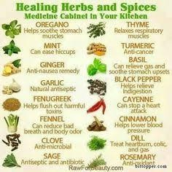
Fig.1 The various type of immunity booster

MATERIAL AND METHOD

Microbiological analysis
  - Ager diffusion method
Cultivation, maintenance, enrichment, differentiation, tests, and long-term preservation are all possible uses for these medium. Each functional classification is constrained by the formulation and has a limited shelf life. The shelf-life of these culture media refers to the amount of time the medium preserves its chemico-physical properties. Commercially accessible solid growth media on Petri dishes (agar plates) often have a short shelf life, typically ranging from 30 to 90 days. Medium composition (i.e., general-purpose to specialized formulations), sterilization process, storage temperature, exposure to light, and packaging are all important elements that influence total shelf-life and microbiological growth efficiency. Several studies have shown that packed agar plates intended for drug sensitivity testing, isolation, enrichment, or selection have a variable shelf life. Bacteria, fungus, and parasites are all examples of microorganisms. Ulisse et al., for example, examined 12 different media types with varying degrees of complexity, packed in shrink-wrap film, stored at 5 °C, and coded for shelf-lives ranging from 3 to 30 days. These media could be given shelf-lives of 90 to 120 days after testing for weight loss (water loss), sterility, pH, and ability to maintain bacterial growth. It is required to support the target microorganism's development and characterisation.
  - Test Method
    - TSS (Total Suspended Solids)
      - The refractometer prism surface was cleaned and dried.
      - Then, the placed a small amount of sample drops on to the prism of the refractometer
      - After look through the eyepiece while pointing the prism in the direction of good light*not directly at the sun
      - Focused and took the reading of where the base of the blue color sits on the scale.
      - Then, recorded the % Brix
    - Total Plate Count Microbial Shelf Life
      - Make a dilution series from a sample upto10-4
      - Pipetted out 100µl from the appropriate desired dilution series on to the center of the surface of an agar plate.
      - Flamed the glass spreader over a lamp.
      - Spread the sample evenly over the surface of agar using the sterile glass spreader, carefully rotating the petri dish underneath at the same time
      - Incubated the plate at 37ͦC for 24 hours.
      - At the end of the incubation period, selected all of the petri plates containing between 30 and 300 colonies. Plates with more than 300colonies cannot be counted and are designated too many to count (TMTC).

      - Calculated the number of bacteria (CFU) per milliliter or gram of sample by dividing the number of colonies multiplied by dilution factor divided by the amount of specimen added to liquified agar.
      - This process was done for different time period (day1,3,5) of same sample.
    - Determination of Colony forming units
      - Using aseptic technique, the initial dilution was made by transferring 1 ml of sample to a 9ml sterile peptone water. This is a 1/10 dilution.
      - The 10-1 dilution is then shaken by grasping the tube between the palms of both hands and rotating quickly to create a vortex.
      - This serves to distribute the bacteria and break up any clumps.
      - Immediately after the 10-1 was shaken, uncapped it and aseptically transferred 1ml to a second 9ml peptone water.
      - Since this was a 10-1dilution, second blank represents a 10-2dilution of the original sample. It was subsequently diluted upto 10-4dilution.
      - Pipetted out 100µl from the appropriate desired dilution series on to the center of the surface of an agar plate
      - Then poured the cooled medium into the plate and then agar-sample mixture are immediately mixed gently moving the plate in a figure-eight motion or a circular motion while it rests on the table top/platform of LAF cabinet.
      - After the pour plates cooled down and the agar was solidified completely, they were inverted and incubated at 37ͦC for 24 hours.
      - At the end of the incubation period, selected all of the petri plates containing between 30 and 300 colonies. Plates with more than 300colonies cannot be counted and are designated too many to count (TMTC).
      - Plates with fewer than 30 colonies are designated too few to count (TFTC). Count the colonies on each plate.
      - Calculated the number of bacteria (CFU) per milliliter or gram of sample by dividing the number of colonies by the dilution factor multiplied by the amount of specimen added to liquified agar.
Number of Bacteria/ml = Number of colonies observed/ amount plated on media*Dilution factor
  - CFU
Stands for colony forming units, which is a measure of live bacteria or fungi. Unlike a direct microscopic count, which counts all cells alive and dead, CFU estimates viable cells. The development of a viable colony necessitated tremendous growth, and it is impossible to tell whether the colony came from one cell or 1,000 cells at the moment of counting. To account for this uncertainty, the findings are reported as CFU/ ml for liquids and CFU/ g for solids.

    - Total Suspended Solids (TSS)
Sample filtration of a known volume via 4.7 cm Whatman GF/C glass fiber filters and drying at 103–105 °C were used to estimate TSS. The TSS was calculated using the difference in filter weight before and after filtration.
  - Qualitative phytochemical analysis
Phytochemical have a great antioxidant potential and their beneficial effects on human health, and they give greater health benefits to the consumers. The extracts of immunity booster soup were analysed for alkaloids, saponin, tannin, flavonoids, glycosides, phenols, steroids.

Test for phenols
Phenols is a bioactive compound derived from plants and foods.
2 ml of immune booster sample was treated with four drops of 5 % (weight/volume) glacial acetic acid followed by four drops of 5 % (w/v) NaNO2 solution. The mixture was shaken for 5 minutes and allowed to stand. The appearance of muddy brown precipitate indicates the presence of phenols.

Test for saponin
Saponin used as a natural cleanser and cardiac.
2 ml of the immune booster sample was diluted with 10 ml distilled water and vigorously shaken well for 20 minutes in a graduated cylinder. An appearance of 1 cm layer of foam indicates the presence of saponins.

Test for flavonoids
Flavonoids are present in plant which possess many useful activities like anti-inflammatory, anti-bacterial and antioxidant.
2 ml of the immune booster sample was diluted in 1ml of sodium hydroxide(NaoH), formation of yellow colour indicates the presence of flavonoids.

Test for glycosides
Glycosides are used are ulcer and diabetic treatment.
2 ml of the immune booster sample was added in 3 ml of chloroform then added 10% ammonium solution. Formation of pink colour indicates the presence of glycosides.

Test for alkaloids
Alkaloids are used in medicines for decreases headache and fever. These are assign for antibacterial and analgesic properties.
5 drops of Wagner’s reagent were added to 2 ml of immune booster sample. The mixture was warmed for one minute. Formation of reddish brown precipitate indicates the presence of alkaloids.

Test for Steroids

2ml of immune booster sample extract was taken in test tube and dissolve 10 ml chloroform then add add equal volume of conc. H2SO4 to test tube. Upper layer turns red and sulphuric layer show yellow with green indicates the presence of steroids.

Test for tannin
Tannin used as acetylated mannose polymers hence it is used for the medical purpose and it also protect plant from abiotic stresses.
2 ml of 10 % ferric chloride was added to 2 ml immune booster sample. Appearance of dark blue or greenish grey coloring indicates the presence of tannins.
    - Determination of Antioxidants:
The free radical scavenging activity of methanol extract of energy bar was measured by 1,1- diphenyl-2-picryl-hydrazyl (DPPH) using the method of Blois (1958) The free RSA of the energy bar was tested using a 1,1- diphenyl- 2-picryl hydrazyl (DPPH) technique. A total of 24 milligrams of DPPH were dissolved in 100 mL of methanol for making the stock solution. Filtration of DPPH stock solution using methanol yielded a usable mixture with an absorbance of around 0.973 at 517 nm. In a test tube, 3 mL DPPH workable solutions were combined with 100 µL of energy bar and methanol solution.
      - Four different concentration of energy bar ranging from 10-1 to 10-4 were prepared for antioxidant analysis in methanol.
      - Three milliliters of solution containing DPPH in 100 µL of methanol is often given as a standard. After that, the tubes were kept in complete darkness for 30 min. The absorbance was therefore determined at 517 nm. The following formula was used to compute the percentage of antioxidants.
% Of antioxidant activity= [(Ac−As) ÷Ac] × 100
where: Ac—Control reaction absorbance; As—Testing specimen absorbance.
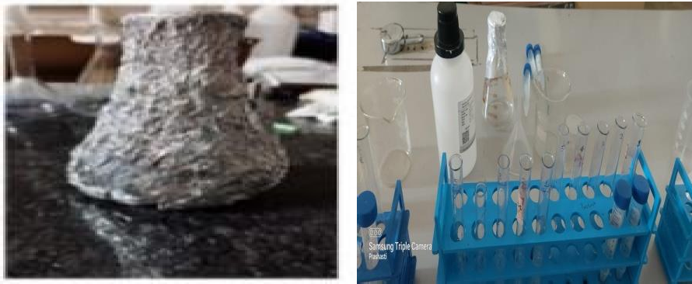

Fig. 2 Antioxidant estimation

RESULT & DISCUSSION
  - Microbiological Analysis
    - Test Report
Test: Determination of Colony forming units (CFU/ml).

Method used: Total Plate Count by Pour Plate Method.
    - Media Used:
      - Total Plate count: Plate Count Agar Media
      - TSS: Total suspend solid
      - Test Sample: T1
    - Observation and result
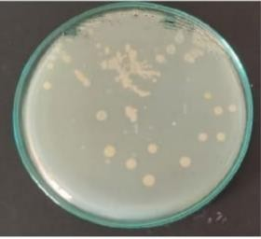
Fig.3 Total Plate Count on plate count agar media
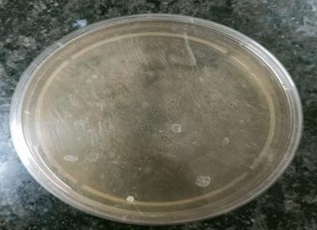
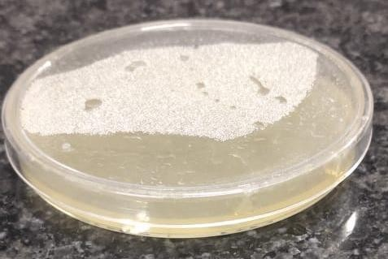
Day 1 Day 3

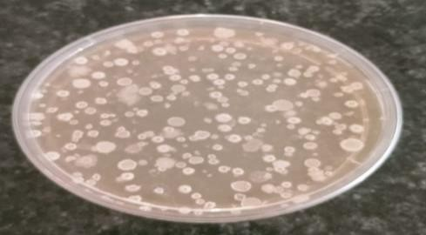
Day 5
Fig.4 Shelf-life on Plate count media in different time period for sample T1

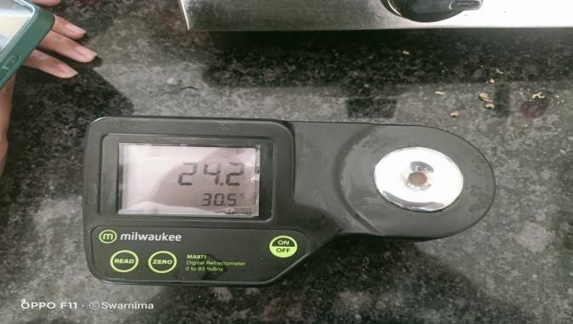
Fig.4 Measuring TSS (Total Suspended Solids) on Refractometer Table 1. Total % Brix (T1 Sample)
S. No. | Sample code | % Brix | Average TSS±SD
1. | T1 T1 T1 | 2% | 2.33±0.471
2. | T1 T1 T1 | 2% | 2.33±0.471
3. | T1 T1 T1 | 3% | 2.33±0.471

Table.2. Total CFU count

S.No. | Sample code | PCA
1. | T1 | Count | CFU/ml
1. | T1 | 65 | 65×10⁻⁵

Table.3. Shelf- life in different time period (T1 Sample)

S.No. | Sample code | Day 1 |  | Day 3 |  | Day 5
1. | T1 | Count | CFU/ml | Count | CFU/ml | Count | CFU/ml
 |  | 3 | 3×10⁻⁵ | 6 | 6×10⁻⁵ | 66 | 66×10⁻⁵

*PCA: Plate count Agar (total plate count); MAM: MacConkey Agar Media (total coliform count); SDA: Sabouraud dextrose Agar (yeast and mold count); Dilution used: 10-4; Sample amount plated: 100 µl; N.A.: Not applicable; TMTC: Too many to count
Table.4 Phytochemical analysis of immunity booster soup

Phytochemical constituents | Water extract
Phenol | +
Saponin | +
Flavonoids | +
Tannin | -
Glycosides | -
Alkaloids | +
Steroids | -
(+) Represents presence & (-) Represents absence

3.3 Antioxidant analysis of immunity booster soup
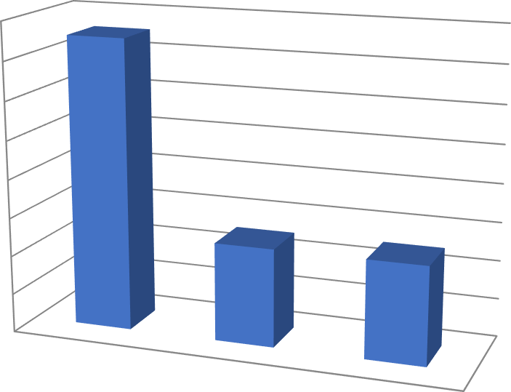
18.2
18.11
18
17.8
17.6
17.4
17.2
17.11
DPPH…
17.11
17
16.8
16.6
F1
F2
F3

Conclusion
In conclusion, the presence of saponins confirmed the ability of the immune boosting potential of the formulation which is supported by previous reports saying that saponins could lower the

cholesterol level, act as anti-carcinogenic agent and immune booster. Furthermore, the presence of Saponins justifies the usage of the formulation as immune booster and the presence of flavonoids supports the usage of the formulation as antioxidant agent. The immune booster was effective as radical scavengers at various concentrations, thereby making them potential for developing anti-stress agents and will require further medicinal formulation investigation. In India, people are using spices as well as herbs from ancient times due to their taste, antiviral, antimicrobial, antioxidant, and immunity-boosting properties. Since ages Indians are habitual of taking these natural products that have conferred immunity in the Indian population, which probably is the major cause for low mortality in India. However, the excessive use of spices and herbs may cause various side effects, namely, acidity in the stomach, heartburn, constipation, diarrhea, ulcers in the mouth, high blood pressure, and so on. Therefore, detailed studies about the bioactive compounds present in common Indian herb and spices and their effectiveness and mode of action against lethal viruses need to be explored.

Acknowledgement
Author acknowledge with gratitude the contribution of the faculty of the department of Food and Nutrition, Babasaheb Bhimrao Ambedkar University, Lucknow. A sincere thanks and a huge amount of credits goes to Prof. Sunita Mishra, School for Home Sciences, Babasaheb Bhimrao Ambedkar University who aided and provided with all possible resources for completing this research work successfully, secondly I would like to thank my friends who helped me a lot in finalizing this research work within the limited time frame

References
- Ahmad I, Beg AZ. Antimicrobial and phytochemical studies on 45 Indian medicinal plants against multi-drug resistant human pathogens. J. Ethnopharmacol. 2001;74(2):113- 23.
- Gupta S. Prospects and perspectives of natural plant products in medicine. Indian J. Pharmacol. 1994 Jan 1;26(1):1-2.
- Lehmann I, Sack U, Lehmann J. Metal ions affecting the immune system. Met. Ions Life Sci. 2010;8:157-85.
- Marth E, Jelovcan S, Kleinhappl B, Gutschi A, Barth S. The effect of heavy metals on the immune system at low concentrations. Int. J. Occup. Med. Environ. Health. 2001;14(4):375-86.
- Saad B, Azaizeh H, Abu-Hijleh G, Said O. Safety of traditional Arab herbal medicine. Evid. Based Complement. Alternat. Med. 2006;3(4):433-9.
- Tambe VD, Bhambar S. Estimation of total phenol, tannin, alkaloid and flavonoid in Hibiscus tiliaceus Linn. wood extracts. Res. Rev. J. Pharm. Phytochem. 2014;2(4):41- 7.
- Akinmoladun AC, Ibukun EO, Afor E, Obuotor EM, Farombi EO. Phytochemical constituent and antioxidant activity of extract from the leaves of Ocimumgratissimum. Sci. Res. Essays. 2007 May 31;2(5):163-6.

- Kurmukov AG. Phytochemistry of Medicinal Plants. Medicinal Plants of Central Asia: Uzbekistan and Kyrgyzstan. Eisenman SW, Zaurov DE, Struwe L, editors. Springer New York, NY; 2013.
- Özçelik B, Kartal M, Orhan I. Cytotoxicity, antiviral and antimicrobial activities of alkaloids, flavonoids, and phenolic acids. Pharm. Biol. 2011 Apr;49(4):396-402.
- . Upreti, B. M., Bhatt, S., & Bohra, N. (2020). Ayurvedic immunity boosting measures during COVID 19 pandemic. Int J Botany Stud, 5(6), 331-33.
- Guan, W. J., Ni, Z. Y., Hu, Y., Liang, W. H., Ou, C. Q., & He, J. X. (2019). & Zhong,
NS (2020). Clinical characteristics of coronavirus disease, 1708-1720.
- WHO. The Classical Definition of a Pandemic is Not Elusive.
- Patil, A., & Kakde, M. (2020). Medicinal plant as a natural immunity booster for COVID19-A review. Indian Journal of Integrative Medicine, 24-27
- Namdeo, P. (2021). A Review on Herbal Immunity Booster and Nutrition–To Fight against Covid-19. J Pharm Adv Res, 4(5), 1226-1237.
- C. Leitzmann Characteristics and health benefits of phytochemicals Complement Med Res, 23 (2) (2016), pp. 69-74
- A. Thakur, R. Sharma Health promoting phytochemicals in vegetables: a mini review Int J Food Ferment Technol, 8 (2) (2018), pp. 107-117
- S.J. Maleki, J.F. Crespo, B. Cabanillas Anti-inflammatory effects of flavonoids Food Chem, 299 (2019), Article 125124
- V.S. Somerville, A.J. Braakhuis, W.G. Hopkins Effect of flavonoids on upper respiratory tract infections and immune function: a systematic review and meta-analysis Adv Nutr, 7 (3) (2016), pp. 488-497
- Roy, R., Chowdhury, B. R., Majumdar, P., Mandal, D., Basak, S., & Rout, T. (2021). Study on antiviral activities of some immunity boosting herbs-extraction, encapsulation and development of functional food. Int. J. Innov. Sci. Res. Technol, 6.
- Saggu, A. K., Tomer, V., Kumar, A., & Pandey, P. (2022). Consideration of Phytonutrients, Probiotics and Prebiotics for enhanced immunity during disaster relief situation-A review. Clinical Nutrition Open Science.
- Huq, A. O., Uddin, I., Islam, M. T., Ahmed, E., Siddique, M. A. B., Rahim, A. B., ... & Arjoo, M. (2021). COVID-19 pandemic and immune boost up: the synergistic role of nutrients. Current Research in Nutrition and Food Science, 9(3), 755.
- Bhavani, M., Sonia, Deepika, & Awuchi, C. G. (2023). Bioactive, antioxidant, industrial, and nutraceutical applications of banana peel. International Journal of Food Properties, 26(1), 1277-1289.

