**DEVELOPMENT AND EVALUATION OF ANTI – AGING HERBAL CREAM A COMPREHENSIVE REVIEW**

**Abstract :** Anti-aging herbal creams are used to improve the skin's appearance by reducing dark spots, softening the skin, and helping to cleanse and tighten pores. Similar to cold cream or vanishing cream, these products are designed to nourish and hydrate the skin. They work by providing soothing and moisturizing effects, which can help promote smoother and brighter skin. These creams typically include various ingredients that target specific concerns like dark spots, wrinkles, and other signs of aging.

There are many types of creams available, from lighter options for daytime use to heavier creams for deep hydration or night treatments. The main purpose of an anti-aging herbal cream is to reduce the appearance of dark spots, giving the skin a more youthful and even tone

**Keywords :-Herbal cream, pores, skin brightening, vit E, anti-aging activity.**

**Introduction :**

Anti-aging creams are skincare products primarily based on moisturizers. They promise to help users look younger by reducing the visible signs of skin aging. These beauty products are designed to protect the skin from harmful elements and improve its appearance. Using anti-aging creams not only enhances one's outer beauty but also promotes healthier skin by addressing various skin concerns. [1]An anti-getting old cream is usually made by way of Vit C and Vit A.[2]

Skin aging is the result of ongoing damage to cellular DNA and proteins. It can be categorized into two types: "Sequential Skin Aging" and "Photo Aging," each with distinct clinical and historical features. Chronological skin aging is a natural, predictable process marked by changes in skin function over time. As we age, keratinocytes lose their ability to produce a healthy stratum corneum, and the production of neutral lipids slows down. This leads to wrinkles and dry, pale skin.[3]

Skin aging is a complex biological process shaped by a combination of internal (intrinsic) and external (extrinsic) factors. Internal factors include genetics, cellular metabolism, hormones, and metabolic processes, while external factors involve chronic sun exposure, pollution, radiation, chemicals, and toxins. These factors work together, causing gradual structural and physiological changes in each layer of the skin, which ultimately affect its appearance, particularly in areas exposed to the sun.[4-14]

**Formulation Of Cream :**

An Oil-in-Water (O/W) emulsion-based cream was prepared by first dissolving the emulsifier (Beeswax) and other oil-soluble ingredients (Liquid paraffin) in the oil phase (Part A), then heating it to 75°C. Separately, the preservatives (Methyl paraben) and water-soluble ingredients (Glycerin, Borax) were dissolved in the aqueous phase (Part B) and also heated to 75°C. After both phases were heated, the aqueous phase was gradually added to the oil phase in small portions while stirring constantly. This process was continued for 2 minutes, ensuring constant stirring. Afterward, the mixture was removed from the heat and stirred until it cooled, resulting in a smooth cream[15] The formula for the cream is given in Table no. 1

**Table 1: Formulation of herbal Anti-aging Cream**

**Synthetic** **Ingredients**

|  |  |  |
| --- | --- | --- |
| **Ingredients** | **Category** | **formula** |
| Carica papaya seeds extract | Anti-aging | 1 ml |
| Beeswax | Emulsifiers +Base | 3.5 gm |
| Liquid Paraffin | Lubricating Agent | 15ml |
| Borx | Alkaline agent | 0.4gm |
| Glycerin | Humectant, Moisturising agent | 1 ml |
| Methyl Paraben | Preservative | 0.04 gm |
| Rose Oil | Perfume | 2-3 drops |
| Water | Vehicle | Q.S |

**HERBAL INGREDIENTS:**

**Pepper Mint:**

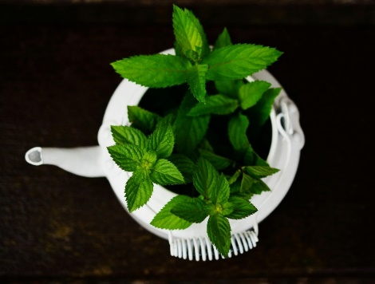Family : Labiatae

Botanical name : Mentha pipertia L.

Parts used **:** Leaves & whole plant

**Chemical constituents :** Menthol, Menthone, Menthyl acetate, Menthofuran, 1,8-cineol, Limonene, Pilegone, Caryophyllene, Pinene, Eriocitrin, Hesperidin[16]

**Mechanism of action:**

Peppermint oil behaves as a smooth muscle relaxant by blocking the calcium channel. Menthol is the major ingredient in peppermint oil. Regulate visceral sensation: pepper oil (menthol) is often used as a topical analgesic, and when taken orally, it reduces visceral discomfort Peppermint oil has antibacterial, antifungal, and antiviral properties that are beneficial to select anaerobes. Regulate immune system: Menthol suppresses the release of inflammatory mediators in human monocytes, indicating that it has anti-inflammatory

**Pharmacokinetics :** Absorption: Because peppermint oil (menthol) is highly fat soluble, it absorbs quickly into the proximal intestine after intake.

**Metabolism :**Menthol is mostly metabolised in the liver, with simple glucoronides and oxidation products as metabolites.

**Excretion :**Menthol is mostly eliminated in the bile, although it is also excreted in the kidneys and faeces.[17]

**Uses:**

• Cough

• Reduces spasm

• It protect from gingivitis

• In migraine headache

• Sore throat

• Help in healing of ulcer

• Kill parasites

**Side Effects:**

• Severe burning

• Burning sensation on skin

• Heart burn

• Allergic reaction (mouth sore)

• Nervousness

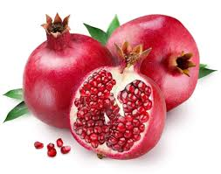**2.Pomegranate:**

Botanical Name : Punica Granatum

Kingdom : Plantae (angiosperms)

Order : Myrtales

Family : Lythraceae

Genus : Punica

Species : Pgranatum[18]

**Chemical Constituents** : Anthocyanins, Quercetin, Gallic acid, Asistic acid, Rutin, Punicic acid,Flavones, Punicalin.[19]

**Mechanism of Action:** Pomegranate ellagitannins interact with gut microflora, killing acute and chronic intestinal disorders. Punicalagins stimulate the peroxisome proliferator-activated receptors (PPARs), which inhibit the development of pathogens such as staphylococcus aureus, clostridia species, and pseudomonas aeruginosa. Pomegranates stimulate the PPARβ/δ, PPARα and PPARγ receptors, which help to reduce obesity and insulin resistance. Activation of PPAR, which suppresses the transcription of pro-inflammatory molecules, has an anti-inflammatory impact. Cox 2 has anti-cancer properties via the NF-kB and MAPK pathways.[20]

**Uses:**

• Sore throats

• Digestive disorder

• Tape worms

• Prostate cancer

• Diabetes

• Arthritis

• Osteoarthritis

• Urinary infection

• Free radical scavengers

**Side Effects:**

• Itching

• Swelling

• Runny nose

• Difficulty breathing

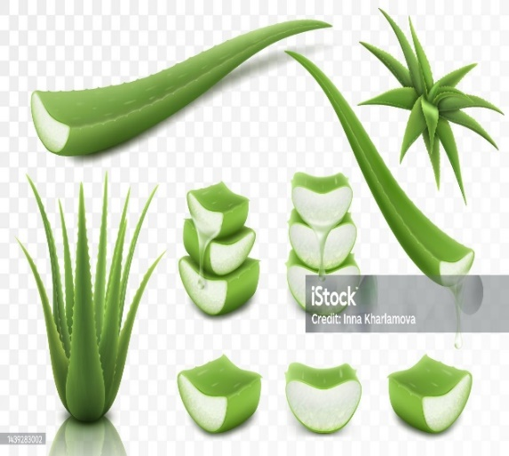**3. Aloe Vera:**

Kingdom : Plantae

Order : Asparagales

Division : Spermatophyta

Class : Monocotyledoneae

Family : Liliaceae

Genus **:** Aloe[21]

* **Chemical Constituents & Active Components:**

**Vitamins –** Vit-A,C,E,B1, B2,B6 and B12

**Enzymes –** Aliiase, amylase, oxidase, catalase, lipase

**Minerals –** Calcium, copper, potassium selenium,chromium

**Sugars –** Glucose, polymannose, alprogen,

**Organic Acids** – salicylic acid sorbate

**Anthraquinones -** Aloin, anthranol, emodin.

**Fatty acids & Steroids –** Beta-sisosterol, Lupeol, cholesterol

**Non-essential amino acid-** Arginine, glycine, alanine

**Essential aminoacids** – Methionine, leucine, lysine

**Hormones** – Auxins, Gibberellin.[21]

**Mechanism of Action:**

**Anti-aging —** Oligoelements such as manganese and selenium produce the antioxidant enzymes glutathione peroxidase and superoxide dismutase, which aid in cellular anti-aging. **Healing effect –** Gibberlin (growth hormones) and glucomannan (mannose rich polysaccharide) interacts with the receptor of growth factor on fibroblasts,causing collagen production to rise**Anti Viral and Anti Tumor –** Here by indirect action immune system is stimulated and it’s direct action posses by enthraquinones. **Anti-Diabetic –** Aloe vera gel reduce the free fatty acid, fasting blood glucose tissue cholesterol and increases the plasma insulin levels. [21,22]

**Uses:**

• Anti aging

• Anti fungal

• Anti oxidant

• Analgesic

• Anti cancer • Hepatoprotective

• Wound healing

• Anti inflammatory

**Side Effects:**

• Stinging sensation

• Redness

• Red urine

• Abdominal cramps [21,22]

**4. Coconut Oil:**

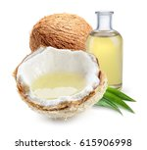Kingdom : Plantae

Family : Arecaceae

Order : Arecales

Genus : Cocos L.

Species : C. nucifera [23]

**Chemical Constituents:** Saturated fats : Lauric acid (45% to 52%), Myristic acid (16% to 21%), Palmitic acid (7% to 10%), Caprylic acid (5% to 10%), Capric acid ( 4% to 8%), Stearic acid (2% to 4%), Caproic acid (0.5% to 1%), Palmitoleic acid ( in traces)

Unsaturated fats: Oleic acid (5% to 8%), Linoleic acid (1% to 3%), Linolenic acid (up to 0.2%)

**Mechanism of Action with Therapeutic benefits:**

**Wound Healing Effect:**Virgin coconut oil (VCO) increase the wounds healing activity much rapid by decreased the epithilization add on to various levels of tissue of the wound’s granulation. Collagen soluble pepsin enhance the VCO thus cross-linking of collagen increase **Anti-inflammatory, Antipyretic & Analgesic Effects of VCO:** Anti-inflammatory action of VCO is shown by reducing the phosphatase activity, transudative weight, seum alkaline and granuloma formation. Antipyretic action is due to yeast-induced hyperthermia & each analgesic action due to induced of acitic acid. **Dermatitis Effect of VCO:** In Atopic dermatitis condition the VCO act by decreasing the transepidermal water loss thus increase the function of epidermal barrier and provide hydration Antioxidant Activity: VCO reduce the inflammation and lipid peroxidation by increasing the antioxidant enzyme level as it’s rich in polyphenols.

**5.Tulsi:**

Kingdom : Plantae

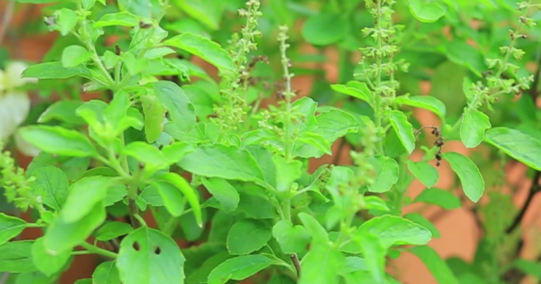

[This Photo](https://www.phakhaolao.la/kb/0000324) by Unknown Author is licensed under [CC BY](https://creativecommons.org/licenses/by/3.0/)

Order : Lamiales

Class : Magnoliopsida

Family : Lamiaceae

Genus : Ocimum

Species : O. sanctum [24]

**Chemical Constituents & Active Components:** Eugenol, methyl eugenol, carvacrol, sesquiterpine hydrocarbon caryophyllene, cirsilineol, rosameric acid, isothymusin, curcimaritin, apigenin.[25]

**Mechanism of Action:** **Skin Care:** To treat ringworm and other associated disorders such as leucoderma, a paste made from tulsi leaves is administered to the afflicted region. Tulsi leaves are used to cure chicken pox when applied topically with saffron. **Antioxidant Property:** The antioxidant potential of essential oils produced by steam hydro distillation from Ocimum sanctum was assessed using hypoxanthine xanthine oxidase with OPPH tests based on high performance liquid chromatography (HPLC). Ocimum sanctum showed significant antioxidant ability in a hypoxanthine xanthine oxidase experiment. **Antifungal:** Methanolic and aqueous fractions of Ocimum sanctum demonstrated antifungal efficacy against dermatophytic fungus such as T. rubrum and others. In comparison to the methanolic fraction, the aqueous fraction had superior anti-dermatophytic efficacy.[26,27]

**6. Ginseng:**

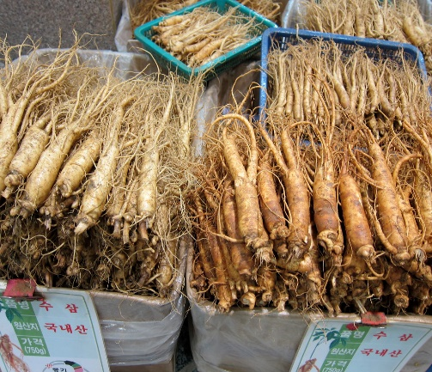

[This Photo](https://www.flickr.com/photos/eekim/5152649004) by Unknown Author is licensed under [CC BY](https://creativecommons.org/licenses/by/3.0/)

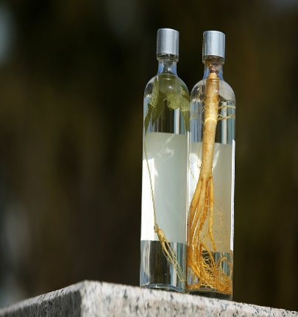

[This Photo](https://www.flickr.com/photos/koreanet/16615045126/) by Unknown Author is licensed under [CC BY-SA](https://creativecommons.org/licenses/by-sa/3.0/)

Kingdom : Plantae

Order : Apiales

Class : Magnoliopsida

Family : Araliaceae

Genus : Panax L.

Species : Panax ginseng[28]

**Chemical Constituents:**[17,18] Triterpenoid glycosides, also known as ginsenosides, are the most active components in ginseng. Ginsenosides are divided into two groups: protopanaxadiols (PPD), which include Rb1, Rb2, Rg3, Rh2, Rc, Rd, & Rh3; and protopanaxatriols (PPT), which include Rg1, Rg2, Rh1, Re, & Rf. It also includes saponins, polysaccharides, amino acids, volatile oil, polyacetylenes.[29,30]

**Mechanism of Action:** **Skin elasticity/Collagen:** Ginseng can help the skin keep its smoothness by slowing the loss of collagen. "There are so many chemicals in ginseng root," It contains vitamin D & vitamin B12." All of this leads to enhanced oxygen circulation, as well as an increase in collagen formation in the dermis of skin." **Antioxidant and blood circulation:** Ginseng also plays an antioxidant action via Nrf2 and increases the amounts of antioxidant enzymes including superoxide dismutase and glutathione peroxidase. **Neuroprotection:** Modulation of the Akt and ERK 1/2 signalling pathways, repression of NF-𝜅𝜅B, control of Ca2+ overinflux, shielding against NO excess production, and decrease of the apoptosis-inducing factor.[30,31]

**EVALUATION TEST OF CREAM**

1. **Oganoleptic evaluation:**

The cream thus obtained was evaluated for its organoleptic properties like color, odor, and state. The appearance of the cream was judged by its color and roughness.

1. **Washability:**

The cream was applied on the hand and observed under the running**.**

1. **pH of the cream:**

The pH meter was calibratedusing standard buffer solution. Weigh 0.5 gm of cream dissolved it in 50 ml of distilled water and its pH was measured with the help of digital pH meter.

1. **Acid value:**

10g of the cream was dissolved in 50ml mixture of equal volume of alcohol and solvent ether in a flask. The flask is connected to a reflux condenser and slowly heated, until the sample dissolve completely, to this 1ml of phenolphthalein was added and titrated with 0.1N NaOH, until faintly pink colour appears after shaking for 30sec. Acid value= n*5.61/w Where, n= The number of ml of NaOH required w = The weight of the cream

1. **Saponification Value:**

2g of the cream was refluxed with 25ml of 0.5N alcoholic KOH for 30min, to this 1ml of phenolphthalein is added and titrated immediately, with 0.5N HCL. Saponification value=(b-a)*28.05/w

Where, a= volume of titrant

b= volume of titrate

w= weight of the cream

1. **Accelerated stability testing:**

The purpose of stability testing is to provide evidence on how the quality of drug substance or drug product varies with time under the influence of variety of environmental factors such as temperature, humidity and light and enables to recommend storage condition and to predict the shelf life. Stability study for cream was performed at accelerated condition i.e., 40°C±2°C / 75%RH±5%RH. The formulations were kept both at room and elevated temperature and observed on 0,5th, 10th, 15th and 20th day for the various parameters.[32]

1. **Irritancy test:**

Mark an area (1sq.cm) on the left-hand dorsal surface. The cream was applied to the specified area and time was noted. Irritancy, erythema, edema, was checked if any for regular intervals up to 24hours and reported

1. **Homogeneity:**

The formulations were tested for homogeneity by visual appearance and by touch.[33]

1. **Test for Microbial Growth:**

Agar media was prepared then the formulated cream was inoculated on the plate’s agar media by steak plate method and a controlled is prepared by omitting the cream. The plates were placed in the incubator and are incubated in 37 C for 24 hours. After the incubation period, the plates were taken out and the microbial growth were checked and compared with the control.[34]

1. **Spreadability Test:**

Spread ability of formulated cream was measured by placing sample in between two slides then compressed to uniform thickness by placing a definite weight for defined time. The specified time required to separate the two slides was measured as spread ability. Lesser the time taken for separation of two slides results showed better spread ability. Spread ability was calculated by the following formula.[26] Spreadability = m×l /T Where, m = weight tied to the upper slide (30g), l =length of glass slide (5cm), t =time taken in seconds. (10 sec).[35]

1. **Phase Separation:**

The prepared cream was transferred in a suitable wide mouth container. Set aside for storage the oil phase and aqueous phase separation were visualizing after 24 hours.[36]

**Ideal Properties of Herbal Cold Cream**

1. It should not normally be diluted.

2. The pH of the cold cream must be optimum from 4.6–6.0

3. Its consistency should be optimum so that it can be easily put out from the container and apply easily.

4. Should give a cooling effect on the skin after external application.

5. It must provide a thin waxy protective layer on the skin to protect the water evaporation from the skin surface.

6. Should give a faster emollient effect, so that very dry skin can swell up and become soft within a short time.

7. Less greasy than ointment and Easily spread on the skin.

8. It should be physically and chemically stable throughout its shelf-life.

9. The excipients should be compatible with each other. It should be sterile [37,38]

**Usage of Anti-aging cream**

* Use anti-getting old creams to moisturize,
* brighten,
* tighten, and lift up your sagging skin,
* specifically the skin around your eyes and neck. those potions do not have artificial colourings, scents, and parabens.
* The moisturizing impact of those lotions will work wonders on males and females’ skin.[39]

**Some Incredible benefits of using anti-aging creams**

• Pores and pores and skin Tightening and Hydration

• Benefit pores and pores and skin Radiance

• Will increase your self-confidence

• Advantageous impact to your fitness

• Prevents the occurrence of age spots and discoloration

• It saves you from highly-priced dermal techniques.[39]

**Reference :**

1. Archived from the original on 2014-07-10. Retrieved 2012-02-14
2. Varani J, Warner RL, Gharaee-Kermani M, Phan SH, Kang S, Chung JH, et al. Vitamin A antagonizes decreased cell growth and elevated collagendegrading matrix metalloproteinases and stimulates collagen accumulation in naturally aged human skin. J Invest Dermatol. 2000; 114:480–6. doi: 10.1046/j.1523-1747.2000.00902.x. [PubMed] [CrossRef] [Google Scholar] Image Source – seniority.in [Google Scholar]
3. Kaur IP, Kapila M, Agarwal R. Role of novel delivery Systems in developing topical antioxidants as therapeutics To combat photo aging, Int J of Pharm Sci, 2007; 6:271-288.
4. Uitto J. Understanding premature skin aging. N Engl J Med 1997; 337:1463-5; PMID:9358147; http:// dx.doi.org/10.1056/NEJM199711133372011
5. Scaffidi P, Misteli T. Lamin A-dependent nuclear defects in human aging. Science 2006; 312:1059- 63; PMID:16645051; http://dx.doi.org/10.1126/science.1127168
6. Fisher, G.J. The pathophysiology of photoaging of the skin. Cutis, 75, 5–9 (2005)58–69
7. Schmuth M, Watson RE, Deplewski D, Dubrac S, Zouboulis CC, Griffiths CE. Nuclear hormone receptors in human skin. Horm Metab Res 2007; 39:96-105; PMID:17326005; http://dx.doi. org/10.1055/s-2007-961808
8. Reichrath J, Lehmann B, Carlberg C, Varani J, Zouboulis CC. Vitamins as hormones. Horm Metab Res 2007; 39:71-84; PMID:17326003; http://dx.doi. org/10.1055/s-2007-958715
9. Verdier-Sévrain S, Bonté F, Gilchrest B. Biology of estrogens in skin: implications for skin aging. Exp Dermatol 2006; 15:83-94; PMID:16433679; http:// dx.doi.org/10.1111/j.1600-0625.2005.00377.x
10. Susan J. Hewlings et al.” Curcumin: A Review of Its’ Effects on Human Health”, MDPI Foods 2017, 6, 92;Hall G, Phillips TJ. Estrogen and skin: the effects of estrogen, menopause, and hormone replacement therapy on the skin. J Am Acad Dermatol 2005; 53:555-68, quiz 569-72; PMID:16198774; http:// dx.doi.org/10.1016/j.jaad.2004.08.039
11. Brincat MP, Baron YM, Galea R. Estrogens and the skin. Climacteric 2005; 8:110-23; PMID:16096167; <http://dx.doi.org/10.1080/13697130500118100>
12. Draelos ZD. Topical and oral estrogens revisited for antiaging purposes. Fertil Steril 2005; 84:291- 2, discussion 295; PMID:16084864; http://dx.doi. org/10.1016/j.fertnstert.2005.03.033
13. Kanda N, Watanabe S. Regulatory roles of sex hormones in cutaneous biology and immunology. J Dermatol Sci 2005; 38:1-7; PMID:15795118; http:// dx.doi.org/10.1016/j.jdermsci.2004.10.011
14. Shin MH, Rhie GE, Park CH, Kim KH, Cho KH, Eun HC, et al. Modulation of collagen metabolism by the topical application of dehydroepiandrosterone to human skin. J Invest Dermatol 2005; 124:315-23; PMID:15675949; [http://dx.doi.org/10.1111/j.0022- 202X.2004.23588.x](http://dx.doi.org/10.1111/j.0022-%20202X.2004.23588.x)
15. Puangsri T, Abdulkarim SM, Ghazali HM (2005) Properties of Carica papaya L. [Papaya] seed oil following extraction using solvent and aqueous enzymatic methods. J. Food Lipids 12:62–67. doi: 10.1111/j.1745- 4522.2005.00006.x
16. Prof Dr Ali Esmail Al-Snafi,” Chemical constituents, pharmacological effects and therapeutic importance of Hibiscus rosasinensis- A review”, IOSR Journal Of Pharmacy, Volume 8, Issue 7 Version. II (July 2018), PP. 101-119
17. Missoum Asmaa,”An update review on Hibiscus rosa sinensis phytochemistry and medicinal uses”, Journal of Ayurvedic and Herbal Medicine 2018; 4(3): 135-146.
18. Sangram et al,“pharmaceutical and pharmacological activities of Hibiscus rosa sinensis MUCILAGE”, The Global Journal of Pharmaceutical Research Vol. 2 (3), pp. 1822-29
19. <https://en.wikipedia.org/wiki/Turmeric>
20. Susan J. Hewlings et al.” Curcumin: A Review of Its’ Effects on Human Health”, MDPI Foods 2017, 6, 92;
21. https://www.webmd.com/vitamins/ai/ing redientmono-662/turmeric
22. <https://greatist.com/health/turmeric-forskin#fade-acne-scars>.
23. Khurshid et al. “Green Tea (Camellia Sinensis): Chemistry and Oral Health”, The Open Dentistry Journal, 2016, 10, (Suppl-1, M3) 166-173.
24. Talreja et al. “A Complete Pharmacognostic Review On Amla”, WIPPS; Volume 8, Issue 4, 622-637.
25. Dasaroju Swetha et al. “Current Trends in the Research of Emblica officinalis (Amla): A Pharmacological Perspective”, Int. J. Pharm. Sci. Rev. Res., 24(2), Jan – Feb 2014; nᵒ 25, 150-159.
26. Talreja et al. “A Complete Pharmacognostic Review On Amla”, WIPPS; Volume 8, Issue 4, 622-637.
27. Dasaroju Swetha et al. “Current Trends in the Research of Emblica officinalis (Amla): A Pharmacological Perspective”, Int. J. Pharm. Sci. Rev. Res., 24(2), Jan – Feb 2014; nᵒ 25, 150-159.
28. <https://www.tuscany> diet.net/2015/03/08/olive-oil-chemical composition
29. Badiu Diana, et al.” Effect of Olive Oil on the Skin”, Olives and Olive Oil in Health and Disease Prevention. ISBN: 978-0-12-374420-3; 1125-1132.
30. Md. Keen Adid, Hasan Iffat, “Vitamin E in dermatology”, Indian Dermatology Online Journal - July-August 2016 - Volume 7 - Issue 4; 311-315.
31. Syed T. Raza et al. “The Role of Vitamin E in Human Health and Some Diseases”, SQU Medical Journal, May 2014, Volume 14, Issue 2; pp. e157-165.
32. Indian Materia Medica by K M Nadkarni, 1st Edn by A. K. Nadkarni, Popular Prakashan Pvt. Ltd, Bombay,1954, pp.273-277.
33. Marotta F, Weksler M, Naito Y, Yoshida C, Yoshioka M and Marandola P, Nutraceutical supplementation,effect of a fermented papaya preparation on redox status and DNA damage in healthy elderly individuals and relationship with GSTM1 genotype, a randomized, placebo-controlled, cross-over study, Ann N Y Acad Sci, 2006, 1067(1): 400-407.
34. Pal Arti, Soni Manish*, Patidar Kalpana, Mandsaur Institute of pharmacy, Mandsaur 458001. (M.P), Formulation and Evaluation of Poly Herbal Cream, International Journal of Pharmaceutical & Biological Archives, 2014; 5(4): 67–71.
35. Arya Vaidya Sala, Carica papaya, In: Indian Medicinal Plants & Compendium of 500 species, 1st Edn, Vol I, Orient Longman Pvt Ltd, Hyderabad, 2005, pp. 383-384.
36. Indian Medicinal Plants by KR Kirtikar and BD Basu, Reprint, 2nd Edn, International Book Distributors,Dehra Dun, Vol. II, 1998, pp.1097-1099.
37. Mali, A. S., Karekar, P., &Yadav, A. V. (2015). Formulation and evaluation of multipurpose herbal cream. International Journal of Science and Research, International Journal of Science and Research, 4(11), 1495- 1498.
38. R. Patel, H. U.Momin, R.L. Dhumal, K, L. Mohite, (2017), Prepara preparation and evaluation of multipurpose herbal cream , Adv Pharm Life sci Res;5(1);27-32.
39. ^ "Anti-aging cosmetic reduced wrinkles in clinical trial". Eurekalert.org. 2009-04-28. Retrieved 2012-02-14. [https://www.lux-review.com/6- incredible-benefits-of-using-anti-aging-creams/](https://www.lux-review.com/6-%20incredible-benefits-of-using-anti-aging-creams/).