Paper Title (16 Bold)

First Author¹, Second Author² (14 Bold)
Research scholar, Department of Pharmaceutical Science, JNTUH, Hyderabad, (10 Italic)
Department of Pharmacognosy, Anurag Pharmacy College, Kodad, Telangana, India.
Corresponding Author:
Received XXXX 2019; Accepted XXXX 2019

Abstract: (11Bold) Investigations were conducted to determine the identity and sensitivity patterns of microorganisms isolated from wounds of diabetic patients to the selected medicinal plants. The efficacy of the plants was compared with standard antibiotics/ antifungal agents using agar well diffusion method. Ethanol, n- Hexane, cold water and hot water were used as solvents for the extraction at different concentrations. Bacteria isolated from the wound swabs include; Bacillus subtilis, Enterobacter cloacae, Escherichia coli, Klebsiella pneumonia, Micrococcus luteus, Proteus vulgaris, Pseudomonas aeruginosa, Serratiamarcescens,Salmonella typhil, Shigellaflexineri, Staphylococcus aureus, Staphylococcus epidermidis, Streptococcus pyogenesand Pseudomonas Putidae, and fungal isolates viz; Candida albicans, Candida dubliniensis,Neurosporacrassaand Saccharomyces cerevisiae. Staphylococcus aureusand Pseudomonas aeruginosawere the most frequently encountered bacteria, whereas Candida dubliniensis and Candida albicans were the most frequently isolated fungi from the wound samples. Quantitative phytochemical screening revealed the highest amount of saponins in Jatrophacurcas, while Nicotianatabacum had the highest concentration of alkaloids. Nicotianatabacum had considerable amount of anti-oxidant and total phenol compared with Jatrophacurcas. Ethanolic and hot water extracts induced remarkable antimicrobial activity, than the other solvents, hence, Ethanol rated best as the extraction solvent, followed by hot water, n- Hexane and cold water in that order. The extracts were found to induce remarkable antimicrobial potential against the test organisms, most especially the hot water and ethanolic extracts with varying ranges of inhibition against the isolates. Generally the antimicrobial potential of the extracts increased with a corresponding increase in extract concentration. Proteus vulgaris and Escherichia coliwere most susceptible to 75% of ethanolicextracts, Jatrophacurcasat 75% ethanolic root extracts with12.50±0.00mm and 12.50±0.33mm diameter of the zones of inhibition. Ethanolic seed extracts of Jatrophacurcasat 75% concentration was most effective against P. aeruginosawith 10.50±0.33mm diameter of the zone of inhibition, whereas P. aeruginosawas least susceptible at 75% n-hexane extracts with 3.50±0.00mm diameter of the zone of inhibition.Antimicrobial efficacy of the extracts of JatrophacurcasLinnand NicotianatabacumLinnevaluated in this study had been proven to be well effective and cheap preventive therapy against the microbial effects in wounds treatment that often facing antimicrobial resistance and it could be a suitable source of new antimicrobial natural product or as a base for the development of new drugs in phytomedicine. This intends to procure prevention and cure to microbial effects in the cases of delayed healing of diabetic wounds in spite of the use of broad spectrum standard antibiotics and to provide clinically relevant and comprehensive information on the virulence of diabetes wound’s isolates and their antibiotic resistance pattern of activity.

Keywords: (11Bold) Antimicrobial, Antibiotics/ Antifungal, Jatrophacurcas, Nicotianatabacum, Phytochemical, Antimicrobial Sensitivity and Sensitivity (10)

- INTRODUCTOION(11Bold)
The human body is a wonderful machine which requires fuel named oxygen for its function. It plays a pivotal role in the energy metabolism of the body which involves various physical and chemical processes ^{[1]} .While oxygen supports our life, it also produces free radicals (ROS) in the body as the waste products. Oxygen-centered free radicals (ROS) includes superoxide anion (O₂^{.-}), hydroxyl radical (.OH), hydrogen peroxide (H₂O₂), peroxyl, hypochlorous acid and nitric oxide ^{[2]}. These are highly reactive unstable molecules which have a hunger for electrons, reacts with biomolecules (lipids, proteins, DNA etc.) and alters its structure and function. This, in high levels, leads to oxidative stress ^{[3, 4]}.Oxidative stress occurs when our body defense systems fail to wipe off this excess amount of free radicals. These free radicals spring from different sources such as endogenous (mitochondria, peroxisomes, endoplasmic reticulum etc.) and exogenous (pollution, ionization radiation etc.) sources ^{[5]}.It has implications for a broad range of disorders including stroke, ischemia-reperfusion injury, arthritis, cancer, diabetes, neurodegenerative diseases, spinal cord injury, cardiovascular diseases, sepsis, inflammation and respiratory diseases ^{[6, 7]}.Here comes the concept of antioxidants, nature’s way of cell defense against free radical (ROS) attack. These antioxidants synthesized invivo (SOD, catalase, glutathione peroxidase) or taken as dietary antioxidants (vitamin C, vitamin E, β-carotene and selenium) either quenches or scavenges free radicals (ROS) and repairs the damages caused by them ^{[8]}.The quest for effective and beneficial natural antioxidants has been increased nowadays as the synthetic antioxidants like butylated hydroxytoluene (BHT) and butylated hydroxyanisole (BHA) found to be harmful ^{[9]}.Plants are found to be a good source of natural antioxidants as they can synthesize phytoconstituents such as phenolics, tannins, flavonoids etc. in different parts which have the ability to scavenge free radicals ^{[10].} (10)
Taxillus heyneanus Danser (TH) and Dalechampia indica Wight (DI) plants were selected for the study. T. heyneanus (Loranthaceae), commonly called as badanika is a parasitic herb on shrubs and small trees common in dry deciduous forests of Andhra Pradesh, Karnataka, Kerala and Tamilnadu. Branches are densely covered with white shiny abietiform hairs intermixed with stellate hairs. Branchlets are tawny pubescent Nodes are prominently ribbed with leaf scars. Leaves are alternate, orbicular to ovate, attenuate at base, rounded at apex, crustaceous and evanescently hairy on both surfaces. The petiole is hairy to glabrous. Axillary Inflorescence which is shortly peduncled or sessile simple dichasium. Flowers are 5-merous with long pedicels. Bracts are obovate to oblanceolate and foliaceous. Calyculus is five lobed. Petals (5) are united to form a ventricose tube with a median split. Stamens are 5 in number. Oblong anther, turbinate ovary and bifid or depressed stigma are present. Fruits are broadly ellipsoid, crowned by persistent calyculus ^{[11-13]}. Dalechampia indica (Euphorbiaceae), commonly called as aliparnika, is a twining undershrub commonly found in dry hills of Andhra Pradesh and Tamil Nadu. This is finely pubescent with stinging hairs except on upper surface of leaves. Leaves are foliolate, chartaceous, glabrous whereas leaflets are sessile or shortly petiolulate, which is acute to rounded at base and short-acuminate at the apex. Flowers are surrounded by fleshy scales formed out of deformed flowers. Female flowers are ciliate with stalked glands along margins; pubescent globose ovary, long style, copular stigma, depressed-subglobose fruits, glandular hairy fruiting calyx and mottled dark grey globose seeds are present ^{[14.15]}. (10)
Though, both the plants come under the category of medicinal plants, the exact traditional uses of them were not mentioned in the literature. In the present study, the whole plant of Dalechampia indica (DI) and Taxillus heyneanus (TH) were evaluated for DPPH, Hydrogen peroxide, Nitric oxide radical scavenging activities, Reducing power assay, Total phenolic content (TPC) and Total flavonoid content (TFC).

- MATERIALS AND METHODS(11Bold)
2.1 Plant material Collection and Authentication(10Bold)
The whole plant of both T. heyneus and D. indica were collected in the month of April, 2014 from chittur dist. The plant materials were identified and authenticated by Prof. Madhav Shetty, Dept. of botany, Taxonomist, SV University, Tirupati. A voucher was kept in the Department of Pharmacognosy for reference.

2.2 Chemicals (10 Bold)
The chemical agents such as 1,1-Diphenyl-2-picrylhydrazyl (DPPH) , ferric chloride (FeCl₃), Folin-Ciocalteu Phenolic reagent, Sodium bicarbonate, Potassium ferricyanide, L- Ascorbic acid, ethanol,chloroform,PET ether,Ethylenediamine tetraacetic acid (EDTA),Ferric chloride, sodium nitroprusside, Hydrogen peroxide (H₂O₂), rutin, glacial acetic acid, sulphanilamide, Trichloroacetic acid (TCA) and Sodium hydroxide were purchased from Sigma Chemicals Co. (St. Louis, USA) or Himedia, Mumbai. All the chemicals used were of analytical grade.

2.3 Preparation and Fractionation of crude extract of plant material(10Bold)
Plant materials were first chopped, then washed with fresh water to remove dirt and other contaminants. They were shade-dried for several days with occasional sun drying. The dried materials were pulverized into coarse powder by a grinding machine and the materials were stored at room temperature (RT) for future use. The dried coarse powder (150g) of plant extracts was macerated with absolute ethanol at room temperature for a period of 10 days with frequent agitation in clean, sterilized and properly sealed flat bottomed glass container. The solution was then subjected to filtration on a piece of clean, plain sterilized cotton cloth. The resulting filtrate was concentrated on a water bath maintaining 40°C to dryness. The concentrate obtained was designated as crude extract ^{[16]}. The crude extracts (10g) of each plant were subjected to fractionation by suspending in EOH: H₂O (3:7; v/v) and extracted successively with petroleum ether and chloroform in this order using separating funnel. Dried plant extracts of different solvents were weighed and stored for future use ^{[18]}. PET ether fraction of the plants formed was very little which is insufficient to carry out analysis. In the present study, except PET ether extracts, the ethanolic (ETH & EDI) and chloroform fractions (CTH & CDI) of crude extracts of T. heyneus and D. indica were analyzed for invitro antioxidant activity, total phenolic and total flavonoid content. (10)

2.4 Estimation of Total Phenolic Content (TPC) (10 Bold)
The phenolic content in plant extracts was determined using spectrophotometric method ^{[17]}. The reaction mixture was prepared by mixing 0.5 ml (1 mg/ml) sample solution of extract with 2.5 ml of 10% Folin-Ciocalteu’s reagent dissolved in water and 2.5 ml 7.5% NaHCO₃. Blank was concomitantly prepared, containing 0.5 ml ethanol, 2.5 ml 10% Folin-Ciocalteu’s reagent and 2.5 ml of 7.5% of NaHCO₃. The samples were thereafter incubated in a thermostat at 45ºC for 45 min. The absorbance was measured using spectrophotometer at 765 nm. The samples were prepared in triplicate and the mean value of absorbance was obtained. The same procedure was repeated for the standard solution of gallic acid (25, 50, 75,100 & 250 µg/ml) and the calibration line was construed. Based on the measured absorbance, the concentration of phenolics in the extract was read (mg/ml) from equation obtained from the constructed calibration line of gallic acid and expressed in terms of gallic acid equivalent (mg of GAE/g of extract) ^{[19]}. (10)

2.5 Total Flavonoid Content estimation (TFC) (10 Bold)
Total flavonoid content of different fractions of plant extracts ( ETH, EDI, CTH & CDI) was measured by the aluminum chloride colorimetric assay.1 ml of sample extract solution of concentration 1mg/ml and 4 ml of distilled water was taken in a 10 ml volumetric flask. To the flask, 0.30 ml of 5 % sodium nitrite was added and allowed to stand for 5 minutes, then 2 ml of 1M Sodium hydroxide was treated and volume was made up to 10 ml with distilled water. A set of reference standard solutions of rutin (25, 50, 75, 100 and 250 μg/ml) were prepared in the same manner as described earlier. The absorbance of test and standard solutions were determined against the blank at 510 nm using UV/Visible spectrophotometer ^{[20]}. Based on the measured absorbance, the concentration of flavonoids in the extract was read (mg/ml) from equation obtained from the Rutin calibration line and was expressed was expressed as mg of RE/g of extract.

2.6 DPPH free radical scavenging assay (10 Bold)
The free-radical scavenging activity of the plant extracts was determined by the method described by Chang et al using DPPH with some modifications ^{[21]}. Various concentrations (25, 50, 75,100 & 250µg/ml) of plant extracts were obtained from stock solution (1 mg/ml) by serial dilutions in respective solvent systems. In this method, 1 ml of extract solutions of various concentrations was added to freshly prepared 4ml of 0.004% of the ethanolic DPPH solution and mixed properly. Then the solutions were allowed to stand for 30 mins at room temperature in dark for the chemical reaction to occur. After half an hour, absorbance was measured against blank at 517 nm using a UV-Visible spectrophotometer. Ethanol served as blank. Ascorbic acid used as a standard. A control sample was prepared in a similar way without adding any extract and standard solution in the reaction mixture. The percentage scavenging activity of plant extracts was calculated as:
% scavenging activity = (Ab_{control}-Ab_{sample}/Ab_{control}) × 100 (1)

Where Ab_{control} indicates absorbance of control & Ab_{sample} indicates absorbance of sample

2.7 Reducing power assay(10 Bold)
Oyaizu method was followed to determine the reducing power of different fractions (ETH, EDI, CTH and CDI) of crude extracts ^{[22]}. One ml of extract solution of various concentrations (25, 50, 75,100,250 µg/ml) was mixed with 2.5 ml of phosphate buffer (0.2 M, pH 6.6) and 2.5 ml of (1% w/v) potassium ferricyanide [K3Fe(CN)6]. This mixture was incubated at 50 °C for 20 min. By adding 2.5 ml of 10% trichloroacetic acid the reaction was terminated and centrifuged at 3000 rpm for 10 min. After centrifugation, 2.5 ml of the supernatant solution was mixed with distilled water (2.5 ml) and 0.1% ferric chloride (0.5 ml) solution. Then the absorbance was read at 700 nm against a blank using UV spectrophotometer. Increased absorbance value of the reaction mixture indicates increased reducing power. Each test sample was made in triplicates and average data was noted. Here, ascorbic acid was standard. (10)

2.8 Hydrogen peroxide scavenging assay (10 Bold)
Scavenging activity of plant extracts and its subfractions (ETH, EDI, CTH and CDI) were determined by Ruch et al method with slight modification using hydrogen peroxide ^{[23]}. 40 mM of the H₂O₂ solution was prepared in PBS (pH 7.4). 4 ml of plant extract solution prepared in ethanol at various concentrations (25, 50, 75,100,250 µg/ml) was mixed with 0.6 mL of 40mM H₂O₂ solution and incubated for 10 min. The absorbance of the solution was determined at 230 nm against a blank containing the extract in PBS without H₂O₂. Ascorbic acid was used as a standard. The amount of hydrogen peroxide radical scavenged by the extract was calculated using the following equation:
% Inhibition= (A_{control}-A_{test}/A_{control}) ×100 (2)

Where Ab_{control} indicates absorbance of control & Ab_{sample} indicates absorbance of sample
2.9 Nitric oxide scavenging assay(10 Bold)
This assay was determined by Griess Illosvoy reaction using sodium nitroprusside ^{[24]}. 0.5 ml of extract fractions (ETH, EDI, CTH and CDI) at various concentrations (25, 50, 75,100,250 µg/ml) was mixed with 2 ml of 10 mM sodium nitroprusside in 0.5 ml phosphate buffer saline (pH 7.4) and incubated at 25°C for 150 minutes. From this mixture, 0.5 ml was taken out and 1.0 ml sulphanilamide solution (0.33% in 20% glacial acetic acid) was added to it. It was further incubated at room temperature for 5 more minutes. Finally, 1.0 ml (0.1% w/v) naphthyl ethylenediamine dihydrochloride was mixed and allowed to stand at room temperature for 30 minutes. A control solution contained the same solution mixture without plant extract or standard. Ascorbic acid was used as a standard. The absorbance of the control, standard and sample solution was measured at 546 nm. The percentage inhibition was calculated according to the following equation:

NO Scavenged (%) = (A _{cont} - A _{test})/A _{cont} × 100 (3)

Where A_{cont} is the absorbance of the control and A_{test} is the absorbance of the extract solution
2.10 Statistical Analysis
All the experiments were done in triplicates. The experimental results are expressed as mean ± SD of triplets. Statistical analysis was performed using Graph Pad Prism Software, Version 7 (Graph Pad Software, San Diego, CA, USA).

- RESULTS AND DISCUSSION(11Bold)
Most of the natural antioxidants perform different functions. Therefore, a reliable antioxidant evaluation protocol requires different assessments of antioxidant activity to account various mechanisms of action. In this study, several techniques have been used to determine the invitro antioxidant activity to allow rapid screening of substances such as DPPH, Hydrogen peroxide, Nitric oxide scavenging activity and reducing power assay. The fractions were also evaluated for the presence of phenolic and flavonoid content which are responsible for antioxidant activity.

3.1 Total phenolic content(10Bold)
Phenolic content in the given plant extracts was determined by using Folin-Ciocalteu reagent. This is also called as Gallic acid equivalence method as the total phenolic amount was calculated from the equation (y=0.0084x+0.3499, R² = 0.991) obtained from gallic acid standard curve (Fig 1A) and results were expressed as mg gallic acid equivalents (GAE)/g dry extract. This method is preferred more because of its accuracy. In the present study, the ethanolic extracts (ETH & EDI) of the plants T. heyneanus and D. indica showed comparatively high phenolic content (125.40±5.24,71.54±3.58 mg GAE/G dry extract) than chloroform (CTH & CDI) extracts (66.61±3.78,35.29±4.36 mg GAE/G dry extract) respectively. Among all ETH showed high phenolic content whereas CDB showed the least. The results were given in Table 1 and Fig 1C.
Phenolic compounds are the plant’s secondary metabolites with one or more hydroxyl groups linked to aromatic rings, perform various physiological functions which include antioxidant activity as they are excellent oxygen radical scavengers and free radical terminators. Several studies have shown the close relationship between the total phenolic amount and antioxidant activity ^{[25]}.

3.2 Total flavonoid content(10 Bold)
Flavonoid content in plant extracts was obtained by Aluminum chloride colorimetric method using Alcl₃.It involves complex formation between the aluminum ion, Al (III), and the carbonyl and hydroxyl groups of flavonoids to produce characteristic yellow color ^{[26]}. Total flavonoid content was calculated from equation (y=0.009x+0.157, R² = 0.996) obtained from the standard calibration curve of rutin (Fig 1B). The ethanolic fraction of T.heyneanus extract showed highest flavonoid content (89.41±1.21mg RE/g dry extract) against other fractions (CTH, EDI, CDI) whose flavonoid content reported as 56.43±2.97,64.51±1.94 & 28.52±0.52 mg RE/g of dried weight, respectively. The results were seen in Table 1 & Fig 1D.
Flavonoids are polyphenolic plant metabolites that perform different functions and provide various potential health benefits to humans because of their antioxidant nature, anti-inflammatory, anticancer, antiviral, antibacterial, vasodilatory and immune stimulating activity^{[27]}.Flavonoids mediate their antioxidant effects by scavenging free radicals or by chelating metal ions or by inhibiting generation of free radicals ^{[28]}.

3.3 DPPH free radical scavenging activity(10 Bold)
Scavenging activity of crude extract fractions was determined based on their DPPH neutralization. The percentage scavenging activity of various concentrations (25, 50, 75,100,250 µg/ml) of all extract fractions and ascorbic acid (5, 10, 15, 20, 25µg/ml) determined, was found to be concentration dependent. More the scavenging activity, less is the IC₅₀ value. ETH showed maximum free radical scavenging activity with IC₅₀ 38.75±0.83 µg/ml when compared to other fractions (EDI, CTH, CDI) whose IC₅₀ Values were 135.04±3.99,105.72±5.11,477.61±0.69 µg/ml against the standard (7.56±0.24µg/ml). T.heyneanus fractions (ETH &CTH) showed good scavenging ability than D.indica fractions (EDI & CDI). Fig 2A, Table 2, and Fig 3 represents the percentage of DPPH neutralization activity and IC₅₀ of all extracts considered in the study.
DPPH (2, 2-diphenyl-1-picryl-hydrazyl) is a stable, free radical that produces purple color in alcohol. This color fades in presence of antioxidant molecule as it converts into 2, 2-diphenyl-1-picryl-hydrazine.More the scavenging ability less the absorbance detected at 517nm.This method was chosen as it is easy to perform and gives accurate results ^{[29]}. (10 )

3.4 Reducing power assay(10 Bold)
All four extracts fractions (ETH, CTH, EDB, and CDB) showed concentration-dependent reducing activity with increasing absorbance. Among all, ETH showed high reducing activity with more absorbance (0.883±0.03) when compared to other extracts (CTH, EDI, CDI) absorbance 0.365±0.04, 0.676±0.05, and 0.122±0.03 respectively at 250µg/ml concentration. The absorbance of ascorbic acid at its high concentration was 1.268±0.06. Fig 2B describes the reducing power of four extract fractions and ascorbic acid. In reducing power assay, the test solution changes color from yellow to green depending on the reducing power of the test sample. Antioxidants cause the reduction of the Fe³⁺/ferricyanide complex to the ferrous form which can be determined by absorbance measurement at 700 nm. Increasing absorbance at 700 nm indicates an increase in reducing ability ^{[30]}. The antioxidants present in the ethanolic fractions of T. heyneanus & D.indica caused the reduction of Fe³⁺ / ferricyanide complex to the ferrous form and thus proved to have good reducing power ^{[31]}.

3.5 Nitric oxide scavenging activity(10 Bold)
Figure 3 and Table 2 represents the comparative IC₅₀ values of various fractions of plant extracts and ascorbic acid (standard) were shown. All extracts have shown a significant amount of carrying activity which indicates antioxidant effect. ETH has shown low IC₅₀ (80.89±0.47µg/ml) whereas CDI showed high IC₅₀ (505.52±4.83 µg/ml).Ascorbic acid showed 18.47±1.24 µg/ml IC₅₀ value. Fig 2C shows the nitric oxide scavenging activity of extract fractions and ascorbic acid.
Nitric oxide (NO), an important chemical mediator generated by the human body responsible for altering structural and functional components of cell associated with several diseases ^{[32]}. In this assay, nitric oxide generated from sodium nitroprusside interacts with oxygen to produce nitric ions which can be estimated by the use of Griess reagent at 546 nm. Scavenger of nitric oxide competes with oxygen, leading to reduced production of nitric oxide indicated by a decrease in the absorbance ^{[33]}. This decrease in absorbance of ETH is attributed to the presence of phenolics and flavonoids that scavenge free radicals.

3.6 Hydrogen peroxide scavenging activity(10 Bold)
50% Hydrogen peroxide scavenging activity (IC₅₀) of different extract fractions is presented in Fig 3 & Table 2. High IC₅₀ values of CTH, EDB, and CDB (128.80±14.49, 153.80±9.61, 404.00±1.27µg/ml) indicate less antioxidant activity than ETH (62.67±5.23 µg/ml).The IC₅₀ value of standard was found to be 22.65±0.51 µg/ml. Percentage scavenging of hydrogen peroxide of all extract fractions and standard were given in Fig 2D.
Hydrogen peroxide, cytotoxic agent contribute to oxidative stress indirectly by generating highly reactive toxic hydroxyl radicals in the body which show deleterious effects on the cells by readily reacting with biological molecules ^{[34]}. The ethanolic fraction of T. heyneanus efficiently scavenged H₂O₂ may be attributed to the phenolic compounds that could donate electrons to hydrogen peroxide, thereby neutralizing it into water.

Table Size (10)
Table 1: Yield of the plant extract Jatrophacurcas Nicotianatabacum
Percentage yield (%)
Solvent | Stem | Leaf | Seed | Shaft | Root |  | Stem | Leaf | Seed | Shaft | Root
Ordinary Water | 15 | 22 | 9 | 8 | 18 |  | 11 | 25 | 8 | 6 | 19
Hot Water | 13 | 18 | 11 | 4 | 22 |  | 13 | 20 | 11 | 4 | 15
Normal –Hexane | 12 | 15 | 12 | 9 | 19 |  | 15 | 15 | 15 | 13 | 20
Ethanol | 25 | 29 | 15 | 10 | 25 |  | 22 | 27 | 17 | 18 | 27

Table2: IC₅₀ values of different extract fractions of plants and Ascorbic acid for various scavenging activities
Sample Extract IC₅₀(µg/ml)
DPPH HSA NSA

Taxillus heyneanus Ethanolic (ETH) 38.75±0.83 62.67±5.23 80.89±0.47
Chloroform (CTH) 105.72±5.11 128.80±1.49 176.00±5.60
Dalechampia.indica Ethanolic (ETH) 135.04±3.99 153.80±9.61 100.41±0.96
Chloroform (CTH) 477.61±0.69 404.00±0.38 505.52±4.83
Ascorbic acid ------------------- 7.56±0.24 22.65±0.51 18.47±1.24
Values presented as the mean ± SD, n = 3
Table Size (10)

Fig 1: Total Phenolic and Flavonoid content of various extract fractions of plants T.heyneanus & D.indica
A. Calibration curve of Gallic acid B. Calibration curve of Rutin
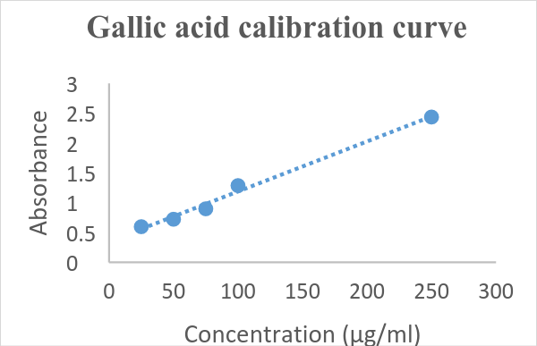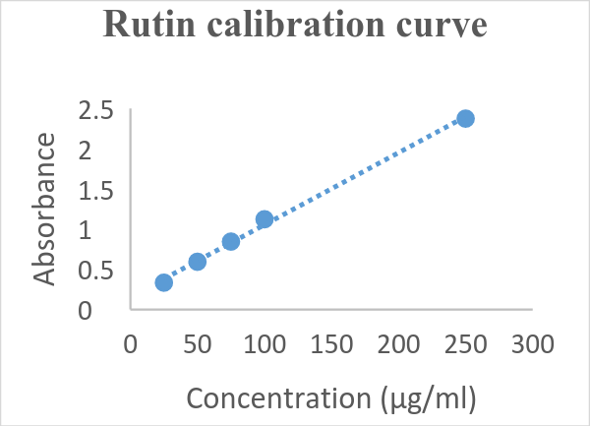

C. Total Phenolic Content of plant Extract Fractions D. Total Flavonoid Content of plant Extract Fractions
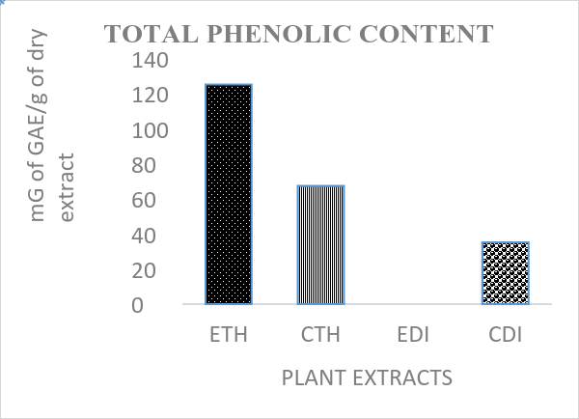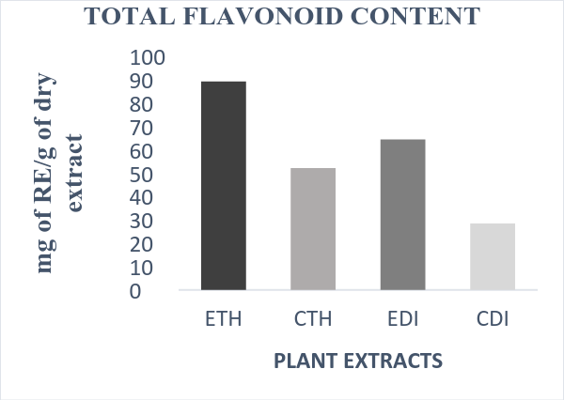

Fig 2: Various Scavenging Activities of Different Extract Fractions of T.heyneanus, D.indica and Ascorbic Acid
A.DPPH Activity B. Reducing Power
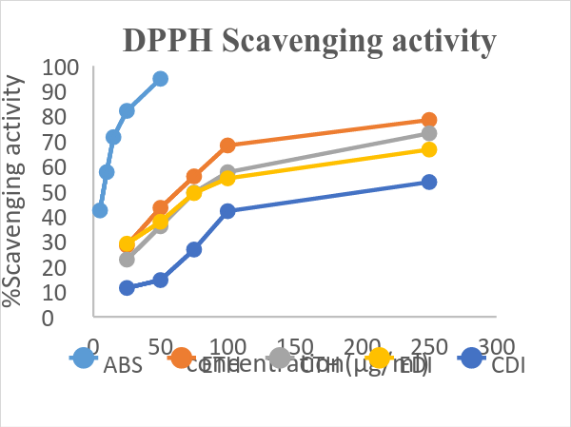
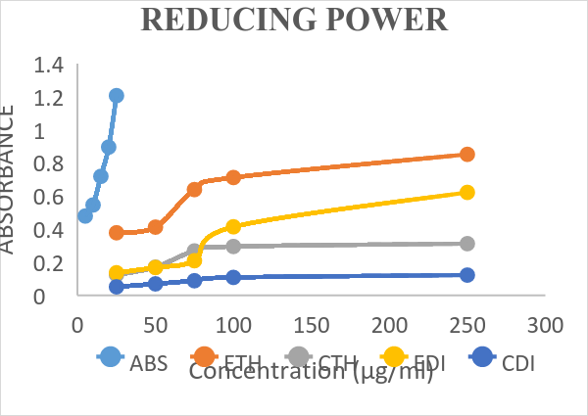
C. Nitric Oxide Scavenging Assay D. Hydrogen Peroxide Scavenging Assay
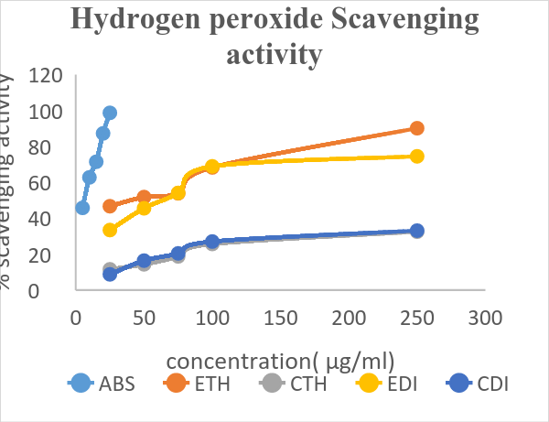
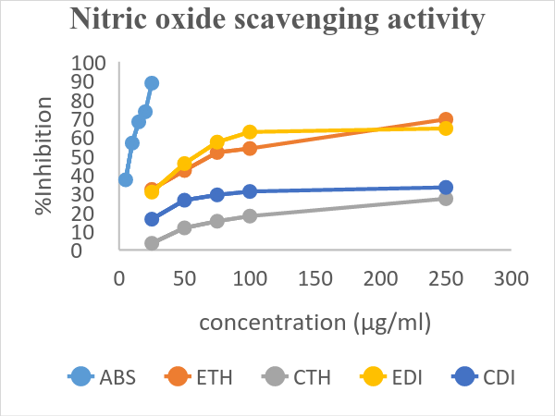
Fig 3: Comparative IC₅₀ values of Ascorbic acid, T.heyneanus and D.indica extracts fractions for various scavenging activities
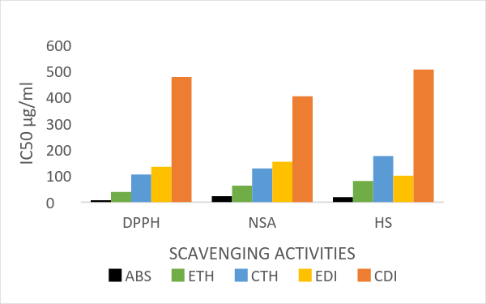

- CONCLUSION(11 Bold)
Both ethanolic and chloroform fractions of the plants T. heyneanus & D.indica were evaluated. The results clearly indicated that T.heyneanus fractions (ETH & CTH) tested in this investigation possess significant antioxidant activity than D.indica fractions (EDI&CDI).ETH exhibited high phenolics, flavonoid contents and also, high antioxidant activity with a low IC₅₀ suggests that phenolic compounds, including flavonoids, are the main contributors of antioxidant activity in these species. However, to the best of our knowledge, this is the first report of investigation on the antioxidant capacity and total phenolics as well as flavonoid content of T. heyneanus & D.indica species. However, further detailed investigation, especially invivo antioxidant and toxicity studies are needed to justify its use as a natural source of antioxidants to prevent the progression of many diseases.

ACKNOWLEDGEMENTS(11 Bold)
I would like to thank the management and Principal of Anurag Pharmacy College for providing all the facilities required to carry out my work. (10)

Abbreviations
ETH: Crude ethanol extract of T.heyneanus; CTH: Chloroform fraction of T.heyneanus; EDI: Crude ethanol extract of D.indica; CDI: Chloroform fraction of D.indica; ABS: Ascorbic acids; GAE: Gallic acid equivalent; QE: Quercetin equivalent; SD: Standard deviation; TPC: Total phenolic content;TFC:Total flavonoid content. (10)

REFERENCES(11Bold)
- H. Ahsan, A. Ali, and R. Ali, Oxygen free radicals and systemic autoimmunity, Clinical & Experimental Immunology, 131(3), 2003, 398-404.
- LA. Pham-Huy, H. He, and C. Pham-Huy, Free radicals, antioxidants in disease and health, Int J Biomed Sci,, 4(2),2008,89-96.
- P. Pietta, P. Simonetti, and P. Mauri, Antioxidant activity of selected medicinal plants, Journal of Agricultural and Food Chemistry, 46(11), 1998, 4487- 4490.
- I. Abdul Rahman, H. Tijani, B. Mohammed, H. Saidu, H. Yusuf, M. Jibrin Ndejiko, and S. Mohammed, An overview of natural plant antioxidants, Analysis and evaluation, Advances in Biochemistry, 1(4), 2013, 64-72.
- M. Valko, D. Leibfritz, J. Moncol, MT. Cronin, M. Mazur, and J. Telser, Free radicals and antioxidants in normal physiological functions and human disease, Int J Biochem Cell Biol, 39(1), 2007,44–84.
- A. Phaniendra, J. Dinesh-Babu, and P. Latha, Free Radicals: Properties, Sources, Targets, and Their Implication in Various Diseases, Ind J Clin Biochem, 30(1), 2015, 11–26.
- K. Griffiths, B. Aggarwal, R. Singh, H Buttar, D. Wilson, and F. De. Meester, Food Antioxidants and Their Anti-Inflammatory Properties, A Potential Role in Cardiovascular Diseases and Cancer Prevention. Diseases, 4(28), 2016, 1-15.
- S. Partap, and S. Pandey, A Review on Herbal Antioxidants, Journal of Pharmacognosy and Phytochemistry, 1(4), 2012, 26-37.
- D. Kasote, S. Katyare, M. Hegde, and H. Bae, Significance of Antioxidant Potential of Plants and its Relevance to Therapeutic Applications, Int J Biol Sci, 11(8), 2015, 982-991.
- V. Lobo, A. Patil, A. Phatak, and N. Chandra, Free radicals, antioxidants and functional foods Impact on human health, Pharmacogn Rev, 4(8),2010, 118–126.
- M. Serafini.The role of antioxidants in disease prevention. Medicine, 34(12), 2006, 533–535.
- K. Subramanyam, and M. P. Nayar, Vegetation and Phytogeography of the Western Ghats. In: Ecology and Biogeography in India Ed, (Junk Publishers, The Hague, 1974, 178-196).
- N.P. Singh, Taxillus Van Tiegh, In: Flora of Eastern Karnataka 2.India, (Mittal Publications, 1988, 552).
- Botanical Survey of India.org.India, Organization of Ministry of Environment, Forests and Climate Change, Government of India, 1890.
- Available from: http://efloraindia.nic.in/efloraindia/taxonList.action?id=595&type=4
- K. M Prabhu Kumar, N. P Balakrishnan, A Kabeer, and B Indira, Taxonomic notes on the genus Dalechampia L (Euphorbiaceae) in India, Journal of Science (1), 2015, 70-77.
- Botanical Survey of India.org.India, Organization of Ministry of Environment, Forests and Climate Change, Government of India, 1890.
- Available from: http://efloraindia.nic.in/efloraindia/taxonList.action?id=1532
- N. Das, M. Islam, N. Jahan, A. Khan, M. Islam, and M Parvin,, Antioxidant activities of ethanol extracts and fractions of Crescentia cujete leaves and stem bark and the involvement of phenolic compounds, BMC Complementary and Alternative Medicine, 14(45),2014,1-9.
- P. Govindan, and S. Muthukrishnan, Evaluation of total phenolic content and free radical scavenging activity of Boerhavia erecta, Journal of Acute Medicine, 3(3), 2013, 103–109.
- B. John, C. Sulaiman, S. George, and V. Reddy, Total phenolics and flavonoids in selected medicinal plants from kerala, Int J Pharm Pharm sci, 6(1), 2014, 406-408.
- S. Baba, and S. Malik, Determination of total phenolic and flavonoid content, antimicrobial and antioxidant activity of a root extract of Arisaemjacquemontii Blume, Journal of Taibah University for Science, 9(4), 2015,449–454.
- K. Pavithra, and S. Vadivukkarasi, Evaluation of free radical scavenging activity of various extracts of leaves from Kedrostis foetidissima (Jacq.) Cogn, Food Science and Human Wellness, 1(4), 2015, 42–46.
- P. Ayyasamy, D. Menaga, and S. Rajakumar, Free radical scavenging activity of methanolic extract of pleurotus florida mushroom, Int J Pharm Pharm Sci, 5(4), 2015, 601-606.
- M. Shahriar, M. Hossain, F. Sharmin, S. Akhter, M. Haque, and M. Bhuiyan, InVitro Antioxidant and Free Radical Scavenging Activity of Withania Somnifera Root, Iosr Journal of Pharmacy 2013,3(2),38- 47.
- S. Islam, K. Ahmed, M. Manik, M. Wahid, and C. Kamal, A comparative study of the antioxidant, antimicrobial, cytotoxic and thrombolytic potential of the fruits and leaves of Spondias dulcis, Asian Pac J Trop Biomed, 3(9), 2013, 682-691.
- D. Ahmed, S. Zara, and H. Baig, Invitro analysis of antioxidant activities of Oxalis corniculata Linn Fractions in various solvents, Afr J Tradit Complement Altern Med, 10 (1), 2013, 158-165.
- S. Saha, and R. Verma, Antioxidant activity of polyphenolic extract of Terminalia chebula Retzius fruits, Journal of Taibah University for Science, 10(6), 2016, 805–812.
- R. Khan, M. Khan, S. Sahreen, and M .Ahmed, Evaluation of phenolic contents and antioxidant activity of various solvent extracts of Sonchus asper (L.) Hill. Chemistry Central Journal, 6(12), 2012, 1-7.
- S. Sahoo, G. Ghosh, D. Das, and S. Nayak, Phytochemical investigation and invitro antioxidant activity of an indigenous medicinal plant Alpinia nigra B.L. Burtt, Asian Pac J Trop Biomed, 3(11), 2013, 871-876.
- B. Hazra, S. Biswas, and N. Mandal, Antioxidant and free radical scavenging activity of Spondias pinnata,International Society for Complementary Medicine Research,8(63), 2008, 1-10.
- M. Hossain, M. Sarwar, S. Dewan, A. Shahid-Ud-Daula, and M Islam, Investigation of total phenolic content and antioxidant activities of Azadirachta indica roots, AJP, 4(2), 2014, 97-102.
- S. Sannigrahia, U. Mazuder, D. Palc, S. Paridaa, and S. Jaina, Antioxidant Potential of Crude Extract and Different Fractions of Enhydra fluctuans Lour, Iranian Journal of Pharmaceutical Research, 9(1), 2010, 75-82.
- N. Saeed, M. Khan, and M. Shabbir, Antioxidant activity, total phenolic and total flavonoid contents of whole plant extracts Torilis leptophylla L. Complementary and Alternative Medicine, 12(221), 2012, 1-12.
- M. Farasata, R. Khavari-Nejada, S. Nabavib, and F. Namjooyan, Antioxidant Activity, Total Phenolics and Flavonoid Contents of some Edible Green Seaweeds from Northern Coasts of the Persian Gulf, Iranian Journal of Pharmaceutical Research, 13(1), 2014,163-170.
- B. Birasuren, N. Kim, H. Jeon, and M. Kim, Evaluation of the Antioxidant Capacity and Phenolic Content of Agriophyllum pungens Seed Extracts from Mongolia, Prev Nutr. Food Sci, 18(3), 2013, 188-195.
References Sige (10)

